Looking at @dog_rates’ Twitter page, we can see that there are definitely some ratings that break the traditional “1-10” scale. As a matter of fact, it seems common for every dog to get above 10/10 and very rare for a dog to get below 10/10. Has this account always been this generous in rating dogs? Perhaps in the past, they were stricter. Let’s do an analysis and see if this is true. I’ve made a plot which displays all of the ratings (excluding some ridiculous outliers) from 2016 – present with a linear regression line representing the trend of ratings over the years.

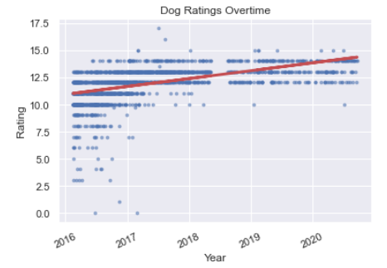

We can see that there is clearly an uptrend in this data by looking at the red regression line. In 2016, the account appeared to hand out far more ratings below 10. From 2018 onwards, ratings below 10 were nonexistent. By running this data through a statistical significance test, we can conclude with nearly 100% certainty that this data is statistically significant.

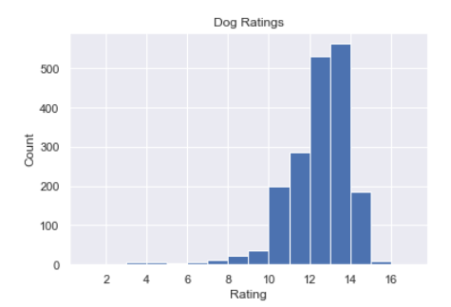A histogram of the ratings will allow us to better visualize how often a given rating is handed out by this account.

It appears that ratings below 10 are nearly never given out in general, even when we account for the lower ratings in the past. This is largely due to the massive number of ratings above 10. The number of ratings above 10 dwarf the ones below 10. The @dog_rates account must really like dogs.