**MACM 316 – Assignment 1**

Rajan Grewal | 301335629 | January 13, 2020

1. As n gets larger, the curve wavers in a given direction with greater strength. If n is even, the function is always positive. If n is odd, the function negative on x = [-∞,2).
2. The program will calculate f(x) for any set of real numbers x, a single real number a, and a single positive integer n.

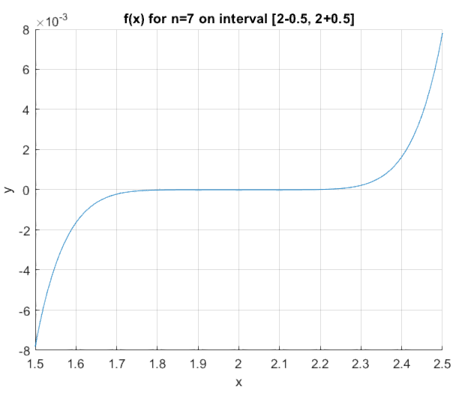

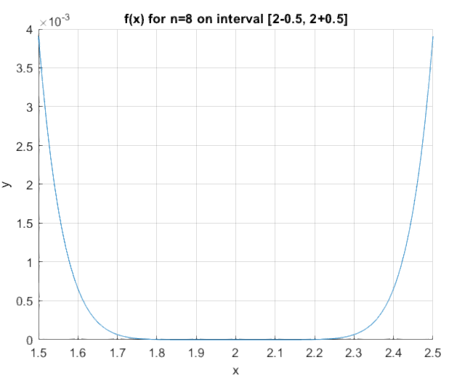



**n=7**

Delta=0.5: line is smooth.

Delta=0.05: line is smooth.

Delta=0.005: line becomes very inaccurate.

**n=8**

Delta=0.5: line is smooth.

Delta=0.05: line becomes inaccurate.

Delta=0.005: line is very inaccurate.

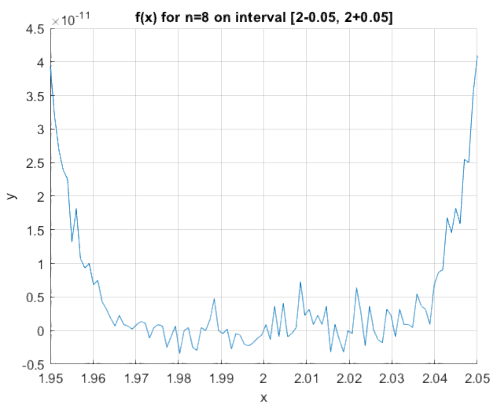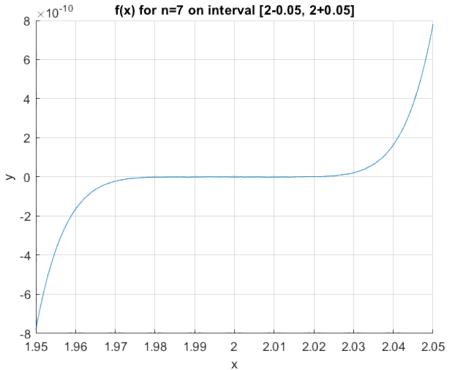a) The smallest value would be 5. After this, we can visually notice a difference. ­­

b) As n gets larger, the graph gets more and more inaccurate.

c) When we have a term with a large exponent, its result is often rounded, and by adding this to other rounded terms, we begin to accumulate an increasingly large error.

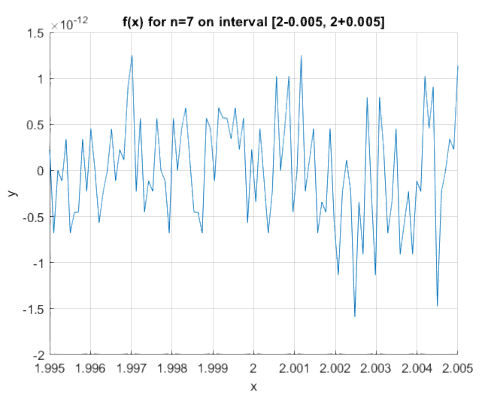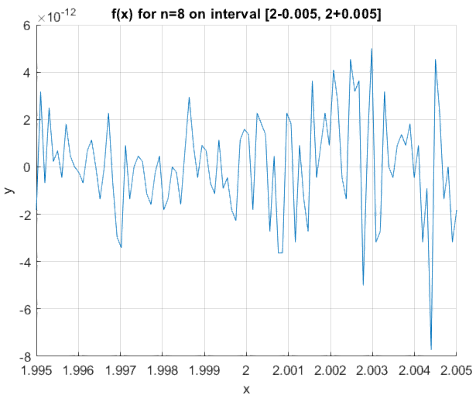

1. 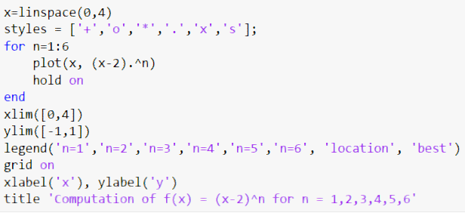

1. 