**MACM 316 - CA2**

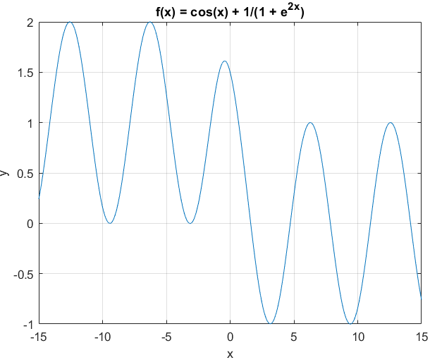Rajan Grewal 301335629

Figure 1 for part a)

1. The behaviour of the function oscillates with an amplitude of one in a downward trend on [-15, 15]. The first two humps are the same level, the third is about 0.4 units below, and the fourth and fifth are about 0.6 units below the third. There are roots at -9.425, -3.200, -3.075, 1.610, 4.712, 7.854, 11.000, 14.140 for a total of 8 roots.
2. The roots for f+(x) = cos(x) are π(n - 1/2), n∈Z+ for x>0

The roots for f-(x) = cos(x) + 1 are 2πn + π, n∈Z- for x<0

These roots relate to the zeros of f(x) because when f(x) is a large negative number, the 1/(2+e2x) portion approaches 1, and when f(x) is positive, that portion approaches 0, so we can use these limits as an approximation to the roots of f(x) for large magnitudes of x.

1. 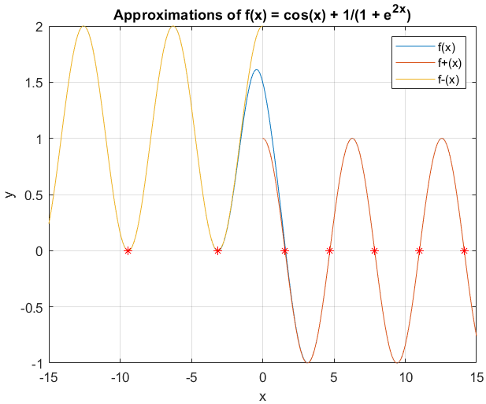x* = 1.6093 whereas the smallest positive root of f+(x) = π/2 = 1.5708. Relative error is 2.3923% and absolute error is 0.0385. Relative error is fairly large so it doesn’t approximate it so well in this case because the root is so close to zero. I chose the endpoint of 3 by looking at the graph and noticing that there is clearly one root between 0 and 3, with no possibility of hidden root(s).

Figure 2 for

part b)

1. x* = -3.0764 where as the smallest negative root of f-(x) = -π = -3.1416. Relative error is 2.1194% and absolute error is 0.0652. Relative error is smaller than part c), but still fairly large so the approximation isn’t too great for the same reason as part c). I chose the endpoint -3.104 because there is another root just to the left of this one around -3.19, which would have yielded incorrect results with an interval larger than roughly -3.2. An interval smaller than roughly -3.0764 would yield no result as there is no root in such an interval.

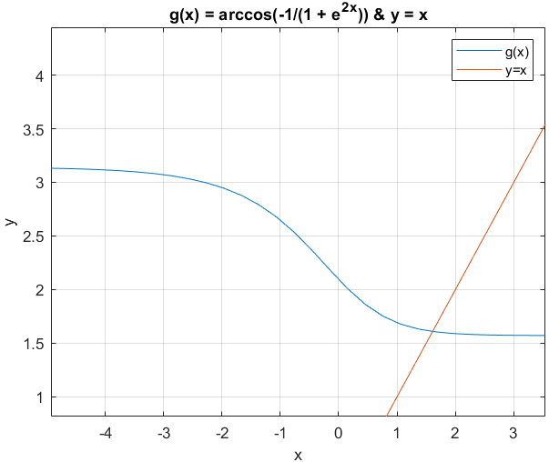

Figure 3 for

part e)

1. Finding a fixed point to g(x) is equivalent to finding a root for f(x) = 0. This is shown by the following steps:

cos(x) + 1/(1 + e2x) = 0

cos(x) = -1/(1 + e2x)

x = arccos(-1/(1 + e2x))

We can now see that the equation is in fixed-point form.

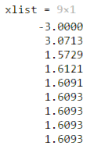The program returns an incorrect result of 1.6093 because there is only one solution to the fixed-point equation which is the intersection of g(x) and y=x. We can see that the intersection is around x = 1.6 and that there is only one. Fixed point converges in two ways: staircase and spiral. In this case, by looking at the table from figure 3, we can see that the convergence is in a spiral pattern. We can help see this by plugging in the initial value of -3, and drawing horizontal line from g(x) to y=x, and then a vertical line from y=x to g(x) to get our next input value. Continuing this pattern, we slowly converge to the point 1.6093.

1. 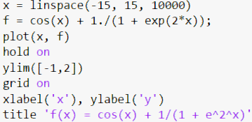
2. 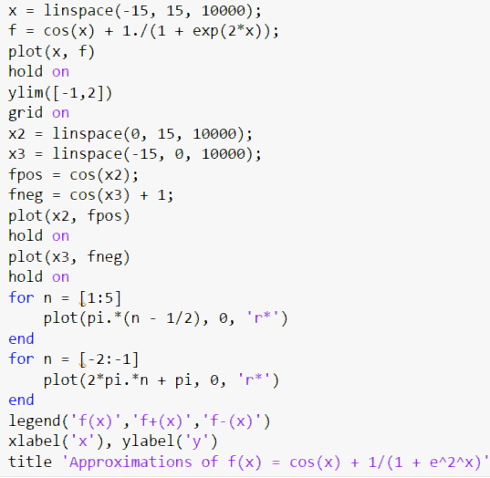
3. 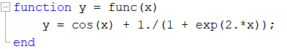



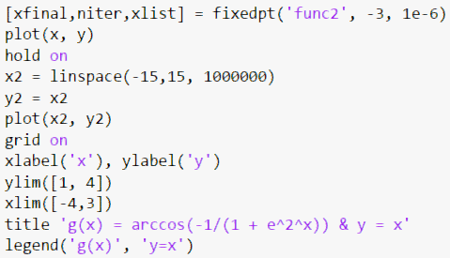

1. 