Report 2
The team’s GitHub repository is:

Github: https://github.com/Rioo-o/322-Project-Team-M

The login GUI prototype is available through GitHub Pages at:
https://rioo-o.github.io/322-Project-Team-M/prototype/LoginPrototype.html
The prototype demonstrates role-based login for students, instructors, and registrars. It includes sample credentials, invalid-login handling, visitor access, and application links.

Collaboration Class Diagram
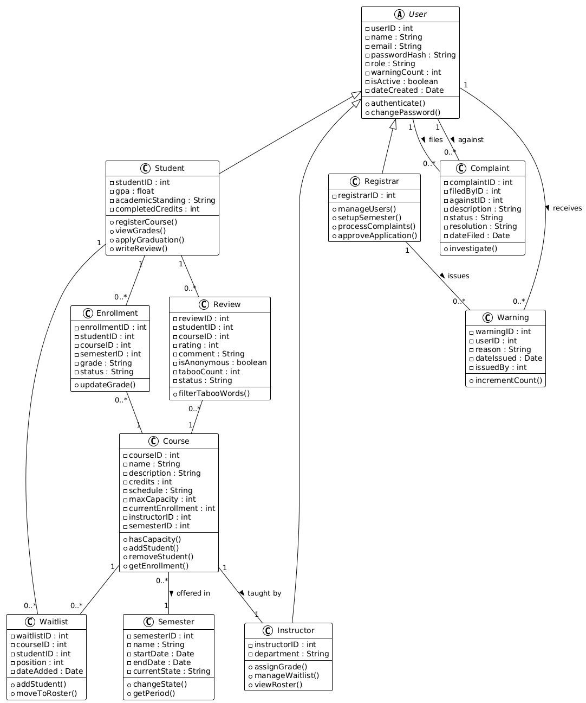

2.
UC-4 Register for Classes
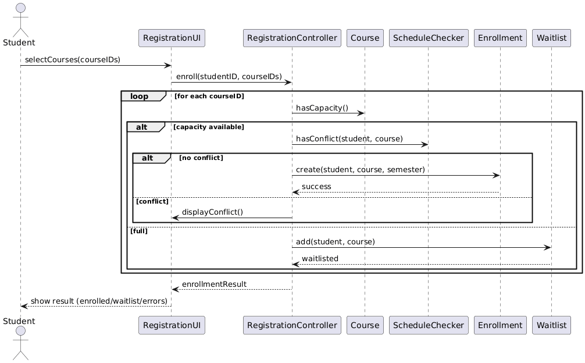

Petri-Net for UC-4 Register for Classes
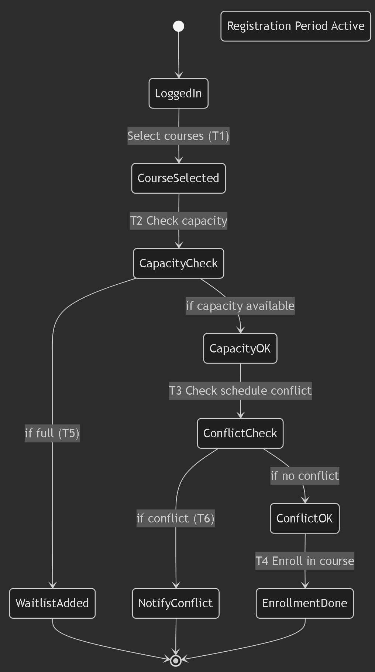
UC-8 Assign Grades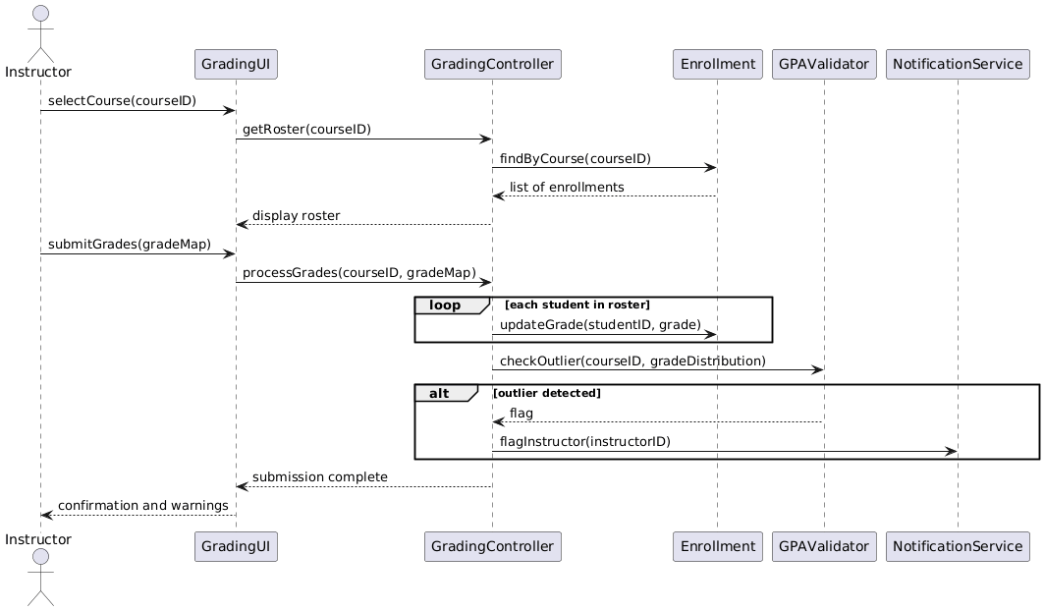

Petri-Net for UC-8 Assign Grades
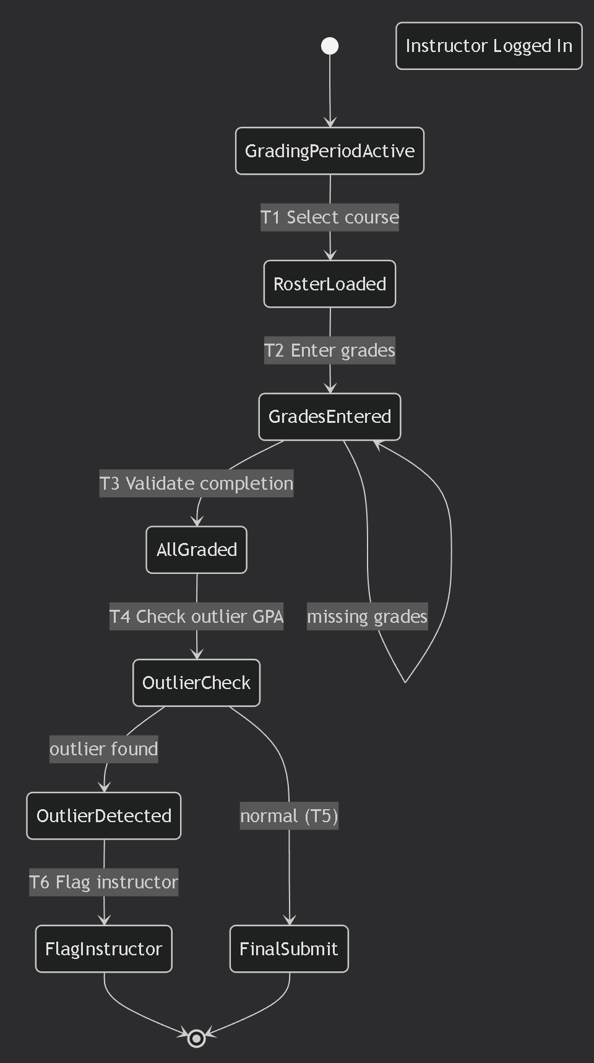

UC-10 Apply for Graduation
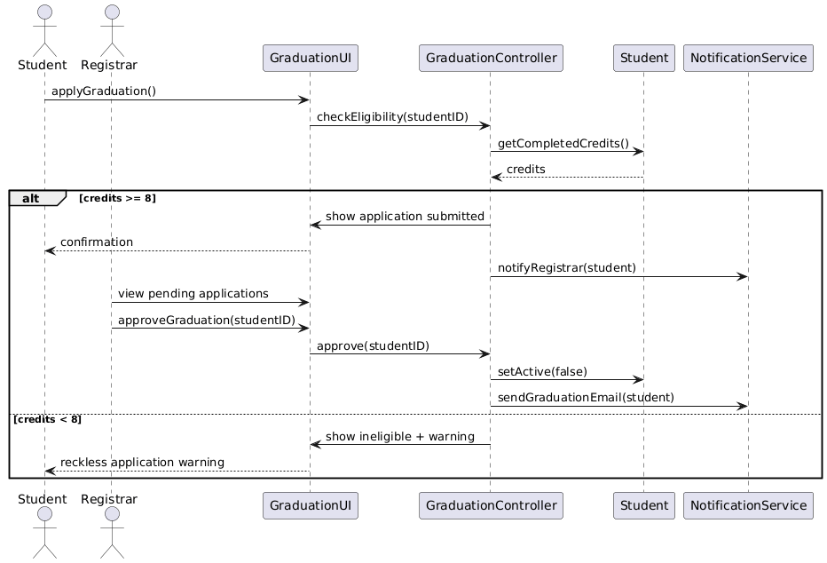

Petri-Net for UC-10 Apply for Graduation
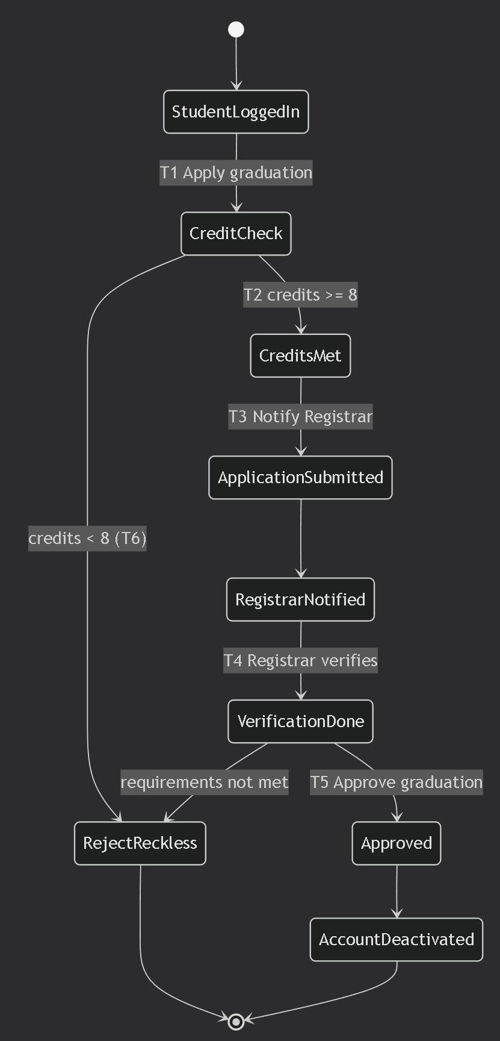

3.
Detailed Design
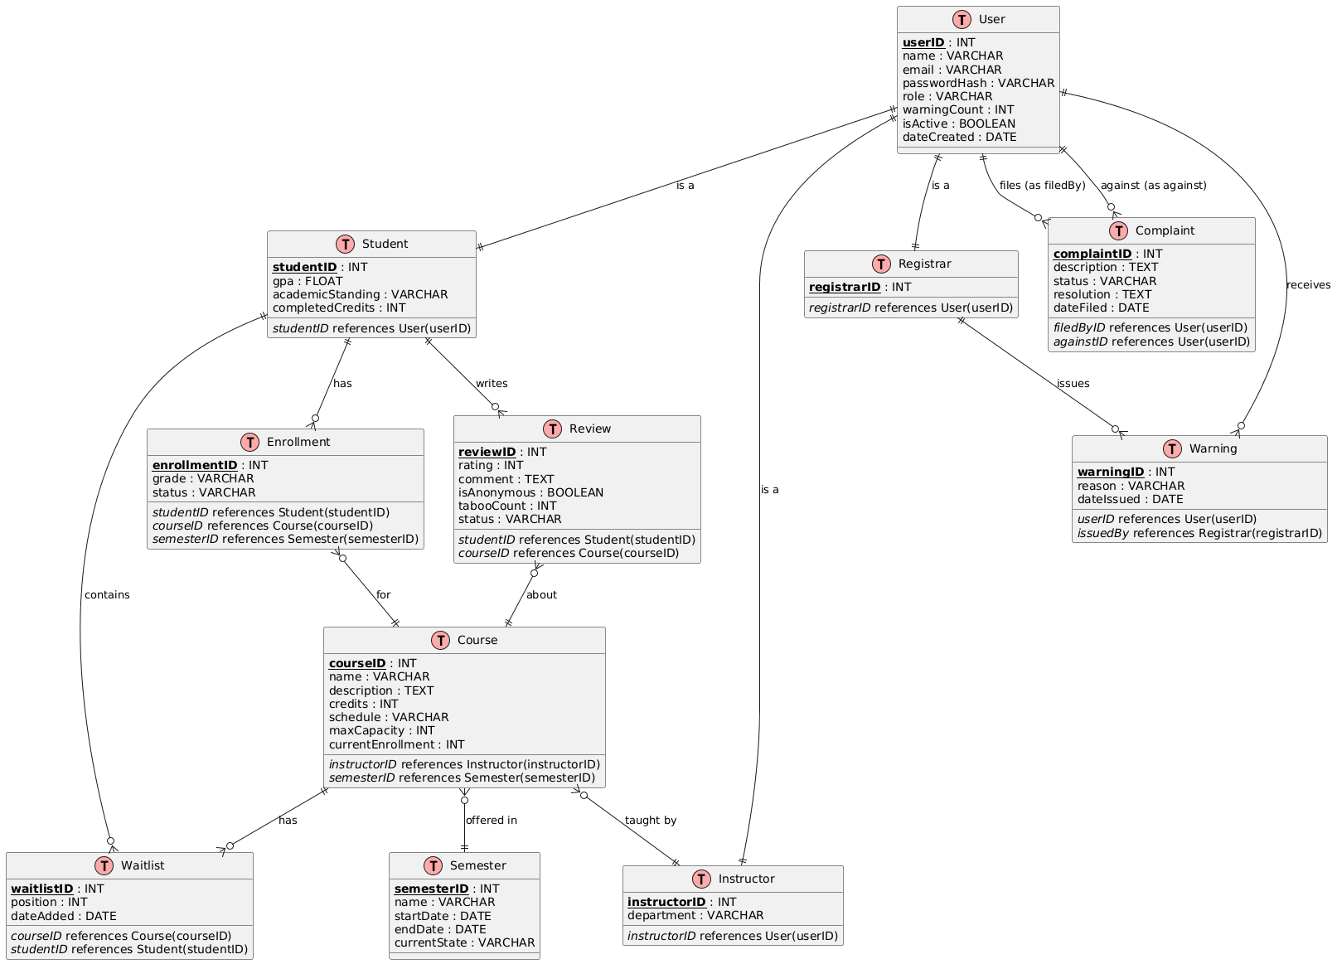
4.
Detailed Design
Class: UserController

method authenticate(email, password):
input: email (string), password (string)
output: User object or null
begin
user = database.findUserByEmail(email)
if user == null then return null
if hash(password) != user.passwordHash then return null
if user.isFirstLogin then
user.forcePasswordChange = true
return user
end

method changePassword(userID, oldPass, newPass):
input: userID (int), oldPass (string), newPass (string)
output: boolean (success)
begin
user = database.getUser(userID)
if hash(oldPass) != user.passwordHash then return false
if not validatePasswordStrength(newPass) then return false
user.passwordHash = hash(newPass)
user.forcePasswordChange = false
database.updateUser(user)
return true
end

Class: RegistrationController

method enrollStudent(studentID, courseIDs[]):
input: studentID (int), list of courseIDs (int)
output: EnrollmentResult (success/waitlist/failure with reason)
begin
student = database.getStudent(studentID)
if student.isSuspended then return failure("Student suspended")
if currentSemester.state != "REGISTRATION" then return failure("Not registration period")
enrolledCount = database.countEnrollments(studentID, currentSemester)
if length(courseIDs) + enrolledCount < 2 or > 4 then return failure("Must enroll in 2-4 classes")

result = new EnrollmentResult()
for each cid in courseIDs:
course = database.getCourse(cid)
if course.hasConflict(student.schedule) then
result.addFailure(cid, "Schedule conflict")
continue
if not course.canRetake(studentID) then
result.addFailure(cid, "Cannot retake (previous grade not F)")
continue
if course.currentEnrollment < course.maxCapacity then
enrollment = new Enrollment(studentID, cid, currentSemester, "ENROLLED")
database.save(enrollment)
course.currentEnrollment++
result.addSuccess(cid)
else
waitlist.add(studentID, cid)
result.addWaitlist(cid)
database.update(course)
return result
end

Class: GradingController

method submitGrades(instructorID, courseID, gradeMap):
input: instructorID (int), courseID (int), gradeMap (map studentID->grade)
output: boolean success, list of warnings
begin
course = database.getCourse(courseID)
if course.instructorID != instructorID then return false, "Not instructor of record"
if currentSemester.state != "GRADING" then return false, "Grading period not active"

enrollments = database.getEnrollmentsByCourse(courseID)
missingStudents = []
for each enr in enrollments:
if not gradeMap.containsKey(enr.studentID) then
missingStudents.add(enr.studentID)
else
enr.grade = gradeMap[enr.studentID]
database.update(enr)

if not empty(missingStudents) then
warning = new Warning(instructorID, "Missing grades for " + courseID)
database.save(warning)

// Outlier detection
gpaList = gradeMap.values().map(gradeToPoint)
avgGPA = average(gpaList)
if avgGPA > 3.5 or avgGPA < 2.5 then
flag = new Flag(instructorID, courseID, "Unusual GPA distribution")
database.save(flag)

return true, missingStudents
end

Class: StandingController

method updateAcademicStanding():
input: none (runs after grading period ends)
output: none (updates database)
begin
students = database.getAllActiveStudents()
for each student in students:
enrollments = database.getEnrollmentsForSemester(student.studentID, currentSemester)
if enrollments.isEmpty() then continue
totalPoints = 0
totalCredits = 0
for each enr in enrollments:
if enr.grade != null then
points = gradeToPoint(enr.grade) * enr.course.credits
totalPoints += points
totalCredits += enr.course.credits
if totalCredits == 0 then continue
gpa = totalPoints / totalCredits
student.gpa = ((student.gpa * student.completedCredits) + totalPoints) / (student.completedCredits + totalCredits)
student.completedCredits += totalCredits

if gpa < 2.0 then
student.academicStanding = "TERMINATED"
student.isActive = false
database.update(student)
else if gpa >= 2.0 and gpa < 2.25 then
student.academicStanding = "WARNING"
warning = new Warning(student.userID, "GPA below 2.25")
database.save(warning)
// Schedule interview notification
else if gpa > 3.75 then
student.academicStanding = "HONOR_ROLL"
// Remove one warning if exists
warnings = database.getWarnings(student.userID)
if not empty(warnings) then
database.deleteWarning(warnings[0].warningID)
database.update(student)
end

5. System Screens
This section presents the major graphical user interface screens of the College0 system. All screens share a consistent single-window layout: a top navigation bar, a collapsible left sidebar, and a main content area. No separate pop-up windows are used; all interactions take place within the same frame. The six screens below cover the key workflows for every user role.

5.1 Screen 1: Public Home Dashboard
The home screen is accessible to all users including visitors. It displays a program introduction banner, a row of quick statistics (active courses, enrolled students, instructors, current semester), a side-by-side table of the highest-rated and lowest-rated classes with star ratings, and an honor roll panel highlighting the top-GPA students. Navigation links to the login and AI assistant are present in the top bar.
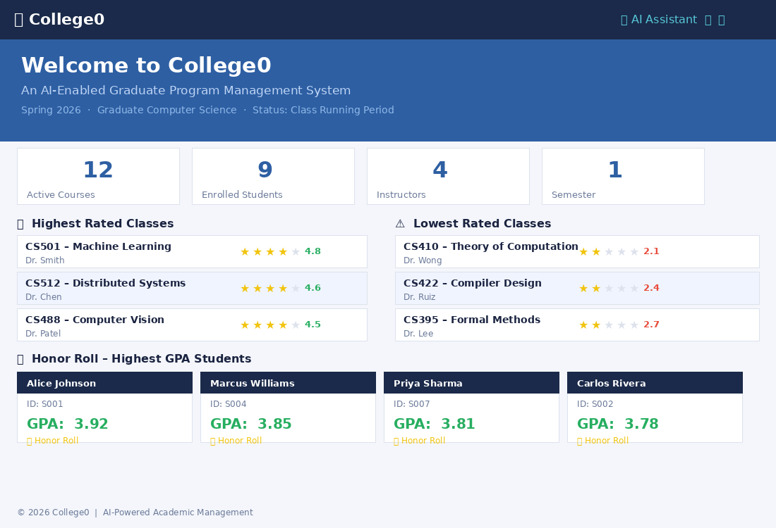

5.2 Screen 2: Login / Account Access
The login screen presents a centered card with email, password, and role-selector (Student / Instructor / Registrar) fields, a Sign In button, and links for visitors to apply as a student or instructor. First-time students who log in are redirected to a mandatory password-change dialog before entering the system.
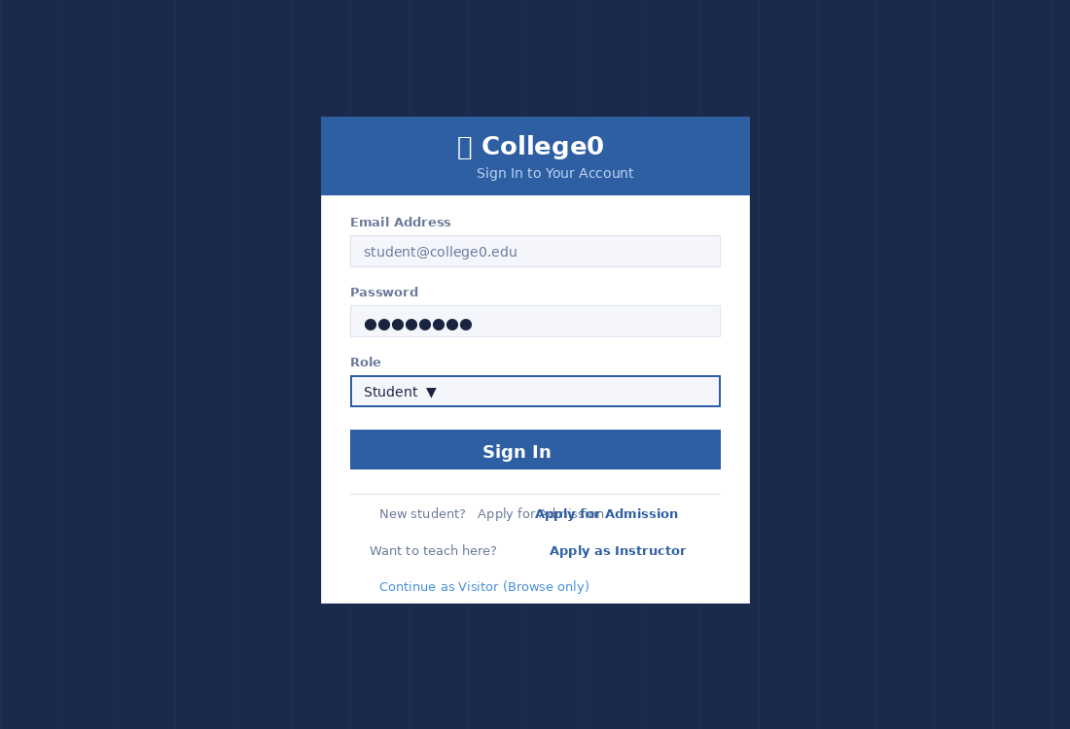

5.3 Screen 3: Student Dashboard
After login, a student lands on a personal dashboard showing their name, student ID, status, and warning count in the header. Four summary cards display overall GPA, credits completed, current-semester course count, and academic standing (e.g., Honor Roll). Below is a table of current courses with time, instructor, enrollment status (Enrolled / Waitlisted), and the student’s own rating for each class. Quick-action buttons for writing a review, filing a complaint, applying for graduation, and opening the AI assistant are shown at the bottom.
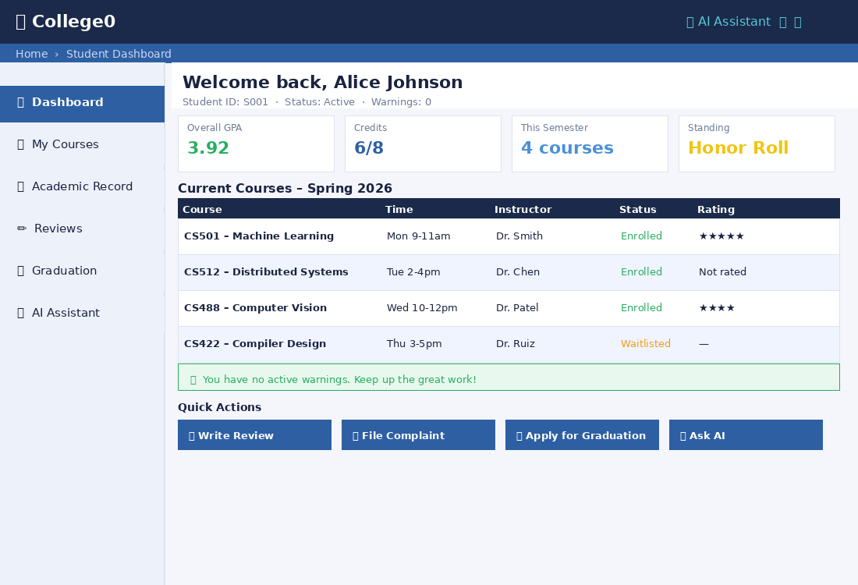

5.4 Screen 4: Course Registration
During the registration period a student sees their currently selected courses (highlighted in green with a remove button) and a table of all available courses showing code, name, instructor, meeting time, current enrollment vs. capacity, aggregate star rating, and an Add / Waitlist button. A conflict-detection banner appears at the bottom if the student attempts to add a course whose meeting time overlaps an already-selected course. A Confirm Enrollment button finalizes the selection once 2–4 courses are chosen.
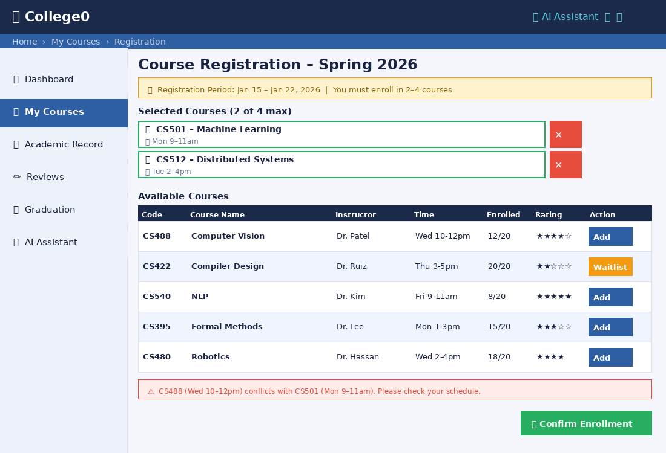

5.5 Screen 5: Registrar Control Panel
The registrar dashboard provides a system-wide overview. A four-phase progress bar at the top indicates the current semester phase (Class Setup → Registration → Class Running → Grading). Summary cards show total students, instructors, active courses, and the number of pending actions. Below, a table lists student and instructor applications awaiting Accept/Reject decisions. A recent-warnings panel at the bottom lists automatically and manually issued warnings with reasons, targets, and dates, allowing the registrar to review system health at a glance.
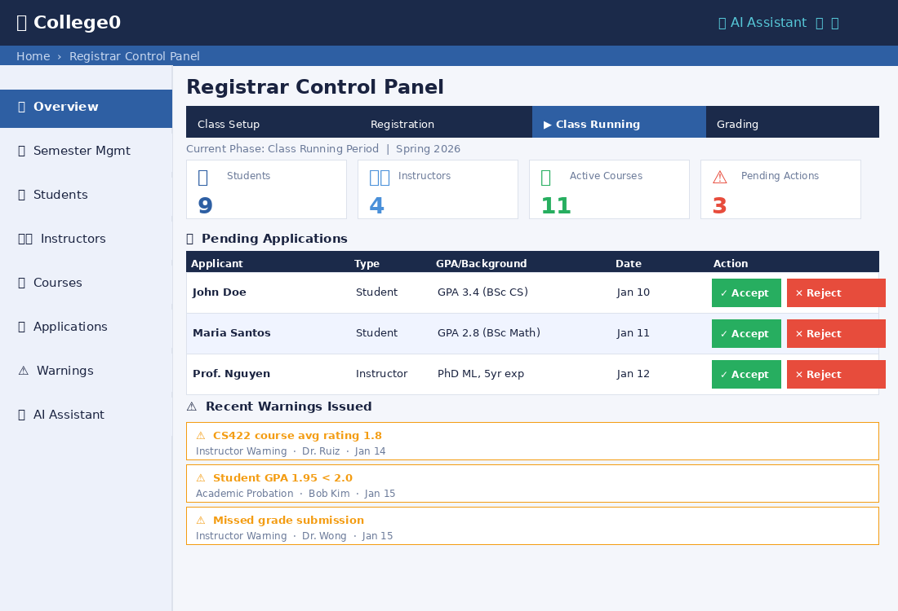

5.6 Screen 6: AI Assistant (Student View)
The AI chat panel is embedded within the main application window. The conversation history shows both user and bot messages in styled bubbles. A “Local KB” badge on bot responses indicates the answer was sourced from the college’s local vector database; if no local answer is found the query is escalated to the general LLM and a hallucination-warning banner is displayed below the input field. Students can ask about their own enrolled courses; instructors see additional context about students in their classes; visitors are restricted to general policy questions.
