Boston JATC
Conference Rooms and Auditorium

User Interfaces Submittal Version 1.0.0 – May 2023.

Custom Controls
(Crestron TS(W)-1070)

This submittal reflects the general look, feel, and operation proposed for the system touchpanel. It may be necessary to add, delete, or revise specific functionality based on field conditions or unexpected hardware operation.
Note: The Primary user interface for the Microsoft Teams Room, including placing and ending calls, volume, and microphone muting, is standardized by Microsoft and is not depicted in this submittal.

When the Microsoft Team Rooms system reports that it is awake, sharing content, or in a call the room display(s) will be powered on and display the output of the MTR system. When the system reports that it is asleep, the display(s) will be powered off.

If an HDMI input is detected or if sharing is started using the AirMedia Device (provided that the AirMedia device is able to communicate with the Crestron processor via the building network) it will be automatically shared in a “last-in, first-out” manner, e.g. the most recently detected source will be shared, and when that source is no longer detected the next most recently detected source (if any) will be shared.

The pages depicted in this submittal are accessed from the “Room Controls” option on the main MTR interface and the user may return to the Microsoft Teams controls by touching the “Back to Teams” button. After a period of inactivity the touchscreen will automatically revert to the Microsoft Teams interface.

Room Camera Controls (All Rooms Except Auditorium)
This is the default landing page for the Room Controls and allows the user to adjust pan, tilt, and zoom for the camera.

Presets operate like a car radio: Press to recall, press and hold to store.
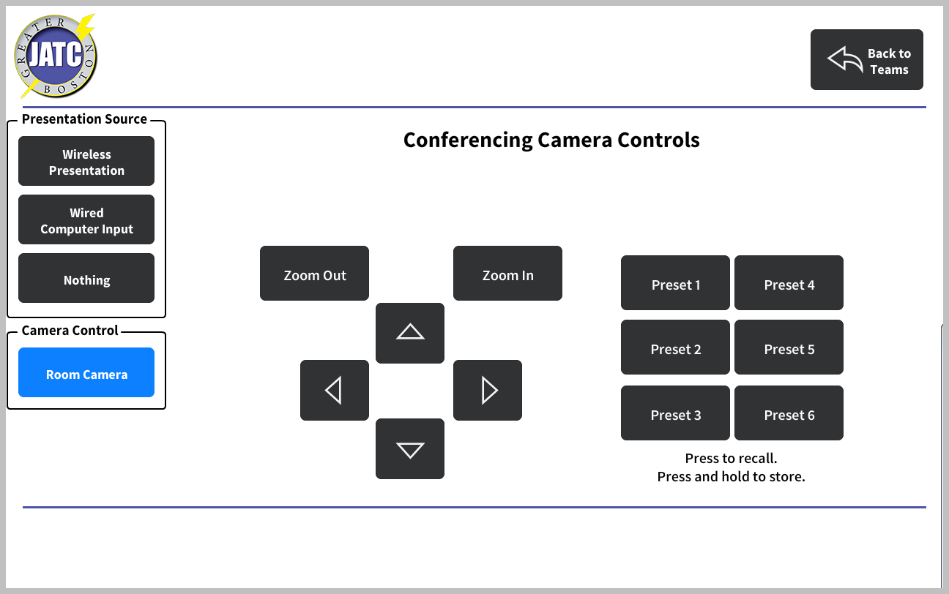

Room Camera Controls (Auditorium)
This is the default landing page for the Room Controls and allows the user to adjust pan, tilt, and zoom for the camera.

Presets operate like a car radio: Press to recall, press and hold to store.

The user may switch between the two cameras by using the options on the left menu.
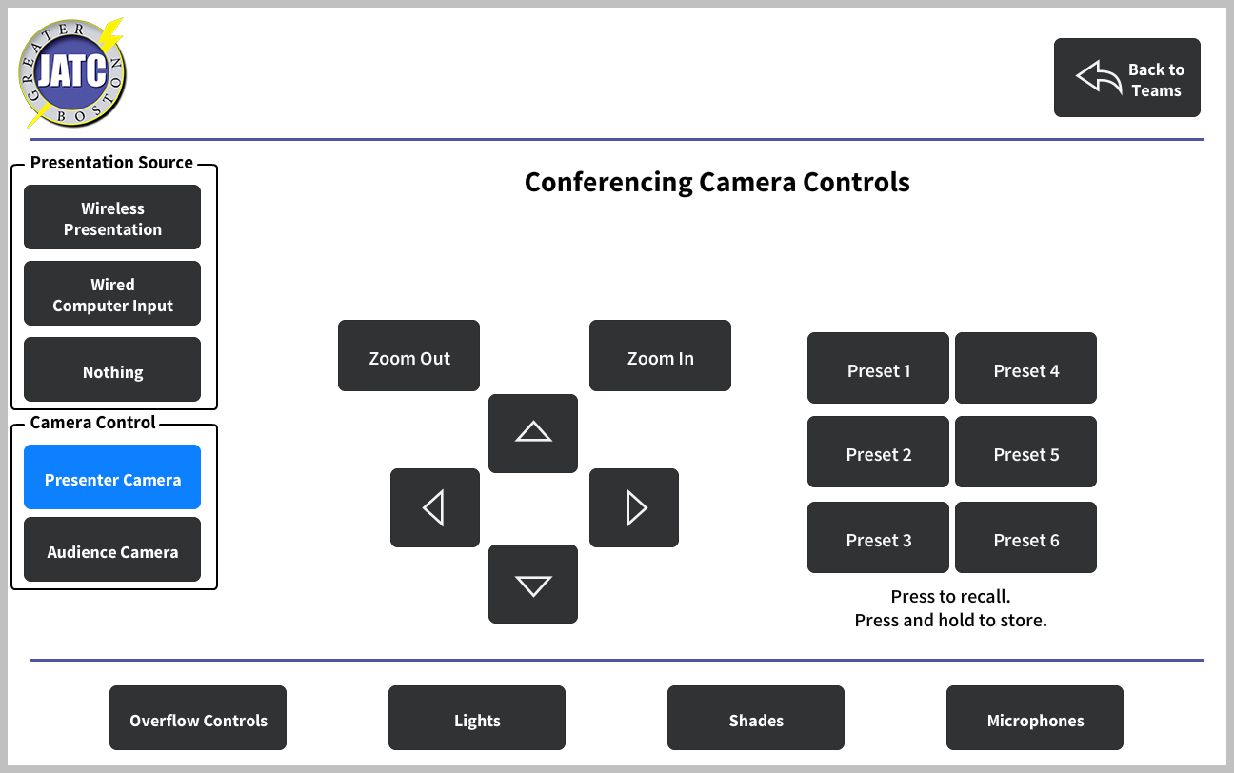

Wireless Presentation (All Rooms)
This page is displayed if the user selects the “Wireless Presentation” option from the left menu and serves as a confirmation of the user’s selection as well as providing the connection information for the wireless presentation device (if the Crestron processor is able to communicate with it over the network)

(Note: the left and footer menus shown here represent rooms except the Auditorium; for the auditorium those shown on page 4)
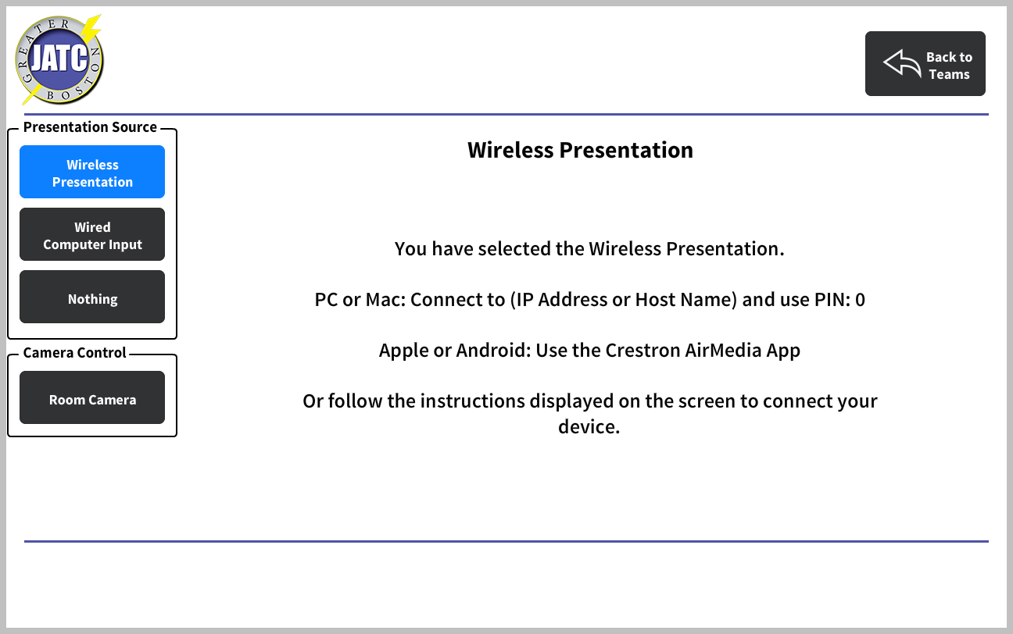

Room Computer (All Rooms)
This page is displayed when the user selects the “Wired Computer Input” option and confirms the user’s selection

(Note: the left and footer menus shown here represent rooms except the Auditorium; for the auditorium those shown on page 4)
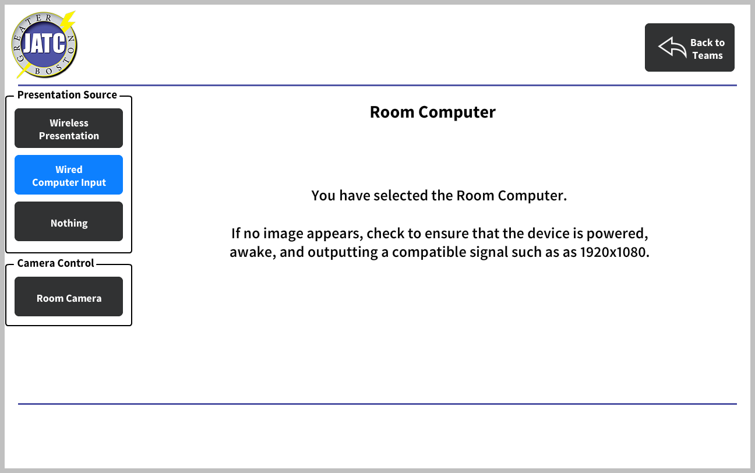

Receive Overflow (All Rooms Except Auditorium and Boardroom)
This page is displayed in rooms selected by the Auditorium to receive overflow video and audio. In this mode, the room may choose to receive either the camera or the presentation source and adjust the volume being received but all other controls are unavailable
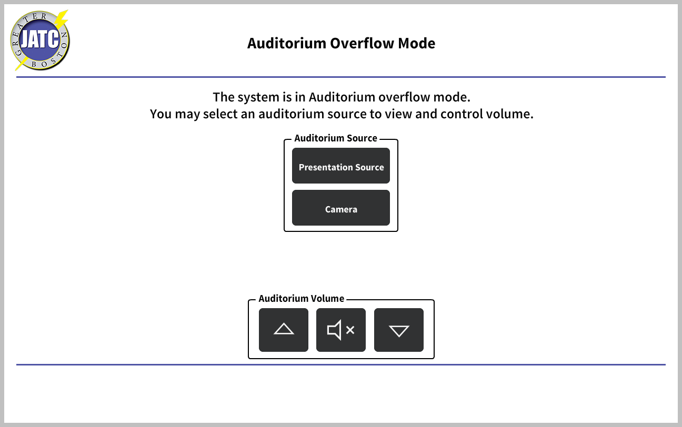

Overflow Controls (Auditorium Only)
This page is displayed in the Auditorium when the user selects the Overflow Controls option from the touchpanel footer.

From this page the user can enable or disable the overflow mode for rooms capable of receiving overflow from the Auditorium.
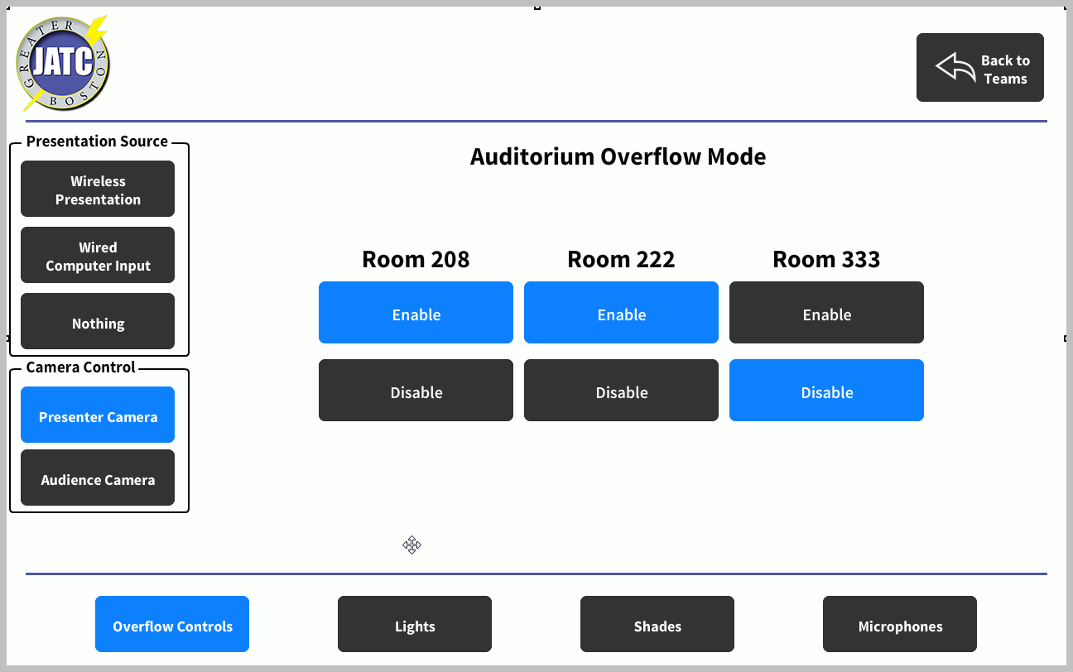

Lighting Controls
This page is displayed when the user selects the Lights option in the footer and allows for control of the lighting.
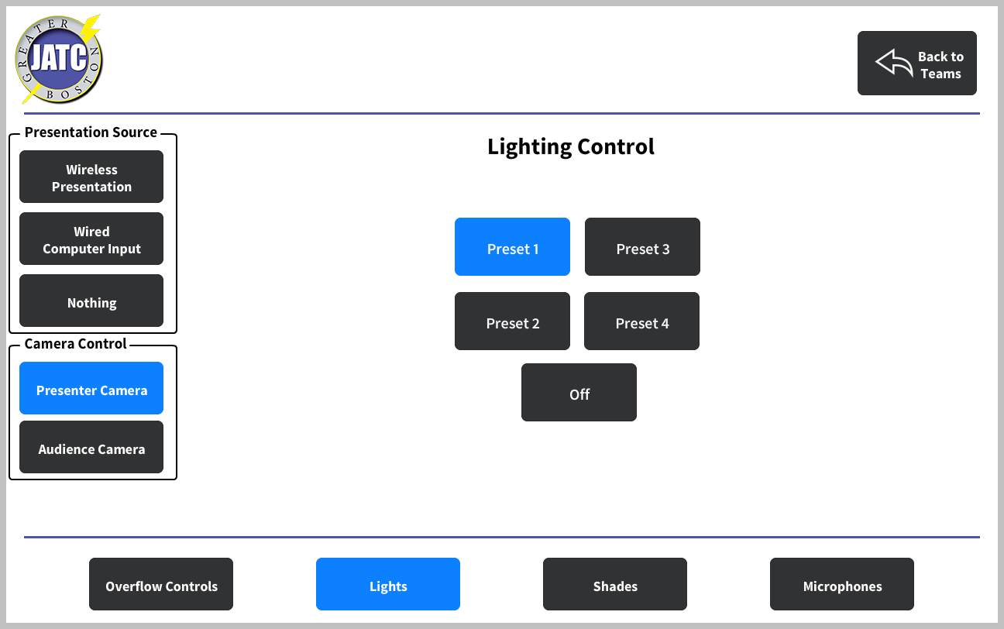

Shade Controls
This page is displayed when the user selects the Shades option in the footer and allows for control of the shades.

Note: The exact functionality is pending confirmation of shading capabilities.
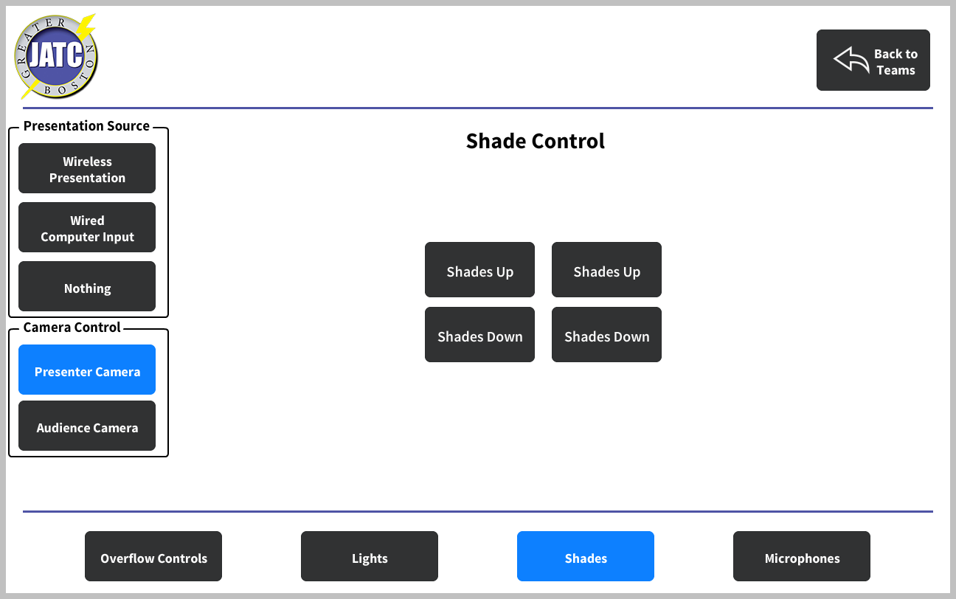

Microphone Control
This page is displayed when the user selects the Microphones option and allows for adjustment of the volume of the wireless microphones as well as the ability to mute the ceiling microphones independently if needed.
