
Manufacturing Brief

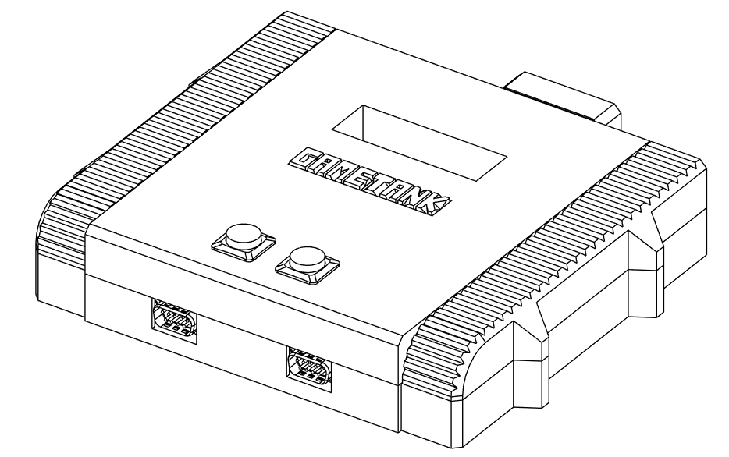

Prepared by Clydeware, LLC
Updated December 12 2025
Table of Contents
Hardware Descriptions | 3
Bill of Materials
Motherboard | 4
Audio/Visual Board | 6
Console Assembly | 7
Controller | 8
Data Cartridge | 8
Cartridge Flasher Tool | 9
3D Printed Parts
Main Game Console Unit | 10
Controller | 11
Data Cartridge | 12
Cartridge Flasher Tool | 13
Assembly Procedure
Main Console PCB Stack | 14
Enclosure Top Half Preparation | 16
Console Assembly | 18
Controller Wiring | 20
Controller Assembly | 21
Data Cartridge | 22
Cartridge Flasher Tool | 25
Cartridge Flasher Firmware | 26
Cartridge Flasher Operation | 27
Parts Sourcing Notes | 28

Hardware Descriptions

Main Game Console Unit
A GameTank console consists of two PCBs inside a plastic enclosure. The two PCBs are connected electrically by a pair of flat flexible cables, and mechanically by four standoff fasteners. There is also a 3D-printed spacer placed in the center of the board stack. The enclosure consists of four printed parts, and two push-buttons. The buttons have a wire harness soldered on, which plugs into the motherboard in three places. The bottom half of the enclosure is one solid piece. The upper half of the enclosure has a printed decorative “badge” piece which is thermally bonded to the main upper part of the enclosure body. Lastly, a “vent” cover is placed at the rear of the console. The enclosure is held together by four screws which self-tap into the plastic.

Controller
The input device consists of an assembled PCB, a cable with an attached molded flangeless D-shape connector, four 3D printed parts, two screws, and two spacers. The printed parts include the main body of the controller in which the PCB rests, a faceplate with holes for buttons, a flexure holding four buttons and a plus-shaped directional pad, and an insert to be placed beneath the directional pad that prevents simultaneous opposite direction inputs. The cable is soldered directly to the PCB, and has a rubber strain relief boot that mates with a tab inside the controller body. The two screws are installed from the back of the controller through all other parts, and into the faceplate. The spacers support the center of the flexure, above the PCB. The faceplate is designed so that the screws self-tap.

Data Cartridge
The data cartridge consists of an assembled PCB, a 3D printed shell in two parts, and two screws. The PCB has plated finger contacts for use with the edge connector in the Console and the Flasher. The side of the PCB with mounted components is considered the front of the cartridge. The two halves of the shell have diagonal tabs to allow the cartridge to be stably held together by the two screws near the top. The screws should fit loosely through the back half of the shell, and self-tap into the front half. The cartridge may be affixed with a label bearing artwork for a particular game title. The front half of the shell has a gap to allow the label to be folded over for improved long term adhesion.

If being used as distribution media for software, the Cartridge Flasher Tool is used to load data into the flash memory of the cartridge.

Cartridge Flasher Tool
The cartridge flasher tool consists of an assembled PCB, a 3D printed base, and two screws. The AVR microcontroller on the PCB requires a bootloader and firmware. The programming header is exposed both as header pins and as Tag-Connect contacts. If the Tag-Connect header can be used for flashing at scale, the header pins may be omitted.

Bill of Materials

Main Game Console Unit – Motherboard
Qty | MPN | Description | Manufacturer
9 | 74HC257PW,118 | Quad 2-to-1 multiplexer (HC series) | Nexperia
1 | SN74HC640PWR | Octal bus transceiver, inverting | Texas Instruments
2 | CD74HCT238PWR | 3-to-8 line decoder/demultiplexer | Texas Instruments
61 | CC0805KRX7R9BB104 | Capacitor 0.1µF, 50V, X7R, 0805 | Yageo
1 | CC0805MRX5R5BB106 | Capacitor 10µF, 6.3V, X5R, 0805 | Yageo
1 | CC0805KRX7R7BB104 | Capacitor 0.1µF, 16V, X7R, 0805 | Yageo
2 | CC0805MRX5R5BB226 | Capacitor 22µF, 6.3V, X5R, 0805 | Yageo
1 | 860020273009 | Capacitor 220µF, Electrolytic | Wurth
4 | CD74HC08PWR | Quad 2-input AND gate | Texas Instruments
2 | 74HC40103PW,118 | 8-bit synchronous binary down counter | Nexperia
1 | FR1M-LTP | Power Diode | MCC
3 | 74AHCT74PW,118 | Dual D-type flip-flop | Nexperia
8 | SN74HC163PWR | 4-bit binary counter | Texas Instruments
1 | AP63205WU-7 | DC-DC buck converter, 5A | Diodes Inc.
11 | SN74AHC573PWR | Octal latch, transparent, active-high | Texas Instruments
3 | 74HC04PW,118 | Hex inverter | Nexperia
3 | SN74HCS00PWR | Quad 2-input NAND gate | Texas Instruments
2 | 74AC32MTCX | Quad 2-input OR gate (AC series) | ON Semiconductor
1 | 74AHC30PW,118 | 8-input NAND gate | Nexperia
1 | HDL26-SL-B | D-sub connector, 26-pin | 3M / NorComp
1 | DCJ200-10-A-K1-K | DC power jack | CUI Devices
3 | TSM-102-01-L-SV-TR | 2-pin header, 2.54mm | Samtec
1 | CIGW252010GL4R7MNE | Inductor 4.7µH, 2520 size | Samsung Electro-Mechanics
2 | LD09P13A4GX00LF | D-sub connector, 9-pin female | Amphenol
7 | RC0805FR-073K3L | Resistor 3.3kΩ, 1%, 0805 | Yageo
1 | RC0805FR-07150RL | Resistor 150Ω, 1%, 0805 | Yageo
5 | 74AHC86PW,118 | Quad 2-input XOR gate | Nexperia
1 | SN74HC139PWR | Dual 2-to-4 line decoder | Texas Instruments
2 | F34G-1A7Q1-E8C40 | Connector, Flex Cable | Amphenol Aorora
1 | LFSPXO022134 | Oscillator / clock generator | IQD
1 | 5530843-3 | Card Edge Connector | TE Connectivity
1 | AS6C4008-55TIN | SRAM, 512K x 8, 55ns | Alliance Memory
1 | AS7C256A-15TIN | SRAM, 32K x 8, 15ns | Alliance Memory
1 | CD74AC161M96 | Binary counter, synchronous, 4-bit | Texas Instruments
1 | W65C02S6TQG-14 | WDC 65C02 CPU, 14MHz, QFP | Western Design Center
1 | W65C22S6TQG-14 | WDC 65C22 VIA, 14MHz, QFP | Western Design Center
1 | 74LVC2G07GW,125 | Dual buffer, open drain | Nexperia
1 | MCP130T-475I/TT | Voltage supervisor, reset IC, 4.75V | Microchip
(Main Game Console Unit- Motherboard, cont’d)

Main Game Console Unit – Audio/Visual Board
2 | SN74AHC573PWR | Octal D-type transparent latch
1 | AD7524JRZ-REEL7 | 8-bit multiplying DAC
1 | RCJ-013 | RCA Connector, Yellow (Video Out)
1 | 74HC40103PW,118 | 4-bit synchronous up/down counter
39 | CC0805KRX7R9BB104 | 0805 100kΩ resistor, 0.1%
1 | CC0805JRNPO9BN101 | 0805 100Ω resistor, 1%
3 | 860020273009 | Capacitor 220µF, Electrolytic
1 | CC0805KRX7R9BB821 | 0805 8.2MΩ resistor
1 | CC0805JRNPO9BN820 | 0805 8.2kΩ resistor
1 | CC0805KRX7R9BB681 | 0805 680kΩ resistor
2 | CD74HC08PWR | Quad 2-input AND gate
4 | 74HC4040PW,118 | 12-stage binary ripple counter
3 | 74AHCT74PW,118 | Dual D-type flip-flop
2 | AS7C256A-10TIN | Parallel SRAM 10ns 32k X 8
2 | 74AC32MTCX | Quad 2-input OR gate
5 | SN74HCS00PWR | Quad 2-input NAND gate
1 | LM358APWR | Dual operational amplifier
1 | 74AHC30PW,118 | 8-input NAND gate
1 | 74AHC86PW,118 | Quad 2-input XOR gate
2 | SN74HC257PWR | Quad 2-input multiplexer
1 | SN74ACT564PWR | Octal D-type flip-flop with tri-state outputs
1 | 74HC04PW,118 | Hex inverter
2 | F34G-1A7Q1-E8C40 | Flex Cable Connector
2 | SN74HC164PWR | 8-bit serial-in parallel-out shift register
1 | SN74HC151PWR | 8-input multiplexer
14 | RC0805FR-071KL | 0805 1kΩ resistor, 1%
1 | RC0805FR-07470RL | 0805 470Ω resistor
1 | RC0805FR-07150RL | 0805 150Ω resistor
4 | RC0805FR-073K3L | 0805 3.3kΩ resistor
1 | RC0805FR-0775RL | 0805 75Ω resistor
1 | RC0805FR-0710KL | 0805 10kΩ resistor
1 | RC0805FR-0768KL | 0805 68kΩ resistor
1 | RC0805FR-0716KL | 0805 16kΩ resistor
2 | MC74HC161ADTR2G | Synchronous 4-bit counter
1 | CY7C1342-35JCT | Dual ported SRAM 35ns 4k X 8
1 | W65C02S6TQG-14 | 65C02 CMOS microprocessor
1 | THS7374IPWR | Quad, 2-channel video switch
1 | 8468-21B1-RK-TR | 68 Pin PLCC Socket
1 | RCJ-014 | RCA Connector, White (Audio Out)
3 | 74VHC373MTCX | 8-bit Latch, 3-state outputs
2 | 74HC244PW,118 | 8-bit Buffer/Line Driver 3-state

Main Console Unit – Combined Assembly

Qty | MPN | Description
2 | 15166-0434 | Ribbon Cable, 0.5mm pitch, 40 pos, 127mm lg, opposite side contacts
1 | RP3508ABLKYELYELNS | Pushbutton, Momentary, Yellow
1 | RP3508BBLKREDREDNS | Pushbutton, Latching, Red
3 | Custom | Red/black wire pair, 2pin XH 2.5mm crimp housing, 25cm
4 | R30-3011402 | Standoffs, 14mm, M3 thread
4 | 91292A112 | Cap screw, 8mm, M3 thread
4 | 91292A123 | Cap screw, 20mm, M3 thread
4 | 90591A121 | Hex Nut, M3 thread
1 | SMI6B-9-K-P5 | 9V DC Power Supply
1 | https://www.alibaba.com/product-detail/RCA-TV-Composite-Video-Lead-1_1600507184687.html | RCA Cable pair Yellow/White plugs

Controller
Qty | MPN | Description
1 | SN74HC157DR | Multiplexer IC
8 | RC0805FR-073K3L | Resistor
8 | KSC2 TE 01J LFS | Tactile Switch
1 | https://www.alibaba.com/product-detail/New-1-8M-6FT-9-Pin_1600240153607.html | 9-conductor cable with molded D-type flangeless connector
2 | 91292A115 | Cap screw, 16mm, M3 thread

Data Cartridge
Qty | MPN | Description
4 | CC0805KRX7R9BB104 | Capacitor
1 | M29F160FT55N3E2 | NOR Flash, Parallel, 16Mbit
1 | 74HC595D,118 | Shift Register
1 | 74HC244D,653 | Non Inverting CMOS Buffer
1 | 74HC1G04GW,125 | NOT Gate
2 | 91292A112 | Cap screw, 8mm, M3 thread

Cartridge Flasher Tool
Qty | MPN | Description
7 | CC0805KRX7R9BB104 | Capacitor
2 | CC0805JRNPO9BN470 | Capacitor
1 | TAJR475K010RNJ | Capacitor
1 | CC0805KRX7R9BB103 | Capacitor
1 | CC0805JRNPO9BN220 | Capacitor
2 | LTST-C170KFKT | Orange LED
1 | LTST-C170GKT | Green LED
1 | MI0805K400R-10 | Ferrite
1 | USB4110-GF-A | USB-C Port
2 | RC0805JR-075K1L | Resistor
3 | RC0805JR-07270RL | Resistor
1 | RC0805FR-0710KL | Resistor
1 | EVP-BFAC1A000 | Button
1 | 5530843-3 | Card Edge Connector
1 | AVR64DA64-I/PT | Microcontroller
1 | FT232RNL-REEL | USB-UART Interface IC

3D Printed Parts

Main Game Console Unit
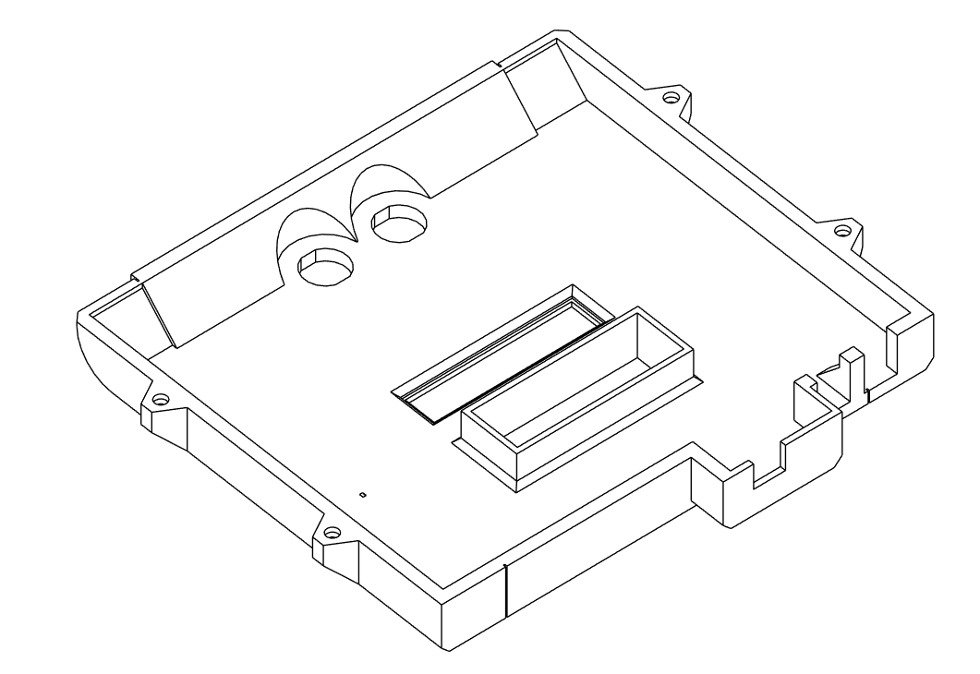Figure 2: Upper Enclosure Body (Underside view)
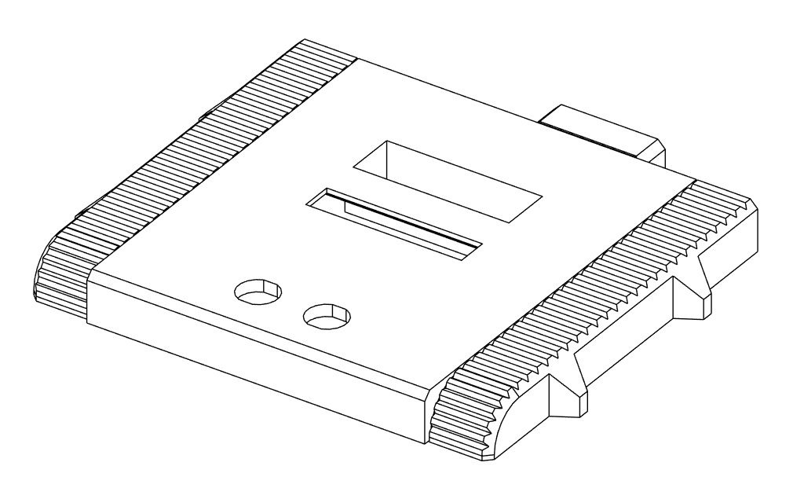Figure 1: Upper Enclosure Body (Top view)
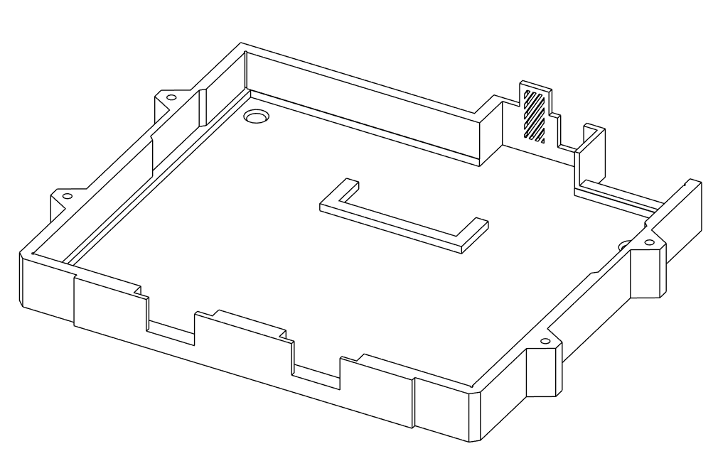Figure 3: Lower Enclosure Body
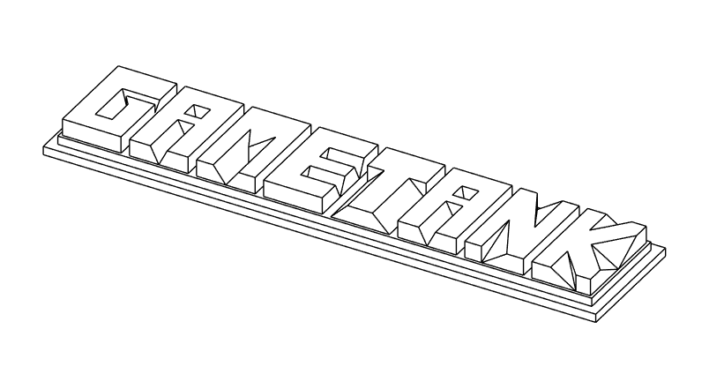Figure 4: Badge
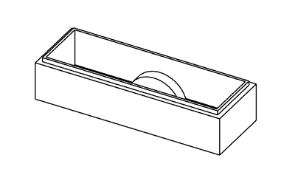Figure 5: Center Board Support

Controller
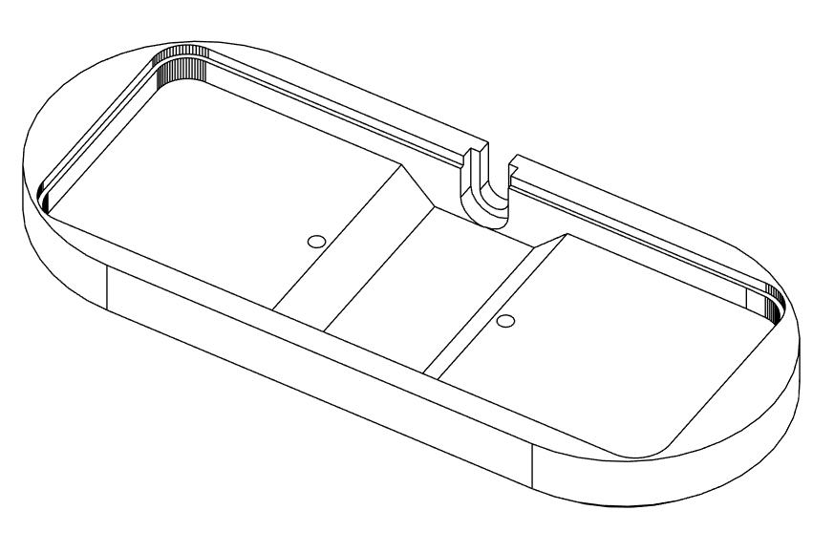Figure 7: Controller Body
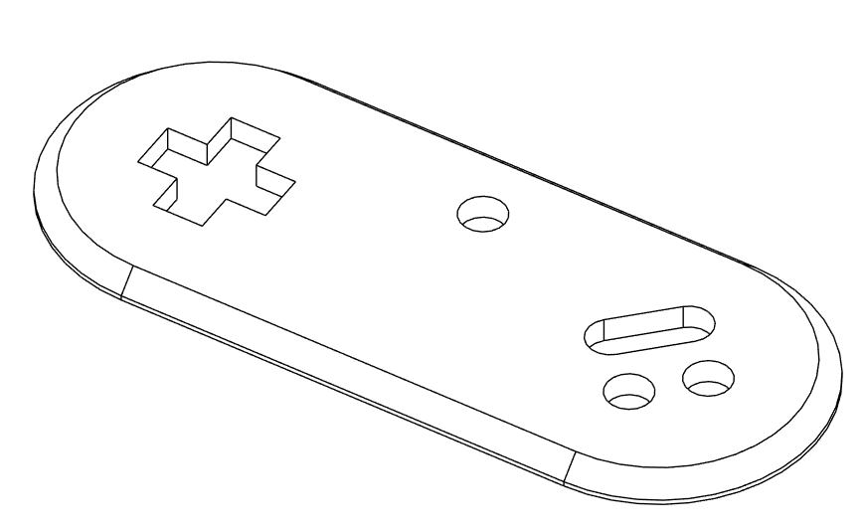Figure 6: Controller Faceplate

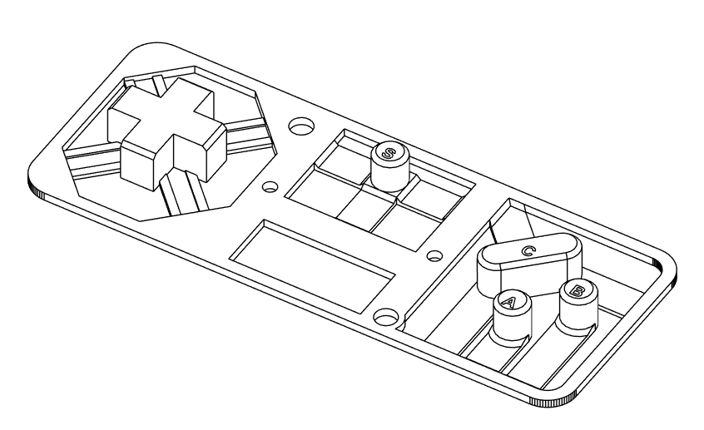Figure 8: Button Flexure, Multi Material Print Labels
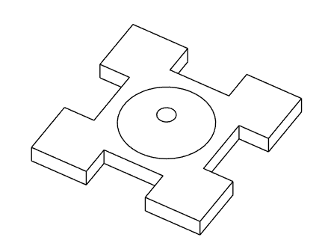Figure 9: Directional Pad Pivot
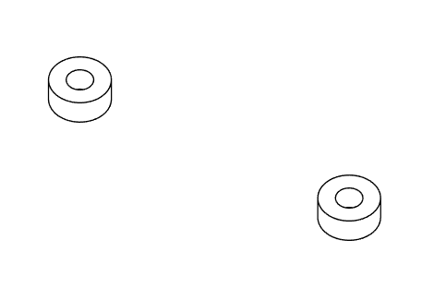Figure 10: Spacers (If printed)

Data Cartridge
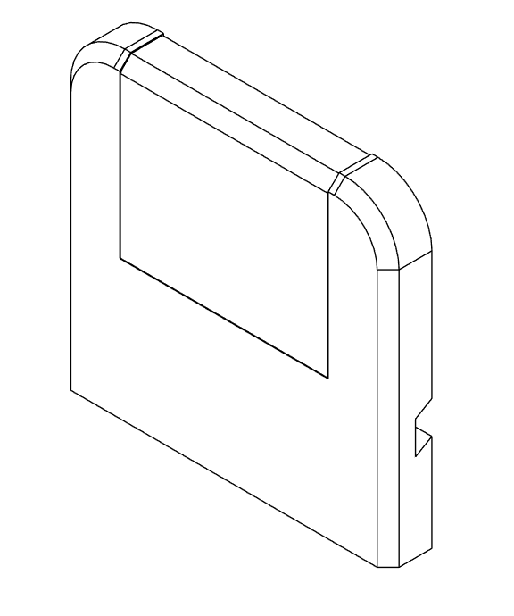Figure 11: Cartridge Front (Outside)
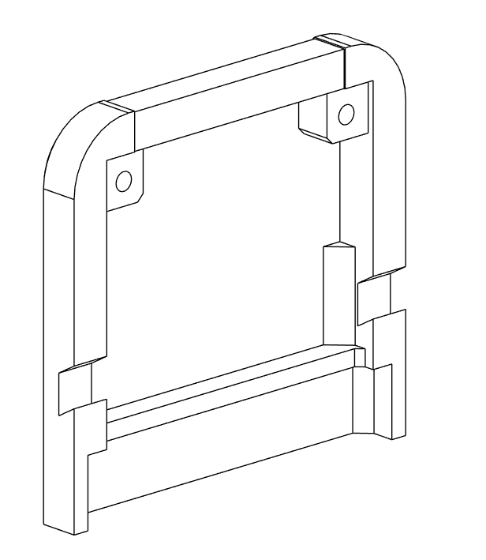Figure 12: Cartridge Front (Inside)
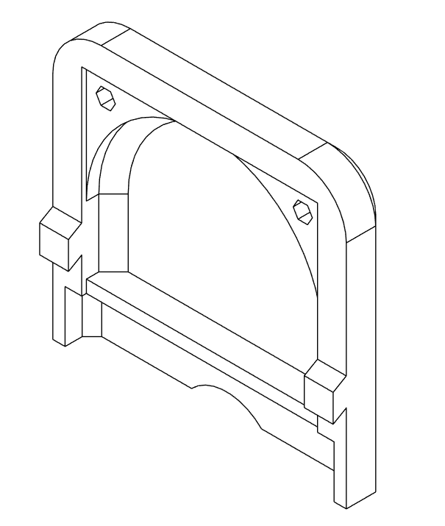Figure 14: Cartridge Back (Inside)
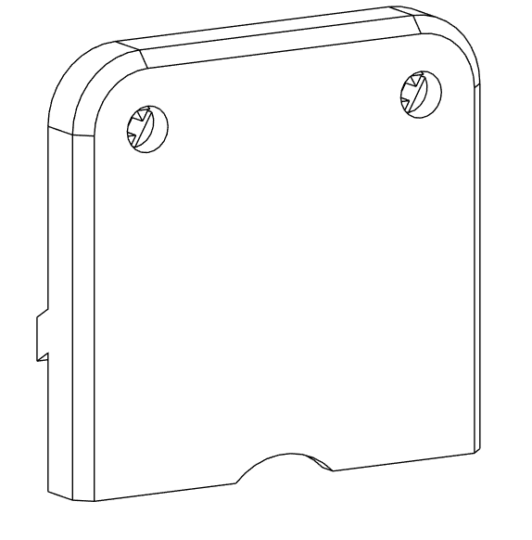Figure 13: Cartridge Back (Outside)

Cartridge Flasher Tool
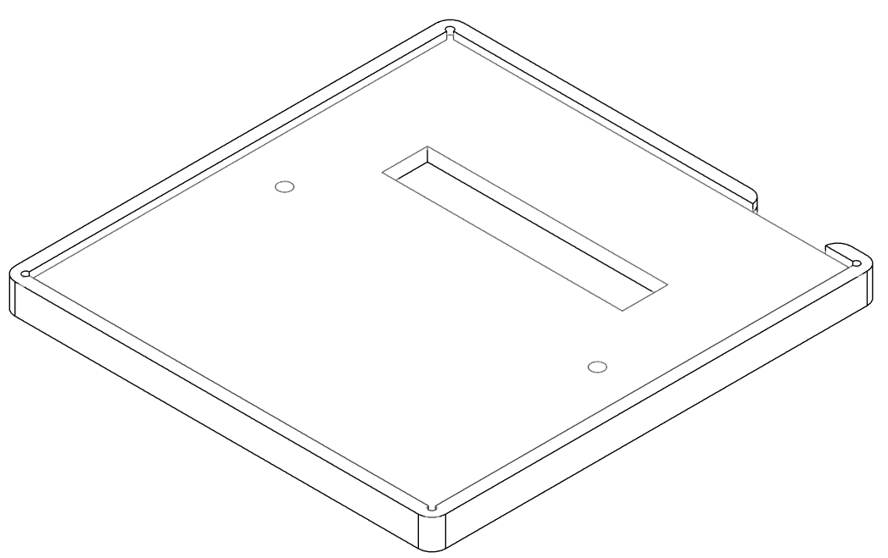Figure 15: Cartridge Flasher Base

Assembly Procedure

Main Console PCB Stack
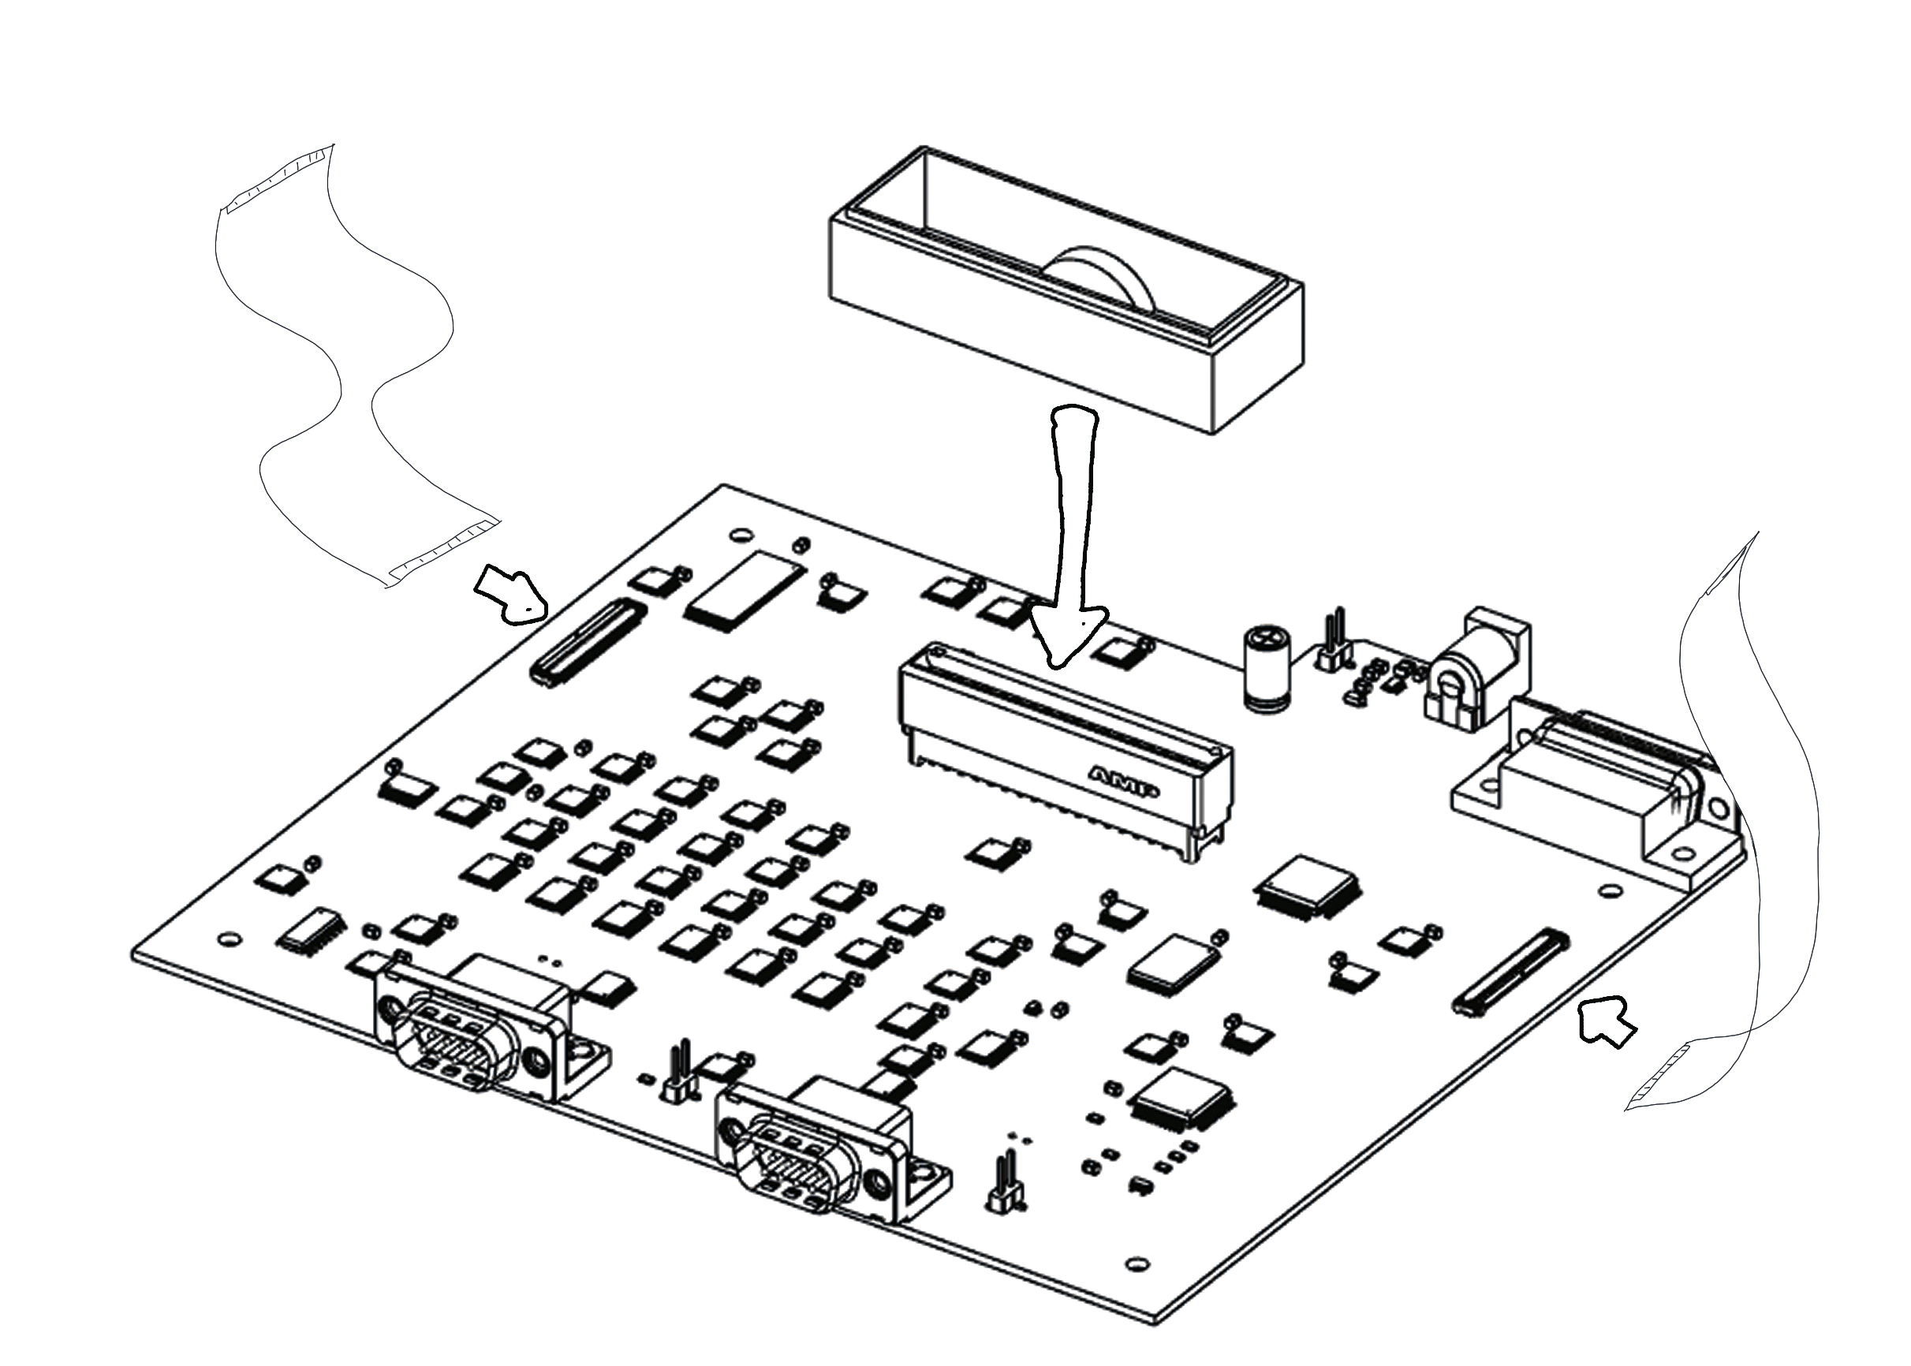Figure 16: Install FFCs and Cartridge Slot Spacer (Ensure Bump is towards rear)

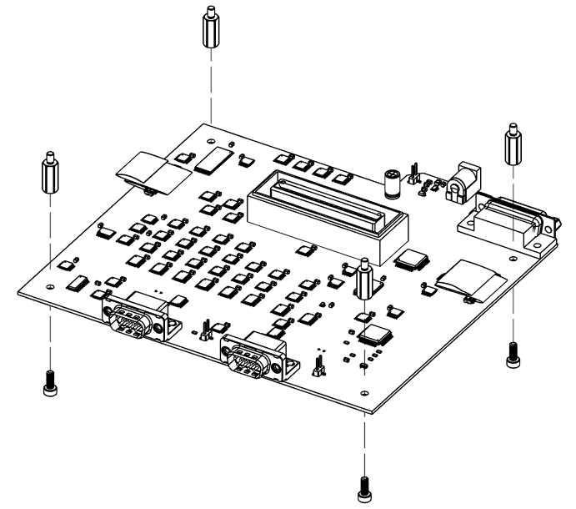Figure 17: Install standoffs at corners with 8mm screws
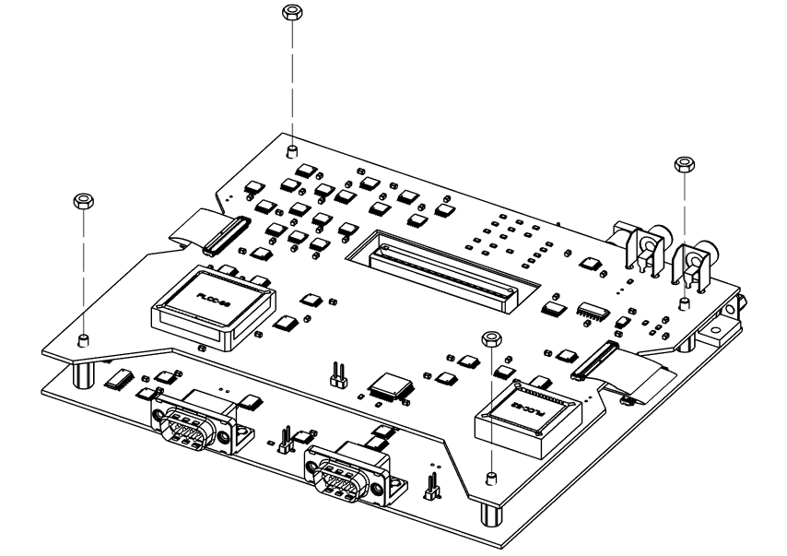Figure 18: Place video board on standoffs, connect FFCs, and fasten with nuts
NOTE: Illustration features previous version of board, large square chip on left will be absent in current version.

Enclosure Top Half Preparation

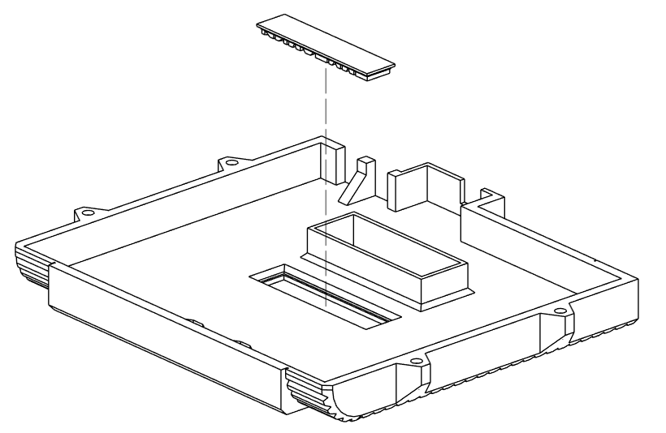Figure 19: Snap GAMETANK badge into place from inner side

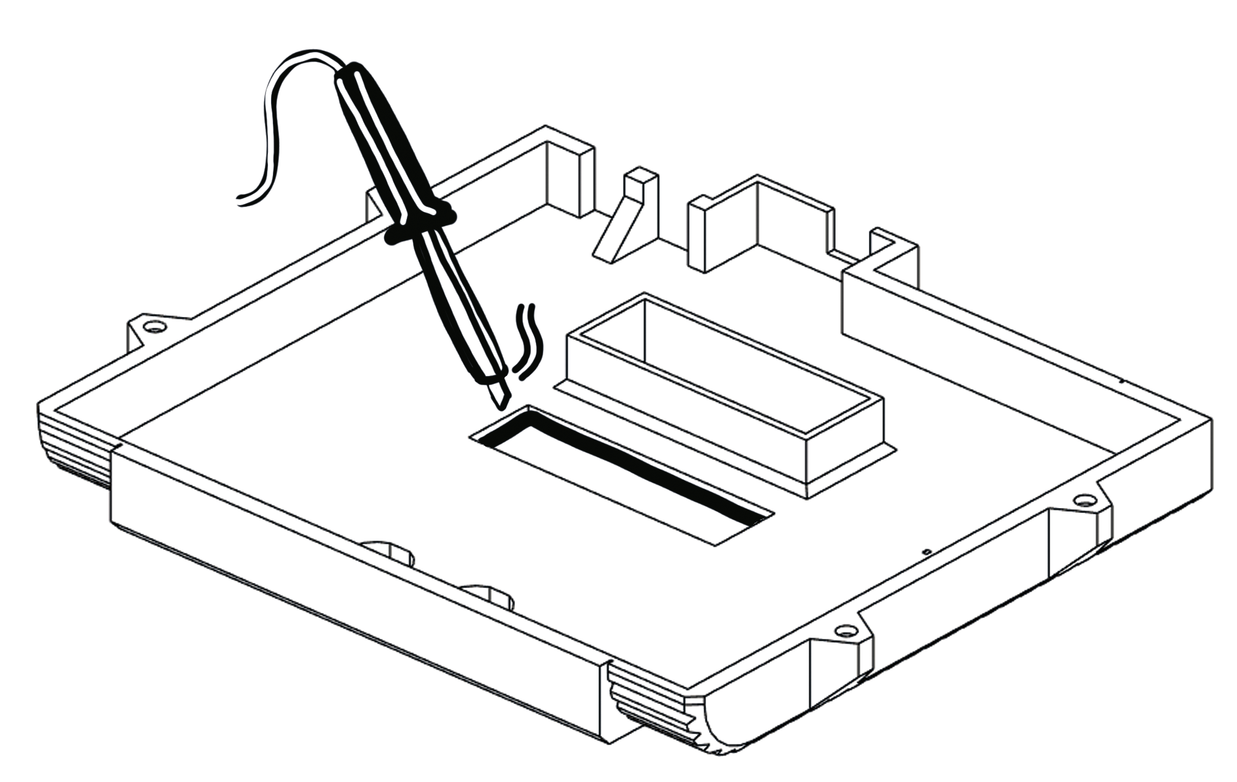Figure 20: Thermally bond at edges
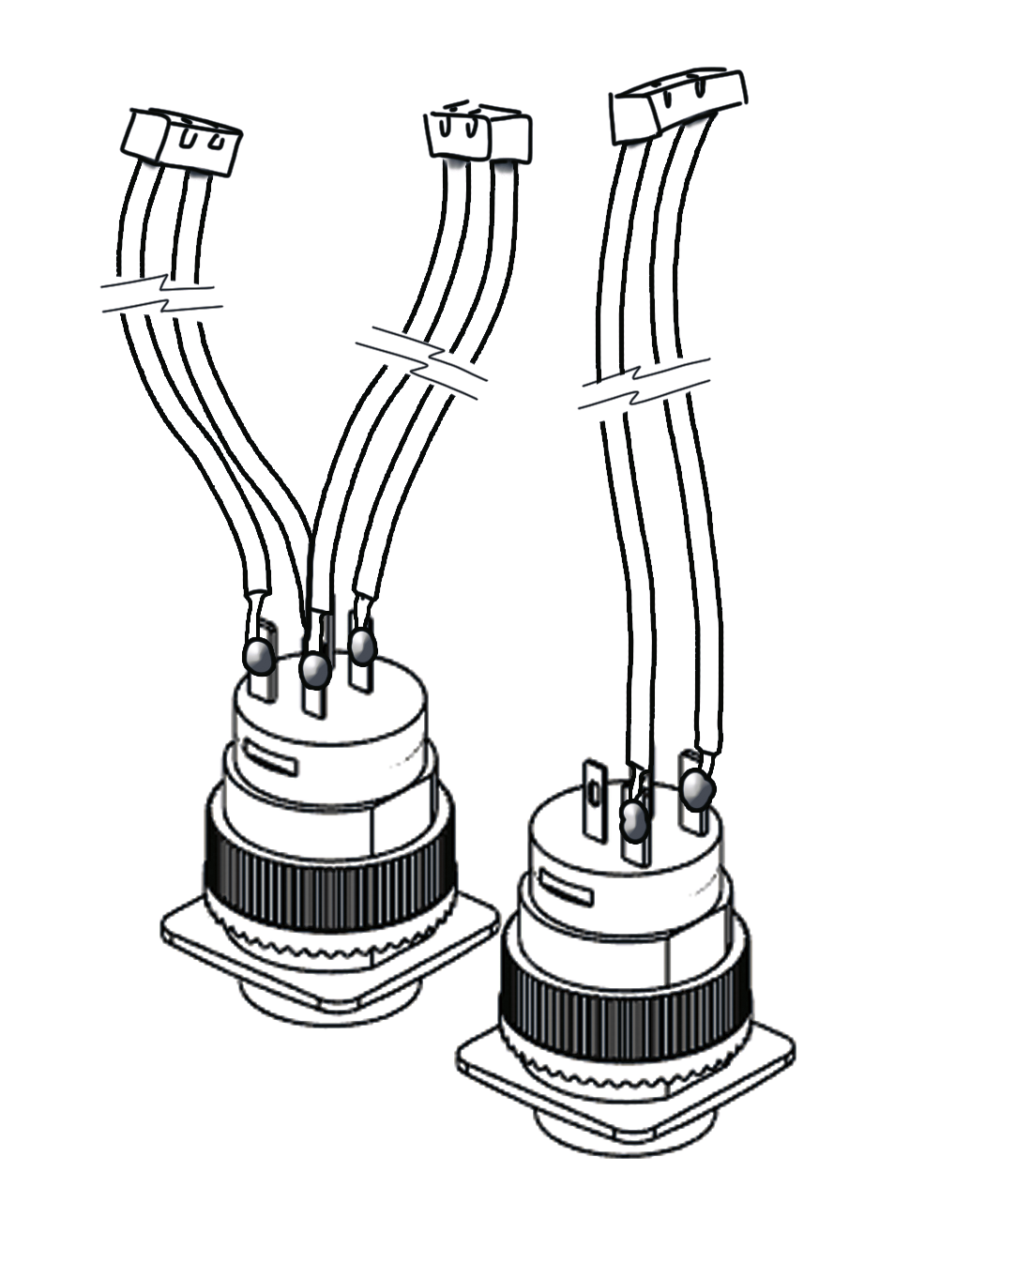Figure 21: Soldering button wires. Red button gets wires on all terminals. Yellow button gets wires on switched terminals only.

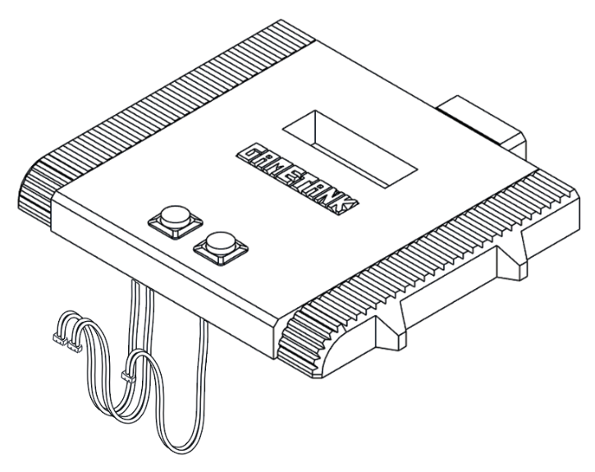Figure 22: Thread button wires through button holes, fasten buttons with threaded collars

Combining Top Shell, PCB Stack, and Bottom Shell
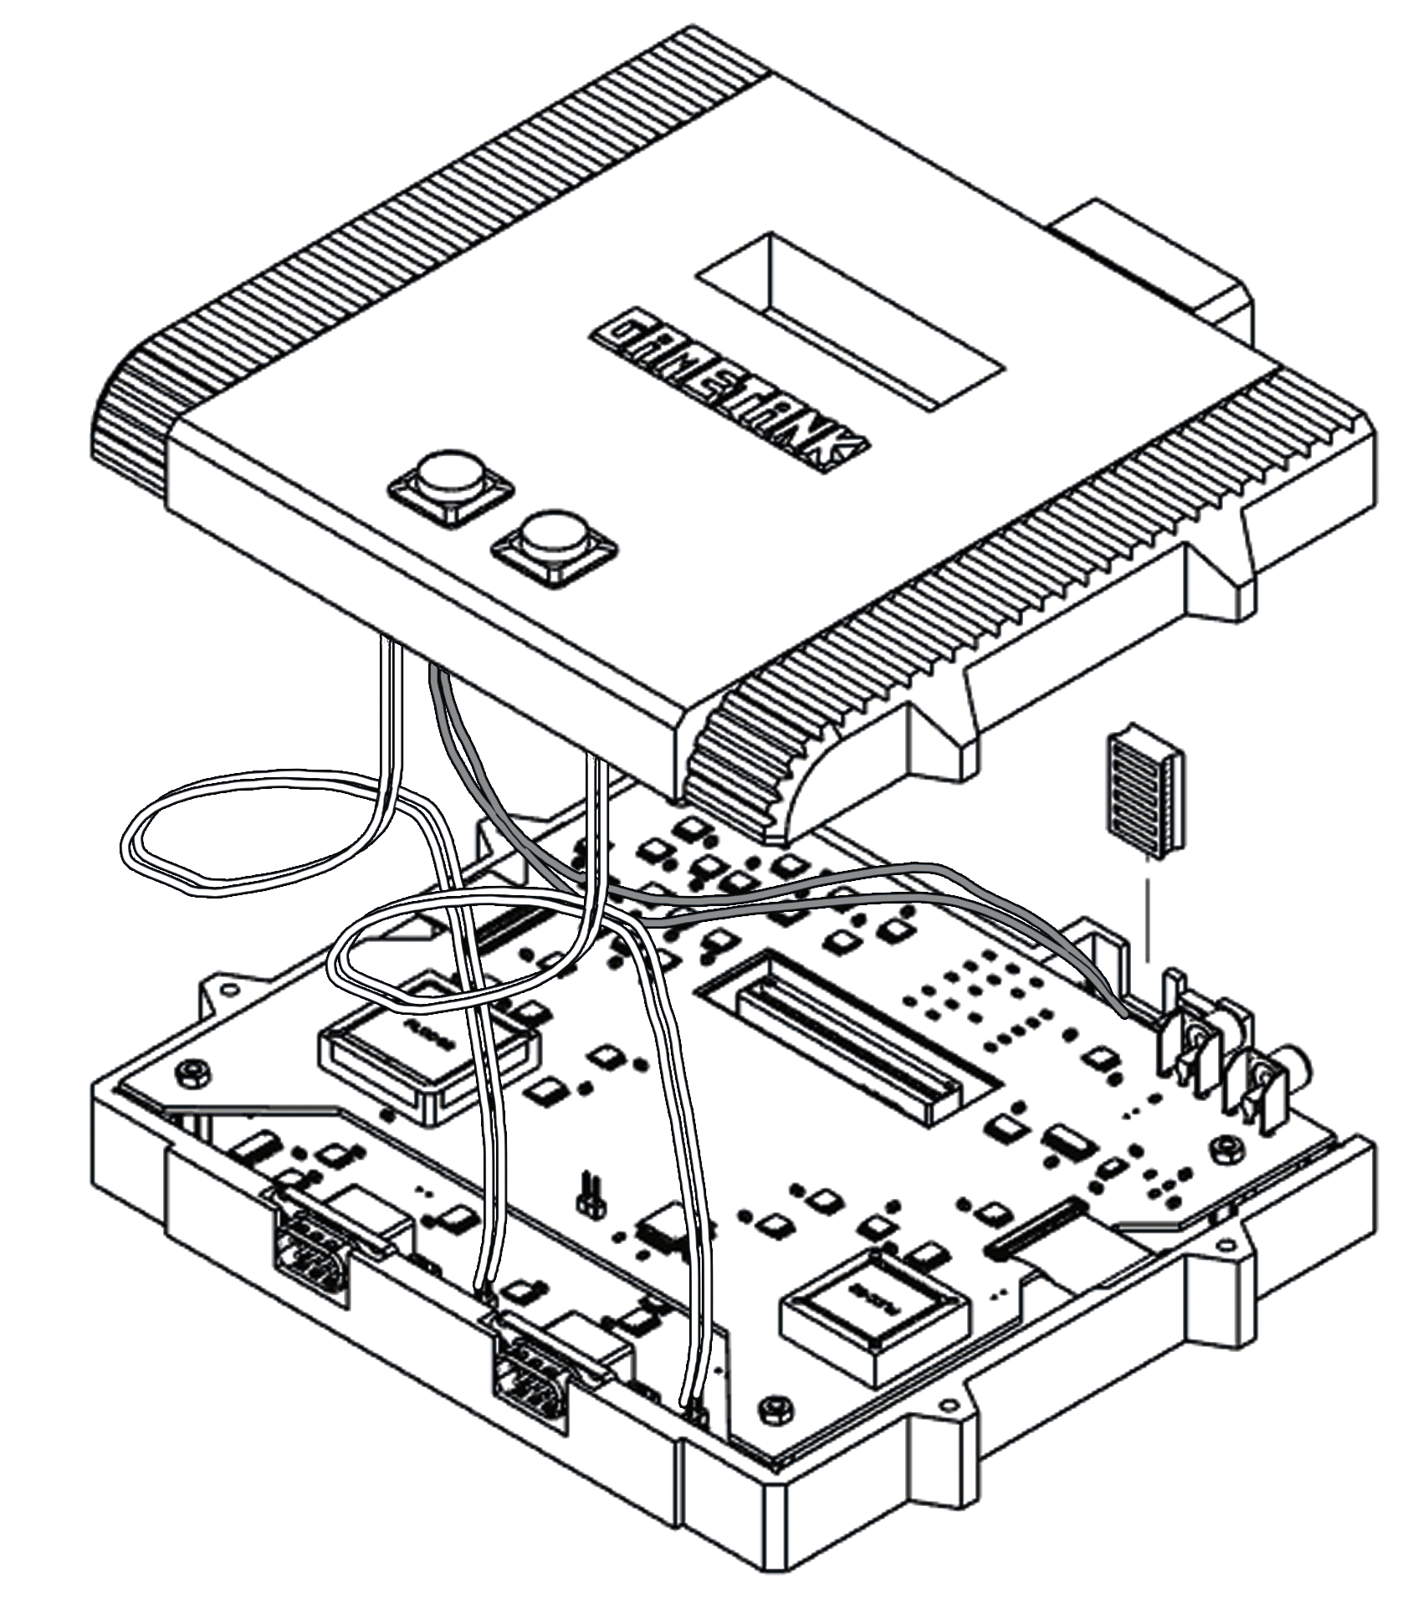Figure 23: Wires from buttons plug into headers on board. Vent piece is also added.

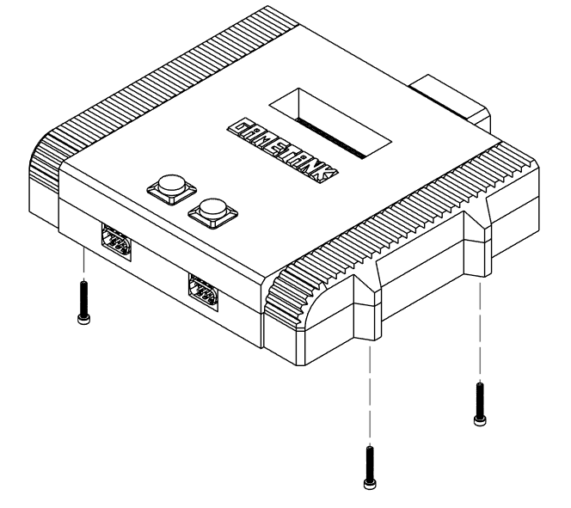Figure 24: Fasten enclosure together with M3x20mm screws

Controller Wiring

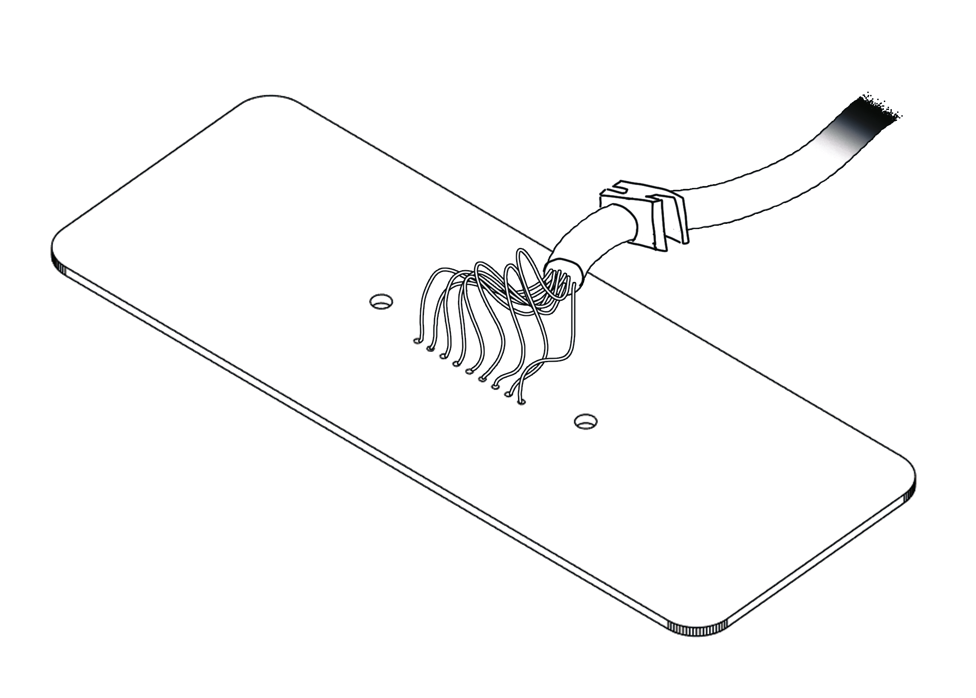

9 Wires soldered from cable, note the strain relief boot that seats into controller body

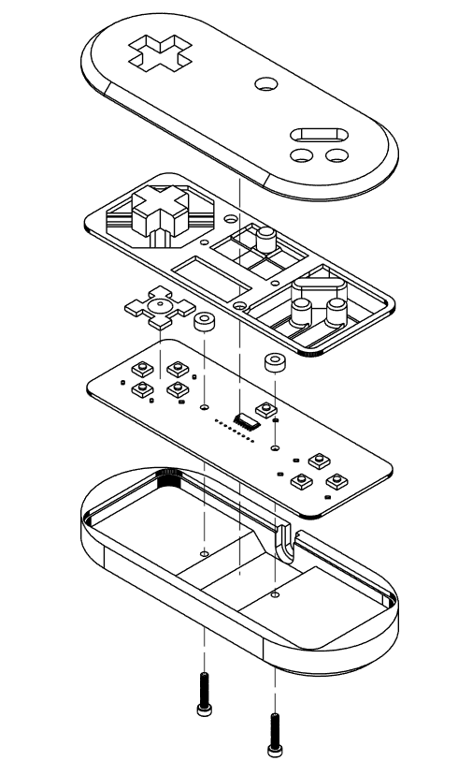
Controller Assembly

Data Cartridge
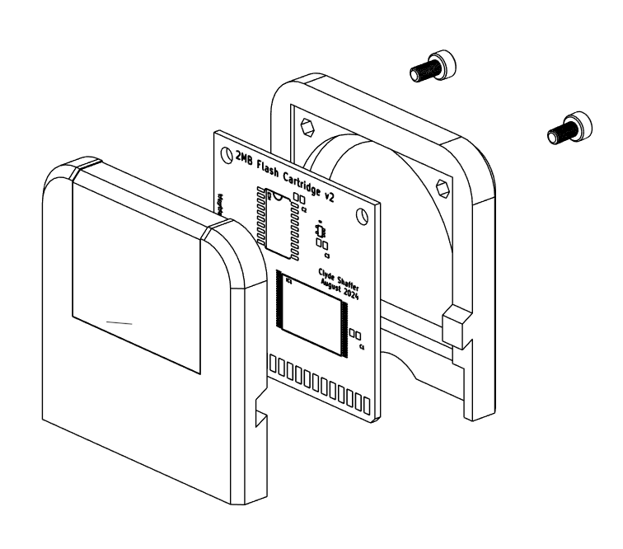
Two screws hold together the cartridge shell at the top, angled tabs stabilize the middle.

Data Cartridge, Labeled

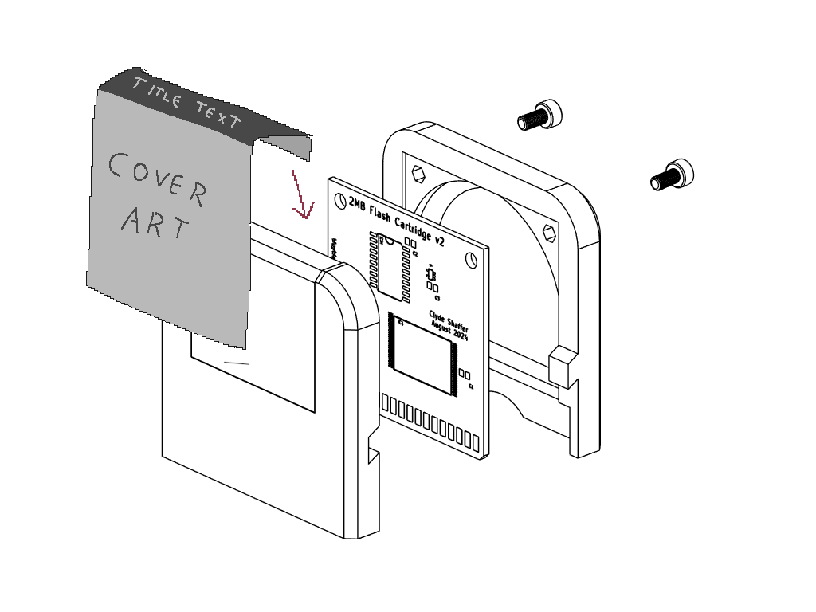
Sticker for labeled cartridge aligns with scribe line on front of cartridge.
Cartridge label is printed slightly taller to fold over top and be clamped by cartridge body.

Cartridge Flasher Tool
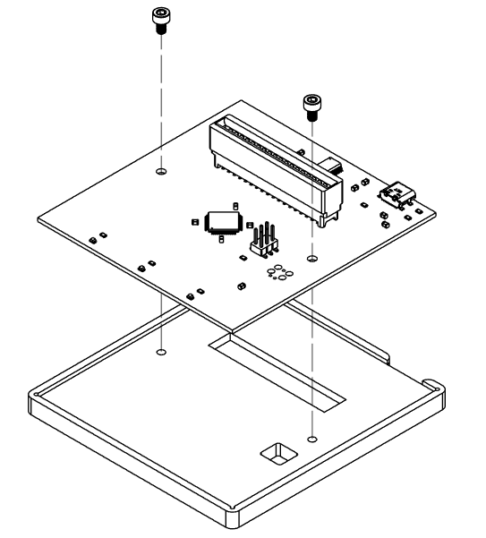
Flasher board drops into base plate and fastens with M3x5 screws

Cartridge Flasher Firmware
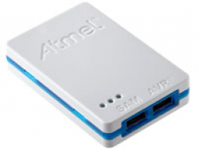
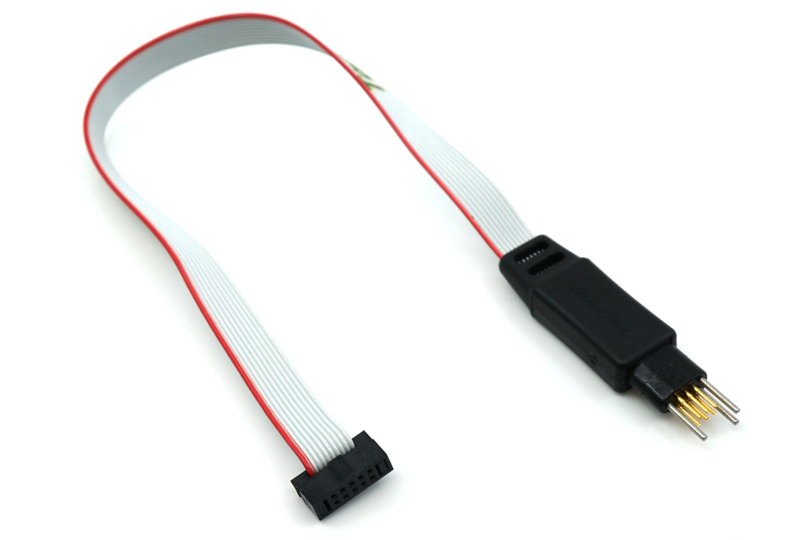

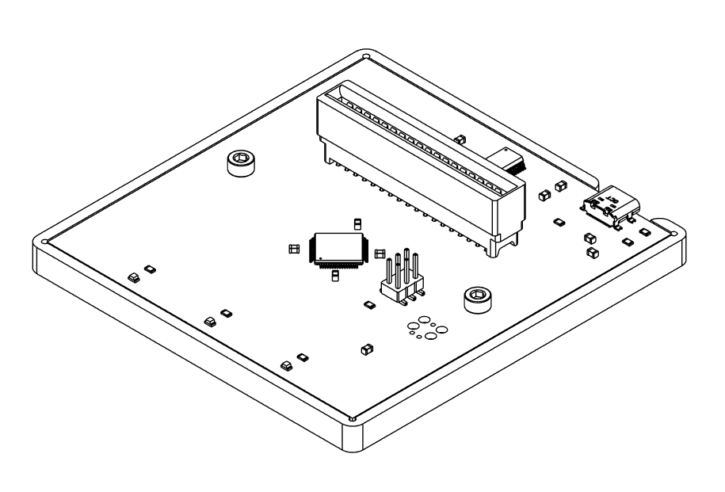
Tag Connect or generic header can be used for programming with Atmel-ICE. Optiboot firmware is flashed, then over USB-C avrdude is used to load the firmware. Afterward the cart flasher should respond to “help”command over serial.

Cartridge Flasher Operation
For cartridges to be labeled and shipped with data on them, the Cartridge Flasher should be used as follows:
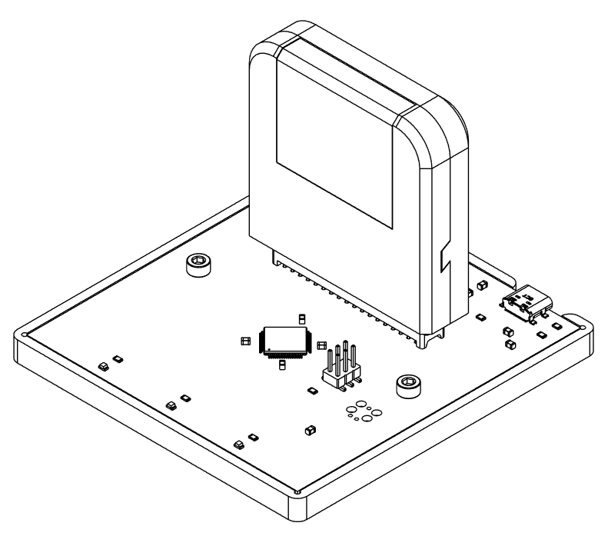
- Cartridge is placed on edge connector, front side towards status LEDs
- Flasher connects to PC with USB-C cable and enumerates as a serial device (COM port on Windows)
- PC program “gtld” is used to initiate loading of the cartridge data

Parts Sourcing Notes

Dual-Ported SRAM IDT7007
This part has a large disparity in price between new cost from mainstream distributors (Mouser, Digikey) vs AliExpress where I’ve been sourcing it. A test rig may be needed to verify components are fit for purpose if sourced this way. This component is socketed on the board in case sourcing it needs to be unchained from assembling the rest of the board. No longer used

Dual-Ported SRAM CY7C1342-35JCT
This is a legacy component. I have pre-sourced more of these than I expect to need and can send them over.

IQD 28.6363MHz Oscillator
This part has a large minimum order. I can send in a partial reel with at least 400 left, if needed.

Controller Cable
Alibaba link: https://www.alibaba.com/product-detail/New-1-8M-6FT-9-Pin_1600240153607.html

A/V Cable
Alibaba link: https://www.alibaba.com/product-detail/RCA-TV-Composite-Video-Lead-1_1600507184687.html

