Application Enablement



*apiGrove Installation Guide*

Aug 2012



1 General pre-requisites 3

1.1 Filesystem Layout 3

1.2 Network allocation 3

1.3 RAM 3

1.4 Supported Amazon EC2 Instance type 3

2 apiGrove installation notes for AIB install 4

2.1 Pre-requisites 4

2.2 Installation instructions 4

2.3 Check installation 5

2.3.1 Basic checking 5

2.3.2 Security Checking 5

2.3.3 Advanced checking 6

3 apiGrove Front door installation notes 8

3.1 Pre-requisites 8

3.2 Installation instructions 8

3.3 Check installation 9

4 apiGrove installation notes for Cluster install 10

4.1 Pre-requisites 10

4.2 Check installation 13

5 apiGrove access mode configuration 16

5.1 HTTP access 16

5.2 HTTPS access 16

5.3 Basic authentication 16

5.4 IP white list access 17

6 System Changes 18

6.1 apiGrove installation system changes 18

6.2 apiGrove GUI Installation system changes 19

# General pre-requisites

This product is currently tested on the Red Hat 5.8 enterprise distribution.

Installation package should be named e3-$VERSION and “$VERSION” should be replaced by the current version of the product.

## Filesystem Layout

Filesystem layout is not critical, but this is the minimum recommended layout:

|  |  |
| --- | --- |
| **Mount Point** | **Size** |
| / | 15 GB (default config) |
| /home | 60 GB |
|  |  |
|  |  |
| /tmp | 5 GB |

## Network allocation

Before any characterization, all the traffic is bound to one network interface.

## RAM

6GB memory

## Supported Amazon EC2 Instance type

The supported instance type is “M1.large”.

|  |  |
| --- | --- |
| **EC2 Instance Type** | **Description** |
| M1.large | 7.5 GB memory 4 EC2 Compute Units (2 virtual cores with 2 EC2 Compute Units each) 85 GB instance storage 64-bit platform I/O Performance: High |

# apiGrove installation notes

This section describes the steps to install apiGrove components on a single target host.

## Pre-requisites

In order to install apiGrove, you need:

1. apiGrove installation package. This package should be named like e3-$VERSION.tar.gz
2. The root credentials
3. Remote access to the machine where apiGrove is to be installed
4. Some experience with Unix shells

## Installation instructions

Follow the instructions below to install:

1. Log-in as root user
2. Create the installation directory

export INSTALL_PACKAGE=e3-$VERSION

mkdir -p /su/$INSTALL_PACKAGE

chmod -R 755 /su

1. Copy the installation package into the /su/$INSTALL_PACKAGE directory
2. Extract the installation package

cd /su/$INSTALL_PACKAGE

tar xvfz $INSTALL_PACKAGE.tar.gz

1. Launch the installation script

cd /su/$INSTALL_PACKAGE/bin

sh ./install_e3_aib.sh

apiGrove is accessed through the ports 80 and 8181. Note that the installer makes a redirect from port 80 to 25100. Security could have to be updated accordingly.

## Check installation

### Basic checking

Once the installation script ended with no error, execute the following steps to check that the installation succeeded:

1. Connect to ServiceMix

ssh -p 8101 smx@localhost

password: smx

1. Check all the components have been installed:

smx@root> list | grep -i E3

The following component (E3 Bundle) has to be 'Active' and 'Started'



1. Disconnect from ServiceMix:

smx@root> logout

### Security Checking

1. Edit /home/e3/apache-servicemix/etc/users.properties to change the ServiceMix username and password to a strong password.

### Advanced checking

This section is optional and will be helpful only to diagnose advanced issues. Alternatively, you can check the installation by running the ‘apiGrove-tutorial-2-commandline-onboard-twitter-api’ available in github.

To proceed with these steps, the following skills are required:

* Installation of SoapUI, version 4.0.1 or newer, on the user machine or on a third machine.
* Minimal experience with SoapUI.

NB: The SoapUI project files to execute will be provided with each release.

* Launch SoapUI
* Click on import project and select the file: e3-*<release>*-soapui-project.xml (available in github)
* Update the SoapUI project properties with the ip address of the machine on which apiGrove is deployed. Please see the screenshot below.

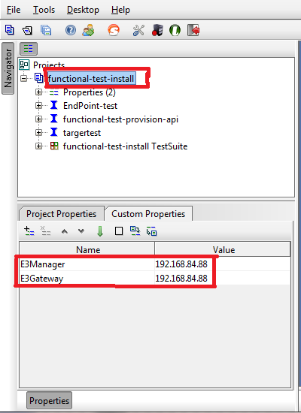

* To execute the tests, select the “functional-test-install” test suite on the left panel, then click on the green run button on the right panel:

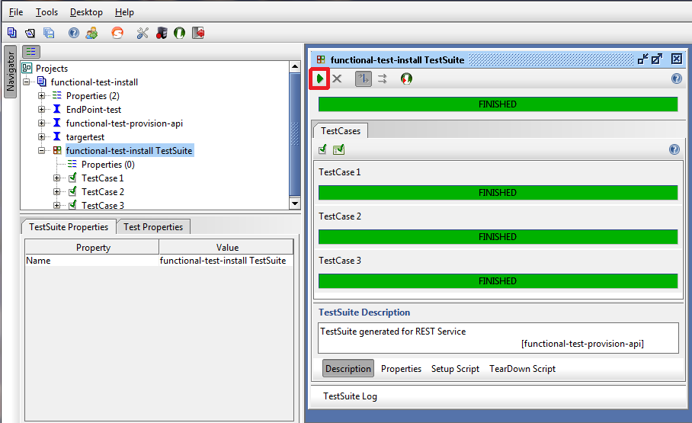

* If all the test cases are passing the installation was succeeded (like in the screenshot above)

# apiGrove Front door installation notes

This section describes the steps needed to install apiGrove GUI.

## Pre-requisites

In order to install apiGrove GUI, you need:

1. The e3 installation package. This package should be named like e3-installer-client-side-module-$VERSION.tar.gz (if not, rename it to this name as application is expecting this file name).

In the remainder of this section, we assume that *INSTALL_PACKAGE = e3-installer-client-side-module-* *$VERSION*.

1. A root ssh access to the machine where apiGrove GUI should be installed.

## Installation instructions

Follow the instructions below to install:

1. Create the installation directory

export INSTALL_PACKAGE=e3-installer-client-side-module-$VERSION

mkdir -p /su/$INSTALL_PACKAGE

chmod -R 755 /su

1. Copy the installation package into the /su/$INSTALL_PACKAGE directory
2. Uncompress the tarball on remote machine

cd /su/$INSTALL_PACKAGE

tar xvfz $INSTALL_PACKAGE.tar.gz

1. Launch installation script

cd /su/$INSTALL_PACKAGE/scripts

sh ./install.sh

1. (Optional) Install PhpMyAdmin

cd /su/$INSTALL_PACKAGE/scripts

sh ./install.sh PHPMYADMIN

1. In case https to apiGrove server is required, the CA certificate must be copied to a folder accessible by Apache HTTPD like:

/var/www/drupal/e3server.crt

## Check installation

Once the installation script has finished and provided no error has been shown in the script execution logs, execute the following steps to check installation success:

1. If apiGrove and apiGrove GUI are installed on the same host, run the following com ands to open port 24100 to apiGrove GUI use. If they are on separate hosts, go to step 2

List the current iptables and note the line rule REJECT –reject-with icmp-host-prohibited is on. Here we assume its line 12

iptables -L

1. Assuming the rule is on line 12, run the following commands to open port 24100

iptables –D E3-Firewall-INPUT **12**

iptables –A E3-Firewall-INPUT –p tcp –dport 24100 –j ACCEPT

iptables –A E3-Firewall-INPUT –j REJECT –reject-with icmp-host-prohibited

1. Launch a browser and connect to Front Door (you should see Drupal Login page)

http://<ip_remote>:24100/e3

1. (Optional) Launch a browser and connect to PhpMyAdmin (you should see PhpMyAdmin Login page)

http://<ip_remote>:24100/phpmyadmin

# apiGrove installation notes for Cluster install

This section describes the steps needed to install apiGrove in cluster mode (Manager and Gateways on separate machines).

## Pre-requisites

In order to install apiGrove, you need:

1. The apiGrove installation package. This package should be named like e3-$VERSION.tar.gz (if not, rename it to this name as application is expecting this file name).

In the remainder of this section, we assume that *INSTALL_PACKAGE = e3-$VERSION*.

1. A root ssh access to the machines where apiGrove should be installed (Manager and Gateway instances).
2. The ssh authentification keys prepared (needed by the manager to install the Gateways).
3. The configuration files:
   1. topology.xml which details the cluster layout.
   2. system_topology.xml which details the external system component layout.
   3. installer-config.xml which is read by the Manager.
4. The SSH authentication key files for the Gateways.

|  |  |
| --- | --- |
| **Important note:** | For now, the system expects to find an installation package named e3-$VERSION in a directory named /su/e3-$VERSION. If the installation package is named e3-distrib.tar.gz, rename it to e3-$VERSION.tar.gz.  This should be removed in future versions of the software. |

#### Prepare the manager machine

First, we need to prepare the first machine that will become the manager. This machine will be referred to as $MACHINE1 in the remainder of this section.

**Important note: “$MACHINE1” should be replaced in the commands with correct ip or domain name of machine on which installation of manager takes place**”

1. Connect to the first machine with root privileges.

ssh root@$MACHINE1

1. Create the installation directory

export INSTALL_PACKAGE=e3-$VERSION

mkdir -p /su/$INSTALL_PACKAGE

chmod -R 755 /su

1. Copy the installation package into the /su/$INSTALL_PACKAGE directory
2. Uncompress the tarball on remote machine ($MACHINE1)

cd /su/$INSTALL_PACKAGE

tar xvfz $INSTALL_PACKAGE.tar.gz

#### Adapt the configuration

In order for the Manager to know which Gateways are to be installed, you have to adapt the xml files listed in the pre-requisites.

For adapting xml files you should use templates of configuration files which are stored in directory /su/$INSTALL_PACKAGE/templates ($MACHINE1):

cd /su/$INSTALL_PACKAGE/templates

For **installer-config.xml** you should do copy of **template-installer-config.xml**

cp template-installer-config.xml installer-config.xml

and edit **installer-config.xml** file if necessary (you shouldn’t have to modify it, unless you patched apiGrove).

For **system_topology.xml** you should do copy of **template-system_topology_cluster.xml**

cp template-system_topology_cluster.xml system_topology.xml

and edit **system_topology.xml** file to match your machine needs.

For **topology.xml** you should do copy of **template-topology_cluster.xml**

cp template-topology_cluster.xml topology.xml

and edit **topology.xml** file to match your machine needs.

**Important note: Please remember to fill the topology.xml file with yours public and private keys.**

**Important note: Ssh keys can be removed from the topology.xml after the installation procedure.**

#### Copy the configuration

Once the configuration is done, files should be in folders described below ($MACHINE1):

/su/e3-$VERSION/installer-config.xml

/su/e3-$VERSION/topology.xml

/su/e3-$VERSION/system_topology.xml

Be sure to place the installer package e3-$VERSION.tar.gz in:

/su/e3-$VERSION/e3-$VERSION.tar.gz

#### Allow SSH communication between Manager and Gateways

In order for the Manager to install the Gateways, you have to allow automatic ssh authentication through keys.

**Important note:** **Public keys should be distributed. Generate key is not in the scope of the document.**

**Important note: Key file will be referred to as $KEY1 and should be replaced in the commands with proper name of key.**

Allow $MACHINE1 to access the machines on which the Gateways should be deployed. These machines will be referred to as $GATEWAY1, $GATEWAY2, … in the remainder of this section.

Copy the key file to $MACHINE1:

scp $KEY1 root@$MACHINE1:/su/

Push the copied key file to all the Gateways (repeat this command for each gateway):

cd /su

scp authorized_keys root@$GATEWAY1:/root/.ssh

**Important note: Make sure a directory named /root/.ssh exists on the gateways before executing the copy command above (otherwise, executing these commands will create a file .ssh and gateway installation will fail).**

Verify that automatic ssh connection between Manager and Gateways works:

ssh root@GATEWAY1

#### Verify hostname

Before starting installation make sure that hostname is correctly set on all nodes:

hostname -i

This command should return proper ip address.

#### Launch cluster installation

To have the manager and the gateways installed, launch the following command from /su/$INSTALL_PACKAGE:

sh bin/install_e3_cluster.sh /su/e3-$VERSION/e3-$VERSION.tar.gz

If the process went well, you should see:

> Install successful

## Check installation

To check that the installation has succeeded, execute the soapUI tests as described in §2.3. Don’t forget to change the properties of the test specifying the ip of the manager and the ip of the targeted gateway.

# apiGrove access mode configuration

To configure the access security for apiGrovesystem, the file **variables.sh** should be edited to change some parameters:

vi /su/$INSTALL_PACKAGE/bin/variables.sh

## HTTP access

* Possible values are 1 and 0. 1 to enable the option and 0 to disable it. Port **8181** is open when enabled.

PROV_REST_API_HTTP_ENABLE=1

## HTTPS access

* Possible values are 1 and 0. 1 to enable the option and 0 to disable it.

PROV_REST_API_HTTPS_ENABLE=1

* The path to apiGrove rest server key store. ex: $E3_HOME/rest-keystore.jks

PROV_REST_API_KEYSTORE_PATH=

* apiGrove rest server key store password

PROV_REST_API_KEYSTORE_PASSWORD=

* apiGrove rest server key passphrase. Must not exceed 7 characters!

PROV_REST_API_KEYSTORE_KEYPASSWORD=

## Basic authentication

* Possible values are 1 or 0. 1 to enable and 0 to disable this option.

PROV_REST_API_BASICAUTH_ENABLE=0

* Username/password that the caller must provide as basic auth http header:

"**Authorization**" : "**Basic** *base64*(**username:password**)"

PROV_REST_API_BASICAUTH_USERNAME=changeit

PROV_REST_API_BASICAUTH_PASSWORD=changeit

## IP white list access

* Possible values are 1 or 0. 1 to enable and 0 to disable this option.

PROV_REST_API_IPWHITELIST_ENABLE=0

* IP list authorized to access apiGrove example:

PROV_REST_API_IPWHITELIST="192.168.84.135 192.168.84.136 192.168.84.137"

* **Note in EC2 clustered installation, this IP list must be declared also in the security group that concerns the cluster installation**.

# System Changes

The installation of apiGrove software makes several system wide changes that may conflict with other use if the target host is not a dedicated host for apiGrove. These changes are listed here.

## apiGrove installation system changes

The apiGrove installation makes the following changes to the Host system

1. Adds an e3 user
   1. The apiGrove services are run as this user
   2. /home/e3 directory is added as the target installation directory
   3. configures sudoers so e3 can adjust log level settings
2. Installs and configures Apache Service Mix version apache-servicemix-4.3.1-fuse-01-09 to /home/e3
3. Installs apiGrove to /home/e3
4. Installs karaf-service on the host
5. Configures iptables (/etc/sysconfig/iptables) to route port traffic.
   1. Blocks traffic on ports not used by apiGrove.
   2. Ports (25100, 25101, 8181, 8101, 1099,5701, 8888, 8889, 161, 8082, 8083, 8084, 8085) are used
   3. Port 80 traffic is rerouted to 25100
   4. Port 443 traffic is rerouted to 25101
6. Configures redhat file limits
   1. fs.file-max (/etc/sysctl)
   2. hard limit (/etc/security/limits.conf)
   3. soft limit (/etc/security/limits.conf)
7. Configures NET-SNMP for apiGrove

# NET-SNMP configurations

# Set in snmpd.conf, proxying requests under E3's OID to E3's Java SNMP Agent

NETSNMP_OID=".1.3.6.1.4.1.637.89.10"

NETSNMP_PROXY_LINE="proxy -v 2c -c public localhost:2001 $NETSNMP_OID"

# Update mib modules to be launched

NETSNMP_OPTIONS="OPTIONS=\"-Lsd -Lf /dev/null -p /var/run/snmpd.pid -a -Iproxy,disk,dlmod,errormix,extensible,file,hpux,lmSensors,loadave,logmatch,memory,pass,pass_persist,proc,versioninfo,vmstat,hardware,cpu,cpu_linux,hw_mem,system_mib,snmp_mib,extend,errormib\""

1. Configures syslog for non java components
2. Modifies syslog config to allow facility write to an e3 logfile

## apiGrove GUI Installation system changes

Front Door installation makes the following changes

1. Configures iptables (/etc/sysconfig/iptables) to route port traffic.
   1. Opens port 24100 to external traffic.
2. Installs the following packages if thery aren’t already installed
   1. yum
   2. apr-1.2.7-11.el5_6.5
   3. apr-util-1.2.7-11.el5_5.2
   4. autoconf-2.59-12
   5. automake-1.9.6-2.3.el5
   6. cpp-4.1.2-51.el5
   7. createrepo-0.4.11-3.el5
   8. gcc-4.1.2-51.el5
   9. glibc-2.5-65.el5_7.1
   10. glibc-common-2.5-65.el5_7.1
   11. glibc-devel-2.5-65.el5_7.1
   12. glibc-headers-2.5-65.el5_7.1
   13. gmp-4.1.4-10.el5
   14. httpd-2.2.3-53.el5_7.3
   15. imake-1.0.2-3
   16. kernel-headers-2.6.18-274.17.1.el5
   17. libgcc-4.1.2-51.el5.i386
   18. libgcc-4.1.2-51.el5
   19. mysql-5.0.77-4.el5_6.6.i386
   20. mysql-server-5.0.77-4.el5_6.6
   21. nscd-2.5-65.el5_7.1
   22. perl-DBD-MySQL-3.0007-2.el5
   23. perl-DBI-1.52-2.el5
   24. php53-5.3.3-1.el5_7.5
   25. php53-cli-5.3.3-1.el5_7.5
   26. php53-common-5.3.3-1.el5_7.5
   27. php53-devel-5.3.3-1.el5_7.5
   28. php53-gd-5.3.3-1.el5_7.5
   29. php53-mbstring-5.3.3-1.el5_7.5
   30. php53-mysql-5.3.3-1.el5_7.5
   31. php53-pdo-5.3.3-1.el5_7.5
   32. php-pear-1.4.9-6.el5