European University of Lefke

COMP415: Artificial Intelligence

**Group 5**

**Instructor: Asst. Prof. Vesile Evrim**

**December 24, 2019**

# **Problem Definition**

To find the shortest distance between a start point and end point in a 12x12 grid using DFS algorithm.

# **Team Members and Responsibilities**

|  |  |  |  |  |
| --- | --- | --- | --- | --- |
| Student No. | Name Surname | Work Assigned | Work Done? | Sign |
| 164202 | Naimul Hasan | Working with grid, files and parsing, assist in hardware programming and circuit. Pipelining software and hardware |  |  |
| 164177 | Abbasagha Babayev | Assembling hardware and writing software for it. Pipelining software and hardware |  |  |
| 164163 | Tafadzwa Imbikani | Creating DFS algorithm, and grid. |  |  |
| 164253 | Baboucarr Sallah | Creating DFS algorithm and parsing and creating files |  |  |
| 164182 | Churchill Makate | Creating graph and assisting with DFS algorithm |  |  |
| 154228 | Muhammad Adil | Create a file parser. |  |  |

# **Programming Languages**

The primary programming language used is C/C++ because the group had the most experience with C/C++. And the secondary programming language used is Python 3 since it is very intuitive and easy to automate programs.

# **Software Logic**

Firstly, a problem creator was made using the given template, and it was coded in a way so that number of available cells were generated randomly along with randomly selected start and end cells.

Given template,

Problem Generator Code Snippet,

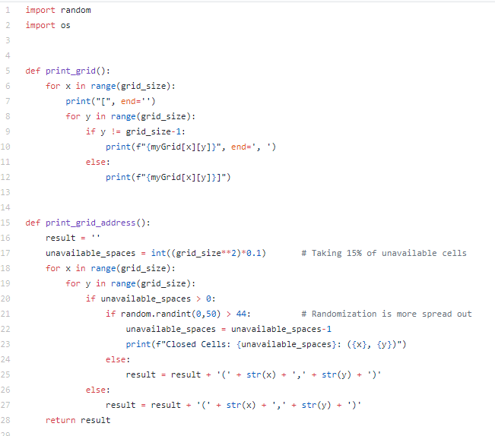

Problem Generator Snippet 2

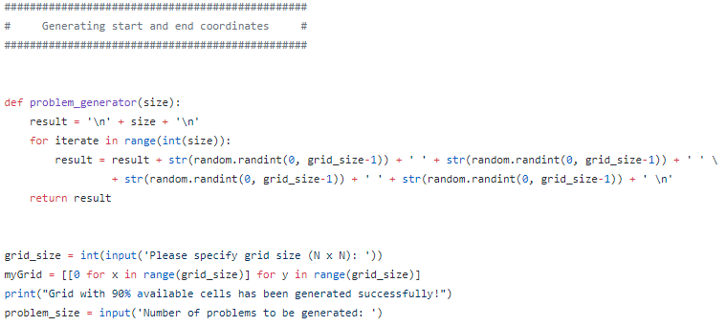

Secondly, Problem Parser was created, the first line is read for the number of available cells and applied into the grid variable. The grid variable is initialized with all cells unavailable. Code snippet is provided below: (File name: problem_file_parser.cpp)

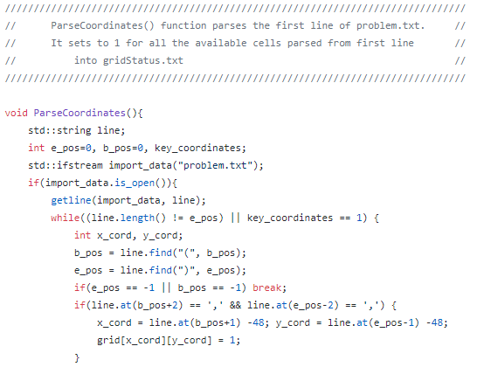

Problem Parser Snippet 2:

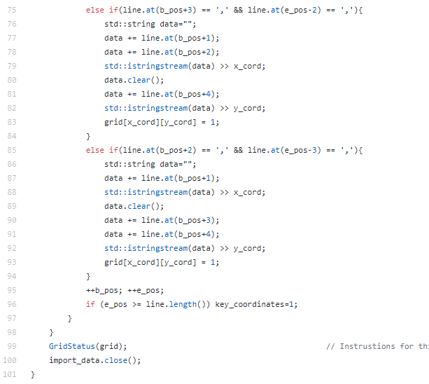

The second line of problem contains the number of problems, we will use this number to create a loop and record the coordinates into line below it. Quantity of Problems finder code snippet:

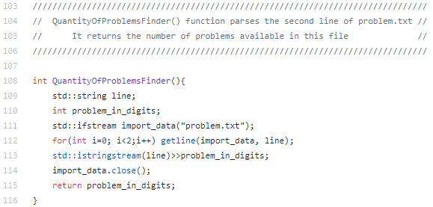

From third line onwards in problem.txt, it contains start and end coordinates separated by a space.

Using the Quantity of Problems Finder function we will look at each line for start and end coordinates. These coordinates are then appended to ‘coordinates.txt’. Code snippet is found below,

(File name: problem_file_parser.cpp)

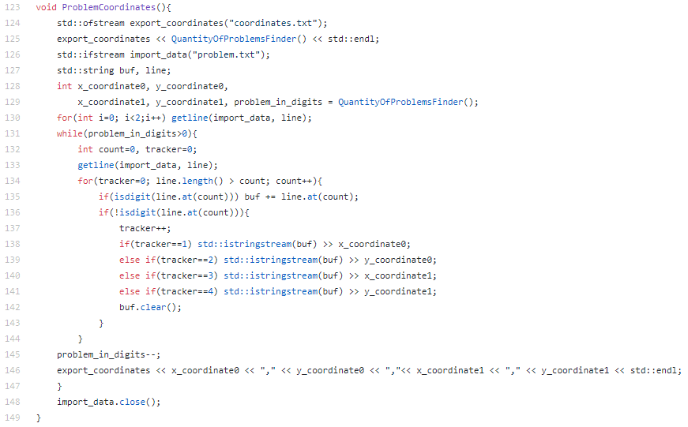

After problem.txt is parsed, solution creator will now be created from the data provided by problem_file_parser.cpp

In file ‘solution_creator.cpp’, first each gird cell will be defined by cell number and cell value, it is implemented by creating a struct as shown below (File Name: solution_creator.cpp)

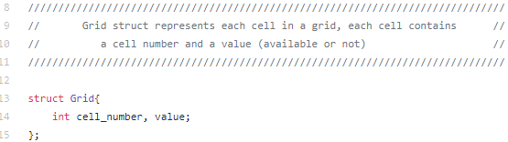

This file reads the coordinates.txt, gridStatus.txt. Grid array is initialized using ‘gridStatus.txt’, start and end coordinates are stored into a variable which is read from ‘coordinates.txt’.

(Storing Grid using SetGrid() function code snippet) (File Name: solution_creator.cpp)

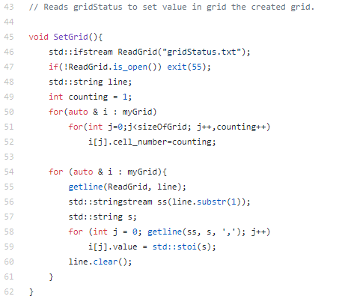

(Storing Start and End Coordinates from EntryPoint() function Code Snippet)(File Name: solution_creator.cpp)

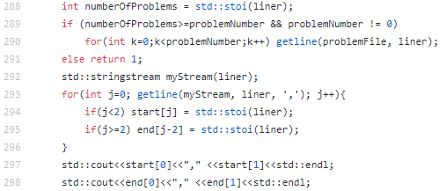

After both files are parsed and stored into its respective variables it initializes the DFS algorithm object by passing the number of nodes, these nodes are calculated using EdgeCounter() function).

As shown in the code snippet below (File name: solution_creator.cpp)

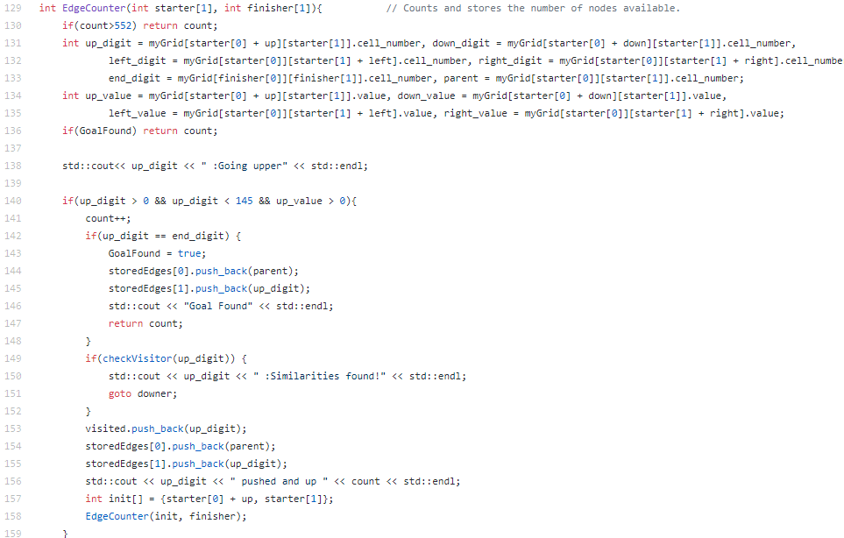

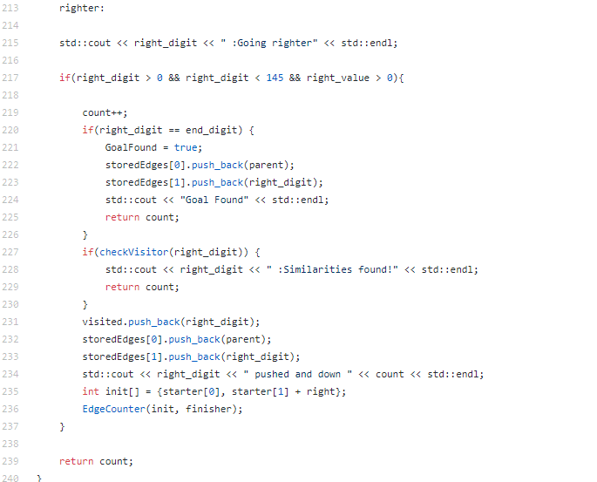

After DFS Graph object is initialized using the number of nodes created the EdgeCounter() also creates a graph and stores it into a vector array by parent and child relation using this vector array this graph is inserted into the DFS algorithm using addEdge() function that is present in the DFS Graph class.

Code snippet of addEdge() function (File Name: solution_creator.cpp)



The vector array is traversed using EdgeAdder() function, which loops thru and adds all the nodes to the DFS Graph object.

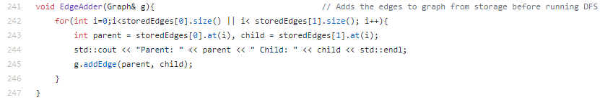

After all the nodes are inserted successfully, the DFS Object runs its algorithm using the DFS() function, start and end nodes are passed as its parameters, the function then call another function DFS_helper() function to run the algorithm recursively, until goal is found.

DFS() function code snippet as shown below (File Name: solution_creator.cpp)

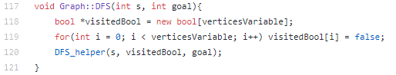

DFS_helper() function code snippet as shown below (File Name: solution_creator.cpp)

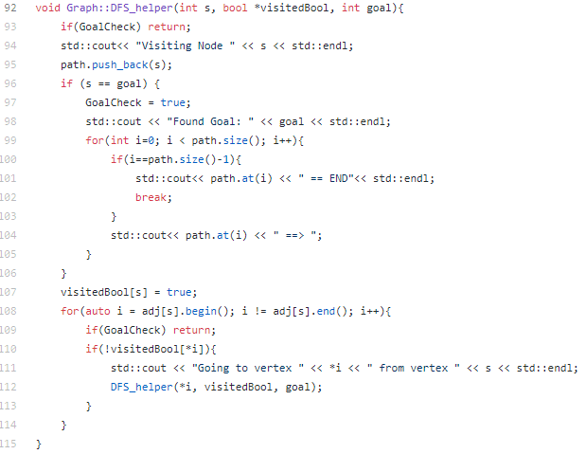

Once DFS Class Object algorithm finds the shortest distance between start and end coordinate, it will then stores it into path vector variable, which is then used by the SolutionCreator() function to create solution.txt and ArdSolution.txt. Code Snippet of SolutionCreator() is shown below:

(File Name: solution_creator.cpp)

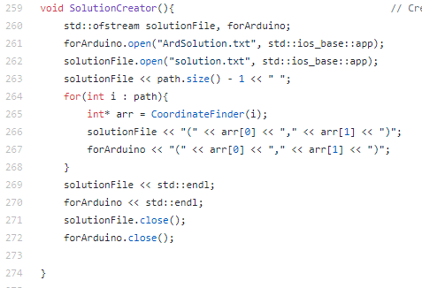

The vector variable path stores the path by cell number of grid, conversion of cell number to coordinates take place in CoordinatesFinder() function which then returns an array of coordinates, which is then stored into the open files.

Code snippet of CoordinatesFinder() shown below (File Name: solution_creator.cpp)

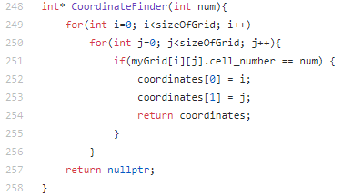

CoordinatesFinder() function takes a number as a parameter which is assumed to be a cell number. It the runs a loop to through the grid to look for a matching cell number, once it matches it then returns the result as an array.

If Goal is not found it will give an output to let the user know. Code snippet is shown below;

(File Name: solution_creator.cpp)

