Ripa Shah
Course: INFO 531/ISTA 431: Data Warehousing and Analytics in the Cloud
Module/Week: 7 - Week of October 3, 2022
Topic: Cloud Data Platform Architecture

Week 7 Assignment: Understand data store models on Azure

PURPOSE:
Week 7 assignment introduces you to Understand data store models, how to create Azure blob storage on Azure, how to create an Azure Cosmos account and database, Azure Database for MySQL server, and how to create Azure Database for PostgreSQL server in the Azure portal. This also shows you how to delete resource groups when you are finished with all these activities. You will perform activities to delete the resource group you created.

Part I: Azure blob storage
Follow the instructions here to create a container in Azure Storage, and to upload and download block blobs in that container.

https://learn.microsoft.com/en-us/azure/storage/blobs/storage-quickstart-blobs-portal

Assumption: You already have an account using your university email address. Go to the portal and login. Perform the steps as mentioned below (5 points each):
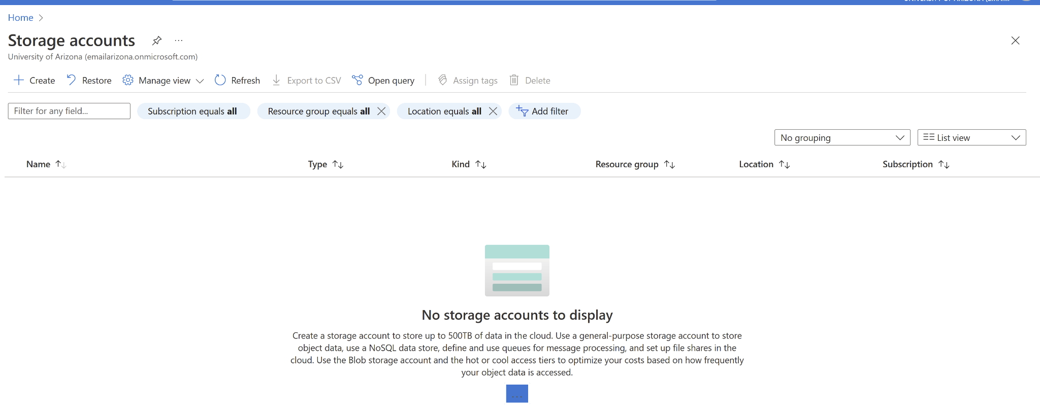
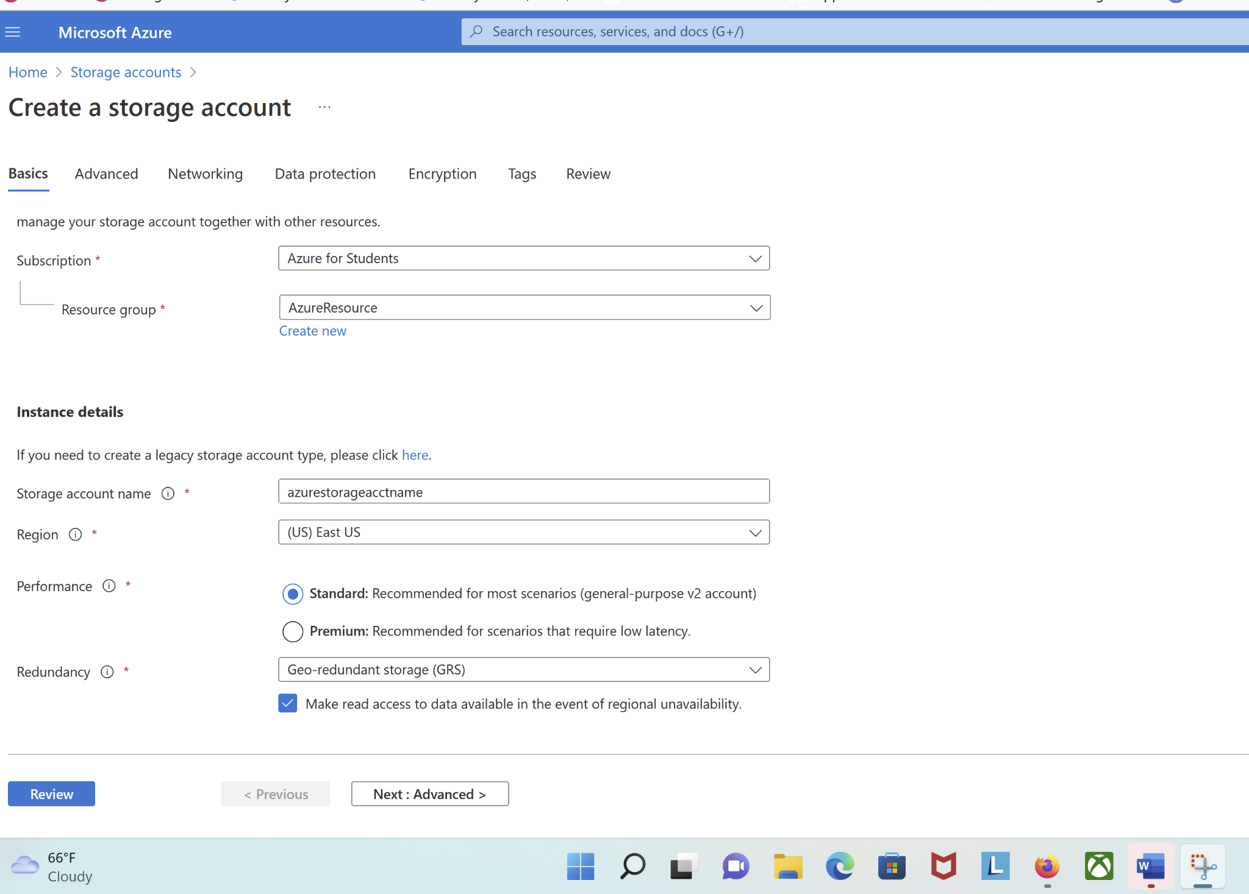
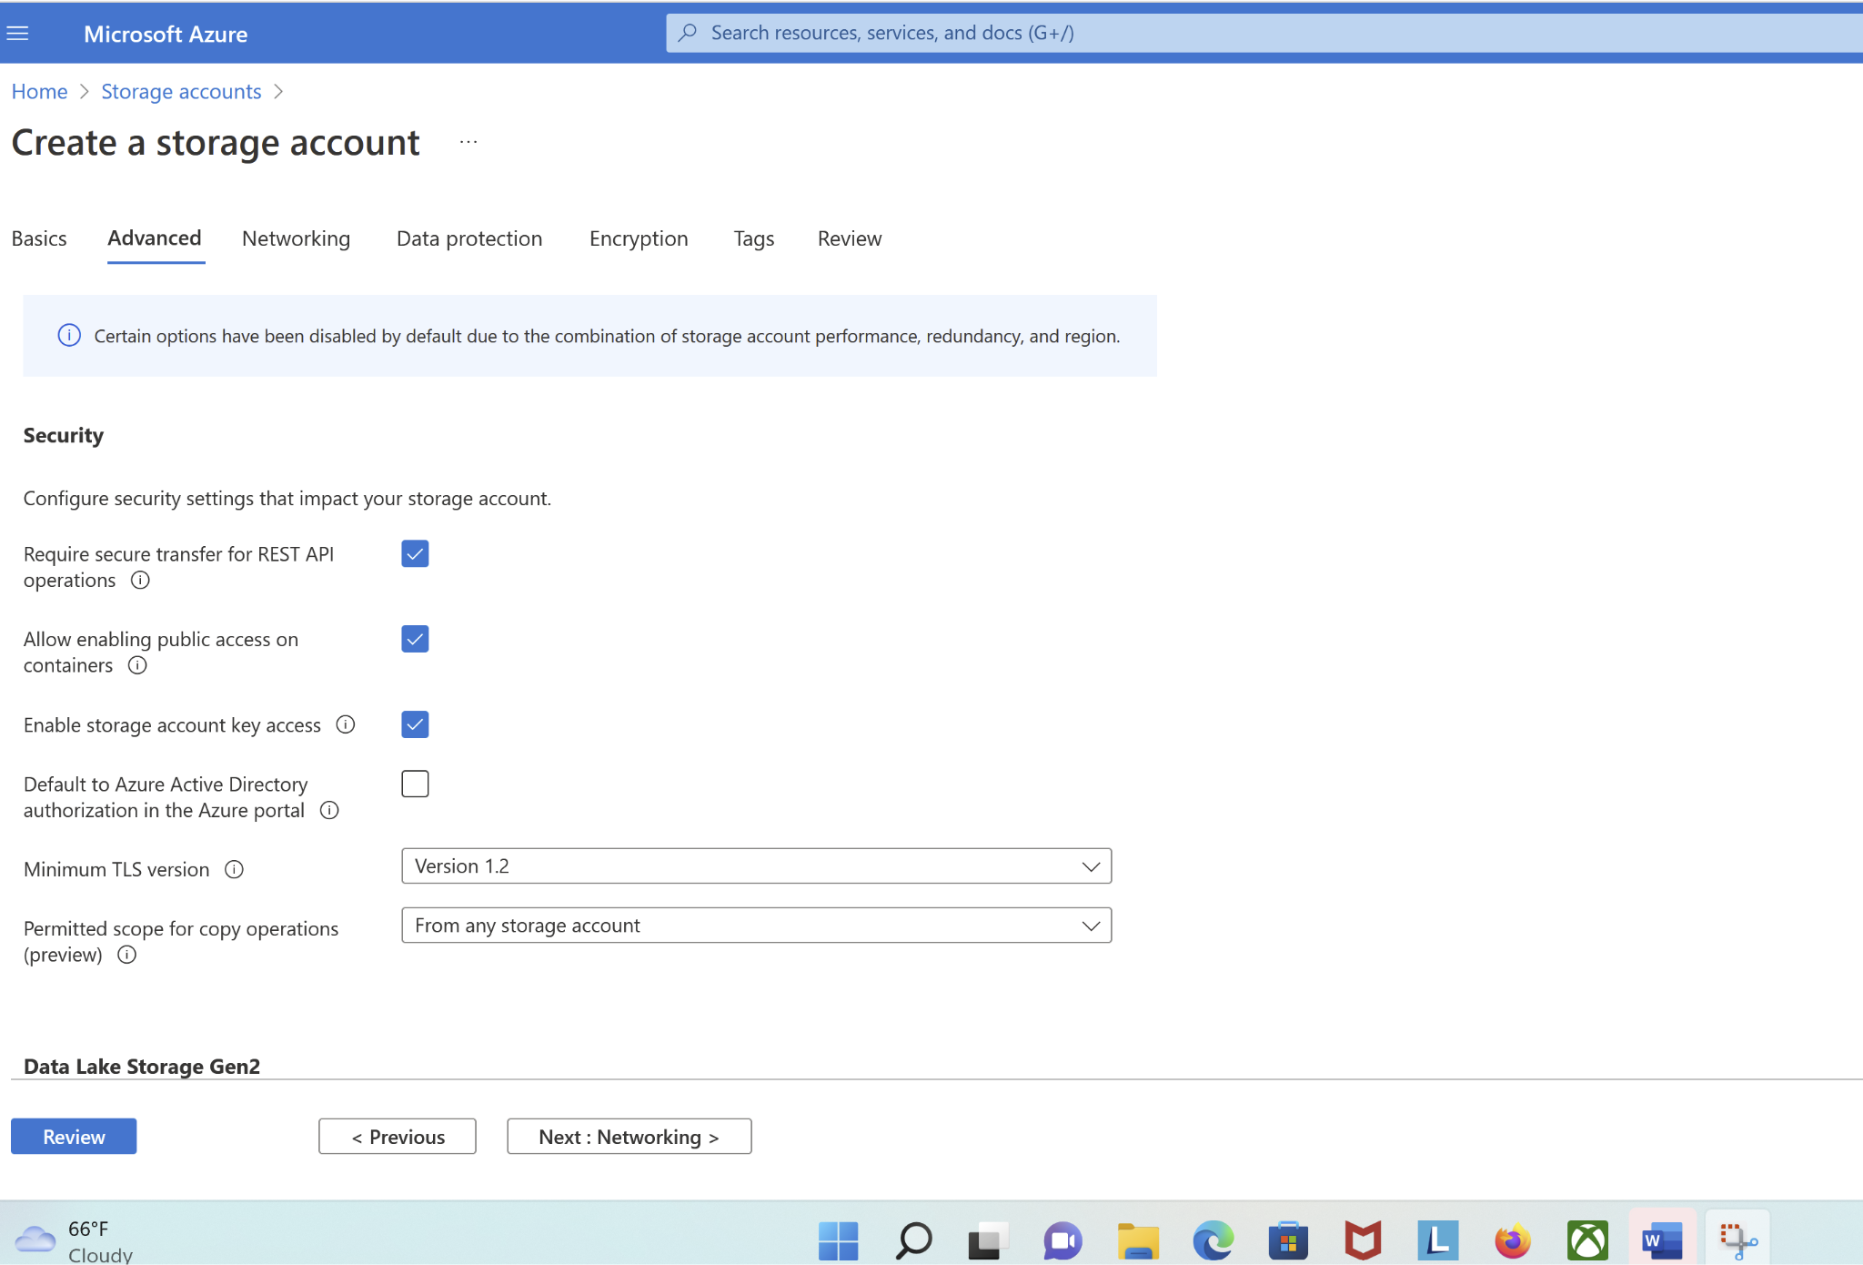
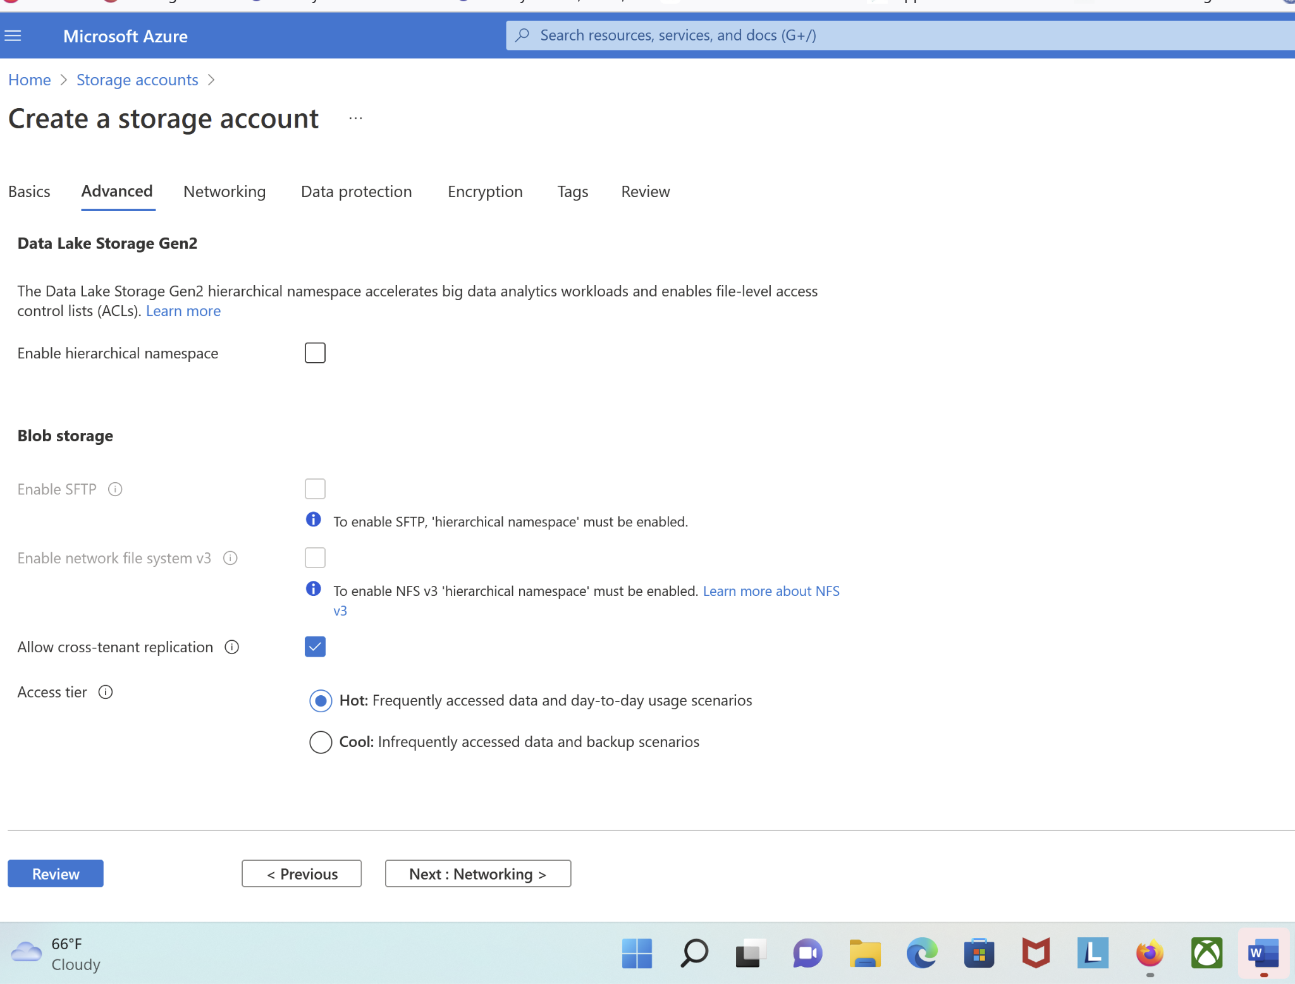

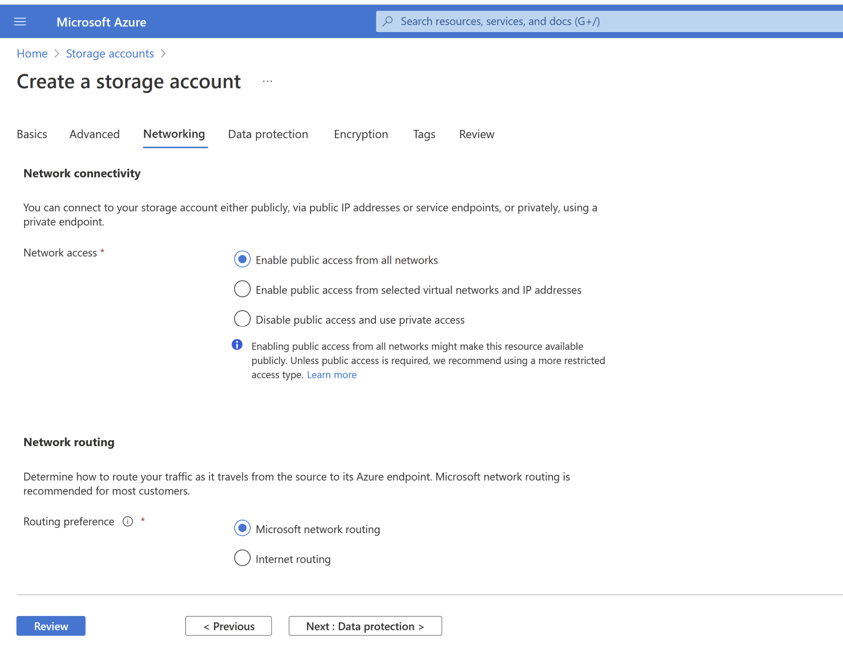

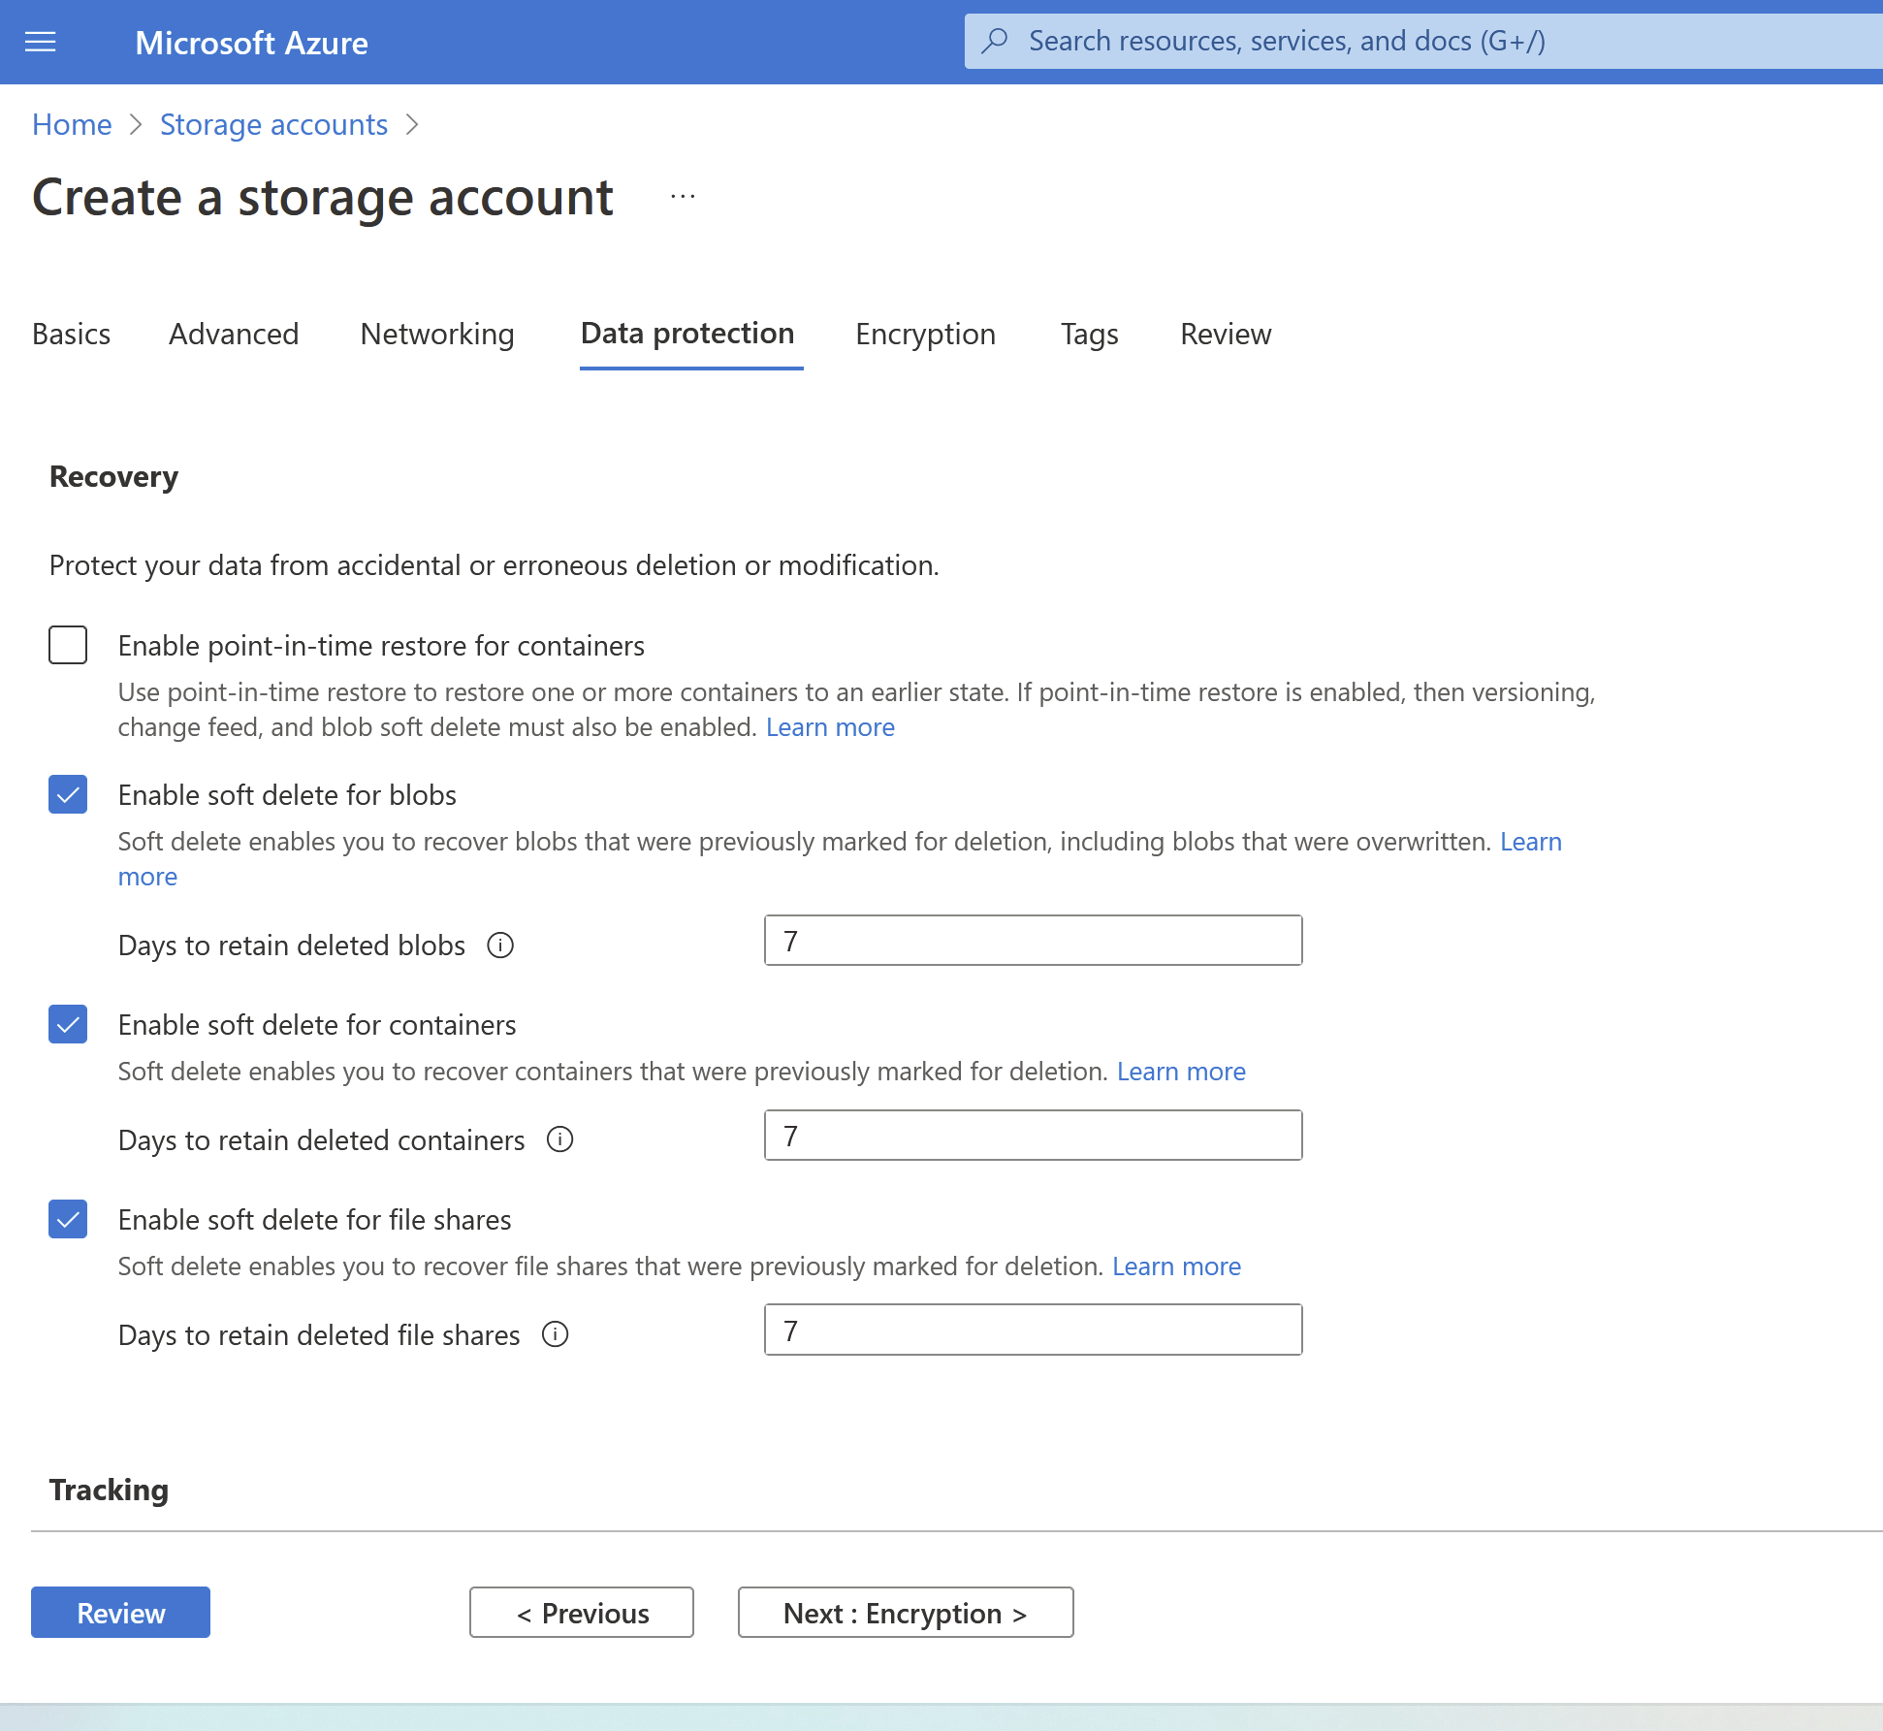

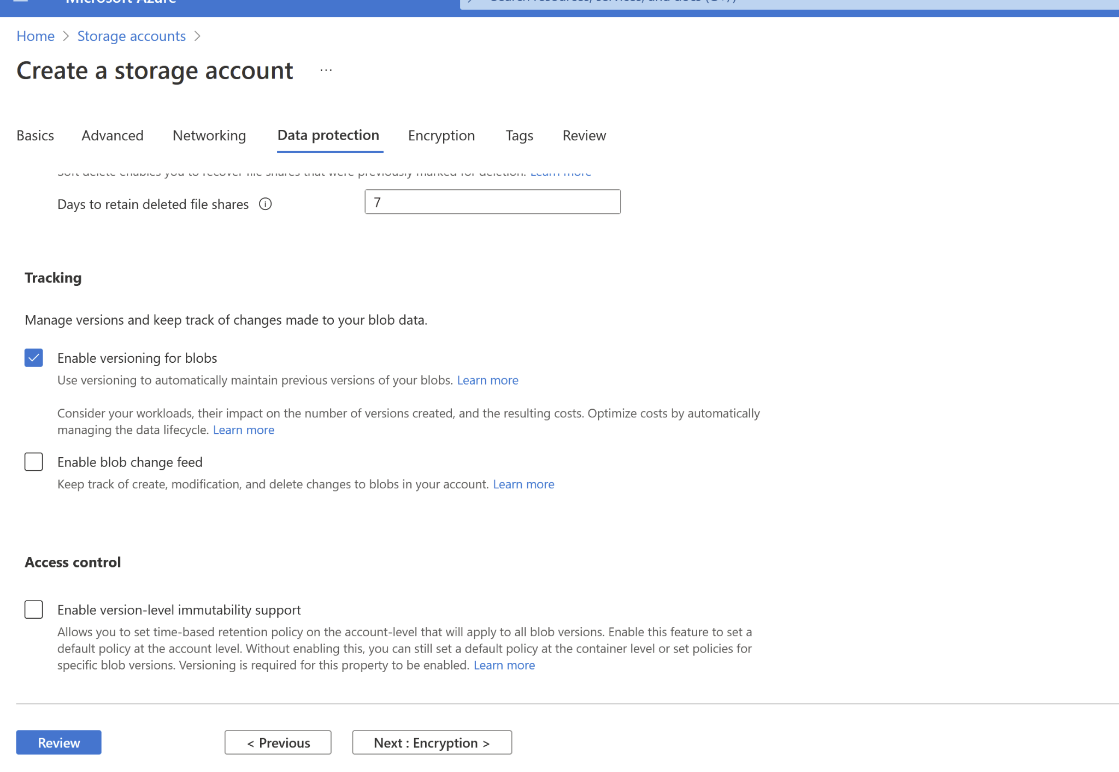
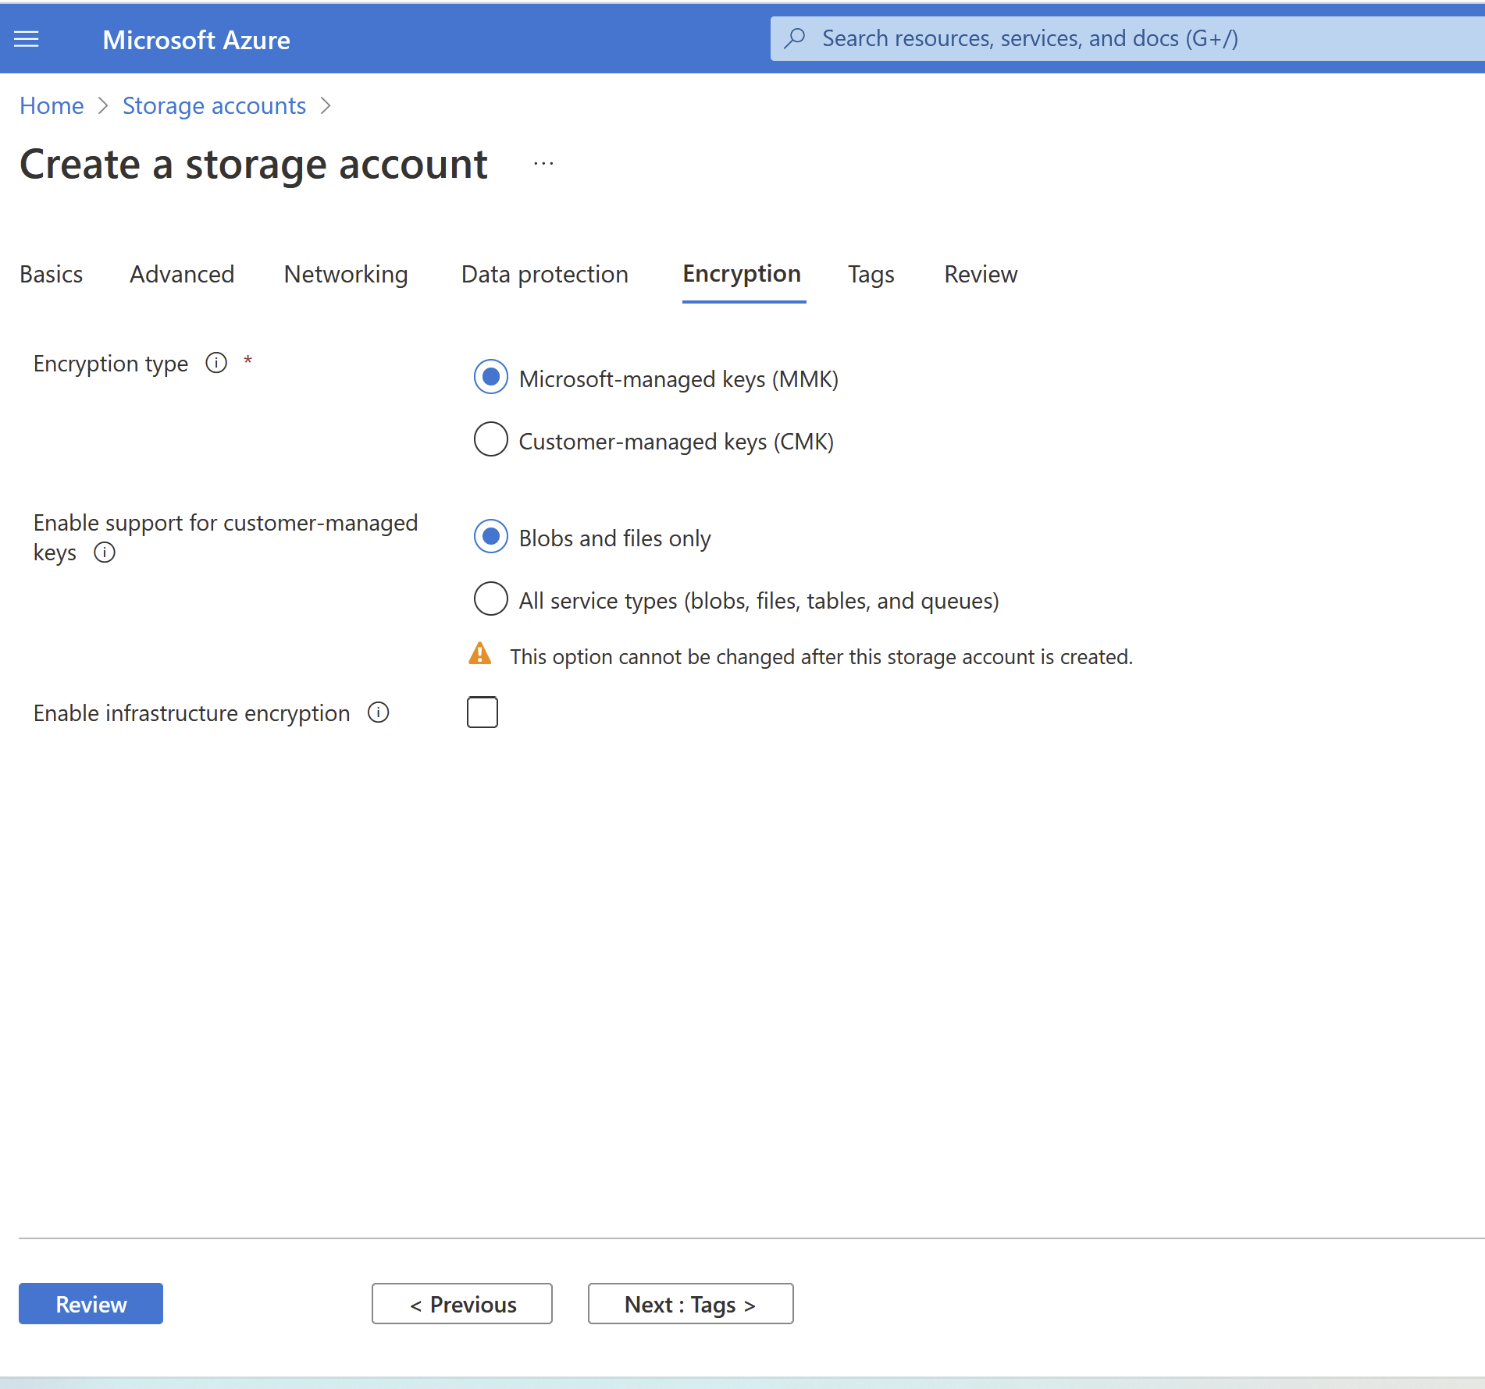
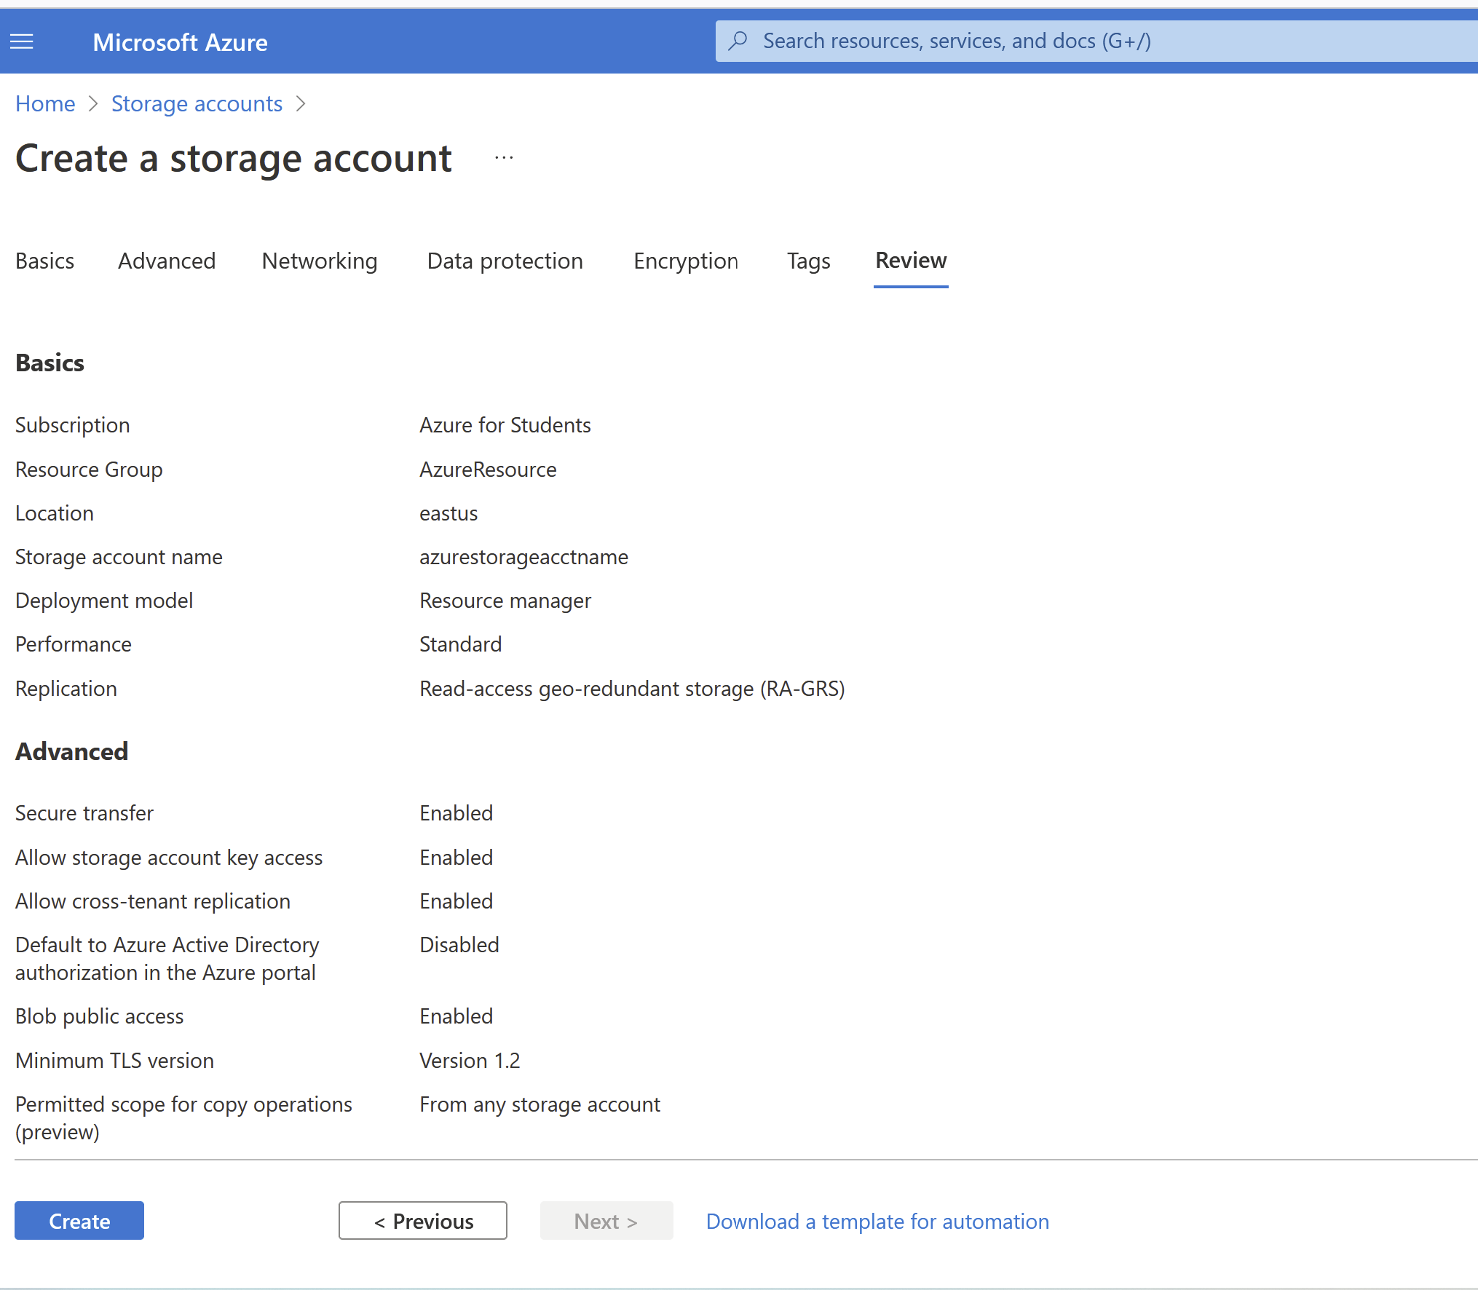

Prerequisites: Create a storage account.

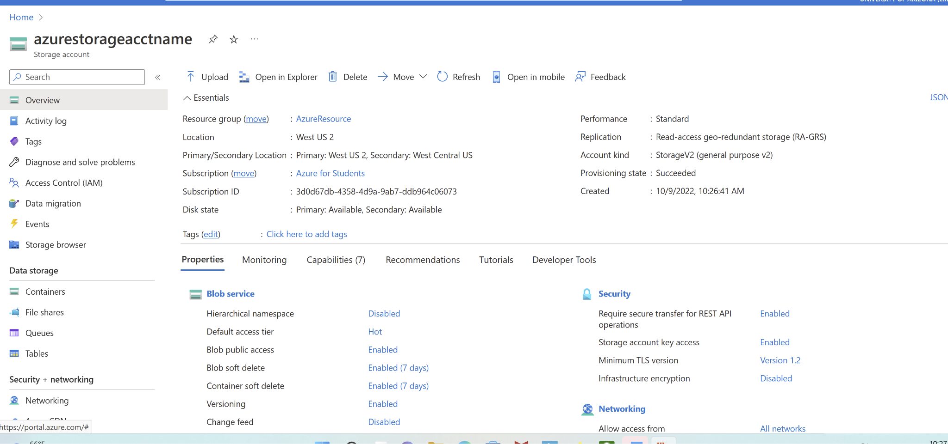
create a container in the Azure portal
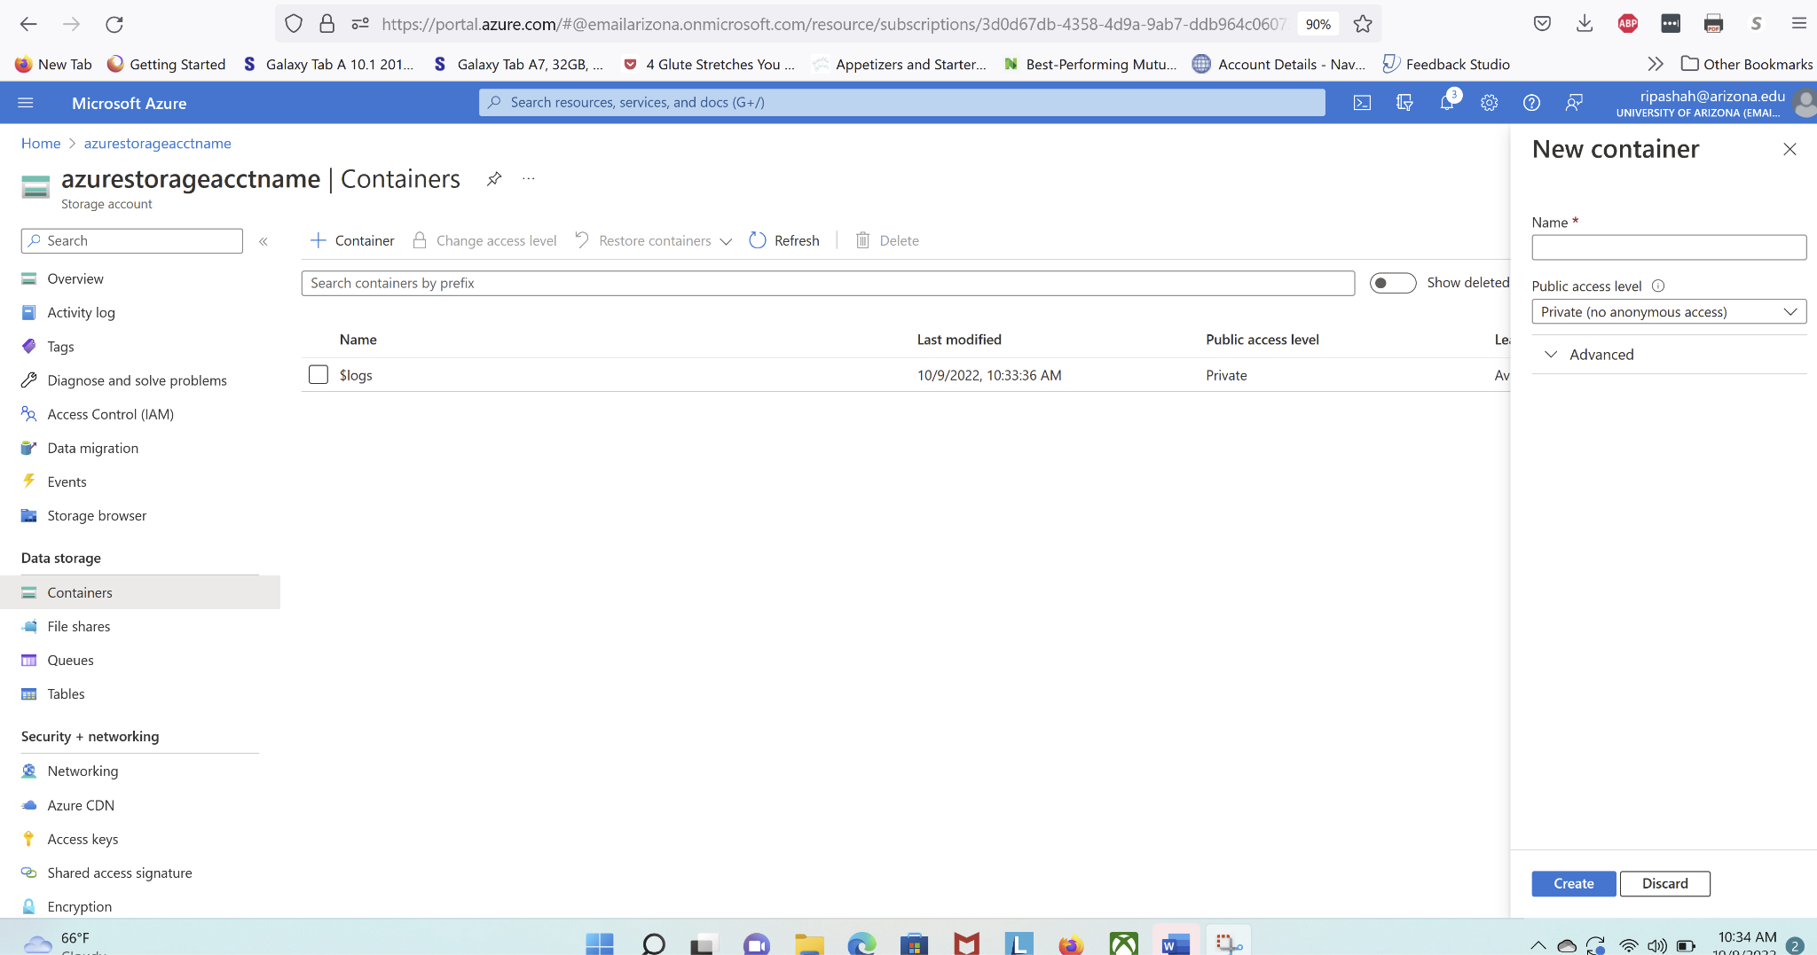
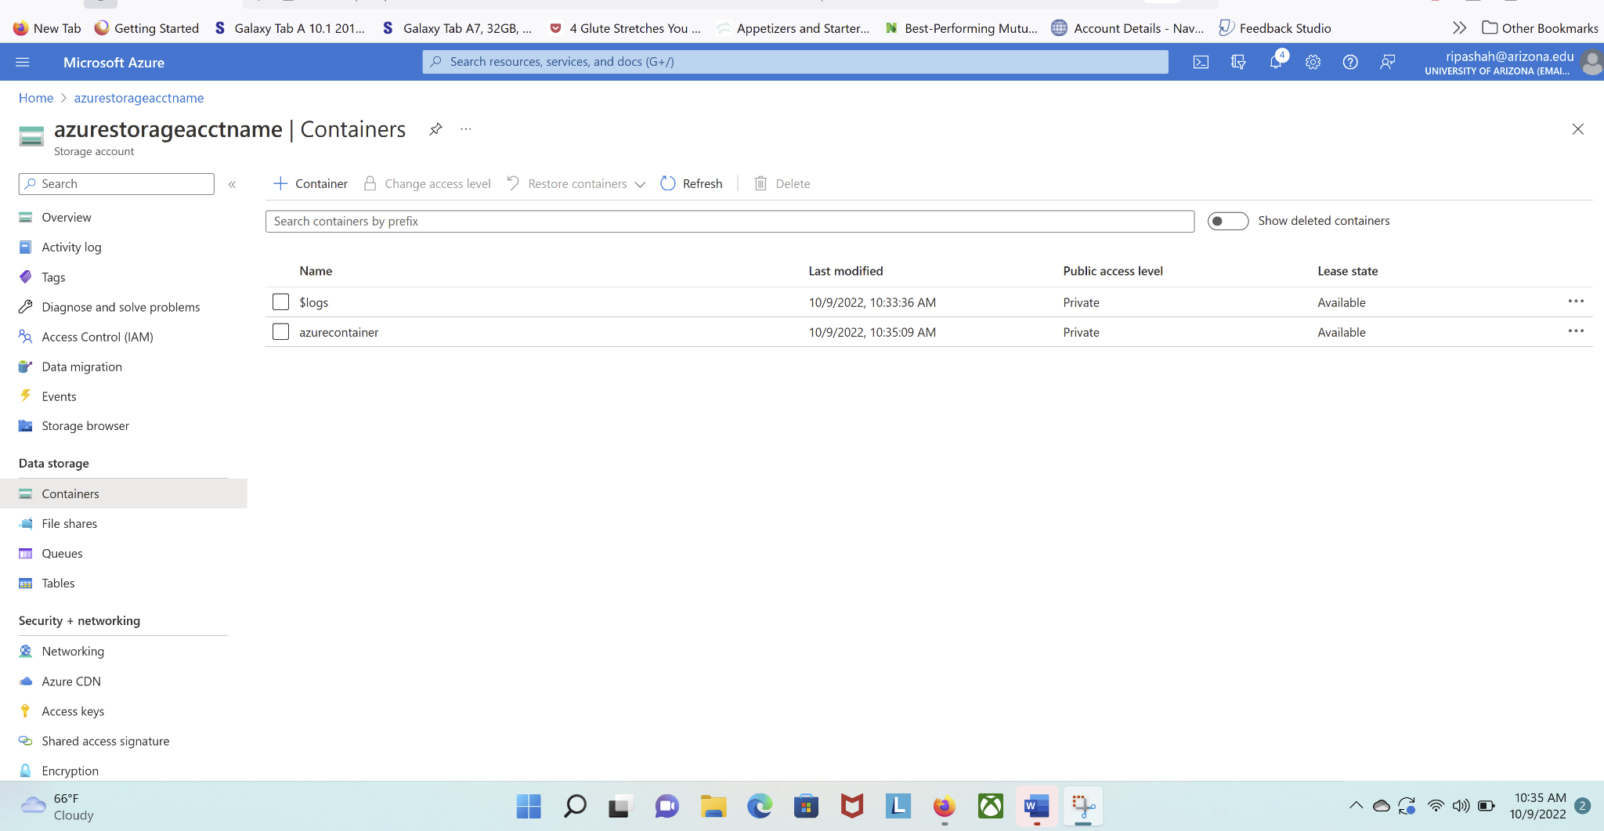
Upload/Download a block blob
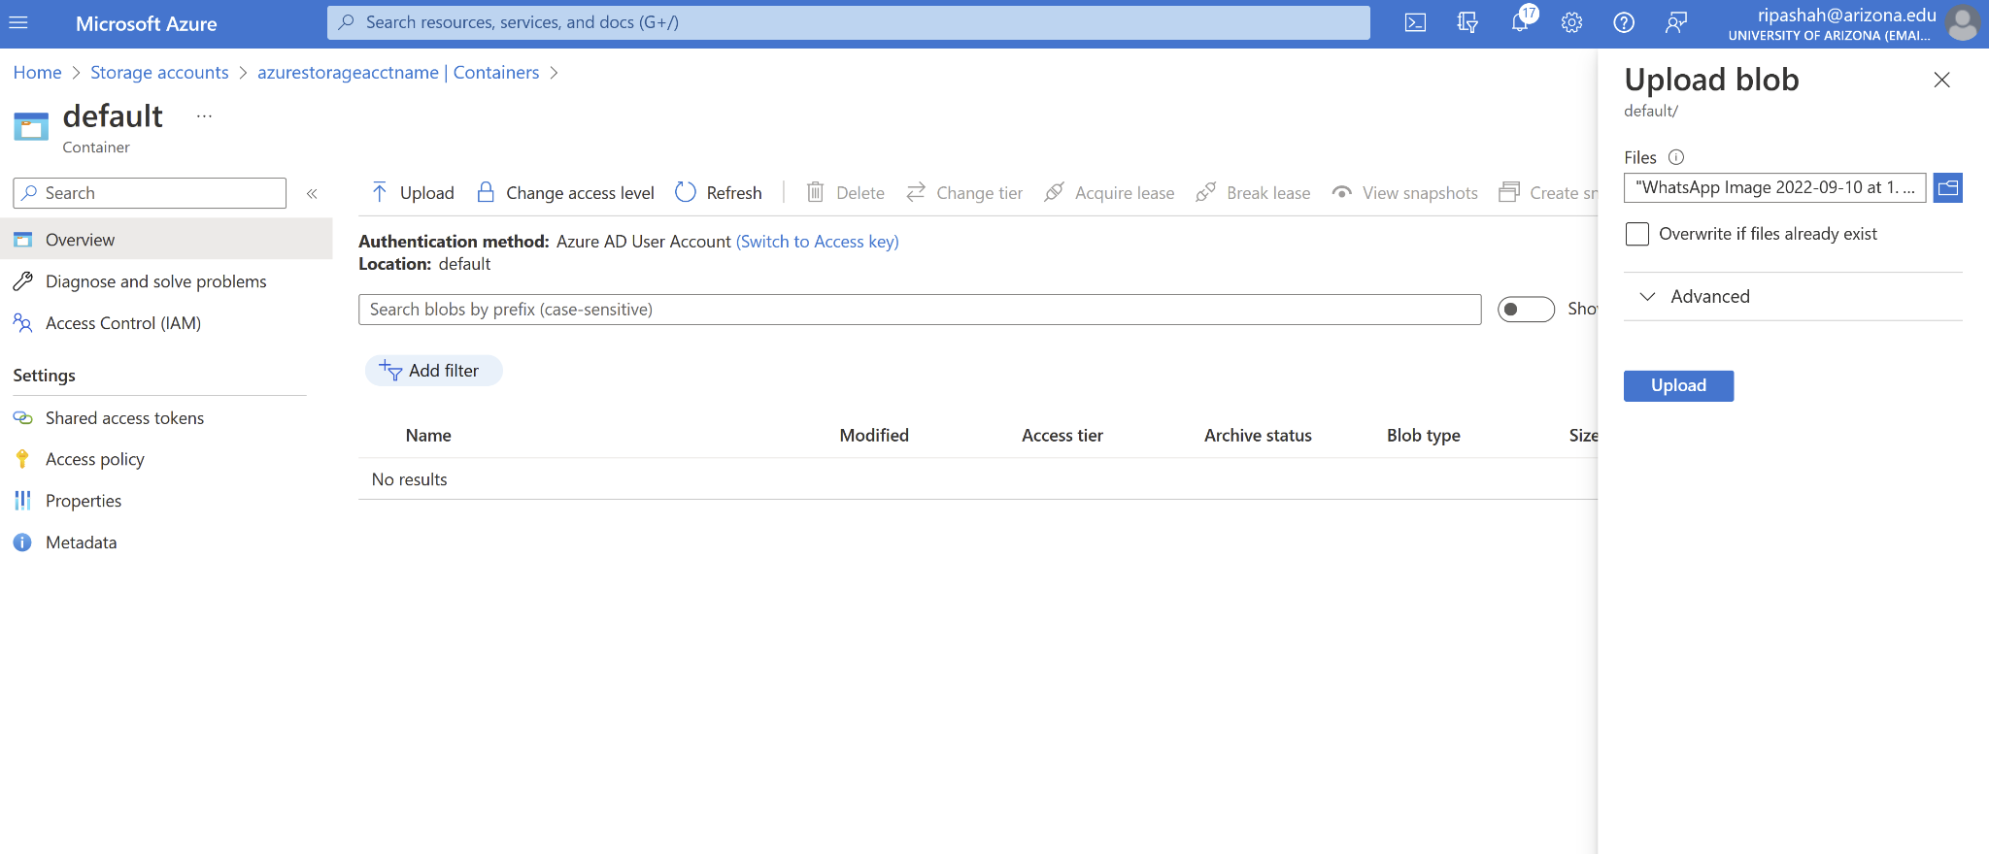
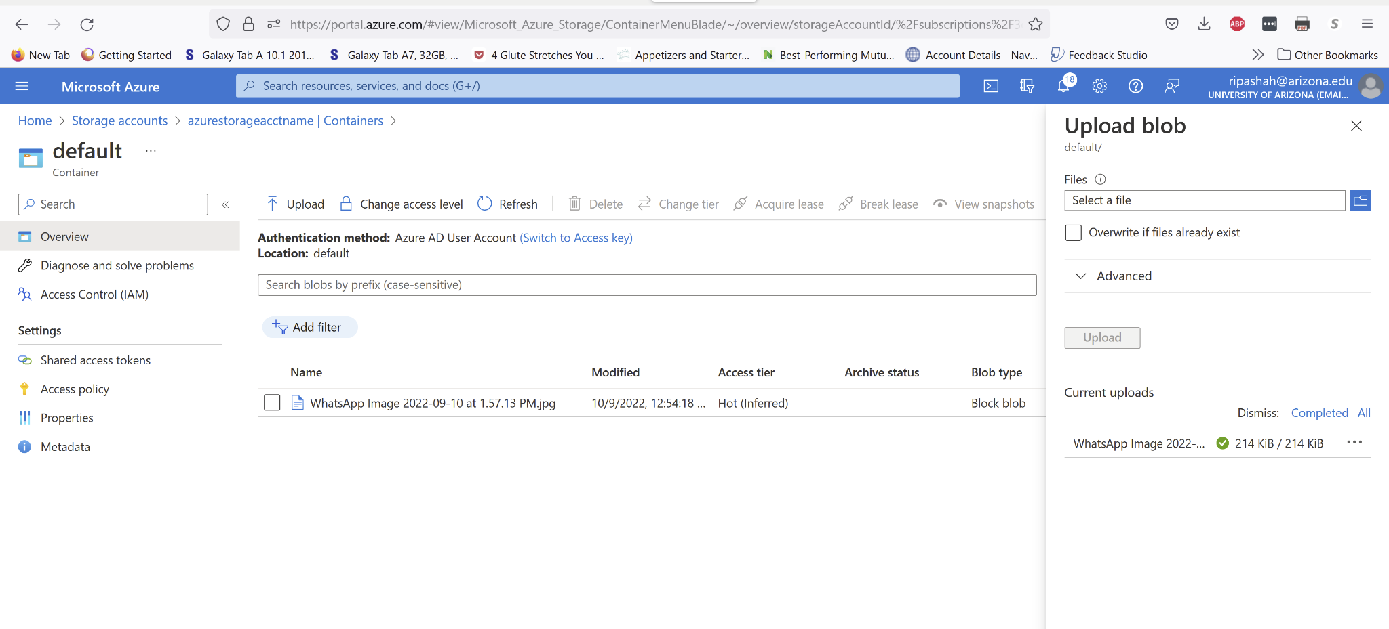
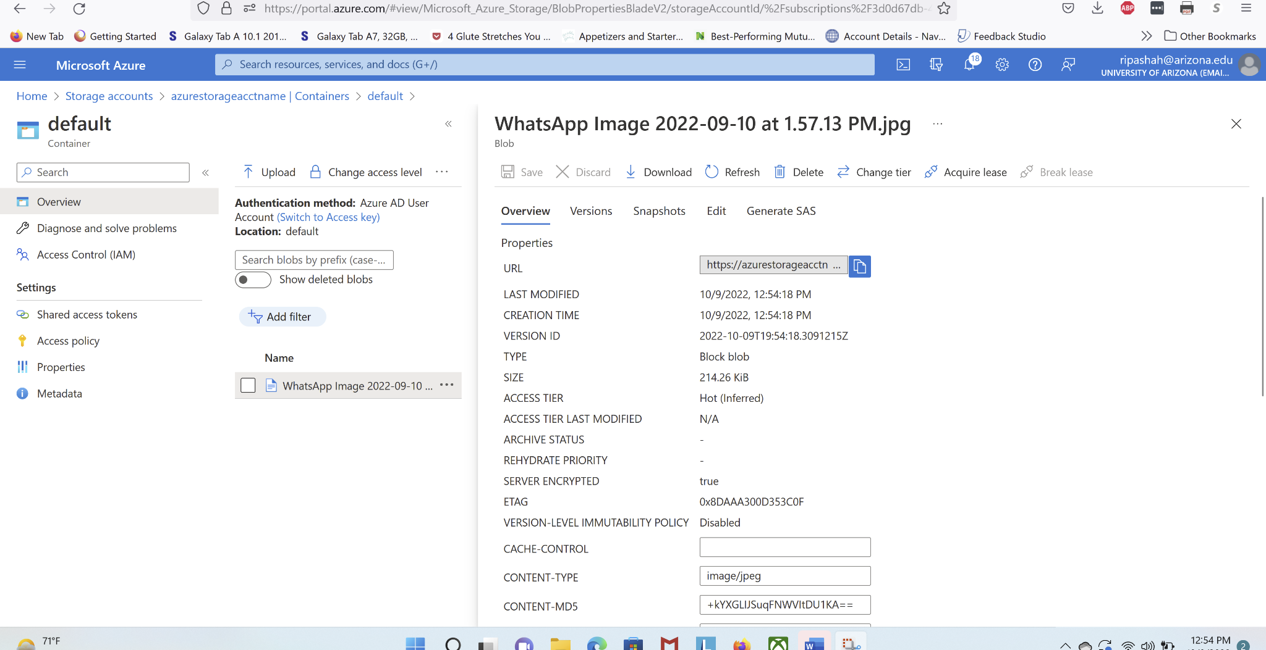
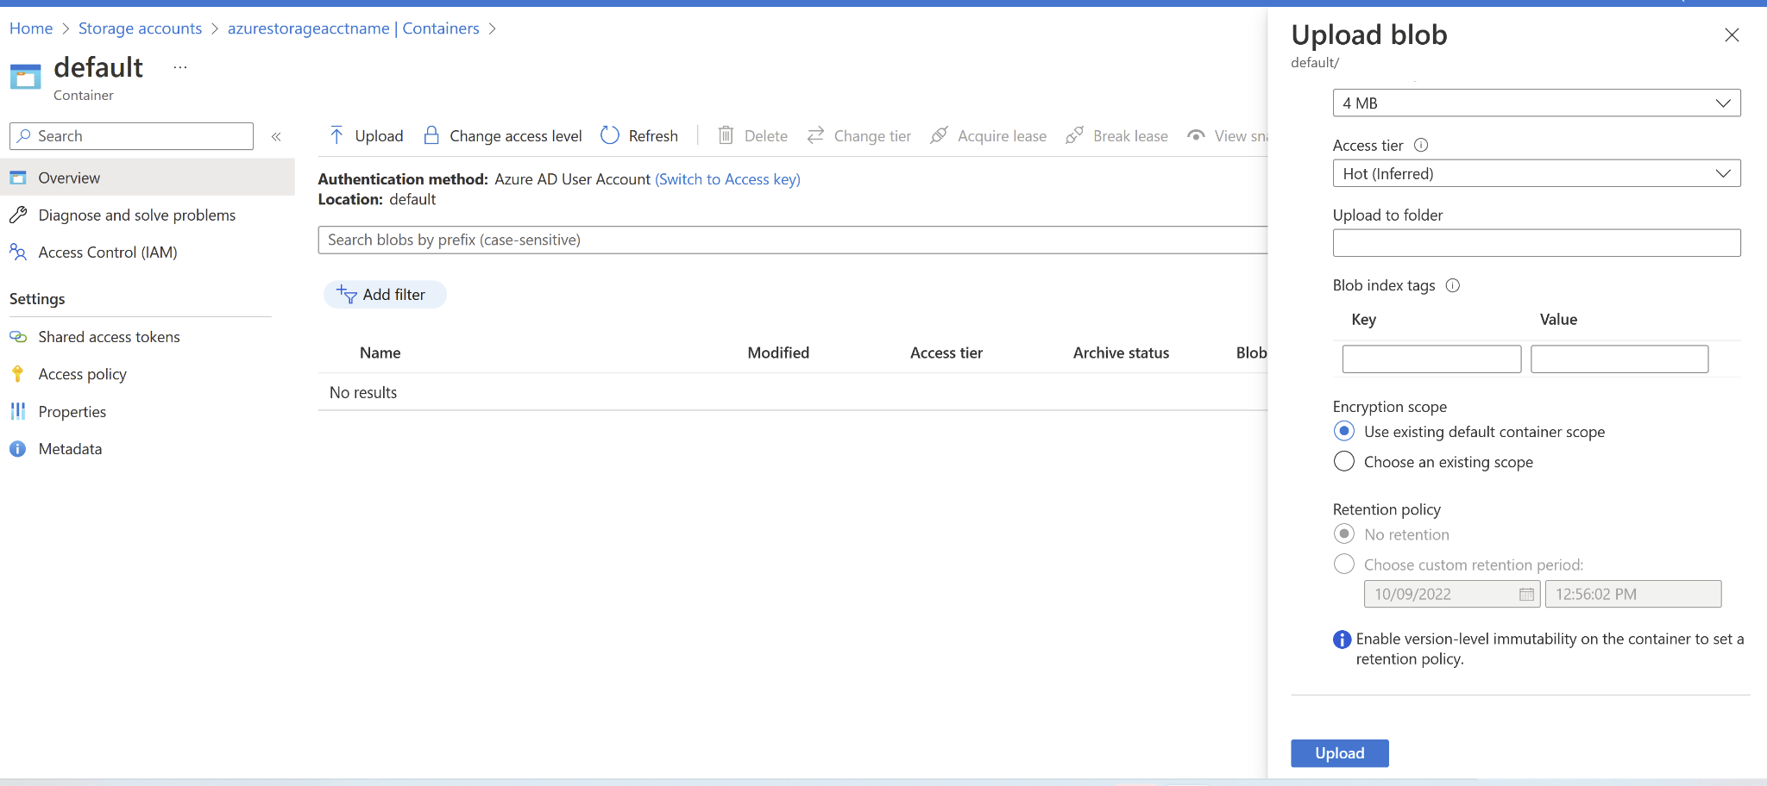
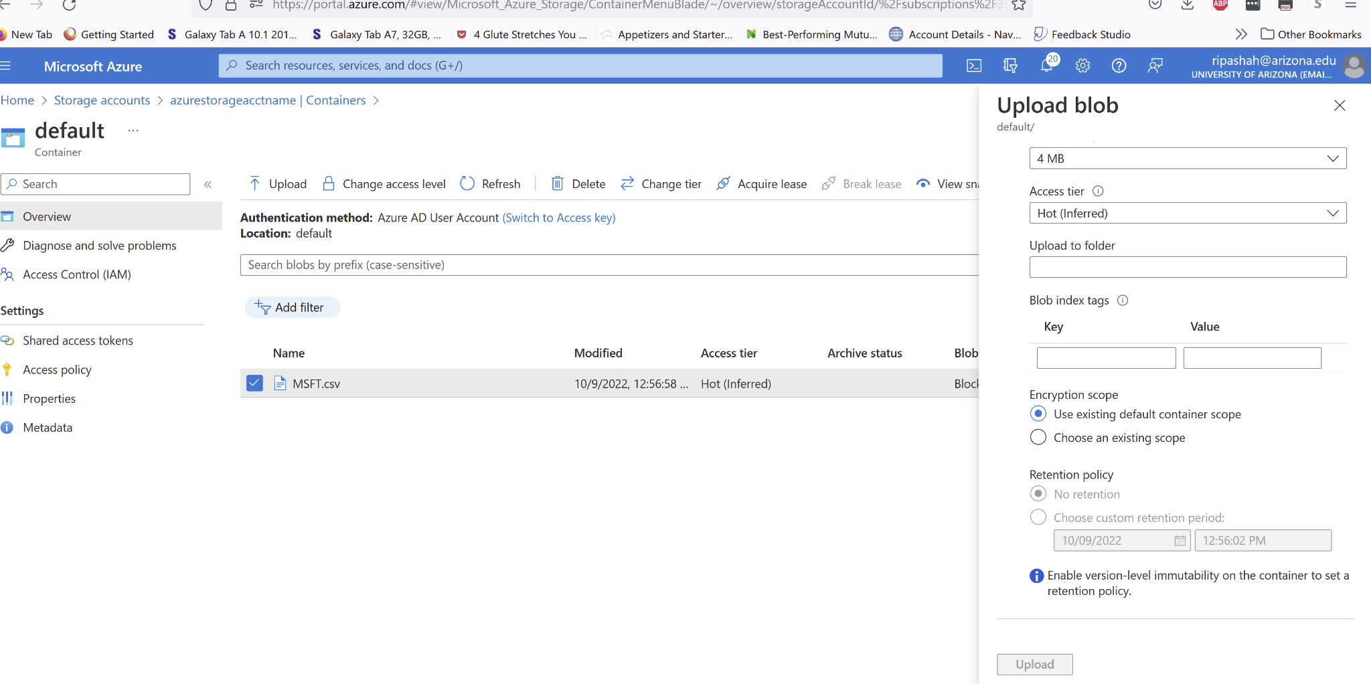
Delete a block blob
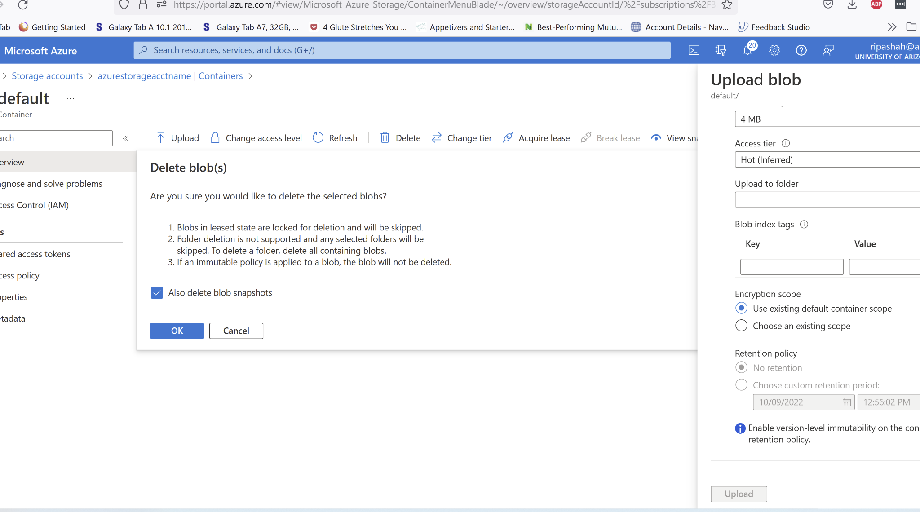

Clean up resources - storage account.
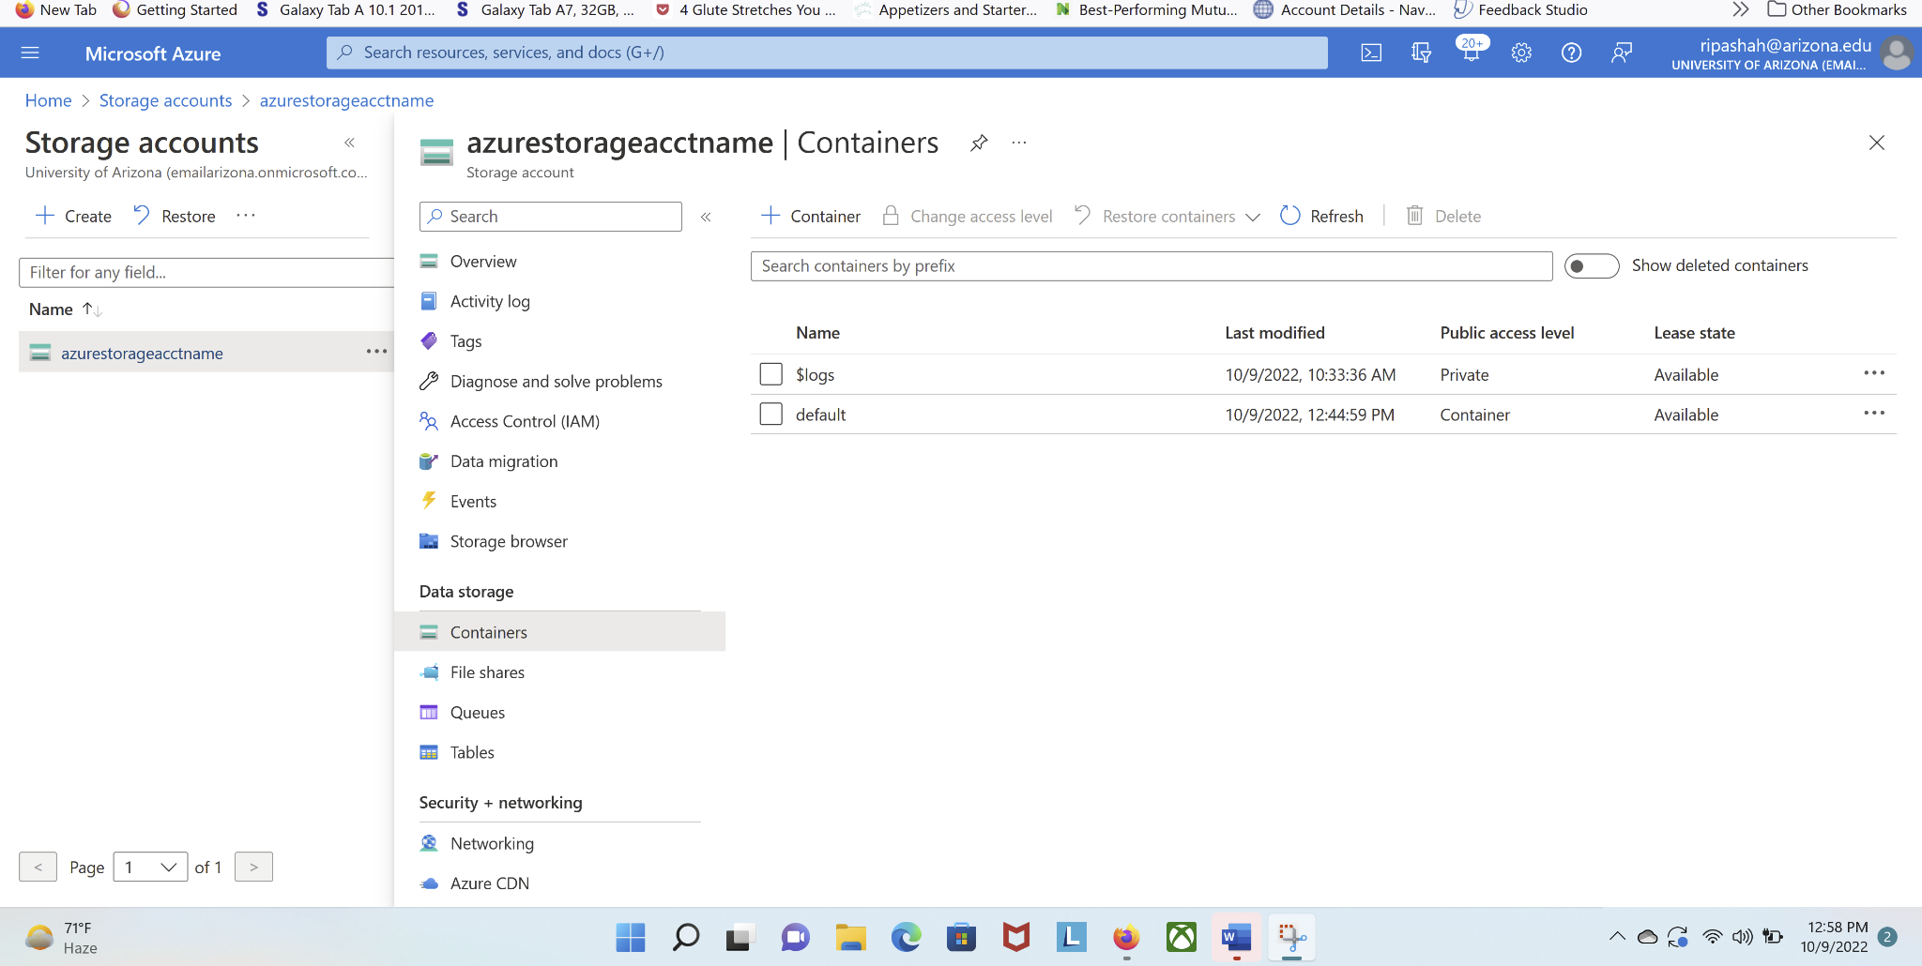
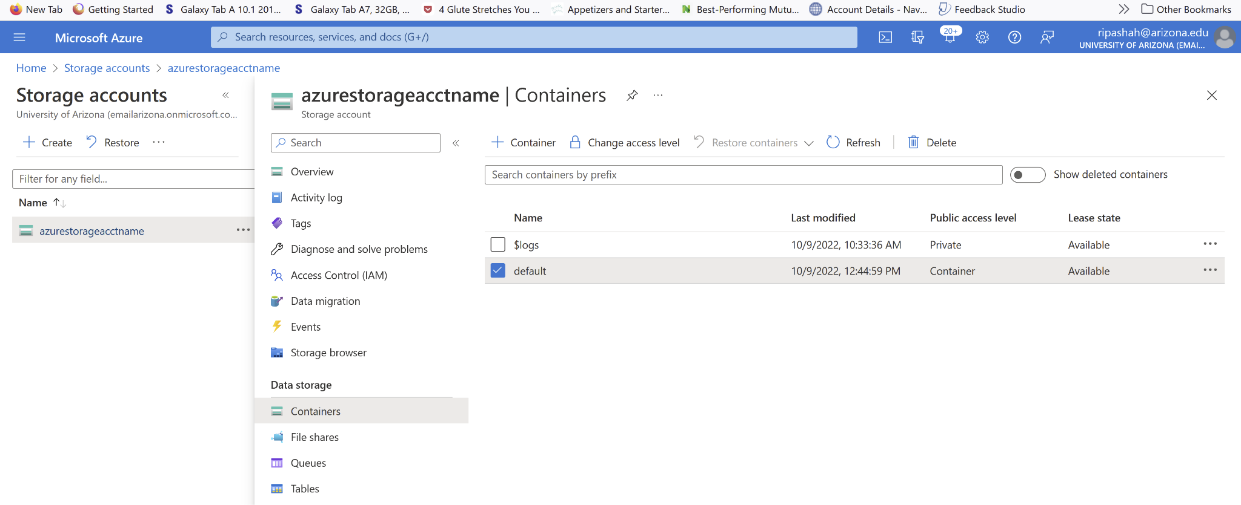
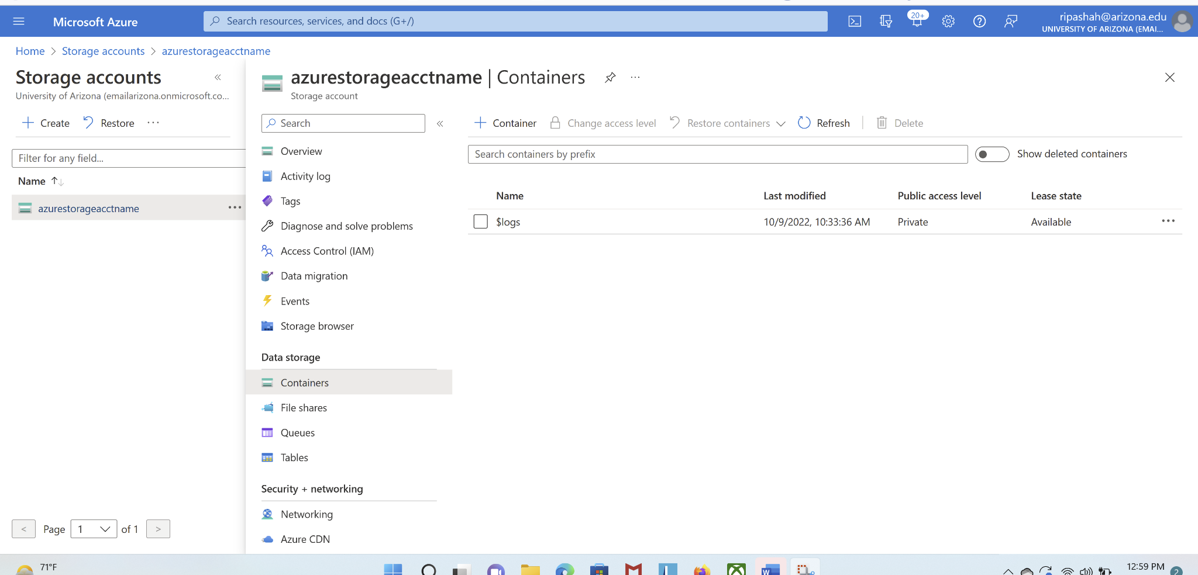
references: https://www.youtube.com/watch?v=dgGV2HlVE9E
https://learn.microsoft.com/en-us/azure/storage/blobs/storage-quickstart-blobs-portal

Part II: Create an Azure Cosmos account and database
Follow the instructions here to create an Azure Cosmos DB SQL API account, create a document database, and container, and add data to the container.

https://learn.microsoft.com/en-us/azure/cosmos-db/sql/create-cosmosdb-resources-portal

Assumption: You already have an account using your university email address. Go to the portal and login. Perform the steps as mentioned below (5 points each):

Create an Azure Cosmos DB account
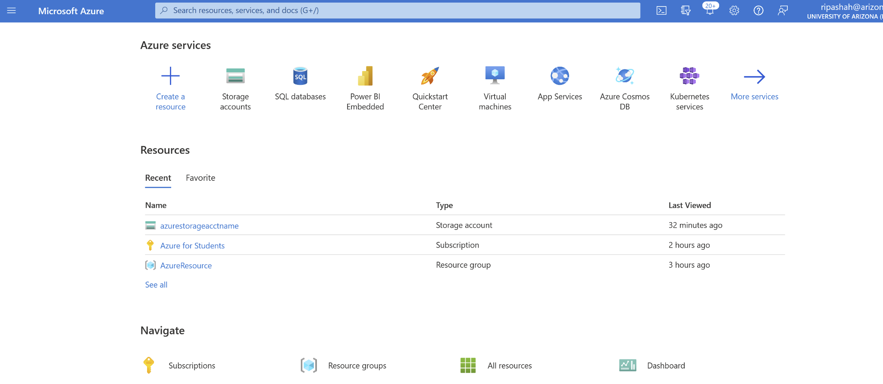
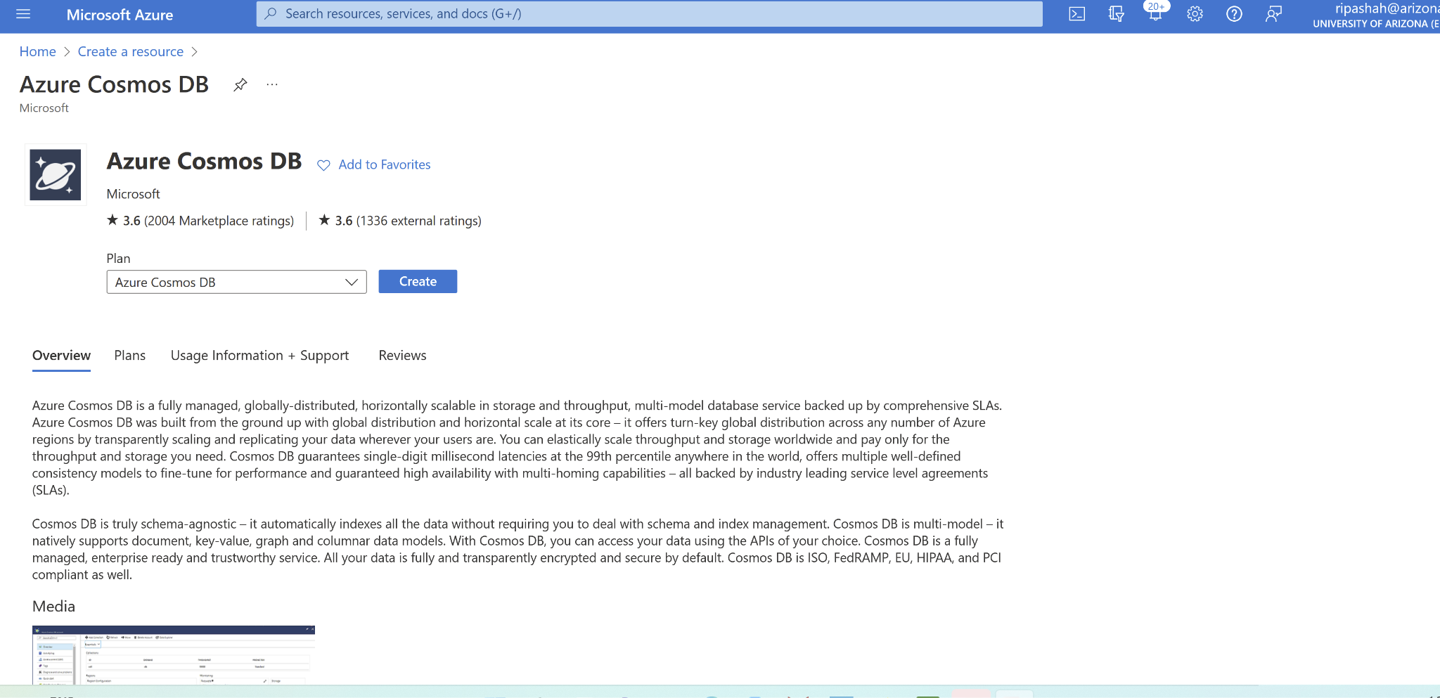
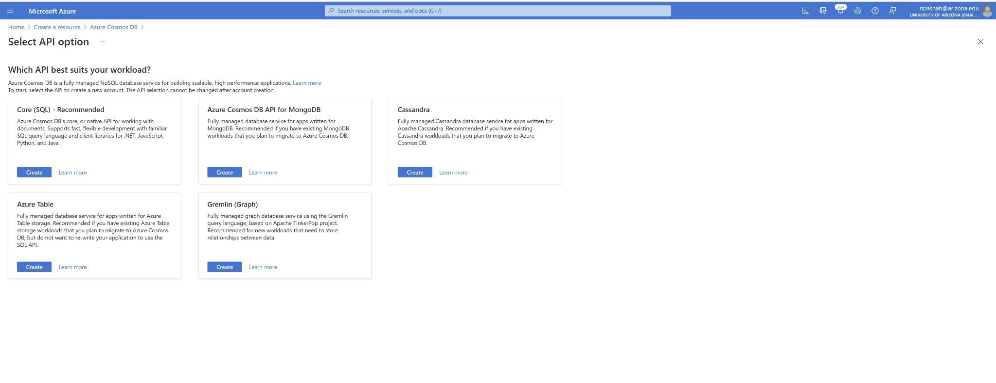
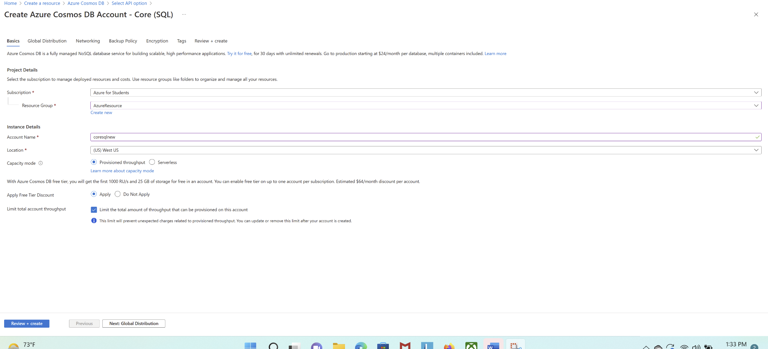
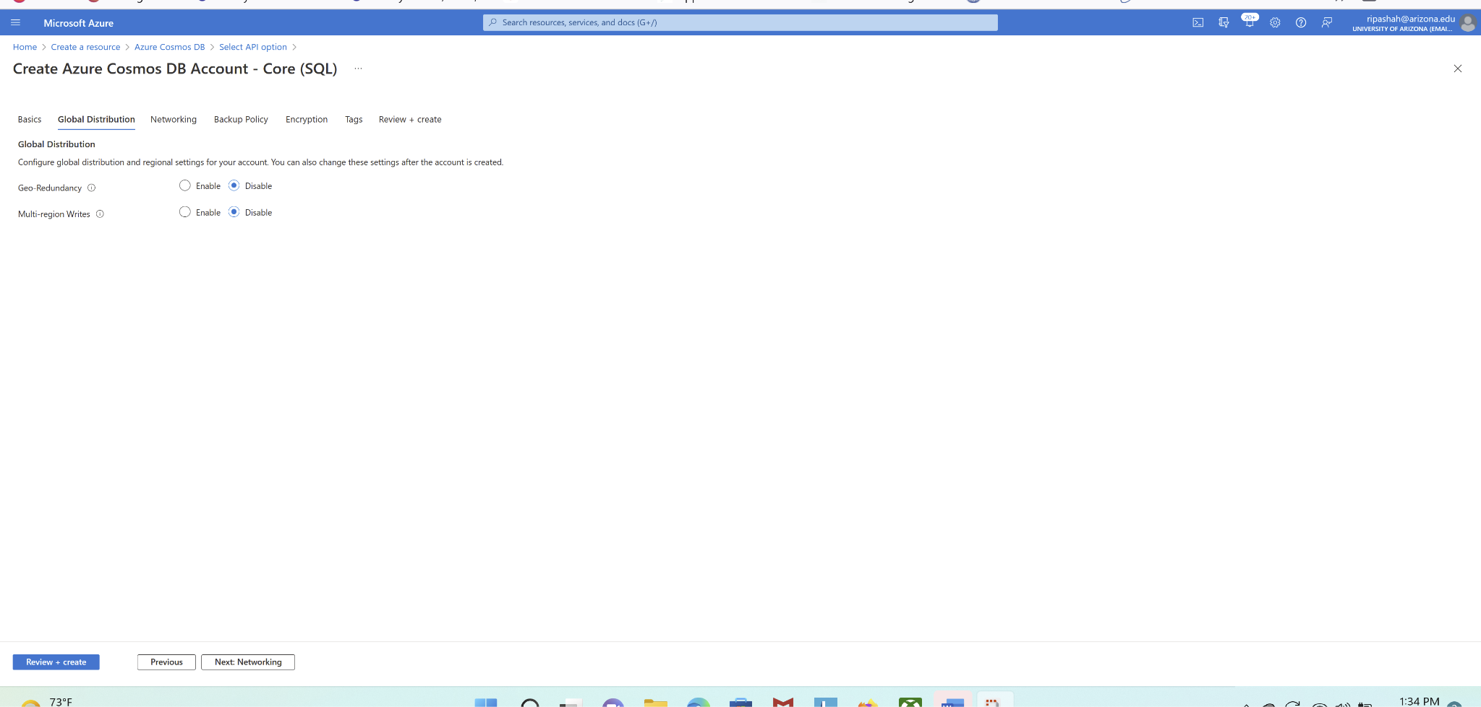
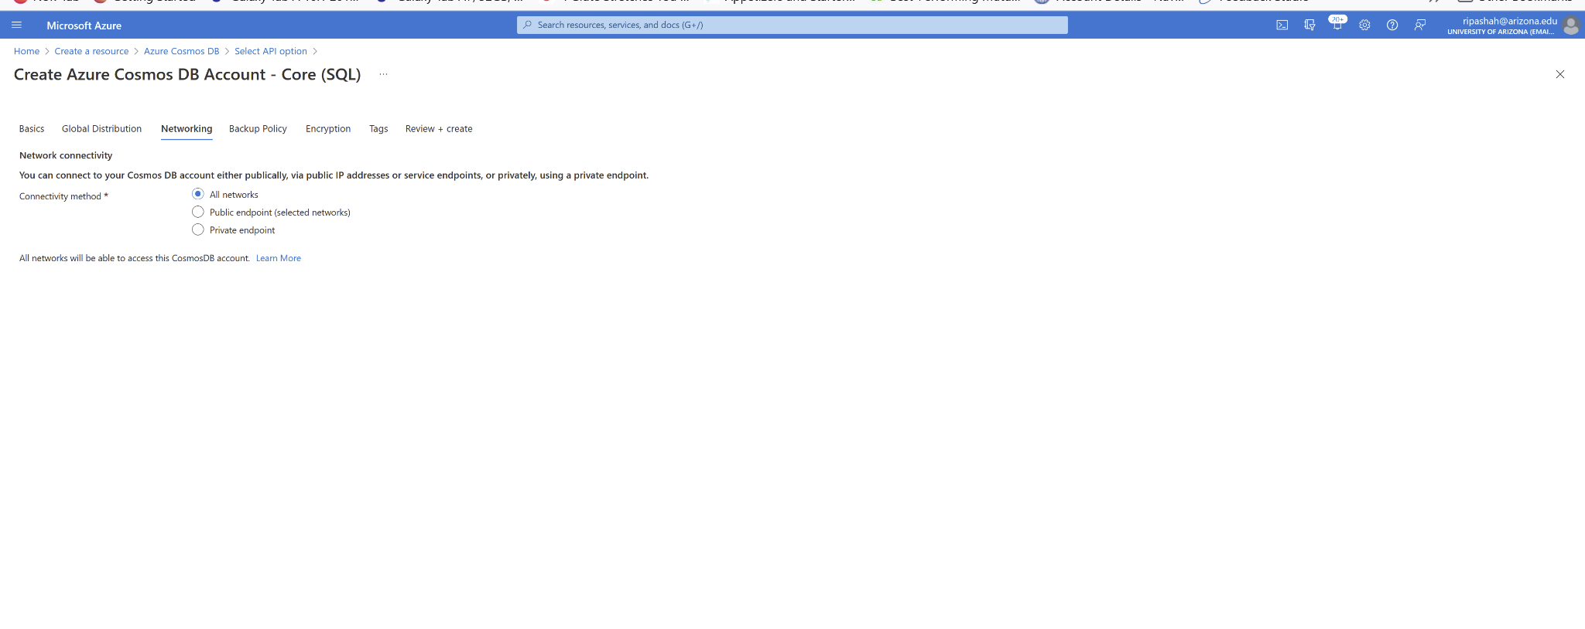
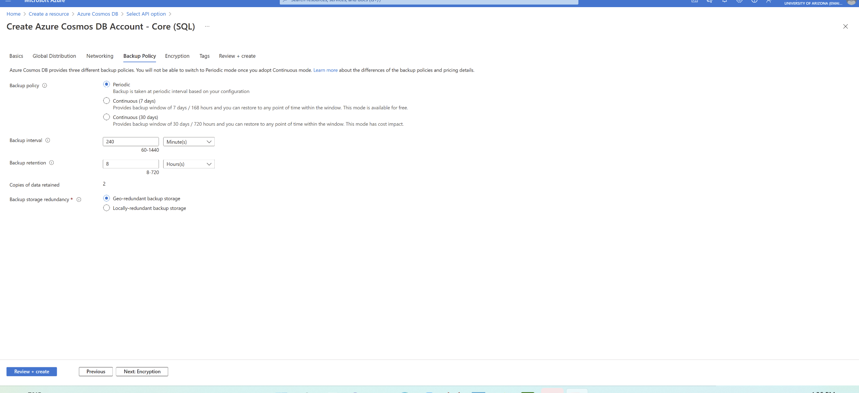
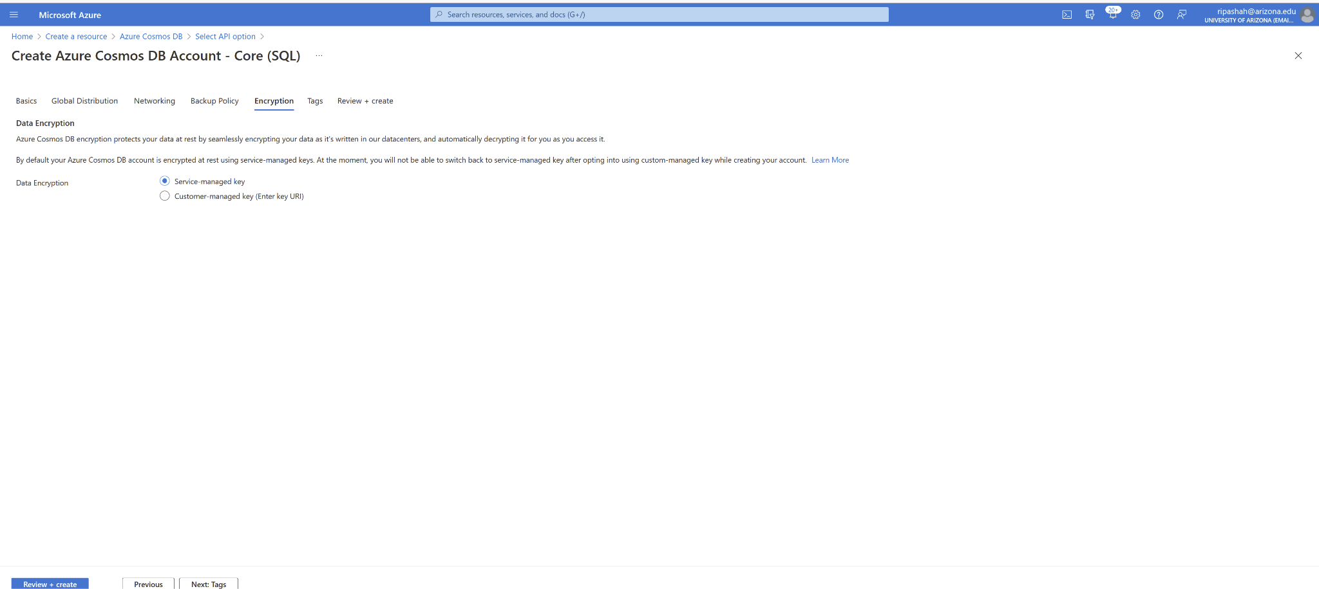
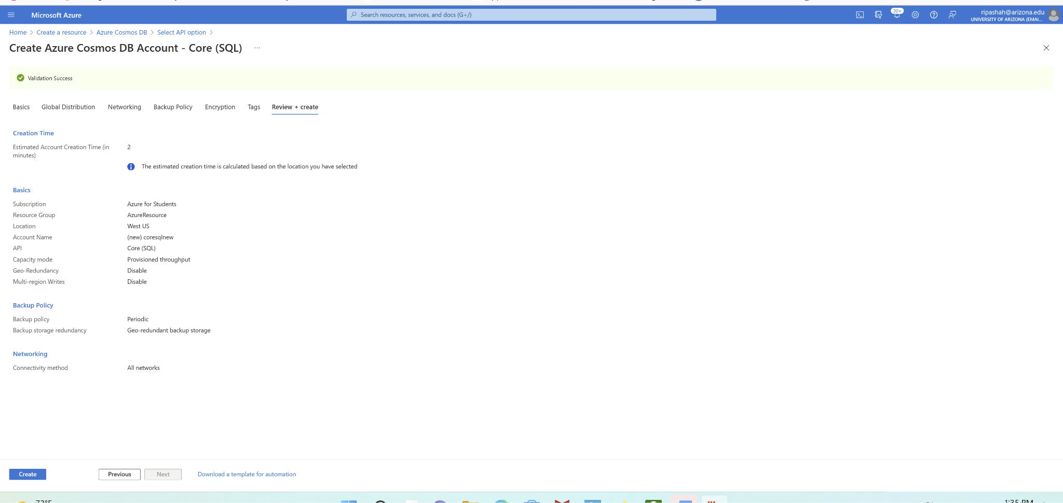

Add a database and a container
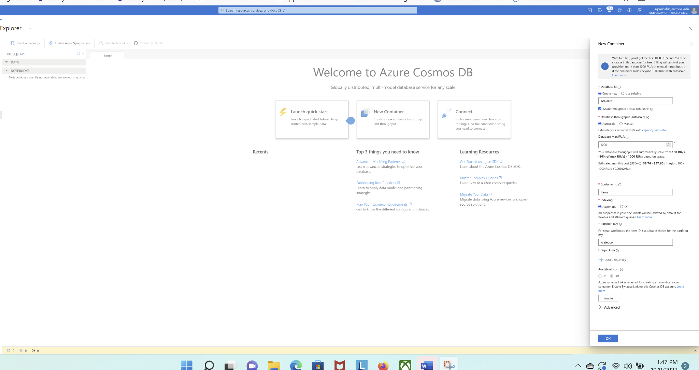
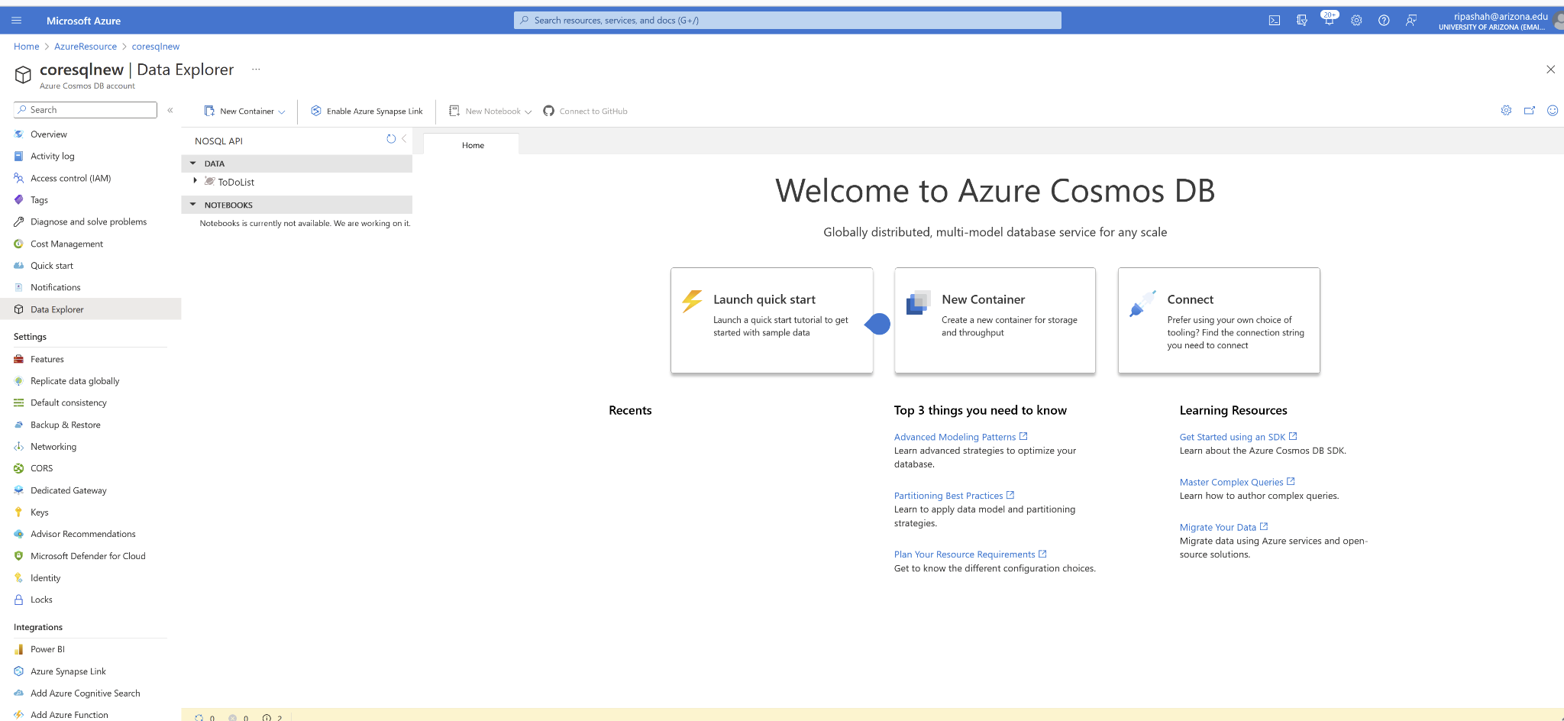
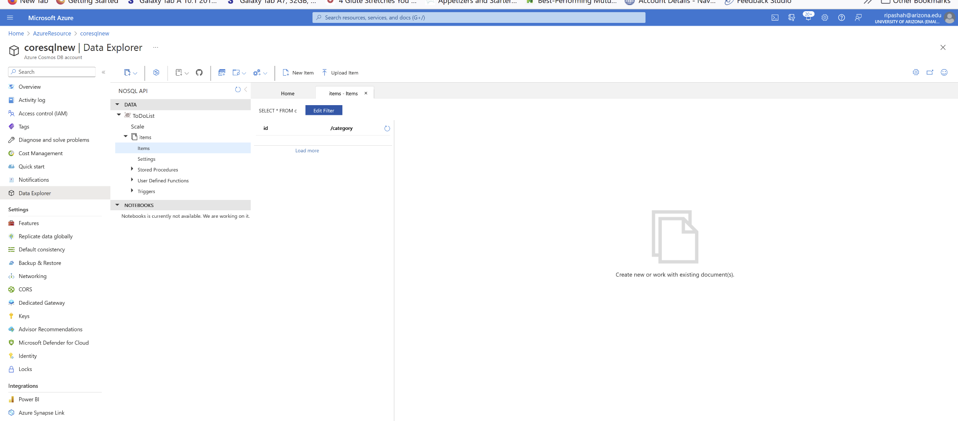
Add data to your database
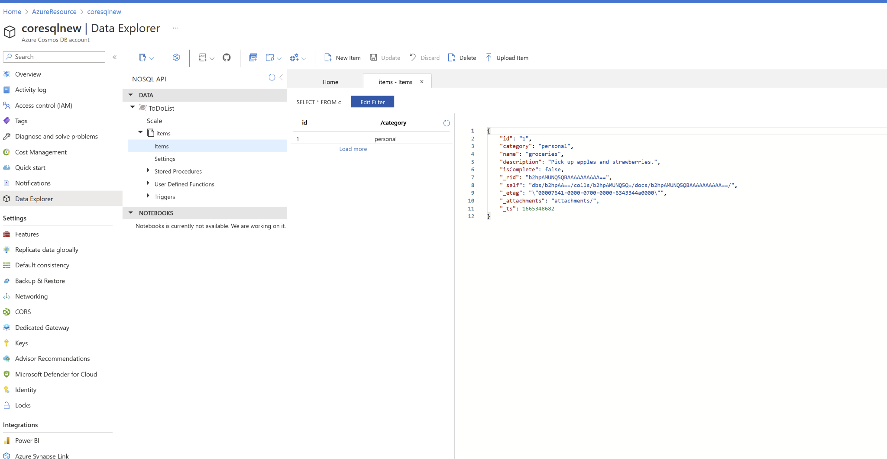
Query your data
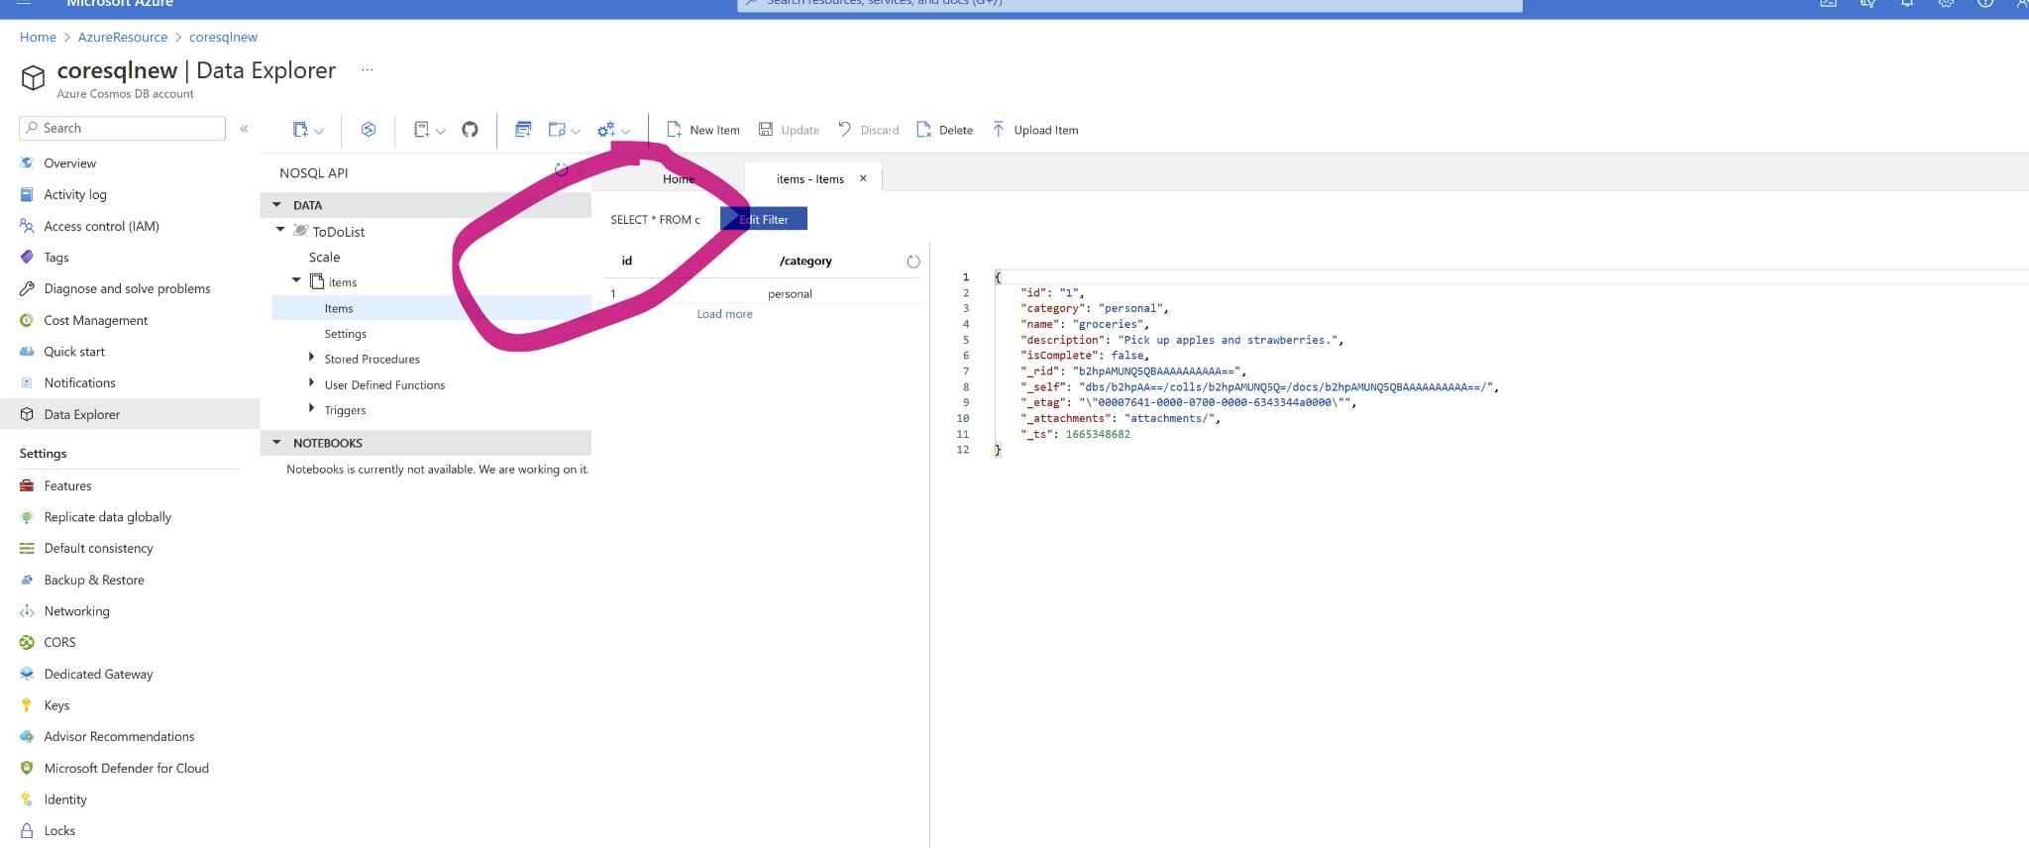
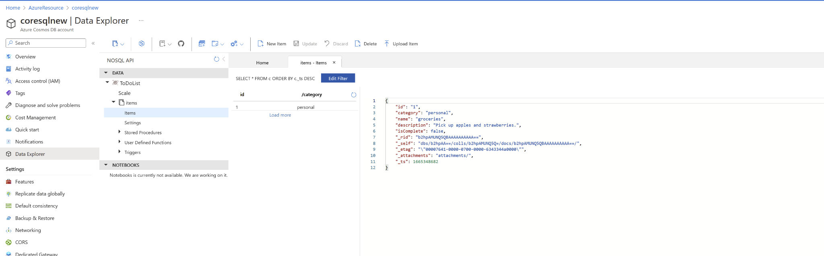
Clean up resources - Resource groups
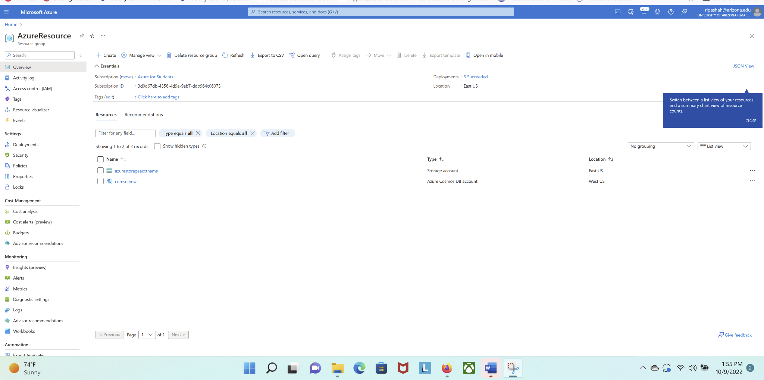
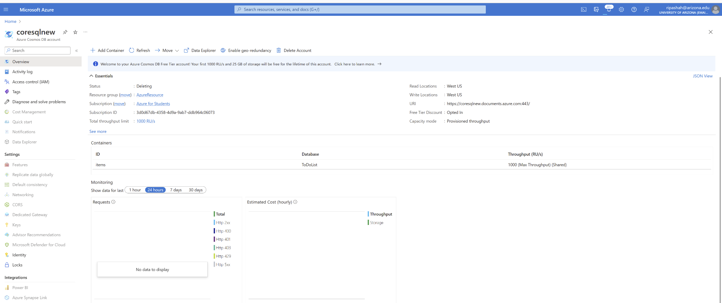
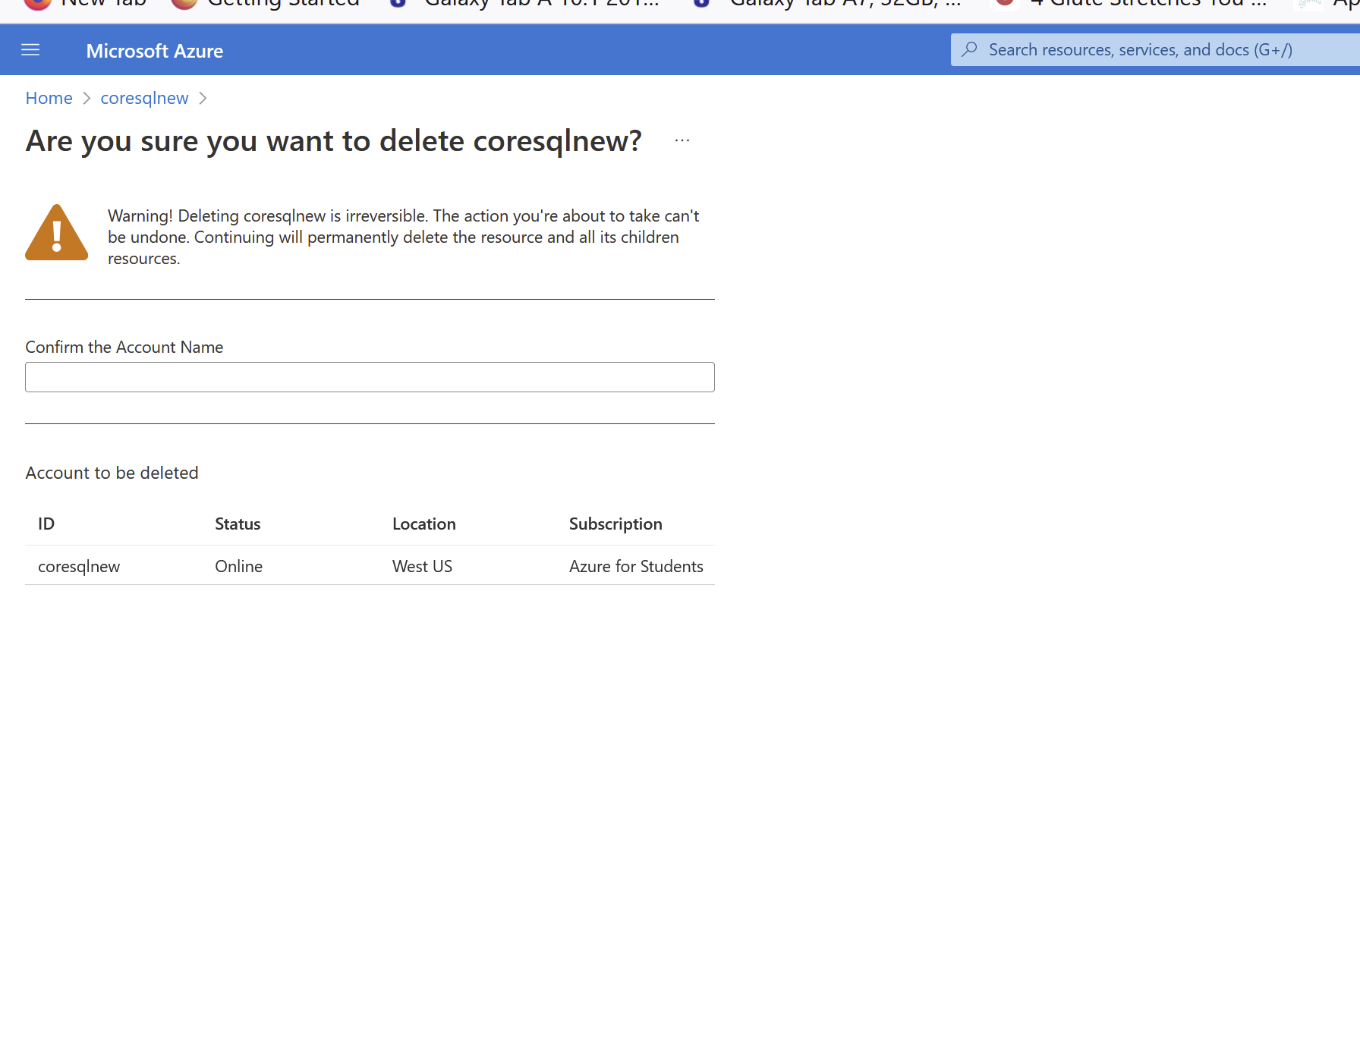

Part III: Create an Azure Database for MySQL server
Follow the instructions here and create an Azure Database for MySQL single server.
https://learn.microsoft.com/en-us/azure/mysql/single-server/quickstart-create-mysql-server-database-using-azure-portal

Assumption: You already have an account using your university email address. Go to the portal and login. Perform the steps as mentioned below (5 points each):

Create an Azure Database for MySQL single server
Configure a server-level firewall rule
Connect to the server by using mysql.exe
Clean up resources - Delete resource group.
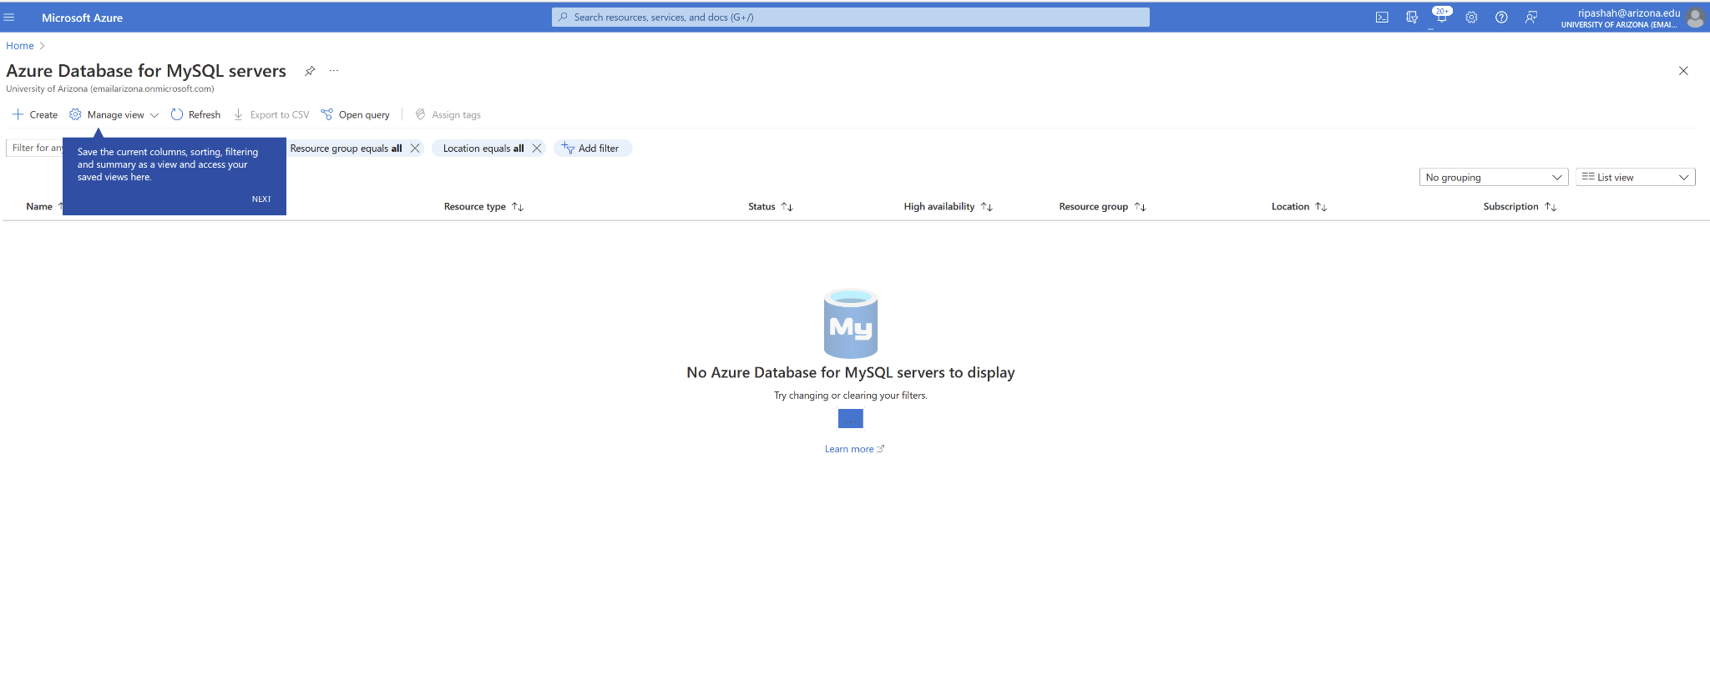
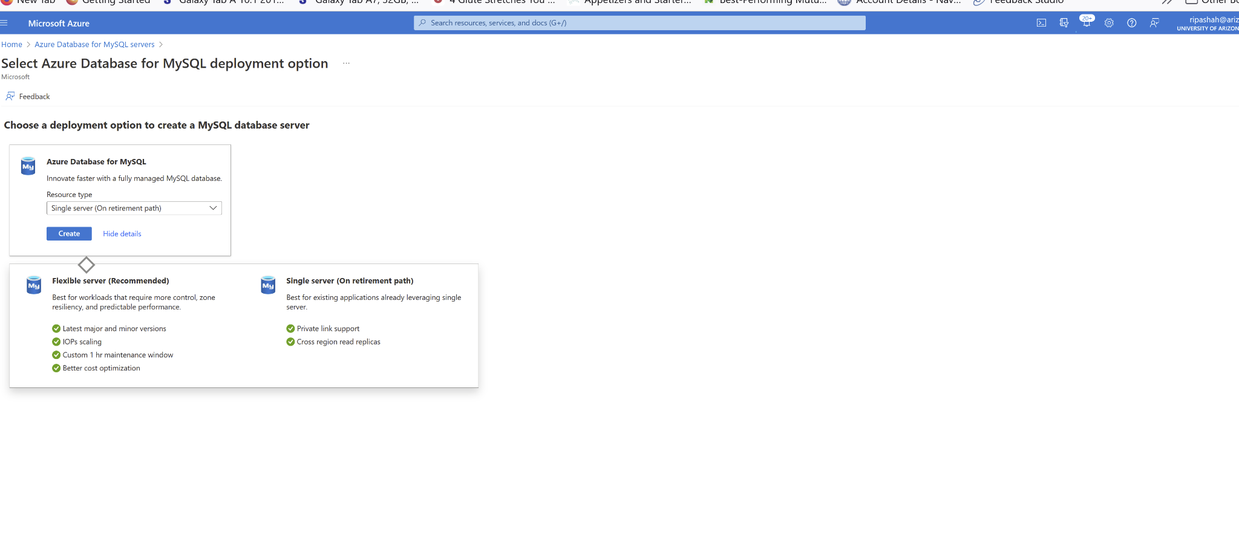
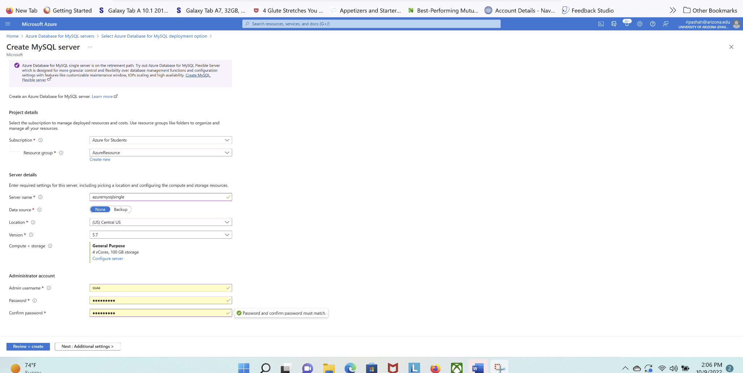

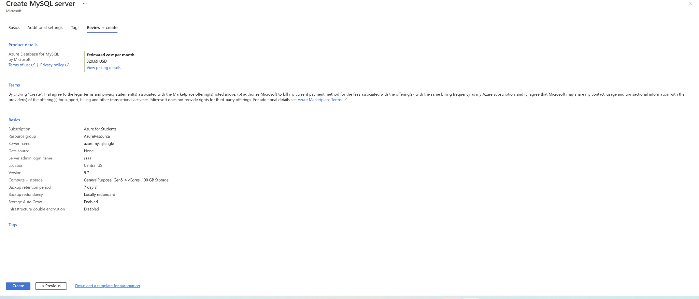

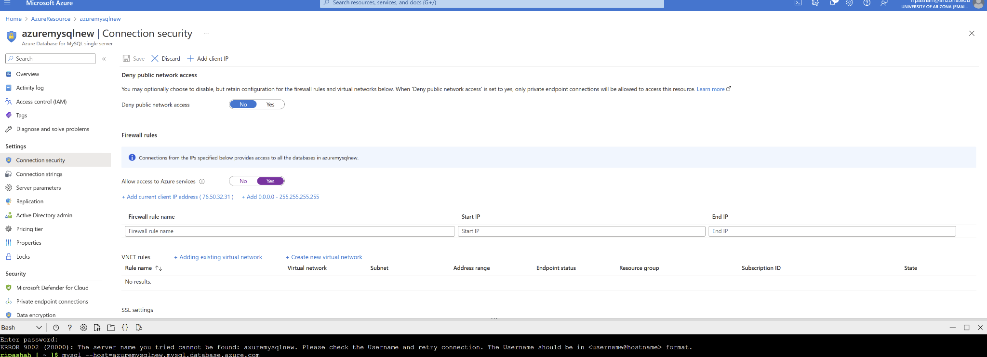

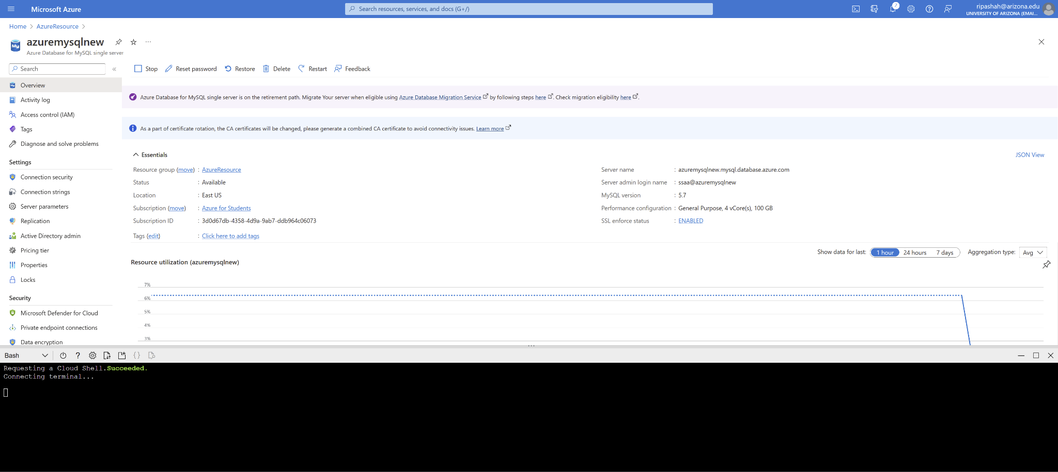

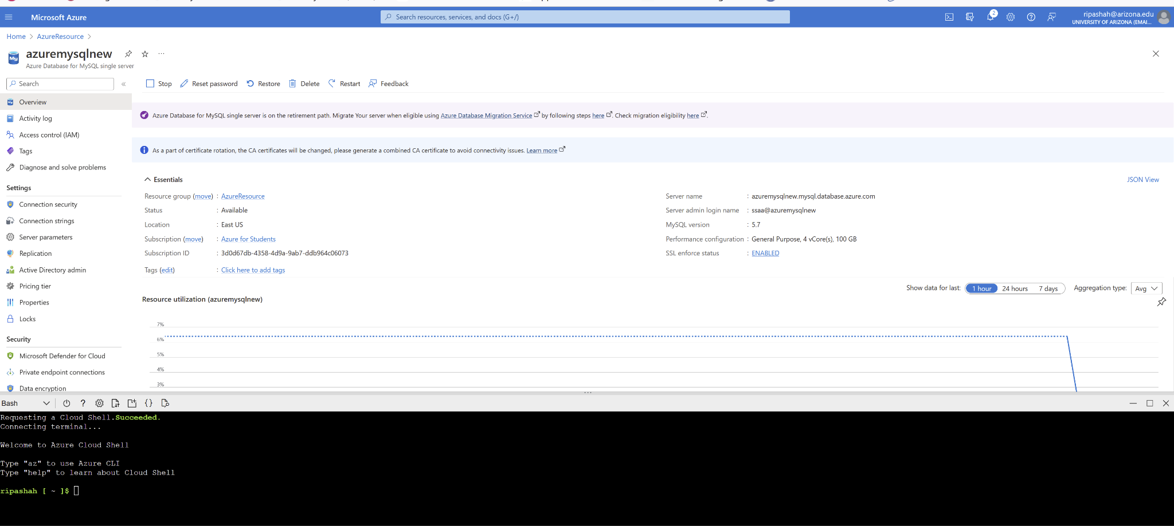

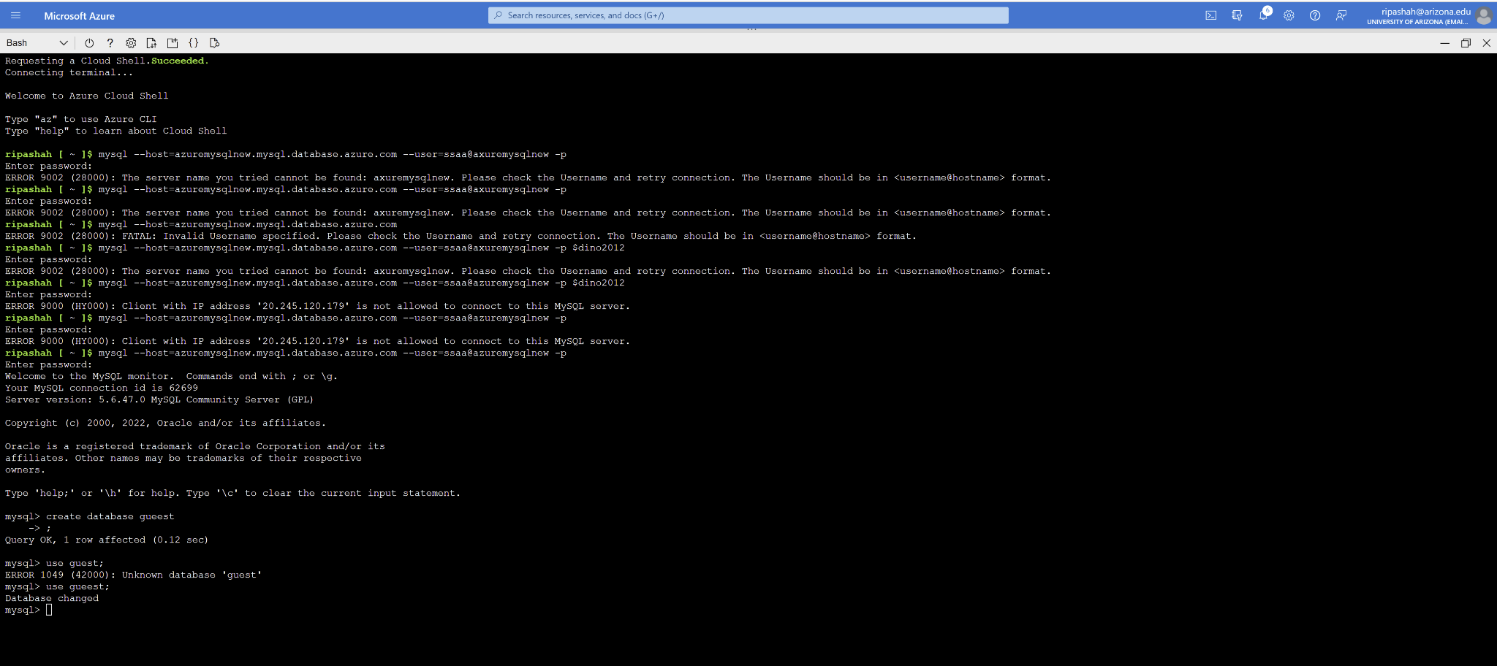
Part IV: Create an Azure Database for PostgreSQL server
Follow the instructions here and create a single Azure Database for PostgreSQL server and connect to it.

https://learn.microsoft.com/en-us/azure/postgresql/single-server/quickstart-create-server-database-portal

Assumption: You already have an account using your university email address. Go to the portal and login. Perform the steps as mentioned below (5 points each):

Create an Azure Database for PostgreSQL server
Configure a firewall rule
Connect to the server with psql
Clean up resources - Delete resource group

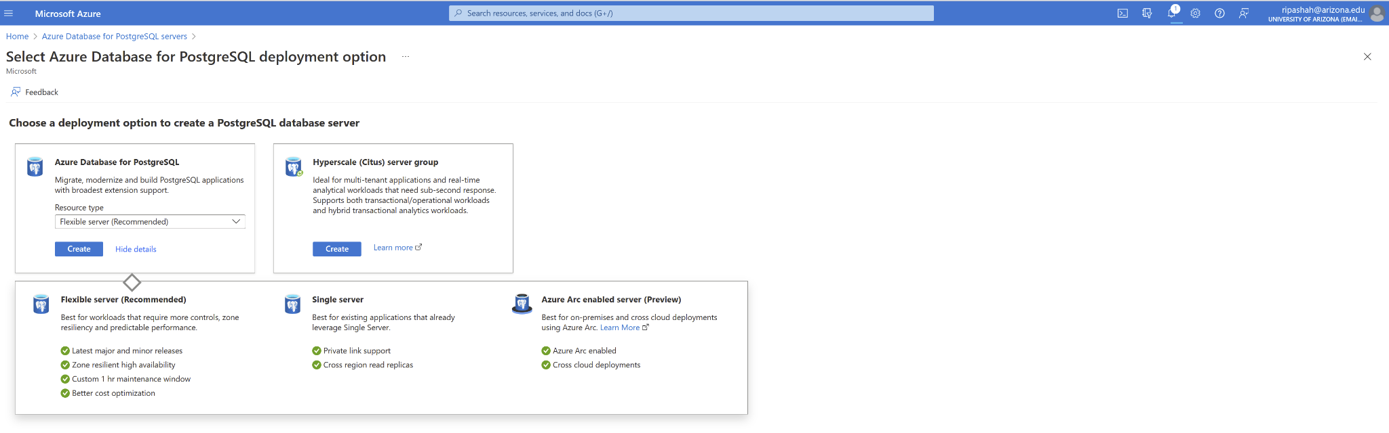

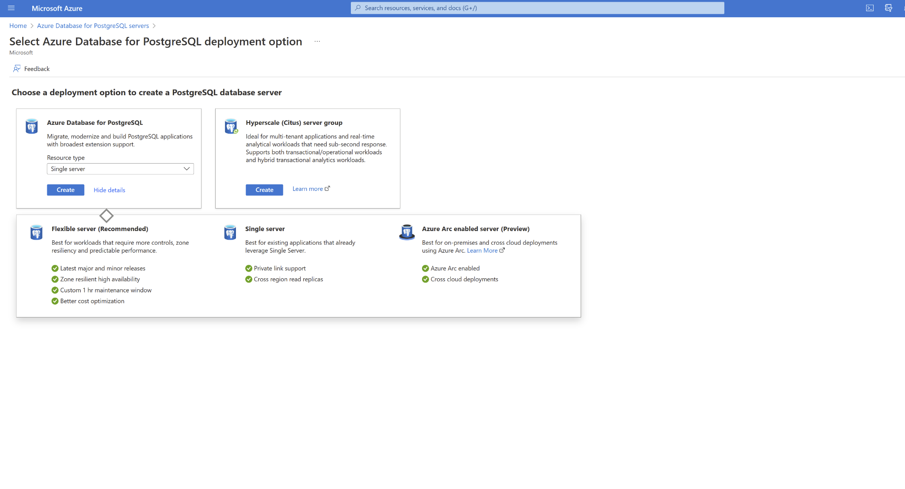
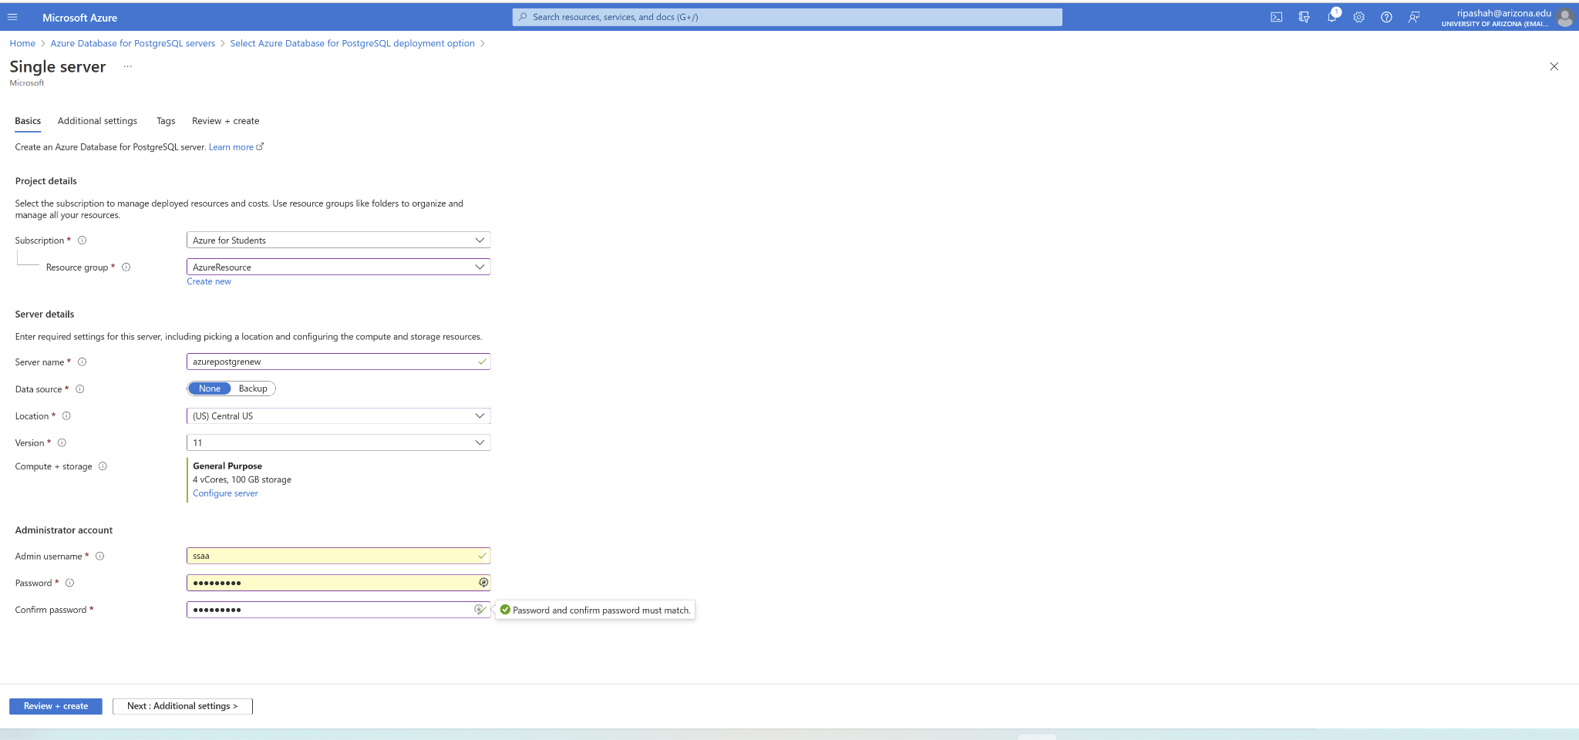
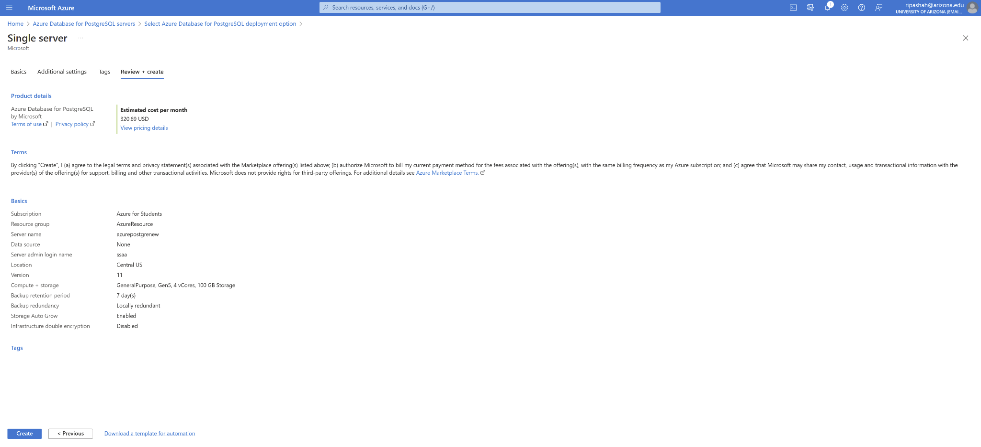

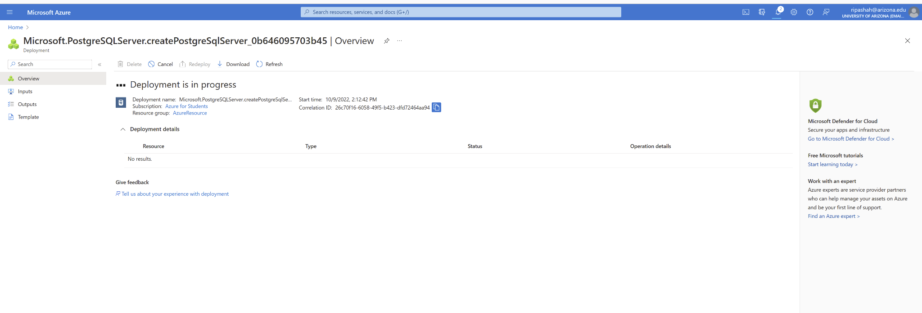
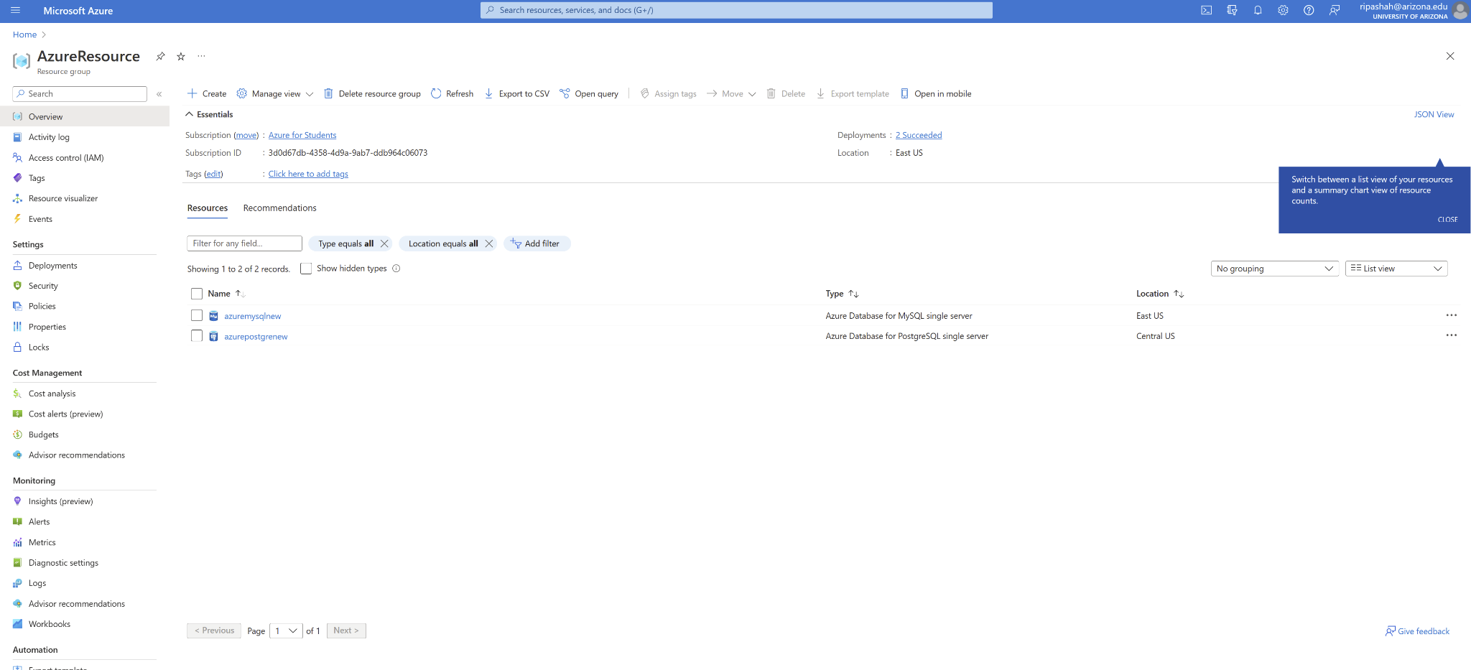

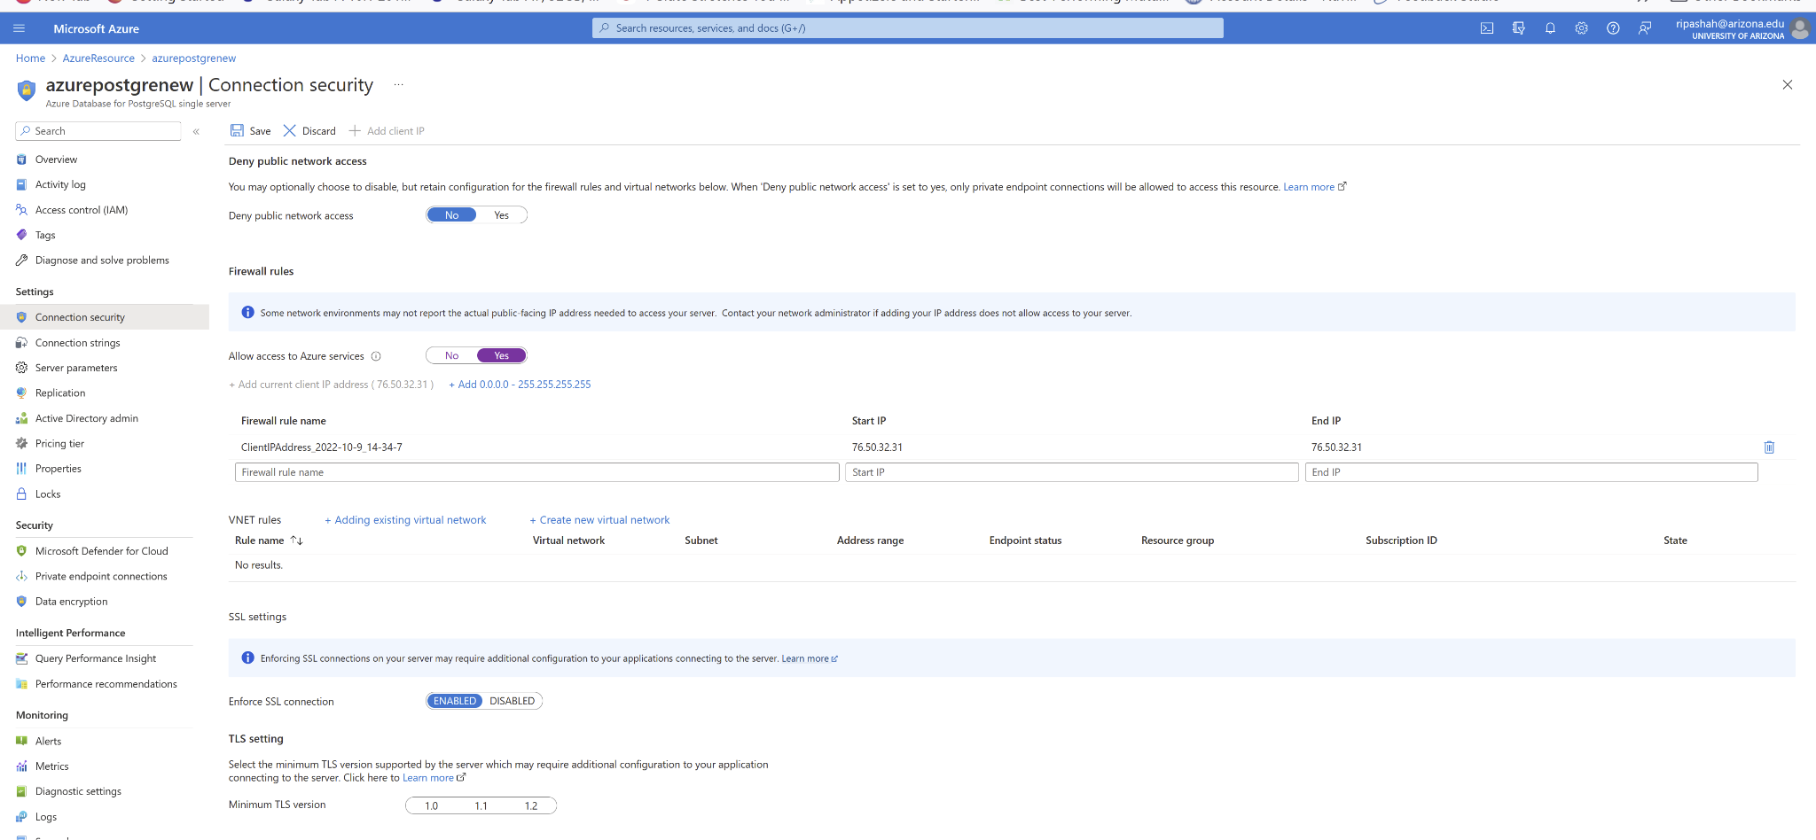

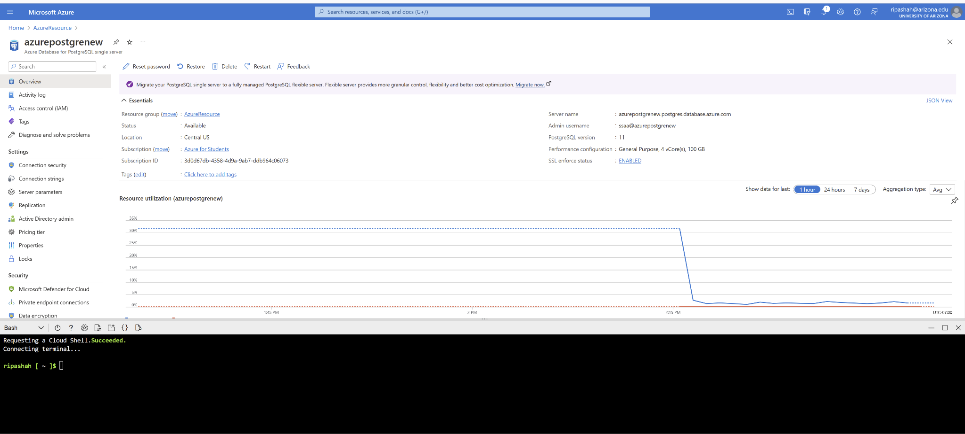

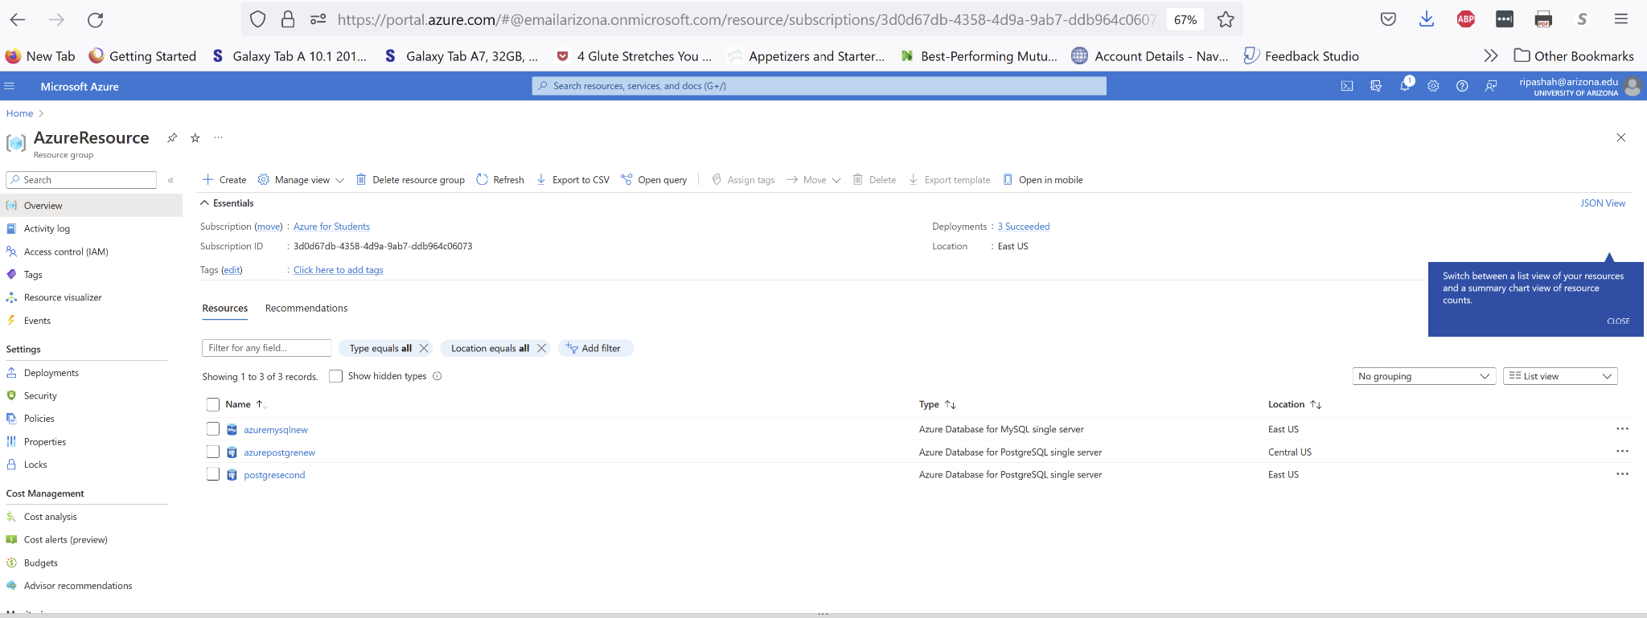

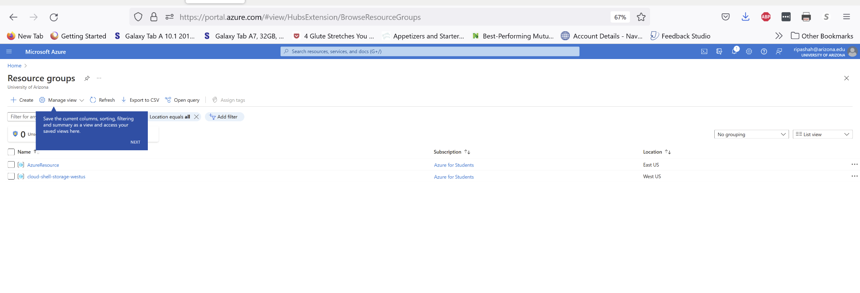
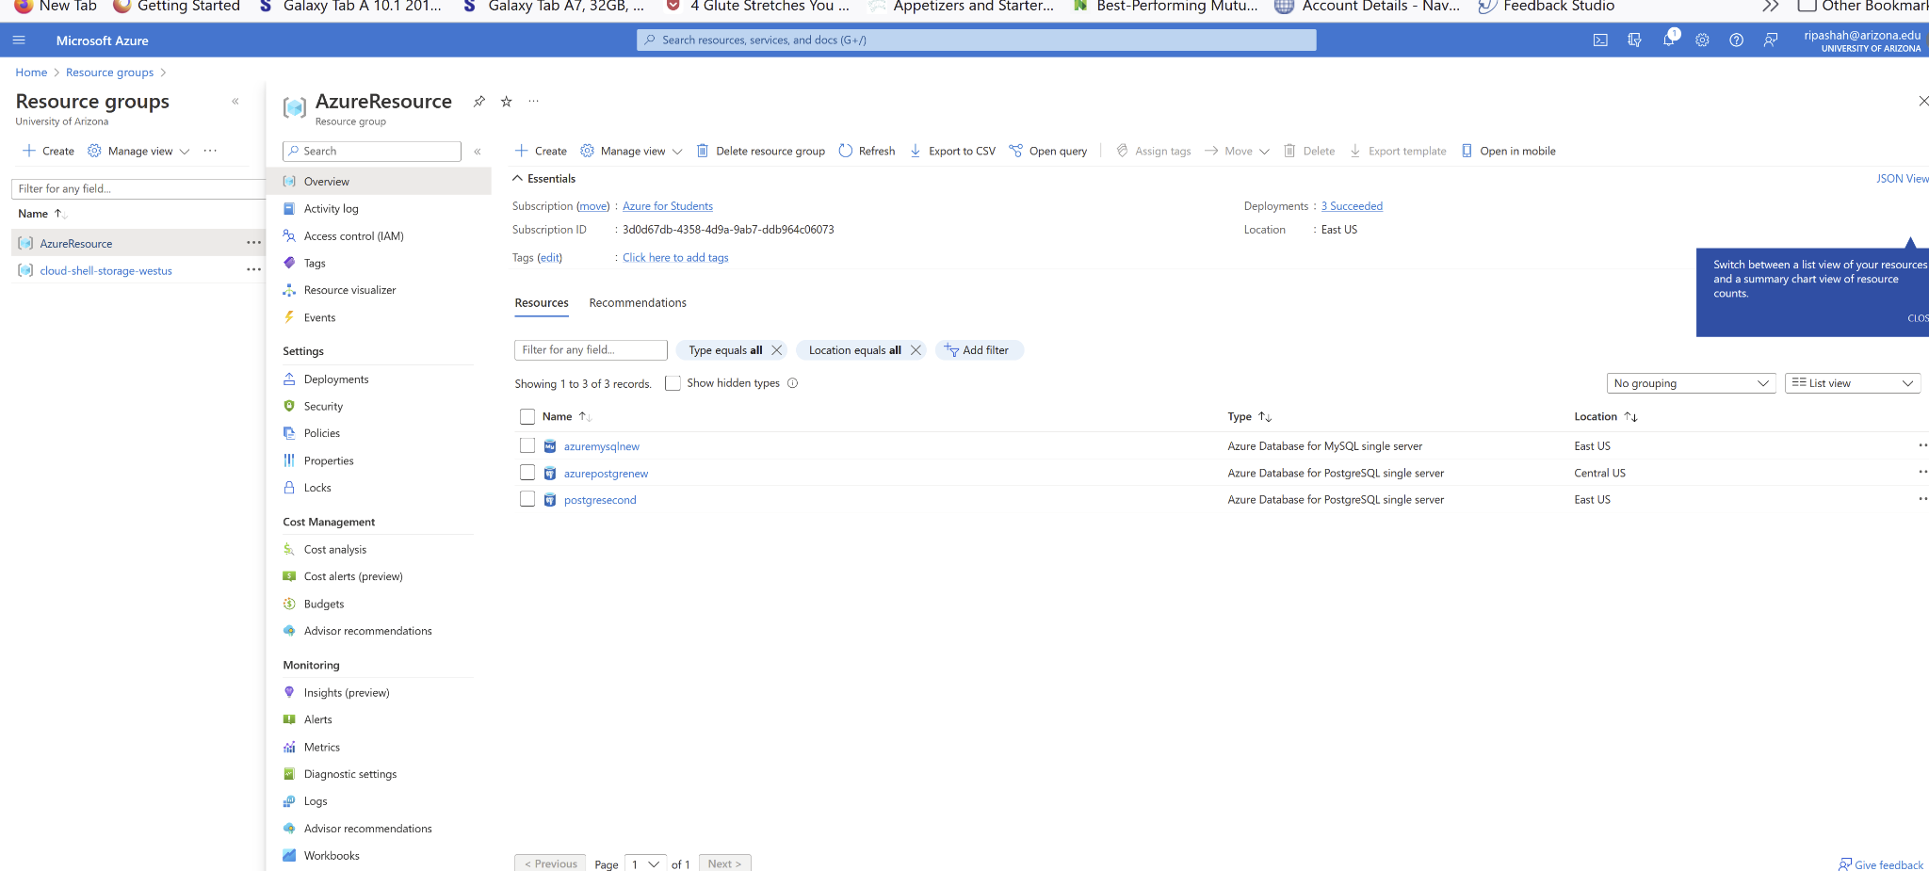

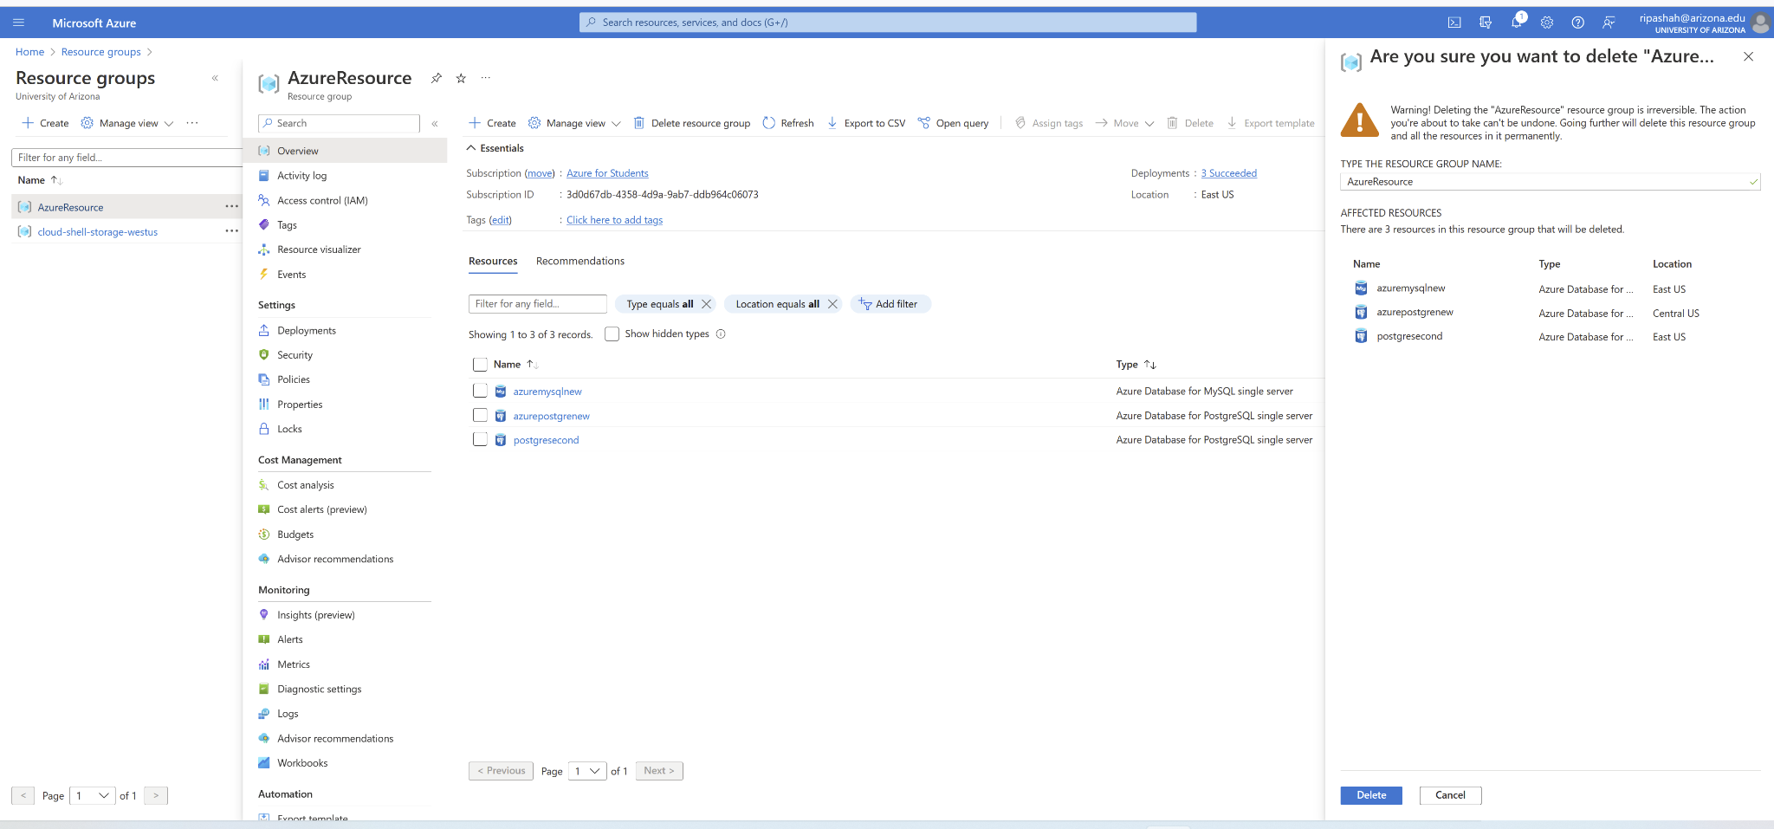

Upload your submission to the Week 7 Assignment Dropbox in D2L. The file name should be: Week7_Assignment_YourLastName.docx/pdf

