INFO 579 Week 7 Final Project Report
Course: INFO 579: SQL/NoSQL Databases for Data and Information Sciences
Module/Week: 7 - Week of August 18, 2025
Topic: Week 7 Final Project Report
NOTE: The assignment document must provide the following information. Up to 5 points may be deducted due to the lack of the below information.

Student’s Full Name: Ripa Shah
Course Title: INFO 579: SQL/NOSQL Databases for Data and Information Sciences
Term name and year: Example, Summer 2025
Submission Week: [example, Week 7 Final Project Report]
Instructor’s Name: N. Rahman
Date of Submission: 8/23/2025

The above information must be provided at the upper left corner of the first page of the document.

Each answer(s) must be preceded by the question/ title of the topic/article of the assignment.

Acceptable File: PDF.

File Name Format: Name your file according to this convention: INFO579_Final Project_Report_Lastname.pdf. Submission must be made in a single document.

NOTE: A 20% deduction of points will be applied for any late submission.

Week 7 Final Project Report: Total Points – 100

Goodwill Store Database

Abstract:

The Goodwill store doesn’t have a database system to manage the inventory, transaction and store information so I’ve gathered Goodwill store information by going into store physically. Also, I’ve gathered a little information from the online website. After that, I’m able to create a normalized data for Goodwill store. As a result, I’m able to store the information into Goodwill store database related to all day to day transactions, inventory, sales and sponsors etc.

Introduction:

The Goodwill store is near my home, so I visit it often. I also interact with them. After interacting with them, I figured it out that Goodwill store would like to organize its data by using a relational database. By this way, they can manage goods branch wise. As well as they can see how many items are sold from the store. Along with that, they can keep track of their partners and program services. In this report, I’ve gathered Goodwill store information and create a database and tables.

It is crucial to understand foundation before we implement the Goodwill Store project so let me walk you through some basic concepts which will be beneficial to read entire project report.

Relational Data model:

Relational models are a graphical representation of relational database where it depicts how it will be managed and stored into the relational database. There are three types of relational data models:

- Conceptual data model: It is a high level of business model where data are not normalized yet. It consists of entities and attributes. Entities are something about which we store the data. And attributes are characteristics of entities.

- Logical data model: A logical model provides detailed description of entities, attributes and constraints including foreign keys and primary keys. In this model, it demonstrates the graph in a normalization form.

- Physical data model: A Physical data model is similar to logical data model. In addition to logical model, it provides attributes data type, which is helpful while building a table in any relational database language including SQL, MySQL, PostgreSQL, and Oracle. It will convert entities into tables. Attributes into columns along with data types, and relationships into foreign keys/ constraints.

To follow physical data models, we must have a basic idea about the normalization concepts:

Normalization: Normalization is a design technique which eliminates data redundancy. It divides the larger tables into smaller tables and links them with relationships. The purpose of normalization is to eliminate redundancy from the table and maintain atomicity. I’m using following example to explain normalization concept. It’s a video library that maintains data without any normalization which movies have rented out.

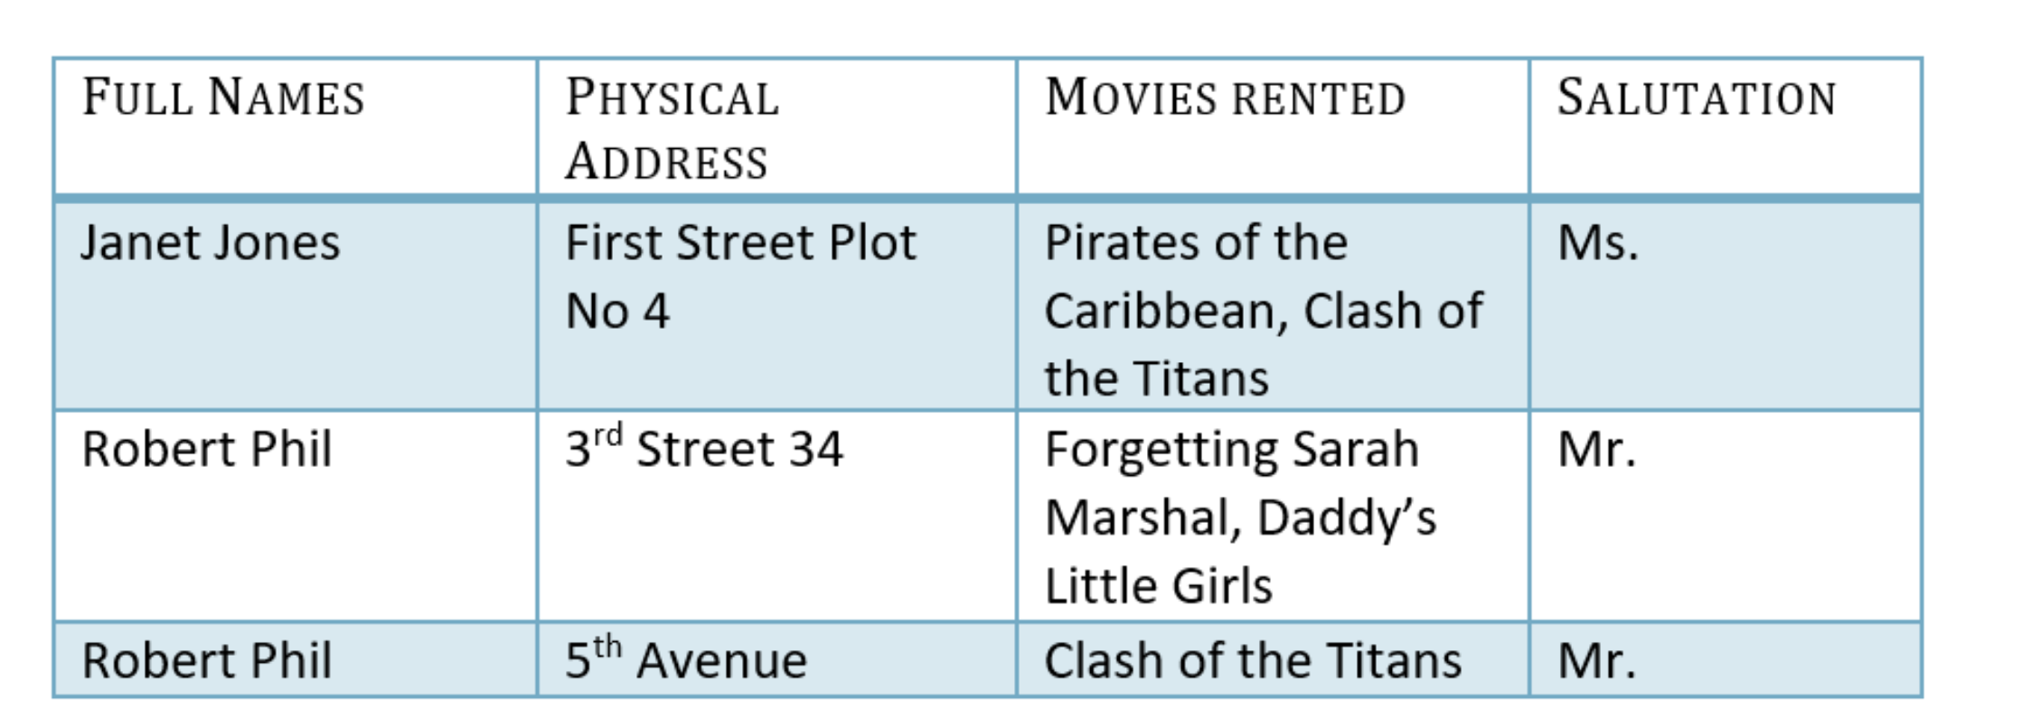

1NF: It ensures that database tables contain an atomic values and each record is unique.

Example:

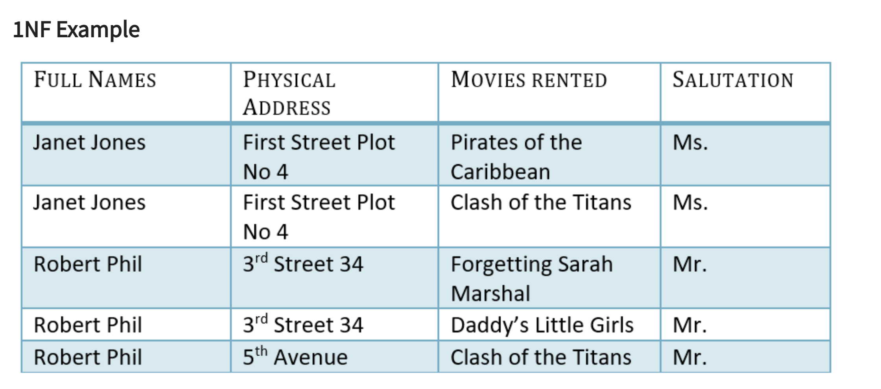
2NF: It must be in 1NF. There is no partial dependency.

Partial dependency means a single Column Primary Key that is not functionally dependent on any subset of candidate key relation.

Example:
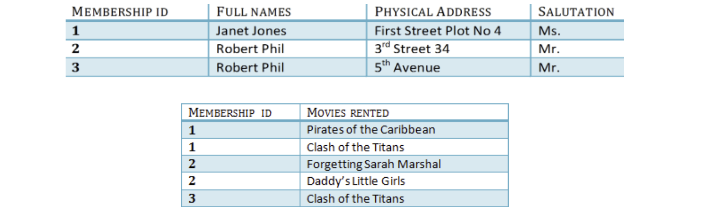

3NF: It must be in 2NF. There is no transitive dependency.

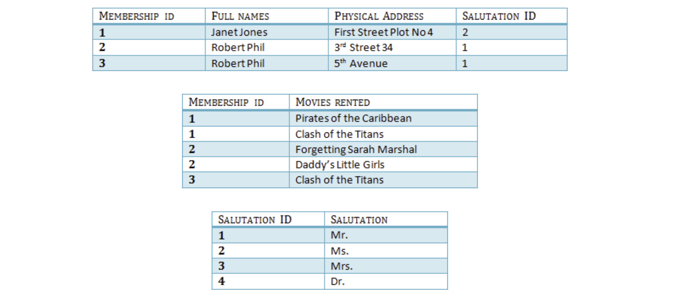

A transitive functional dependency means changing a one non key column may cause changing in another non-key column. Thus, we’ve created another salutation table to remove transitive dependency in above example.

Primary Key: A single column value used to identify a database record uniquely. Primary key cannot be null. It must be unique.
Foreign Key: It ensures that rows in one table have corresponding rows in another.
Composite Key: A primary key composed of multiple columns used to identify a record uniquely.

I’ve gathered Goodwill store data. By collecting that information, I’ve designed conceptual, logical and physical models. To implement this project, I’ve utilized Azure PostgreSQL Server functionality. In this report, I’ve implemented following activities for Goodwill store.

- Data model – (Physical, Logical and conceptual model)
- Implemented normalization concepts
- Applied constraints to Goodwill tables
- Insert the data into Goodwill tables.
- Create a variety of SQL queries to retrieve data from one or many tables

Related Work:

Hierarchical model: The hierarchical model stores data in a tree-like structure form. Windows registry is one of the best examples of hierarchical models. The hierarchical structure was developed by IBM in the 1960s and used in early mainframe DBMS. Records’ relationships form a tree-like model. It has a first node called a root node. It is a kind of parent-child relationship. The root node at the peak depicts the beginning, and branches facing downwards to child nodes, exemplifying the relationships and route of data access. Active directory, File system and geographic information system is an example of hierarchical model. Hierarchical models have a few limitations including data rigidity, data redundancy, complex implementation which will be cured by relational database management system due to its normalized structure.

Network Database Model:

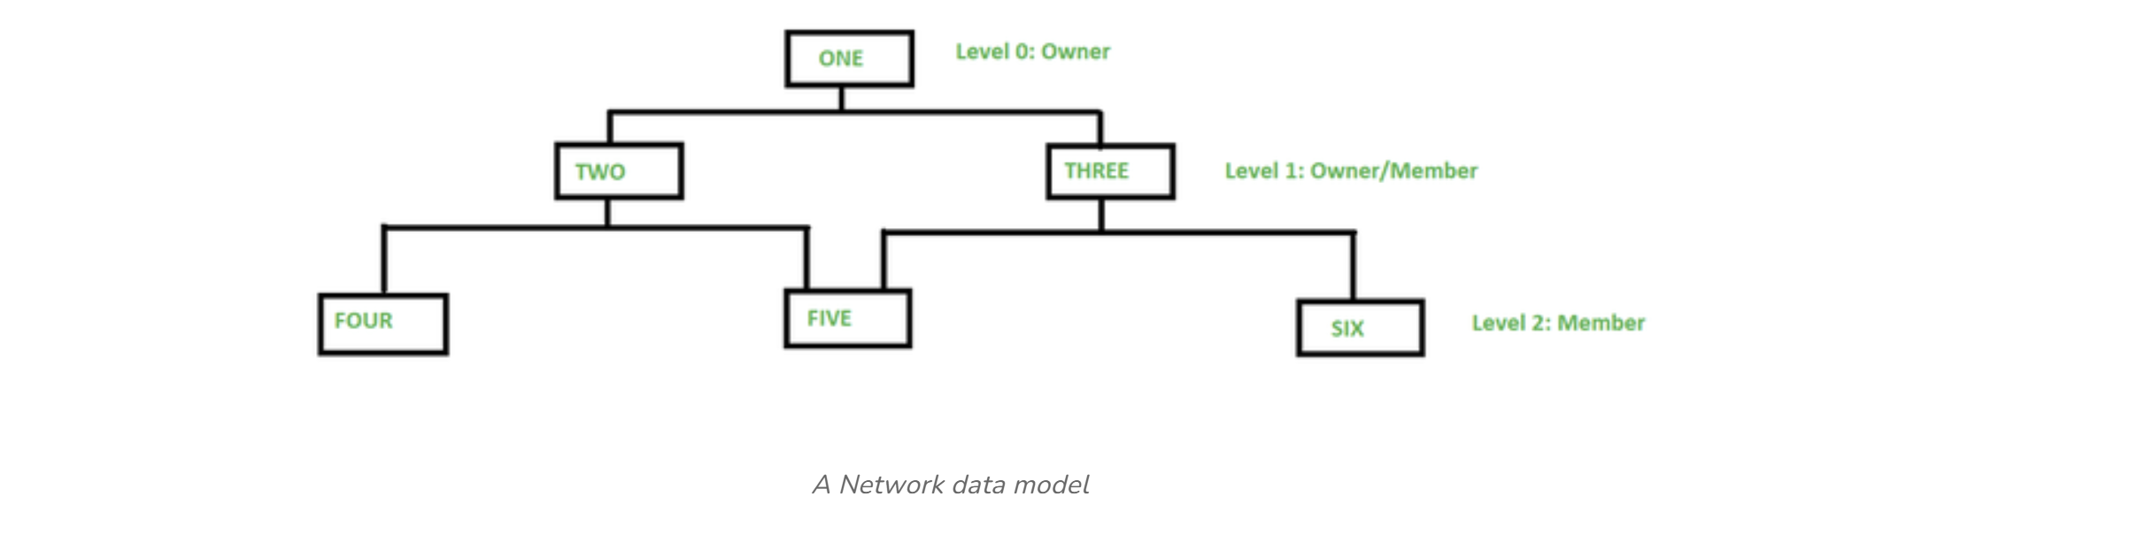
In the 1960s, the Database Task group established this paradigm. The hierarchical model is generalized in this model. There is a logical connection between the segments that belong to each level, even if this model may have several parent segments that are grouped as levels. Most of the time, any two segments have a reasonable many-to-many relationship. The logical relationships between the segments are referred to as graphs. Consequently, this model substitutes a graph-like structure for the hierarchical tree, allowing for more general linkages between various nodes. A record can have more than one parent section thanks to M: N relations, or many-to-many.

Week 2 Final Project Update 1: Total Points - 25

Week 2 Final Project Update 1:

1. Come up with a business plan for which you need to collect and store data

2. Come up with the data about your business. Example: like the one I gave you for the assignment.

Requirements: As part of the Final Project Update 1, submit a single-spaced one-page report:

1. A brief description of your project
A goodwill store would like to organize its data by using a relational database. By this way, they can manage goods branchwise. As well as, they can see how many items are sold from the store. Along with that, they can keep a track of their partners and program services. Here I’m providing data to implement a detailed relational management system.
2. Data you will use and source of that data:
Source:https://www.goodwill.org/

- Goodwill branch / store location

Goodwill is a franchise. It has a branches all over to the USA.
GoodWill  BranchId | Location | City | Zipcode | State
GW1 | 5526 Renner Rd | Columbus | 43228 | OH
GW2 | 2550 North High St | Columbus | 43202 | OH
GW3 | 608 Main St, | Hilliard | 43026 | OH

- Goodwill Employee Information:

Employee information who works for Goodwill
EmployeeI d | FirstName | LastName | Position | BranchId | HireDate | Phone
Emp1 | John | Johnson | Manager | GW2 | 03/02/2021 456-456-6 | 788
Emp2 | Joshua | Soboti | Cashier | GW1 | 04/02/2024 345-345-6 | 789
Emp3 | Ashlee | Nimmo | Cashier | GW3 | 05/06/2025 908-890-7 | 890

(3) Goodwill Donor information:
Individuals or organizations providing goods to Goodwill
DonorId | Donar Name | Item Received | Date
Donor01 | John | Clothes | 03/02/2023
Donor02 | Kelly Mcclure | furniture | 04/05/2021
Donor03 | Jessica Mendez | miscellaneous | 05/03/2020
Donor04 | Amber Hammer | clothes | 06/02/2024

(4) Warehouse:
Where donations are sorted, cleaned, repaired and priced.
DatawarehouseID | Location | Capacity | ProcessingStaffcount
DW01 | Columbus | 1000 | 40
DW02 | Michigan | 1000 | 50

- Goodwill Donation information

The goods contributed by donor.
DonationId | Item Received | Date Received | Quantity | Condition | BranchId
Donation01 | Clothes | 03/04/2023 | 10 | Good | GD01
Donation02 | Furniture | 02/03/2023 | 5 | Fair | GD01
`

(6) Item:
Individual salable goods after processing.
ItemId | Category | Subcatego | Price | Status | DatePriced | BranchId

 |  | ry
It01 | Clothing | Men’s  apparel | 10 | In Stock,  Sold,  Recycled | 01/03/2025 | GD01

- Customer:

Individual who purchases items from goodwill store.

CustomerId | PurchaseHistory | Item purchased | Transaction details
Cust01 | 01/03/2024 | it01 | 30
Cust02 | 02/04/2025 | it02 | 40

- Transaction:

Records of sales made at the stores

TrasactionId | Date Of Sale | Total Amount | Payment  Method | CustomerId | BranchId
Tr01 | 04/03/2025 | 400 | Visa Credit | Cust01 | GW1
Tr02 | 05/02/2024 | 450 | Master Credit | Cust02 | GW2

- Program / Service (Community Impact):

The social programs and services funded by Goodwill's retail operations (e.g., job training, career services).
ProgramId | Program Name | Description | Target  Beneficiaries | Funding Source
Pr01 | Job training |  | Job seekers | Sp01
Pr02 | Career Services |  | Job seekers | SP02

- Sponsor:

provide financial support. Donate goods or services. Raise awareness. Collaborate on training programs. Support community events.

SponsorId | Sponsor Name | Sponsor Type
Sp01 | amazon | Targeted Sponsors
Sp02 | comcast | Enterprise Solution Partners

(11) Item subCategory

Subcategory | Category | Item details
sub01 | Men’s apparel | Clothes, jackets, pants
sub02 | Women’s apparel | Clothes, blouses, jackets, pants
sub03 | Furniture | Couches, chairs, dining tables, tables

3. Upload the data file (like the one I gave you to do the assignments).

I have uploaded an excel document.

Week 4 Final Project Update 2: Total Points - 25
3. Develop a Conceptual Model. Consider 4 or 5 entities. Make sure you have at least one many-to-many relationship. Explain with data why it's a many-to-many relationship.
Start by capturing the main objects of interest:
- Donor – Individuals donating items
- Donation – Details about each donation
- Item – Individual items donated
- Store Location – Where items are sold
- Warehouse - where donation are sorted, cleaned, priced and repaired.
- Transaction - Records of sales made at the store.
- Customer – Buyers of items
- Employee – Staff who manage operations
- Category – Item classification (e.g. clothing, furniture)
- Program/ Service - The social programs and services funded by goodwill’s retail operations.
- Sponsor- sponsors who donates in support of running programs and services.
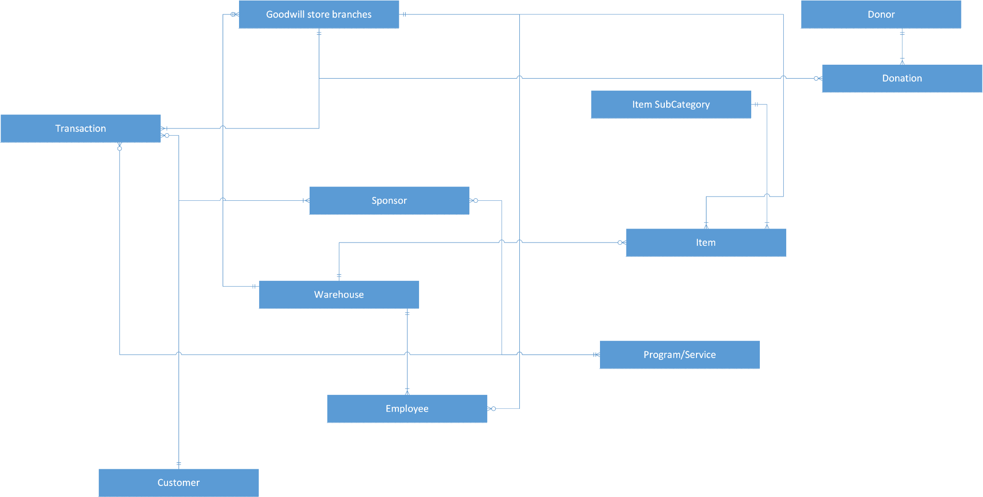

4. Develop a Logical Model using the Conceptual Model. Make sure you come up with a junction entity to resolve the many-to-many relationship.
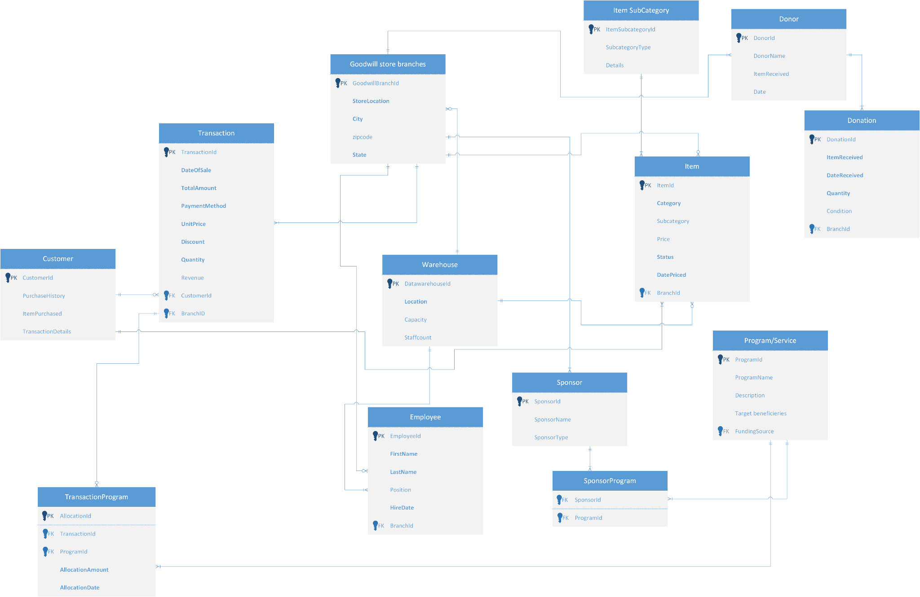

5. Develop the physical model based on the Logical Model

Once I’m able to create PostgresSQL in azure. I’ll install editor to work with PostgresSQL using PostgreSQL: Downloads

Now I’ve install PostgresSQL-PGAdmin4 on my machine. Also, I’m able to connect Azure Postgres with PGAdmin4.

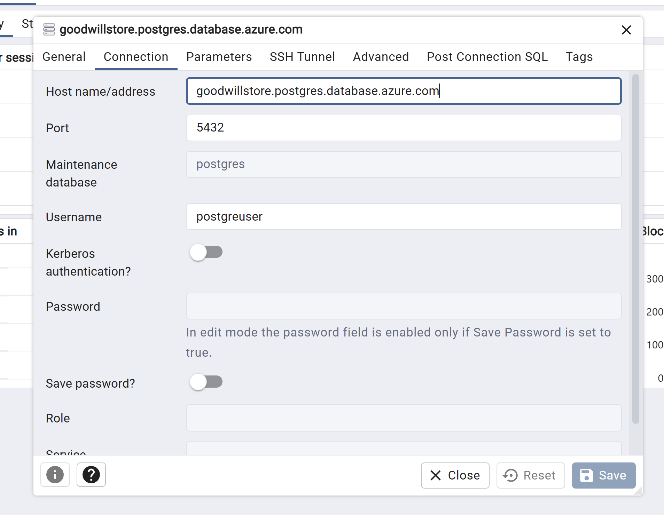

I can also populate the databases which I’ve created in azure.

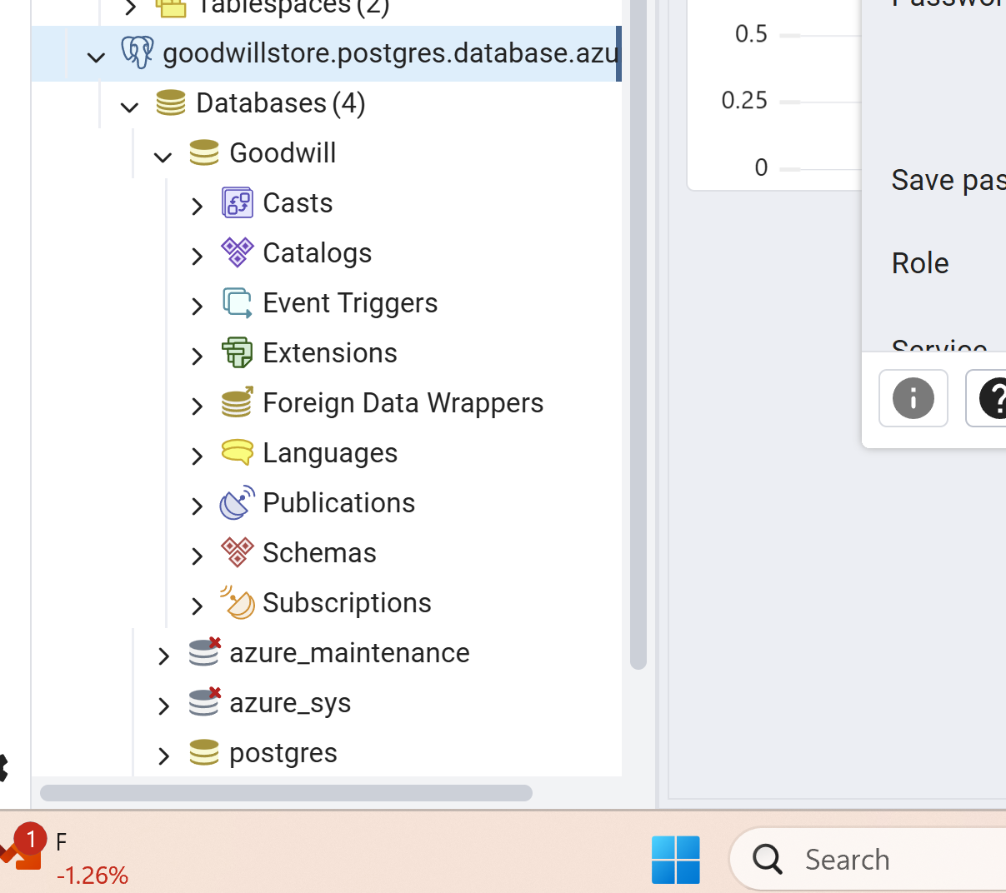

Now, let me focus on creating tables that I’ve utilized in my physical data model. By this way, I’m able to implement database normalization concepts. Along with that, I’m able to perform DML (Data manipulation Language), DQL (Data Query Language) and DDL (Data definition Language).

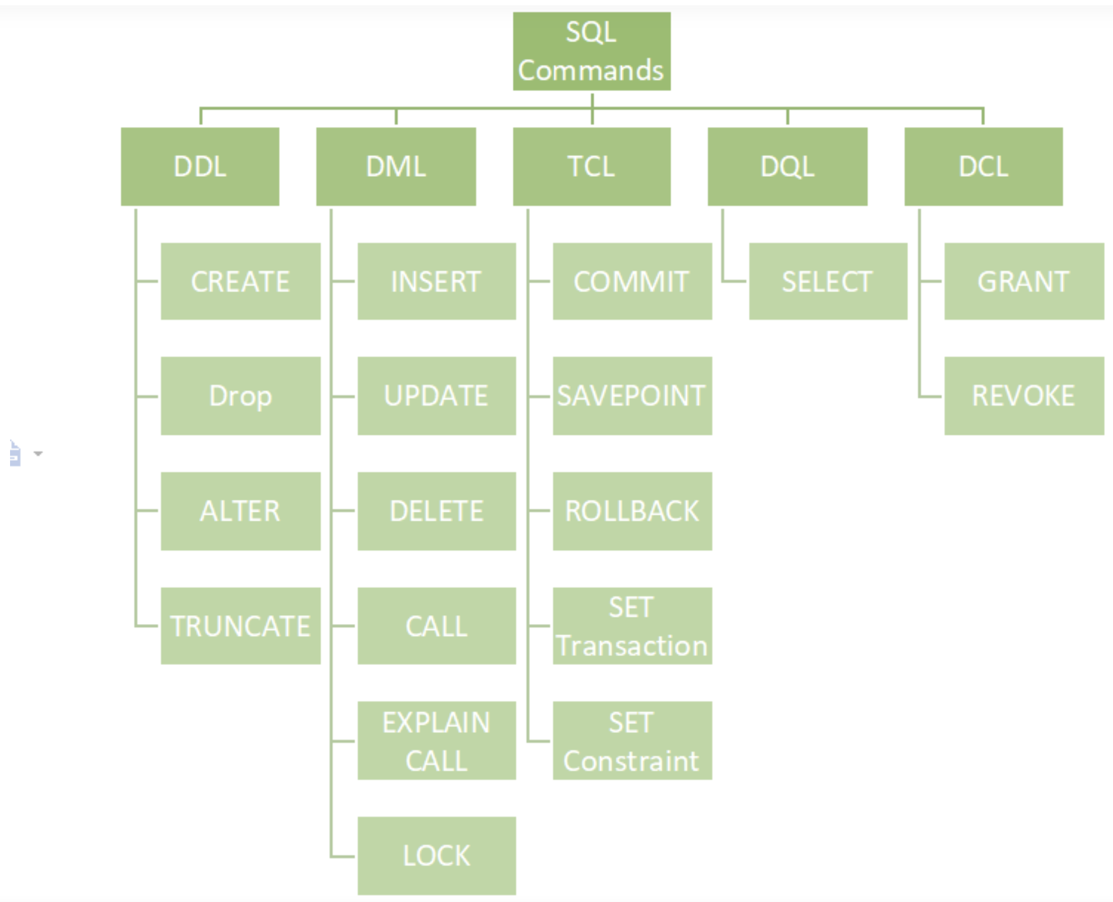

So let’s start with a DDL. There are two options we can create tables. (1) GUI (2) Script

Here, I’ve taken a screenshot of GUI. I believe it’s more cumbersome than script option so let me choose script instead of choosing GUI since you just need to go step by step and it’s more time consuming than script.

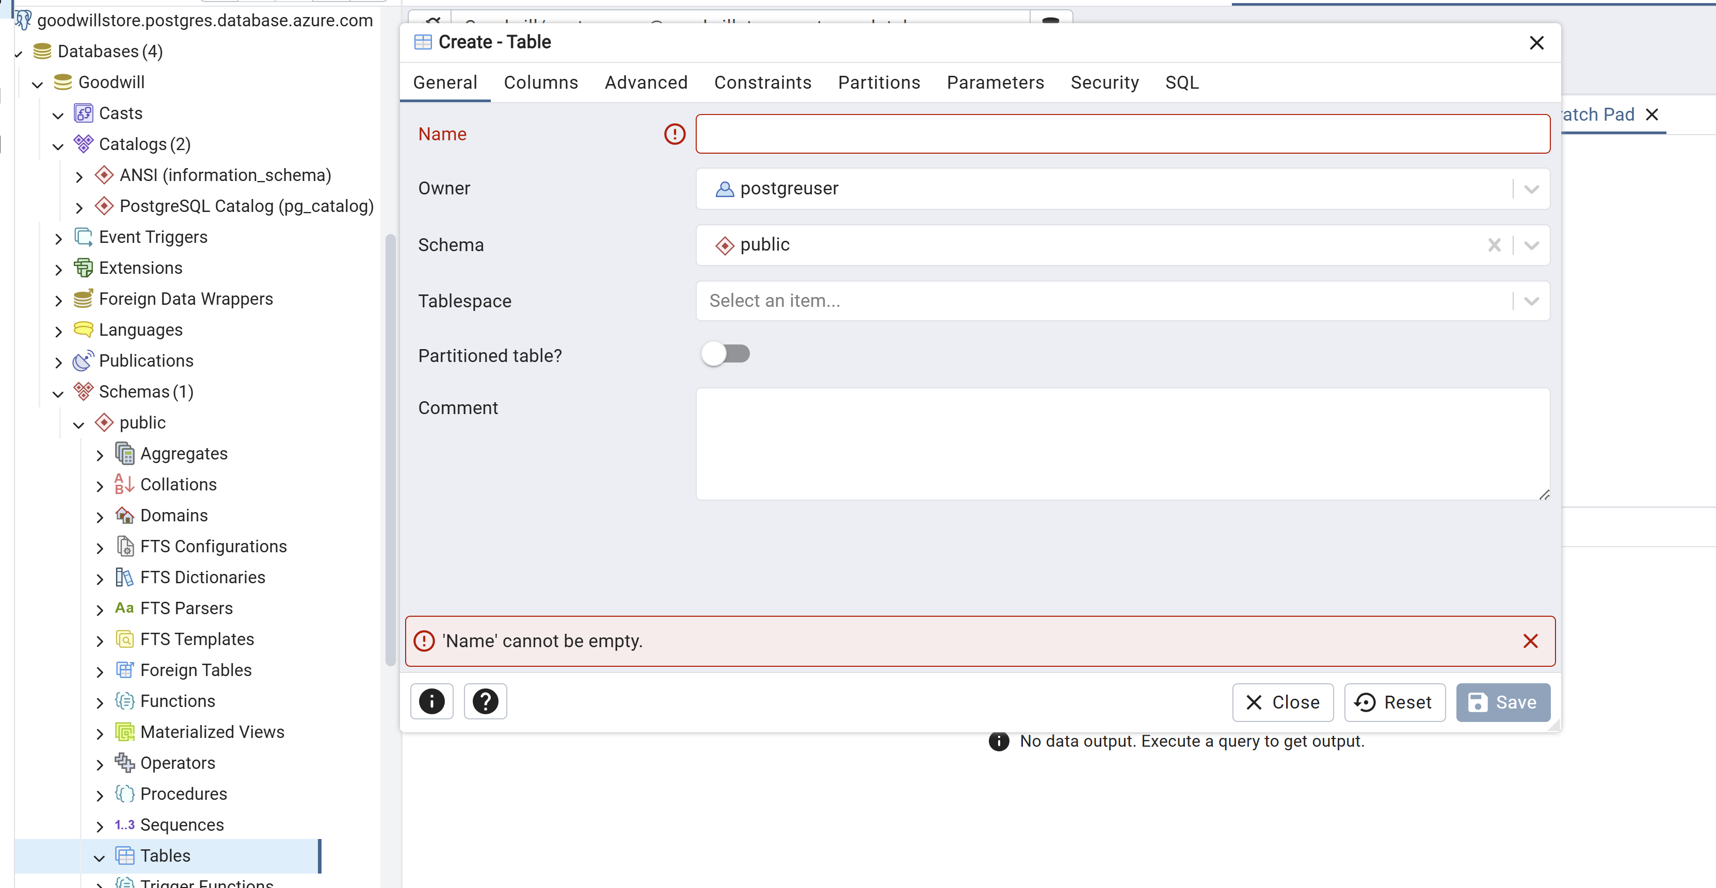

Here is my create table option. We’ll utilize this option throughout creating a table from physical data model.

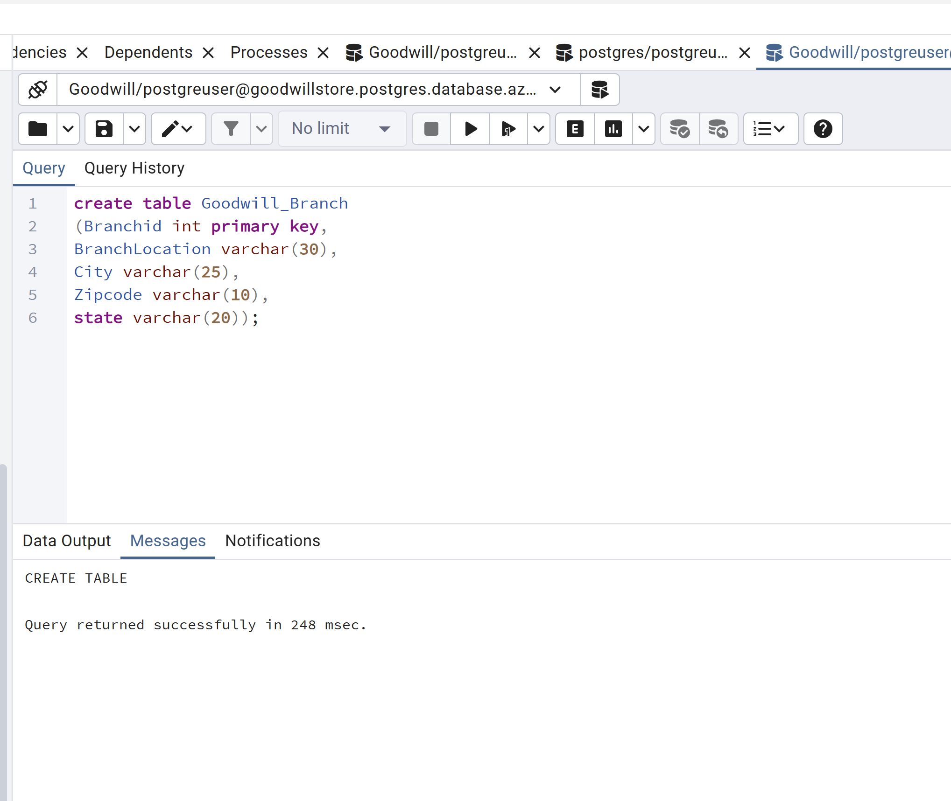

6. Create tables using a database system. Insert data into the database tables. You must provide the DDL (CREATE TABLE statements), INSERT statements, and SELECT statements.

Details: Create the tables that you have come up with (the table must be based on the Physical Model).
(a) Columns, Primary Key (PK), Data Type, and length, and NULL/NOT NULL need to be implemented, per the Physical Model.
(b) Show the table definition (DDL) that you implemented (not in a graphical view).
(c) Insert the complete set of data that you have come up with and show the insert statements used.



Now I’m following this option in entire table creation and insertion so I’ll just attach a code.

Now, I’m following select statement to fetch records from different tables.
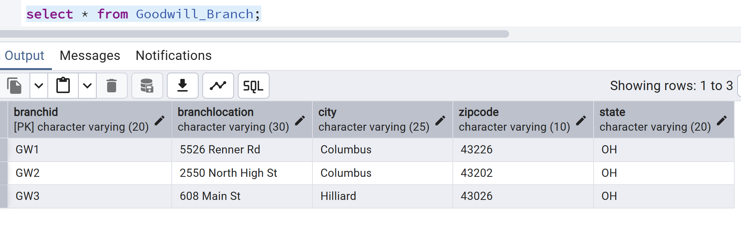
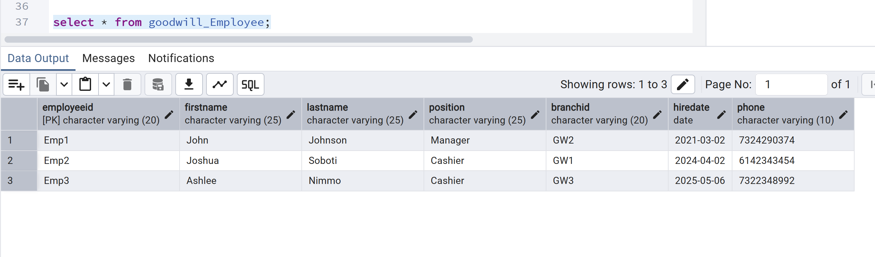
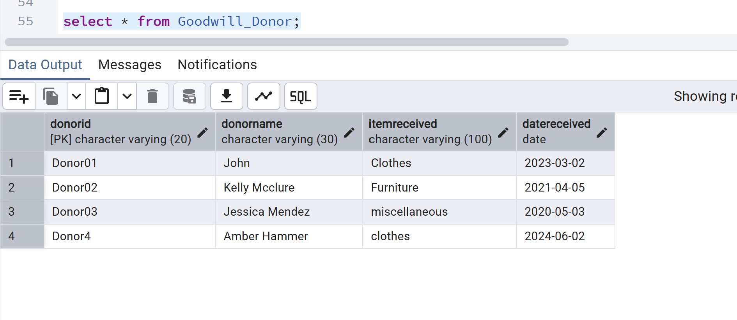
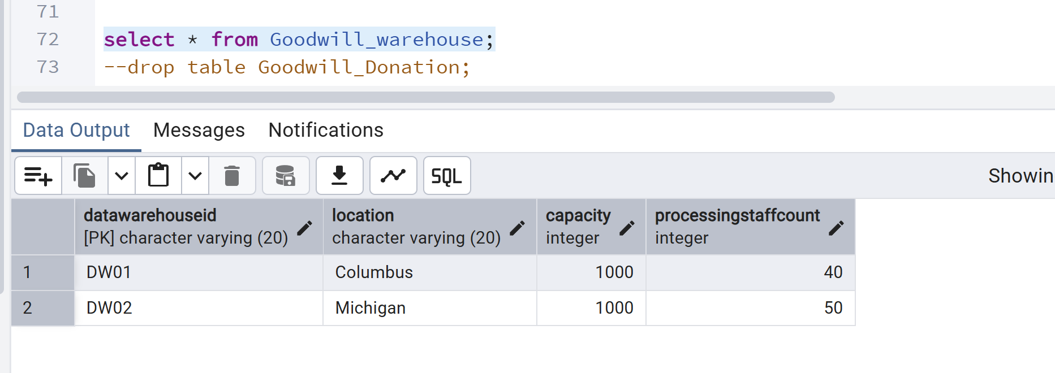
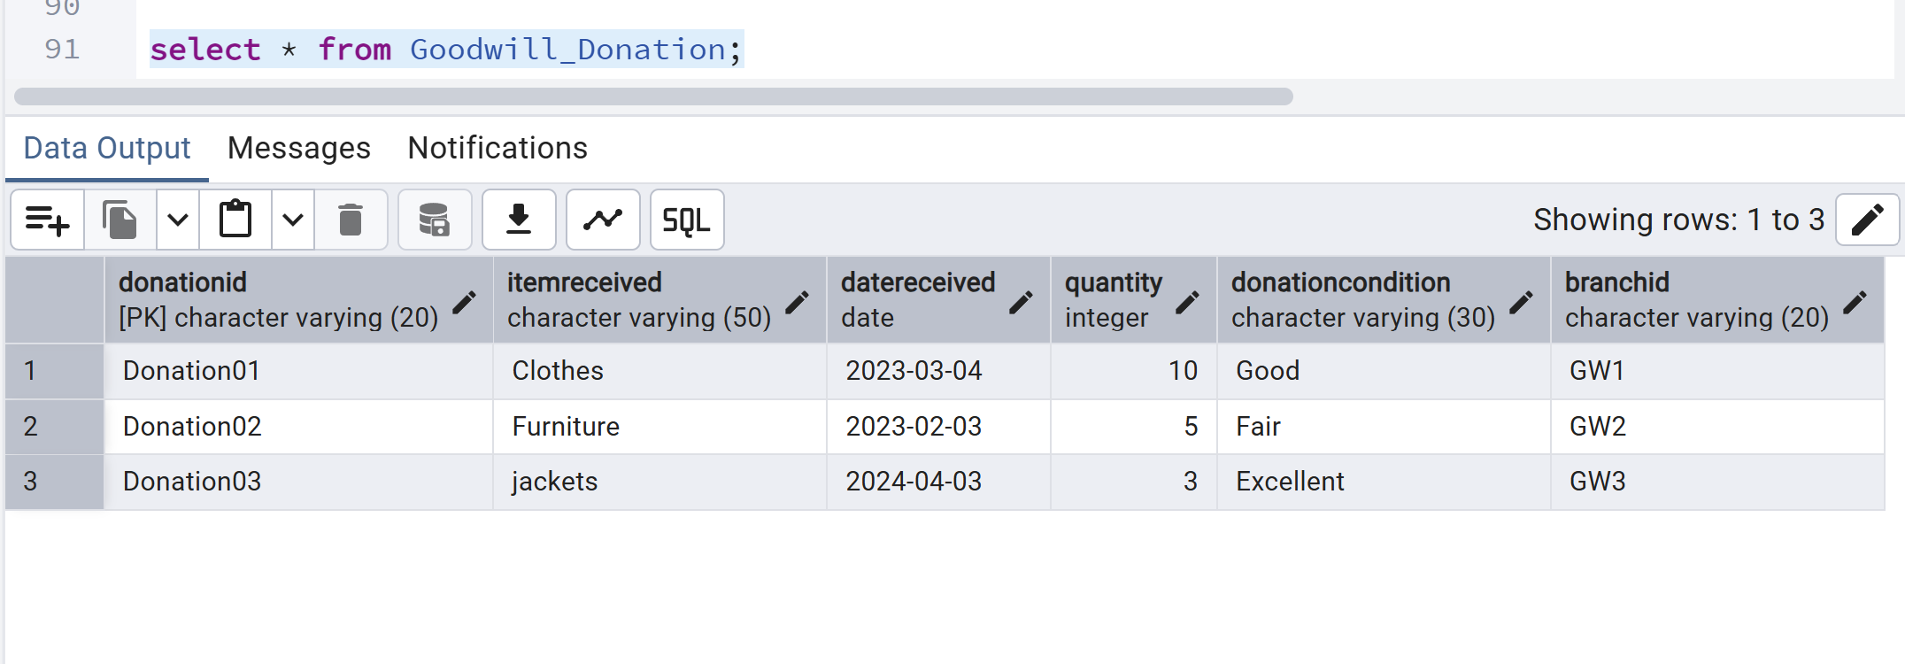
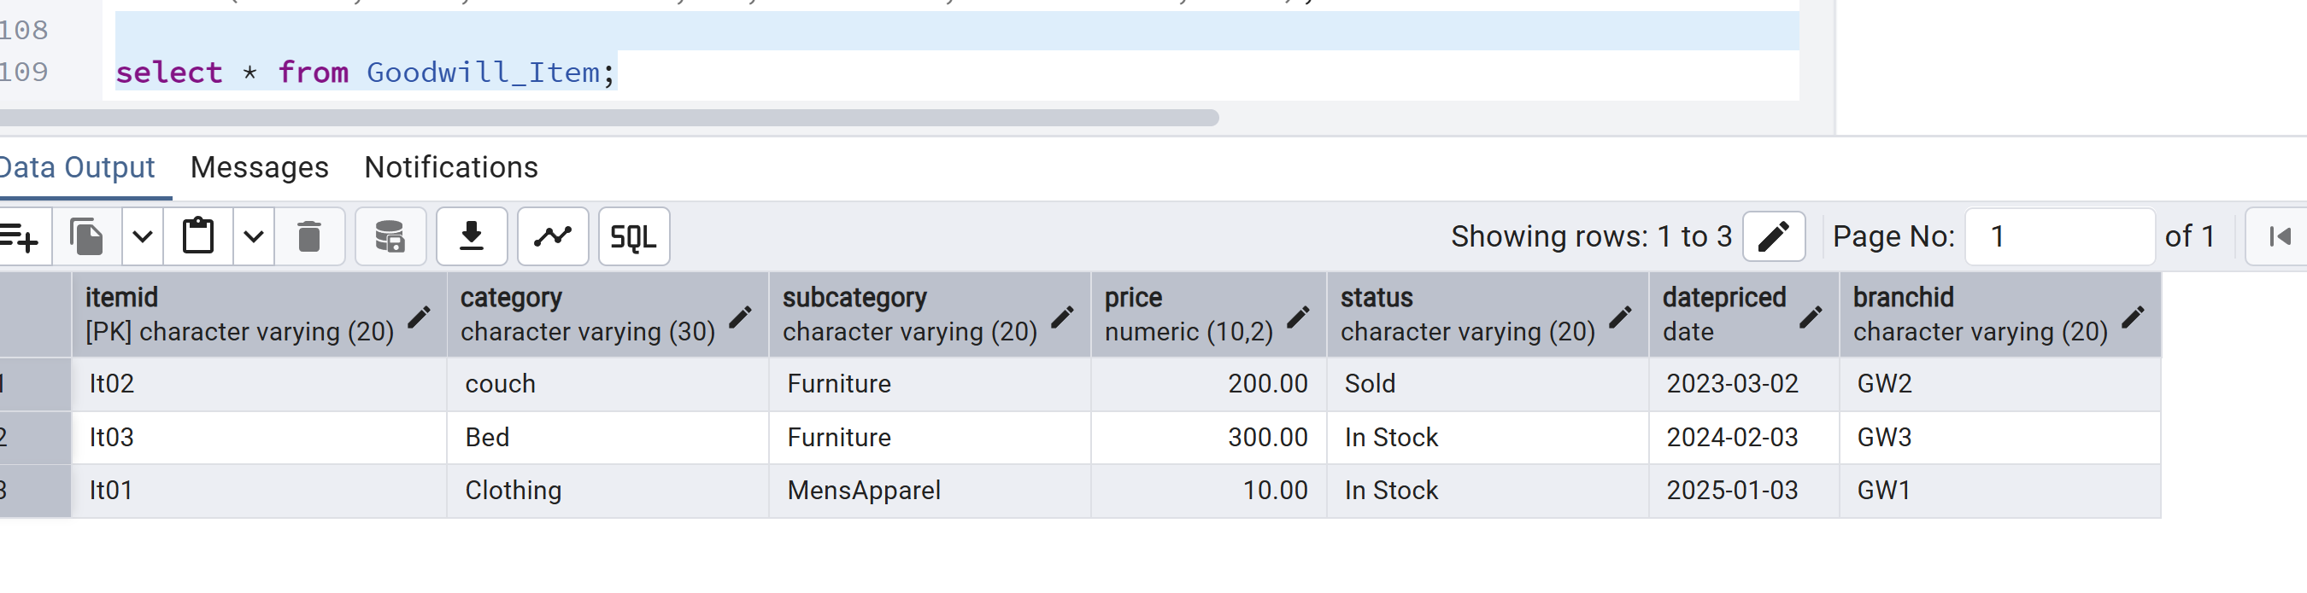
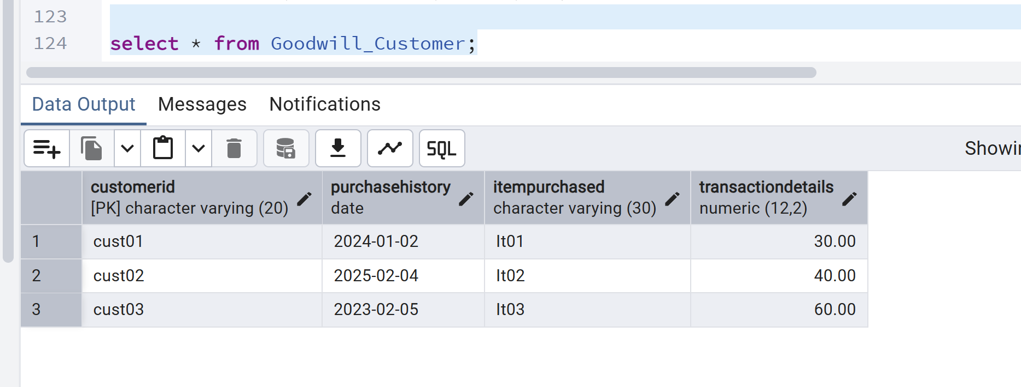

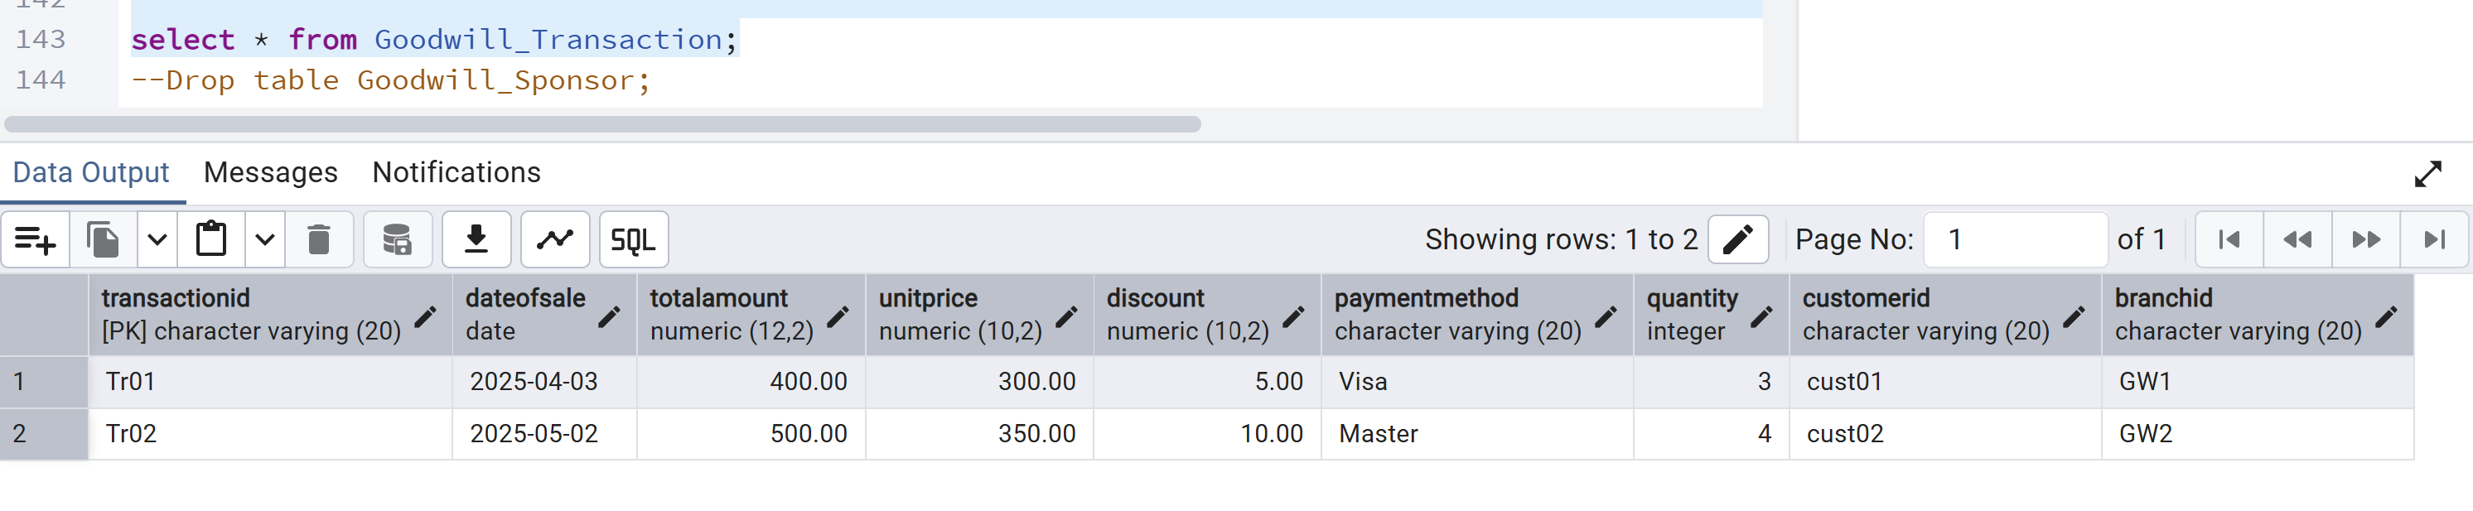
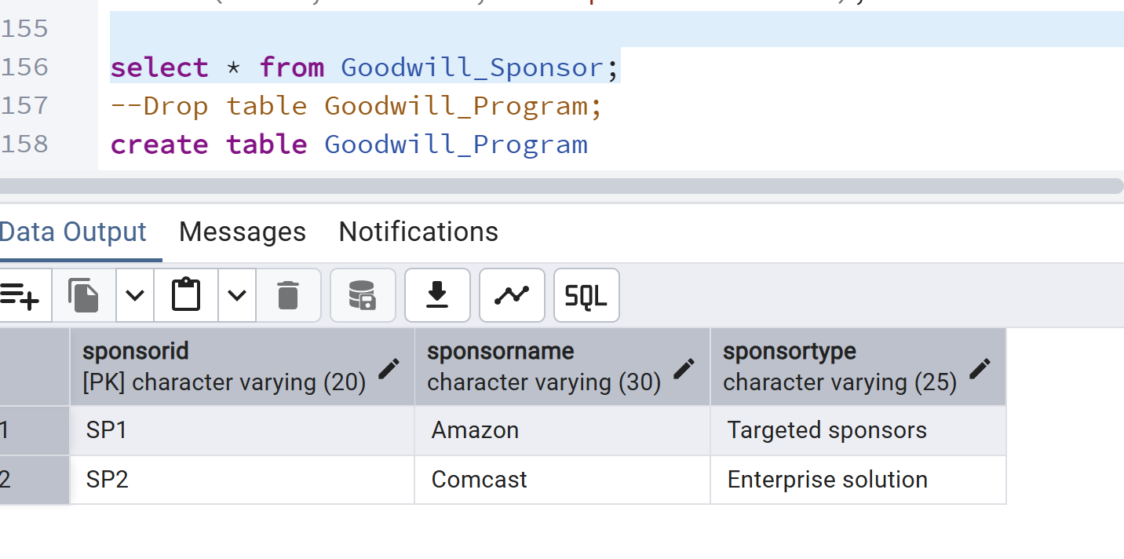
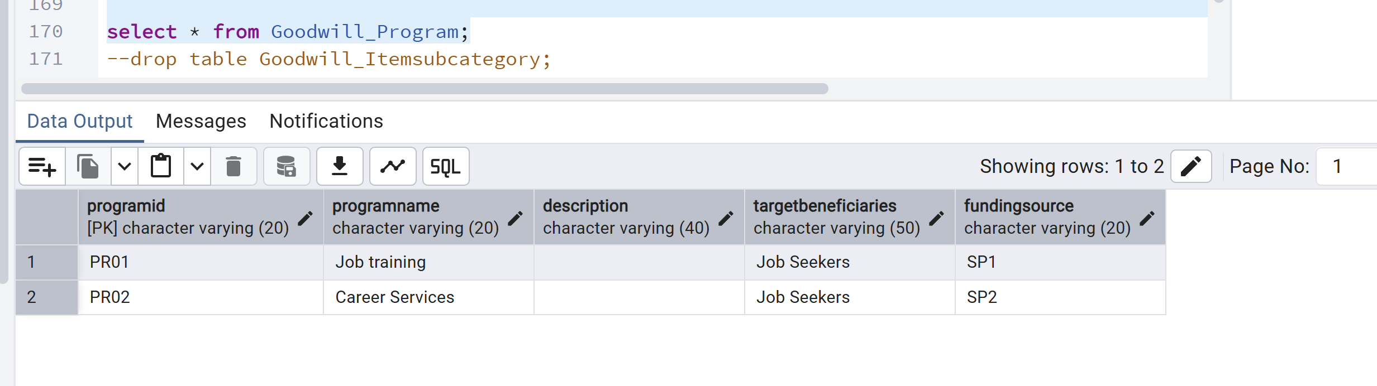
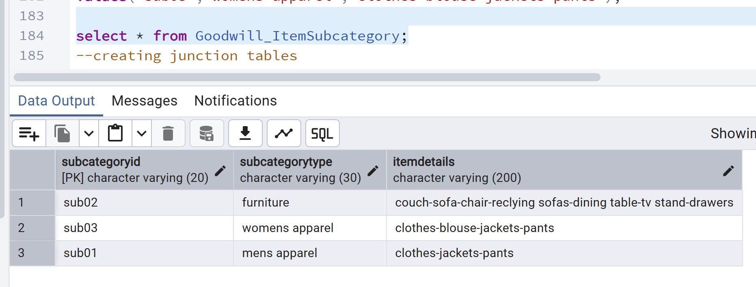
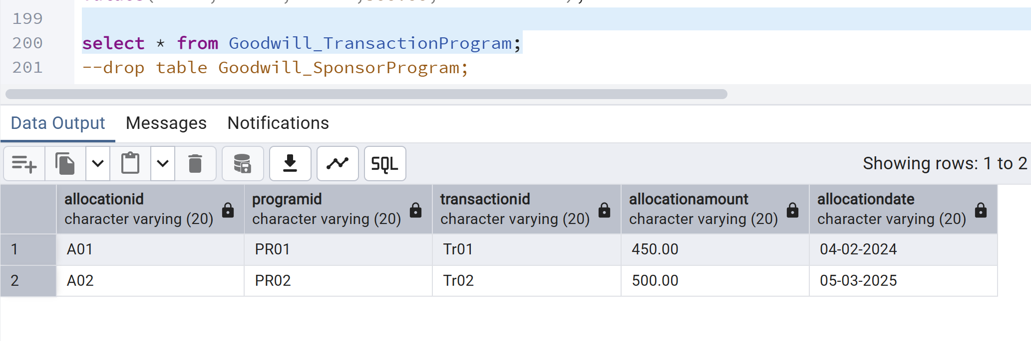
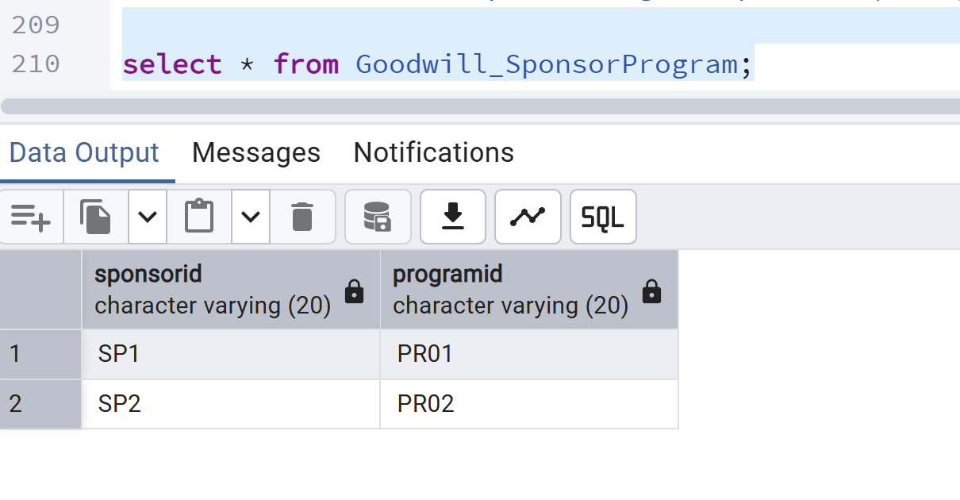
Sometimes we realize after certain period that these fields are necessary and we should have it. To add a specific field, after creating a table, we can follow following steps:

7. Create a variety of SQL queries to retrieve data from one or many tables:

1. Retrieve the data from each table by using the SELECT * statement and order by PK column(s).
Show the output. Make sure you show the print screen of the complete set of rows and columns.
The rows must be ordered by the PK column(s).
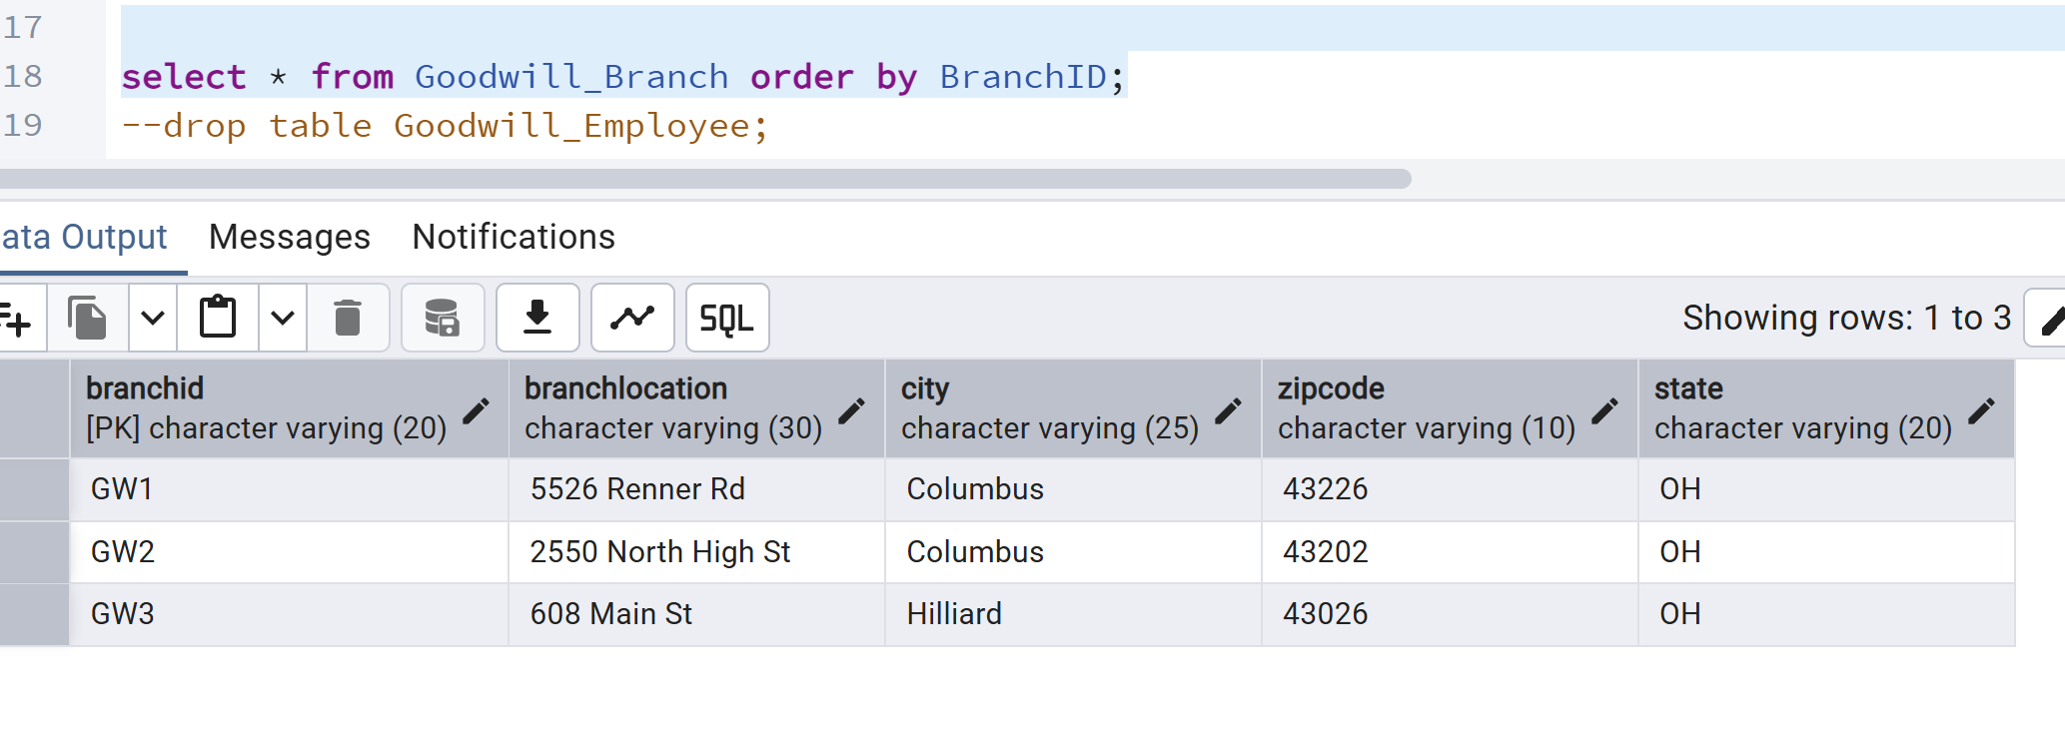
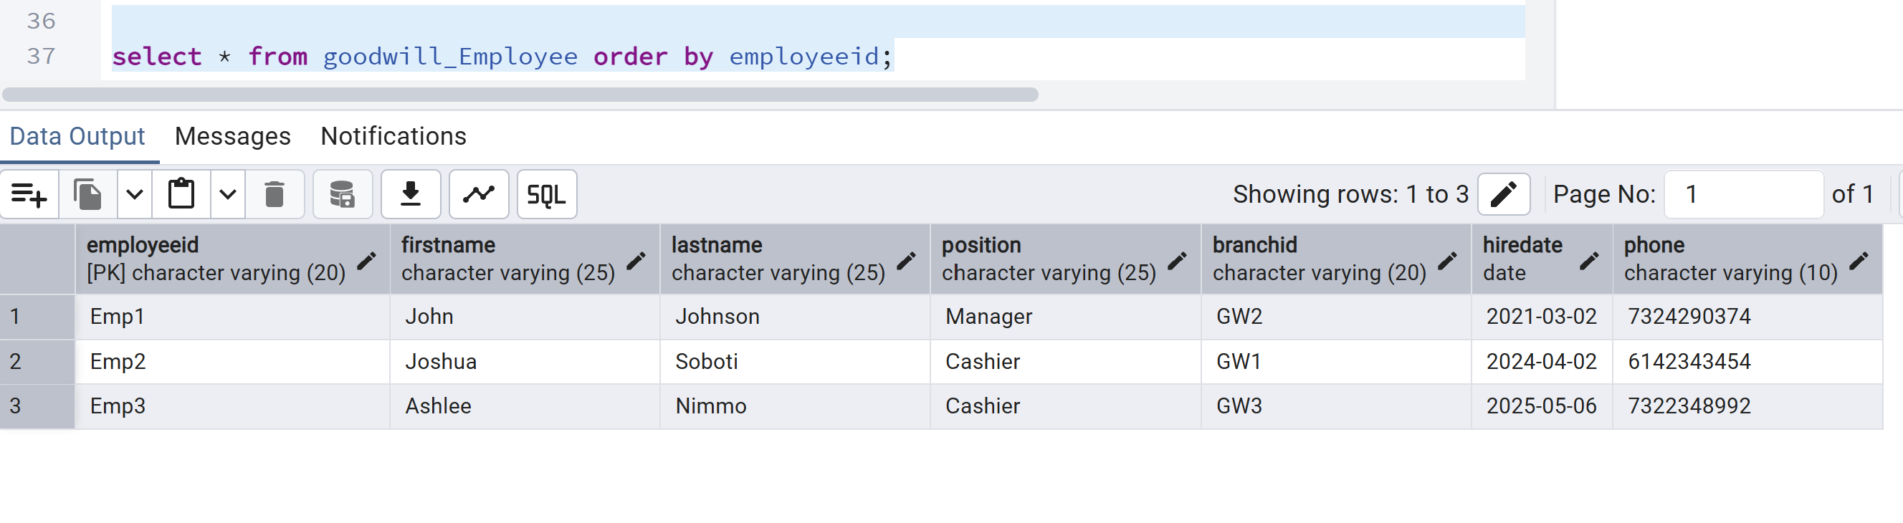
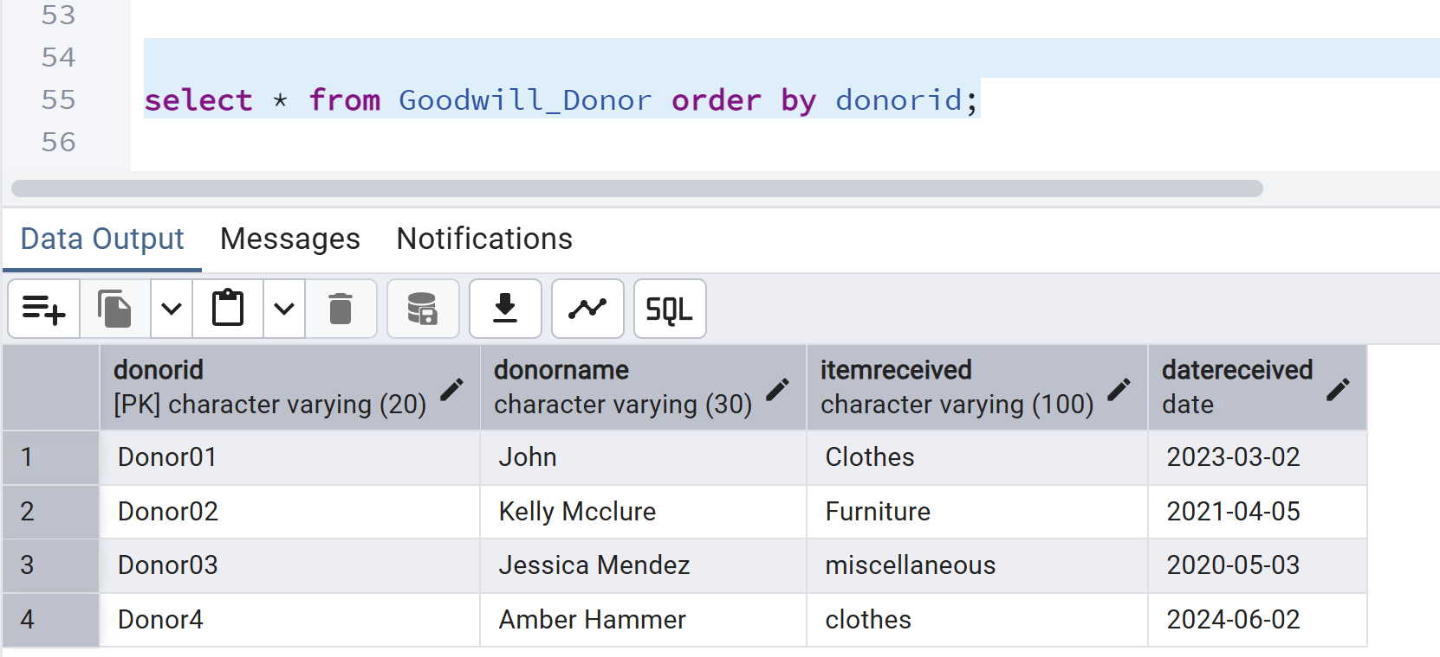
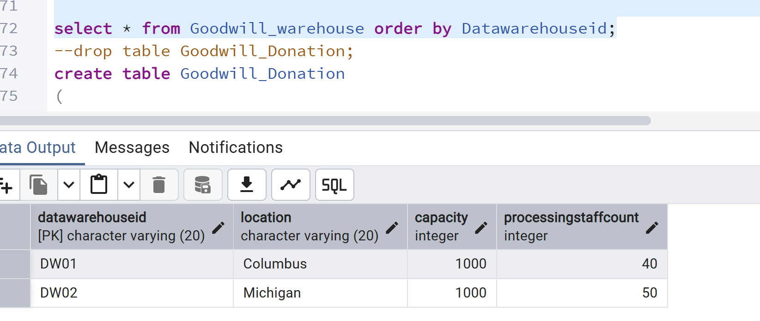
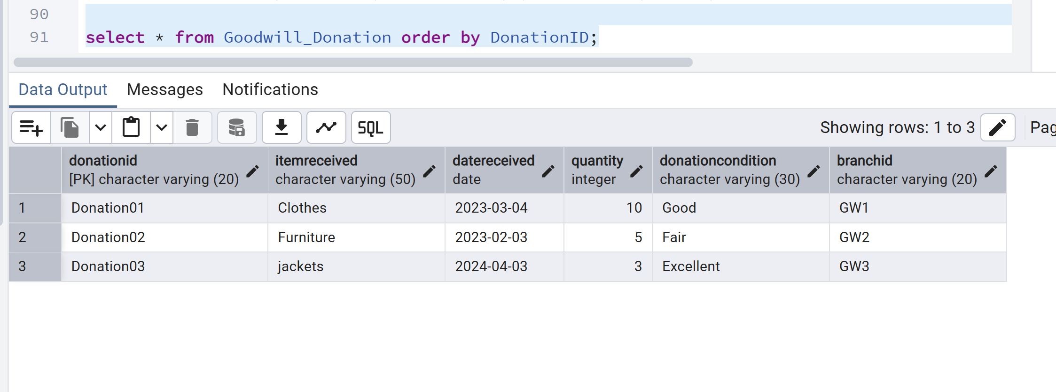

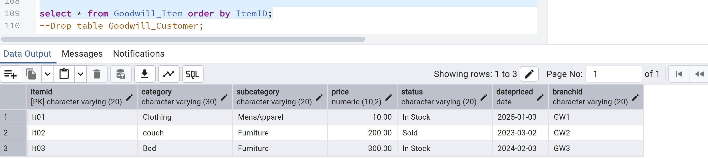

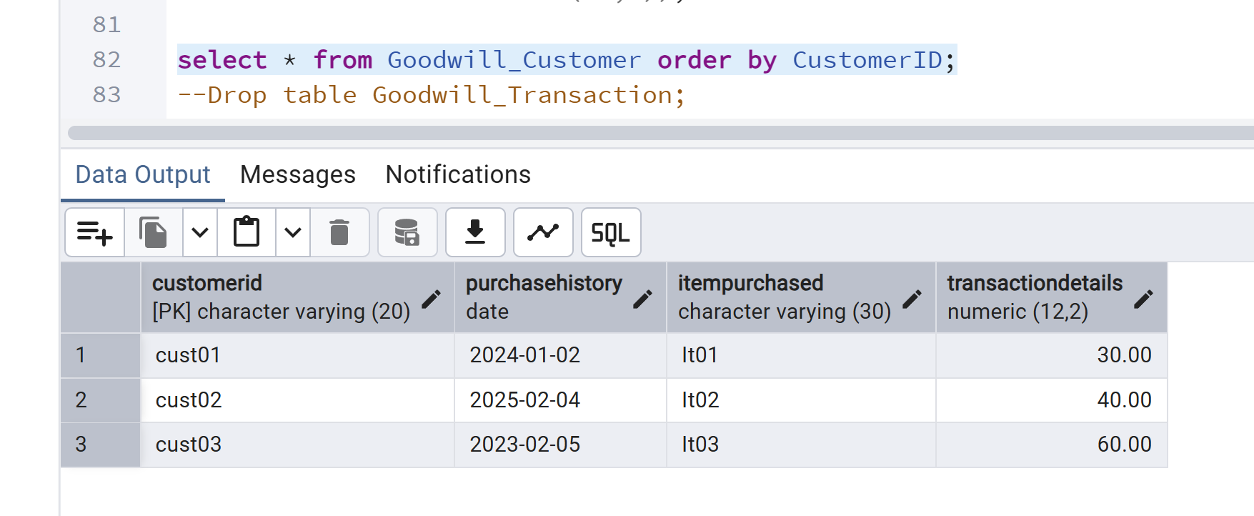
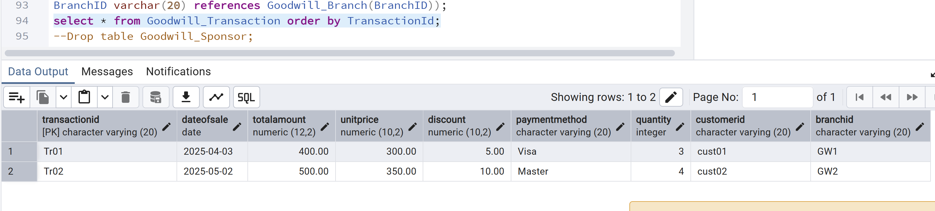

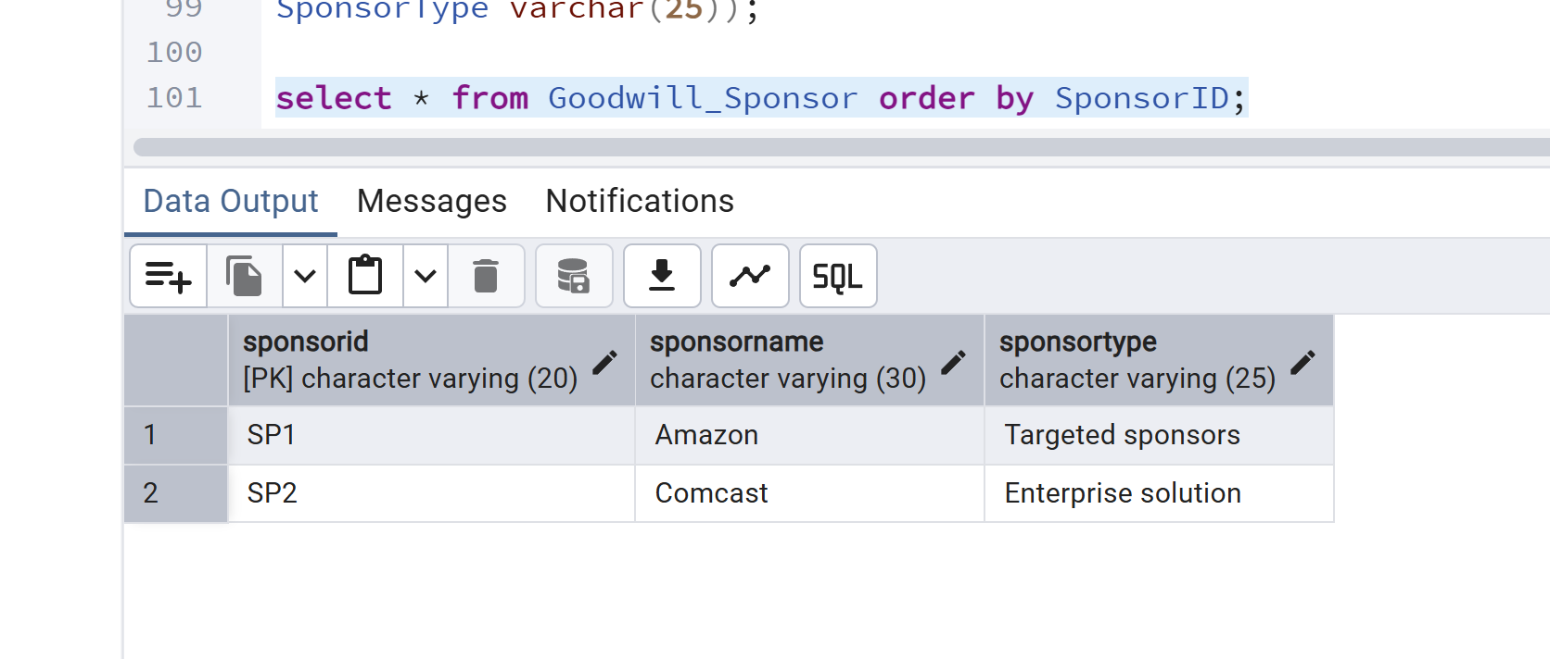
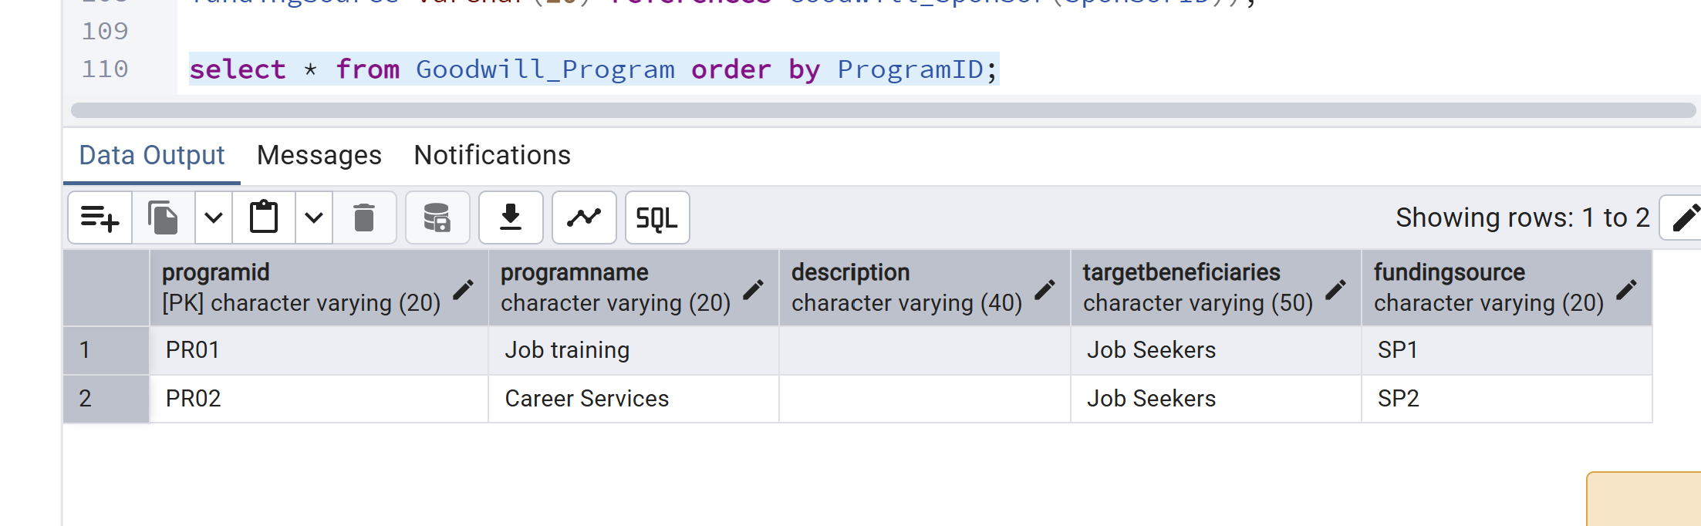

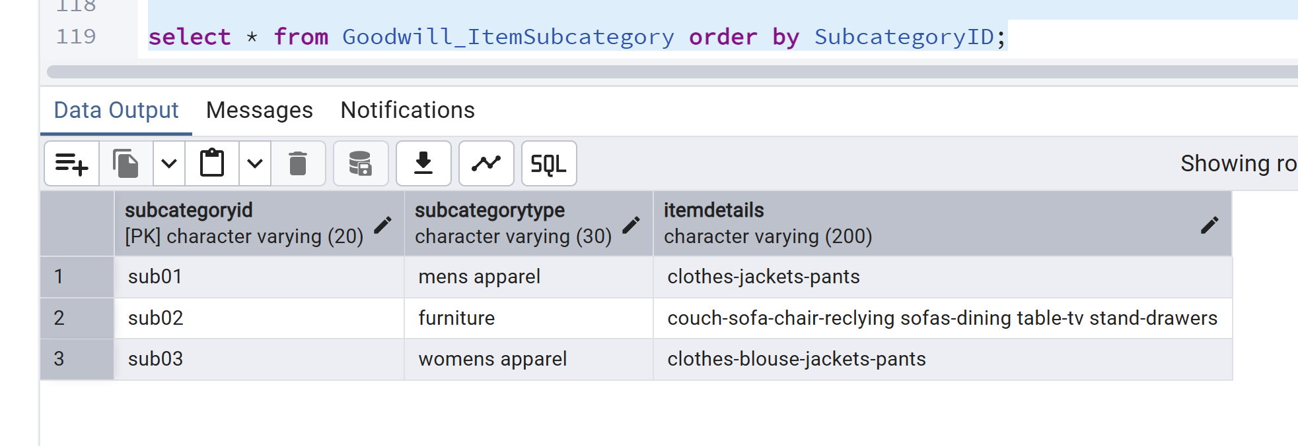

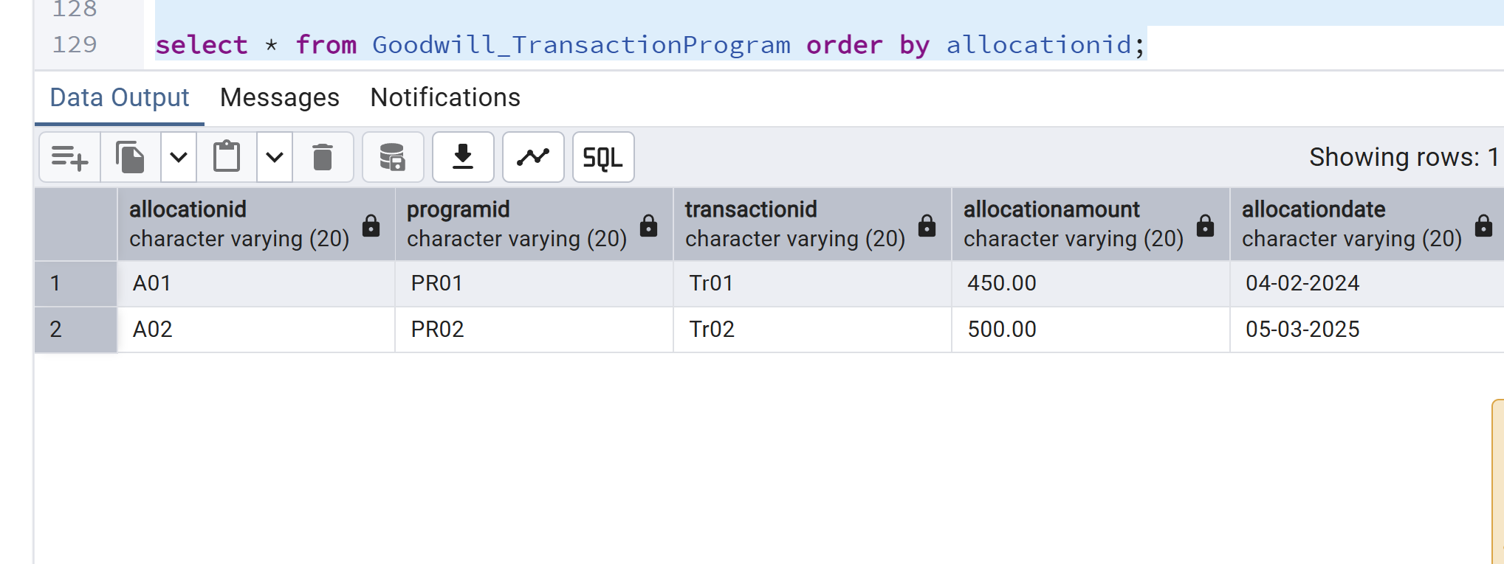

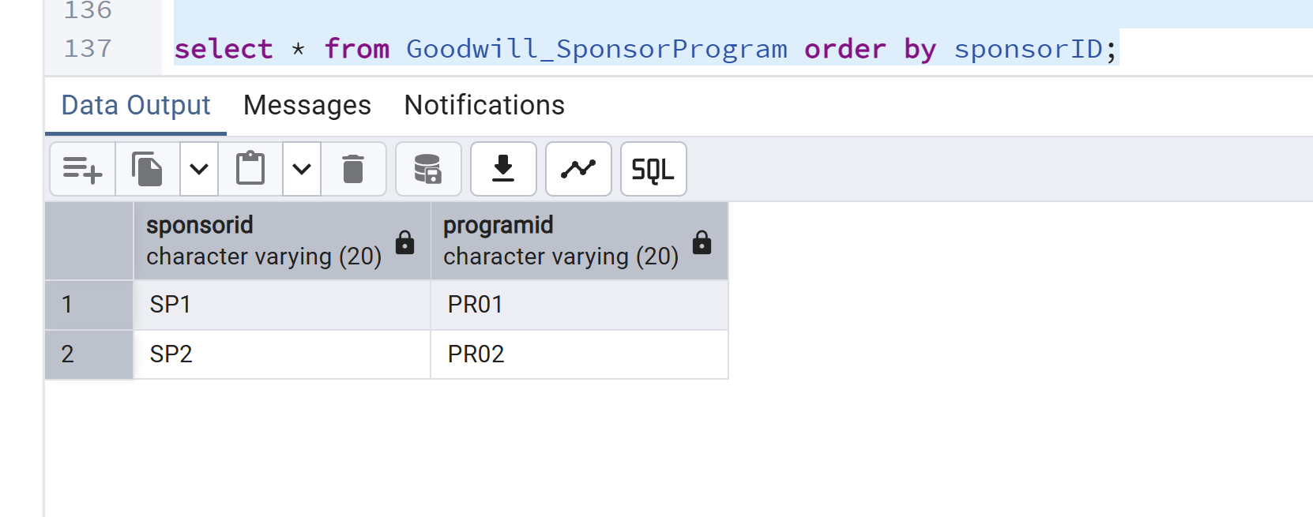

2. Write an SQL involving the junction table and two other related tables. You must use the INNER JOIN to connect with all three tables. The database that you created must be included in your SQL queries.

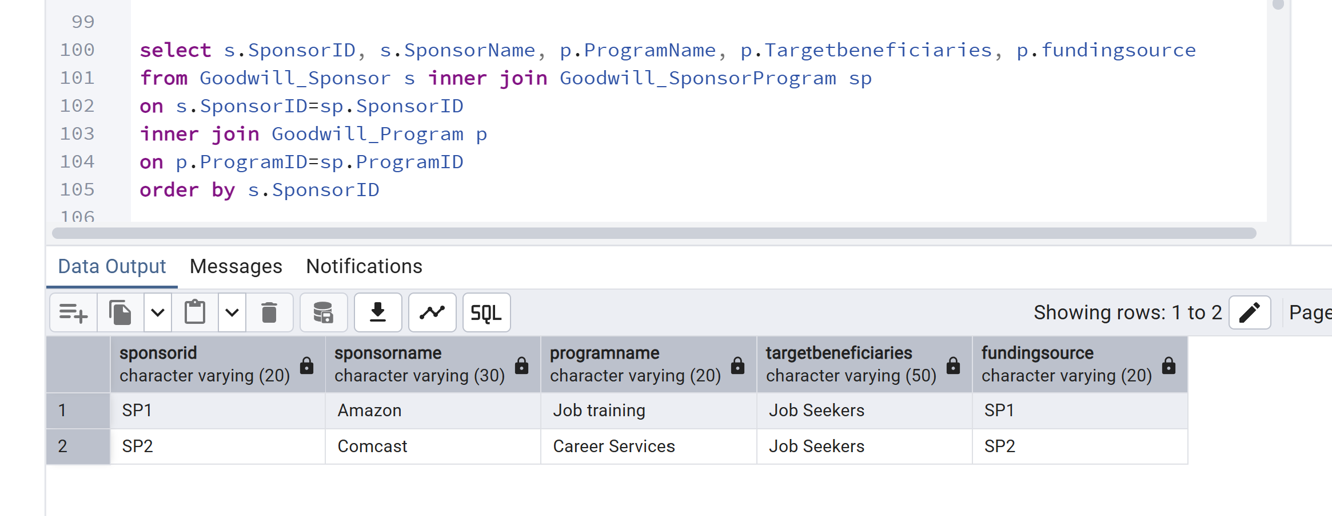
3. Write an SQL statement by including two or more tables and using the LEFT OUTER JOIN. Show the results and sort the results by key field(s). Interpret the results compared to what an INNER JOIN does.

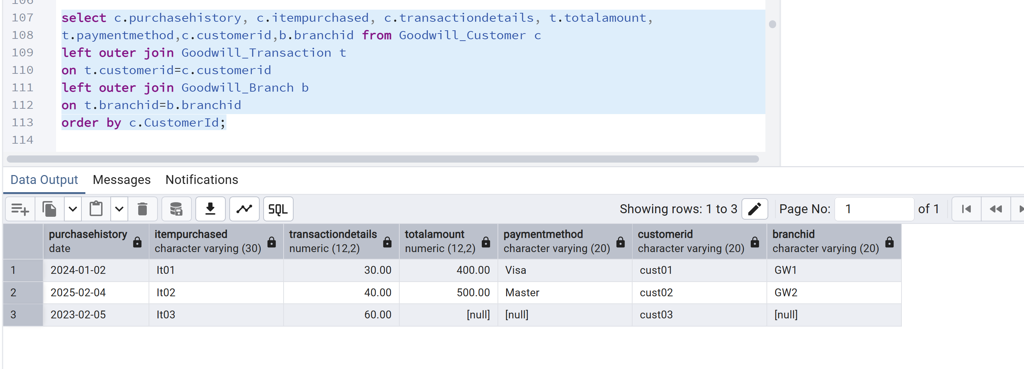

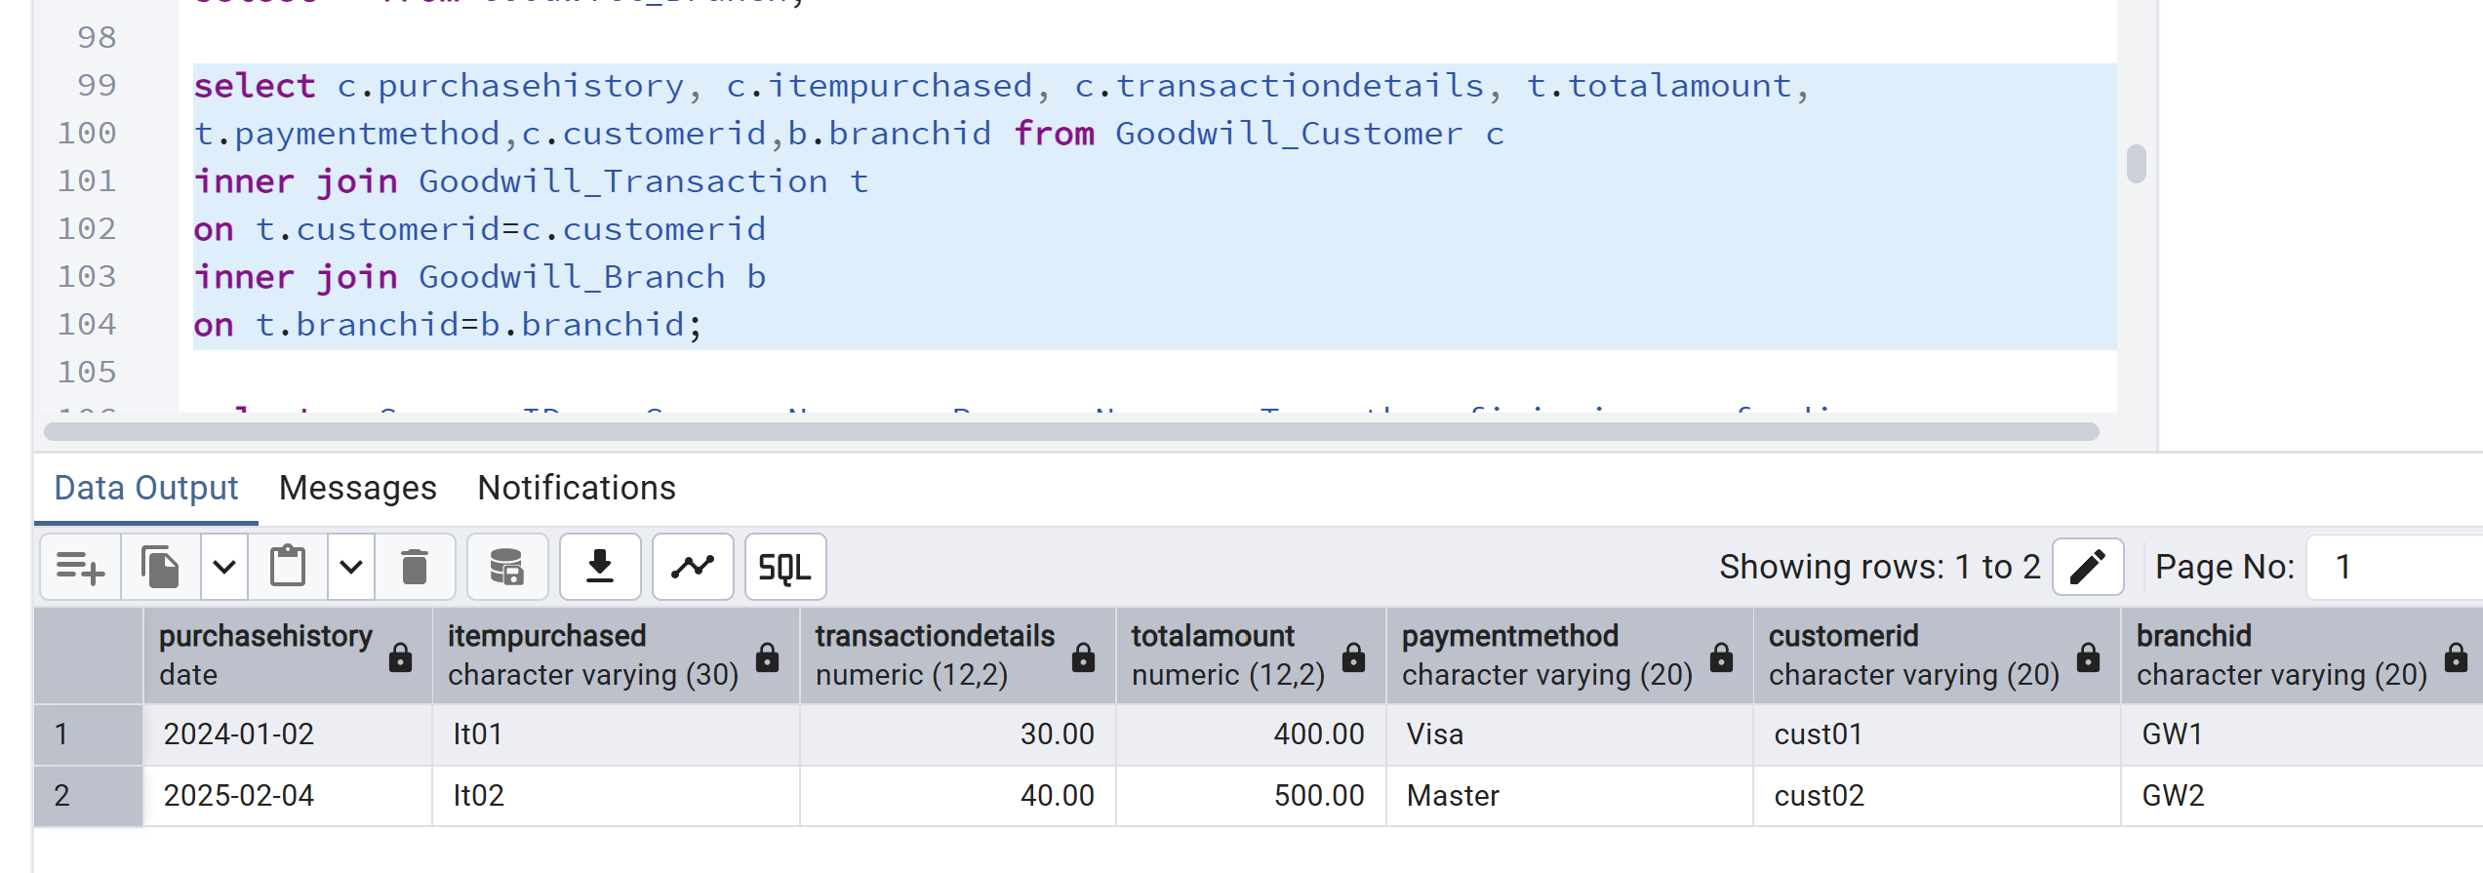

Inner join will display only those records which are common in three tables when left join will display those records which are present in the left table.

4. Write a single-row subquery. Show the results and sort the results by key field(s). Interpret the output.
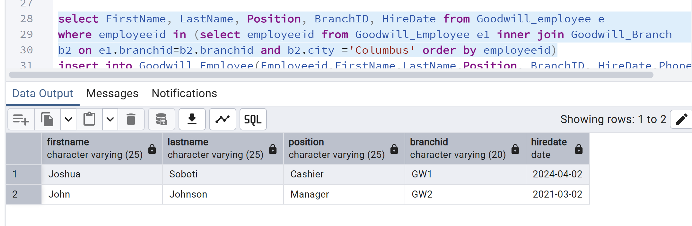
5. Write a multiple-row subquery. Show the results and sort the results by key field(s). Interpret the output.

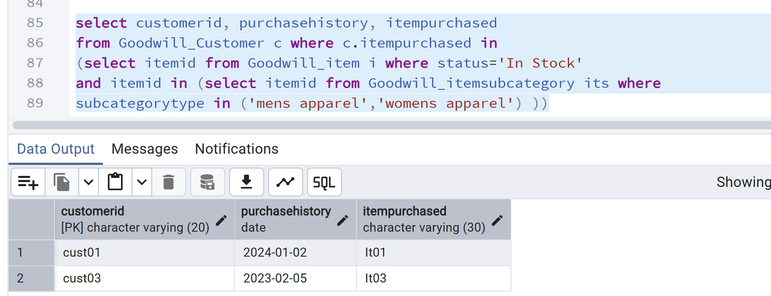

6. Write an SQL to aggregate the results by using multiple columns in the SELECT clause. Interpret the output.

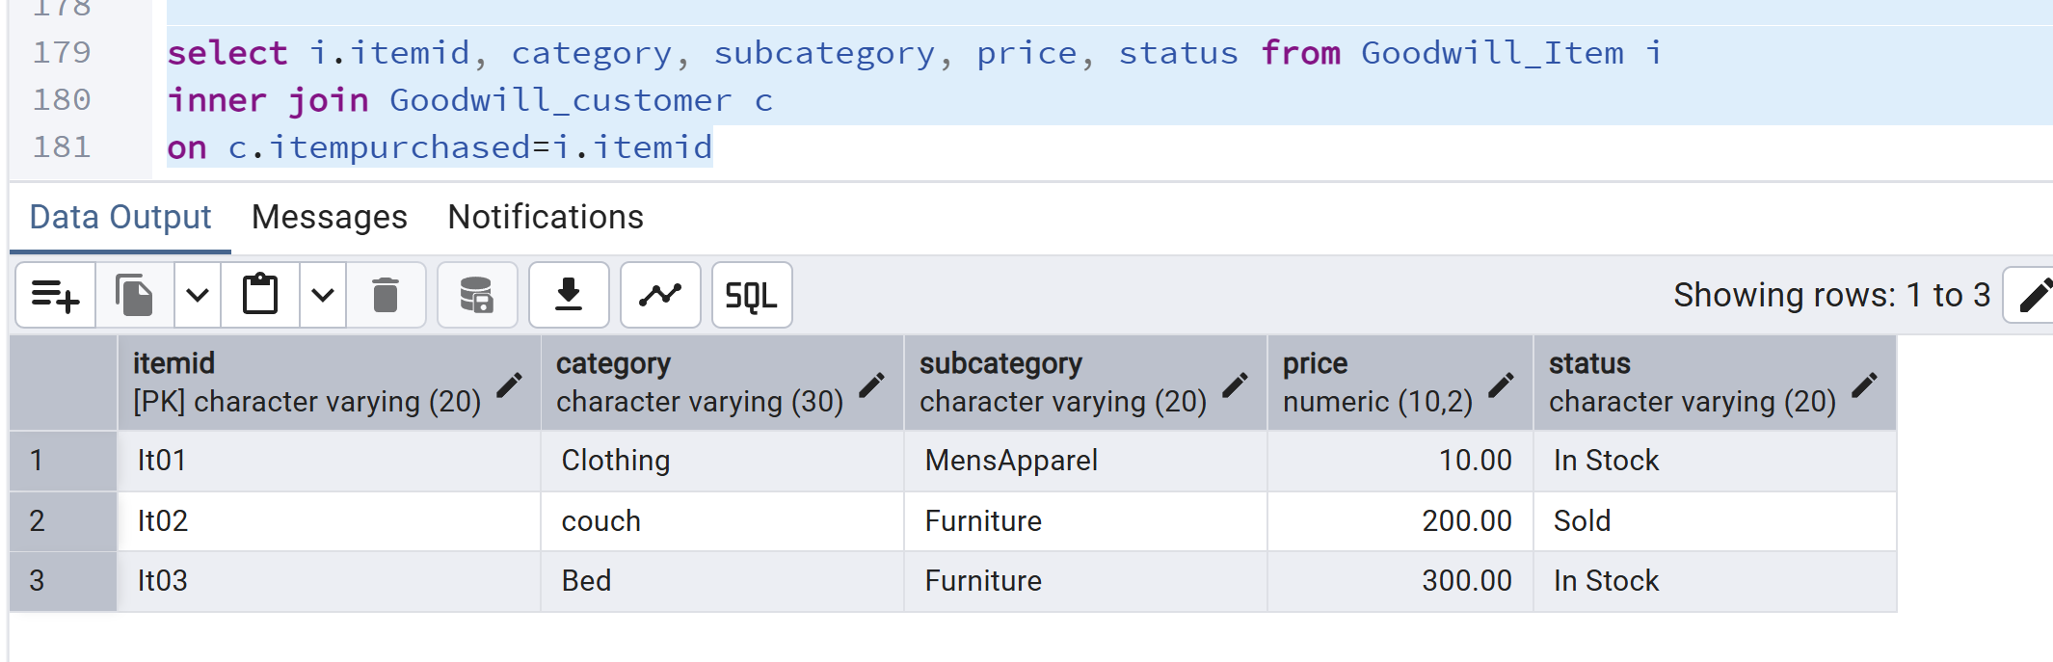

7. Write a subquery using the NOT IN operator. Show the results and sort the results by key field(s). Interpret the output.

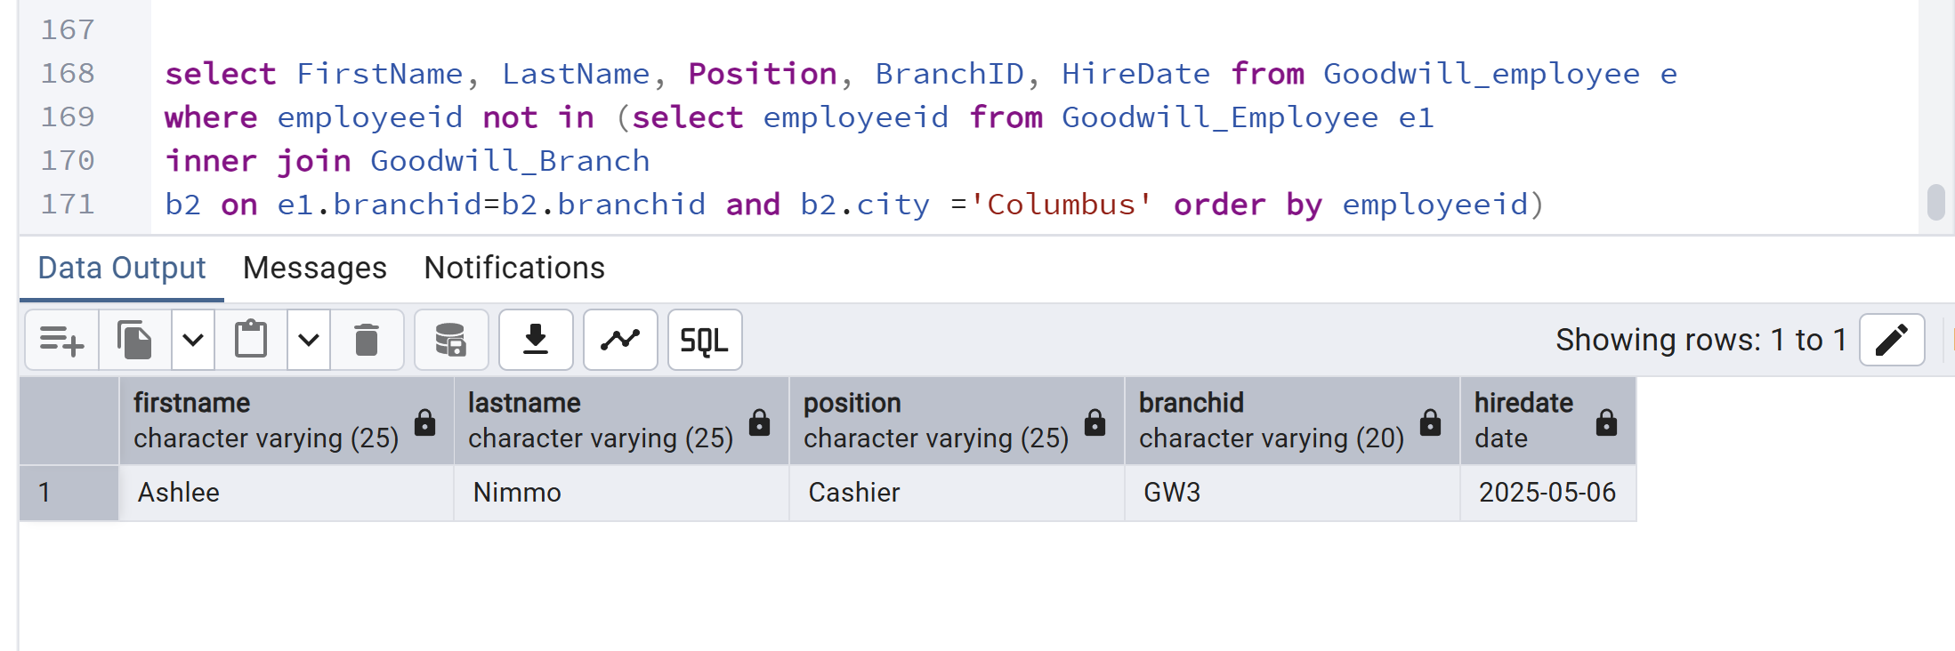

8. Write a query using a CASE statement. Show the results and sort the results by key field(s). Interpret the output.

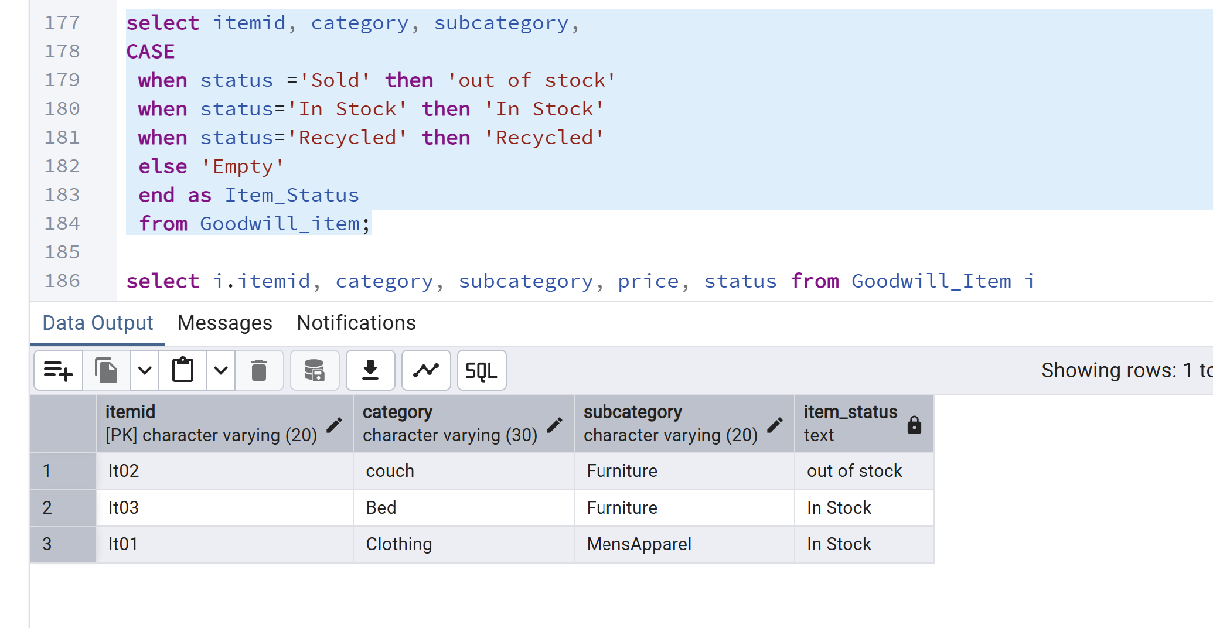

9. Write a query using the NOT EXISTS operator. Show the results and sort the results by key field(s). Interpret the output.

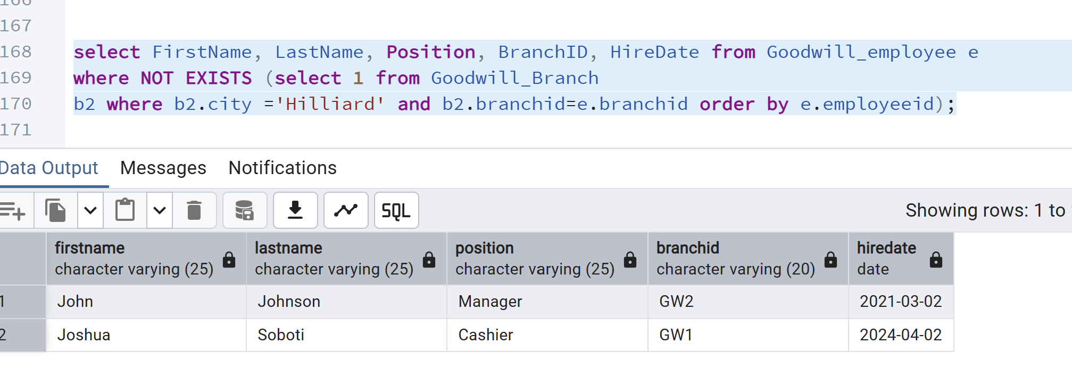

10. Write a subquery using the NOT NULL operator in the inner query. Show the results and sort the results by key field(s). Interpret the output.

To see the proper output, I’ve added a null row here.

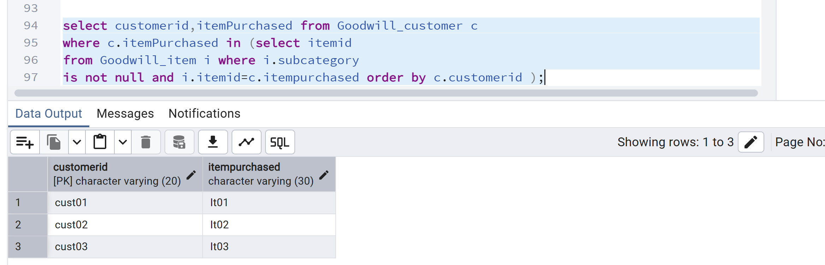
SUBMISSION REQUIREMENT:
Submit the final report with details of each phase of the project, starting from the problem statement. That means you must submit all the above 7 steps (including the requirements of Update 1, Update 2, and steps 5, 6, and 7). Provide a summary (two paragraphs) of your work at the very end of the report.

Upload your submission to the Week 7 Final Project Report Dropbox in D2L.

Conclusion:

By this approach, Goodwill store can store data in an organized manner. They’re able to see revenue and inventory records. They can segregate data by state, city and zip code as well. They can also identify what items need to be polished. By this way, they can keep track of their inventory, employees, sponsors, programs, donors, donations and transactions.

This database will be accessible to each Goodwill store. It’s kind of enterprise resource planning system where one system will be able to organize stores all over USA.

Future Work:

I’m planning to implement change audit log to see if any record has been either removed or modified. Also, I’m planning to implement Azure data factory pipelines to make automation insertions. Along with that, to see the inventory sale, I’ll generate a few PowerBI graphs.

This was all about databases and data analysis. Going forward, we’ll think about frontend side as well. The frontend is also imperative to access the system. I’ll develop the frontend using either PHP or .NET application.

References:

- Relational Model in DBMS - GeeksforGeeks
- DBMS Normalization: 1NF, 2NF, 3NF Database Example
- Hierarchical Model in DBMS - GeeksforGeeks
- Hierarchical Database (Model, Advantages, Disadvantages)
- Network Model in DBMS - GeeksforGeeks

