Ripa Shah

- How do you define clustering? Can you name a few clustering algorithms? Describe two techniques to select the right number of clusters when using K-Means.

Clustering is a technique that allows us to find groups of homogeneous objects, or objects that are closely related to each other than the objects in other groups. It is important that the difference between objects is measured by predefined distance metrics.

Sci-kit learn has many Clustering algorithms. Among which are: KMeans, DBSCAN, Birch, etc.

Two methods to select the right number of clusters are following:
- Computing the number of clusters using the elbow method. Using elbow method, we plot error vs. number of clusters plot. This plot looks like a exponential decay, and will give us an elbow as the name suggests. The fundamental key to this method is that elbow generated should be the minimum number of clusters after which the error reduction becomes insignificant. And we choose that number and set it as n_clusters parameter. Keep in mind that this requires running KMeans clustering algorithm multiple times for different clusters.
- Gap statistic:

- What is centroid in K-Means Clustering? How are the Centroids computed in K-Means Clustering?
Centroids are means of the cluster. Assuming that distance metric is euclidean distance, the centroid are simple-average of all of the points within the cluster.

K-Means is one of the most popular "clustering" algorithms. K-means stores $k$ centroids that it uses to define clusters. A point is considered to be in a particular cluster if it is closer to that cluster's centroid than any other centroid. K-Means finds the best centroids by alternating between (1) assigning data points to clusters based on the current centroids (2) chosing centroids (points which are the center of a cluster) based on the current assignment of data points to clusters.

- What is WCSS (within-cluster sum of square) in K-Means clustering? WHat is Elbow Criterion Method in K-Means Clustering?
The sum of the squared deviations from each observation and the cluster centroid.

The within-cluster sum of squares is a measure of the variability of the observations within each cluster. In general, a cluster that has a small sum of squares is more compact than a cluster that has a large sum of squares. Clusters that have higher values exhibit greater variability of the observations within the cluster.
However, similar to sums of squares and mean squares in ANOVA, the within-cluster sum of squares is influenced by the number of observations. As the number of observations increases, the sum of squares becomes larger. Therefore, the within-cluster sum of squares is often not directly comparable across clusters with different numbers of observations. To compare the within-cluster variability of different clusters, use the average distance from centroid instead.
K-means clustering is an unsupervised learning algorithm that groups data based on each point euclidean distance to a central point called centroid. The centroids are defined by the means of all points that are in the same cluster. The algorithm first chooses random points as centroids and then iterates adjusting them until full convergence.
An important thing to remember when using K-means, is that the number of clusters is a hyperparameter, it will be defined before running the model.

4.Import pandas (for data frame) as pd, matplotlib.pyplot (for data visualization) as plt, K-means [from sklearn.cluster import KMeans] as KMeans, numpy as np, and seaborn as sns
import pandas as pd
import matplotlib.pyplot as plt
from sklearn.cluster import KMeans
import numpy as np
import seaborn as sns

5. Create a DataFrame with this data set:
{"X":[12,15,18,11,10,8,9,12,18,20,19,21],
"Y":[6,16,17,8,7,8,6,9,15,18,16,19]}
X = pd.DataFrame([12,15,18,11,10,8,9,12,18,20,19,21], columns=['X'])
Y = pd.DataFrame([6, 16, 17, 8, 7, 8, 6, 9, 15, 18, 16, 19], columns=['Y'])
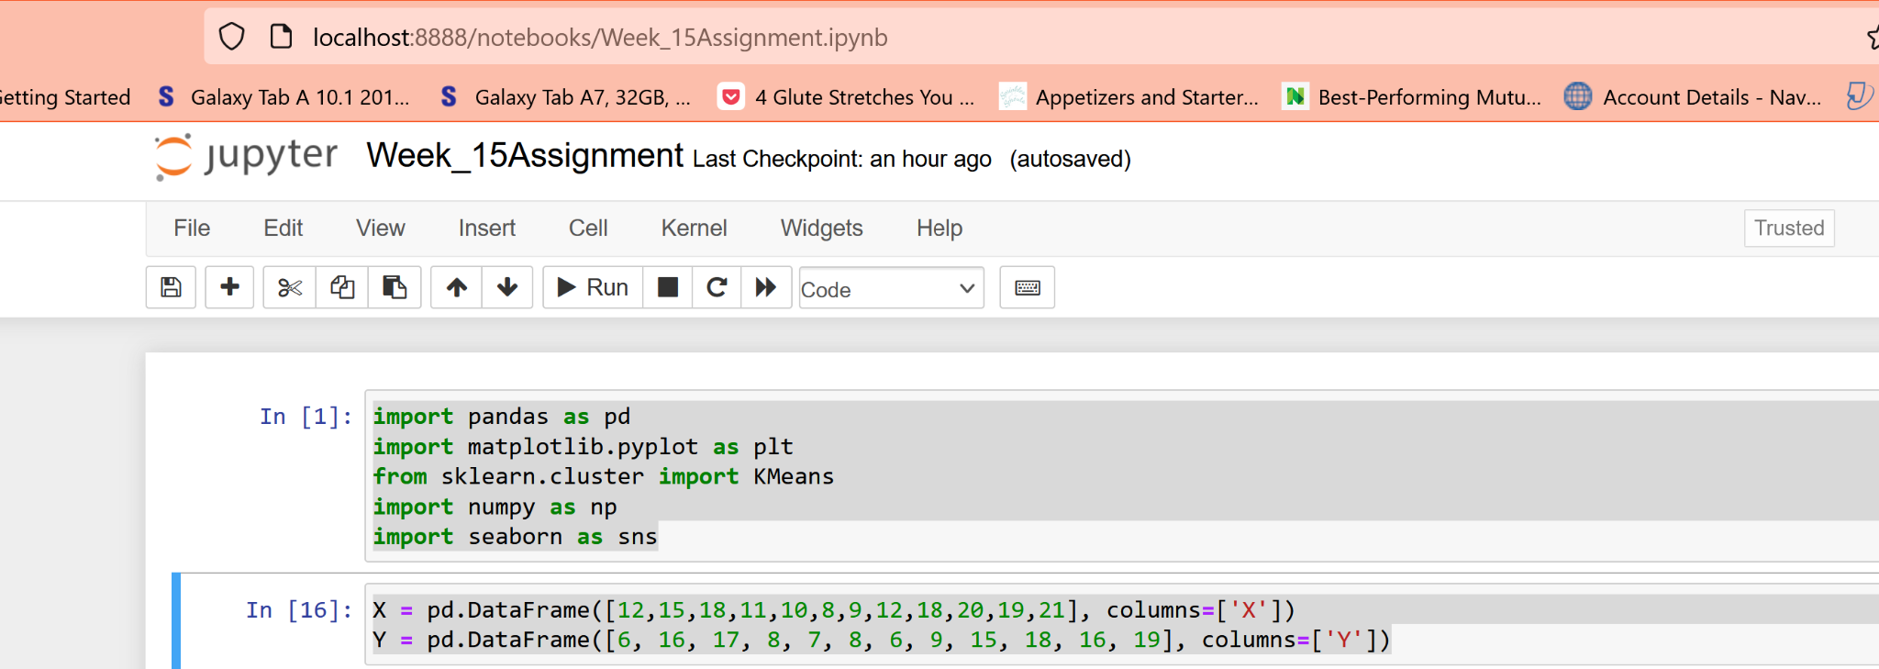
6. For data in #5, define the number of clusters. Try with num_clusters = 2. Create and fit the KMeans model. Fit the data. Plot the Clusters. Display the plot. Interpret the result.
kmeans = KMeans(n_clusters=2, random_state=42).fit(X)
Kmeans.cluster_centers_
[{"metadata":{"trusted":true},"cell_type":"code","source":"kmeans.labels_","execution_count":19,"outputs":[{"output_type":"execute_result","execution_count":19,"data":{"text/plain":"array([0, 1, 1, 0, 0, 0, 0, 0, 1, 1, 1, 1])"},"metadata":{}}]}]

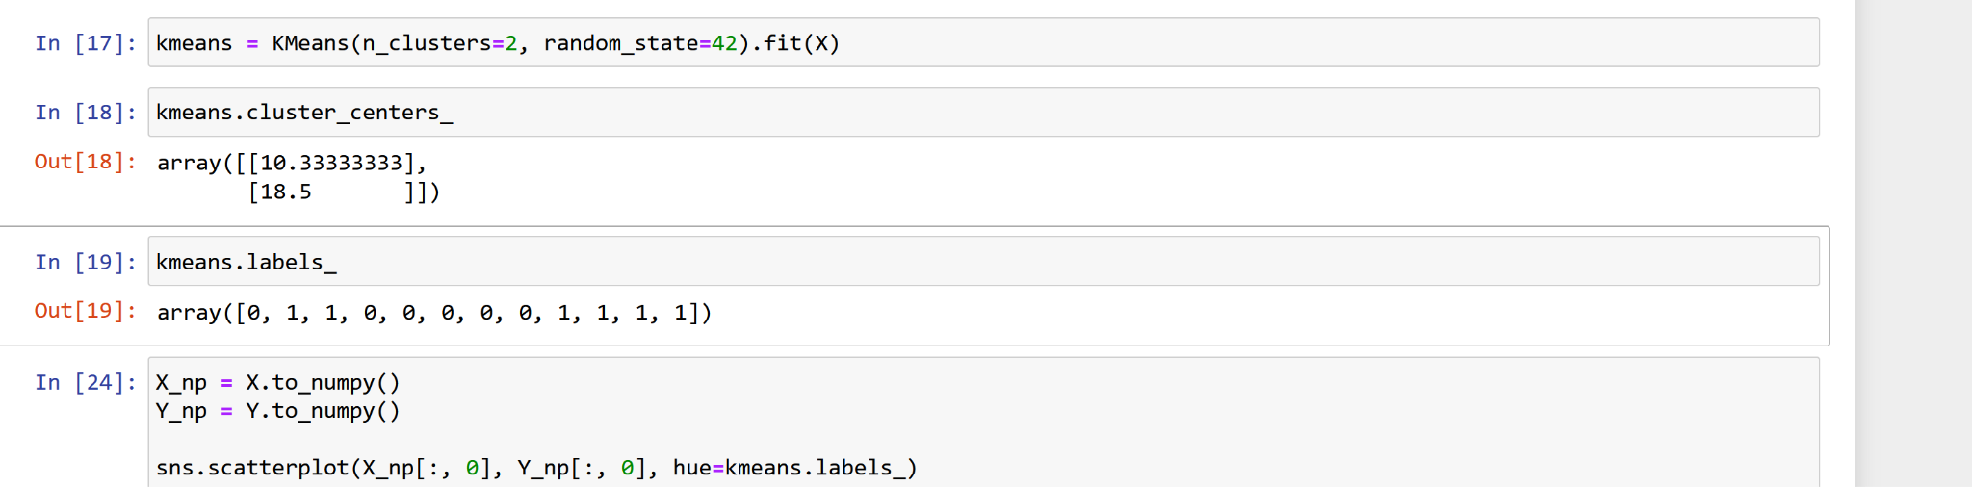
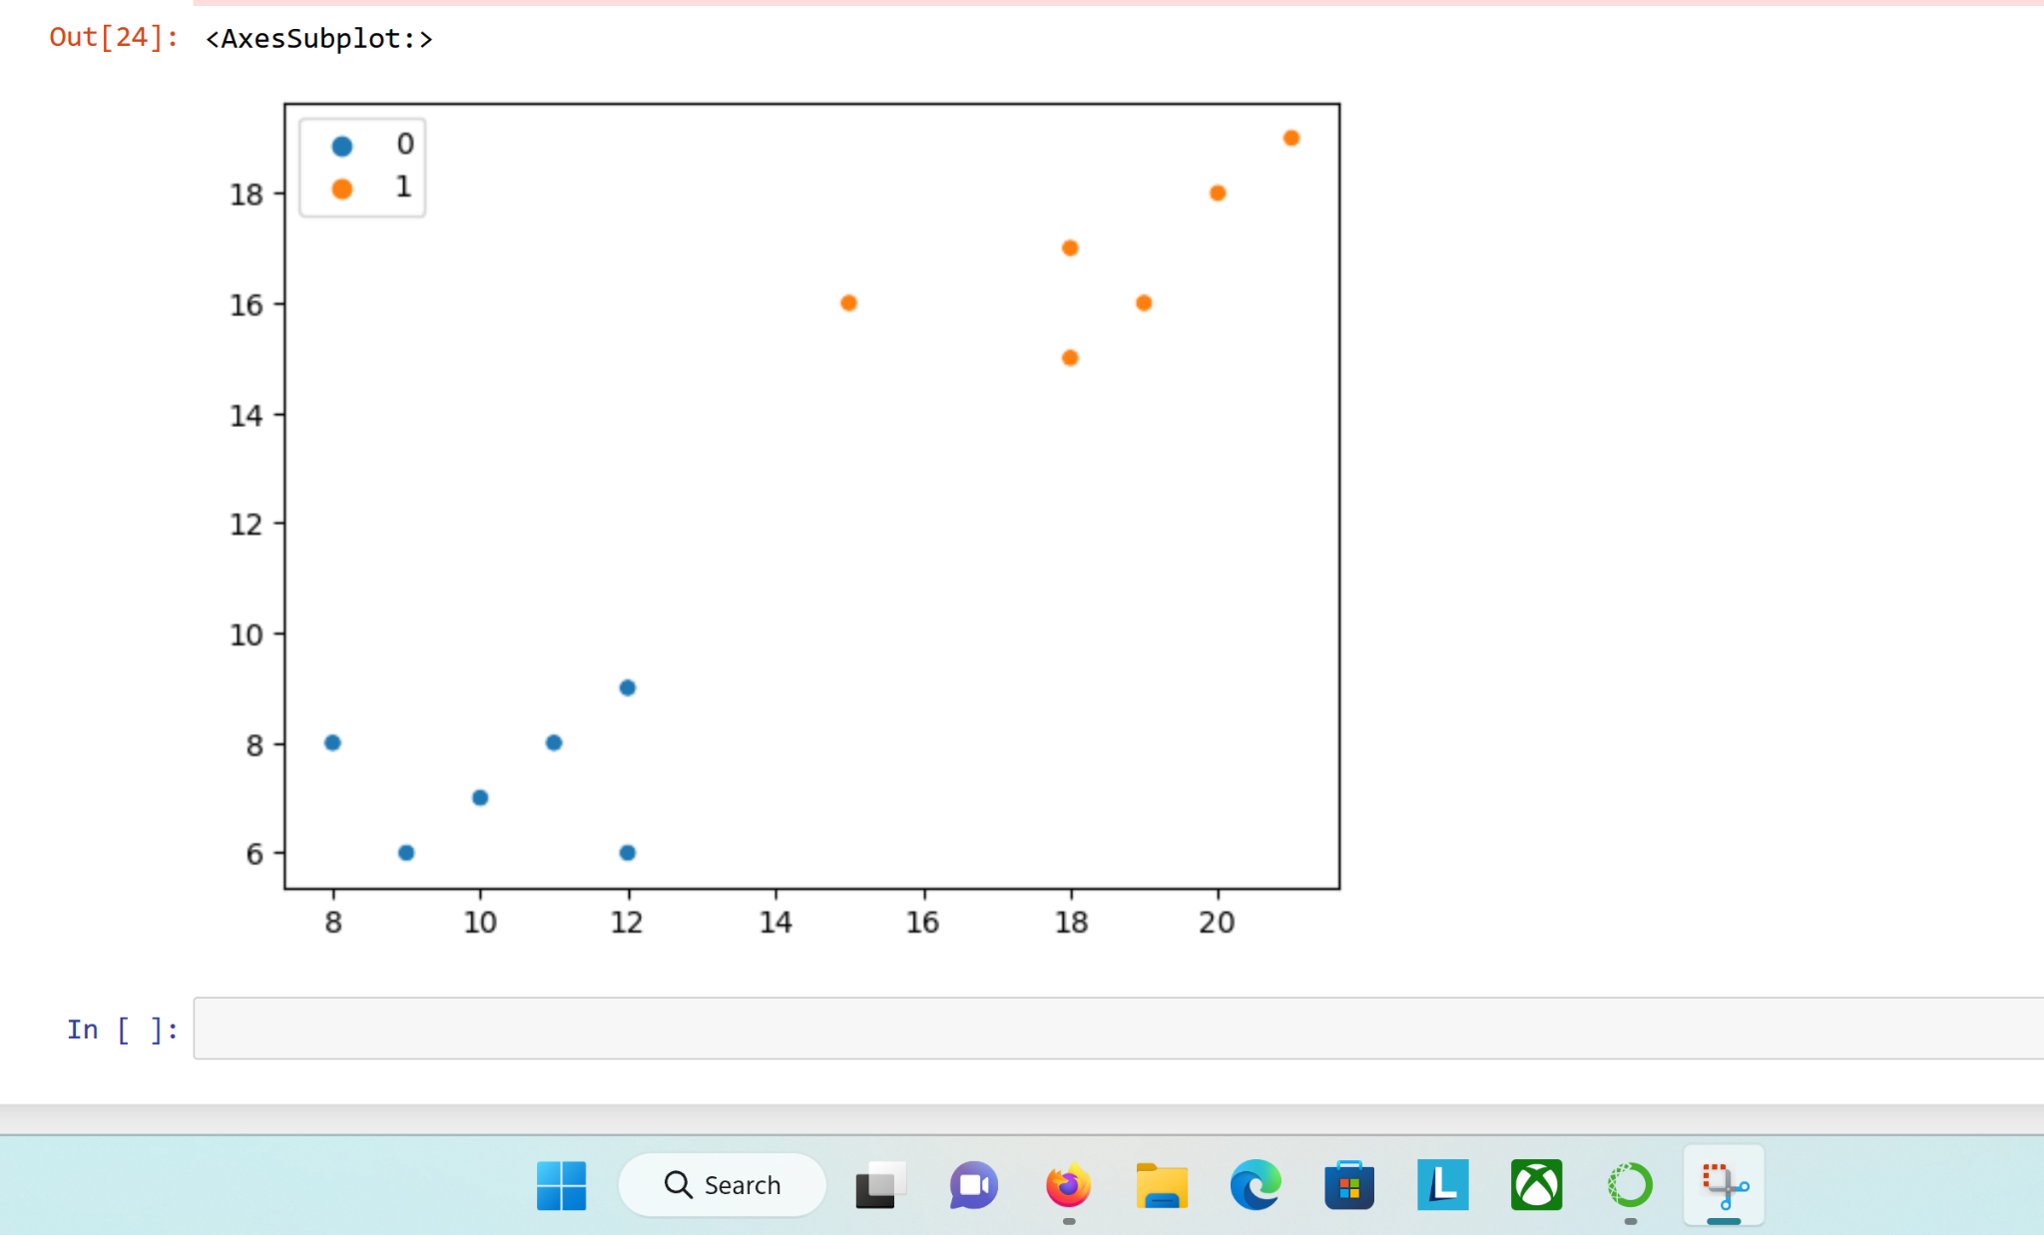

7. Download this Customer Segmentation data file (Mall_Customers.csv) from the Kaggle site.

https://www.kaggle.com/shwetabh123/mall-customers

Then (1) Read the data into a Pandas’ DataFrame, (2) Rename columns from ‘Annual Income (k$)' to 'Income' and 'Spending Score (1-100)' to 'Spending_Score' (3) Display the number of rows and columns in the data file, and the first five lines of the data file, including the variable names, and (4) Display the data type for each variable.
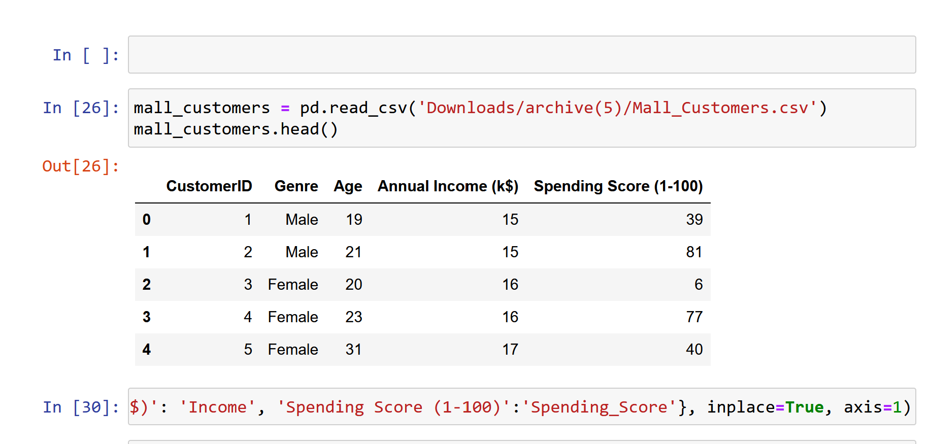
mall_customers.rename({'Annual Income (k$)': 'Income', 'Spending Score (1-100)':'Spending_Score'}, inplace=True, axis=1)
mall_customers.head()
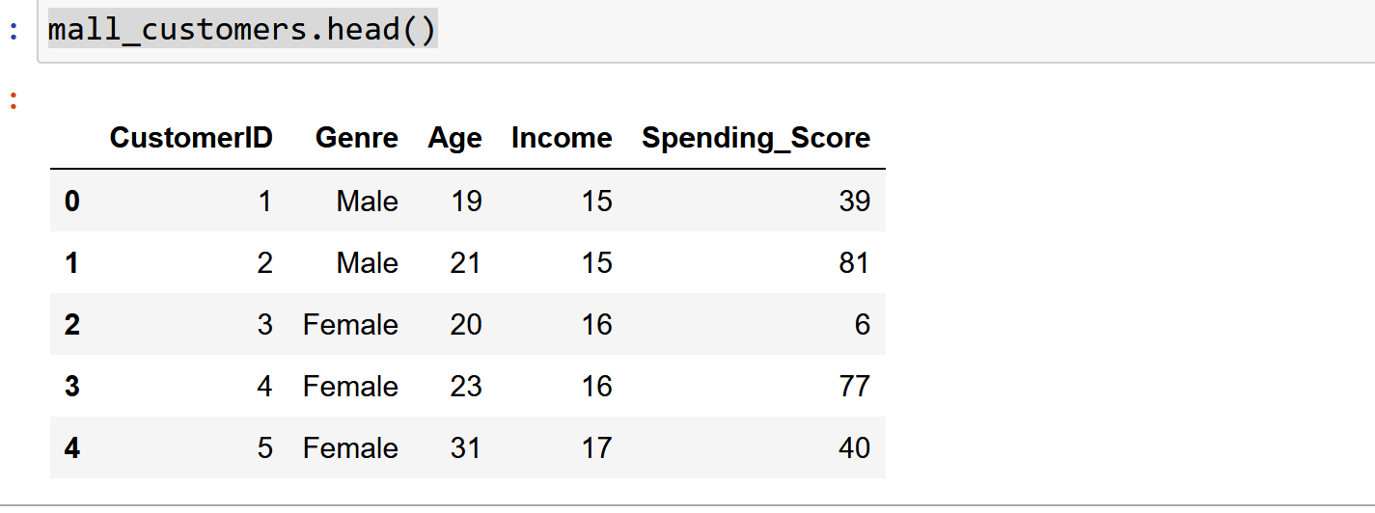
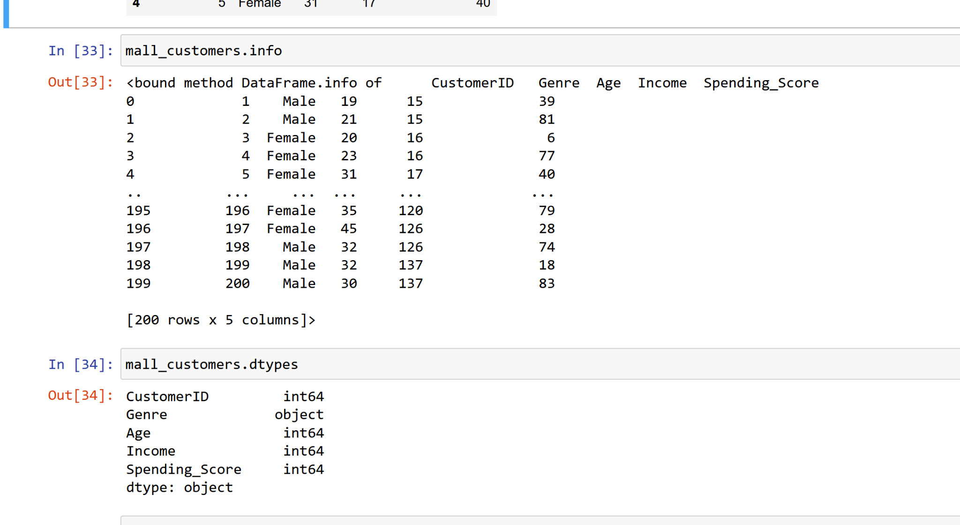
8. Create independent variable, x, with 'Income' and 'Spending_Score'. Implement the Elbow Method to come up with optimum number of clusters using Python code with the data in these two variables. Show the output of the Elbow method using the matpotlib library and Identify the optimal number of clusters.
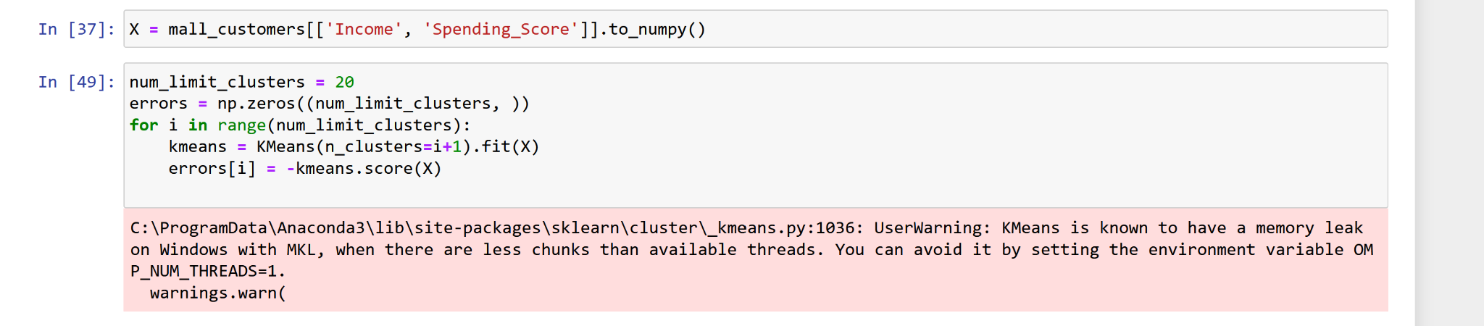
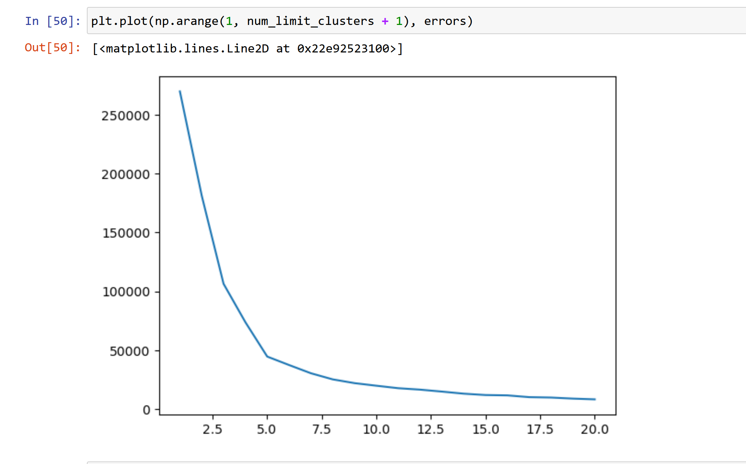

9. You have identified the optimal number of clusters. Display the data for each of those clusters using the scatter plot with different colors. Also, display the centroids using the marker for each cluster [Hints: Cluster_Centroid = kmeans.cluster_centers_
plt.scatter(Cluster_Centroid[0][0], Cluster_Centroid[0][1], marker='*', s=200, c='black')]
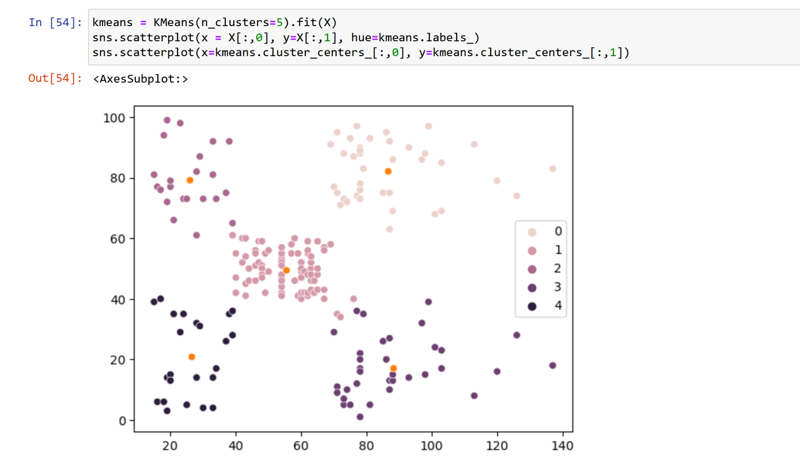
10. Interpret the clusters shown in graph with real-world business implications. How this data could be used in real world business settings.

For this experiment, we have identified the two independent variables: Spending Score and Annual Income. Using these features, we are grouping (clustering) customers into separate groups. With this process and other independent variables such as age and gender, we understand that the relation between affluence vs. age and affluence vs. gender. Additionally, using these two clusters, we may also devise a strategy which attracts the relative affluence of people.
For people who are in group 2, we understand that their income is low, but spending power is high - meaning they rely on credit lending. To attract such customers, business owner may offer such solutions. Similar strategies can be thought of for other groups.

