Ripa Shah
Course: INFO 531/ISTA 431: Data Warehousing and Analytics in the Cloud
Module/Week: 6 - Week of September 26, 2022
Topic: Introduction to Cloud Computing

Week 6 Assignment: Part-1: Create a single database - Azure SQL Database

PURPOSE:
Part-1 assignment introduces you to the Microsoft Azure portal, how to create Azure Resource Group, Azure SQL databases using the Azure portal, and how to connect to the database and query data using the Query editor (preview) in the Azure portal. This also shows you how to delete resource groups when you are finished with all these activities. You will perform activities to delete the resource group you created, which will also delete the server and single database within it.

The Part-1 assignment will consist of 40 points.

Part I: Environment setup

Step 1: Create your Azure free account (5 points)
Go to the address https://azure.microsoft.com/en-us/free/students/ and create a free Azure account using your university email address. Note that you do NOT need a credit card to create the account. If you find yourself entering your credit card information know that you are doing it wrong.

Step 2: Download and install DBeaver (5 points)
DBeaver is a free multi-platform database tool. Download it from here: https://dbeaver.io/

Part II: Create an Azure SQL Database single database

Step 1: Create a SQL database on Azure (10 points)
Follow the steps in the quickstart available here.

Create a single database - Azure SQL Database | Microsoft Learn

This step consists of the major part of assignment part 1. All steps need to be completed in it except for the section, “Clean up resources” which you will do in Step 5 below. Submit a screenshot of each of the steps. Feel free to redact any personal information in the screenshot.

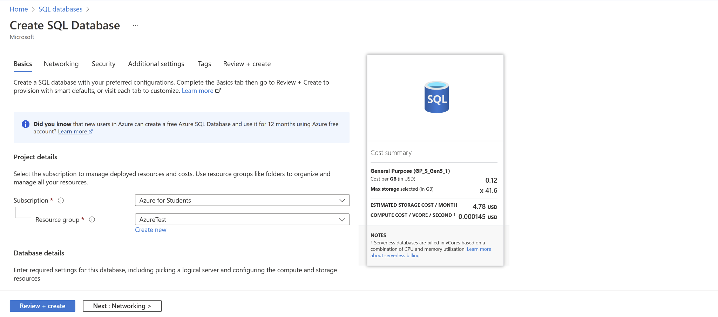

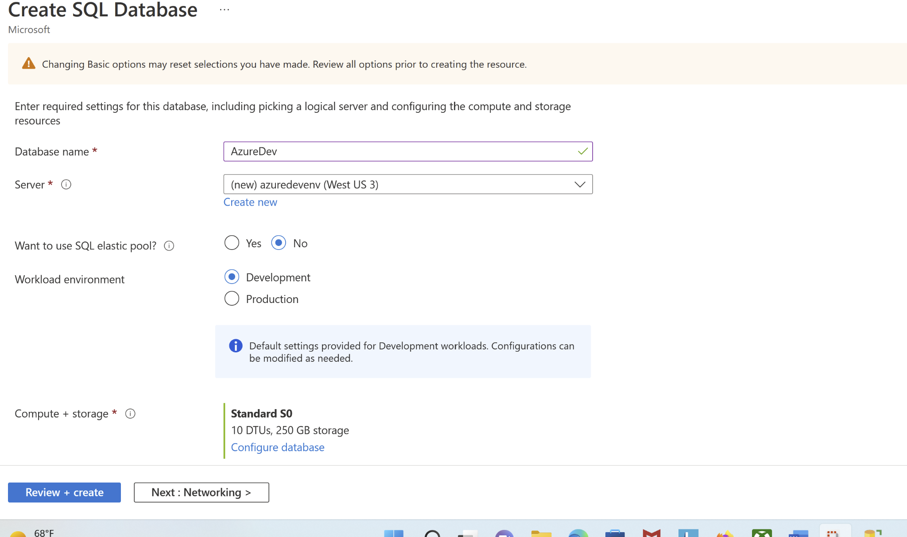
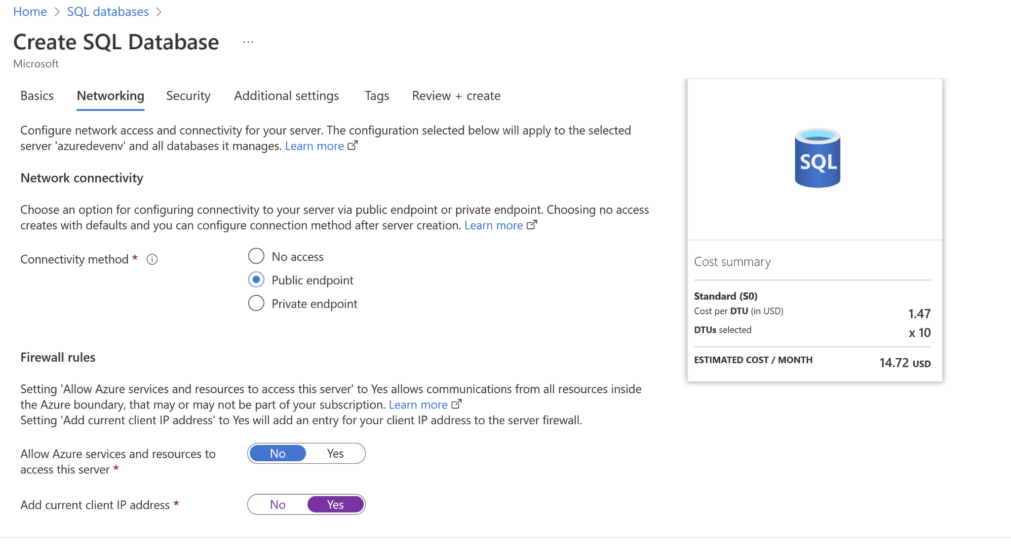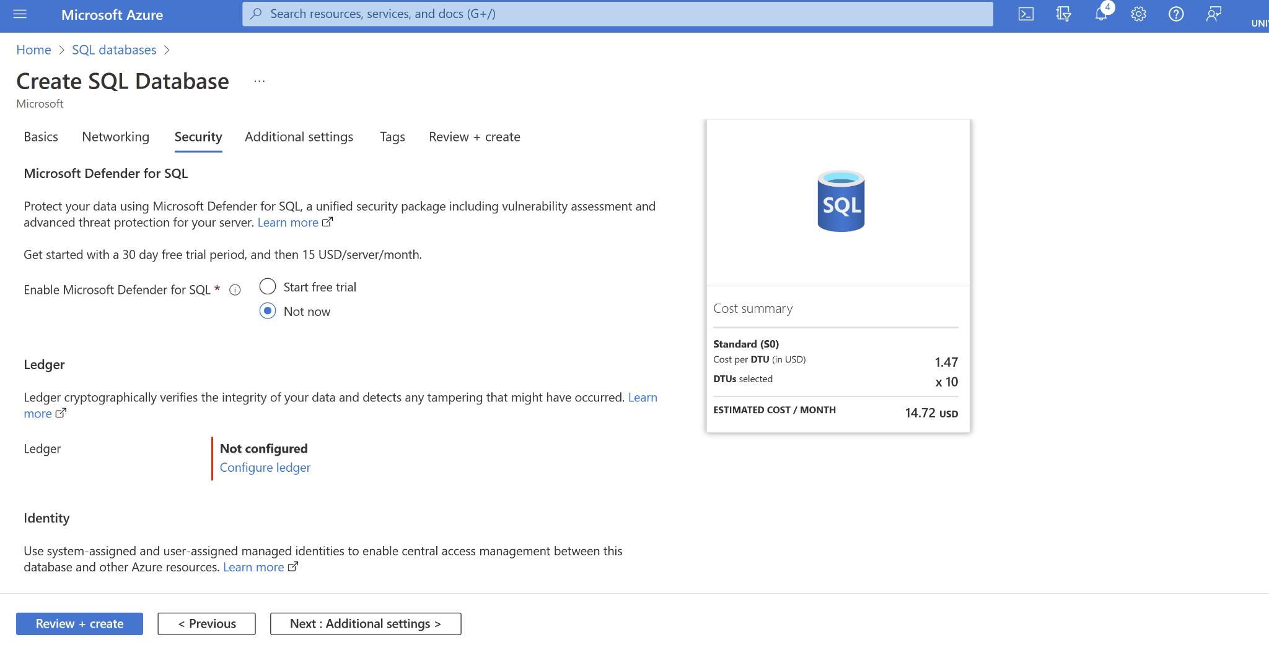
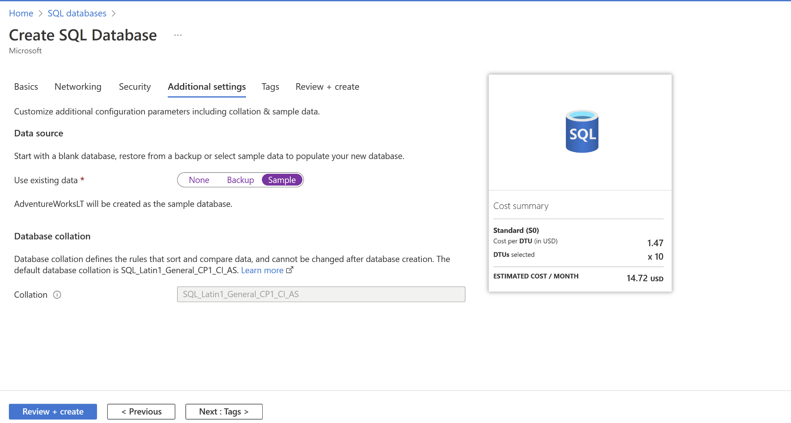

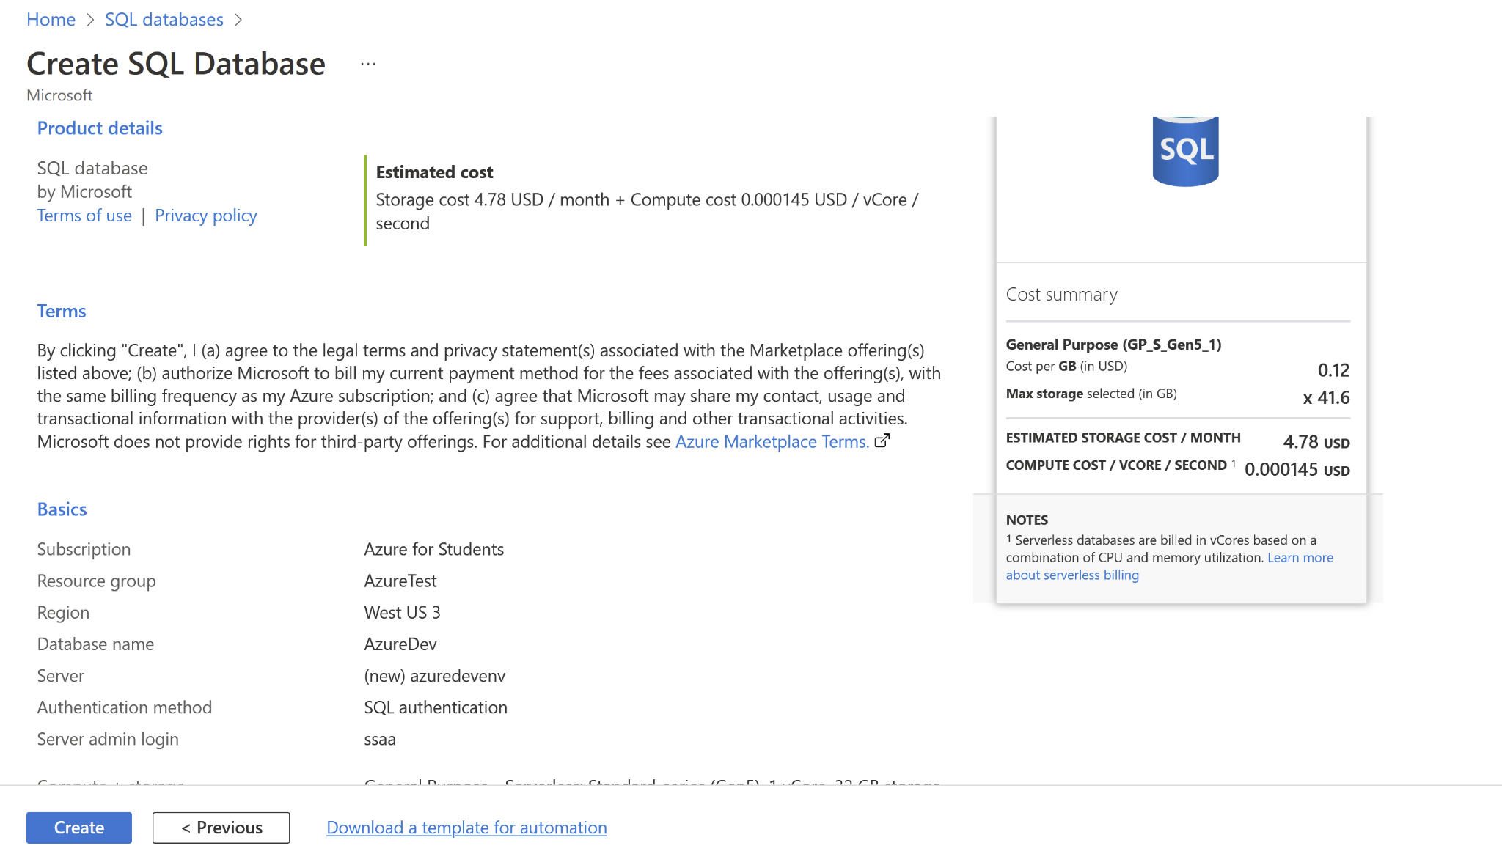

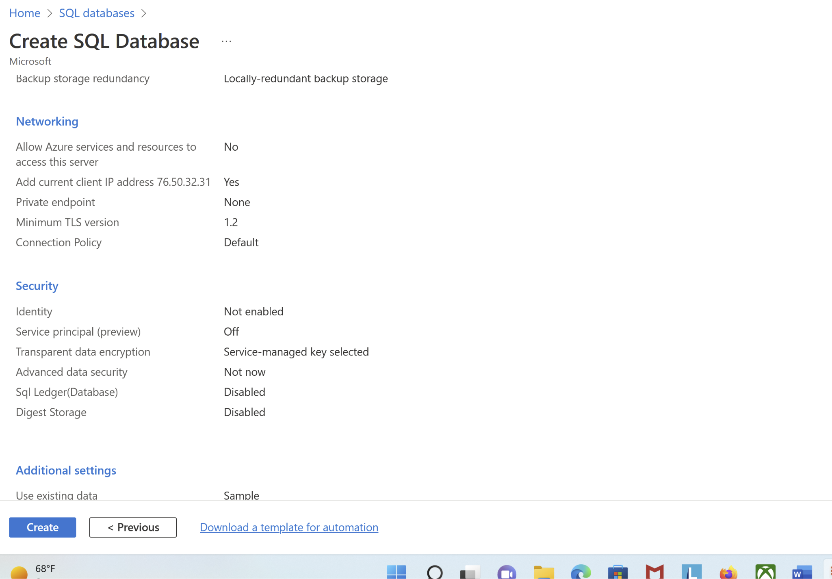

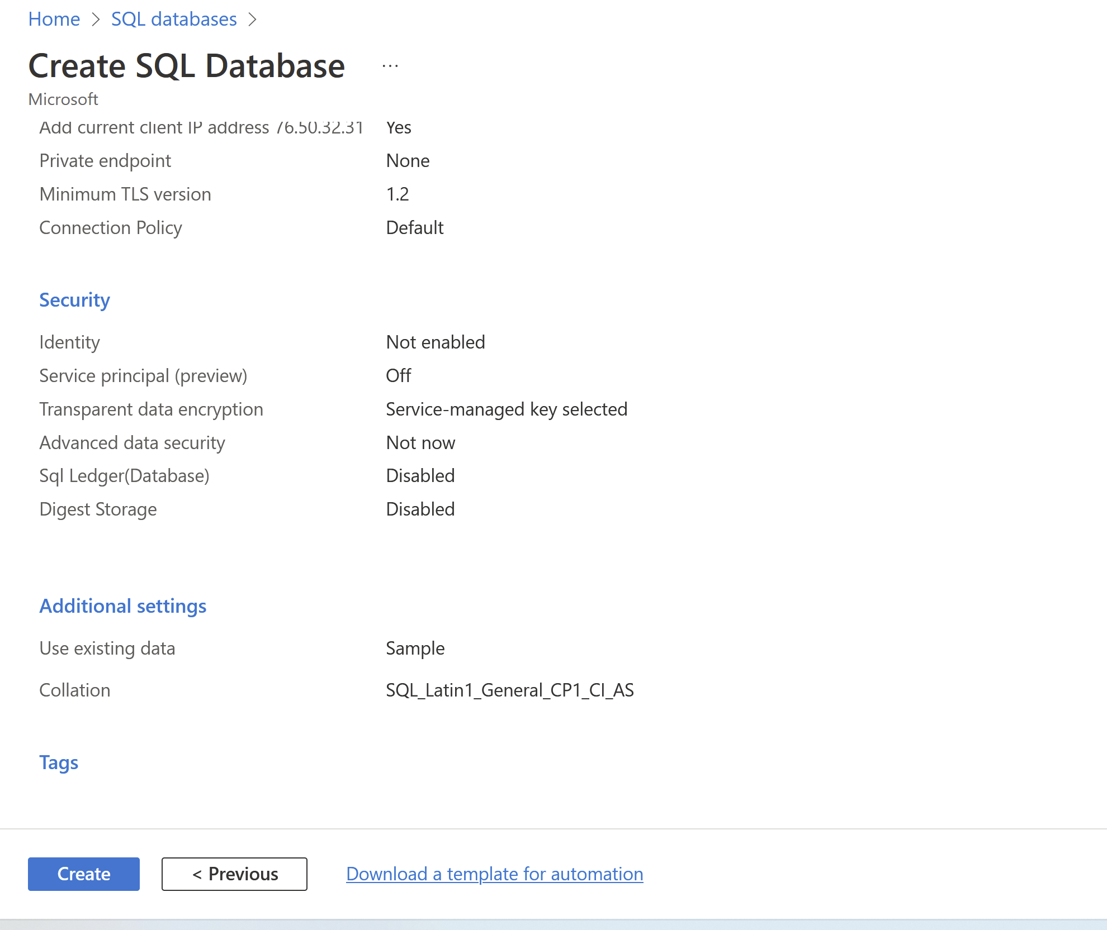

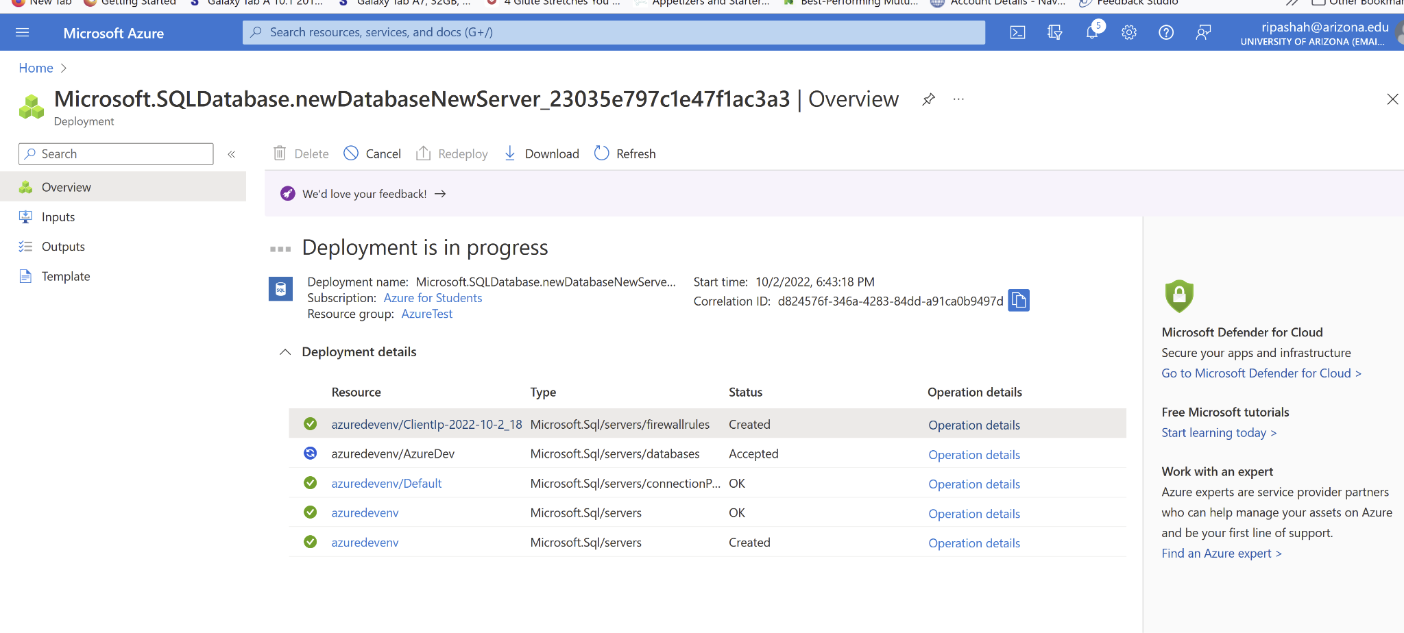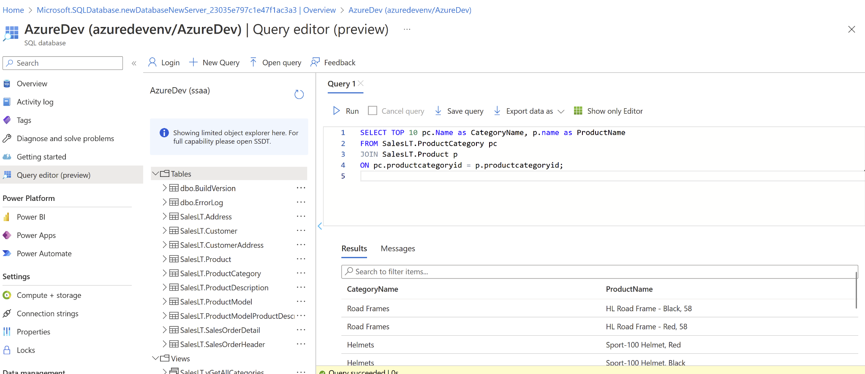’

Step 2: Summary of SQL database creation in Azure (5 points)
Write in one or two paragraphs what you have done and learned by creating a single database - Azure SQL Database – in Azure Portal.
First of all, I have to create azure student free account. Otherwise, it will charge money.
Azure SQL database is on the cloud so the backup will be stored on the cloud.
You just need to specify the server name, database name, authentication type, password, admin information and backup storage information while creating the azure database.
There are also other tabs including network and security. You can use those if you want to.
It will accept and start creating an account. I have provided the screenshots in the above question.

Step 3: Query the SQL database in Azure (5 points)
Query the database you created in Azure. You can use the Query editor (preview) in the Azure portal to connect to the database and query data.
Run the following query in the query editor of the database on the Azure portal and take a screenshot of the result of the query.
SELECT TOP 10 pc.Name as CategoryName, p.name as ProductName
FROM SalesLT.ProductCategory pc
JOIN SalesLT.Product p
ON pc.productcategoryid = p.productcategoryid;



Step 4: Describe the SQL database on Azure (5 points)
Analyze data in the tables in the SalesLT database schema using the Azure Query editor. Identify the primary key (PK) columns, and different data types, and observe the relationships among these tables. Write at least one paragraph.
In this database, I am seeing only primary keys but not foreign keys. It has dbo and SalesLT schema.

dbo.BuildVersion
dbo.ErrorLog
SalesLT.Address
SalesLT.Customer
SalesLT.CustomerAddress
SalesLT.Product
SalesLT.ProductCategory
SalesLT.ProductDescription
SalesLT.ProductModel
SalesLT.ProductModelProductDescription
SalesLT.SalesOrderDetail
SalesLT.SalesOrderHeader

Step 5: Clean up resources in Azure (5 points)
When you're finished using these resources, delete the resource group you created, which will also delete the server and single database within it. Show the screenshot that you deleted the resource group.

Upload your submission to the Week 6 Assignment Dropbox in D2L. The file name should be: Week6_Assignment_Part1_YourLastName.docx/pdf

