

**Department of CSE**

Mini Project Report

**Mini Project Title:** Give a comparative study of 8085, 6502, and NSC micro-processors.

**Submitted to:**

**Course Title:** Computer Architecture

**Course Code:** CSE360

**Course Instructor:** Assoc. Prof. Dr. Ahmed Wasif Reza, Department of Computer Science &amp; Engineering.

**Section:** 01

**Semester:** Summer 2021

**Submitted by:**

|  |  |
| --- | --- |
| **Name** | **ID** |
| Fariha Tabassum | 2018-3-60-077 |
| Plabon Hasan | 2018-2-60-028 |
| Tanjina Akter Ripa | 2018-3-60-024 |

**Date of Submission:** September 20, 2021

# Problem Statement: Have to give a comparative study of 8085, 6502, and NSC micro-processors.

# Introduction:

* **What is Processor:**

A processor or CPU is a portion of hardware (an integrated electronic circuit) that interprets the instructions as arithmetical, logical, input/output (I/O), and other basic instructions that enforce by a Computer Operating System.

* **What is Processor Made of:**

Processors are manufactured primarily from silicon, the second most common element on the planet (only the element oxygen is more common). Silicon is the primary ingredient in beach sand; however, in that form it isn't pure enough to be used in chips.

* **Here is some information given by image step by step,**

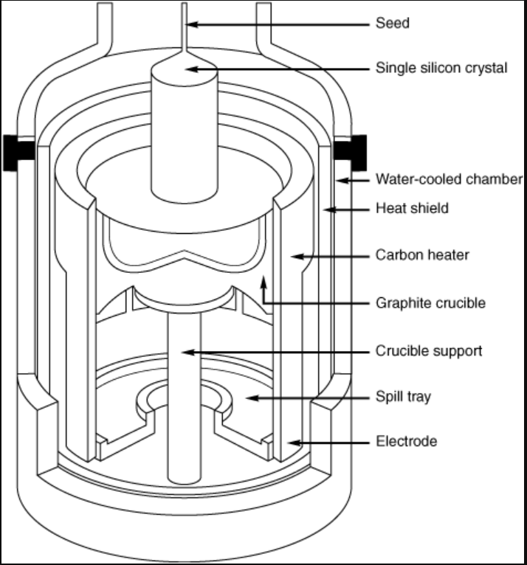

**Step: 01.** Growing a pure silicon ingot in a high-pressure, high-temperature oven.

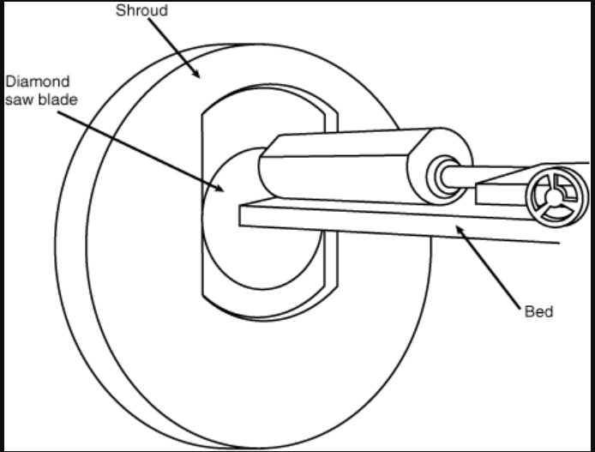

**Step: 02.** Slicing a silicon ingot into wafers with a diamond saw.

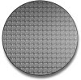

**Step: 03.** 200mm wafer of the 0.13-micron Pentium 4 processor

* **Here is some kind of processor,**

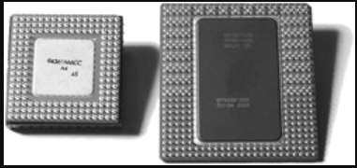

**Fig.01:** PGA on Pentium 66 (left) and dual-pattern SPGA on Pentium Pro (right).

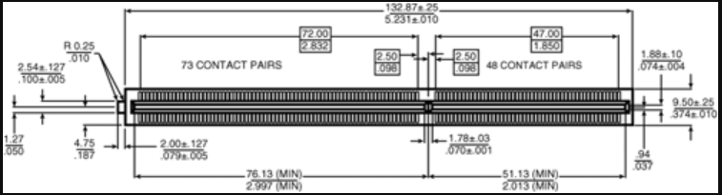

**Fig.02:** Pentium II Processor Slot 1 dimensions (metric/English).

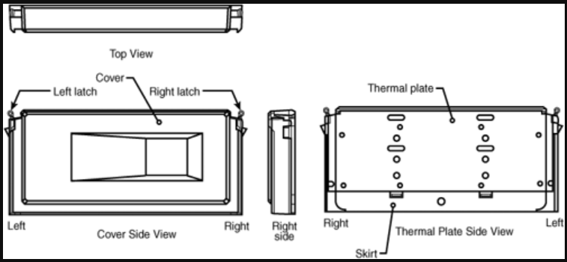

**Fig.03:** Pentium II Processor SEC package parts

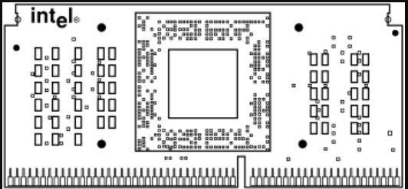

**Fig.04:** Celeron Processor SEP package front-side view.

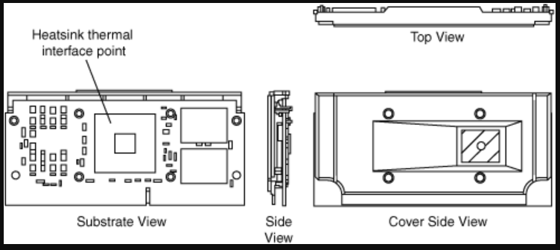

**Fig.05:** SECC2 packaging used in newer Pentium II and III processors.

* **What is Microprocessor:**

The microprocessor, any of a type of miniature electronic device (the central unit of a computer system) that contains arithmetic and logic operations, which usually perform actions like adding, subtracting, transferring numbers from one area to another, and comparing two numbers, despite that in arithmetic operation the multiplications and division cannot be perform.

* **Key Differences between Processor and Microprocessor:**
* The microprocessor is the latest and upgraded version of the processor or CPU.
* CPUs or processors can be microprocessors but all microprocessors are not CPUs.
* Although microprocessor is the latest and advanced technology but still, the main processing function of the computer is controlled by the processor. Etc.
* **Different type of Microprocessor:**

There are different types of microprocessors designed to be used for specific purposes. It has been evolved to be used in various different applications. They are mainly classified into three major types. As follows,

* **CISC** (Complex Instruction Set Computer) 🡪 CISC stands for Complex Instruction Set Computer may be designed to minimize the number of instructions per program and ignoring the number of cycles per instruction. The compiler does very little work to translate a high-level language into assembly-level language/machine code because the length of the code is relatively short, so very little RAM is required to store the instructions. The emphasis is on building complex instructions directly into the hardware.

**Example:** Intel 386, Intel 486, IBM 370/168, VAX 11/780, Intel 8048, Pentium, Pentium Pro, Pentium II, Pentium III, etc.

* **RISC** (Reduced Instruction Set Computer) 🡪 RISC is a microprocessor architecture that is designed to reduce the execution time by simplifying the instruction set of the computer. RISC stands for Reduced Instruction Set Computer. Within RISC processors each instruction needed only one clock cycle to execute results in uniform execution time. RISC chips are simple to design and inexpensive and reduce efficiency as there are many lines of code, hence more RAM is needed to store the instructions. The compiler of RISC also has to work more to convert high-level language instructions into machine code.

**Example:** IBM RS6000, DEC Alpha 21064, DEC Alpha 21164, Power PC: 601, 604, 615, 620, DEC Alpha: 210642, 211066, 21068, 21164, MIPS: TS (R10000) RISC Processor, PA-RISC: HP 7100LC etc.

* **EPIC** (Explicitly Parallel Instruction Computing) 🡪 EPIC stands for Explicitly Parallel Instruction Computing. The working of EPIC processors is supported by using a set of complex instructions which contain both basic instructions as well as the information of execution of parallel instructions. It substantially increases the efficiency of these processors.

**Example:** IA-64 (Intel Architecture-64), etc.

* **Evolution of Microprocessor:**
* First Generation 4-bit Microprocessor. This is the first microprocessor invented by Intel in 1971. They named it Intel 4004 because it was a 4-bit microprocessor.
* Second Generation 8-bit Microprocessor. The Second generation processor was an 8-bit microprocessor developed by Intel in the year 1973. It was named Intel 8008 because it was 8 bit.
* Third Generation 16-bit Microprocessor. The third generation microprocessors were 16-bit microprocessors introduced in 1978 by Intel. 80286 is a 3rd generation microprocessor.
* Fourth Generation 32-bit Microprocessor. The Fourth generation microprocessors were introduced in 1985 and they were 32 bit. 80386 or also known as i386 or just 386 is the most renowned 4th generation microprocessor.
* Fifth Generation 64-bit Microprocessor. The fifth-generation microprocessor or 64-bit microprocessors were introduced in 1995 and they are being used till now. The Intel Pentium processors were based on 64-bit architecture. The recent 64-bit microprocessor use super scaling to offer high speed and high performance such as Intel dual, quad, octa-core microprocessors.
* **Definition and History:**
* **8085 Microprocessor:**

**8085** was the first commercially successful microprocessor by Intel. **8085** is an 8-bit microprocessor as it operates on 8 bits at a time and is created with N-MOS technology also it spread some unique characteristics and this is the reason it still holds popularity among the microprocessors.

* **6502 Microprocessor:**

**6502**, an eight-bit microprocessor was designed by MOS Technology around 1975 and made by Rockwell. **6502** (MOS Technology) is an 8-bit microprocessor that was designed by a small team led by Chuck Peddle for MOS Technology. The design team had formerly worked at Motorola on the Motorola 6800 project.**6502** is essentially a simplified, less expensive, and faster version of that design.

* **NSC Microprocessor:**

National Semiconductor or **NSC** was an American semiconductor manufacturer which specialized in analog devices and subsystems, formerly with headquarters in Santa Clara, California. The company produced power management integrated circuit, display drivers, audio and operational amplifiers, communication interface products and data conversion solutions. National's key markets included wireless handsets, displays and a variety of broad electronics markets, including medical, automotive, industrial and test and measurement applications.

* **Clock Rate of 8085, 6502, and NSC Microprocessor:**

Each and every CPU, there is a particular wire that turns on and off at a steady rate to help keep everything in sync and that wire is called the clock. In **6502** processor clock turning twice in a second. Modern CPUs are measured in gigahertz. Giga meaning billion and hertz meaning times per second. So the clock in modern CPUs turns on several billion times per second. As well as **8085** microprocessor clock rate is 3, 5 and 6 megahertz. National Semiconductor or **NSC** microprocessor 500 kHz, 715 kHz, and 1 Mega Hz. That speed is what allows CPUs to do very complicated things so quickly.

* **Clock Circuit of 8085, 6502, and NSC Microprocessor:**

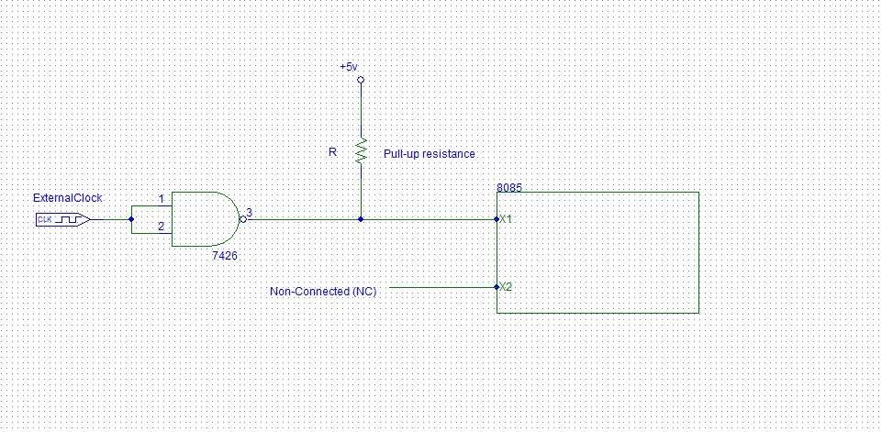

**Fig.01: 8085** Microprocessor Clock Circuit

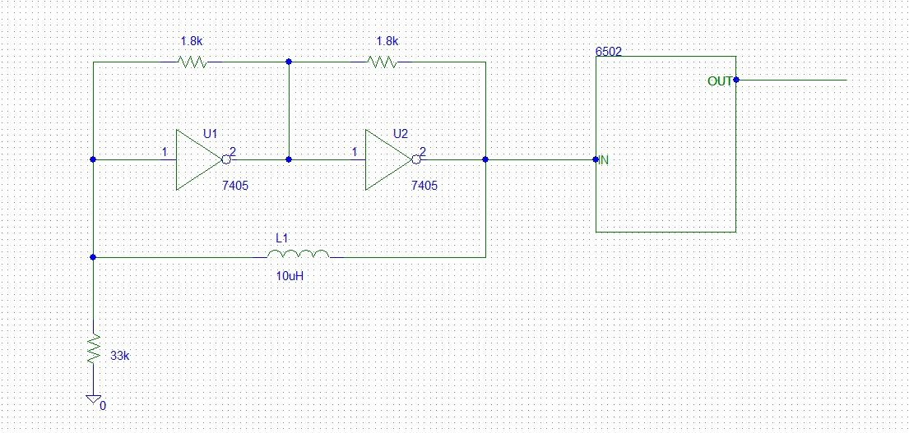

**Fig.02: 6502** Microprocessor Clock Circuit

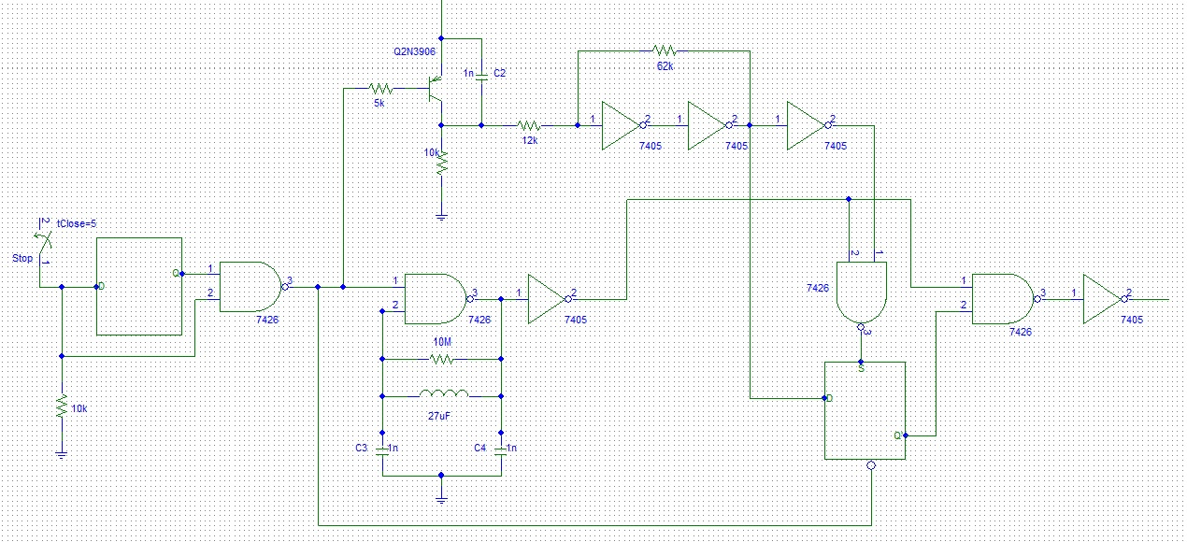

**Fig.03: NSC** Microprocessor Clock Circuit

* **Pin Diagram of 8085 , 6502 and NSC Microprocessor:**

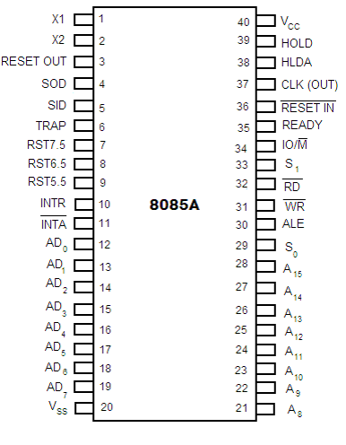

**Fig.01: 8085** Microprocessor CPU Pin Diagram

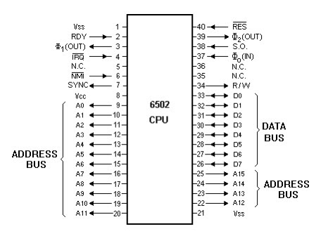

**Fig.02: 6502** Microprocessor CPU Pin Diagram

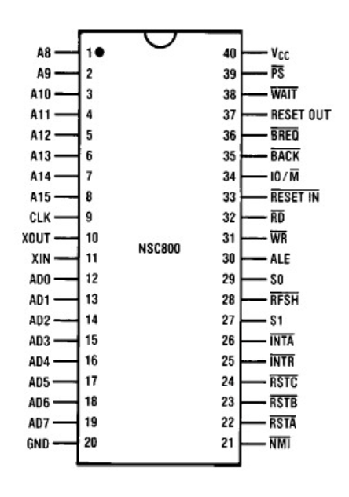

**Fig.03: NSC800** Microprocessor CPU Pin Diagram

* **Internal Architecture Of 8085 , 6502 and NSC Microprocessor:**

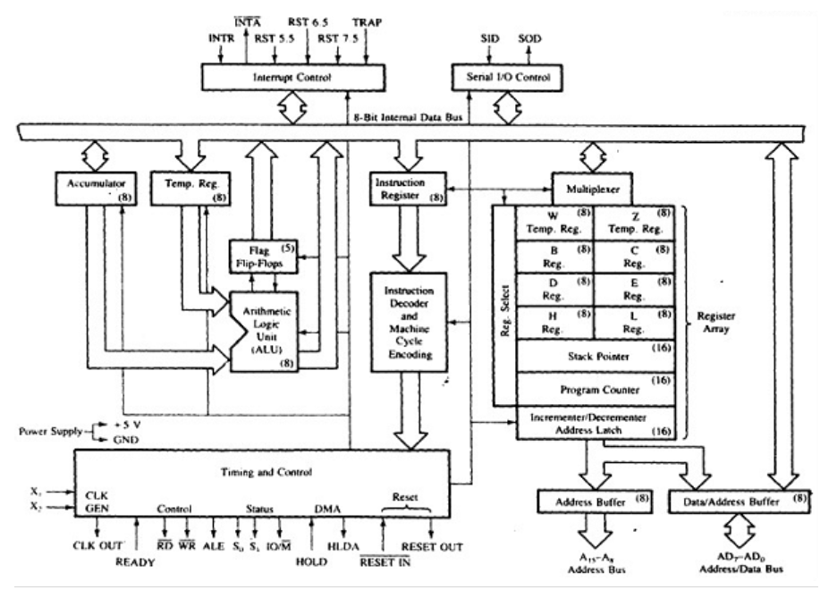

**Fig.01:** Internal Architecture of **8085** Microprocessor

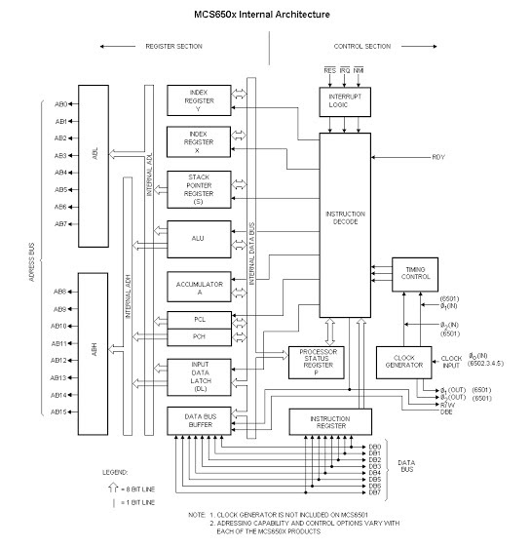

**Fig.02:** Internal Architecture of **6502** Microprocessor

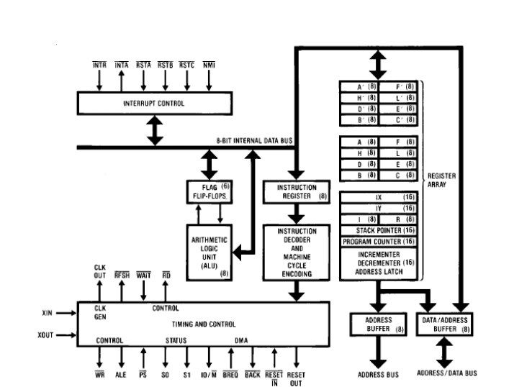

**Fig.03:** Internal Architecture of **NSC800** Microprocessor

* **Register of 8085, 6502, NSC Microprocessor:**

A processor register is a quickly accessible location available to a computer's processor. Registers usually consist of a small amount of fast storage, although some registers have specific hardware functions, and may be read-only or write-only. In computer architecture, registers are typically addressed by mechanisms other than main memory, but may in some cases be assigned a memory address e.g. DEC PDP-10, ICT 1900. Almost all computers, whether load/store architecture or not, load data from a larger memory into registers where it is used for arithmetic operation and is manipulated or tested by machine instruction. Manipulated data is then often stored back to main memory, either by the same instruction or by a subsequent one. Modern processors use either static or dynamic RAM as main memory, with the latter usually accessed via one or more cache levels.

* **8085 Microprocessor:**

The **8085** microprocessor contains six 8-bit general purpose registers. They are: B, D, C, E, H and L register. To hold data of 16-bit a combination of two 8-bit registers can be employed. The combination of two 8-bit registers is called a register pair. There is an accumulator and temporary register.

* **6502 Microprocessor:**

The **6502** has one main 8-bit accumulator register and two auxiliary 8-bit index registers called X and Y. The index registers are often used as array subscripts when referencing memory. Instructions are one, two, or three bytes in length. Six internal and 1 temporary register.

* **NSC Microprocessor:**

The National Semiconductor or **NSC** internally provided five registers plus the program counter. Subroutine and Interrupt handling were implemented by Pointer Register 3 (P3) although this could also be used as a general purpose 16 bit Index register.

* **Accumulator of 8085, 6502, and NSC Microprocessor:**

The accumulator is an 8-bit register that is a part of the arithmetic/logic unit (ALU). This register is used to store 8-bit data and to perform arithmetic and logical operations. The result of an operation is stored in the accumulator. The accumulator is also identified as register A.

* **8085 Microprocessor:**

Register A is an 8-bit register used in **8085** to perform arithmetic, logical, I/O & LOAD/STORE operations. Register A is quite often called an Accumulator. An accumulator is a register for short-term, intermediate storage of arithmetic and logic data in a computer's CPU (Central Processing Unit).In an arithmetic operation involving two operands, one operand has tobe in this register. And the result of the arithmetic operation will be stored or accumulated in this register. Similarly, in a logical operation involving two operands, one operand has to be in the accumulator. Also, some other operations, like complementing and decimal adjustment, can be performed only on the accumulator.

* **6502 Microprocessor:**

The **6502** family microprocessors usually consist of six registers. Accumulators, being one of the six registers, are always regarded as the most important registers. It is because the 6502 Microprocessor family regards their accumulators as a place storing the result from almost all types of arithmetic and logical operation.

* **NSC Microprocessor:**

**NSC**'s IPC-16A/520 PACE, short for "Processing and Control Element", was the first commercial single-chip 16-bit microprocessor PACE had four general-purpose accumulation, with an instruction architecture loosely based on the earlier IMP-16(The IMP-16, by National Semiconductor, was the first multi-chip 16-bit microprocessor, released in 1973) architecture, which in turn had been inspired by the Data General Nova minicomputer.

* **Temporary Register of 8085, 6502, NSC Microprocessor:**

Temporary register is also an 8-bit register which the programmer can't access at all.

* **8085 Microprocessor:**

Temporary register is temporarily stored inside an **8085** microprocessor which is 8 bit operand to the instruction set. For example, when the fetching of instructions “MVI M, 34H” is done the instruction register IR register will receive the OPCode for MVI M, and the Temp register receives 34H.

* **6502 Microprocessor:**

The **6502** Microprocessor uses seven Registers (6 Internal, 1 Temporary) in data manipulation/handling.

* **NSC Microprocessor:**

There is no temporary register in National Semiconductor or **NSC**.

* **Uses:**
* **8085 Microprocessor:**

**8085** uses in washing machines, microwave ovens, mobile phones, etc.

* **6502 Microprocessor:**

**6502** uses in the BBC Microcomputer, Apple II, Commodore PET, the Commodore 64, not to mention game systems like the Nintendo Entertainment System Apple Computer, and Atari personal computers.

* **NSC Microprocessor:**

**NSC** uses in a unique feature of the SC/MP is a daisy-chained control pin that allowed up to three SC/MP's share a single main memory to produce a multiprocessor system. NSC uses a unique feature of the SC/MP is a daisy-chained control pin that allowed up to three SC/MP's share a single main memory to produce a multiprocessor system.

* **Comparison Chart:**

|  |  |  |  |
| --- | --- | --- | --- |
| **Basis of Comparison** | **8085 Microprocessor** | **6502 Microprocessor** | **NSC Microprocessor** |
| * **Micro-Processor Type** | 8 bit | 8 bit | 8 bit |
| * **Size of Data Bus** | 8 bit | 8 bit | 32 bit |
| * **Size of Address Bus** | 16 bit | 16 bit | 23 bit |
| * **Supportable Memory Capacity** | 64 KB | 64 KB | 256 KB |
| * **Operating Frequency** | 3 MHz – 6MHz | 1 MHz, 2 MHz, & 3 MHz | 2.5 MHz – 4 MHz |
| * **Number of Flags Present** | 8 | 7 (bits) | 6 (status bits) |
| * **Number of Transistors** | Around 6500 | Around 3510, Around 3218 | **……………….** |
| * **Instruction Set** | 8085 | MOS 6502 | Powerful set of 158 |
| * **Pipelining** | Unsupportable | Supportable | Supportable |
| * **Cost** | Low | Low | Cost Effective |
| * **Memory Segmentation** | Unsupportable | Unsupportable | Unsupportable |
| * **Instruction Queue** | Absent | Present | Present |

**\*in this chart information’s of 8085, 6502, and NSC was collected from different resources**

* **Analysis:**

**8085** is an 8-bit microprocessor as it operates on 8 bits at a time and is created with N-MOS technology. This microprocessor exhibits some unique characteristics and this is the reason it still holds popularity among the microprocessors. Basically, 8085 was the first commercially successful microprocessor by Intel. As some of the architectural drawbacks associated with 8080 was also eliminated by **8085**.

The **6502** has three basic layers. The bottom layer is a wafer of silicon known as the "substrate." Above it is a thin layer of polysilicon wires that form transistors and build circuits around the chip. The top layer is thick metal wiring primarily for supplying power. Its bulky structures obscure the polysilicon's complex maze of wiring. Wires in a single layer can't cross over one another, so connections can be made between layers to clear the cobweb of polysilicon and pack circuits closer together.

A detailed analysis of the SEU vulnerability of the Zilog Z-80 microprocessor is presented based upon data obtained with heavy ions and protons. The analysis demonstrates a method for separating upsets of the general purpose registers from upsets of the internal latches. Furthermore, the analysis shows that the bulk of the upsets observed below a LET value of 4 Mev-cmsq/mg is associated with upset of these internal latches. To obtain the data which made this analysis possible, a novel test technique was developed which associates all upsets with the machine cycle during which they first appear on the device pins. Limited data for the **NSC-800** are included.

* **Conclusion:**

In this report, we have studied **8085**, **6502**, and **NSC** microprocessors. As we know one of the greatest inventions to technology was the microprocessor because it makes life easier to inflict effect on technologic engineering, different prospects of life, and stores data larger than the size of the actual chip which makes technology easier to use. The outcome of the microprocessor on life had an argument on whether it was for the better the invention or not. Though **8085**, **6502**, and **NSC** microprocessors are from different constitutions they all make an impact on a person's life in different ways and also better ways day by day. The constitutions are working on the improvement of microprocessors day by day thus people can get their daily work easier. Overall can say that the **8085** microprocessor, **6502** microprocessor, and **NSC** microprocessor these three microprocessors are different but they have been used for the same purpose.

* **References:**
* Datasheet on NSC800TM High-Performance Low-Power CMOS Microprocessor from Datasheet:https://www.datasheetarchive.com/pdf/download.php?id=d3fd1ee7b2161f73b370e7056e48e2d006adbb&type=M&term=NSC800
* Intel 8085 from Wikipedia: https://en.wikipedia.org/wiki/Intel_8085
* MOS Technology 6502 from Wikipedia: https://en.wikipedia.org/wiki/MOS_Technology_6502

# SEU Vulnerability of the Zilog Z-80 and NSC-800 Microprocessors from https://ieeexplore.ieee.org/document/4334095?fbclid=IwAR16hp_yRld6cTnc5nLIYlP5fgZ-JO5a30R7o-uHnTQ47XuRd69SIr97FOg

# The 8085 Microprocessor Architecture: Working & Its Applications from https://www.elprocus.com/8085-microprocessor-architecture/?fbclid=IwAR2NCxozk4S0lTmViuR9IDPLhN8qk_0wHCMa0jfSlXHJPSipjt_zxHwULNE