**AI-Powered Excel Mock Interviewer**

The system conducts a 5-question technical interview on Excel skills, progressing from beginner to advanced levels, with dynamic follow-ups if misunderstandings are detected. After 5 questions, it delivers personalized feedback.

**Agentic AI Workflows:**



This document describes the function and behavior of each node in the LangGraph-powered Excel interview workflow. The system simulates a structured technical interview consisting of five adaptive questions, progressing from foundational to advanced Excel concepts. Each node represents a discrete step in the conversation flow, managing state transitions, question delivery, evaluation logic, and feedback generation.

**Nodes Overview**

**1. Greeting**

**Purpose**

Serves as the entry point of the interview process. Introduces the AI interviewer and sets expectations for the session.

**Behavior**

- Delivers a warm, concise welcome message.

- Explains that the interview will consist of exactly five questions.

- Asks the user if they are ready to begin.

- Initializes key state variables such as `total_questions`, `skills_assessed`, and `asked_questions`.

**Role in Flow**

Triggers the start of the interaction and routes control unconditionally to the first content node (`warm_up`).

**2. warm_up**

**Purpose**

Presents the first technical question, designed at a beginner level to ease the candidate into the interview.

**Behavior**

- Generates a unique beginner-level Excel question (e.g., related to basic functions like `IF`, `SUM`, or formatting).

- Ensures the question has not been previously asked during the session.

- Records the generated question in the state to prevent repetition.

- Outputs the question to the user via an AI message.

**Role in Flow**

Marks the beginning of skill assessment. After response, transitions to `evaluate_warmup`.

**3. evaluate_warmup**

**Purpose**

Evaluates the user’s response to the initial warm-up question using LLM-based scoring.

**Behavior**

- Extracts the last human message (user answer) and corresponding AI-generated question.

- Uses a rubric embedded in the question metadata to assess correctness.

- Classifies the response as `CORRECT`, `PARTIAL`, or `INCORRECT`.

- Updates performance metrics including:

- `total_questions`

- `correct_answers`

- `skills_assessed` dictionary

- List of `misunderstandings` (if incorrect)

**Role in Flow**

Unconditionally advances to `core_technical`, regardless of evaluation outcome. This ensures progression while still logging performance.

**4. core_technical**

**Purpose**

Asks an intermediate-level Excel question focused on core functionalities such as lookup functions, data validation, or conditional formatting.

**Behavior**

- Selects and generates a new intermediate-difficulty question.

- Avoids repeating prior questions by referencing the `asked_questions` list.

- Stores the current question context in the state for later evaluation.

**Role in Flow**

Part of the main assessment sequence. After the user responds, control passes to `evaluate_core`.

**5. evaluate_core**

**Purpose**

Assesses the accuracy and completeness of the user's answer to the first intermediate question.

**Behavior**

- Performs semantic evaluation using an LLM guided by a predefined rubric.

- Determines whether the response demonstrates sufficient understanding.

- Increments counters and tracks skill proficiency based on rating.

- If the answer is `CORRECT` or `PARTIAL`, proceeds to `core_technical2`.

- If `INCORRECT`, diverts to `follow_up` for clarification.

**Role in Flow**

Introduces conditional branching based on performance — enabling adaptive questioning.

**6. core_technical2**

**Purpose**

Presents a second intermediate-level question to further probe core Excel competencies.

**Behavior**

- Similar to `core_technical`, but occurs only after successful completion (or partial success) of the first core question.

- Maintains diversity in topic coverage (e.g., moving from lookups to date functions or error handling).

**Role in Flow**

Second stage of mid-level assessment. On completion, transitions to `evaluate_core2`.

**7. evaluate_core2**

**Purpose**

Evaluates the response to the second intermediate question.

**Behavior**

- Applies the same LLM-driven evaluation framework as `evaluate_core`.

- Updates state with results.

- Routes correctly answered responses to `scenario`.

- Redirects poor answers to `follow_up` for remediation.

**Role in Flow**

Final gate before advancing to advanced topics; reinforces consistency in understanding.

**8. scenario**

**Purpose**

Delivers an advanced, scenario-based question requiring synthesis of multiple Excel features (e.g., PivotTables, dynamic arrays, or cross-sheet analysis).

**Behavior**

- Focuses on real-world use cases such as reporting, automation, or large dataset management.

- Encourages problem-solving over rote recall.

**Role in Flow**

Represents the penultimate challenge. After response, moves to `evaluate_scenario`.

**9. evaluate_scenario**

**Purpose**

Evaluates the candidate’s ability to handle complex, applied Excel tasks.

**Behavior**

- Judges depth, practicality, and conceptual clarity of the response.

- Logs skill mastery and identifies high-level gaps.

- Successful answers proceed to `candidate_qa`.

- Incorrect responses trigger a supportive `follow_up`.

**Role in Flow**

Tests higher-order thinking; failure here still allows recovery via follow-up dialogue.

**10. candidate_qa**

**Purpose**

Asks the fifth and final question — typically another advanced or open-ended prompt allowing the candidate to demonstrate expertise.

**Behavior**

- Acts as the concluding assessment item.

- May revisit a weakened area or explore a new advanced topic (e.g., macros, Power Query, or dashboard design).

- Always followed by evaluation and termination.

**Role in Flow**

Ensures the interview concludes after exactly five questions, even if earlier paths were rerouted.

**11. evaluate_final**

**Purpose**

Scores the final answer and triggers conclusion of the interview.

**Behavior**

- Evaluates the last response using standard rubric-based judgment.

- Regardless of outcome, advances to `wrap_up` because the maximum question limit (5) has been reached.

**Role in Flow**

Guarantees termination after five questions, enforcing fixed-length interview structure.

**12. follow_up**

**Purpose**

Provides a supportive, clarifying question when the system detects a misunderstanding.

**Behavior**

- Analyzes the failed question and crafts a simpler, probing version.

- Designed to be non-punitive and encouraging.

- Does not generate a new formal question — instead seeks explanation or reasoning.

**Role in Flow**

Acts as a remedial loop to gather more insight before resuming the main path. Prevents premature advancement while maintaining engagement.

**13. evaluate_followup**

**Purpose**

Processes the user’s response to the follow-up question.

**Behavior**

- Does not re-evaluate correctness.

- Assumes diagnostic purpose is fulfilled upon response.

- Resumes the primary interview path:

- If fewer than 4 questions completed → returns to `scenario`

- Otherwise → proceeds to `candidate_qa`

**Role in Flow**

Serves as a routing node, reintegrating the conversation back into the main assessment track after intervention.

**14. wrap_up**

**Purpose**

Generates personalized, constructive feedback summarizing the candidate’s performance.

**Behavior**

- Computes overall accuracy and infers confidence level:

- >70% → Advanced

- 40–70% → Intermediate

- <40% → Beginner

- Aggregates assessed skills and identified misunderstandings.

- Crafts a mentor-like summary highlighting strengths, growth areas, and one actionable tip.

- Marks `interview_complete = True` and prepares final output.

**Role in Flow**

Terminal action node. Finalizes state and delivers comprehensive closing message before ending the graph.

**15. END**

**Purpose**

Terminates the execution of the graph.

**Behavior**

No processing occurs. Signifies end-of-interview.

**Role in Flow**

Final destination in all paths. Reached via `wrap_up`.

**Tech Stack**

- LangGraph: Orchestrates the stateful interview workflow using a directed graph of nodes for conversation flow and decision-making.

- LangChain: Provides core framework for chains, prompts, memory, and integration with LLMs.

- ChatGroq + Llama-3.1-8b-instant: Powers fast, efficient reasoning and response generation with low latency.

- Streamlit: Enables simple, interactive web UI for real-time chat interface and user input handling.

- Python Typing (TypedDict): Ensures structured, type-safe state management across the graph.

- JSON + LLM Parsing: Used for structured output generation (e.g., questions, evaluations) via prompt engineering.

**System Architecture**

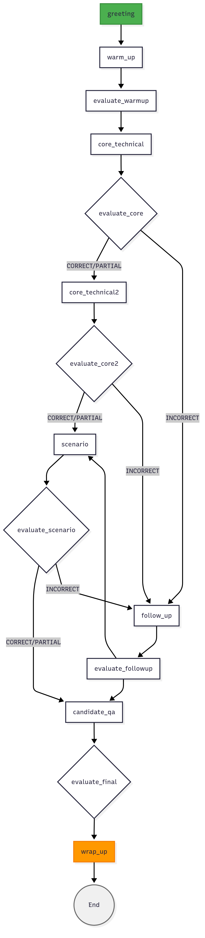

**Sample Conversation:**

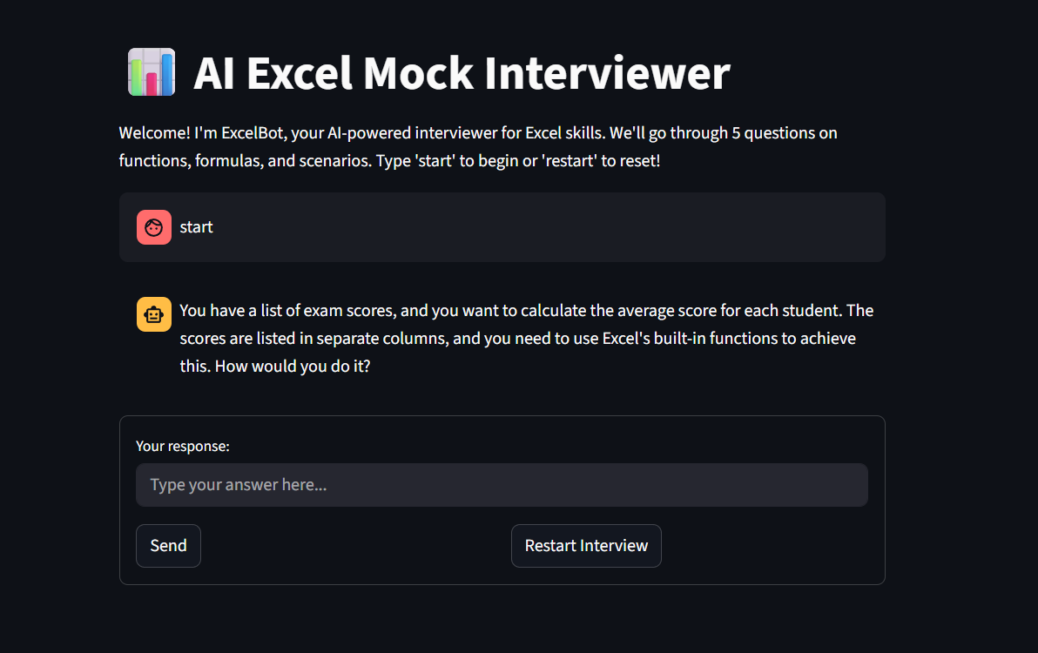

**Future Scope: Enhancements with VLM, MCP, TTS, and STT**

- Vision Language Model (VLM) Integration: Enable candidates to upload Excel screenshots or formula snippets for real-time analysis and feedback using models like GPT-4o, allowing the bot to see and explain errors in visual spreadsheets.

- Multimodal Context Processing (MCP): Combine text, images, and structured data (e.g., CSV/Excel files) to simulate real-world tasks — such as interpreting charts or debugging pivot tables — for a more comprehensive skill assessment.

- Speech-to-Text (STT) Support: Allow voice responses during the interview, making the experience more natural and accessible, especially on mobile devices, using APIs like Whisper or Google STT.

- Text-to-Speech (TTS) Output: Deliver AI interviewer responses via natural-sounding voice narration, improving engagement and enabling hands-free interaction.