

IISxpressAPI User Manual

Version 2.1A

© Copyright 2007 Ripcord Software.
All rights reserved.

Introduction
The IISxpressAPI is a .NET programming interface for IISxpress 2.0 and higher. To use the API you must have an installation of IISxpress and the Microsoft .NET 2.0 Framework. The examples in this document assume that you have a working knowledge of C# and in some cases technologies like ASP.NET.

For more information about IISxpress please consult the Ripcord Software website using the following URL: http://www.ripcordsoftware.com.

Background
The IISxpress compression plug-in for IIS exposes a programming interface via the IISxpressAPI.DLL .NET 2.0 assembly. IISxpress is a native COM application, the IISxpressAPI.DLL file provides the call interface to the COM server. You do not need COM knowledge in order to use the IISxpressAPI.

The IISxpressAPI contains a CHM help file which displays information about the API in the same format as the Visual Studio help files. We recommend viewing this file for detailed information about the API.

The IISxpressAPI.DLL file is a signed .NET assembly, you can therefore install it into the GAC on your system. All .NET applications would therefore be able to use the same API DLL, alternately you can just copy the DLL to the appropriate place on your system.

It is important that you match the API version to the version of IISxpress you are using. If you mismatch the versions you may observe undesirable behavior.

The IISxpressAPI uses the IISxpressAPIException type to report error conditions. This special exception type exposes the HResult property which can be queried by the caller to determine the source of the error. When COM is the source of the error this code can be used to help track down the source of the fault. If you have access to Visual Studio you probably have installed the 'Error Lookup' tool. This tool can map COM (and Windows) error codes to a standard error string. For example the error code 5 will be mapped to 'Access is denied.'
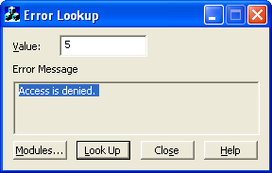Illustration 1: Error Lookup tool output

Quick Start
The IISxpressAPI contains the API DLL assembly, a CHM help file and a sample ASP.NET page which calls the API and displays the results in a web page. In this section of the document we will get your web server to process this ASPX page and display the result in a browser window.

For this example to work correctly you should have the Microsoft .NET Framework 2.0 installed and ASP.NET processing enabled on your web server. If IIS fails to process the ASPX page you should check that ASP.NET is enabled on your server.

File System
First we need to create a file system directory in your web server directory. If you have a default installation this will probably be c:\inetpub\wwwroot. Navigate to this directory and create a new sub-directory called stats.

Copy the supplied web.config and stats.aspx files into the new stats sub-directory. Now create a new sub-directory under stats called bin.
Copy the IISxpressAPI.DLL file into the newly created bin sub-directory.
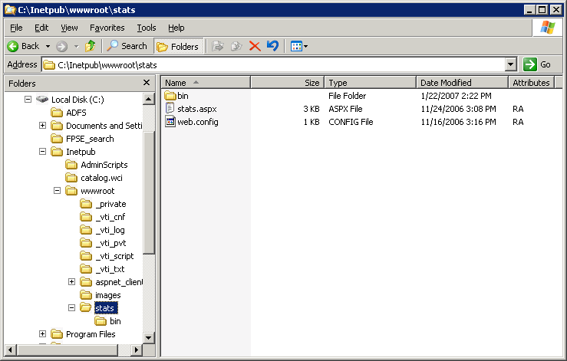Illustration 2: Create the stats directory
Create the stats directory in
your web server's directory tree

Web Server
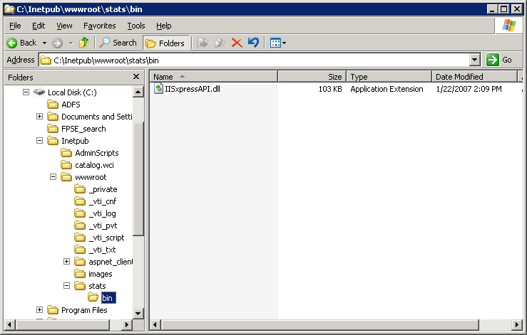Illustration 3: Create the bin directory
Create the bin directory under the
new stats directory
You now need to create a virtual directory so that IIS will process the web.config file properly. Open the IIS Manager, open the web site hierarchy on the left of the window until you see the stats directory you created earlier. Right click on the appropriate web site item in the tree and select New►Virtual Directory from the context menu.
The Virtual Directory Creation Wizard dialog will now be displayed. Click the next button to move onto the second wizard page.
Illustration 4: Create the virtual directory in the IIS Manager
You must now specify the name of the virtual directory, in this example we will set the name to stats. Now click next to move onto the next page.
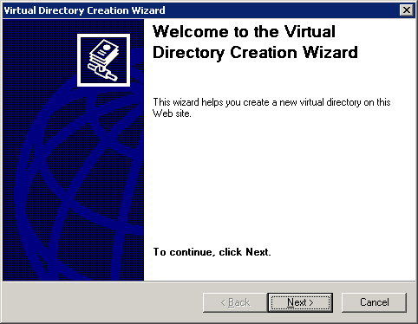Illustration 5: The Virtual Directory Creation Wizard
You must now specify the path to the directory containing the stats.aspx page you copied earlier. This directory will probably be c:\inetpub\wwwroot\stats. Now press the next button to move onto the next page.
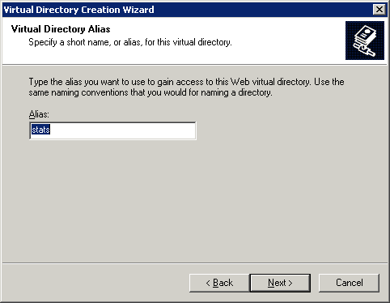Illustration 6: Set the virtual directory alias
The 'Virtual Directory Access Permission' page is now displayed. Make sure you select the 'Run scripts (such as ASP)' option. Now press the next button to move onto the next page.
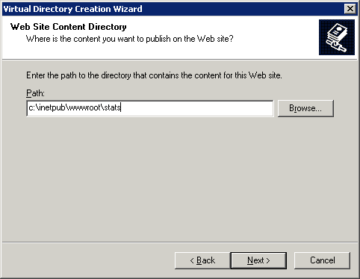Illustration 7: Set the file system path for the new virtual directory
You have now completed the virtual directory creation process, click the Finish button.
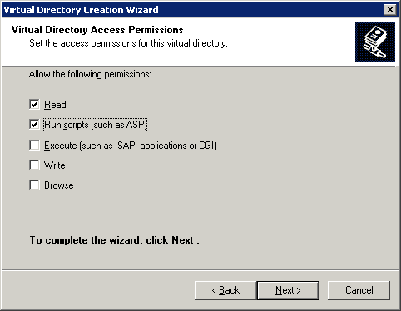Illustration 8: Set the virtual directory permissions
Make sure scripts are enabled
The stats item in the hierarchy on the left of the IIS Manager window should now have changed to a cog icon, this denotes that it able to run the ASPX script.
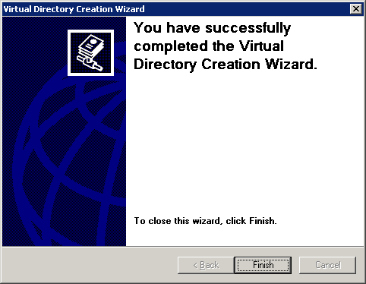Illustration 9: The Virtual Directory has now been created

Browser Window
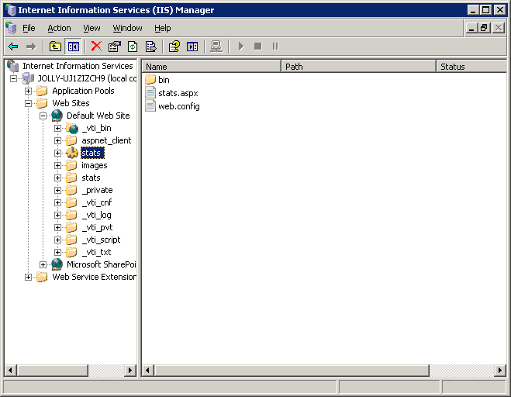Illustration 10: The stats Virtual Directory has now been created
The Virtual Directory must have a cog icon
which denotes that it can run scripts
Now it's time to test the stats.aspx page. Open a browser window and enter the URL for the web site where you added the stats virtual directory.
The browser should render a page similar to Illustration 11.
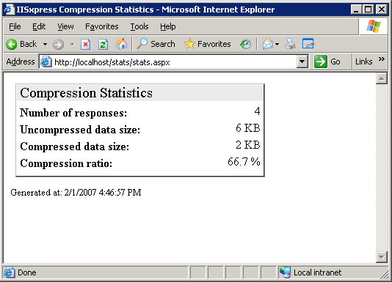Illustration 11: Browser window showing rendered ASP.NET page

If the HTML is displayed but it does not contain any stats data then it means that either the IISxpress service is not running or no responses have been compressed. Try pressing F5 in your browser window to refresh the data, if no stats data appears then check that the IISxpress service is running by opening the Service Manager window as shown in Illustration 12.
Since you are running tests on the same computer as the web server IISxpress may not be compressing the responses, during testing you can switch off the 'Exclude compression requests from the local computer' option as shown in Illustration 13.
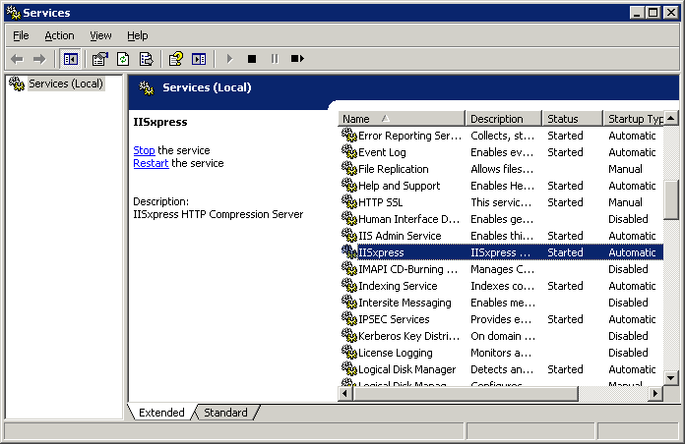Illustration 12: Service Manager window
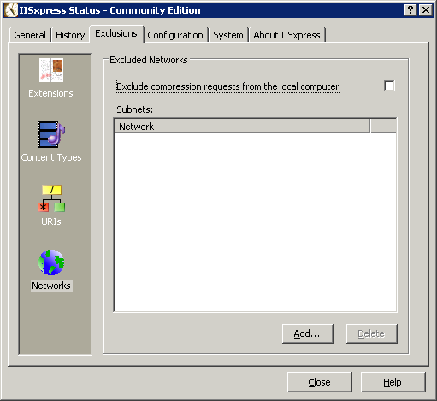Illustration 13: Switch off the 'Exclude compression requests from the local computer' option during testing
During testing you may
want to switch this off

API Documentation

CompressionStats Class
The CompressionStats class allows access to global compression statistics. This class can be consumed by any .NET language running under ASP.NET or otherwise.

GetStats() Method
The GetStats() method gets the compression statistics from the IISxpress server process. The declaration is as follows:
public void GetStats(out uint filesCompressed, out uint rawSize, out uint compressedSize)

Example C# code
// create a stats object
IISxpressAPI.CompressionStats stats = new IISxpressAPI.CompressionStats();

// get the information from the server
UInt32 filesCompressed, rawSize, compressedSize;
stats.GetStats(out filesCompressed, out rawSize, out compressedSize);

ResetStats() Method
The ResetStats() method resets the IISxpress global compression statistics. The declaration is as follows:
public void ResetStats()

Example C# code
// create a stats object
IISxpressAPI.CompressionStats stats = new IISxpressAPI.CompressionStats();

// reset the statistics
stats.ResetStats();

IISxpressAPIException Exception Class
The IISxpressAPIException class is the base class for IISxpress specific exceptions. The class is derived from System.ApplicationException. You can use the HResult property to determine the source of the IISxpress error.

Example C# code
try
{
// create a stats object
IISxpressAPI.CompressionStats stats = new IISxpressAPI.CompressionStats();

// use the stats object ....
}
catch (IISxpressAPI.IISxpressAPIException x)
{
// we failed for some reason, handle it in some way ...
}

Appendix

Contacting Ripcord Software
For help with technical queries or assistance with problems please email our support team at the following address: support@ripcordsoftware.com.

All sales inquiries should be directed to our sales team at: sales@ripcordsoftware.com.

Alphabetical Index
CompressionStats 16
Error Lookup 3
Exclude compression requests from the local computer 14
GAC 3
GetStats 16
HResult 3
IIS Manager 5
IISxpressAPIException 3, 16
ResetStats 16
Run scripts (such as ASP) 9
Service Manager 13
Virtual Directory Creation Wizard 6
web.config 5

Global Assembly Cache
Selecting this option enables ASP.NET to run the ASPX files from this virtual directory.
If you have followed the instructions so far this will probably be http://localhost/stats/stats.aspx.

