

PROJECT REPORT OF NETWORKING

Program - CST-412 (Internship project of Networking)

**SUBMITTED TO :**

* Ayda Roknaldin
* Ahmad Reza Madabadi

**SUBMITTED BY :**

|  |  |
| --- | --- |
| **NAME** | **STUDENT ID** |
| Ripenpreet kaur | 1896417 |
| Jaswinder kaur | 1896537 |
| Armaan Singh | 1895749 |
| Attardeep Singh | 1893658 |

**TABLE OF CONTENTS**

**Introduction** **3**

**Design Solution** **4**

**Addressing Table** **5**

Section 1 : Network 5

Section 2 : Addressing Table for Routers 6

Table 1 : Router -(HQ-Toronto) 6

Table 2 : Router -(Ottawa) 7

Table 3 : Router(Mississauga) 7

Table 4 : Router (Hamilton) 8

Table 5 : Router (London) 8

Section 3 : Wireless Access Points 9

Table 1 : Wireless Access Point (CISCO) 9

Table 2 : Wireless Access Point (CISCO 1) 9

Section 4 : Switches 10

Table 1 :Distribution Switch (DSW0) 10

Table 1 :Access Switch (ASW0) 11

Table 2 :Access Switch (ASW1) 12

Section 5 : DNS Services 13

**Configuration** **13**

**Problems faced by team** **28**

**Glossary of Terms** **29**

**Conclusion** **30**

# Introduction

A medium sized company wants to design and implement a network of its different office locations in which the Head office is located in Toronto. Company has 5 offices located in different cities with different numbers of users in them. Three offices(Ottawa,Mississauga and Hamilton) are connected via leased line and the London office will be connected via fiber with Hamilton.

Main requirements of the design are mentioned below:

* Switch Network Design
* Configuring of VLANs
* Implementation of Trunking
* Inter Vlan Routing
* Configuring EtherChannel
* Implementation of Spanning Tree
* VTP implementation
* Configuring DHCP
* Configuring servers
* Implementation of port security
* Configuring serial links with HDLC or PPP
* Configuring OSPF
* Implementation of ACL
* Implementation of PAT
* Implementation of WAN Securities

Company Management wants you to develop a complete plan so that the said items can be implemented at HQ. Users from one vlan can access the resource for which they are allowed and cannot access the resource of another vlans.

# Design Solution

After the initial screening and discussion with the implementation team. The below design was approved and we are going to implement this design.

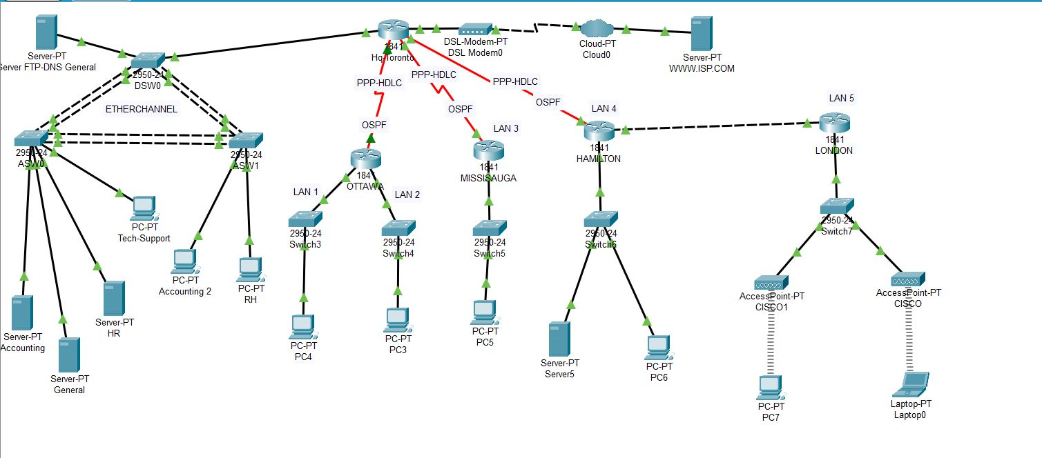

We will be executing the above design according to the requirements of the company. This design has been created in Packet Tracer 8 and configuring of every part will be covered in this documentation

# Addressing Table

Addressing schemes is very important for the implementation of any topology.

We have used the data mentioned in these tables to configure the topology.

### Section 1 : Network

This table includes all the network addressing. It includes all VLANS and LANS.

|  |  |  |  |  |  |  |
| --- | --- | --- | --- | --- | --- | --- |
| **Network Name** | **VLAN** | **Number of host addresses required** | **Network Address** | **Subnet Mask** | **Maximum number of hosts possible** | **Gateway Address** |
| Accounting | 2 | 240 | 172.18.1.0 | 255.255.255.0 | 254 | 172.18.1.1 |
| HR | 3 | 160 | 172.18.2.0 | 255.255.255.0 | 254 | 172.18.2.1 |
| General | 4 | 400 | 172.18.4.0 | 255.255.254.0 | 510 | 172.18.4.1 |
| Technical Support | 5 | 70 | 172.18.3.0 | 255.255.255.128 | 126 | 172.18.3.1 |
| Ottawa (LAN 1) | N/A | 700 | 172.18.8.0 | 255.255.252.0 | 1022 | 172.18.8.1 |
| Ottawa (LAN 2) | N/A | 800 | 172.18.12.0 | 255.255.252.0 | 1022 | 172.18.12.1 |
| Mississauga (LAN 3) | N/A | 200 | 172.18.16.0 | 255.255.255.0 | 254 | 172.18.16.1 |
| Hamilton (LAN 4) | N/A | 200 | 172.18.17.0 | 255.255.255.0 | 254 | 172.18.17.1 |
| London (LAN 5) | N/A | 140 | 172.18.18.0 | 255.255.255.0 | 254 | 172.18.18.1 |

### Section 2 : Addressing Table for Routers

Section 2 is divided into different tables for all routers.

#### Table 1 : Router -(HQ-Toronto)

|  |  |  |  |  |  |  |  |
| --- | --- | --- | --- | --- | --- | --- | --- |
| **Network Name** | **Description and purpose** | **Interface /SubinterfaceType /Number** | **VLAN** | **Encapsulation** | **Network Number** | **Interface IP Address** | **Subnet Mask** |
| HQ-Toronto | Inside Connectivity | Sub-interface Fa 0/0.1 | 2 | 802.1q | 172.18.1.0/24 | 172.18.1.1 | 255.255.255.0 |
| HQ-Toronto | Inside Connectivity | Sub-interface Fa 0/0.2 | 3 | 802.1q | 172.18.2.0/24 | 172.18.2.1 | 255.255.255.0 |
| HQ-Toronto | Inside Connectivity | Sub-interface Fa 0/0.3 | 4 | 802.1q | 172.18.3.0/25 | 172.18.3.1 | 255.255.255.128 |
| HQ-Toronto | Inside Connectivity | Sub-interface Fa 0/0.4 | 5 | 802.1q | 172.18.4.0/23 | 172.18.4.1 | 255.255.254.0 |
| HQ-Toronto | Outside Connectivity | Interface  Fa 0/1 | N/A | N/A | 199.165.201.224/30 | 199.165.201.225 | 255.255.255.252 |
| HQ-Toronto | Toronto to Ottawa | Serial Interface  S 0/1/0 | N/A | PPP | 172.18.19.0/30 | 172.18.19.1 | 255.255.255.252 |
| HQ-Toronto | Toronto to Mississauga | Serial Interface  S 0/0/0 | N/A | PPP | 172.18.19.4/30 | 172.18.19.5 | 255.255.255.252 |
| HQ-Toronto | Toronto to Hamilton | Serial Interface  S 0/0/1 | N/A | PPP | 172.18.19.8/30 | 172.18.19.9 | 255.255.255.252 |

#### Table 2 : Router -(Ottawa)

|  |  |  |  |  |  |  |  |
| --- | --- | --- | --- | --- | --- | --- | --- |
| **Network Name** | **Description and Purpose** | **Interface/Subinterface Type /Number** | **VLAN** | **Encapsulation** | **Network Number** | **Interface IP Address** | **Subnet Mask** |
| Ottawa | LAN Connectivity | Fa 0/0 | N/A | N/A | 172.18.8.0/22 | 172.18.8.1 | 255.255.252.0 |
| Ottawa | LAN Connectivity | Fa 0/1 | N/A | N/A | 172.18.12.0/22 | 172.18.12.1 | 255.255.252.0 |
| Ottawa | Toronto to Ottawa | Serial interface  S0/1/0 | N/A | PPP | 172.18.19.0/30 | 172.18.19.1 | 255.255.255.252 |

#### Table 3 : Router(Mississauga)

|  |  |  |  |  |  |  |  |
| --- | --- | --- | --- | --- | --- | --- | --- |
| **Network Name** | **Description and Purpose** | **Interface/ Subinterface type / Number** | **VLAN** | **Encapsulation** | **Network Number** | **Interface IP Address** | **Subnet Mask** |
| Mississauga | LAN Connectivity | Fa 0/0 | N/A | N/A | 172.18.16.0/24 | 172.18.16.1 | 255.255.255.0 |
| Mississauga | Toronto to Mississauga | Serial Interface  S 0/1/0 | N/A | PPP | 172.18.19.4/30 | 172.18.19.5 | 255.255.255.252 |

#### Table 4 : Router (Hamilton)

|  |  |  |  |  |  |  |  |
| --- | --- | --- | --- | --- | --- | --- | --- |
| **Network Name** | **Description and Purpose** | **Interface/ Subinterface type / Number** | **VLAN** | **Encapsulation** | **Network Number** | **Interface IP Address** | **Subnet Mask** |
| Hamilton | LAN Connectivity | Fa 0/0 | N/A | N/A | 172.18.17.0/24 | 172.18.17.1 | 255.255.255.0 |
| Hamilton | Toronto to Hamilton | Serial Interface  S 0/1/0 | N/A | PPP | 172.18.19.8/30 | 172.18.19.9 | 255.255.255.252 |
| Hamilton | Hamilton to London | Fa 0/1 | N/A | N/A | 172.18.20.0/30 | 172.18.20.1 | 255.255.255.252 |

#### Table 5 : Router (London)

|  |  |  |  |  |  |  |  |
| --- | --- | --- | --- | --- | --- | --- | --- |
| **Network Name** | **Description and Purpose** | **Interface/ Subinterface type / Number** | **VLAN** | **Encapsulation** | **Network Number** | **Interface IP Address** | **Subnet Mask** |
| London | LAN Connectivity | Fa 0/1 | N/A | N/A | 172.18.18.0/24 | 172.18.18.1 | 255.255.255.0 |
| London | Hamilton to London | Fa 0/0 | N/A | N/A | 172.18.20.0/30 | 172.18.20.2 | 255.255.255.252 |

### Section 3 : Wireless Access Points

It includes information about two wireless access points linked to LAN 5.

#### Table 1 : Wireless Access Point (CISCO)

|  |  |  |  |  |  |  |  |
| --- | --- | --- | --- | --- | --- | --- | --- |
| **Interface Type/ Port** | **Description and Purpose** | **Network Name** | **Network Number** | **SSID** | **Security-WEP key** | **Interface IP Address or IP range** | **Subnet Mask** |
| Port 0  (Wired) | Access- Point0 | N/A | N/A | N/A | N/A | N/A | N/A |
| Port 1  (Wireless) | Access- Point0 | Port Details | N/A | LONDON | cisco123456 | 172.18.18.0/24 | 255.255.255.0 |

#### Table 2 : Wireless Access Point (CISCO 1)

|  |  |  |  |  |  |  |  |
| --- | --- | --- | --- | --- | --- | --- | --- |
| **Interface Type/ Port** | **Description and Purpose** | **Network Name** | **Network Number** | **SSID** | **Security-WEP key** | **Interface IP Address or IP range** | **Subnet Mask** |
| Port 0  (Wired) | Access- Point0 | N/A | N/A | N/A | N/A | N/A | N/A |
| Port 1  (Wireless) | Access- Point0 | Port Details | N/A | LONDON_1 | cisco123456 | 172.18.18.0/24 | 255.255.255.0 |

### Section 4 : Switches

It includes information about switches DSW0,ASW0 and ASW1.

#### Table 1 :Distribution Switch (DSW0)

VLAN : 2,3,4,5

|  |  |  |  |  |  |  |
| --- | --- | --- | --- | --- | --- | --- |
| **Port/Number** | **Description and Purpose** | **Speed** | **Duplex** | **VLANs allowed** | **Switchport type** | **Encapsulation(if needed)** |
| Fa 0/1 | Connectivity to HQ-Toronto Router | Auto | Full | 2,3,4,5 | Trunk | N/A |
| Fa 0/2-3 | Port-Channel 1 (from DSW0 to ASW0) | Auto | Full | 2,3,4,5 | Trunk | N/A |
| Fa 0/4-5 | Port-Channel 2 (from DSW0 to ASW1) | Auto | Full | 2,3,4,5 | Trunk | N/A |
| Fa 0/6 | Connectivity to DNS Server | Auto | Full | 4 | Access | N/A |

#### Table 1 :Access Switch (ASW0)

VLAN : 2,3,4,5

|  |  |  |  |  |  |  |  |  |  |
| --- | --- | --- | --- | --- | --- | --- | --- | --- | --- |
| **Interface/Subinterface Type/Port/Number** | **Description and Purpose** | **Speed** | **Duplex** | **Network Name** | **Network Number** | **Subnet Mask** | **VLAN** | **Switchport Type** | **Encapsulation(if needed)** |
| Fa 0/2-3 | Port-  Channel 1 from DSW0 to ASW0 | Auto | Full | N/A | N/A | N/A | 2,3,4,5 | Trunk | N/A |
| Fa 0/1,Fa 0/6 | Port-  Channel 3 from ASW0 to ASW1 | Auto | Full | N/A | N/A | N/A | 2,3,4,5 | Trunk | N/A |
| Fa 0/4 | Connect to Tech-  Support | Auto | Full | Tech-Support | N/A | N/A | 5 | Access | N/A |
| Fa 0/5 | Connect to Accounting Server | Auto | Full | Accounting | 172.18.2.0/24 | 255.255.255.0 | 2 | Access | N/A |
| Fa 0/7 | Connect to General Server | Auto | Full | General | 172.18.4.0/23 | 255.255.254.0 | 4 | Access | N/A |
| Fa 0/8 | Connect to HR Server | Auto | Full | HR | 172.18.1.0 | 255.255.255.0 | 3 | Access | N/A |
| Interface Vlan5 | Switch Management IP | Auto | Full | General | 172.18.3.0/25 | 255.255.255.128 | 5 | Access | N/A |

#### Table 2 :Access Switch (ASW1)

VLAN : 2,3,4,5

|  |  |  |  |  |  |  |  |  |  |
| --- | --- | --- | --- | --- | --- | --- | --- | --- | --- |
| **Interface/Subinterface Type/Port/Number** | **Description and Purpose** | **Speed** | **Duplex** | **Network Name** | **Network Number** | **Subnet Mask** | **VLAN** | **Switchport Type** | **Encapsulation(if needed)** |
| Fa 0/4-5 | Port-  Channel 1 from ASW1 to DSW0 | Auto | Full | N/A | N/A | N/A | 2,3,4,5 | Trunk | N/A |
| Fa 0/1,Fa 0/6 | Port-  Channel 3 from ASW1 to ASW0 | Auto | Full | N/A | N/A | N/A | 2,3,4,5 | Trunk | N/A |
| Fa 0/2 | Connect to Accounting PC | Auto | Full | Accounting | N/A | N/A | 2 | Access | N/A |
| Fa 0/3 | Connect to HR PC | Auto | Full | HR | N/A | N/A | 3 | Access | N/A |
| Interface Vlan5 | Switch Management IP Connectivity | Auto | Full | General | 172.18.3.0/25 | 255.255.255.128 | 5 | Access | N/A |

### Section 5 : DNS Services

|  |  |  |  |  |  |  |
| --- | --- | --- | --- | --- | --- | --- |
| **Services Provided** | **VLAN** | **Network Number** | **Server/PCs** | **IP address range** | **Subnet Mask** | **Gateway** |
| DNS | 4 | 172.18.4.0/23 | 172.18.4.5 | 172.18.4.0 | 255.255.254.0 | 172.18.4.1 |
| FTP | 4 | 172.18.4.0/23 | 172.18.4.5 | 172.18.4.0 | 255.255.254.0 | 172.18.4.1 |

# Configuration

In this section we will show the configuration of each device with the help of screen shots. We will be showing screenshots site by site.

**HQ- TORONTO**.

**Router Configuration:**

Below screenshots show the configuration on HQ-TORONTO router.

LAN: Subinterfaces have been configured along with VLAN numbers and encapsulation.

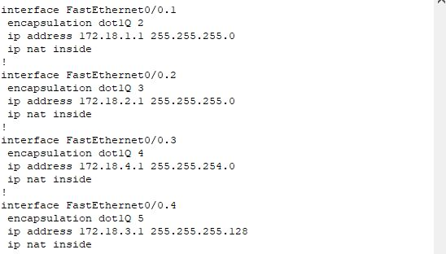

DHCP: DHCP has been configured on the router along with all parameters. Below screenshot shows the DHCP configuration for TORONTO office with respect to the VLANs.

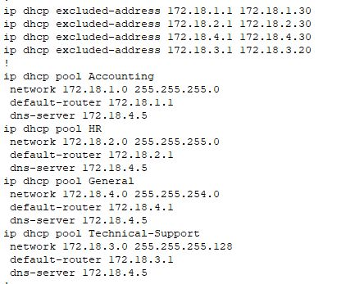

This includes HR, Accounting & General VLANs. With network, default router , DNS server and excluded address from the scope.

**Distribution-Switch:**

VLANs have been configured on the distribution switch(DSW0) then those vlans are being propagated using VTP server. Distribution switch is the root bridge and VTP server. All other switches(ASW0 and ASW1) are in VTP client mode. Etherchannel has been configured on all switches.

VLAN Configuration: Below screenshots shows the number of vlans and their configuration on the distribution switch.

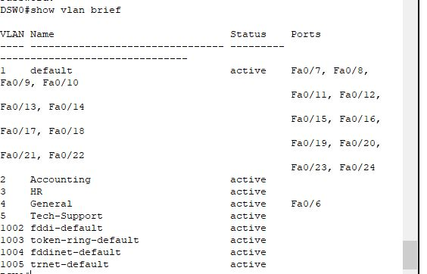

Trunking has been configured among the switches on the port channels. Below are the screenshots related to it.

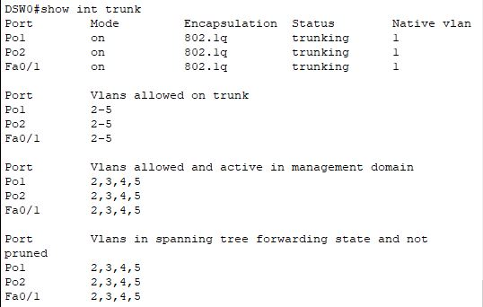

Spanning tree protocol has been configured where DSW0 is elected as root-bridge. We have added the screenshots below

Etherchannels has been configured between distribution switch(DSW0) and access switches(ASW0 & ASW1). We have added the screenshot regarding it below.

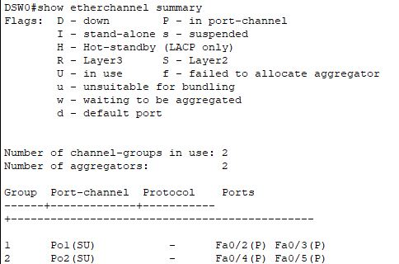

Vlans are being propagated with VTP domains. Below screenshot shows the VTP configuration.

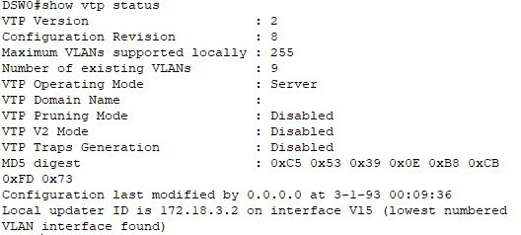

We have configured a Management vlan. Moreover, the switch has been configured with IP address and default gateway. We have added the screenshots below.

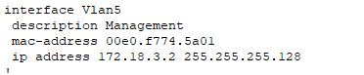

**Access-Switch1:**

Below are screenshots added from the first access switch named as ASW0.

VLAN Configuration: Below screenshots shows the number of vlans and their configuration on the Access switch.

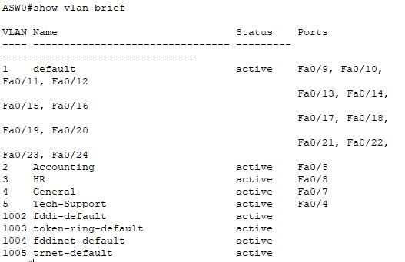

Trunking has been configured between the switches on the port channels. Below screenshots related to it.

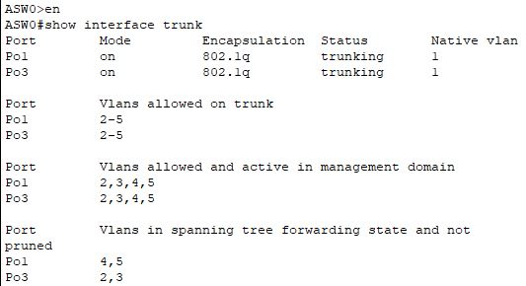

Etherchannels have been configured between distribution switches and access switches. Screenshots are added below.

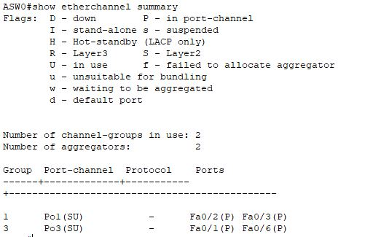

Vlans are being propagated with VTP domains. Below screenshot shows the VTP configuration.

Similarly ASW1, which is the second Access Switch used in our topology, is configured similarly as ASW0.

**OTTAWA**

**Router Configuration:** Below screenshot shows the router configuration. Which includes LAN , WAN , DHCP and Routing Protocol.

LAN: Below screenshot shows the LAN interface configuration. Along with OSPF covered within.

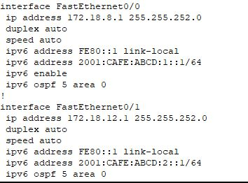

WAN: Below screenshot shows the WAN interface configuration with pap encapsulation along with OSPF configured.

DHCP: Below screenshot shows the DHCP Configuration along with other DHCP settings and excluded addresses as well.

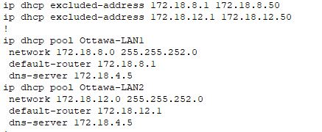

**MISSISSAUGA**

**Router Configuration:** Below screenshot shows the router configuration. Which includes LAN , WAN , DHCP and Routing Protocol.

LAN: Below screenshot shows the LAN interface configuration with ospf configuration included.

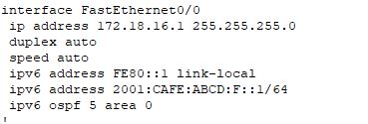

WAN: Below screenshot shows the WAN interface configuration with CHAP encapsulation.

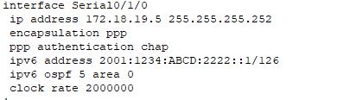

DHCP: Below screenshot shows the DHCP Configuration along with other DHCP settings and excluded addresses as well.

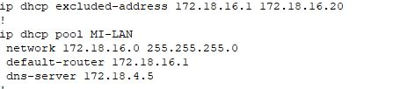

**HAMILTON**

**Router Configuration:** Below screenshot shows the router configuration. Which includes LAN , WAN , DHCP and Routing Protocol.

LAN: Below screenshot shows the LAN interface configuration.

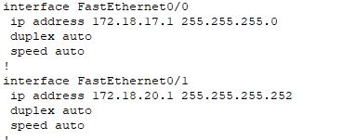

WAN: Below screenshot shows the WAN interface configuration with CHAP encapsulation.



DHCP: Below screenshot shows the DHCP Configuration along with other DHCP settings and excluded addresses as well.

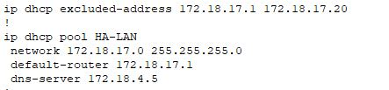

**LONDON**

**Router Configuration:** Below screenshot shows the router configuration. Which includes LAN , WAN , DHCP and Routing Protocol.

LAN: Below screenshot shows the LAN interface configuration.

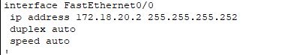

WAN: Below screenshot shows the WAN interface configuration with HDLC encapsulation.

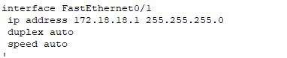

DHCP: Below screenshot shows the DHCP Configuration along with other DHCP settings and excluded addresses as well.

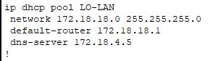

**Verification**

In this section we will show the services and hosts configuration along with reachability to the ISP server.

**HR-PC:** Below screenshot shows the PC is getting IP from DHCP and it can reach ISP cloud as shown in the ping.

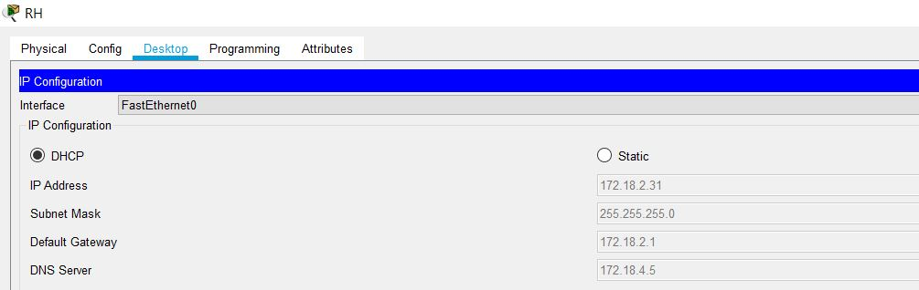

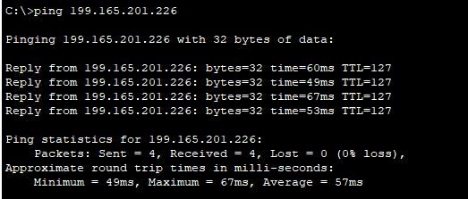

**ACCOUNTING-PC:** Below screenshot shows the PC is getting IP by DHCP and it can reach the ISP cloud(as shown through ping) and web browser working.

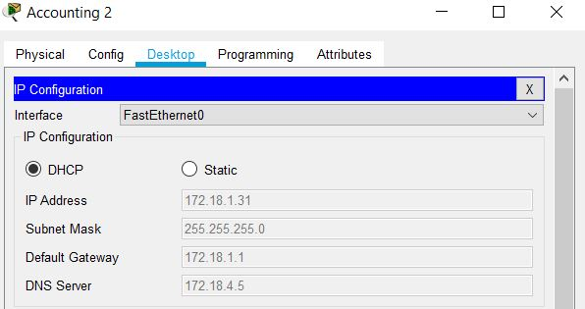

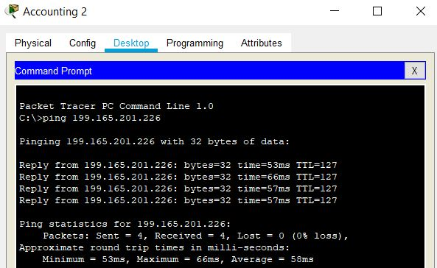

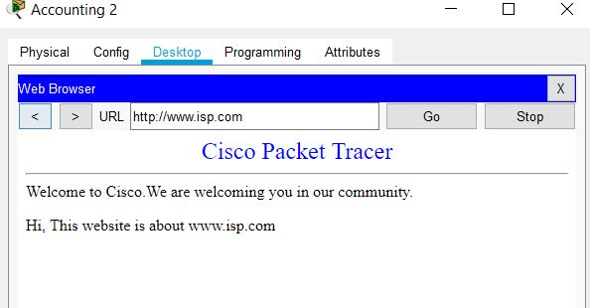

In the similar order, all other pcs are assigned IPs with dhcp and and are able to ping each other over the network as well as are able to access to isp service.

**IPv6 Ping**

Here we are showing ping from PC4(on Ottawa LAN2) to PC5 (on Ottawa LAN4)

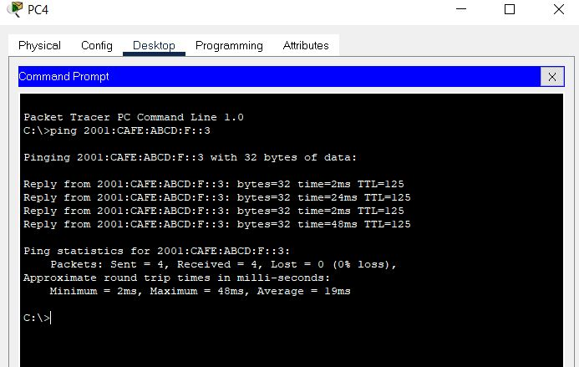

**NAT Translation at HQ Router:** Below screenshot shows the NAT translations.

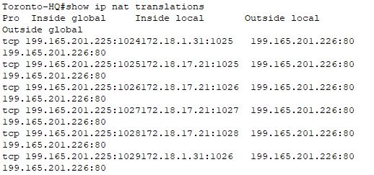

# Problems faced by team

* We have initially divided the individual phases for each member to work on , however, everyone was facing issues while working on them. So, we decided to share our problems and whoever finds the solution , she/he helps to implement it.
* We had a problem understanding its topology as it is a quite big project from our entire course. It took us more than one week to understand it and start working on it.

# Glossary of Terms

WAN: WAN or Wide Area Network , is a private network which connects multiple geographically distributed locations and LANs. An organisation’s WAN connects its headquarters with its branch offices and other facilities so that those distributed sites can access all resources.

LAN: LAN or Local Area Network is a high speed, low-error data network covering a relatively small geographical area(upto few thousand meters).

VPN: A virtual private network that uses encrypted tunnels to connect authorized remote employees to an organization's network and business resources.

OSPF: OSPF or Open Shortest Path First is a link state routing protocol for IP.

AUTONOMOUS SYSTEM: Collection of networks under a common administration sharing a common routing strategy.

ENCAPSULATION: The process of placing one protocol inside of another. Usually implies that the encapsulated protocol was not originally intended by its designers to be carried by the encapsulating protocol.

LINK-STATE ROUTING: A routing protocol that takes links loading and bandwidth when selecting between alternate routes Example-OSPF.

PPP: Point-to-Point Protocol is a specification for synchronous or asynchronous data communication between two routers or between a computer system and a network.

ACCESS LIST: List kept by routers to control access to or from the router for a number of services. Example - to prevent packets with certain IP Address from leaving a particular interface on the router.

VTP: Virtual Terminal Protocol or VTP is an ISO application for establishing a virtual virtual terminal connection across a network.

ETHERCHANNEL: EtherChannel is multiple physical switch interfaces, bundled together, behaving for all intents and purposes as one logical interface.

NAT: It enables private IP networks that use unregistered IP Addresses to connect to the internet. NAT operates on a router, usually connecting two networks together, and translate the private addresses in the internal network into legal addresses, before packets are forwarded to another network.

SPANNING-TREE PROTOCOL: The purpose of STP is to ensure a loop free topology for a LAN. STP removes loops through an algorithm that guarantees that there is only one active path between two network devices.

PAP: Password Authentication Protocol or PAP allows PPP peers to authenticate one another. The remote router attempting to connect to the local router is required to send an authentication request. PAP passes the password and username in unencrypted form.

CHAP: Challenge-Handshake Authentication Protocol or CHAP is a more secure procedure for connecting to a system than PAP.

DHCP: DHCP or Dynamic Host COnfiguration Protocol is used by hosts to dynamically discover and lease an IP address and learn to correct the subnet mask, default gateway, and DNS Server IP addresses.

# Conclusion

In this practical implementation, we have addressed all instructions that were given and implemented all features successfully. VLANs have been created along with Trunking being enabled on the switches as required. Etherchannels have been configured on all the switches.Moreover, we have used a spanning tree protocol as we want to have switching loop-free topology. For this purpose Rapid PVST+ is being used.We also have implemented Inter VLAN routing in combination with static routing protocol. DHCP configuration has also been done so that there is no conflict of IP address among the hosts for this purpose DHCP Server has been used. Implementation of Servers and ACL has been done as required.Furthermore we have configured OSPF as a routing Protocol.Last but not the least we have successfully verified the implementation in the verification section with the help of ping and other utilities available.

Date of finishing the report is february 20, 2021.