Elmira Karami
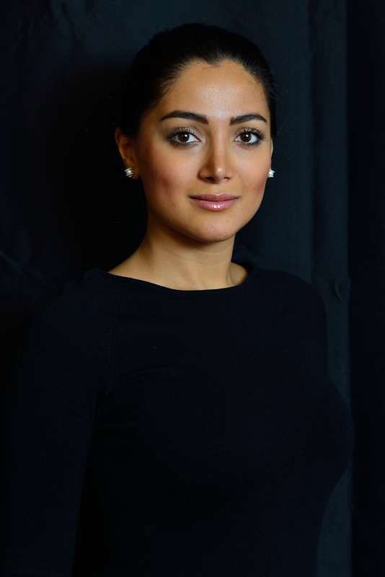

E-mail: Elmira.karami@googlemail.com Mobile 0405095990

Professional Profile
- With almost 2 years of experience in Systems Engineering, Business Analysis, Process Improvement and Business Requirements Development in Financial Market and Gas Turbine Engineering industry seeking to expand my career achievements
- Experienced in Quality Management System project, conducting gap analysis, internal auditing of the system, developing Quality Management System Process Map to identify and capture business processes and preparing the firm to comply with ISO 9001 regulatory requirements and maintain ISO 9001 certification within a telecommunication organization
- Strong knowledge of compliance with regulatory requirements within the business environment and understanding business workflows
- Strong academic knowledge and work experiences of compliance with regulatory requirements as well as ‘AS Is’ and ‘To Be’ delegation models
- Strong knowledge of education system by working as an international office ambassador in The University of Sheffield
- Strong educational background in Systems Engineering and Engineering Management with work experience in business performance analysis, change management, operation’s improvement, process efficiency improvement, systems analysis, customer requirements development and documentations using UML and Visio
- Highly skilled in interpersonal communications, team facilitation and fostering strong working relationships across all levels. Highly analytical individual who employs an unwavering work ethic with an insatiable desire to learn and develop professional skills

Educational Qualifications
2011- 2012 Engineering Management Graduate Diploma RMIT University
Grad Diploma’s main focus:
- Understanding Quality Management Systems, Performance Measurement and Quality Functions Processing
- Risk Identification and Management, Lean Six Sigma process improvement
- Understanding an entire organizational system, functionality and operation
- Anticipating, recognizing and solving system problems to build quality organizations
- Optimizing human capability and performance as well as organizational culture
- Effective utilization and allocation of resources
- Applying systems theory in management or product development situations
- Building and improving IT/IS strategies linked with business strategies
- Analysis and optimization of process lifecycles to improve organization’s effectiveness

2008- 2009 Master of Control and Systems Engineering (High Distinction)
University of Sheffield (UK)
Thesis- “Predictive House Price Modeling” - Using data analysis and systems modeling techniques such as MATLAB and SIMULINK to develop predictive data model used in financial market.
Master’s main focus:
- Analysis of systems and subsystems by utilizing systems identification methods
- Developing predictive systems and future trend identification
- Understanding optimal control and robust control system for systems stabilization
- Interpretation of systems requirement and development of systems diagrams
- Programing various systems such as helicopter and applying control systems
- Signal and Image processing in electrical devices
- Experienced in C++, MATLAB, SIMULINK and MS Project

2005- 2008 Bachelor of Control and Systems Engineering (High Distinction)
University of Sheffield (UK)
Thesis- “Modeling Heat Treatment of Steel Alloy” - Applying data analysis and systems identification methods to model predictive system for Tensile Strength of steel alloy in corporation with Corus Group plc.

Work Experience
Position: Auditor and Business Analyst (Contractor) Nov2012- April 2013
Company: CPS Technology Group (Australia)
Duties & involvements:
- Carrying out a gap analysis on ISO 9001 QMS through series of system audits
- Analyzing the QMS and the business operations and developing Quality Management Process map and production Process map to identify and explain relationships between business components, interaction of processes to perform process improvement
- Identifying opportunities for improvements within operating system
- Consulting on implementation of business improvement
- Documenting procedures and standards where applicable
- Make recommendations on fault prevention, creating corrective and preventive action plans. Applying ‘As Is’ and ‘To Be’ delegation models within the business
- Developing Quality Manual and Quality Policy based on system analysis
- Sound knowledge of business processes and process mapping as well as compliance within the regulatory requirements framework

Position: Junior Quality Management Consultant (Contractor) July 2012- Nov 2012
Company: Quality Plus Pty (Australia)
Duties & involvements:
- Carrying out Quality Planning report writing
- Developing Audit Checklist and selection of Audit Criteria
- Analysis of Audit Reports
- Research into client company background and carrying out risk assessment for audit profile review

Position: Graduate Business Analyst July 2010- July 2011
Company: The Royal Bank of Scotland
Duties & involvements:
- Intensive training on performance and functionality of financial market
- Analyzing and studying business workflow, identifying required projects and future improvements to increase business efficiencies
- Resource forecasting and distribution aligned with BAU and project requirements
- Workload and workflow analysis of IT and other projects running in parallel
- Monitoring projects status and progresses throughout the business on national and international level on a daily basis to meet the deadlines and requirements
- Extract complex, large data from projects reports and creating project status report for senior management
- Developing reports on departments’ performances and functionalities as well as projects’ readiness for user acceptance test and post implementation reviews
- Daily monitoring of workflow in order to ensure that daily performance is in line with plans and project status is updated for management review
- Being involved in national calls to engage all the associated team leaders and stakeholders with the daily workflow and discuss the best options for moving workflow and workload
- Developing systems diagram representing the entire business, its subsystems and their functionalities to assist exploring relationships and workflows between subsystems of the business and write reports on any required changes
- Being involved in currency conversion project of Ukrainian Krona to Euro

Position: Control Systems Engineer (Internship) May 2007- Sep 2007
Company: Rolls-Royce plc.
Duties & responsibilities:
- Working on implementation of Trent 1000 for the Boeing787 Dreamliner jet engine
- Studying system design process as defined in Data Management and Control Systems
- Analyzing data in Unit Requirements Documents provided by stakeholders for various components of jet engine and transforming them to UML models using MS Visio
- Analyzing and modeling the relationship between various components of the jet engine
- Studying the engineering relationships between System Design, Safety, Verification and Software Design
- Explain and model the operation of system fuel flow and its integration with the rest of the system such as EEC, Airframe, Engine and HMU
- Analysis and creation of fuel flow model by extracting data from stakeholder requirement documents, management team and other departments
- Extrapolating data from across the entire business and create formal hierarchical structure of fuel flow system and its component, parameters, constraints which is utilized in the team to better understand and visualize the systems involved
- Identification and modeling of Static and Dynamic requirements of stakeholders

Position: International Office Ambassador April 2007-Aug 2009
Company: The University of Sheffield
Duties & Responsibilities:
- Part of the Student Recruitment, Admission & Marketing team which increased Iranian student recruitment in 2007 by 21%.
- Analyzing recruitment rates and creating relative solutions for further promotion of university
- Advised Prospective students on University processes, procedures
- Understanding student misconduct regulations and suggesting opportunities for improvements
- Delivered student/VIP tours and represented the University in Promotional material

Position: Course Representative Nov 2007- Nov 2008
Company: The University of Sheffield
Duties & Responsibilities:
- Member of the staff - student committee to feed in department students views on a whole range of educational issues
- Meet and communicate with other departments course representatives and university staffs to create possible ways of solving existing problems for current and prospective students
- Analyzing, recommending and implementing business process changes to improve system efficiency

Technical skills
- Experienced in systems modelling using C++, MATLAB, SIMULINK and GUI
- Proven skills in analysing systems requirements and developing UML diagrams
- Experienced in auditing internal systems based on ISO 9001 requirements
- Strong knowledge of systems analysis and developing process maps
- Highly skilled in programming and developing predictive and forecasting systems
- Experienced in transforming business and systems requirements into engineering models using MS Visio
- Proven skills in data analysis, reporting and change management
- Proficient in using MS Excel, Power Point, Word and Project
- Good knowledge of complex systems and their behaviours in chaotic situations
- Developed skills in improving systems efficiency and risk management
- Developed Knowledge of human resources management (HRM) in work place
- Experience in analysing business performances and building quality organizations
- Strong knowledge in systems engineering, embedded control systems, intelligent systems, digital signal processing, communication systems and renewable energy
- Experienced in research methods and data collection
- Good knowledge of supply chain and procurement using Monte Carlo Simulation
- Experienced with compliance framework and ISO certification
Interpersonal Skills
- Self-driven and energetic individual who motivates team members towards achieving business goals
- Working collaboratively across an organisation
- Ability to manage conflicts in a positive approach through pro-active means
- Ability to communicate and work collaboratively across all levels and build professional relationships
- Ability to work under pressure and effective decision making
- Attended several interpersonal skills development classes such as leadership, teamwork, effectiveness and communication skills improvements
- Proven effective written and verbal communication and presentation skills

Awards and Scholarships
- University of Sheffield International Scholarship 2008 that was achieved in recognition of outstanding academic achievements. This scholarship (worth £6,500) was awarded to top 10 students in the University of Sheffield based on academic achievements
- Laverick Webster Hewitt Prize (worth £150) was awarded to the best MSc student in Department of Control Systems Engineering based on examination results
- Iran-Sheffield Scholarship 2008 (worth £2,000) was awarded to the best applicant of the year 2008 with the highest grades in the previous tertiary qualification
- The Sheffield Graduate Award 2008 which acknowledges outstanding skills and experiences obtained outside degree by involvement in various societies and volunteer activities.
- Sheffield Alumni Reward (worth £1,000) received for duration of master’s degree
- Achieved Rolls-Royce ASET Level 2 National Award in Basic Holistic Gas Turbines
- Chartered Institute for Securities and Investment Level 3 Award for Introduction to Investment
Personal Activities & Achievements
- Active member of student society and elected as students’ representative
- Member of Roller Blading team and university events coordinator
References
- Provided upon request

