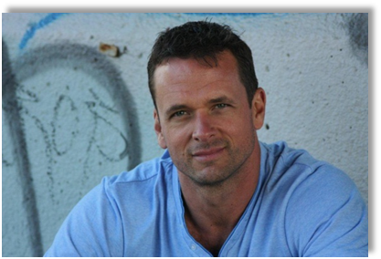
Guy Alexander
○ Ripleys Management Australia ○ ph: 1300 882 422 ○ Email: rm@ripleysmanagement.com ○ web www.ripleysmanagement.com.au
PERSONAL INFORMATION
Residence: Melbourne DOB: August 1968
Eye colour: Green Hair Colour: Brown
Height: 195 cm (6’ 05”) Weight: 95 kg
Suit size: 44 L
LIFE EXPERIENCE
Corruption investigator, police officer, pilot, on-air TV weather presenter, advertising account sales, waiter
TRAINING
John Higginson’s Professional Voiceover Workshop
EXPERIENCE
Winners & Losers, Fremantle Media Wedding guest
Dodo Internet TVC Lead
Underbelly Squizzy, Screentime Productions Drug-buying business man
Samsung Galaxy SIII Web spot – coach of London Olympic athlete
Neighbours, Fremantle Media House-buyer at open house
CommInsure Presenter – web video spot (internal)
Jackson’s View TVC Lead & web video spots
45 second television commercial: http://youtu.be/JAqRui6xHCg
National E-Health Transition Authority Presenter – web video spots
Healthcare Identifiers: http://youtu.be/j-6d0Tz18u4
Intro to eHealth: http://youtu.be/5YpQ0m7i9Hg
eHealth for Aged Care: http://youtu.be/46qxIZ_gcJQ
Channel 9 Weather Presenter Competition Finalist – presented live weather OB’s “Today”
Channel 9 audition spot: http://youtu.be/hKluIU5QK2w
Colorado, USA (KSBS TV) Presenter – live weather & ski reports
Resort Sports Network (USA) Presenter – ‘Apres Ski Reel Thrills’
Colorado, USA (KBCR radio) Voice talent for client spots
Various amateur and school theatre productions
SKILLS & INTERESTS
Former police officer, Colorado, USA: proficient with handguns (semi-auto & revolver) and long arms (shotgun, AR 15 semi-automatic rifle, M 16 fully automatic rifle); trained in ‘active shooter’ techniques.
Driver, motorcycle, & boat licenses; commercial pilot license; skydiving C license; PADI Divemaster scuba diver.
Flying; scuba diving; skydiving; motorcycling; cycling (road & mountain); fitness; bushwalking; travel; wine.

