**CV**

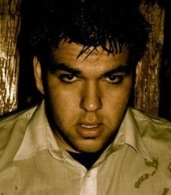

**Name:** Stefan Davis

**Age Range:** 20s-30

**Height:** 5’10 or 179cm

**Eye Colour:** Hazel

**Hair Colour:** Black

**Ripleys Management Australia◾ Ph: 1300 882 422 ◾ Fax: 1300 882 522**

**◾ Email: rm@ripleysmanagement.com.au**

**Experience:** I have acted in over 20 short films ranging from lead roles to supporting roles as well as appearances as an extra on Fox 8’s Wentworth season 1 and winners and losers season 3.

I have also participated in the Melbourne comedy festival and performed Shakespeare in the park with crowds in the hundreds.

Below I have attached links to some of the roles I have played.

**Escape – Supporting Role (2011)**

<http://www.youtube.com/watch?v=c6HtfSoPO1E>

**Spirit – Lead Role (2009)**

<http://www.youtube.com/watch?v=YDiRkxan1UE>

**Army of One – Lead Role (2009)**

<http://www.youtube.com/watch?v=vQBa0v167Fw>

**State Of Confusion – Lead Role (2008)**

<http://www.youtube.com/watch?v=gwiJW8dGxJE>

<http://www.youtube.com/watch?v=H-5flOI8_T0>

<http://www.youtube.com/watch?v=gwiJW8dGxJE>

**Interests/Hobbies:**

**Gym-**I pride on keeping myself fit and active. I participated as a power lifter for a year before continuing on strength training.

**Football-**I have played Aussie rules football for over 12 years now

**Guitar-**I self taught myself on guitar and enjoy playing and creating new songs

**Writing –** As well as writing over 30 songs I have also written several short stories and short film ideas.

**Acting –** Acting, performing and making people laugh has always been a passion of mine.

**Impersonations:** I enjoy working on all my impersonations which mostly consist of accents (Italian, American Italian, American, Scottish, Russian) as well as Sylvester Stallone and Scooby Doo to name a few.

**Basketball Gridiron singing script writing.**