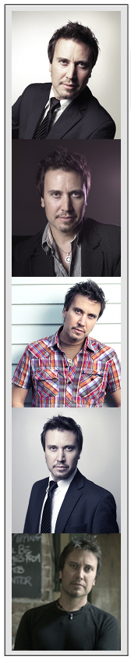  
All Photos Taken on 26 March 2013  
 Jaxon Marc • Melbourne • Independent  
 **0433-346-202 Location: Melbourne** [**jax@jaxonmarc.com**](mailto:jax@jaxonmarc.com) **Height: 5’10”** [**www.jaxonmarc.com**](http://www.jaxonmarc.com) **Weight: 74kg** **www.vimeo.com/theactorsshowreel/thecointrick** **Hair: Dark Brown (short) Availability: Very Flexible 24/7 Eyes: Green**

*“****A fresh new face to tvc & extra work in Melbourne;*** *Jaxon is professional, passionate and takes direction very well. His talent as an actor, voiceover artist & singing musician are diverse & amazing. Willing to assist & easy to get along with on a busy set.”*Josh Peterson

**FILM/THEATRE**  [**The Coin Trick (short)**](http://www.vimeo.com/theactorsshowreel/thecointrick) **Writer/Director/Producer DOP/Camera/Editor/Music** Jaxon Marc **Night Watch (short) Hitchhiker (support)** Josh Peterson **Black & White (feature) Member of Jury (extra)** Craig Lahiff **American Beauty (uni theatre)** **Lester Burnham (lead)** Mikayla Weir

**TRAINING Ann Peters School of Acting:** Performance, Improv, Characterisation, Direction & Camera  
 **Ross Etherington Tutoring:** Theatre techniques, Preperation, Relaxation, Stage/Lighting **Actors Ink Agency:** Voice Over, Acting Workshop, Casting Director Preparation, Extra Work **Open Channel:** Camera, Lighting, Post Production

**IMPROV/COMEDY Objets de Decor (function) Hoax Guest (comedic)** Open Door Events **Radio Sound Library Voice Overs & Accents** Three D Radio/SAFM

**MUSIC The following music is entirely composed/performed/produced/mixed by Jaxon Marc:** [The Coin Trick (film score)](http://www.vimeo.com/theactorsshowreel/thecointrick), [Lonely Satellite Live](http://www.youtube.com/watch?v=J7wpQtTAz_Q), [Girls Gone Electric](https://soundcloud.com/jaxon-marc/girls-gone-electric), [Antenna Sunset](https://soundcloud.com/jaxon-marc/antenna-sunset-sample-download), [All In Your Head](https://soundcloud.com/jaxon-marc/all-in-your-head) **Live Performer/Frontman/Singer/Musician.** **Cover/Original Bands, Solo/Duo Acoustic.** **Styles:** Rock, Pop, Acoustic Rock, Alternate, Jazz, Funk, Piano Bar, Classical, Film Scores.

**SPECIAL SKILLS Music:** [**www.jaxonmarc.com**](http://www.jaxonmarc.com) **-** Singing, Violin, Guitar, Piano/Keyboard, Bass, Percussion, Composition & Arrangement, Performance & Recording, String Arrangement for Film.   
 **Accents:** American, Scottish, Irish, European & British Accents **Voice Impersonations:** Billy Connelly, Guido Hatzis, Sean Connery, Borat, Ocker Aussie, Arnold Schwarzenegger, British General, Helium Balloon Voice, Fat Bastard, Austin Powers, Gold Member, Dr. Evil, Pikey (Snatch Movie) and many more. **Filmmaking:** Writing, Conceptual Design, Storyboarding, Casting, Director of Photography, Post Production Editing, Sound Recordist, Sound Design, Composer & Performance. **Other**: Hoax Guest/Personality, Growling, CPR, Random Voices or Public Acts. Engineering Degree, Business Owner.

**Further Information Available On Request**

