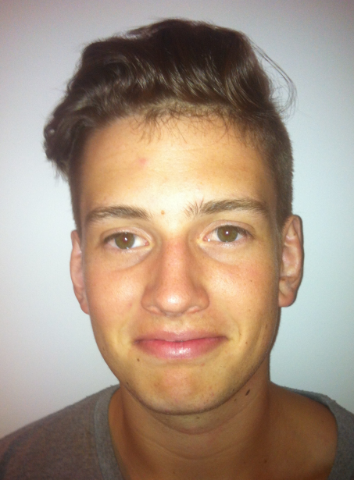**Harry Hayes CV**

**Contact details**

Address: 82 Lennox St Richmond, Melbourne, 3121

Mobile: 0412 479 203

Email: harryhayes1993@gmail.com

Born: March, 1993

**Educational Achievements**

Graduated Xavier College Ballina, NSW, 2011 in the following subjects:

* Mathematics
* Physics
* Chemistry
* English
* Religious Studies

**Work Experience**

I have worked part time in the following establishments:

* Subway Sandwiches, Byron Bay
* Holiday house/apartment cleaning, Byron Bay
* Barcelo Spanish Cafe, Byron Bay
* Beach Hotel Bottle Shop, Byron Bay

Since completion of High School I have worked full time at the following establishments:

* Treehouse Cafe, Byron Bay
* Woolworths, Byron Bay

I have also worked full time overseas at the following establishment:

* Bar Central Restaurant, Stockholm, Sweden
* In 2006-07 I assisted my father manage parking for the Byron Bay Blues and Roots Festival. This festival  
  has an international reputation regularly attracting some 60,000 patrons over the four day festival period. I believe this early work experience as a young teenager provided me with a broader understanding of the management and logistics involved in the entertainment and hospitality industries.
* In 2010-12 I assisted such companies as Slush Management LA and Trip Kicks Australia in promotion for supported events. This involved wide scale distribution of physical and online resources to promote live events.

I believe this work record demonstrates a capacity for:

* good customer relations at front of house restaurant/café establishments
* diligence with restaurant/café back of house operations
* disciplined approach to flexible work requirements in both the part-time and full-time work environment
* Flexibility in coping with difficult work environments included those where business is conducted out of normal hours and in a non-english speaking context.
* An understanding of commercial operations particularly as they relate to the hospitality food and entertainment industries.

**Referees (available upon request)**

1. Christine Lucke, CPA, JP

Director, Freshzest Pty Ltd