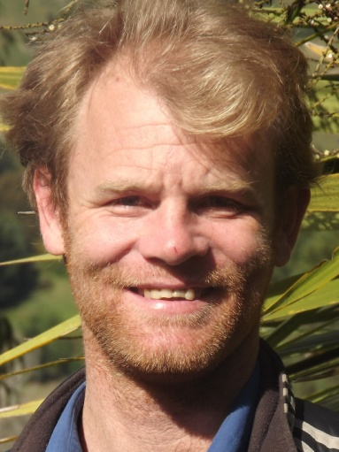

To whom it may concern

My name is Dylan Hutchison, and I am very interested in this line of work.

My previous experience includes being an extra in New Zealand on:

Shark in the Park 1991

Shortland Street 2000, and

Jacksons Wharf 2000.

I follow direction well and get along with all people.

I am 40, 185cm tall, 82kg, blond hair with blue eyes.

I would love to hear from you

Yours sincerely

Dylan