目录

一、初始化 1

二、直线绘制（Line plots） 1

三、散点绘制（Scatter plots） 2

四、线框图（Wireframe plots） 4

五、表面图（Surface plots） 5

六、三角表面图（Tri-Surface plots） 6

七、等高线（Contour plots） 8

八、Bar plots（条形图） 11

九、子图绘制（subplot） 12

补充： 17

一、初始化

假设已经安装了matplotlib工具包。

利用matplotlib.figure.Figure创建一个图框：

import matplotlib.pyplot as plt

from mpl_toolkits.mplot3d import Axes3D

fig = plt.figure()

ax = fig.add_subplot(111, projection='3d')

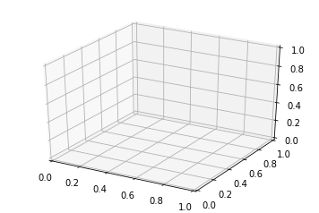

二、直线绘制（Line plots）

基本用法：

|  |  |  |
| --- | --- | --- |
| 1 |  | ax.plot(x,y,z,label=' ') |

code:

import matplotlib as mpl

from mpl_toolkits.mplot3d import Axes3D

import numpy as np

import matplotlib.pyplot as plt

mpl.rcParams['legend.fontsize'] = 10

fig = plt.figure()

ax = fig.gca(projection='3d')

theta = np.linspace(-4 * np.pi, 4 * np.pi, 100)

z = np.linspace(-2, 2, 100)

r = z**2 + 1

x = r * np.sin(theta)

y = r * np.cos(theta)

ax.plot(x, y, z, label='parametric curve')

ax.legend()

plt.show()

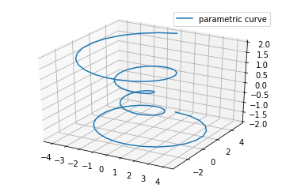

三、散点绘制（Scatter plots）

基本用法：

|  |  |
| --- | --- |
| 1 | ax.scatter(xs, ys, zs, s=20, c=None, depthshade=True, *args, *kwargs) |

* xs,ys,zs：输入数据；
* s:scatter点的尺寸
* c:颜色，如c = 'r'就是红色；
* depthshase:透明化，True为透明，默认为True，False为不透明
* *args等为扩展变量，如maker = 'o'，则scatter结果为’o‘的形状

code:

from mpl_toolkits.mplot3d import Axes3D

import matplotlib.pyplot as plt

import numpy as np

def randrange(n, vmin, vmax):

    '''

    Helper function to make an array of random numbers having shape (n, )

    with each number distributed Uniform(vmin, vmax).

    '''

    return (vmax - vmin)*np.random.rand(n) + vmin

fig = plt.figure()

ax = fig.add_subplot(111, projection='3d')

n = 100

# For each set of style and range settings, plot n random points in the box

# defined by x in [23, 32], y in [0, 100], z in [zlow, zhigh].

for c, m, zlow, zhigh in [('r', 'o', -50, -25), ('b', '^', -30, -5)]:

    xs = randrange(n, 23, 32)

    ys = randrange(n, 0, 100)

    zs = randrange(n, zlow, zhigh)

    ax.scatter(xs, ys, zs, c=c, marker=m)

ax.set_xlabel('X Label')

ax.set_ylabel('Y Label')

ax.set_zlabel('Z Label')

plt.show()

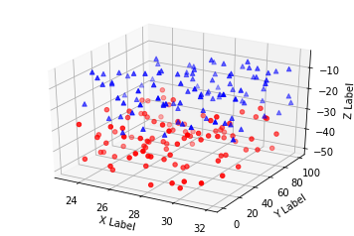

四、线框图（Wireframe plots）

基本用法：

|  |  |
| --- | --- |
| 1 | ax.plot_wireframe(X, Y, Z, *args, **kwargs) |

* X,Y,Z：输入数据
* rstride:行步长
* cstride:列步长
* rcount:行数上限
* ccount:列数上限

code:

from mpl_toolkits.mplot3d import axes3d

import matplotlib.pyplot as plt

fig = plt.figure()

ax = fig.add_subplot(111, projection='3d')

# Grab some test data.

X, Y, Z = axes3d.get_test_data(0.05)

# Plot a basic wireframe.

ax.plot_wireframe(X, Y, Z, rstride=10, cstride=10)

plt.show()

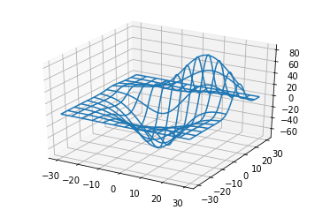

五、表面图（Surface plots）

基本用法：

|  |  |
| --- | --- |
| 1 | ax.plot_surface(X, Y, Z, *args, **kwargs) |

* X,Y,Z：数据
* rstride、cstride、rcount、ccount:同Wireframe plots定义
* color:表面颜色
* cmap:图层

code:

from mpl_toolkits.mplot3d import Axes3D

import matplotlib.pyplot as plt

from matplotlib import cm

from matplotlib.ticker import LinearLocator, FormatStrFormatter

import numpy as np

fig = plt.figure()

ax = fig.gca(projection='3d')

# Make data.

X = np.arange(-5, 5, 0.25)

Y = np.arange(-5, 5, 0.25)

X, Y = np.meshgrid(X, Y)

R = np.sqrt(X**2 + Y**2)

Z = np.sin(R)

# Plot the surface.

surf = ax.plot_surface(X, Y, Z, cmap = cm.coolwarm,linewidth = 0,antialiased = False)

# Customize the z axis.

ax.set_zlim(-1.01, 1.01)

ax.zaxis.set_major_locator(LinearLocator(10))

ax.zaxis.set_major_formatter(FormatStrFormatter('%.02f'))

# Add a color bar which maps values to colors.

fig.colorbar(surf, shrink=0.5, aspect=5)

plt.show()

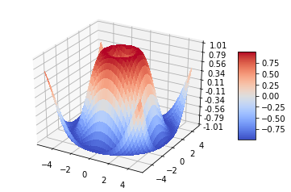

六、三角表面图（Tri-Surface plots）

基本用法：

|  |  |
| --- | --- |
| 1 | ax.plot_trisurf(*args, **kwargs) |

* X,Y,Z:数据
* 其他参数类似surface-plot

code:

from mpl_toolkits.mplot3d import Axes3D

import matplotlib.pyplot as plt

import numpy as np

n_radii = 8

n_angles = 36

# Make radii and angles spaces (radius r=0 omitted to eliminate duplication).

radii = np.linspace(0.125, 1.0, n_radii)

angles = np.linspace(0, 2*np.pi, n_angles, endpoint=False)

# Repeat all angles for each radius.

angles = np.repeat(angles[..., np.newaxis], n_radii, axis=1)

# Convert polar (radii, angles) coords to cartesian (x, y) coords.

# (0, 0) is manually added at this stage,  so there will be no duplicate

# points in the (x, y) plane.

x = np.append(0, (radii*np.cos(angles)).flatten())

y = np.append(0, (radii*np.sin(angles)).flatten())

# Compute z to make the pringle surface.

z = np.sin(-x*y)

fig = plt.figure()

ax = fig.gca(projection='3d')

ax.plot_trisurf(x, y, z, linewidth=0.2, antialiased=True)

plt.show()

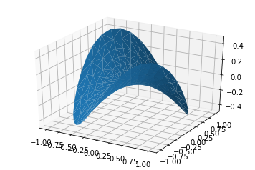

七、等高线（Contour plots）

基本用法：

|  |  |
| --- | --- |
| 1 | ax.contour(X, Y, Z, *args, **kwargs) |

code:

from mpl_toolkits.mplot3d import axes3d

import matplotlib.pyplot as plt

from matplotlib import cm

fig = plt.figure()

ax = fig.add_subplot(111, projection='3d')

X, Y, Z = axes3d.get_test_data(0.05)

cset = ax.contour(X, Y, Z, cmap=cm.coolwarm)

ax.clabel(cset, fontsize=9, inline=1)

plt.show()

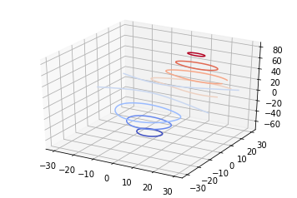

二维的等高线，同样可以配合三维表面图一起绘制：

code:

from mpl_toolkits.mplot3d import axes3d

from mpl_toolkits.mplot3d import axes3d

import matplotlib.pyplot as plt

from matplotlib import cm

fig = plt.figure()

ax = fig.gca(projection='3d')

X, Y, Z = axes3d.get_test_data(0.05)

ax.plot_surface(X, Y, Z, rstride=8, cstride=8, alpha=0.3)

cset = ax.contour(X, Y, Z, zdir='z', offset=-100, cmap=cm.coolwarm)

cset = ax.contour(X, Y, Z, zdir='x', offset=-40, cmap=cm.coolwarm)

cset = ax.contour(X, Y, Z, zdir='y', offset=40, cmap=cm.coolwarm)

ax.set_xlabel('X')

ax.set_xlim(-40, 40)

ax.set_ylabel('Y')

ax.set_ylim(-40, 40)

ax.set_zlabel('Z')

ax.set_zlim(-100, 100)

plt.show()

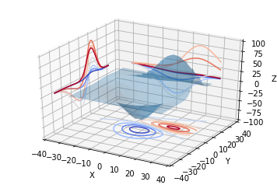

也可以是三维等高线在二维平面的投影：

code:

from mpl_toolkits.mplot3d import axes3d

import matplotlib.pyplot as plt

from matplotlib import cm

fig = plt.figure()

ax = fig.gca(projection='3d')

X, Y, Z = axes3d.get_test_data(0.05)

ax.plot_surface(X, Y, Z, rstride=8, cstride=8, alpha=0.3)

cset = ax.contourf(X, Y, Z, zdir='z', offset=-100, cmap=cm.coolwarm)

cset = ax.contourf(X, Y, Z, zdir='x', offset=-40, cmap=cm.coolwarm)

cset = ax.contourf(X, Y, Z, zdir='y', offset=40, cmap=cm.coolwarm)

ax.set_xlabel('X')

ax.set_xlim(-40, 40)

ax.set_ylabel('Y')

ax.set_ylim(-40, 40)

ax.set_zlabel('Z')

ax.set_zlim(-100, 100)

plt.show()

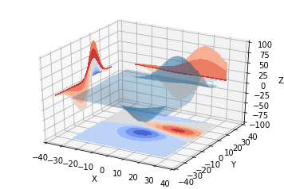

八、Bar plots（条形图）

基本用法：

|  |  |
| --- | --- |
| 1 | ax.bar(left, height, zs=0, zdir='z', *args, **kwargs |

* x，y，zs = z，数据
* zdir:条形图平面化的方向，具体可以对应代码理解。

code:

from mpl_toolkits.mplot3d import Axes3D

import matplotlib.pyplot as plt

import numpy as np

fig = plt.figure()

ax = fig.add_subplot(111, projection='3d')

for c, z in zip(['r', 'g', 'b', 'y'], [30, 20, 10, 0]):

    xs = np.arange(20)

    ys = np.random.rand(20)

    # You can provide either a single color or an array. To demonstrate this,

    # the first bar of each set will be colored cyan.

    cs = [c] * len(xs)

    cs[0] = 'c'

    ax.bar(xs, ys, zs=z, zdir='y', color=cs, alpha=0.8)

ax.set_xlabel('X')

ax.set_ylabel('Y')

ax.set_zlabel('Z')

plt.show()

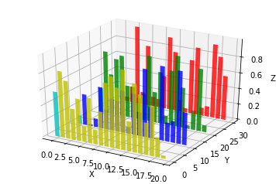

九、子图绘制（subplot）

**A-不同的2-D图形，分布在3-D空间**，其实就是投影空间不空

code:

from mpl_toolkits.mplot3d import Axes3D

import numpy as np

import matplotlib.pyplot as plt

fig = plt.figure()

ax = fig.gca(projection='3d')

# Plot a sin curve using the x and y axes.

x = np.linspace(0, 1, 100)

y = np.sin(x * 2 * np.pi) / 2 + 0.5

ax.plot(x, y, zs=0, zdir='z', label='curve in (x,y)')

# Plot scatterplot data (20 2D points per colour) on the x and z axes.

colors = ('r', 'g', 'b', 'k')

x = np.random.sample(20*len(colors))

y = np.random.sample(20*len(colors))

c_list = []

for c in colors:

    c_list.append([c]*20)

# By using zdir='y', the y value of these points is fixed to the zs value 0

# and the (x,y) points are plotted on the x and z axes.

ax.scatter(x, y, zs=0, zdir='y', c=c_list, label='points in (x,z)')

# Make legend, set axes limits and labels

ax.legend()

ax.set_xlim(0, 1)

ax.set_ylim(0, 1)

ax.set_zlim(0, 1)

ax.set_xlabel('X')

ax.set_ylabel('Y')

ax.set_zlabel('Z')

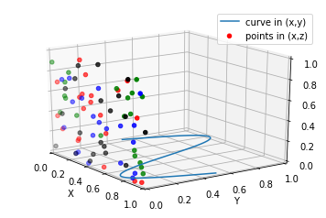

**B-子图Subplot用法**

与MATLAB不同的是，如果一个四子图效果，如：

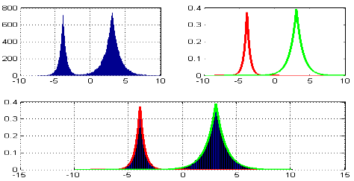

MATLAB：

|  |  |
| --- | --- |
| 1  2  3 | subplot(2,2,1)  subplot(2,2,2)  subplot(2,2,[3,4]) |

Python:

|  |  |
| --- | --- |
| 1  2  3 | subplot(2,2,1)  subplot(2,2,2)  subplot(2,1,2) |

code:

import matplotlib.pyplot as plt

from mpl_toolkits.mplot3d.axes3d import Axes3D, get_test_data

from matplotlib import cm

import numpy as np

# set up a figure twice as wide as it is tall

fig = plt.figure(figsize=plt.figaspect(0.5))

#===============

#  First subplot

#===============

# set up the axes for the first plot

ax = fig.add_subplot(2, 2, 1, projection='3d')

# plot a 3D surface like in the example mplot3d/surface3d_demo

X = np.arange(-5, 5, 0.25)

Y = np.arange(-5, 5, 0.25)

X, Y = np.meshgrid(X, Y)

R = np.sqrt(X**2 + Y**2)

Z = np.sin(R)

surf = ax.plot_surface(X, Y, Z, rstride=1, cstride=1, cmap=cm.coolwarm,

                       linewidth=0, antialiased=False)

ax.set_zlim(-1.01, 1.01)

fig.colorbar(surf, shrink=0.5, aspect=10)

#===============

# Second subplot

#===============

# set up the axes for the second plot

ax = fig.add_subplot(2,1,2, projection='3d')

# plot a 3D wireframe like in the example mplot3d/wire3d_demo

X, Y, Z = get_test_data(0.05)

ax.plot_wireframe(X, Y, Z, rstride=10, cstride=10)

plt.show()

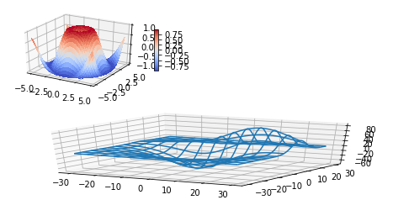

补充：

文本注释的基本用法：

code:

from mpl_toolkits.mplot3d import Axes3D

import matplotlib.pyplot as plt

fig = plt.figure()

ax = fig.gca(projection='3d')

# Demo 1: zdir

zdirs = (None, 'x', 'y', 'z', (1, 1, 0), (1, 1, 1))

xs = (1, 4, 4, 9, 4, 1)

ys = (2, 5, 8, 10, 1, 2)

zs = (10, 3, 8, 9, 1, 8)

for zdir, x, y, z in zip(zdirs, xs, ys, zs):

    label = '(%d, %d, %d), dir=%s' % (x, y, z, zdir)

    ax.text(x, y, z, label, zdir)

# Demo 2: color

ax.text(9, 0, 0, "red", color='red')

# Demo 3: text2D

# Placement 0, 0 would be the bottom left, 1, 1 would be the top right.

ax.text2D(0.05, 0.95, "2D Text", transform=ax.transAxes)

# Tweaking display region and labels

ax.set_xlim(0, 10)

ax.set_ylim(0, 10)

ax.set_zlim(0, 10)

ax.set_xlabel('X axis')

ax.set_ylabel('Y axis')

ax.set_zlabel('Z axis')

plt.show()

