**UNIVERSITY OF CALCUTTA**

**B.Sc. (HONOURS) SEMESTER – VI EXAMINATION, 2023**

**(UNDER CBCS)**

**PROJECT WORK**

**CONFESSIONITY**

**Paper: CMSA-CC-6-13-P & CMSA-CC-6-14-P**

**Submitted to the Department of Computer Science,**

**Seth Anandram Jaipuria College, University of Calcutta.**

**In partial fulfillment of the requirements**

**For the Degree of Bachelor of Science, Computer Science (Hons.)**

**Submitted by,**

**Diganta Biswas (Roll No: 203224-21-0120)**

**Manjima Chatterjee (Roll No: 203224-11-0073)**

**Under the Guidance of Prof. Rajesh Mishra.**

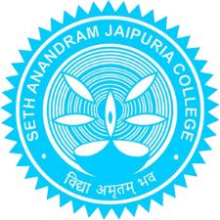

Seth Anandram Jaipuria College,

University of Calcutta