Московский государственный технический университет имени Н. Э. Баумана

Факультет «Информатика и системы управления»
Кафедра ИУ5

Отчёт по
лабораторной работе № 4
«Разработка интернет приложений»

Подготовил:
Кан Андрей Дмитриевич
Группа ИУ5-54Б
Подпись______
Дата_______

Москва
2020г.
1.) Задание
1. Необходимо для произвольной предметной области реализовать три шаблона проектирования: один порождающий, один структурный и один поведенческий. В качестве справочника шаблонов можно использовать следующий каталог.
2. Для каждой реализации шаблона необходимо написать модульный тест. В модульных тестах необходимо применить следующие технологии:
- TDD — фреймворк.
- BDD — фреймворк.
- Создание Mock-объектов.
2.) Текст программы
Тесты:
def test_charging():
iphone = Iphone()
lightningwire = LightningWire()
usbwire = UsbWire()
adapterusb = AdapterUsb(usbwire)
assert iphone.charge(lightningwire)
assert not iphone.charge(usbwire)
assert iphone.charge(adapterusb)

def get_cheese_list():
cheese_list = [Cheese(), Cheese(), Cheese()]
return cheese_list
def test_fabric(monkeypatch):
cheesefabric = CheeseFabric()
monkeypatch.setattr(cheesefabric, "deliver", get_cheese_list)
assert len(cheesefabric.deliver()) == 3
sourcreamefabric = SourCreameFabric()
assert type(sourcreamefabric.deliver(2)) == list
assert len(sourcreamefabric.deliver(2)) == 2
assert type(sourcreamefabric.deliver(2)[0]) == SourCreame

def test_bases():
elf_base = ElfBaseAI(2000)
assert elf_base.gather_army() == "5 elves were recruited"
assert elf_base.build_structures() == "2 structures were built"
orc_base = OrcBaseAI(3000)
assert orc_base.gather_army() == "20 orcs were recruited"
assert orc_base.build_structures() == "3 structures were built"

Классы:
class AdapterUsb(LightningWire):
def __init__(self, usbwire: UsbWire):
self.usbwire = usbwire
def get_port(self) -> str:
if self.usbwire.get_port() == "usb": # если разъемы переходника и кабеля совпадают, то мы соединяем переходник и получаем другой разъем на выходе
return "lightning"
else:
return "incompatible ports"

class LightningWire:
def __init__(self):
self.__port = "lightning"
def get_port(self) -> str:
return self.__port

import time
class Iphone:
def __init__(self):
self.__port = "lightning"
def charge(self, wire: LightningWire):
if self.__port == wire.get_port():
print("Charging...")
time.sleep(1)
print("Your iphone is fully charged")
return True
else:
print("Incompatible ports")
return False
class UsbWire:
def __init__(self):
self.__port = "usb"
def get_port(self):
return self.__port

class MilkFabric(ABC):
@abstractmethod
def create_milk_product(self) -> MilkProduct:
pass
def deliver(self, amount: int) -> list[MilkProduct]:
products = []
for i in range(amount):
products.append(self.create_milk_product())
print("Products with code name {} were successfully delivered".format(products[0]))
return products
class CheeseFabric(MilkFabric):
def create_milk_product(self) -> MilkProduct:
return Cheese()
class SourCreameFabric(MilkFabric):
def create_milk_product(self) -> MilkProduct:
return SourCreame()

class MilkProduct(ABC):
@abstractmethod
def __repr__(self) -> str:
pass
class Cheese(MilkProduct):
def __repr__(self) -> str:
return "Cheese"
class SourCreame(MilkProduct):
def __repr__(self) -> str:
return "SourCreame"

class BaseAI(ABC):
"""Base class"""
@abstractmethod
def build_structures(self):
pass
@abstractmethod
def gather_army(self):
pass
def attack(self, target: BaseAI):
"""default method"""
return "Attacking {}".format(target)
def turn(self, target: BaseAI):
print(self.build_structures())
print(self.gather_army())
print(self.attack(target))
class ElfBaseAI(BaseAI):
"""Elves are more advanced and prefer to spend more money on buildings
but their army and buildings cost more"""
def __init__(self, money):
self.__money = money
self.__unit = Elf()
self.__building_cost = 500
self.built_structures = 0
self.army = []
self.__unit_cost = 200
def build_structures(self):
amount = int((self.__money/2) / self.__building_cost)
self.built_structures = amount
return "{} structures were built".format(self.built_structures)
def gather_army(self):
amount = int((self.__money/2)/self.__unit_cost)
for i in range(amount):
self.army.append(Elf())
return "{} elves were recruited".format(len(self.army))
def __repr__(self):
return "ElfBase"
class OrcBaseAI(BaseAI):
"""Orcs prefer unreasonable fights to tactic moves that's why they
like to spend money on army"""
def __init__(self, money):
self.__money = money
self.__unit = Orc()
self.__building_cost = 300
self.built_structures = 0
self.army = []
self.__unit_cost = 100
def build_structures(self):
amount = int((self.__money / 3) / self.__building_cost)
self.built_structures = amount
return "{} structures were built".format(self.built_structures)
def gather_army(self):
amount = int((self.__money * 2 / 3) / self.__unit_cost)
for i in range(amount):
self.army.append(Elf())
return "{} orcs were recruited".format(len(self.army))
def __repr__(self):
return "OrcBase"

class Unit(ABC):
@abstractmethod
def __repr__(self):
pass
class Elf(Unit):
def __init__(self):
self.__unit = "elf"
def __repr__(self):
return self.__unit
class Orc(Unit):
def __init__(self):
self.__unit = "orc"
def __repr__(self):
return self.__unit
Main:
from patterns.fabric_pattern.MilkFabric import CheeseFabric, SourCreameFabric
from patterns.adapter_pattern.Smartphone import Iphone
from patterns.adapter_pattern.LightningWire import LightningWire
from patterns.adapter_pattern.AdapterUsb import AdapterUsb
from patterns.adapter_pattern.UsbWire import UsbWire
from patterns.method_pattern.GameAI import ElfBaseAI, OrcBaseAI
if __name__ == '__main__':
cheeseFabric = CheeseFabric()
print(cheeseFabric.deliver(2))
sourcreameFabric = SourCreameFabric()
print(sourcreameFabric.deliver(3))
iphone = Iphone()
lightningwire = LightningWire()
usbwire = UsbWire()
adapterusb = AdapterUsb(usbwire)
print(iphone.charge(lightningwire))
print(iphone.charge(adapterusb))
print(iphone.charge(usbwire))
elfbase = ElfBaseAI(2000)
orcbase = OrcBaseAI(2000)
elfbase.turn(orcbase)
orcbase.turn(elfbase)

3.) Экранные формы с результатами выполнения задания

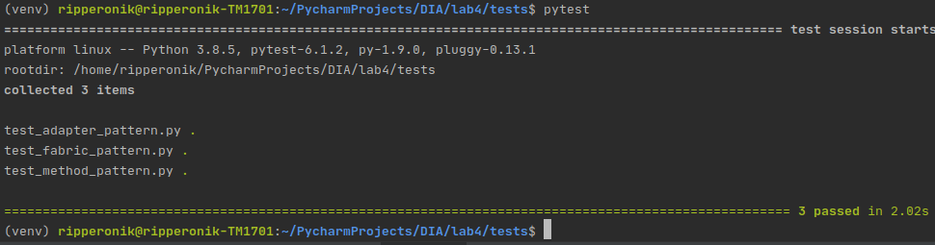
Результаты работы main:
Products with code name Cheese were successfully delivered
[Cheese, Cheese]
Products with code name SourCreame were successfully delivered
[SourCreame, SourCreame, SourCreame]
Charging...
Your iphone is fully charged
True
Charging...
Your iphone is fully charged
True
Incompatible ports
False
2 structures were built
5 elves were recruited
Attacking OrcBase
2 structures were built
13 orcs were recruited
Attacking ElfBase

