

BIT3208 Weekly Logbook

Student Name: Ian Ombuna Maburi
Admission Number: BSCCS/2024/54322
Course/Class: BSc Computer Science — Year 3
Unit Code: BIT3208
Unit Name: Advanced Web Design and Development
Lecturer: Mr. Michael Nyoro
Semester/Academic Year: Semester 1 / 2025–2026
Project Title: MediCare Clinic — Patient Management System
Technologies: HTML5, CSS3, JavaScript, Supabase (PostgreSQL), GitHub Pages
GitHub Repository: https://github.com/ripperrashy/medicare-clinic
Live Site: https://ripperrashy.github.io/medicare-clinic/

Contents
Table of Contents 2
WEEK 1: Environment Setup 3
WEEK 2: Wireframes and UI Design 6
WEEK 3: JavaScript and DOM Manipulation 10
WEEK 4: Server-Side Components and Backend 12
WEEK 5: Database and CRUD Operations 15

WEEK 1: Environment Setup
Title: Setting Up the Cloud Development Environment
For this project I decided to go with a cloud-based setup instead of the traditional XAMPP approach. I installed VS Code as my main editor and created a Sup abase project to handle the database Supabase uses PostgreSQL in the cloud and works like an online version of phpMyAdmin. GitHub was used for version control and the site is hosted on GitHub Pages so it is accessible online without needing a local server.
[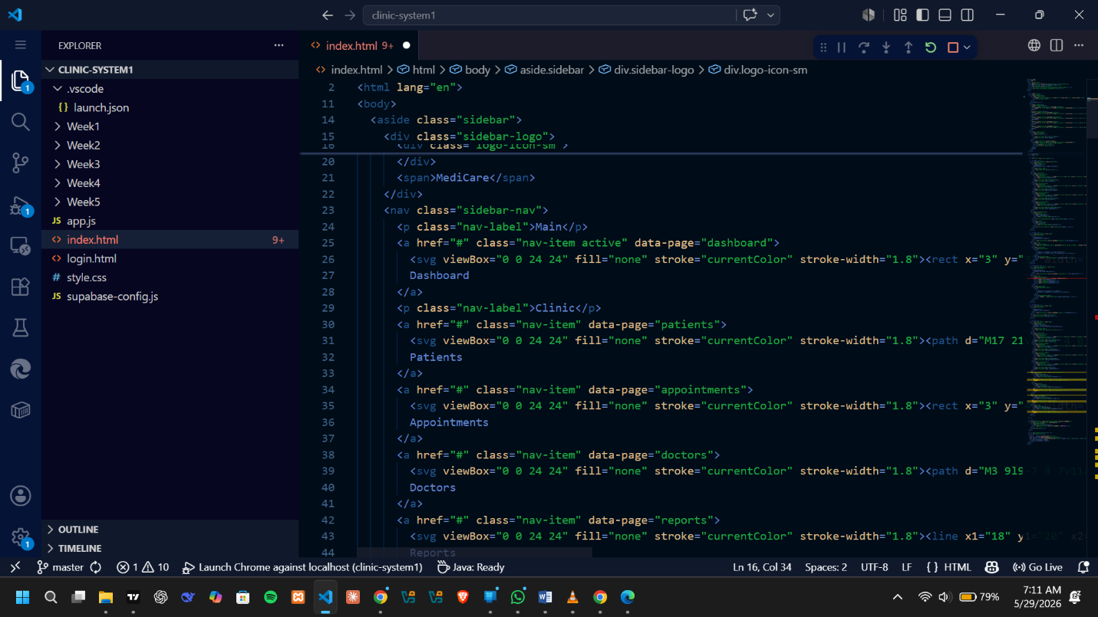
Fig 1: VS Code open with the MediCare project folder showing all project files

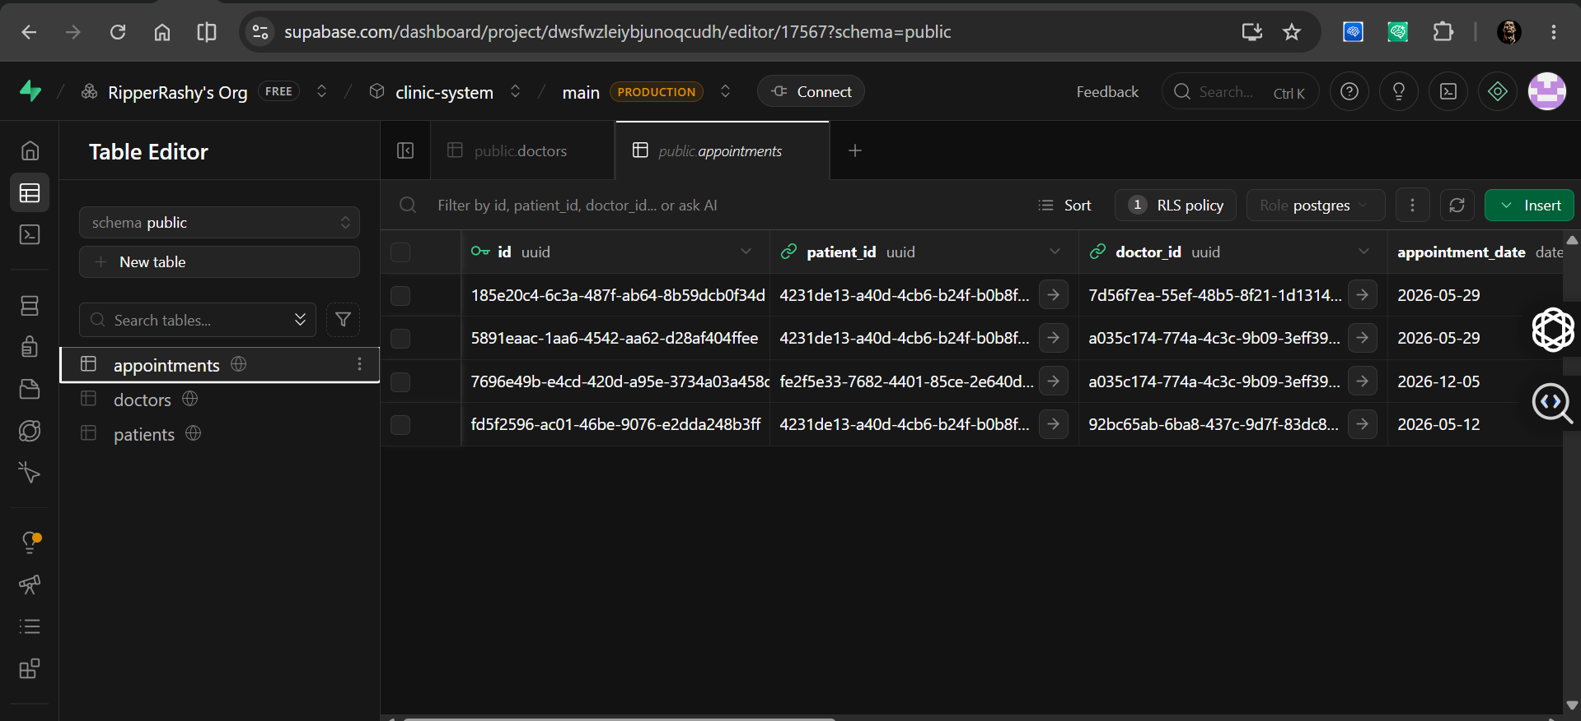
Fig 2: Supabase dashboard showing the project and the three database tables created
[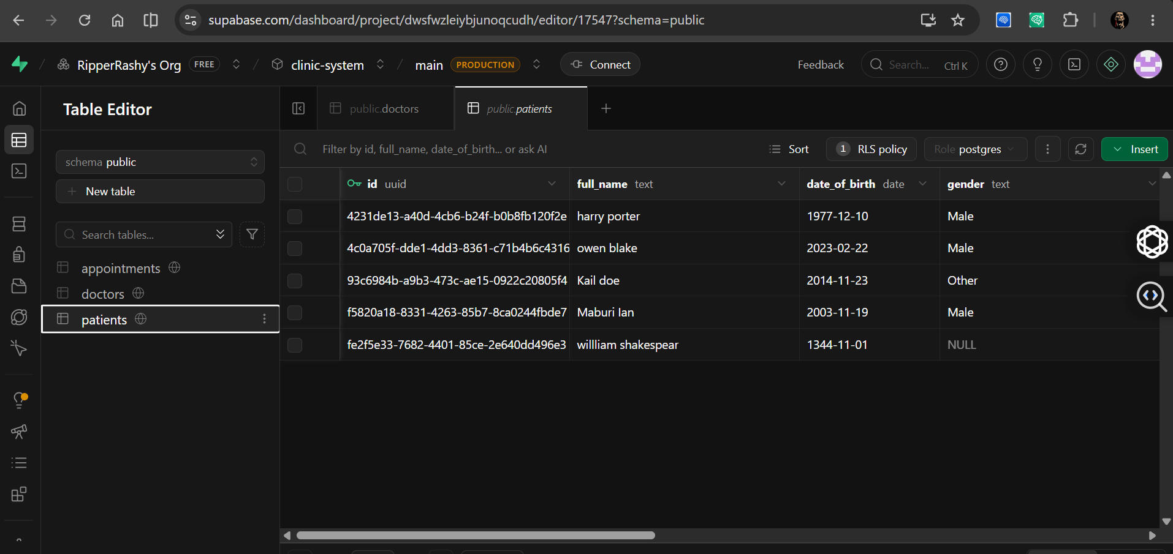
Fig 3: Supabase Table Editor showing the patients table with all its columns
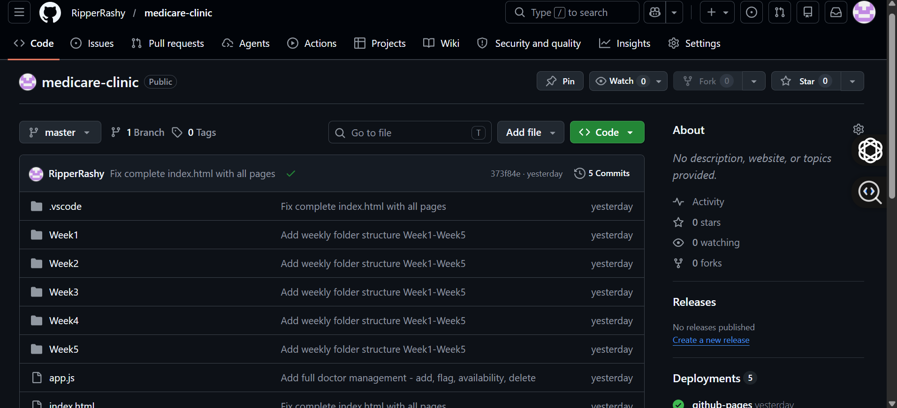
Fig 4: GitHub repository showing all files committed and pushed to the master branch
[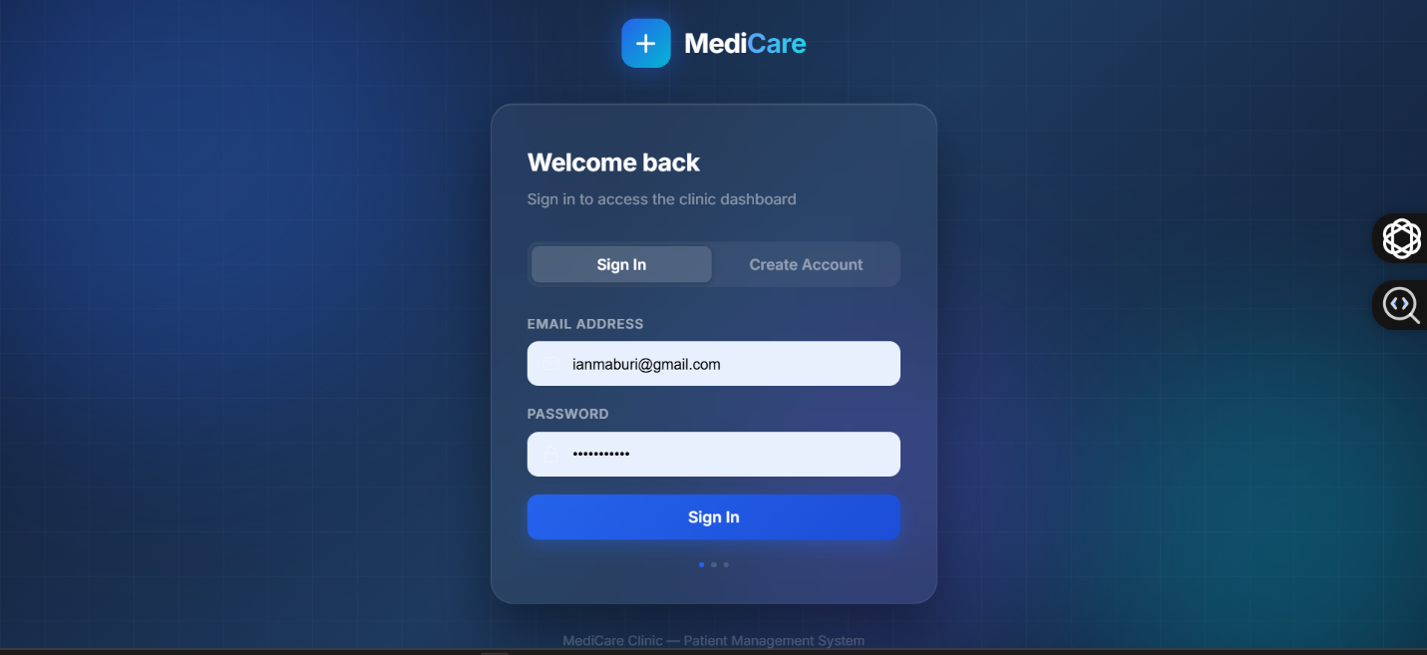
Fig 5: Live site running on GitHub Pages — MediCare login page visible in the browser
Student Reflection
This week was about getting everything ready before writing any real code. Setting up Supabase was straightforward I created a project, got the API URL and key, and added them to a supabase-config.js file which connects the frontend to the database. This works the same way as mysqli_connect() in PHP but using a cloud REST API instead of a local server. Getting the site live on GitHub Pages early was useful because it meant I could test the project in a real browser environment from the start rather than only on localhost.

WEEK 2: Wireframes and UI Design
Title: Planning the User Interface and Navigation Structure
Before writing HTML I planned out how the system would look and how users would move between pages. The MediCare system was designed around a sidebar layout with five sections Dashboard, Patients, Appointments, Doctors, and Reports. I chose a dark sidebar with a light content area because it separates navigation from content clearly and looks professional.

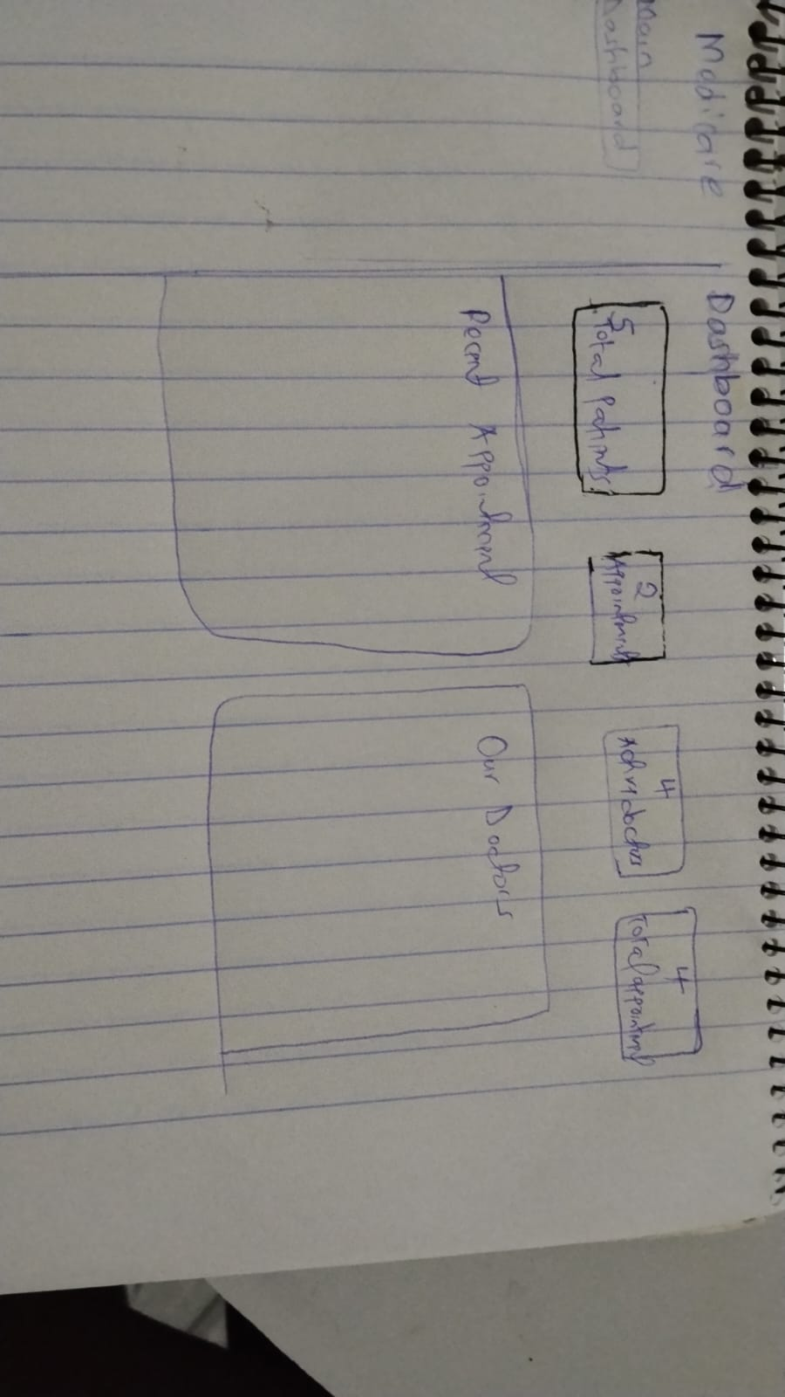
Fig 1: Wireframe or sketch of the dashboard layout with stat cards and recent appointments
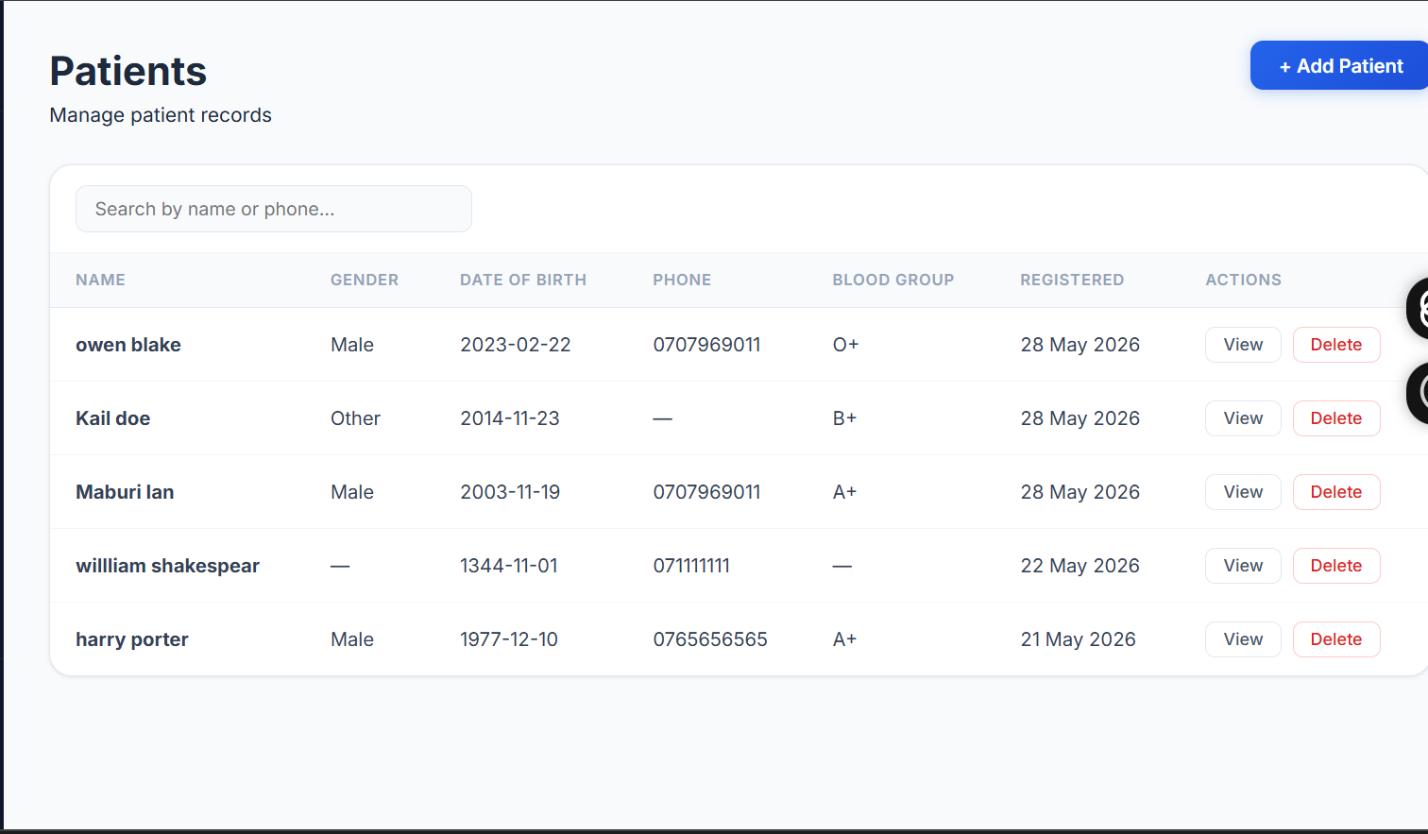Fig 2: Wireframe of the Patients page showing the data table and Add Patient button

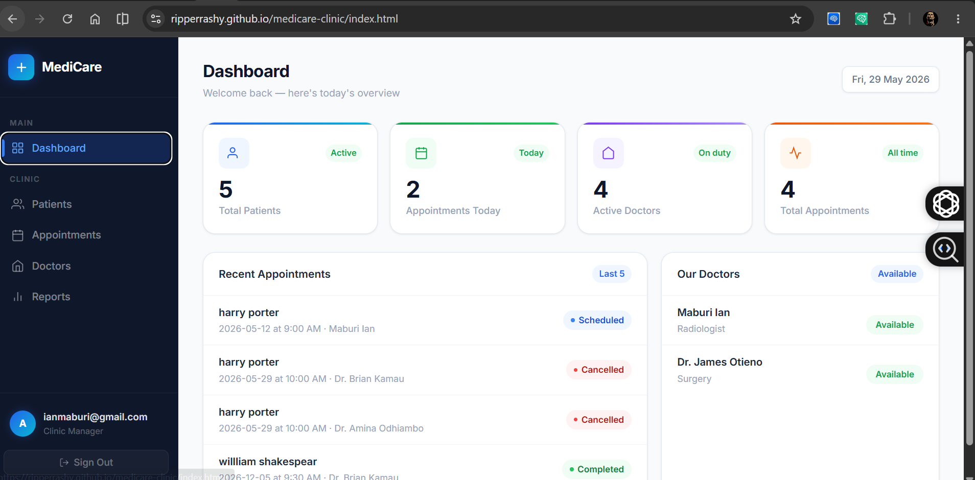
Fig 3: Planned navigation structure — sidebar with Dashboard, Patients, Appointments, Doctors, Reports


Fig 4: Colour scheme planning — dark navy sidebar (#0f172a), blue accent (#2563eb), white content area
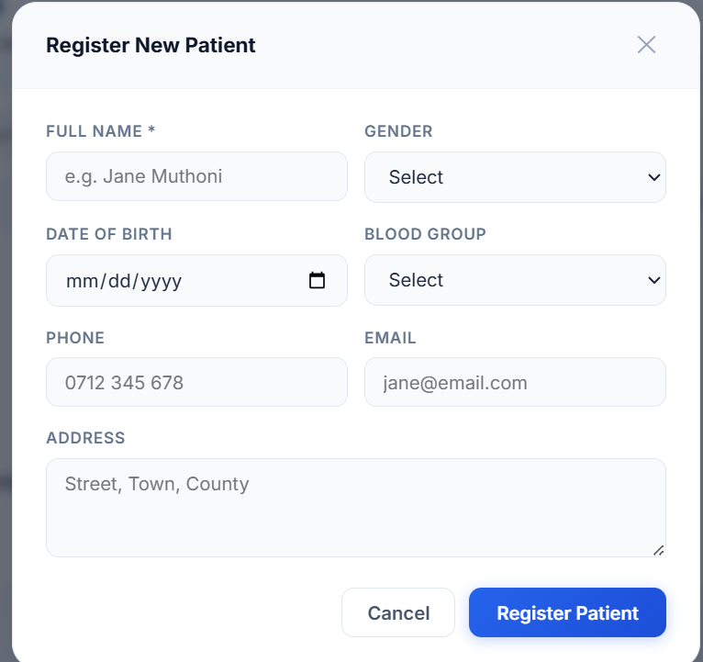
Fig 5: Mockup of the modal form design used for adding patients and booking appointments

Student Reflection
Planning the interface first saved me a lot of time during development. I decided on a single page application approach meaning all five sections are on one HTML file and JavaScript switches between them — this avoids full page reloads and feels faster to use. The modal forms were a deliberate design choice to keep users on the same page when adding data rather than navigating away. The colour choices were intentional — blue is commonly associated with healthcare and trust, and the dark sidebar gives the system a modern dashboard feel similar to what you see in real hospital management software.

WEEK 3: JavaScript and DOM Manipulation
Title: Frontend Interaction — JavaScript, Events, and Form Validation
This week I focused on making the interface interactive using JavaScript. All the dynamic behaviour in the system — loading data into tables, showing and hiding modals, searching through patients, and displaying toast notifications — is handled in app.js using vanilla JavaScript with no frameworks.

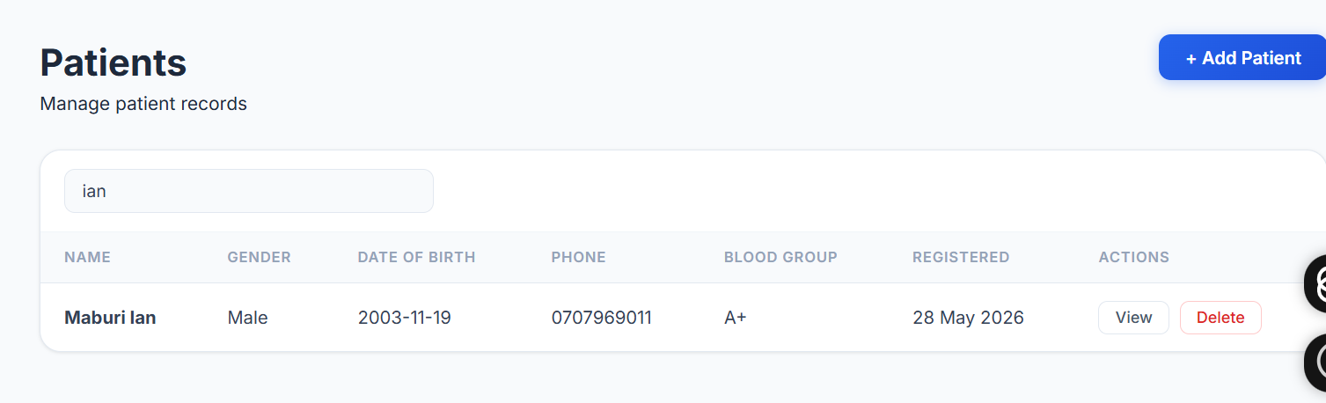Fig 1: Patient search working — typing in the search box filters the table rows in real time

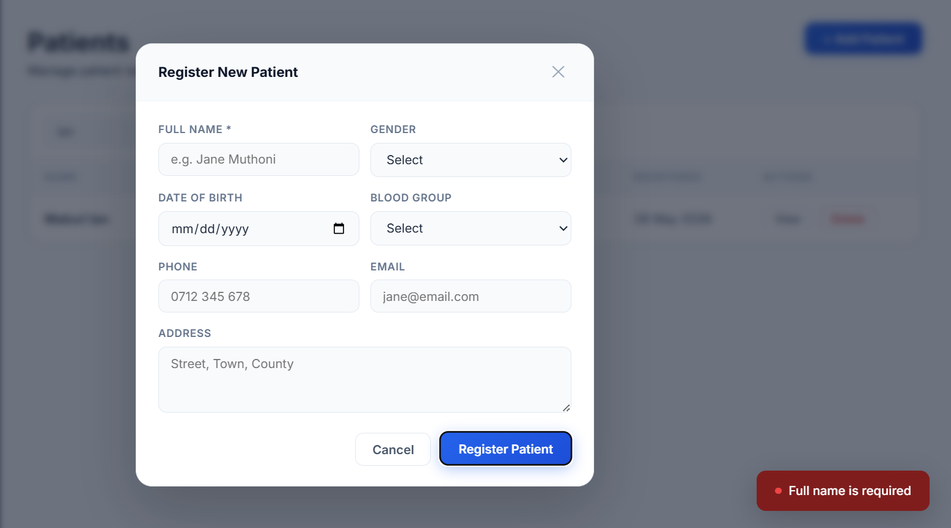Fig 2: Add Patient modal open — showing form validation stopping an empty name from being submitted

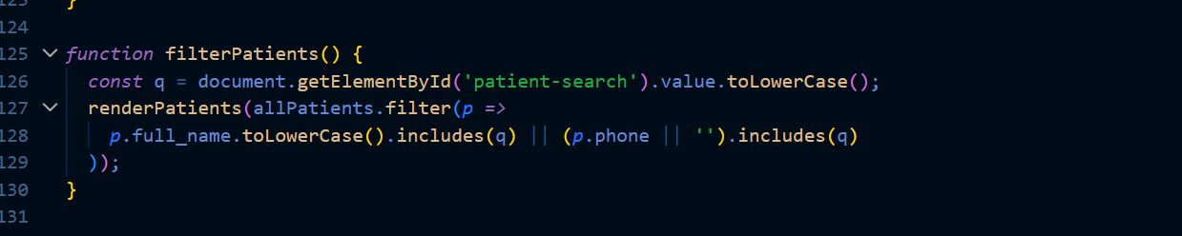
Fig 3: app.js open in VS Code — showing the filterPatients() function using Array.filter()

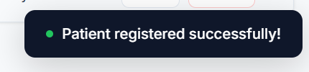
Fig 4: Toast notification appearing after a patient is successfully registered

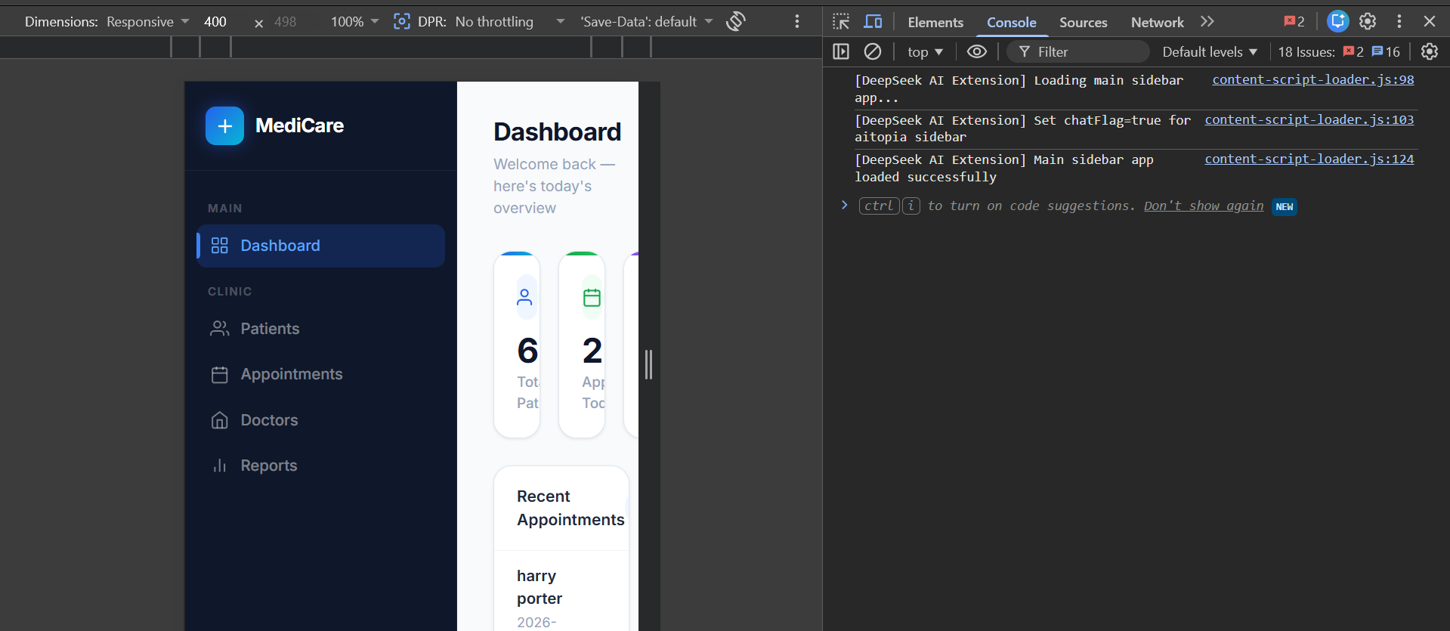Fig 5: Browser console showing async Supabase calls completing without errors

Student Reflection
The most interesting part this week was the real-time patient search. The filterPatients() function reads the search input value, runs Array.filter() on the cached patient list, and re-renders the table body using innerHTML — no database call needed because the data is already in memory. Form validation in submitPatient() checks that the full name field is not empty before allowing the insert to run, which is the same principle as checking $_POST values in PHP before running a query. Using async/await for the database calls kept the code clean and made sure the page did not freeze while waiting for Supabase to respond.

WEEK 4: Server-Side Components and Backend
Title: Backend Integration Using Supabase REST API
Week 4 is about how the application processes form submissions and communicates with the backend. In this project Supabase handles all the server-side logic. When a form is submitted the JavaScript collects the input values and sends them to Supabase using its JavaScript client library. The process is the same as PHP form handling — collect input, validate, send to the database, and give feedback to the user.
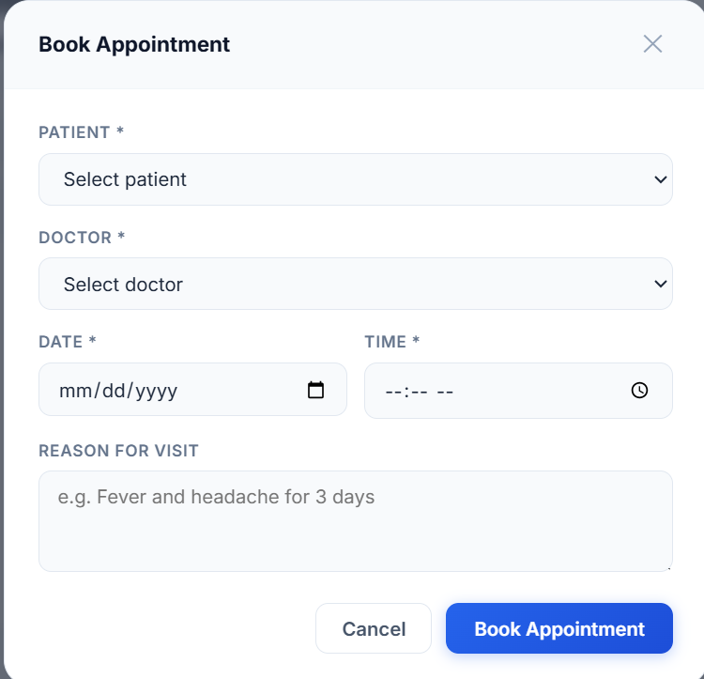
Fig 1: Book Appointment form showing all required fields — Patient, Doctor, Date, Time, Reason
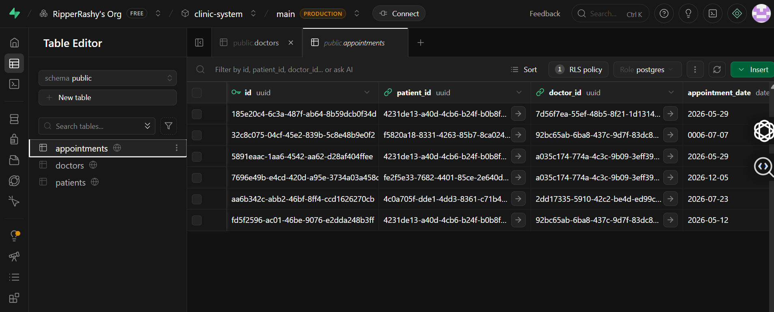
Fig 2: Supabase Table Editor showing the appointments table after a new appointment was inserted

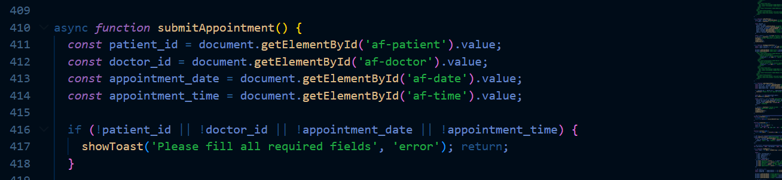Fig 3: submitAppointment() function in VS Code — showing form data collection and db.insert() call

Fig 4: Appointment status being changed from Scheduled to Completed in real time
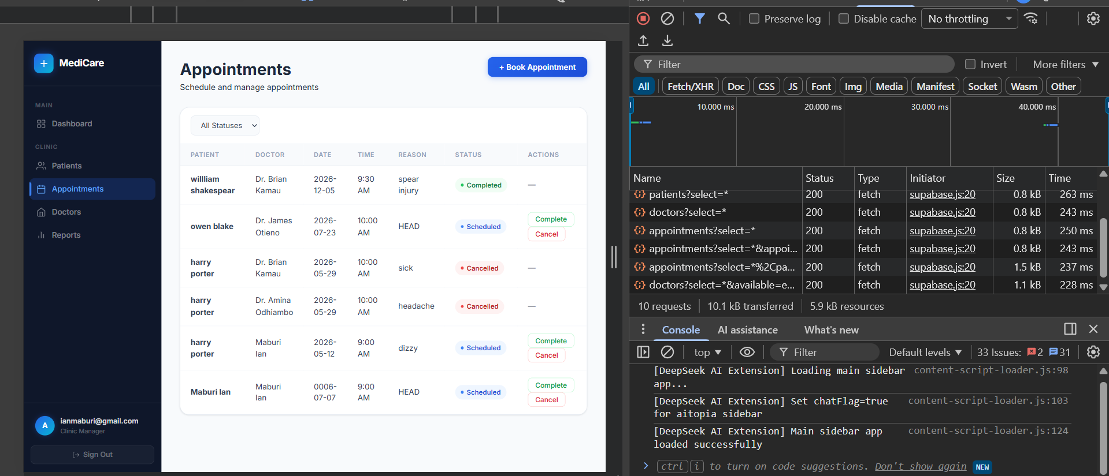Fig 5: Browser Network tab showing the API request sent to the Supabase REST endpoint after form submit
Student Reflection
The main difference between this approach and PHP is that instead of the browser submitting a form to a .php file, JavaScript catches the submit, collects the values using getElementById(), and calls db.from('appointments').insert() which sends a POST request to Supabase. The response comes back as a JavaScript object — if there is no error the operation worked and I show a success toast. If there is an error I display the message to the user. The updateStatus() function works the same way but uses db.update() instead of db.insert(), which is equivalent to running an UPDATE query in MySQL.

WEEK 5: Database and CRUD Operations
Title: Database Design and Full CRUD Implementation
This week covers how the database is structured and how all four CRUD operations work in the system. The MediCare database has three main tables — patients, doctors, and appointments. The appointments table connects to both patients and doctors using foreign keys, which is relational database design. All four operations (Create, Read, Update, Delete) are implemented across the system.
patients table: id (UUID, PK), full_name, gender, date_of_birth, blood_group, phone, email, address, created_at
appointments table: id (UUID, PK), patient_id (FK), doctor_id (FK), appointment_date, appointment_time, reason, status, created_at
doctors table: id (UUID, PK), full_name, specialization, phone, email, available, flagged, created_at

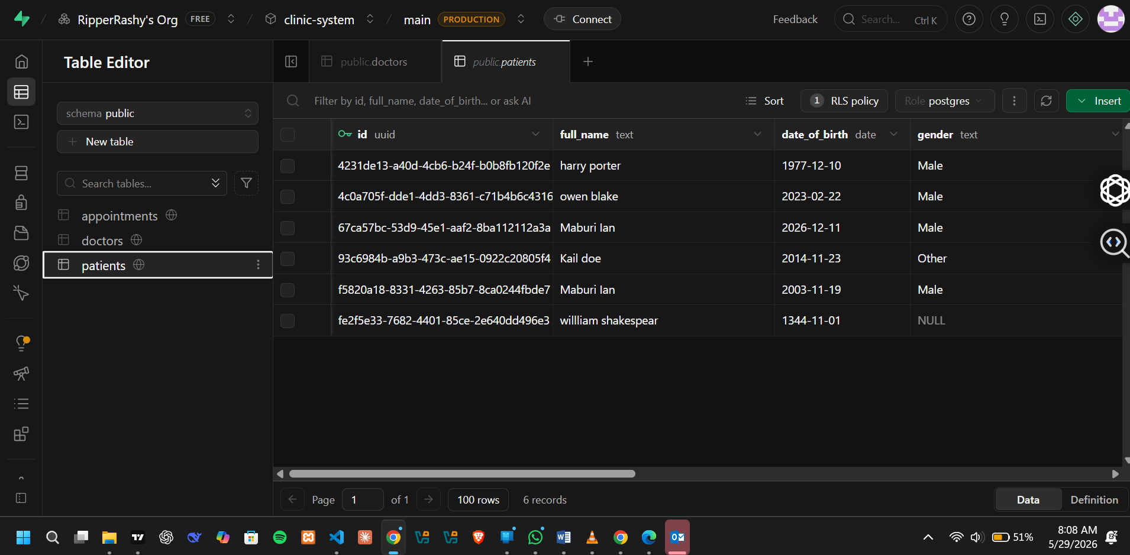
Fig 1: Supabase Table Editor — patients table showing several patient records inserted
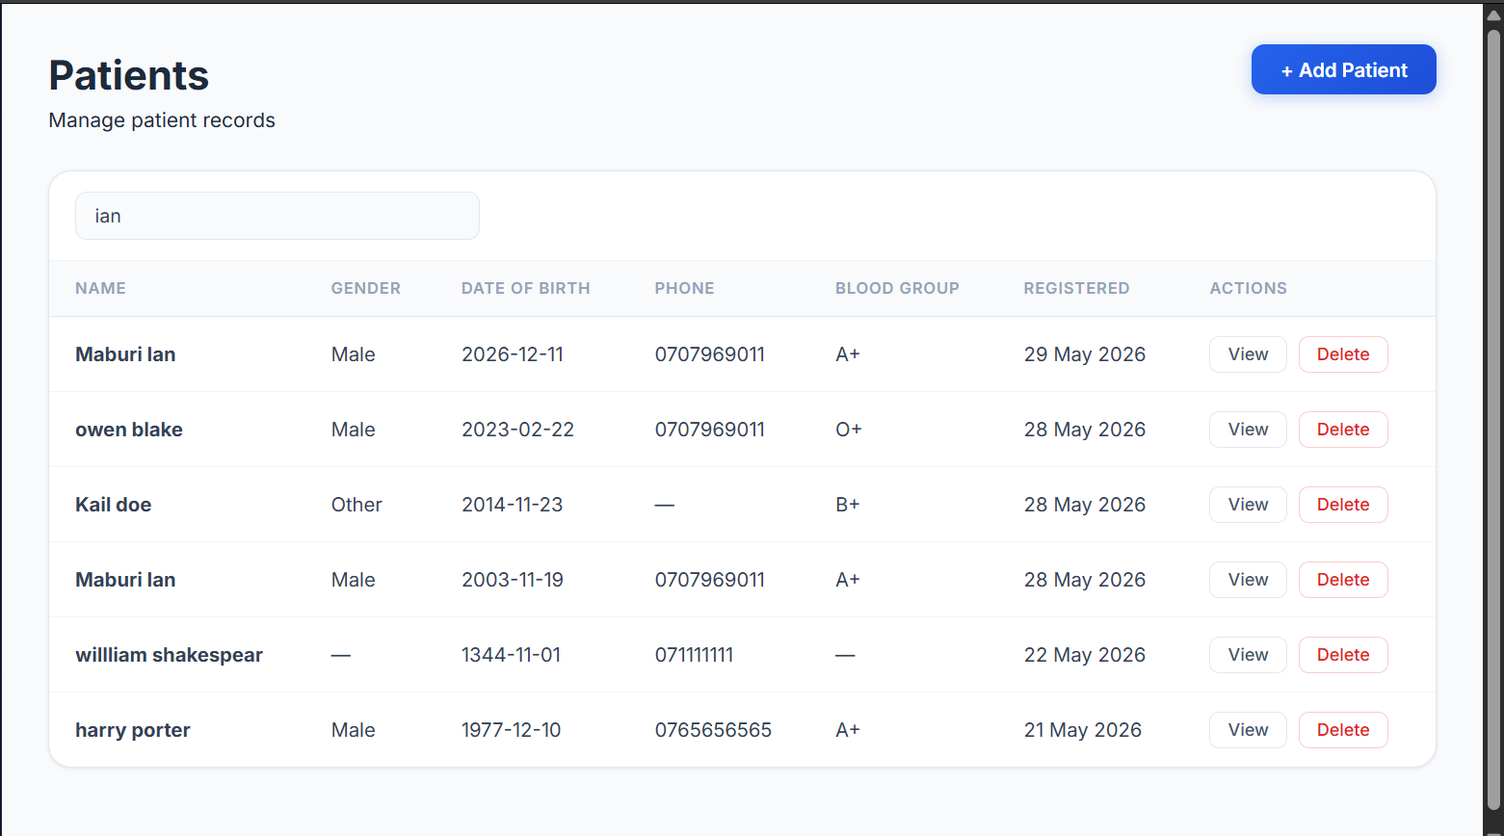Fig 2: Patients page in browser — table fully populated with records fetched from the database

Fig 3: Add Patient form submitted — new record appearing in the table immediately (CREATE)

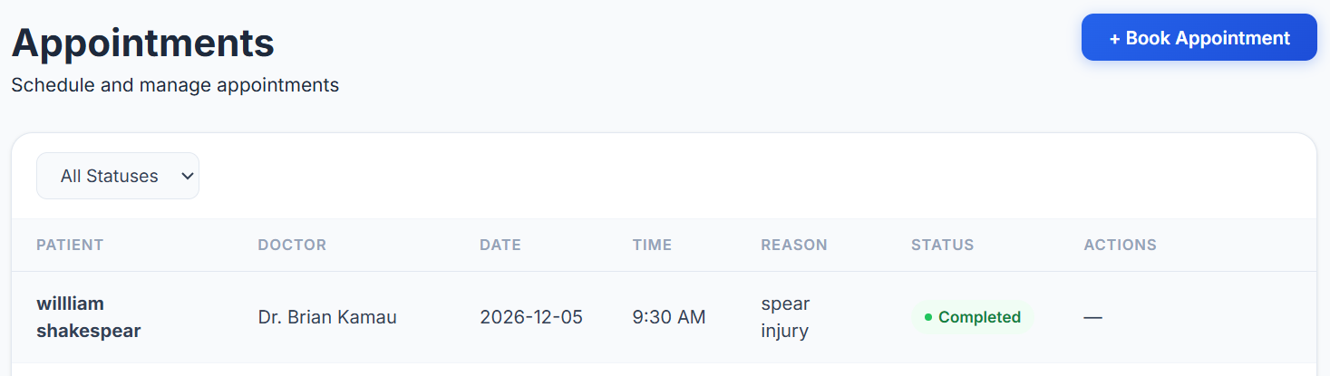
Fig 4: Appointment status changed from Scheduled to Completed — badge updates instantly (UPDATE)
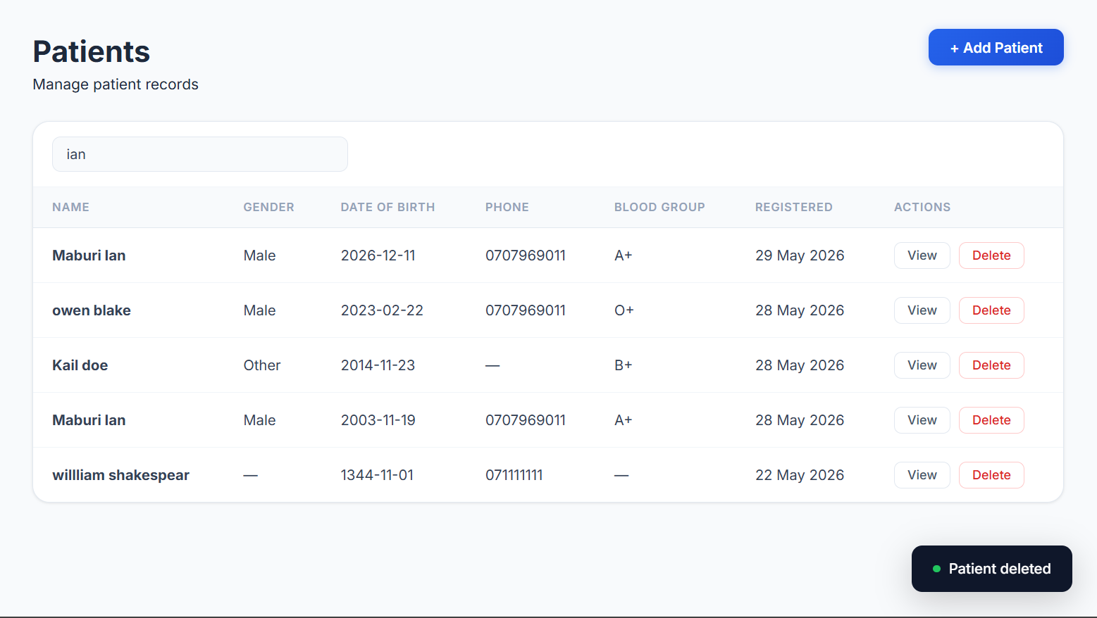
Fig 5: Delete patient — record disappears from the table after confirmation (DELETE)

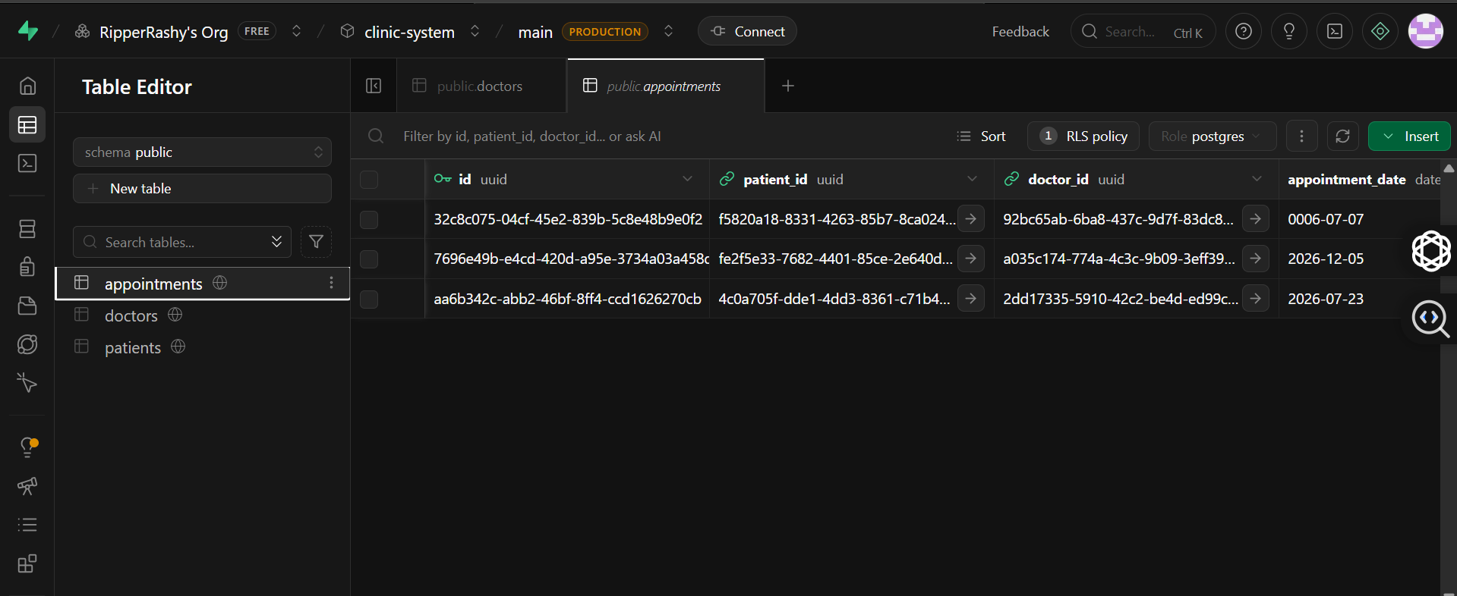Fig 6: Supabase appointments table — showing patient_id and doctor_id foreign key columns

Student Reflection
The relational design was important here. By linking appointments to patients and doctors through foreign keys I can pull all the information needed for the appointments table in one query using Supabase's select('*, patients(full_name), doctors(full_name)') — this is the equivalent of a JOIN in SQL. The doctors page has full CRUD too — you can add a new doctor, toggle their availability between available and unavailable, flag them for review, or delete them. The Reports page uses the same data to generate charts showing appointments by status, patients by gender, appointments per doctor, and patients by blood group, which gives a visual overview of the clinic's activity.

