**Test3：Login（student）**

**1.student**

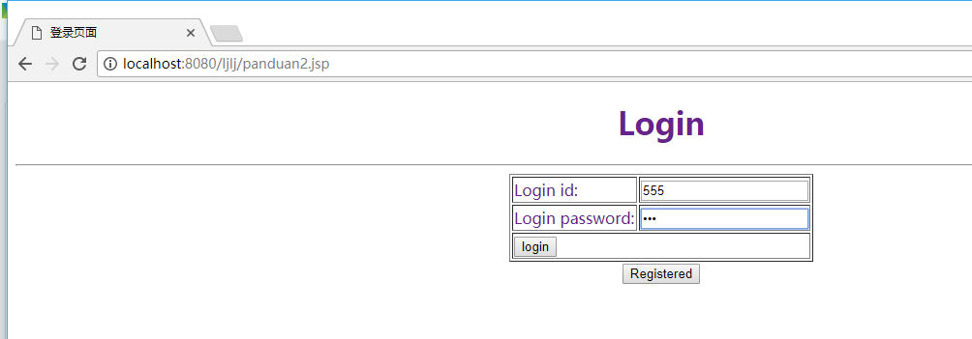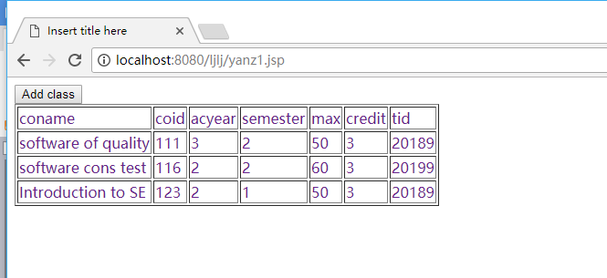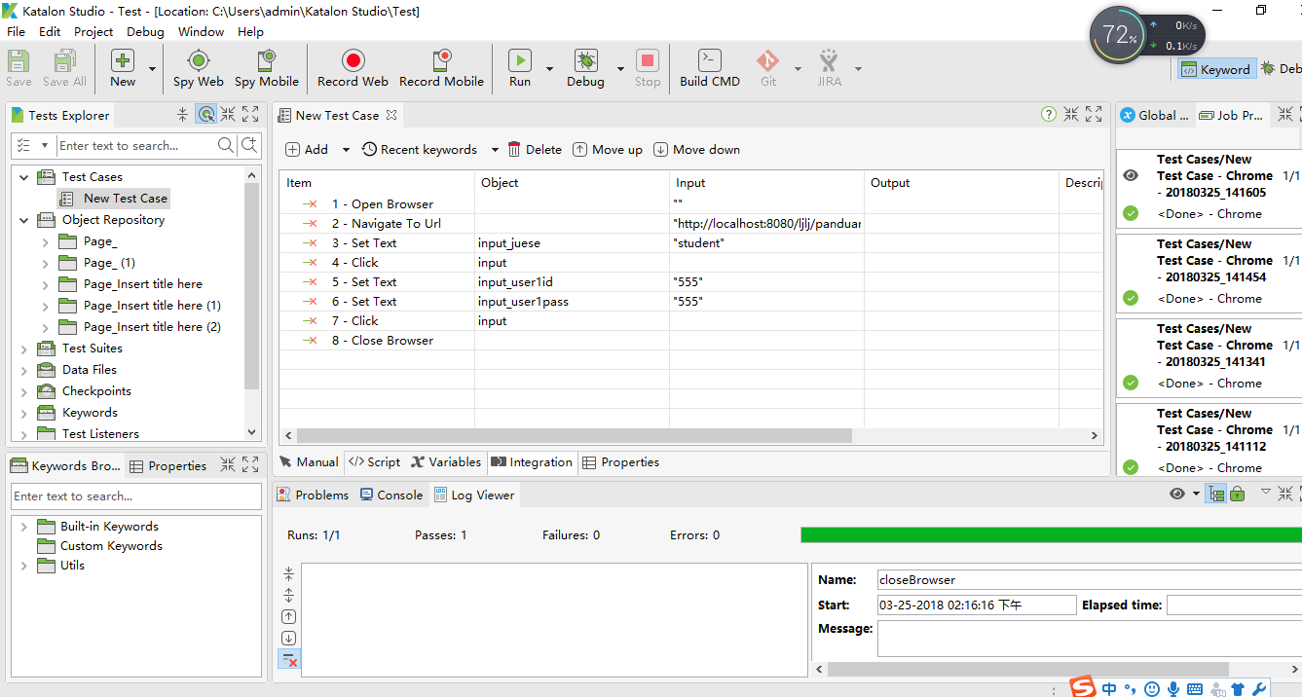

WebUI.*openBrowser*('')

WebUI.*navigateToUrl*('http://localhost:8080/ljlj/panduan.jsp')

WebUI.*setText*(*findTestObject*('Page_Insert title here (2)/input_juese'), 'student')

WebUI.*click*(*findTestObject*('Page_Insert title here (2)/input'))

WebUI.*setText*(*findTestObject*('Page_ (1)/input_user1id'), '555')

WebUI.*setText*(*findTestObject*('Page_ (1)/input_user1pass'), '555')

WebUI.*click*(*findTestObject*('Page_ (1)/input'))

WebUI.*closeBrowser*()

**Test4：Login（teacher）**

1. **Teacher**

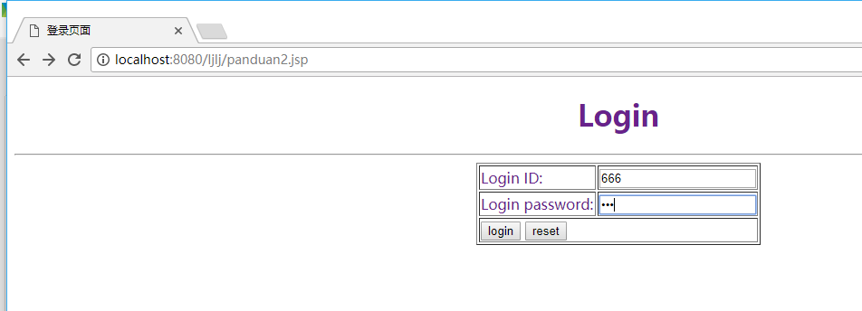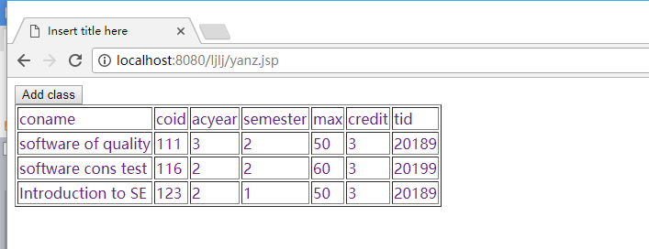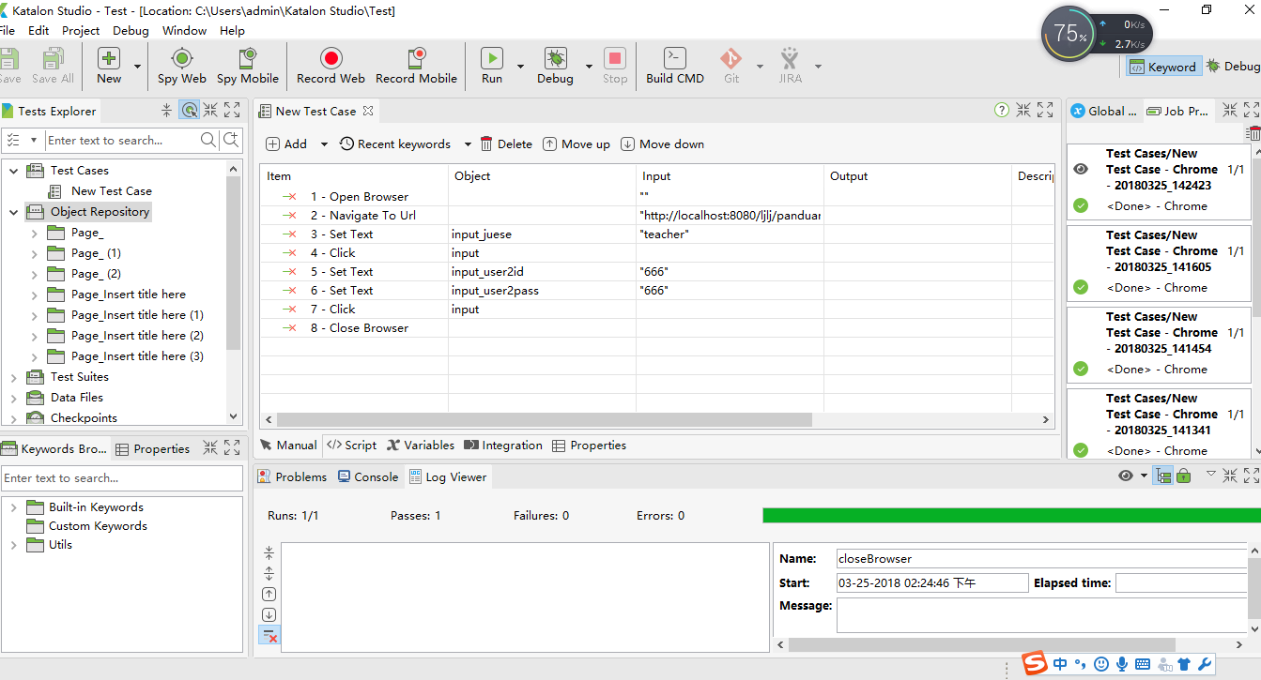

WebUI.*openBrowser*('')

WebUI.*navigateToUrl*('http://localhost:8080/ljlj/panduan.jsp')

WebUI.*setText*(*findTestObject*('Page_Insert title here (3)/input_juese'), 'teacher')

WebUI.*click*(*findTestObject*('Page_Insert title here (3)/input'))

WebUI.*setText*(*findTestObject*('Page_ (2)/input_user2id'), '666')

WebUI.*setText*(*findTestObject*('Page_ (2)/input_user2pass'), '666')

WebUI.*click*(*findTestObject*('Page_ (2)/input'))

WebUI.*closeBrowser*()

1. Error

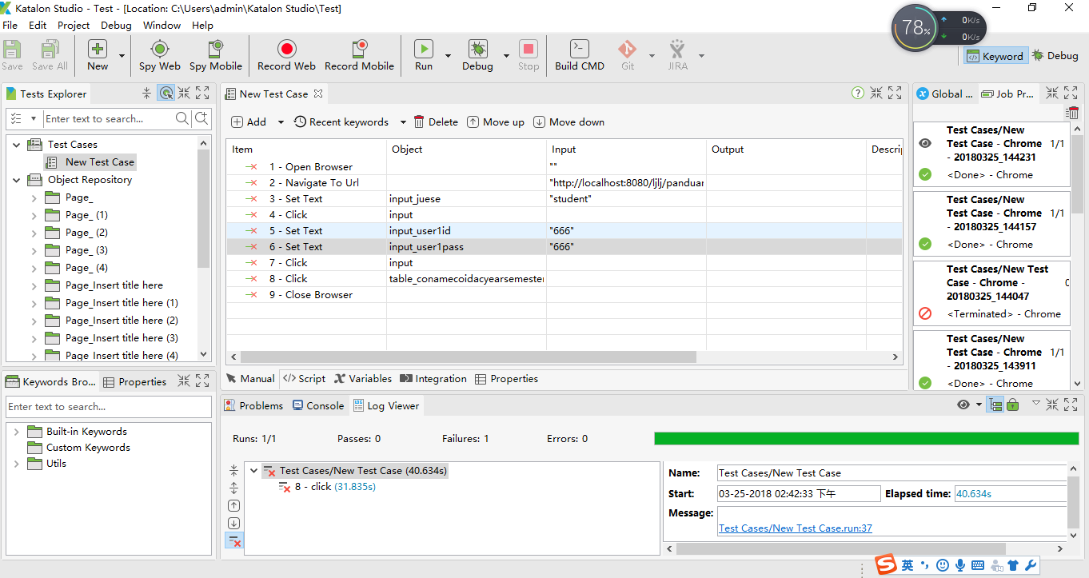

WebUI.*openBrowser*('')

WebUI.*navigateToUrl*('http://localhost:8080/ljlj/panduan.jsp')

WebUI.*setText*(*findTestObject*('Page_Insert title here (5)/input_juese'), 'student')

WebUI.*click*(*findTestObject*('Page_Insert title here (5)/input'))

WebUI.*setText*(*findTestObject*('Page_ (4)/input_user1id'), '666')

WebUI.*setText*(*findTestObject*('Page_ (4)/input_user1pass'), '666')

WebUI.*click*(*findTestObject*('Page_ (4)/input'))

WebUI.*click*(*findTestObject*('Page_Insert title here (5)/table_conamecoidacyearsemester'))

WebUI.*closeBrowser*()