REVISION HISTORY

|  |  |  |  |
| --- | --- | --- | --- |
| **Date** | **Version** | **Description** | **Author** |
| 22/10/2018 | 1.0 | Initial edits on the paper (1.2, 1.3, 1.4, 2.1, 2.3, 2.4) | Arman Hasanzade, Kaan Kırlı,  Kaan Yıldız,  Güneş Büyükgönenç |
| 23/10/2018 | 1.1 | Edits & addition of data of some parts (1.2,1.3,2.4) | Yazan Shehab,  Kaan Kırlı,  Arman Hasanzade |
| 24/10/2018 | 1.2 | Added Use Case, Activity and Package diagrams and Edits on parts (2.3 and 2.4) | Arman Hasanzade, Kaan Kırlı |
| 25/10/2018 | 2.0 | Minor edits to 1.2, 2.1, 2.4. The paper is ready for Review | Arman Hasanzade |
| 26/10/2018 | 2.1 | New tests added to 2.1 and 2.4 | Arman Hasanzade |

**TABLE OF CONTENTS**

**1 INTRODUCTION 3**

**1.1 Document overview 3**

**1.2 System overview 3**

**1.3 Abbreviations 3**

**1.4 References 3**

**1.5 Conventions 3**

**2 REQUIREMENTS 4**

**2.1 User Requirements Specification 4**

**2.2 System Architecture 5**

**2.3 Use Cases and Usage Scenarios 5**

**2.4 System Requirements Specification 6**

# INTRODUCTION

## Document overview

This document presents the software requirements specifications of SUP software development project. It describes functional requirements, quality requirements, constraints, use cases, and usage scenarios. It also provides an overview of the system architecture.

## System overview

SUP is a software which lets the user draw anything they want using different colors and brushes, in addition the user can save their brush presets to our mySQL database and save their images to their computer. The user can also open an existing image file from their computer and work on it in SUP.

The system requires the user’s computer to have Java and Internet connection for accessing the Database and enough disk space for the software to store images that user decides to save.

User shall create and save their brushes to database and access/use them whenever they want.

## Abbreviations

SUP: Super Paint

UML: Unified Modeling Language

IDE: Integrated Development Environment

JDK: Java Development Kit

SRS: Software Requirement Specification

STP: Software Test Plan

SDD: Software Design Document

STR: Software Test Report

## References

|  |  |  |
| --- | --- | --- |
| # | Document Identifier | Document Title |
| [R1] | MSPaint3D | <https://www.microsoft.com/tr-tr/p/paint-3d/9nblggh5fv99#activetab=pivot:overviewtab> |
| [R2] | Gimp | <https://www.gimp.org/> |

# 

## Conventions

Requirements listed in this document are constructed according to the following structure:

**SRS-XXX-000**

Description of XXX-000 requirement

Version of XXX-000

Every system requirement id includes the id of the corresponding user requirement as a prefix.

**SRS-XXX-000.1**

Description of *XXX-000.1 system requirement, which is related to the user requirement XXX-000*

Version of XXX-000.1

# REQUIREMENTS

## User Requirements Specification

***SRS-SUP-001***

User shall draw in the drawing area using different brushes, colors, brush sizes and shapes.

V1.0

***SRS-SUP-00*2**

User shall define a directory to SUP and shall save their images (drawn by SUP) to the specified directory.

V1.0

***SRS-SUP-003***

User shall select different types of Brushes with different colors and different sizes from the preset brushes.

V1.0

***SRS-SUP-004***

User shall create and save their Brushes and use them whenever they want.

V1.0

***SRS-SUP-005***

User shall open and edit JPG files from their computer.

V1.0

***SRS-SUP-006***

The time between drawing something and it getting displayed on the screen shall not be more than 2 seconds.

V1.0

***SRS-SUP-007***

The software shall be downloaded and installed.

V1.0

***SRS-SUP-008***

When the software is uninstalled it shall not leave any traces behind.

V1.0

***SRS-SUP-009***

When SUP is installed again, it shall access the brushes in the Database before uninstallation.

V1.0

## System Architecture

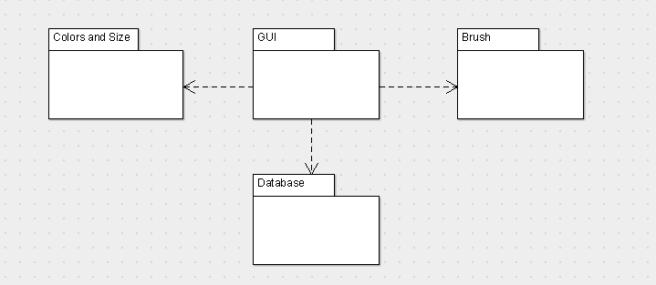

## Use Cases and Usage Scenarios

**Activity Diagram**

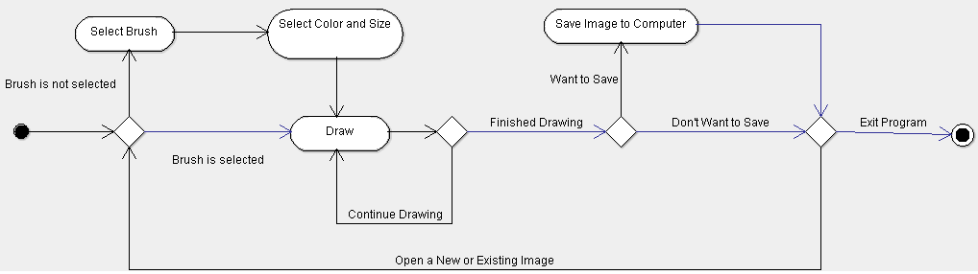

**Use Case Diagram**

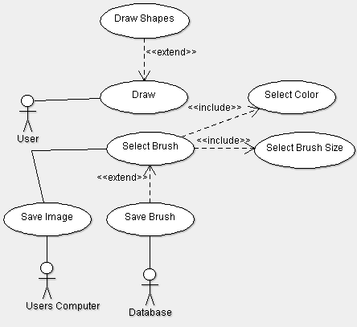

## System Requirements Specification

***SRS-SUP-001.1***

SUP shall draw the canvas with the mouse and system inputs from the user.

The inputs are:

* X value,
* Y value
* Brush information

V1.0

***SRS-SUP-001.2***

The user should be able to use different brushes, colors and brush sizes.

V1.0

***SRS-SUP-002.1***

SUP shall generate a JPG file to save the painting by using functions such as:

* BufferedImage
* Image.IO

V1.0

***SRS-SUP-003.1***

SUP shall contain the preset brushes in the database with several properties.

Brush properties are:

* Size
* Shape
* Color
* Name

V1.0

***SRS-SUP-004.1***

SUP shall let the user to create custom brushes with properties such as:

* Size
* Color
* Shape
* Name

V1.0

***SRS-SUP-004.2***

SUP shall save the user created brushes to the Database using different JDBC functions such as:

* Query
* createStatements

V1.0

***SRS-SUP-005.1***

SUP shall be able to open any JPG formatted images from users computer and display it on the drawing area.

V1.0

***SRS-SUP-006.1***

When the user moves his/her cursor while left mouse button is toggled, it should not exceed more than 2 seconds for the drawing to show up in the display area.

V1.0

***SRS-SUP-007.1***

SUP shall be downloaded and installed from the link provided by us to the Users.

V1.0

***SRS-SUP-008.1***

When SUP is uninstalled from the user’s computer, it shall leave no trace (files and folders which are used by the SUP) on user’s computer.

V1.0

***SRS-SUP-009.1***

When SUP is re-installed to the user’s computer, the user shall have access to the same brushes that s/he created before uninstalling the software as well as the preset brushes that SUP provides.

V1.0