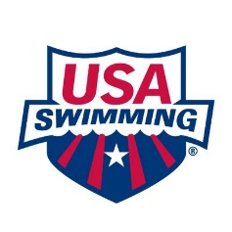
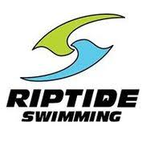
Become a USA Swimming Stroke and Turn Official
For Riptide Swim Team!

Make a splash: Join our Officiating Team

Do you want to support young athletes and be part of the action on deck? Becoming a USA Swimming Stroke & Turn Official for Riptide Swim Team is a rewarding way to get involved, make a positive impact, and ensure fair and fun competitions.

Why join as an Official?
- Front-Row Action: Experience every race up close and be part of the energy and excitement.
- Support Young Athletes: Help ensure that swimmers have a fair and encouraging environment to compete and achieve their best.
- Personal Growth: Gain valuable knowledge about competitive swimming and develop leadership and communication skills.
- Community Connection: Be part of a supportive, dedicated group of volunteers and make lasting friendships.

How to Become Certified:
- Complete USA Swimming Membership: Register as an Official with USA Swimming, including background check, Concussion Training, and Athlete Protection Training.
- Complete Stroke and Turn Online Training & Foundations of Officiating: Learn the rules of competitive swimming and how to officiate with confidence.
- On-the-job Training: Shadow experienced officials at swim meets to gain hands-on experience.

Join us today!
Ready to dive in? Becoming a Stroke & Turn Official is easier than you think and incredibly rewarding. No prior swimming experience is required—just your enthusiasm and dedication to helping every swimmer shine.

We are looking for passionate volunteers like YOU to ensure our swim meets run smoothly. Rest assured; we will be with you every step of the way!

Curious but not ready to commit? Contact Wendy Peterson to arrange a shadow session at a Riptide-hosted swim meet and see firsthand how you can make a difference!

Wendy Peterson
Riptide Officials Coordinator
whpeterson@gmail.com
612-708-7227

Resource Links

Link to USASwimming.org


Link to Riptide’s Officials Documentation for Becoming an Official


Riptide’s SignUp Genius Link for swim meets


Link to MN Swimming Officials Page


Email Wendy Peterson
whpeterson@gmail.com


