Riptide Officials – Register with USA Swimming - 2026

IF YOU ARE A NEW OFFICIAL - PLEASE REGISTER AS AN APPRENTICE OFFICIAL

The apprentice official membership will allow you to have access to the education resources for the officials for a 60 day grace period without paid membership fee.

Links
Follow this link for first time officials.

Follow this link to RENEW your membership.

Follow this link to UPGRADE your Apprentice status to Registered.

- Use this link to get started - new 2026 link
Team registration link: sign in at riptideofficials.github.io, Documents, Training (login required)

FIRST TIME OFFICIALS

- If this is your first time registering, then click the box “Register New Member”
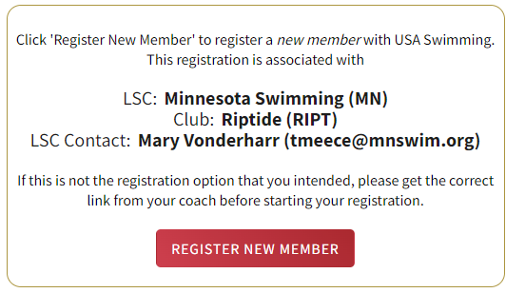

- The membership is for yourself.

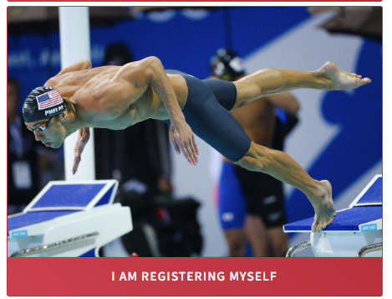

- Click through the screens and enter information
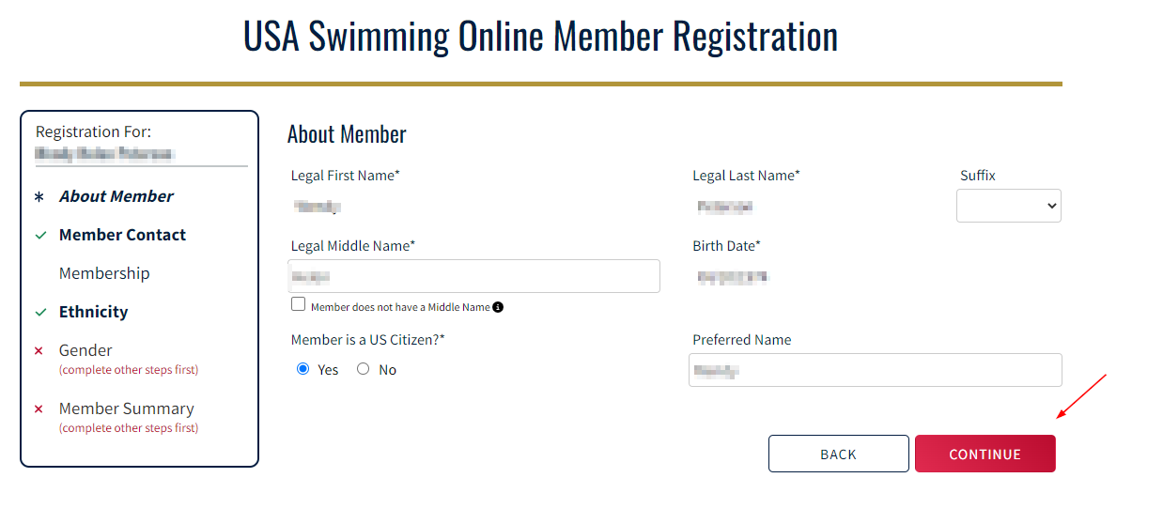

- Choose the Officials check box or Apprentice Official – this is for the year 2025.
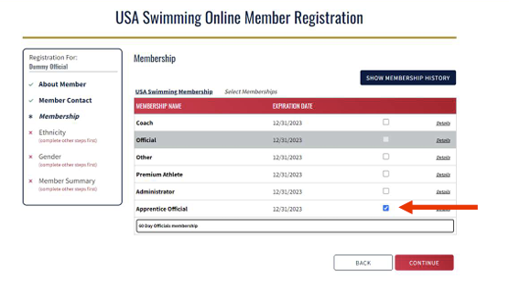

- Proceed with the checkout and choose the option to “Pay for this Later”.

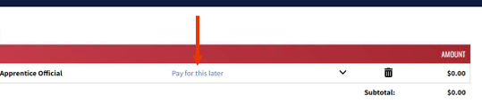

EXISTING OFFICIALS - Renew

- Log in and scroll to the bottom and check mark Official next to your name.

- Click Renew


- Log back in and make sure you see this on your dashboard – Official and Parent and make sure your Officials status is in “Good Standing”.
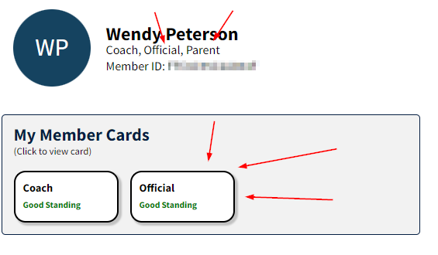

Upgrade your Membership to Registered - follow the link below for instructions.

https://websitedevsa.blob.core.windows.net/sitefinity/docs/default-source/swims-documents/members/how-do-i-upgrade-a-membership.pdf?sfvrsn=398d0632_1

