Stroke and Turn Officials (ST)
USA Swimming Officials Website
Minnesota Swimming Officials Page

Riptide Officials Coordinator: Wendy Peterson
whpeterson@gmail.com
612-708-7227

FOLLOW THESE STEPS TO BECOME A USA SWIMMING OFFICIAL
STEP 1
☐ Register with USA Swimming as an APPRENTICE

IF you DID NOT create a Parent account when registering your swimmer, then you will need to do this first. Register an Account or Login

Use this link to get started - new 2026 link
Team registration link: sign in at riptideofficials.github.io, Documents, Training (login required)

Otherwise, follow this link to get started and login with the same account you used as a Parent.

The apprentice official membership will allow you to have access to the education resources for the officials for a 60 day grace period without paid membership fee. You should try to finish all steps within the 60 days. You are allowed on deck to shadow during this time.

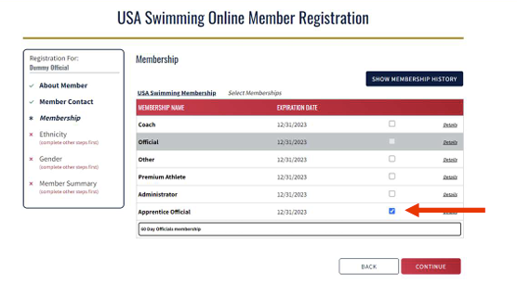
Proceed with the checkout and choose the option to “Pay for this Later”.

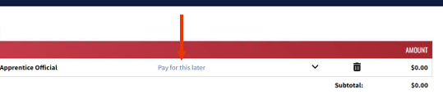

After the 60 days - you will need to register as an Official.

Riptide Registration Instructions https://docs.google.com/document/d/1l-mcmnjZHFdIezmzTYrdT4eIydvNo4T4/edit?usp=sharing&ouid=103882449600752076109&rtpof=true&sd=true

If you have not completed all of the steps listed here, you will be listed as “Not in good standing” and will not be allowed to shadow or work as ST on deck until you have completed everything.

STEP 2
☐ Athlete Protection Training (Safe Sport)
- Athlete Protection Training (APT) – must complete annually
- Must be added to your cart and check out before you can start
  - Should take about 45 minutes

STEP 3
☐ Complete the Stroke and Turn training for USA Swimming and take the test
https://university.usaswimming.org/landing
Also take “Foundations of Officiating”.
- Click on the Officials icon - to find both classes
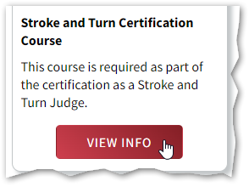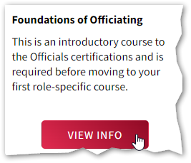
NOTE!
Please remember to take the survey at the end to complete the course!!!

STEP 4
☐ Complete a level 2 background check to be completed every 2 years
- Initiate a Background Check
- Riptide will reimburse with this form - MUST include copy of receipt and email to hr@elsmoreswim.com

STEP 5
☐ Complete Concussion Protocol Training ➜ CDC or NFHS
- CDC ➜ http://www.cdc.gov/headsup/youthsports/training/index.html
  - On the right side of the page, you will see a window, Launch the course.
- NFHS ➜ https://nfhslearn.com/courses/concussion-in-sports-2
- Watch the materials and take the quiz
- Save the certificate as a pdf document and email to bvonderharr@mnswim.org
- Must have a USA Swimming account for her to update your credentials. So register first with USA Swimming before completing the concussion training.

STEP 6
☐ Watch Stroke and Turn training videos found at the bottom of page - very useful!
- https://www.usaswimming.org/officials/how-to-become-an-official

STEP 7
☐ Shadow sessions at sanctioned USA Swimming meets. (XJ)
- Print the Stroke and Turn (ST) Apprentice Form and gather signatures from the Meet Ref at each session
Apprentice Form – Non-swimmers and non-coaches
Apprentice Form – Former swimmers and coaches
- ST session guide to follow – link – print and use this as reference for each session.
- Bring a clipboard to each shadow session.

STEP 9
☐ Officials Uniform
- White Polo Shirt – first shirt to be provided by Riptide. Additional shirts can be purchased from this link.
- Black pants, shorts, or skirt (Belt optional) - No yoga pants
- Black or mostly black shoes, closed toed

Follow your progress - Officials Tracking System

☐ Riptide Officials Google Group
- If you haven’t been added already, request subscription to google group for Riptide Officials by sending email to Riptideofficials+subscribe@googlegroups.com

☐ Name Badges
- Contact Wendy Peterson (whpeterson@gmail.com) to order a name badge.

ANNUAL USA SWIMMING OFFICIALS’ MAINTENANCE
- Annual training and testing for recertification at your top level
- Background check every 2 years
- Concussion Training update
- Athlete protection training update
- Volunteer at least 5 sessions annually
- Non-Athlete Member Renewal Annually, use link and instructions above.

ADVANCED POSITIONS
Starter (SR)
- Apprentice Form –Non-swimmer / Non-coach (XS)
- Apprentice Form – Former Swimmer / Coach (XS)
- Guideline: After Stroke and Turn for a year
- Starter Test - online

Meet Ref/Deck Ref (MR/DR)
- Guideline: After Starter for a year
- Apprentice Sheet (XM/XR)
- Referee Test - online

Admin (AR or AO)
- Guideline: Can be done with (AR) or without (AO) Stroke and Turn
- Apprentice sheet
- Admin Test - online

Chief Judge
- Apprentice Sheet

Wendy Peterson, Riptide Officials Coordinator

