哈尔滨工业大学深圳研究生院
2012年 秋 季学期期末考试试卷
HIT Shenzhen Graduate School Examination Paper
Course Name: Lecturer:
Question | One | Two | Three | Four | Five | Six | Seven | Eight | Nine | Ten | Total
Mark
General directions:
This exam is closed book. You may not use the text book, your notes, computer, or any other materials during the exam.
No credit will be given for questions left unanswered, so you should be sure to answer all questions, even if you are only taking your best guess.
Write your answer to each question or problem in the paper provided. If necessary, extra sheets will be provided. Make sure your name is written on all of these pages.
Please be sure to write neatly and answer all questions unambiguously.
This exam has a total of _100_ points, and you have 120 minutes.

Single choice [10 points]
1、Which case is most commonly used to evaluate the running time of one algorithm. ( )
(A) Worst case (B) Average case
(C) Best case (D) Ideal case.

2、Which method is not used to resolve a recurrence. ( )
(A) Substitution method (B) Recursion tree method
(C) Master method (D) Linear programming method.

3、An order-statistic tree is an augmented red-black tree. In addition to its usual fields, each node x has a field size[x], which is the number of nodes in the subtree rooted at x. For an order-statistic tree with n nodes, the time for insertion, deletion and maintenance of the size field are ( )
(A) 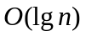
(B) 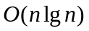
(C) 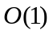
(D) 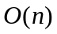
4、Computing a discrete Fourier transform (DFT) of N points takes __ arithmetical operations, while computing a fast Fourier transform (FFT) of N points takes __ arithmetical operations. ( )
(A) 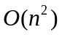 (B)
(C) (D)

5、In a hash table in which collisions are resolved by chaining, a successful search takes time __, under the assumption of simple uniform hashing. The load factor of this hash table is . ( )
(A)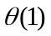 (B) 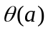 (C) 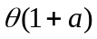 (D) 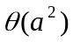

[31 points]
- Using figure to illustrate the operation of COUNTING-SORT on the array

A=<6,0,2,0,1,3,4,6,1,3,2>.
C=<2,2,2,2,1,0,2>
C’=<2,4,6,8,9,9,11>
B=<0,0,1,1,2,2,3,3,4,6,6>

- Using figure to illustrate the operation of RADIX-SORT on the following list of English words: COW, DOG, SEA, RUG, ROW, MOB, BOX, TAB. [8 points]

- Please write inorder, preorder and postorder tree walks of the following binary search tree. [9 points]
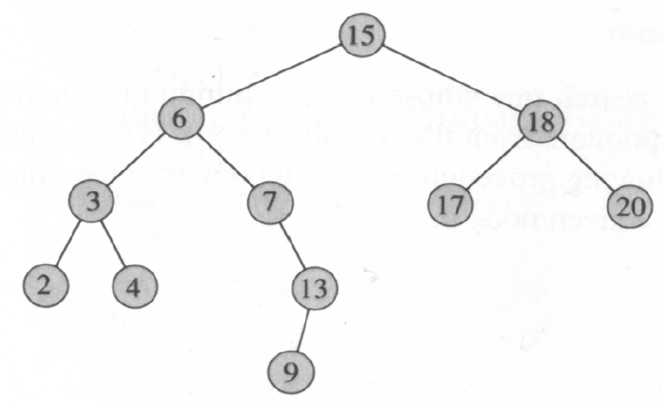

- Please write down the elements of dynamic programming. [6 points]

[59 points]
Using a recursion tree to give an asymptotically tight solution to the recurrence T(n) = T(n/3)+T(2n/3)+cn. [9 points]

11、A red-black tree is a binary search tree with one extra bit of storage per node: its color, which can be either RED or BLACK, and the red-black is a nearly balanced tree. [10 points]
1) Please write down the red-black properties. [5 points]

- Please prove the lemma: A red-black tree with n internal codes has height at most 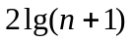? [5 points]

12、Please give an optimal Huffman code for the following set of frequencies. [10 points]

a b c d e f
Frequency 5 9 16 12 13 45

13、 Converting the following linear program into standard form:
Minimize 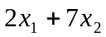
Subject to 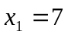
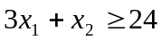
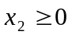
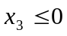

14、 Solve the following linear program using SIMPLEX:
maximize 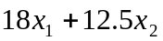
Subject to 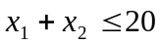
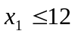
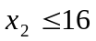
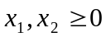

15、Suppose A₁ a 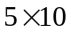 matrix, A₂ a 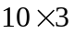 matrix, A₃ a 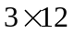 matrix, A₄ a 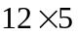 matrix, A₅ a 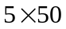 matrix, A₆ a 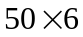 matrix. Please give an optimal parenthesization of a matrix-chain A₁A₂A₃A₄A₅A₆. [10 pints]
 | 1 | 2 | 3 | 4 | 5 | 6
1 | 0 | 150 | 330 | 405 | 1655 | 2010
2 |  | 0 | 360 | 330 | 2430 | 1950
3 |  |  | 0 | 180 | 930 | 1770
4 |  |  |  | 0 | 3000 | 1860
5 |  |  |  |  | 0 | 1500
6 |  |  |  |  |  | 0
The final result is ((A₁A₂)((A₃A₄)(A₅A₆)))

