- Using a recursion tree to give an asymptotically tight solution to the recurrence T(n) = T(n/4)+T(n/2)+ n².

- X=<A, E, B, D, B, C, A, E>, Y=<E, F, B, A, C, A, F, E>. Please illustrate the whole procedure for finding the longest common sequence of X and Y using dynamic programming.

- Please give an optimal Huffman code for the following set of frequencies.

- Please draw the result after the operation Left-Rotate(9)
.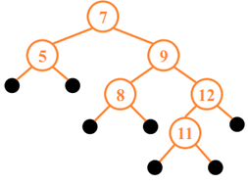

- Please give an optimal Huffman code for the following set of frequencies.
a b c d e f
Frequency 15 19 6 12 13 35
- A red-black tree (RB tree) is a binary search tree with one extra bit of storage per node: its color, which can be either RED or BLACK, and the red-black is a nearly balanced tree. Please prove n-node RB tree has height 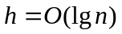

- In the activity-selection problem, 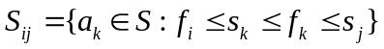represents the activities that start after an activity  finishes and finish before one activity 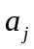 starts. Here, an activity occurs during period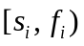, and activities are sorted by monotonically increasing finish time. Let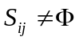, and let 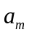 be the activity in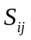 with the earliest finish time: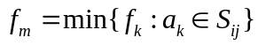. Then prove is used in some maximum-size subset of mutually compatible activities of

