Installation of Software on the Computer

All the required software is included within the folder “FYP_DVD”.

1. Install Visual Studio 2005.
2. Install OpenCV 1.1.
3. Install driver for Logitech Web Camera.
4. Install USB-to-Serial Prolific Driver. (If a USB to Serial Cable is to be used – No Serial ports on the host computer)
5. Connect Camera.
6. Open Visual Studio Project Folder. (“FYP_DVD\Project_MVC++\Project\Project.sln”)
7. Build Project and Debug.
8. If “This application has failed to start because cv110.dll was not found.” Message is displayed, install the VC++ Redistributable package and restart the computer. Open Project folder again and build and debug.

Equipment Setup

1. Connect Camera to Host Computer
2. Stick the camera on the Audio Beam System.
3. Connect the Tilt Servo Motor Channel to the White PWM channel on the microcontroller board. The yellow control wire should be plucked to the pin nearer to the tag "Explorer 16" on the Explorer 16 board.
4. Connect the Pan Servo Motor Channel to the Black PWM channel on the microcontroller board. The yellow control wire should be plucked to the pin nearer to the tag "Explorer 16" on the Explorer 16 board.
5. Power up the Explorer 16 board using 9V DC Power Supply. The Power LED in the board will light up. Another LED (7th LED in the LED set) will start blinking.
6. Power up the Servo Motors using 5V DC power supply by plucking into the power area created in the Explorer 16 work area. The white wire is Ground and red wire is 5V. When it is powered up, the Pan and Tilt motors get charged and they move to a specific position.
7. Connect the USB-to-Serial cable. USB end is connected to the computer and the serial end to the Explorer 16 board.
8. Open the Microsoft Visual Studio Project.
9. File -> Open -> Project/Solution. Select the file "Project.sln" in the folder "FYP_DVD\Project_MVC++\Project ".
10. Debug -> Start Debugging

The program will be up and running.

If required do the following settings: (can be performed from the program itself)

Adjust Skin Extraction thresholds by changing Hmin and Hmax.

Calibrate Pan and Tilt System.

Enable/Disabled Port.

Change Skin Extraction Method.

To work with the microcontroller program, perform the following steps (perform only if the microcontroller program needs to be changed in some way)

1. Install MPLAB IDE 8_40
2. Install MPLAB C30 Educational Compiler
3. Open the Microcontroller Project in MPLAB IDE.  Project -> Open -> “FYP_DVD\Project_MPLAB_IDE\Project\Project.mcp”.
4. View -> Tick “Project” and “Output”.
5. Window -> Tile Horizontally.  Move around the windows as you like.
6. Project -> Build All
7. Connect the MPLAB ICD cable
8. Choose either Programmer or Debugger to download program to the microcontroller. (Please refer to the document <http://ww1.microchip.com/downloads/en/DeviceDoc/Explorer%2016%20User%20Guide%2051589a.pdf> for more details on how to download program to the microcontroller on the explorer 16 board from the MPLAB IDE software)

Steps on creating a project in MPLAB IDE for the Explorer 16 board is given in the document found in the link given below. <http://ww1.microchip.com/downloads/en/DeviceDoc/Explorer%2016%20User%20Guide%2051589a.pdf>

Steps to create a project using OpenCV 1.1 in Visual Studio 2005

Step 1: Create a new project.

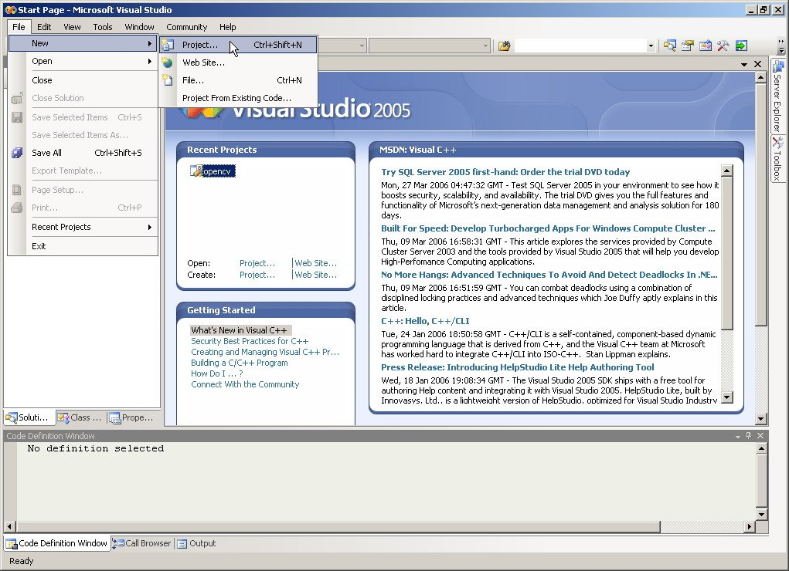

Step 2: Select Win32 Console Application

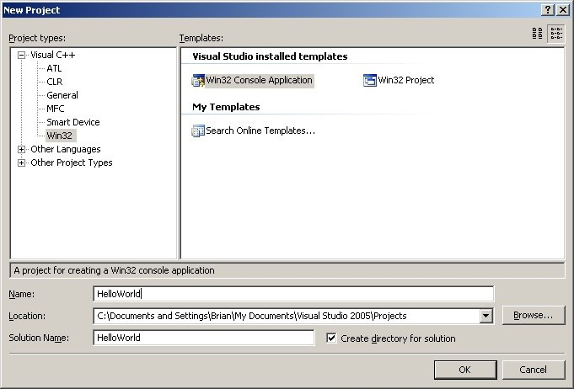

Step 3: Check Empty project

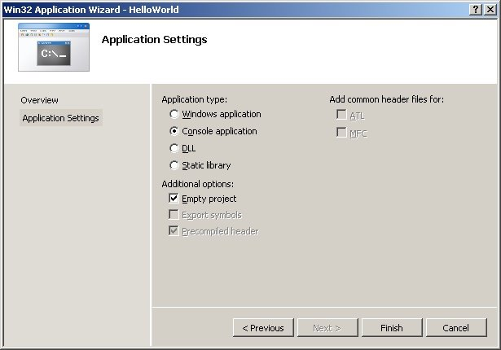

Step 4: Done creating the project

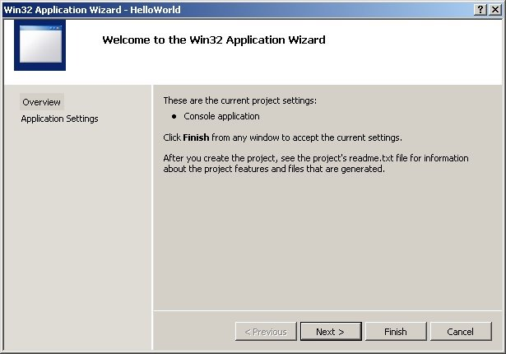

This is what your project screen should look like at this point.

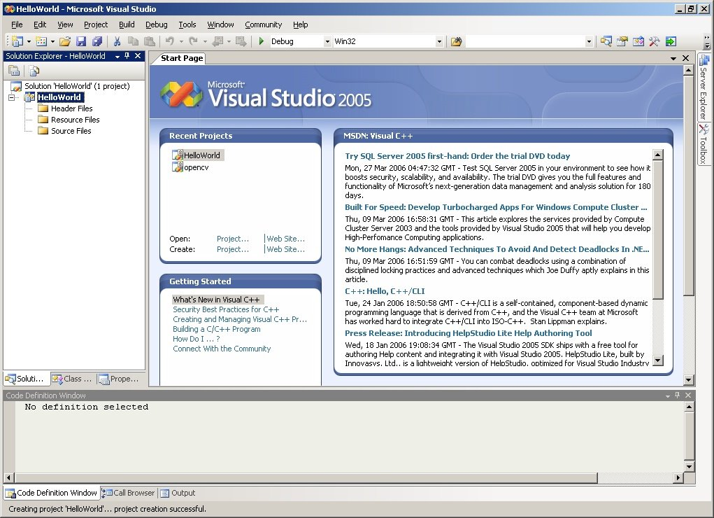

Step 5: Create a new item

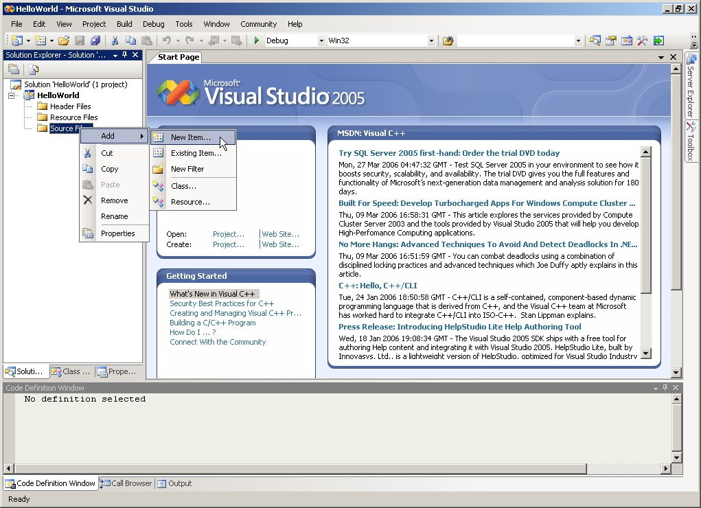

Step 6: Create a C++ file

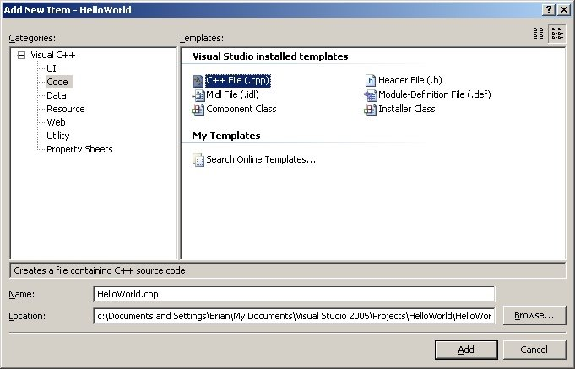

Step 7: Modify the project properties

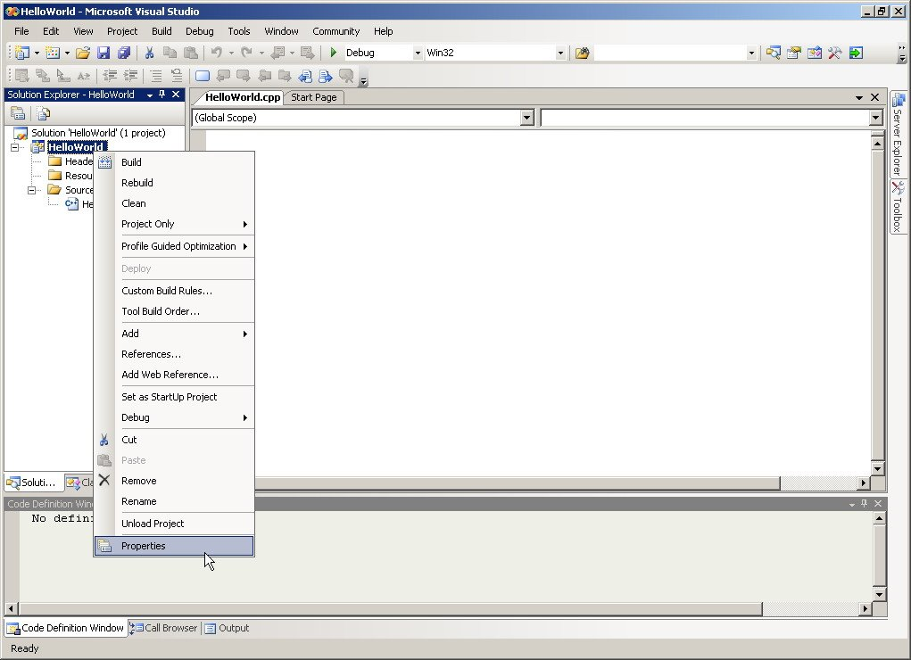

Step 7: Select All Configurations

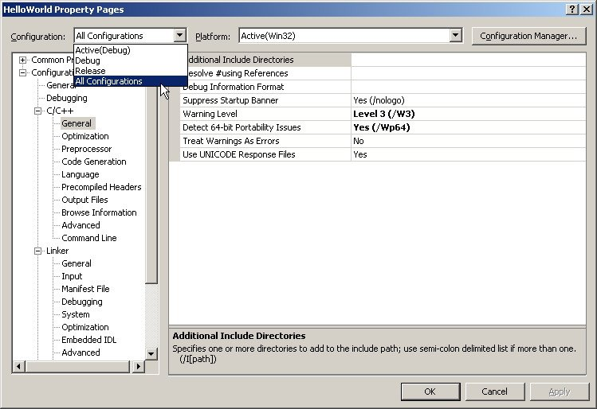

Step 9: Go to Configuration Properties / C/C++ / General / Additional Include Directories

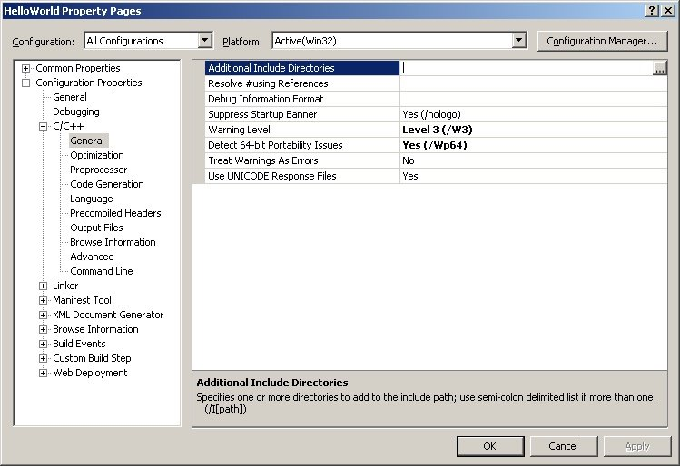

Step 10: Enter the path to your include files: For default OpenCV install location, they are

"C:\Program Files\OpenCV\cvaux\include\";"C:\Program Files\OpenCV\cxcore\include\";"C:\Program Files\OpenCV\cv\include\";"C:\Program Files\OpenCV\otherlibs\highgui\";

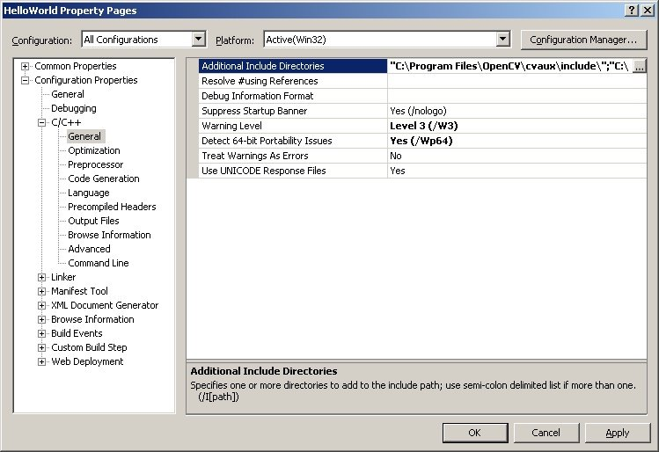

Step 11: Go to Configuration Properties / Linker / Input / Additional Dependencies

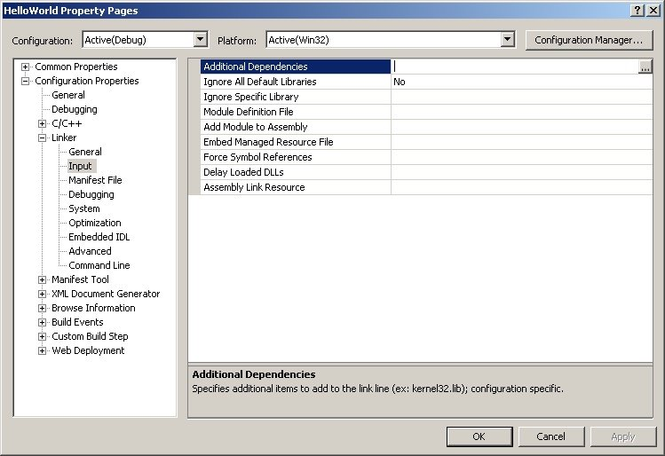

Enter the path to all the relevant cv libs. For a default install, this is:

"C:\Program Files\OpenCV\lib\cv.lib" "C:\Program Files\OpenCV\lib\cvaux.lib" "C:\Program Files\OpenCV\lib\cxcore.lib" "C:\Program Files\OpenCV\lib\highgui.lib"

(notice the spaces instead of ; marks)

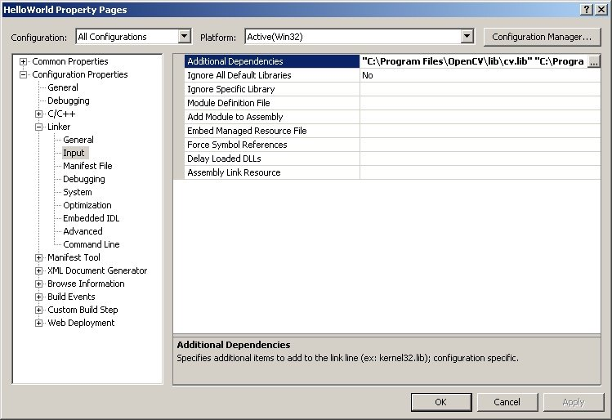

Write some code

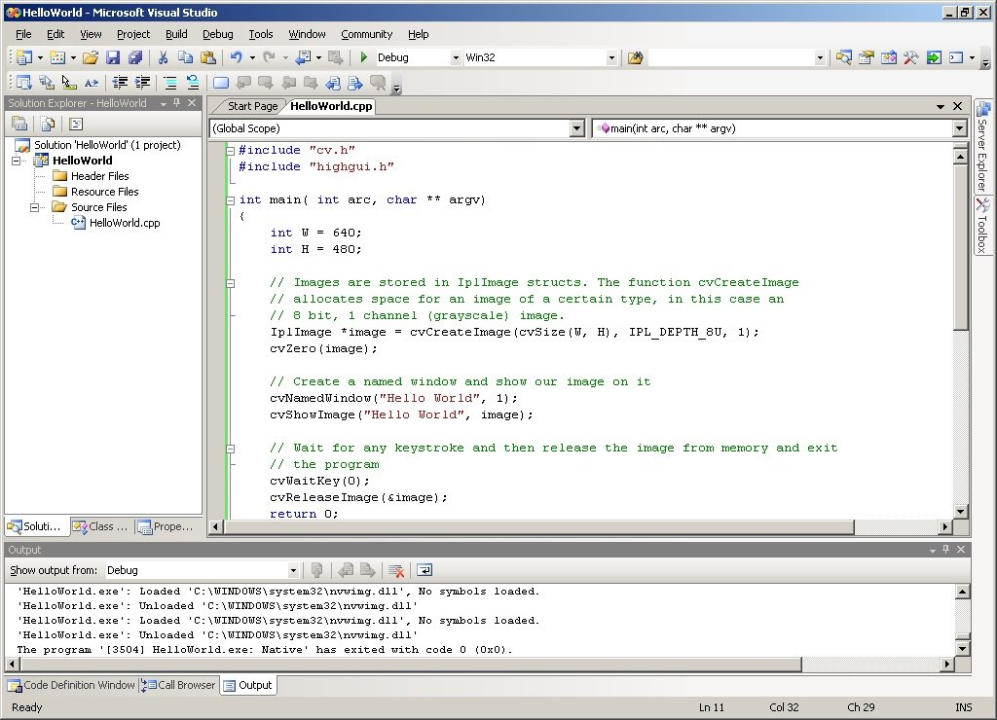

Click on "Start Debug"

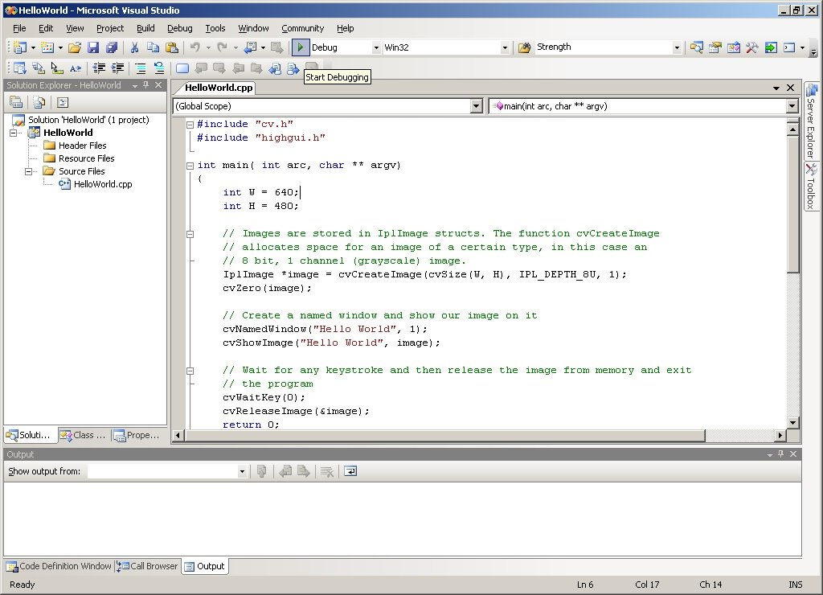

Inclusion of Microsoft Foundation Classes (MFC) in the MVC++ Project

To use the Microsoft Foundation Classes (MFC)

Select Project -> Configuration Properties -> General -> Project Defaults -> Use of MFC

Select either “Use MFC in a Static Library” or “Use MFC in a Shared DLL”

