User manual for the knife-alien sound processing application

Purpose
The knife-alien sound processor is a powerful tool to visualize and modify audio data in real time. It captures audio from the computer's sound card, displays the spectrum of the captured signal and can optionally use a filters to modify the signal. By also displaying the spectrum of the processed signal the effects of the filtering can be clearly seen. The audio filters can be easily reconfigured using sliders, even when the processing is running.
After filtering, the processed audio is saved to disk in a wav file.

System requirements
Knife-alien has been developed and tester using the Linux operating system and MATLAB 7.12.0.635 (R2011a). Therefore, the application cannot be guaranteed to work properly with other operating systems or other versions of MATLAB. The project group will not offer support for other configurations than the one mentioned in this paragraph.

Quick introduction to knife-alien sound processing application
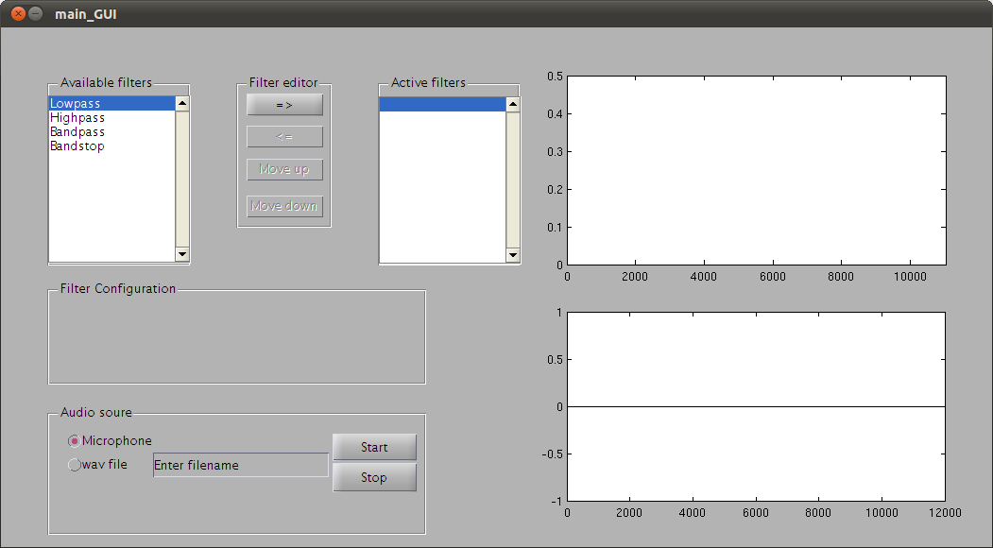Figure 1: GUI after opening the application.
The design team concentrated on get a clean GUI where the functionality were prioritized over the looks. The GUI can be divided in to four parts which handles different tasks within the application.

Selection of audio source
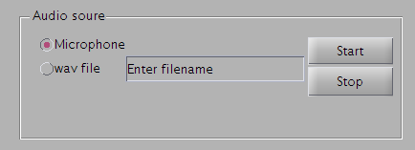Figure 2: Panel holding options for audio source selection.
The audio source selection panel is very straight forward and gives the user the option to choose between using a microphone or a already made wav file as input to the application. The microphone radio button is checked as default
The start and stop button will activate and deactivate the audio player and audio recorder respectively.

The GUI will run even if a microphone is not detected.

Filter handling
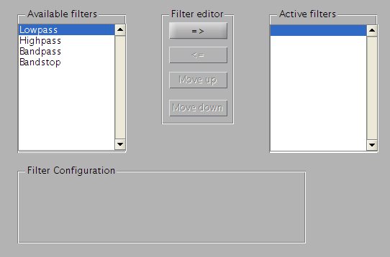Figure 3: Controls that handles the filter configuration.
The filter editor panel, in top middle of Figure 3, handles the most of the underlying processing concerning filter creation and and structure of the filter chain. The push buttons in the panel is only active when the result of a button push is interesting, mainly for making it easy for the user to control the filter chain. This is why the bottom three push buttons are greyed out when the GUI starts. How it looks when all of the buttons are active can be seen in Figure 5 .
The panel Available filters with its child listbox is populated with the different filters that are implemented. It is also possible to define user specific filters and how this works can be read about in Chapter XXX.
The user pushes the topmost button in filter editor panel to a filter to the filter chain. All filters that is added are connected with each other in a liked list. The chain is also populated with two hidden filters that merely connects the chain with the audio capture device and the output graphs. All the filters added by the user are visible in the listbox of the Active filters panel.
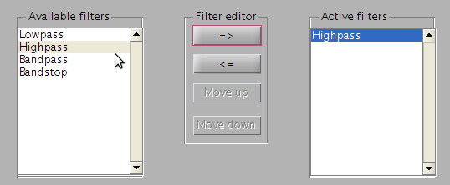Figure 4: Active filters populated with a added filter.
The user can also remove filters from the filter chain by marking the unwanted filter and press the second uppermost button. The remove button is active in Figure 4.
The two bottommost buttons are used to change the filter position in the filter chain. This is useful to get the desired filter output.
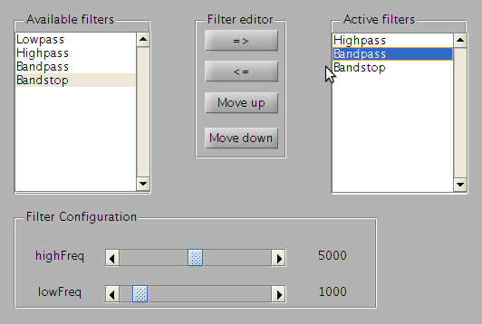Figure 5: The middle filter is moveable both up and down in the filter list. In the bottom one can see the parameter sliders and current setup.
The filter parameters are viewable and editable when the user clicks on a filter in the Active filter panel. The Filter Configuration panel will be populated with sliders and information about the current filter configuration of the when this is done. This can be seen in Figure 5 .
Editing a filters parameters can be done when executing a filtering while add and remove filters automatically will stop the filtering for a short while.

Visualization of input and output audio
The topmost graph contains the unfiltered Fourier transformed input audio data and the bottom one contains the filtered Fourier transformed data.
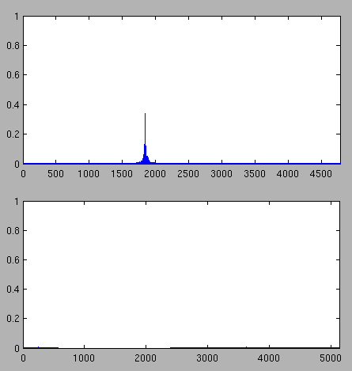Figure 6: A whistle blow as input and the output of a band stop filter.

