User manual for the knife-alien sound processing application

Purpose
The knife-alien sound processor is a powerful tool to visualize and modify audio data in real time. It captures audio from the computer's sound card, displays the spectrum of the captured signal and can optionally use a filters to modify the signal. By also displaying the spectrum of the processed signal the effects of the filtering can be clearly seen. The audio filters can be easily reconfigured using sliders, even when the processing is running.
After filtering, the processed audio is saved to disk in a wav file.

System requirements
Knife-alien has been developed and tester using the Linux operating system and MATLAB 7.12.0.635 (R2011a). Therefore, the application cannot be guaranteed to work properly with other operating systems or other versions of MATLAB. The project grop will not offer support for other configurations than the one mentioned in this paragraph.

Quick introduction to knife-alien sound processing application
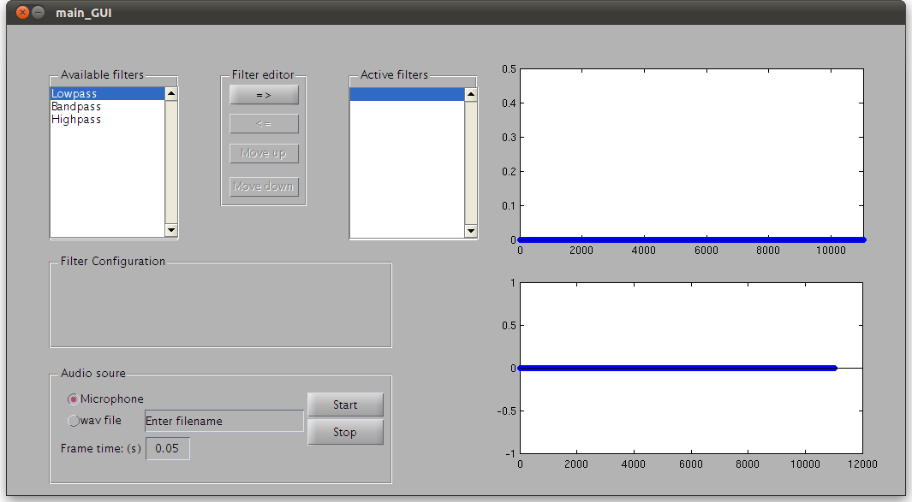Figure 1: GUI after opening the application.

