SCHOOL OF TECHNOLOGY | 

DATABASE MANAGEMENT SYSTEMS
PROJECT-BASED LEARNING (PBL) REPORT
Small Database Application Development using Python

PROJECT TITLE
Software License & Subscription Management System

Program | B.Tech CSE (AI & ML)
Section | CSE AIML-RHINOS
Faculty | Prof. Sahithi
Date of Submission | 12-10-2026
Academic Year | 2026 – 27

Submitted by
Roll Number | Student Name | Mobile | Email ID
25WU0102105 | Jampana Naga Satya Sai Rishvarma | 91+ 918219961 | j.rishvarma@gmail.com

ACKNOWLEDGEMENT

I express my sincere gratitude to Woxsen University, School of Technology, for providing me with the opportunity to undertake this Project-Based Learning (PBL) activity as part of the Database Management Systems (DBMS) course.
I thank my course faculty, Prof. Sahithi, for the guidance, suggestions, and support throughout the design and development of this project. The guidance helped me understand the practical application of database concepts such as ER modelling, relational schema design, normalization, SQL, constraints, queries, and database application development.
This PBL activity has strengthened my understanding of DBMS concepts and provided valuable experience in applying them to a real-world problem.

UNDERTAKING

I hereby declare that the project entitled “Software License & Subscription Management System”, submitted as part of the Project-Based Learning activity for the Database Management Systems (DBMS) course, is my individual work carried out under the guidance of the course faculty.
I undertake that the project report, database design, SQL scripts, application source code, results, and supporting materials submitted by me have been prepared for academic purposes. Wherever information, ideas, tools, datasets, or other resources have been referred to, appropriate acknowledgement has been provided.
I further undertake that I am responsible for the correctness and authenticity of the work submitted and that I have followed the academic and project guidelines prescribed by the University.

Name: | Jampana Naga Satya Sai Rishvarma
Roll Number: | 25WU0102105
Program: | B.Tech CSE (AI & ML)

TABLE OF CONTENTS

Contents | Page No.
Abstract
LIST OF TABLES
LIST OF FIGURES
LIST OF ACRONYMS
1. PROBLEM STATEMENT, SOLUTION STRATEGY AND ER DIAGRAM
1.1 Problem Statement
1.2 Objectives
1.3 Scope and Assumptions
1.4 Proposed Solution Strategy
1.5 Functional Requirements
1.6 Entity-Relationship Diagram (ERD)
1.7 Entity and Relationship Summary
2. LOGICAL DATABASE DESIGN
2.1 Relational Schema
2.2 Keys and Integrity Constraints
2.3 Functional Dependencies
2.4 Normalization up to Third Normal Form (3NF)
2.5 Data Dictionary
2.6 Implementation of Logical Design: DDL and Sample Data
3. APPLICATION DEVELOPMENT USING LOGICAL DATABASE DESIGN
3.1 Application Overview
3.2 Development Environment and Database Connectivity
3.3 Application Modules and Database Mapping
3.4 CRUD Operations
3.5 Business Rules, Validation and Error Handling
3.6 Reports and Database Operations
3.7 Application Screens
3.8 Testing and Results
4. CONCLUSION
4.1 Limitations and Future Enhancements
5. REFERENCES
6. APPENDICES

LIST OF TABLES

Table No. | Table Title | Page No.
Table 1 | Scope and Assumptions
Table 2 | Proposed Solution Strategy
Table 3 | Functional Requirements
Table 4 | Entity and Relationship Summary
Table 5 | Relational Schema
Table 6 | Keys and Integrity Constraints
Table 7 | Normalization Status up to 3NF
Table 8 | Data Dictionary
Table 9 | Database Implementation Environment
Table 10 | Application Development Environment
Table 11 | Application Module-to-Database Mapping
Table 12 | CRUD Operations
Table 13 | Business Rules, Validation and Error Handling
Table 14 | Reports and Database Operations
Table 15 | Test Cases

LIST OF FIGURES

Figure No. | Figure Title | Page No.
Figure 1 | Entity-Relationship Diagram of the Proposed System
Figure 2 | Dashboard — Utilization KPIs, Expiry Monitor and Vendor Spend
Figure 3 | Allocations & Workflows — Seat Allocation and Reclaim Forms
Figure 4 | Purchases & Renewals — Purchase Entry and Licence Renewal
Figure 5 | Compliance — Live Violations and Audit History
Figure 6 | Manage Data — Add, Edit and Delete Rows in All 12 Tables

LIST OF ACRONYMS

Acronym | Expansion
3NF | Third Normal Form
ACID | Atomicity, Consistency, Isolation, Durability
BCNF | Boyce–Codd Normal Form
CRUD | Create, Read, Update, Delete
DBMS | Database Management System
DDL | Data Definition Language
ENUM | Enumeration Data Type
ERD | Entity–Relationship Diagram
FK | Foreign Key
FR | Functional Requirement
GUI | Graphical User Interface
OS | Operating System
PBL | Project-Based Learning
PK | Primary Key
SQL | Structured Query Language
UI | User Interface

ABSTRACT

Universities and growing organizations buy software under volume, subscription and perpetual agreements, yet the details of what was purchased, who is using each seat, when it expires and what a renewal will cost are usually scattered across invoices, spreadsheets and e-mail. The predictable results are over-paid renewals, seats that stay allocated to departed users, and installations that fail vendor audits. This project designs and develops a Software License and Subscription Management System that records the entire licence lifecycle in one relational database. An entity–relationship model covering twelve entities was converted into a third-normal-form schema and implemented in MySQL 8 with primary keys, foreign keys, unique, not-null and check constraints, triggers and stored procedures, supported by a SQLite mirror for demonstration without a server. A Python Streamlit application provides a monitoring dashboard, seat allocation and reclaim workflows, purchase and renewal recording, compliance auditing with a dated audit trail, and full create, read, update and delete management of every table. Because seat limits, validity periods and integrity rules are enforced inside the database itself, invalid data is rejected regardless of the tool used, and the utilization, expiry and vendor-spend reports support timely renewal decisions.

KEYWORDS
Keywords: Software License Management, Subscription Lifecycle, Relational Database, ER Diagram, Normalization, Streamlit

CHAPTER 1

PROBLEM STATEMENT, SOLUTION STRATEGY AND ER DIAGRAM

1.1 Problem Statement
Software is one of the largest recurring expenses of a modern university. Licences are bought department by department from different vendors, under volume agreements, annual subscriptions and perpetual deals, and each purchase produces seats that must be assigned to staff and students, tracked while in use, and renewed before they expire. In the existing manual process these details live in invoice files, departmental spreadsheets and e-mail threads, so no single office can answer basic questions: how many seats were bought, how many are actually in use, which licences expire in the next quarter, and how much a renewal will cost. When a licence quietly expires, classes and research work are interrupted; when seats are never reclaimed, the institution pays twice for the same right.
The stakeholders affected are the IT administration that assigns seats, the procurement cell that records purchases and renewals, department heads who must see how their budget is spent, the compliance officer who responds to vendor audits, and the end users who depend on the software daily. Manual records cannot enforce seat limits, cannot stop an expired licence from being used, and leave no auditable history of who held which seat and when. A centralized database application is therefore required: one that stores every vendor, product, purchase, licence, subscription, user, device, allocation, renewal and compliance check; enforces the business rules inside the database so that bad data cannot enter through any tool; and produces the utilization, expiry and spend reports needed to manage renewals proactively.

1.2 Objectives
- Design an entity–relationship model and a third-normal-form relational schema covering vendors, products, purchases, licences, subscriptions, departments, users, devices, allocations, renewals and compliance checks.
- Implement the database in MySQL 8 using primary key, foreign key, unique, not-null, check and default constraints together with triggers and stored procedures that enforce seat-limit, validity-period and data-integrity rules [3], [4].
- Develop a Python (Streamlit) web application that performs parameterised create, read, update and delete operations on all twelve tables and implements the allocate, reclaim, renew and compliance-sweep workflows [5].
- Generate management reports — licence utilization, department-wise allocations, expiry monitoring, vendor lifetime spend and upcoming renewals — through SQL views presented on a single dashboard.
- Validate the system with positive and negative test cases proving that valid workflows complete successfully and that every attempted rule violation is rejected by the database with a clear message.

1.3 Scope and Assumptions
Table 1. Scope and Assumptions
Item | Description
In Scope | Single-institution licence lifecycle: vendor and software-product catalogue; purchase and invoice recording; licences with seats, validity and status; subscriptions and renewals; departments, users and devices; seat allocation and reclaim; compliance auditing; six reporting views; a web interface with full CRUD over all twelve tables.
Out of Scope / Exclusions | Payment gateways and real money transactions; single sign-on / LDAP integration; e-mail and SMS alert services; vendor API integration and automatic entitlement download; per-feature usage metering and concurrent-session tracking; production deployment, hardening and multi-tenant hosting; mobile application.
Assumptions | One purchase line produces one licence record and one seat equals one active allocation; a renewal extends every licence created from that purchase; sample data represents one academic year of a single campus; all users are internal staff or students; MySQL 8 is the target DBMS, with a bundled SQLite mirror used for demonstrations without a server.

1.4 Proposed Solution Strategy
The proposed solution strategy is summarized in Table 2.
Table 2. Proposed Solution Strategy
Solution Element | Project-Specific Description
Primary Users / Roles | IT Administrator (allocates and reclaims seats), Procurement Officer (records purchases and renewals), Compliance Officer (runs audits), Department Manager (views department usage) and Employee (end user); the five roles are stored in APP_USER.user_role.
Major Application Modules | Dashboard (KPIs, expiry monitor, upcoming renewals, vendor spend); Allocations & Workflows (allocate / reclaim); Purchases & Renewals; Compliance (violations and audit sweep); Manage Data (generic CRUD over all 12 tables).
Proposed Workflow | Record a purchase → create the licence with seats and validity → allocate seats to users and devices → monitor utilization and expiry on the dashboard → run compliance sweeps → reclaim seats when users leave → renew before expiry, which returns the licence to ACTIVE.
Important Business Rules | BR-01 only an ACTIVE licence may be allocated; BR-02 the allocation date must fall within licence validity; BR-03 active allocations must not exceed purchased seats; BR-04 the return date must not precede the allocation date; licence keys, invoice numbers and e-mails are unique; quantities and costs are non-negative.
Expected Reports / Outputs | Licence utilization (seats used, free, %), department-wise allocation report, expiry monitor with OK / WARNING / CRITICAL / EXPIRED bands, compliance violation list with dated audit history, vendor lifetime spend table with chart, and upcoming renewals list.

1.5 Functional Requirements
Table 3. Functional Requirements
Req. ID | Functional Requirement | Remarks / Priority
FR-01 | Record a software purchase against a vendor and product with date, quantity, unit cost, total cost and a unique invoice number. | High — core transaction
FR-02 | Allocate a licence seat to a user, optionally binding it to a registered device. | High — core transaction
FR-03 | Reclaim an allocated seat by recording the return date and changing the status to RECLAIMED. | High — core transaction
FR-04 | Monitor licence expiry and classify every licence into OK, WARNING (<90 days), CRITICAL (<30 days) or EXPIRED bands. | High — management reporting
FR-05 | Run compliance checks over active allocations and store each result as a dated audit record. | High — audit requirement
FR-06 | Record a renewal payment and extend the validity of the related licence in a single step, resetting its status to ACTIVE. | High — core transaction
FR-07 | Generate utilization, department allocation, vendor lifetime spend and upcoming renewal reports from SQL views. | Medium — decision support
FR-08 | Track the complete allocation lifecycle of every user as an auditable history. | Medium — traceability
FR-09 | Provide create, read, update and delete operations over all twelve tables with constraint-safe forms and dropdowns for foreign keys. | Medium — administration

1.6 Entity-Relationship Diagram (ERD)
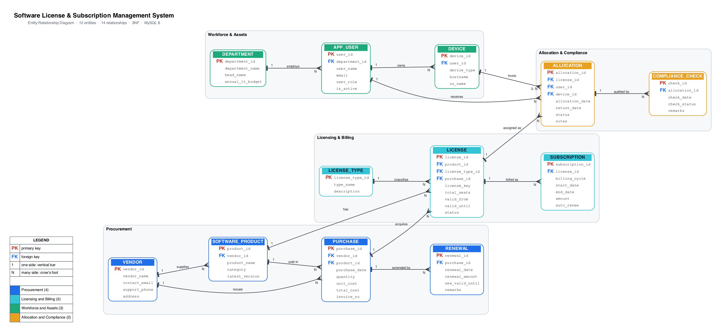
Figure 1. Entity-Relationship Diagram of the Proposed System

1.7 Entity and Relationship Summary
Table 4. Entity and Relationship Summary
Entity / Relationship | Major Attributes / Cardinality | Purpose / Rule
VENDOR | PK vendor_id; vendor_name, contact_email, support_phone, address | Supplier of software products; unique name and e-mail, e-mail format checked.
LICENSE_TYPE | PK license_type_id; type_name, description | Reference data for licensing models: Perpetual, Subscription, Volume, OEM.
SOFTWARE_PRODUCT | PK product_id; FK vendor_id; product_name, category, latest_version | Product sold by a vendor; unique combination of vendor and product name.
PURCHASE | PK purchase_id; FK vendor_id, product_id; purchase_date, quantity, unit_cost, total_cost, invoice_no | Procurement event with cost details; invoice number is unique.
LICENSE | PK license_id; FK product_id, license_type_id, purchase_id; license_key, total_seats, valid_from, valid_until, status | Licensed item with unique key, seat count, validity window and ACTIVE/EXPIRED/REVOKED status.
SUBSCRIPTION | PK subscription_id; FK license_id; billing_cycle, start_date, end_date, amount, auto_renew | Recurring billing period of a licence; end date must be after start date.
DEPARTMENT | PK department_id; department_name, head_name, annual_it_budget | Organizational unit with a unique name and an annual IT budget.
APP_USER | PK user_id; FK department_id; user_name, email, user_role, is_active | End user of allocated software; unique e-mail, role and active flag.
DEVICE | PK device_id; FK user_id; device_type, hostname, os_name | Machine registered to a user; hostname is unique.
ALLOCATION | PK allocation_id; FK license_id, user_id, device_id; allocation_date, return_date, status, notes | A seat handed to a user; ACTIVE until reclaimed; device optional until installed.
RENEWAL | PK renewal_id; FK purchase_id; renewal_date, renewal_amount, new_valid_until, remarks | Extension recorded against a purchase; amount must be non-negative.
COMPLIANCE_CHECK | PK check_id; FK allocation_id; check_date, check_status, remarks | Dated audit result per allocation; unique per allocation, date and status.
VENDOR → supplies → SOFTWARE_PRODUCT | 1 : N | A vendor supplies many products; each product has exactly one vendor.
VENDOR → issues → PURCHASE | 1 : N | A vendor issues many purchases; each purchase belongs to one vendor.
SOFTWARE_PRODUCT → sold in → PURCHASE | 1 : N | A product appears in many purchases; each purchase line is one product.
PURCHASE → acquires → LICENSE | 1 : N | A purchase produces one or more licences; each licence comes from one purchase.
SOFTWARE_PRODUCT → has → LICENSE | 1 : N | A product may own many licences; each licence is for one product.
PURCHASE → extended by → RENEWAL | 1 : N | A purchase may be renewed many times; each renewal extends one purchase.
LICENSE_TYPE → classifies → LICENSE | 1 : N | One licence type covers many licences; each licence has one type.
LICENSE → billed as → SUBSCRIPTION | 1 : N | A licence has zero or more subscription periods; each period belongs to one licence.
DEPARTMENT → employs → APP_USER | 1 : N | A department employs many users; each user belongs to one department.
APP_USER → owns → DEVICE | 1 : N | A user may own several devices; each device is registered to one user.
LICENSE + APP_USER + DEVICE → assigned as → ALLOCATION | M : N resolved by ALLOCATION; DEVICE participation 0..N | A licence seat is assigned to one user at a time; a user may hold many allocations; the device is optional until the software is installed.
APP_USER → receives → ALLOCATION | 1 : N | A user receives many allocations over time; each allocation is for one user.
DEVICE → hosts → ALLOCATION | 1 : N | A device may host several allocated products; an allocation references at most one device (0..1).
ALLOCATION → audited by → COMPLIANCE_CHECK | 1 : N | Each allocation is audited repeatedly; one check row per allocation, date and status.

CHAPTER 2

LOGICAL DATABASE DESIGN

2.1 Relational Schema
Table 5 lists every relation derived from the approved ER model, with its primary key and foreign keys identified.
Table 5. Relational Schema
S.No. | Table Name | Purpose
1 | VENDOR | Master data: suppliers of software products. PK vendor_id; unique vendor_name and contact_email.
2 | LICENSE_TYPE | Reference data: licensing models (Perpetual, Subscription, Volume, OEM). PK license_type_id.
3 | SOFTWARE_PRODUCT | Catalogue of products offered by vendors. PK product_id; FK vendor_id → VENDOR.
4 | PURCHASE | Procurement transactions linking vendor and product with cost and invoice. PK purchase_id; FK vendor_id, product_id.
5 | LICENSE | Licensed items with key, seats, validity and status. PK license_id; FK product_id, license_type_id, purchase_id.
6 | SUBSCRIPTION | Recurring billing periods of a licence. PK subscription_id; FK license_id (ON DELETE CASCADE).
7 | DEPARTMENT | Organizational units with head and annual IT budget. PK department_id.
8 | APP_USER | End users with role and active flag. PK user_id; FK department_id (table named APP_USER because USER is reserved in MySQL).
9 | DEVICE | User machines. PK device_id; FK user_id (ON DELETE CASCADE); unique hostname.
10 | ALLOCATION | Seat assignment of a licence to a user, optionally a device. PK allocation_id; FK license_id, user_id, device_id (SET NULL).
11 | RENEWAL | Renewal payments extending a purchase's licence validity. PK renewal_id; FK purchase_id.
12 | COMPLIANCE_CHECK | Audit outcomes per allocation. PK check_id; FK allocation_id (CASCADE); unique (allocation_id, check_date, check_status).

2.2 Keys and Integrity Constraints
Table 6. Keys and Integrity Constraints
Table Name | Key / Constraint | Attribute(s) | Business Rule Enforced
SOFTWARE_PRODUCT | Primary Key | vendor_id | Uniquely identifies each vendor.
SOFTWARE_PRODUCT | Unique / Check | vendor_name, contact_email; contact_email LIKE '%_@_%._%' | No duplicate vendors or e-mails; malformed e-mail addresses rejected.
SOFTWARE_PRODUCT | Not Null | vendor_name, contact_email | A vendor must have a name and contact.
SOFTWARE_PRODUCT | Primary Key / Unique | license_type_id; type_name | Each licence model is identified once and cannot be duplicated.
SOFTWARE_PRODUCT | Primary Key | product_id | Uniquely identifies each product.
COMPLIANCE_CHECK | Foreign Key / Unique | vendor_id; (vendor_id, product_name) | Product must belong to an existing vendor (DELETE RESTRICT); no duplicate product per vendor.
COMPLIANCE_CHECK | Primary Key | purchase_id | Uniquely identifies each purchase.
COMPLIANCE_CHECK | Foreign Key | vendor_id, product_id | Purchase must reference existing vendor and product (ON UPDATE CASCADE, ON DELETE RESTRICT).
COMPLIANCE_CHECK | Unique / Not Null | invoice_no; purchase_date, quantity, unit_cost, total_cost | Invoice numbers are unique and cost fields cannot be omitted.
COMPLIANCE_CHECK | Check | quantity > 0; unit_cost >= 0 AND total_cost >= 0 | Quantities and costs must be positive or zero (TC-08).
COMPLIANCE_CHECK | Primary Key | license_id | Uniquely identifies each licensable item.
COMPLIANCE_CHECK | Foreign Key | product_id, license_type_id, purchase_id | Licence must reference an existing product, type and purchase (DELETE RESTRICT).
COMPLIANCE_CHECK | Unique | license_key | No two licences may share the same key (TC-07).
COMPLIANCE_CHECK | Not Null / Default | license_key, valid_from, valid_until, status; status DEFAULT 'ACTIVE', total_seats DEFAULT 1 | Core attributes are mandatory; new licences start active with one seat.
COMPLIANCE_CHECK | Check | valid_until >= valid_from; total_seats >= 1 | Validity window must be sane and at least one seat must exist.
COMPLIANCE_CHECK | Primary Key / Foreign Key | subscription_id; license_id | Each billing period is unique and belongs to one licence (ON DELETE CASCADE).
COMPLIANCE_CHECK | Check / Default | end_date > start_date; amount >= 0; auto_renew DEFAULT FALSE | Billing period must be non-empty, amount non-negative, auto-renew opt-in.
COMPLIANCE_CHECK | Primary Key / Unique / Default | department_id; department_name; annual_it_budget DEFAULT 0.00 | Departments are unique; budget defaults to zero when not supplied.
COMPLIANCE_CHECK | Primary Key / Foreign Key | user_id; department_id | Each user belongs to exactly one existing department (DELETE RESTRICT).
COMPLIANCE_CHECK | Unique / Not Null | email; user_name, email | One account per e-mail address; name and e-mail are mandatory.
COMPLIANCE_CHECK | Default | user_role DEFAULT 'EMPLOYEE'; is_active DEFAULT TRUE | New users are active employees unless stated otherwise.
COMPLIANCE_CHECK | Primary Key / Foreign Key | device_id; user_id | Each device is registered to one user (ON DELETE CASCADE).
COMPLIANCE_CHECK | Unique / Not Null | hostname; device_type, hostname | Hostnames are unique so an asset cannot be double-registered.
COMPLIANCE_CHECK | Primary Key | allocation_id | Uniquely identifies each seat assignment.
COMPLIANCE_CHECK | Foreign Key | license_id, user_id, device_id | Allocation references existing licence and user (RESTRICT); device optional (ON DELETE SET NULL).
COMPLIANCE_CHECK | Not Null / Default | license_id, user_id, allocation_date; status DEFAULT 'ACTIVE' | An allocation always has a licence, a user and a start date.
COMPLIANCE_CHECK | Check | return_date IS NULL OR return_date >= allocation_date | A seat cannot be returned before it was issued (BR-04, TC-06).
COMPLIANCE_CHECK | Trigger | BEFORE INSERT trg_alloc_before_insert | Enforces BR-01 (licence ACTIVE), BR-02 (within validity) and BR-03 (seat limit) with SIGNAL messages.
COMPLIANCE_CHECK | Trigger | BEFORE UPDATE trg_alloc_before_update | Sets status to RECLAIMED when a return date is filled and rejects invalid periods (BR-04).
COMPLIANCE_CHECK | Primary Key / Foreign Key | renewal_id; purchase_id | Each renewal extends exactly one purchase.
COMPLIANCE_CHECK | Check / Not Null | renewal_amount >= 0; renewal_date, new_valid_until | Renewal amounts are non-negative and dates are mandatory.
COMPLIANCE_CHECK | Primary Key / Foreign Key | check_id; allocation_id | Each audit record is unique and attached to one allocation (ON DELETE CASCADE).
COMPLIANCE_CHECK | Unique / Not Null | (allocation_id, check_date, check_status); check_date, check_status | At most one result of a given status per allocation per day; dates and status mandatory.

2.3 Functional Dependencies
The functional dependencies below were used to justify normalization. A left-hand side of the arrow determines the right-hand side uniquely; in every relation the determinant is a candidate key, which is the condition for BCNF [1].
VENDOR: vendor_id → {vendor_name, contact_email, support_phone, address}; contact_email → vendor_id
LICENSE_TYPE: license_type_id → {type_name, description}
SOFTWARE_PRODUCT: product_id → {vendor_id, product_name, category, latest_version}; (vendor_id, product_name) → product_id
PURCHASE: purchase_id → {vendor_id, product_id, purchase_date, quantity, unit_cost, total_cost, invoice_no}; invoice_no → purchase_id
LICENSE: license_id → {product_id, license_type_id, license_key, total_seats, valid_from, valid_until, status, purchase_id}; license_key → license_id
SUBSCRIPTION: subscription_id → {license_id, billing_cycle, start_date, end_date, amount, auto_renew}
DEPARTMENT: department_id → {department_name, head_name, annual_it_budget}
APP_USER: user_id → {department_id, user_name, email, user_role, is_active}; email → user_id
DEVICE: device_id → {user_id, device_type, hostname, os_name}; hostname → device_id
ALLOCATION: allocation_id → {license_id, user_id, device_id, allocation_date, return_date, status, notes}
RENEWAL: renewal_id → {purchase_id, renewal_date, renewal_amount, new_valid_until, remarks}
COMPLIANCE_CHECK: check_id → {allocation_id, check_date, check_status, remarks}; (allocation_id, check_date, check_status) → check_id
Note: total_cost in PURCHASE is determined by quantity × unit_cost. It is stored as an application-computed attribute for reporting (controlled denormalization) and does not create a transitive dependency on a non-key attribute.
No relation contains multi-valued or composite attributes, and no non-key attribute depends on part of a composite key, so every relation satisfies 1NF, 2NF and 3NF [1], [2].

2.4 Normalization
Table 7. Normalization Status up to 3NF
Relation Name | 1NF | 2NF | 3NF | BCNF | Remarks / Decomposition
VENDOR | Yes | Yes | Yes | Yes | Candidate keys vendor_id, vendor_name, contact_email; single-valued attributes only.
LICENSE_TYPE | Yes | Yes | Yes | Yes | type_name is a candidate key; no partial or transitive dependencies.
SOFTWARE_PRODUCT | Yes | Yes | Yes | Yes | Composite candidate key (vendor_id, product_name); no non-key attribute depends on only part of it.
PURCHASE | Yes | Yes | Yes | Yes | total_cost is derived from quantity × unit_cost; retained as a stored, application-computed attribute for reporting. All determinants are candidate keys, so 3NF holds.
LICENSE | Yes | Yes | Yes | Yes | license_key is a candidate key; validity dates and status depend only on license_id.
SUBSCRIPTION | Yes | Yes | Yes | Yes | No repeating groups; cycle, period, amount and flag depend only on subscription_id.
DEPARTMENT | Yes | Yes | Yes | Yes | Simple key; head_name and budget depend on department_id alone.
APP_USER | Yes | Yes | Yes | Yes | email is a candidate key; department attributes are not stored here, so no transitive dependency through department_id.
DEVICE | Yes | Yes | Yes | Yes | hostname is a candidate key; os_name depends on device_id, not on user_id.
ALLOCATION | Yes | Yes | Yes | Yes | All non-key attributes depend on the whole key allocation_id; foreign keys do not introduce partial dependencies.
RENEWAL | Yes | Yes | Yes | Yes | Attributes depend on renewal_id; purchase_id is a foreign key only.
COMPLIANCE_CHECK | Yes | Yes | Yes | Yes | Natural candidate key (allocation_id, check_date, check_status) is enforced by a UNIQUE constraint; check_id is the surrogate primary key.

2.5 Data Dictionary
Table 8. Data Dictionary
Table | Attribute | Data Type | Key / Constraint | Description
VENDOR | vendor_id | INT UNSIGNED | PRIMARY KEY, AUTO_INCREMENT | Vendor identifier
VENDOR | vendor_name | VARCHAR(100) | NOT NULL, UNIQUE | Vendor display name
VENDOR | contact_email | VARCHAR(120) | NOT NULL, UNIQUE, CHECK LIKE '%_@_%._%' | Billing contact e-mail
VENDOR | support_phone | VARCHAR(20) | NULL allowed | Support telephone number
VENDOR | address | VARCHAR(255) | NULL allowed | Postal address
LICENSE_TYPE | license_type_id | INT UNSIGNED | PRIMARY KEY, AUTO_INCREMENT | Licence model identifier
LICENSE_TYPE | type_name | VARCHAR(50) | NOT NULL, UNIQUE | Perpetual / Subscription / Volume / OEM
LICENSE_TYPE | description | VARCHAR(255) | NULL allowed | Human-readable definition
SOFTWARE_PRODUCT | product_id | INT UNSIGNED | PRIMARY KEY, AUTO_INCREMENT | Product identifier
SOFTWARE_PRODUCT | vendor_id | INT UNSIGNED | NOT NULL, FK → VENDOR | Owning vendor
SOFTWARE_PRODUCT | product_name | VARCHAR(100) | NOT NULL, UNIQUE (vendor_id, product_name) | Product name
SOFTWARE_PRODUCT | category | VARCHAR(50) | NOT NULL | Office / OS / Design / IDE / CAD
SOFTWARE_PRODUCT | latest_version | VARCHAR(20) | NULL allowed | Latest known version
PURCHASE | purchase_id | INT UNSIGNED | PRIMARY KEY, AUTO_INCREMENT | Purchase identifier
PURCHASE | vendor_id | INT UNSIGNED | NOT NULL, FK → VENDOR | Selling vendor
PURCHASE | product_id | INT UNSIGNED | NOT NULL, FK → SOFTWARE_PRODUCT | Product purchased
PURCHASE | purchase_date | DATE | NOT NULL | Date of procurement
PURCHASE | quantity | INT UNSIGNED | NOT NULL, CHECK > 0 | Seats / units bought
PURCHASE | unit_cost | DECIMAL(10,2) | NOT NULL, CHECK >= 0 | Cost per unit
PURCHASE | total_cost | DECIMAL(12,2) | NOT NULL, CHECK >= 0 | Line total (quantity × unit_cost)
PURCHASE | invoice_no | VARCHAR(40) | UNIQUE | Vendor invoice reference
LICENSE | license_id | INT UNSIGNED | PRIMARY KEY, AUTO_INCREMENT | Licence identifier
LICENSE | product_id | INT UNSIGNED | NOT NULL, FK → SOFTWARE_PRODUCT | Licensed product
LICENSE | license_type_id | INT UNSIGNED | NOT NULL, FK → LICENSE_TYPE | Licensing model
LICENSE | license_key | VARCHAR(120) | NOT NULL, UNIQUE | Product activation key
LICENSE | total_seats | INT UNSIGNED | NOT NULL DEFAULT 1, CHECK >= 1 | Seats purchased
LICENSE | valid_from | DATE | NOT NULL | Start of validity
LICENSE | valid_until | DATE | NOT NULL, CHECK >= valid_from | End of validity
LICENSE | status | ENUM('ACTIVE','EXPIRED','REVOKED') | NOT NULL DEFAULT 'ACTIVE' | Current licence state
LICENSE | purchase_id | INT UNSIGNED | NOT NULL, FK → PURCHASE | Procurement source
SUBSCRIPTION | subscription_id | INT UNSIGNED | PRIMARY KEY, AUTO_INCREMENT | Subscription identifier
SUBSCRIPTION | license_id | INT UNSIGNED | NOT NULL, FK → LICENSE (CASCADE) | Billed licence
SUBSCRIPTION | billing_cycle | ENUM('MONTHLY','QUARTERLY','ANNUAL') | NOT NULL | Billing frequency
SUBSCRIPTION | start_date | DATE | NOT NULL | Billing period start
SUBSCRIPTION | end_date | DATE | NOT NULL, CHECK > start_date | Billing period end
SUBSCRIPTION | amount | DECIMAL(10,2) | NOT NULL, CHECK >= 0 | Amount for the period
SUBSCRIPTION | auto_renew | BOOLEAN | NOT NULL DEFAULT FALSE | Automatic renewal flag
DEPARTMENT | department_id | INT UNSIGNED | PRIMARY KEY, AUTO_INCREMENT | Department identifier
DEPARTMENT | department_name | VARCHAR(80) | NOT NULL, UNIQUE | Department name
DEPARTMENT | head_name | VARCHAR(80) | NULL allowed | Head of department
DEPARTMENT | annual_it_budget | DECIMAL(12,2) | DEFAULT 0.00 | Annual software budget
APP_USER | user_id | INT UNSIGNED | PRIMARY KEY, AUTO_INCREMENT | User identifier
APP_USER | department_id | INT UNSIGNED | NOT NULL, FK → DEPARTMENT | Home department
APP_USER | user_name | VARCHAR(80) | NOT NULL | Full name
APP_USER | email | VARCHAR(120) | NOT NULL, UNIQUE | Institutional e-mail
APP_USER | user_role | ENUM('IT_ADMIN','DEPT_MANAGER','PROCUREMENT','EMPLOYEE','COMPLIANCE_OFFICER') | NOT NULL DEFAULT 'EMPLOYEE' | Application role
APP_USER | is_active | BOOLEAN | NOT NULL DEFAULT TRUE | Employment / activity flag
DEVICE | device_id | INT UNSIGNED | PRIMARY KEY, AUTO_INCREMENT | Device identifier
DEVICE | user_id | INT UNSIGNED | NOT NULL, FK → APP_USER (CASCADE) | Assigned user
DEVICE | device_type | ENUM('LAPTOP','DESKTOP','WORKSTATION','MOBILE','SERVER') | NOT NULL | Hardware class
DEVICE | hostname | VARCHAR(60) | NOT NULL, UNIQUE | Machine host name
DEVICE | os_name | VARCHAR(50) | NULL allowed | Installed operating system
ALLOCATION | allocation_id | INT UNSIGNED | PRIMARY KEY, AUTO_INCREMENT | Allocation identifier
ALLOCATION | license_id | INT UNSIGNED | NOT NULL, FK → LICENSE | Licence whose seat is used
ALLOCATION | user_id | INT UNSIGNED | NOT NULL, FK → APP_USER | Seat holder
ALLOCATION | device_id | INT UNSIGNED | NULL allowed, FK → DEVICE (SET NULL) | Installation device
ALLOCATION | allocation_date | DATE | NOT NULL | Date the seat was issued
ALLOCATION | return_date | DATE | NULL allowed, CHECK >= allocation_date | Date the seat was returned (NULL = in use)
ALLOCATION | status | ENUM('ACTIVE','RECLAIMED','EXPIRED') | NOT NULL DEFAULT 'ACTIVE' | Lifecycle state
ALLOCATION | notes | VARCHAR(255) | NULL allowed | Remarks / audit notes
RENEWAL | renewal_id | INT UNSIGNED | PRIMARY KEY, AUTO_INCREMENT | Renewal identifier
RENEWAL | purchase_id | INT UNSIGNED | NOT NULL, FK → PURCHASE | Renewed purchase
RENEWAL | renewal_date | DATE | NOT NULL | Date of renewal
RENEWAL | renewal_amount | DECIMAL(12,2) | NOT NULL, CHECK >= 0 | Amount paid for the extension
RENEWAL | new_valid_until | DATE | NOT NULL | Validity after renewal
RENEWAL | remarks | VARCHAR(255) | NULL allowed | Renewal comments
COMPLIANCE_CHECK | check_id | INT UNSIGNED | PRIMARY KEY, AUTO_INCREMENT | Audit record identifier
COMPLIANCE_CHECK | allocation_id | INT UNSIGNED | NOT NULL, FK → ALLOCATION (CASCADE) | Audited allocation
COMPLIANCE_CHECK | check_date | DATE | NOT NULL | Date of the check
COMPLIANCE_CHECK | check_status | ENUM('PASS','OVERALLOCATED','EXPIRED_LICENSE','UNASSIGNED_DEVICE','USER_INACTIVE') | NOT NULL, UNIQUE with (allocation_id, check_date) | Outcome of the check
COMPLIANCE_CHECK | remarks | VARCHAR(255) | NULL allowed | Auditor comments

2.6 Implementation of Logical Design: DDL and Sample Data
Table 9. Database Implementation Environment
Item | Details
DBMS | MySQL 8.x (target DBMS); SQLite 3.x (bundled demo mirror data/app.db)
DBMS Version | MySQL 8.0+ scripts using ENUM, SIGNAL, triggers and stored procedures; verified end-to-end with SQLite 3.54
Number of Tables | 12 base tables, plus 6 views, 2 triggers and 5 stored procedures
Sample Data | 59 seed rows: 4 vendors, 6 products, 5 departments, 8 users, 6 devices, 6 purchases, 6 licences, 5 subscriptions, 8 allocations, 2 renewals and 3 compliance checks
The complete build script is given in Appendix A. A representative extract of the DDL for the central LICENSE table, the allocation trigger that implements BR-01 to BR-03, and sample seed rows are shown below.
CREATE TABLE LICENSE (
license_id INT UNSIGNED NOT NULL AUTO_INCREMENT,
product_id INT UNSIGNED NOT NULL,
license_type_id INT UNSIGNED NOT NULL,
license_key VARCHAR(120) NOT NULL,
total_seats INT UNSIGNED NOT NULL DEFAULT 1,
valid_from DATE NOT NULL,
valid_until DATE NOT NULL,
status ENUM('ACTIVE','EXPIRED','REVOKED') NOT NULL DEFAULT 'ACTIVE',
purchase_id INT UNSIGNED NOT NULL,
CONSTRAINT pk_license PRIMARY KEY (license_id),
CONSTRAINT uq_license_key UNIQUE (license_key),
CONSTRAINT fk_license_product FOREIGN KEY (product_id)
REFERENCES SOFTWARE_PRODUCT (product_id)
ON UPDATE CASCADE ON DELETE RESTRICT,
CONSTRAINT chk_license_dates CHECK (valid_until >= valid_from),
CONSTRAINT chk_license_seats CHECK (total_seats >= 1)
) ENGINE=InnoDB;

CREATE TRIGGER trg_alloc_before_insert BEFORE INSERT ON ALLOCATION
FOR EACH ROW
BEGIN
DECLARE v_seats INT UNSIGNED; DECLARE v_status VARCHAR(10);
DECLARE v_until DATE;
SELECT total_seats, status, valid_until
INTO v_seats, v_status, v_until
FROM LICENSE WHERE license_id = NEW.license_id;
IF v_status <> 'ACTIVE' THEN
SIGNAL SQLSTATE '45000'
SET MESSAGE_TEXT = 'BR-01 violated: license is not ACTIVE';
END IF;
IF NEW.allocation_date > v_until THEN
SIGNAL SQLSTATE '45000'
SET MESSAGE_TEXT = 'BR-02 violated: allocation date is past license expiry';
END IF;
SELECT COUNT(*) INTO v_active FROM ALLOCATION
WHERE license_id = NEW.license_id AND status = 'ACTIVE';
IF v_active >= v_seats THEN
SIGNAL SQLSTATE '45000'
SET MESSAGE_TEXT = 'BR-03 violated: all purchased seats for this license are allocated';
END IF;
END;

INSERT INTO VENDOR (vendor_name, contact_email, support_phone, address) VALUES
('Microsoft Corporation','sales@microsoft.com','+1-800-642-7676','Redmond, WA, USA');
INSERT INTO LICENSE (product_id, license_type_id, license_key, total_seats,
valid_from, valid_until, status, purchase_id) VALUES
(1, 2, 'M365-CAMPUS-2025-A1-SEATS50', 50,
'2025-01-10', '2026-01-09', 'ACTIVE', 1);

CHAPTER 3

APPLICATION DEVELOPMENT USING LOGICAL DATABASE DESIGN

3.1 Application Overview
The application is a web-based administration tool for the university's software portfolio, intended for IT administrators, the procurement cell, compliance officers and department managers. Its five screens — Dashboard, Allocations & Workflows, Compliance, Purchases & Renewals and Manage Data — all read from and write to the designed relational database; no screen works on static or duplicated data. The dashboard aggregates licence counts, seat utilization, expiry risk and vendor spend through SQL views, the workflow screens perform the allocate, reclaim, renew and compliance-sweep transactions with parameterised statements, and the Manage Data screen exposes generic create, read, update and delete operations over all twelve tables while the database constraints and triggers continue to guard every change [5].

3.2 Development Environment and Database Connectivity
Table 10. Application Development Environment
Item | Details
Programming Language | Python 3.14
DBMS | MySQL 8.x (primary); SQLite 3.x demo database data/app.db (bundled fallback)
IDE / Framework / GUI Toolkit | Visual Studio Code; Streamlit 1.x web framework with pandas DataFrames for tabular display [5]
Database Connector / Driver | PyMySQL (DB-API 2.0 driver for MySQL) [7] and the built-in sqlite3 module; connection layer in db.py
Operating Environment | macOS (Apple Silicon) with Python 3.10+; runs on any OS with Python and a modern browser
Repository Link | https://github.com/Rish3666/Software-License-Subscription-Management-System

3.3 Application Modules and Database Mapping
Table 11. Application Module-to-Database Mapping
Module / Screen | Purpose | Tables Used | Main Operations
Dashboard | Single view of licences, seats, expiry risk and spend | LICENSE, ALLOCATION, SUBSCRIPTION, RENEWAL, VENDOR, PURCHASE (through 4 views) | SELECT from v_license_utilization, v_expiry_monitor, v_upcoming_renewals, v_vendor_spend; UPDATE of stale LICENSE.status
Allocations & Workflows | Allocate and reclaim seats with rule feedback | ALLOCATION, LICENSE, APP_USER, DEVICE | SELECT joined allocation list; INSERT allocation; UPDATE return_date / status
Compliance | Show live violations and record a dated audit trail | COMPLIANCE_CHECK (joined to LICENSE, APP_USER, DEPARTMENT, SOFTWARE_PRODUCT) | SELECT from v_compliance_violations; INSERT ... SELECT sweep rows
Purchases & Renewals | Record purchases and renew licences in one step | PURCHASE, RENEWAL, LICENSE, VENDOR, SOFTWARE_PRODUCT | INSERT purchase; INSERT renewal together with UPDATE of LICENSE.valid_until and status
Manage Data | Generic create, edit and delete for every table | All 12 tables | SELECT * per table; INSERT; diff-based UPDATE of changed cells only; DELETE by primary key
Connection layer (db.py) | Engine selection and parameterised execution | MySQL schema or SQLite mirror (data/app.db) | PyMySQL / sqlite3 connections; q() and execute() with ? placeholders; MySQL first, SQLite fallback [7]
Reporting layer (03_views_reports.sql) | Keeps report logic inside the database | 6 views over 10 tables | GROUP BY, CASE, DATEDIFF/CURDATE, COALESCE and correlated subqueries

3.4 CRUD Operations
Table 12. CRUD Operations
Operation | Application Feature / Screen | Table(s) Affected | Evidence
Create | Manage Data → Add a row; Purchases & Renewals → Record a new purchase; Allocations → Allocate a seat | All 12 tables (ALLOCATION, PURCHASE, RENEWAL exercised in the workflows) | Figure 6 add form and Figure 4 purchase form; success toasts “Row added ✔”, “Seat allocated ✔”, “Purchase recorded ✔”
Read / Search | Dashboard KPI cards and tables; joined grids on Allocations, Compliance and Manage Data; ID dropdowns instead of typed keys | All 12 tables via the 6 views and JOINed SELECTs | Figure 2 (utilization, expiry monitor) and Figure 3 (joined allocation list)
Update | Manage Data → Edit rows (only changed cells written); Reclaim a seat; Renew a licence; dashboard status synchronisation | ALLOCATION, LICENSE, and any table edited in the data grid | Figure 3 reclaim sets status RECLAIMED; Figure 4 renewal sets valid_until and ACTIVE (TC-10, TC-11)
Delete / Controlled Removal | Manage Data → Delete rows from <table> (explicit row selection required) | All 12 tables; parent rows protected by ON DELETE RESTRICT | Deleting a vendor that has purchases is refused with “FOREIGN KEY constraint failed” (TC-09)

3.5 Business Rules, Validation and Error Handling
Table 13 lists each business rule or validation, how it is implemented, and the evidence observed when it is triggered. Rules BR-01 to BR-04 live inside the database itself, so they hold for any client, not only for this application [3], [6].
Table 13. Business Rules, Validation and Error Handling
Rule / Validation | How Implemented | Evidence / Message
BR-01 Only an ACTIVE licence can be allocated | BEFORE INSERT trigger trg_alloc_before_insert reads LICENSE.status and raises SQLSTATE 45000 | “BR-01 violated: license is not ACTIVE” displayed as a red error toast (TC-04)
BR-02 Allocation must fall within licence validity | Trigger compares NEW.allocation_date with LICENSE.valid_until | “BR-02 violated: allocation date is past license expiry” (TC-05)
BR-03 Seats cannot exceed the purchased quantity | Trigger counts ACTIVE allocations of the licence and compares with total_seats | “BR-03 violated: all purchased seats for this license are allocated” (TC-03)
BR-04 Return date must not precede allocation date | CHECK chk_alloc_dates on both engines plus BEFORE UPDATE trigger in MySQL | “CHECK constraint failed: return_date IS NULL OR return_date >= allocation_date” (TC-06)
Uniqueness and domain checks | UNIQUE on license_key, invoice_no, vendor_name, contact_email, email and hostname; CHECK on quantities, costs and date ranges; ENUM for all status columns | “UNIQUE constraint failed: LICENSE.license_key” (TC-07); “CHECK constraint failed: quantity > 0” (TC-08)
Referential integrity on deletion | ON DELETE RESTRICT for parent entities, ON DELETE CASCADE for subscriptions and audit records, ON DELETE SET NULL for the optional device | Parent delete refused with “FOREIGN KEY constraint failed” (TC-09)
Parameterised queries and constrained input | Every statement is executed with ? placeholders in db.py / crud.py; foreign keys are rendered as dropdowns of existing IDs and enumerated columns as select boxes | No value is ever concatenated into SQL; invalid identifiers cannot be typed (Figures 3, 4, 6)
Application validation and error handling | Required-field checks, try/except around every write, err_box() classifying database errors, explicit row selection before delete; MySQL workflows use stored procedures with START TRANSACTION and a ROLLBACK exit handler [4] | “🚫 Rejected by the database — …” messages in the UI; renewal rows and licence updates commit together or not at all

3.6 Reports and Database Operations
Table 14. Reports and Database Operations
Report / Operation | SQL / Database Concept Used | Application Output
v_license_utilization | Aggregate COUNT over ALLOCATION with LEFT JOIN and GROUP BY; computed seats_free and utilization_pct | Dashboard KPI cards (6 licences, 143 seats purchased, 7 in use, 4.5 % average utilization) and the utilization table, Figure 2
v_department_allocations | LEFT JOIN chain DEPARTMENT → APP_USER → ALLOCATION → LICENSE with GROUP BY and conditional SUM | Department-wise seat usage report
v_expiry_monitor | CASE expression using DATEDIFF / CURDATE to build OK, WARNING, CRITICAL and EXPIRED bands and to detect stale status flags | Colour-banded expiry monitor on the dashboard, Figure 2
v_compliance_violations | CASE classification over a five-table join filtered to ACTIVE allocations | Red-highlighted violation list with a violation count, Figure 5
v_vendor_spend | GROUP BY vendor with COALESCE(SUM(...)) and a correlated subquery for renewal spend | Vendor lifetime spend table (₹448,000 across four vendors) and stacked bar chart, Figure 2
v_upcoming_renewals | Date arithmetic on SUBSCRIPTION.end_date with WHERE and ORDER BY | Upcoming renewals panel on the dashboard, Figure 2

3.7 Application Screens
Figure 2 to Figure 5 show the important screens of the running application: the dashboard that reports utilization and expiry, the allocation workflow where seats are issued and reclaimed, the purchase and renewal forms, and the compliance screen with its dated audit history. A fifth screen from the administrative module is reproduced in Appendix C.
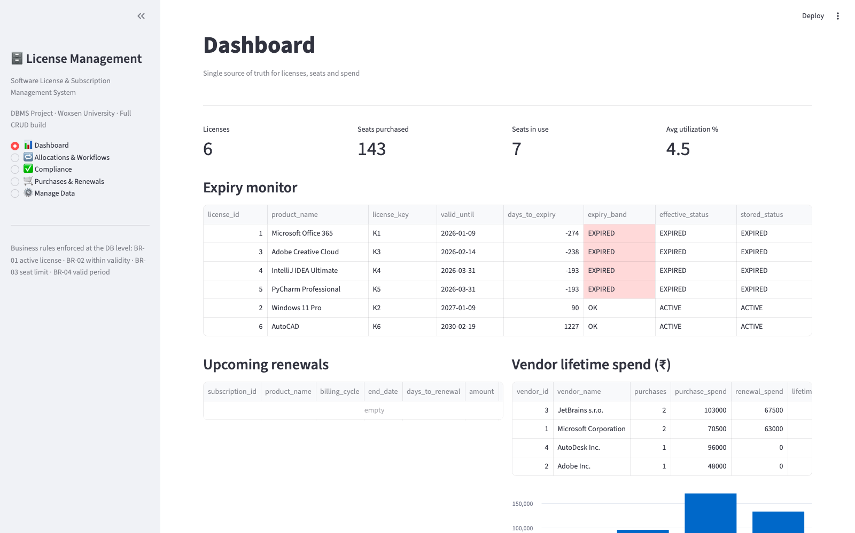
Figure 2. Dashboard — Utilization KPIs, Expiry Monitor and Vendor Spend
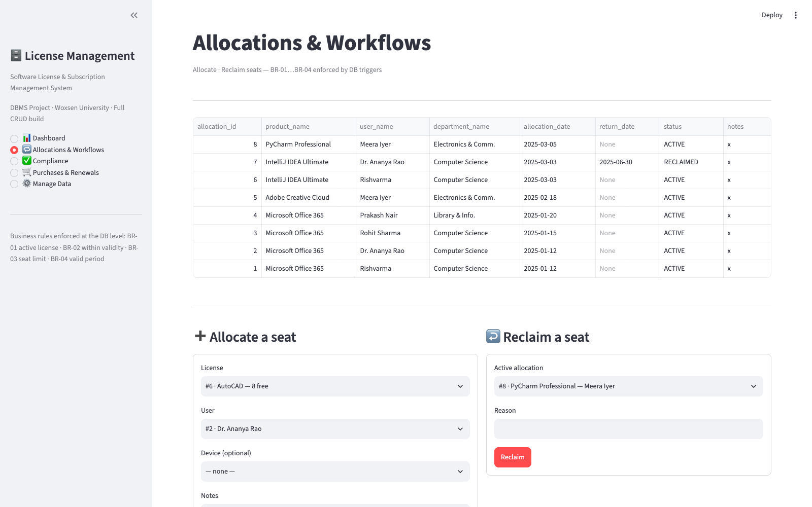
Figure 3. Allocations & Workflows — Seat Allocation and Reclaim Forms
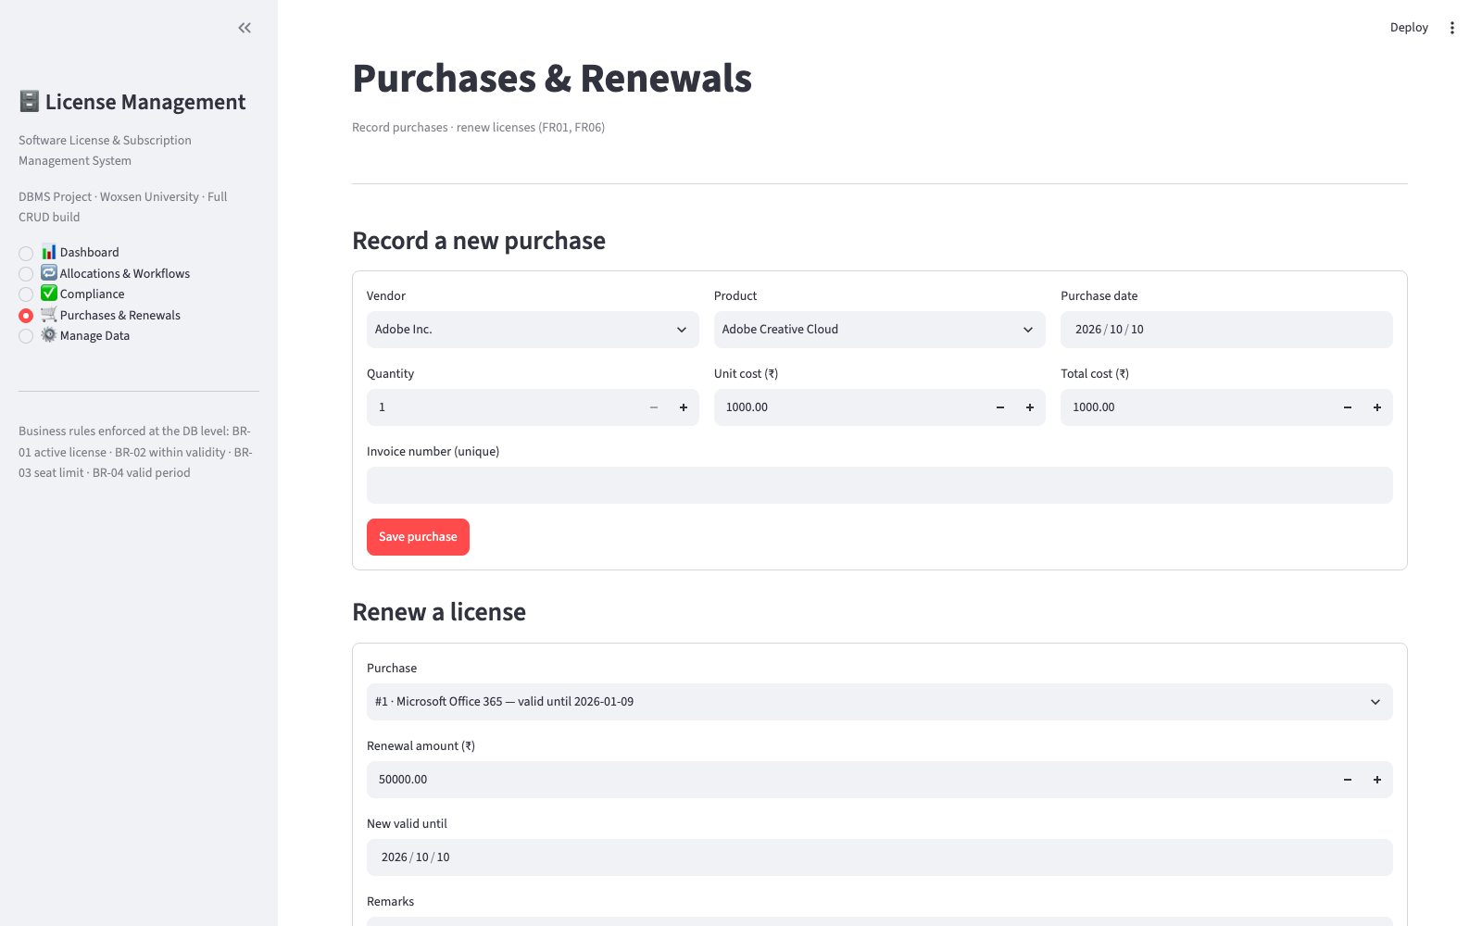
Figure 4. Purchases & Renewals — Purchase Entry and Licence Renewal
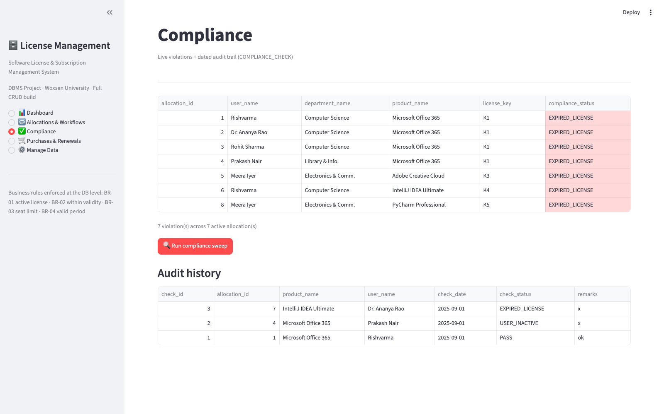
Figure 5. Compliance — Live Violations and Audit History

3.8 Testing and Results
Table 15. Test Cases
Test ID | Feature | Input / Action | Expected Result | Actual Result | Status
TC-01 | Dashboard loads KPIs and expiry bands | Open the Dashboard screen on the seeded database | Licence, seat and utilization figures are computed from v_license_utilization and every licence is banded | 6 licences, 143 seats purchased, 7 seats in use, 4.5 % average utilization; expiry bands EXPIRED (4) and OK (2) shown | Pass
TC-02 | Allocate a seat (positive) | Allocate a free AutoCAD seat to an existing user (FR-02) | A new ACTIVE allocation is created and seats_free decreases | New row inserted with status ACTIVE; after filling, the licence shows 8 of 8 seats in use | Pass
TC-03 | Over-allocation beyond purchased seats (negative) | Keep inserting allocations for the full licence (9th seat) | The database rejects the insert with the BR-03 message | Rejected: “BR-03 violated: all purchased seats for this license are allocated”; seat count stays at 8 | Pass
TC-04 | Allocate on a non-ACTIVE licence (negative) | Set a licence status to EXPIRED, then attempt an allocation (FR-02) | The database rejects the insert with the BR-01 message | Rejected: “BR-01 violated: license is not ACTIVE” | Pass
TC-05 | Allocation date after licence expiry (negative) | Insert an allocation dated 2031-01-01 for a licence valid until 2030-02-19 | The database rejects the insert with the BR-02 message | Rejected: “BR-02 violated: allocation date is past license expiry” | Pass
TC-06 | Return date before allocation date (negative) | Update an allocation so return_date < allocation_date (FR-03) | The database rejects the update (BR-04) | Rejected: “CHECK constraint failed: return_date IS NULL OR return_date >= allocation_date” | Pass
TC-07 | Duplicate licence key (negative) | Insert a licence using an existing license_key | The UNIQUE constraint rejects the row | Rejected: “UNIQUE constraint failed: LICENSE.license_key” | Pass
TC-08 | Purchase quantity of zero (negative) | Insert a PURCHASE row with quantity = 0 (FR-01) | The CHECK constraint rejects the row | Rejected: “CHECK constraint failed: quantity > 0” | Pass
TC-09 | Delete a vendor that still has purchases (negative) | Delete VENDOR vendor_id = 1 from Manage Data | ON DELETE RESTRICT blocks the delete | Rejected: “FOREIGN KEY constraint failed”; vendor and its purchases remain | Pass
TC-10 | Reclaim a seat (positive) | Reclaim an active allocation with a reason (FR-03) | Status becomes RECLAIMED and return_date is set to today | Status RECLAIMED with return_date 2026-10-10; the seat is reported as free again | Pass
TC-11 | Renew an expired licence (positive) | Record a renewal for the Office 365 purchase with a new validity of 2027-06-30 (FR-06) | A RENEWAL row is created, the licence returns to ACTIVE and its expiry band changes | RENEWAL row added; LICENSE status ACTIVE, valid_until 2027-06-30; expiry band changed EXPIRED → OK | Pass
TC-12 | Compliance sweep (positive) | Run the compliance sweep from the Compliance screen (FR-05) | One COMPLIANCE_CHECK row is stored for every active allocation with today's date | Audit rows inserted for all active allocations; the audit history lists each result with its date | Pass
All twelve test cases passed. Every screen read from and wrote to the designed schema, and the database — not the user interface — rejected each invalid operation with the expected message: over-allocation, allocation of inactive or out-of-period licences, impossible dates, duplicate keys, zero quantities and deletion of referenced parents were all refused. The valid workflows behaved as specified: allocations and reclamations updated seat counts correctly, a single renewal moved an expired licence back to ACTIVE and its expiry band from EXPIRED to OK, and the compliance sweep persisted a dated audit record for every active allocation. The six report views returned correct aggregates against the seed data (143 seats purchased, 7 in use, ₹448,000 lifetime vendor spend), confirming that the application uses the logical database design as intended.

CHAPTER 4

CONCLUSION

This project addressed a real operational problem — the lack of a single, reliable record of the software a university owns, who is using it and when it expires — by designing and building a complete Software License and Subscription Management System. An ER model with twelve entities was produced, converted into a relational schema in third normal form, and implemented in MySQL 8 with primary keys, foreign keys, unique, not-null, check and default constraints, two triggers and five stored procedures. A Python Streamlit application then put that design to work: a dashboard for utilization, expiry and spend, allocate and reclaim workflows, purchase and renewal recording, compliance auditing with a dated trail, and full CRUD over every table.
The most important outcome is that the business rules live in the database rather than in the interface. Seat limits, validity periods, unique keys and referential integrity are enforced for every client, and the negative tests showed each rule rejecting bad data with a clear message while the positive tests showed the workflows completing correctly. Building the project also reinforced the full design cycle — requirements, ER modelling, normalization, DDL, constraints, views, procedures, application integration and testing — and demonstrated how a small but well-structured database can replace scattered spreadsheets with trustworthy, auditable information.

4.1 Limitations and Future Enhancements
- No authentication or role-based access control yet — every user of the web application can perform every action; adding login with role checks is the first enhancement.
- Expiry notification is passive: warning bands are visible only when the dashboard is opened; scheduled e-mail alerts 30 and 90 days before expiry are not implemented.
- The application does not integrate with the university's identity store, asset inventory or vendor entitlement APIs, so users, devices and purchases are entered manually.
- Seats are counted per licence rather than measured per concurrent session; real usage metering (login frequency, feature-level consumption) is not captured.
- The SQLite fallback executes the views and plain SQL but not MySQL stored procedures, so the UI issues equivalent parameterised statements when running on SQLite; a scheduled report exporter (PDF/CSV) and multi-campus support are possible further extensions.

REFERENCES

- A. Silberschatz, H. F. Korth, and S. Sudarshan, Database System Concepts, 7th ed. New York, NY, USA: McGraw-Hill, 2019.
- R. Elmasri and S. B. Navathe, Fundamentals of Database Systems, 7th ed. Hoboken, NJ, USA: Pearson, 2015.
- Oracle Corp., “MySQL 8.0 Reference Manual — Triggers,” Accessed: Oct. 10, 2026. [Online]. Available: https://dev.mysql.com/doc/refman/8.0/en/trigger-syntax.html
- Oracle Corp., “MySQL 8.0 Reference Manual — Stored Routines and Objects,” Accessed: Oct. 10, 2026. [Online]. Available: https://dev.mysql.com/doc/refman/8.0/en/stored-routines.html
- Streamlit Inc., “Streamlit API documentation,” Accessed: Oct. 10, 2026. [Online]. Available: https://docs.streamlit.io/
- SQLite Contributors, “SQLite triggers,” Accessed: Oct. 10, 2026. [Online]. Available: https://sqlite.org/trigger.html
- Python Software Foundation, “PEP 249 — Python Database API Specification v2.0,” Accessed: Oct. 10, 2026. [Online]. Available: https://peps.python.org/pep-0249/
- Oracle Corp., “MySQL 8.0 Reference Manual — CREATE TABLE Statement,” Accessed: Oct. 10, 2026. [Online]. Available: https://dev.mysql.com/doc/refman/8.0/en/create-table.html

APPENDICES

APPENDIX A - COMPLETE DATABASE SCRIPT
The complete database script is contained in the sql/ folder of the repository and is executed in order: 01_schema.sql (12 tables with PK/FK, UNIQUE, CHECK and DEFAULT constraints, plus the two allocation triggers), 02_seed.sql (59 sample rows), 03_views_reports.sql (the six reporting views), 04_procedures.sql (sp_allocate_license, sp_reclaim_license, sp_renew_license, sp_run_compliance_check and sp_sync_license_status) and 05_demo_queries.sql (twelve demonstration queries covering FR-01 to FR-08). scripts/sqlite_demo.sql is the SQLite mirror that produces the bundled demo database data/app.db.

APPENDIX B - APPLICATION SOURCE CODE
Source code: app.py (Streamlit user interface), db.py (connection and execution layer) and crud.py (generic create, read, update and delete helpers), together with make_er_diagram.py and make_ppts.py, is available at https://github.com/Rish3666/Software-License-Subscription-Management-System. The repository also contains the sql/ scripts, screenshots/, docs/er_diagram.png and the demo video Final_presentation_demo_video.mp4.

APPENDIX C - ADDITIONAL TEST DATA AND OUTPUTS
Figure 6 shows the administrative Manage Data screen through which rows are added, edited and deleted in all twelve tables. The repository additionally holds the negative-test session transcript underlying Table 15 (TC-03 to TC-09), in which every attempted rule violation was rejected by the database with the messages quoted in this report.
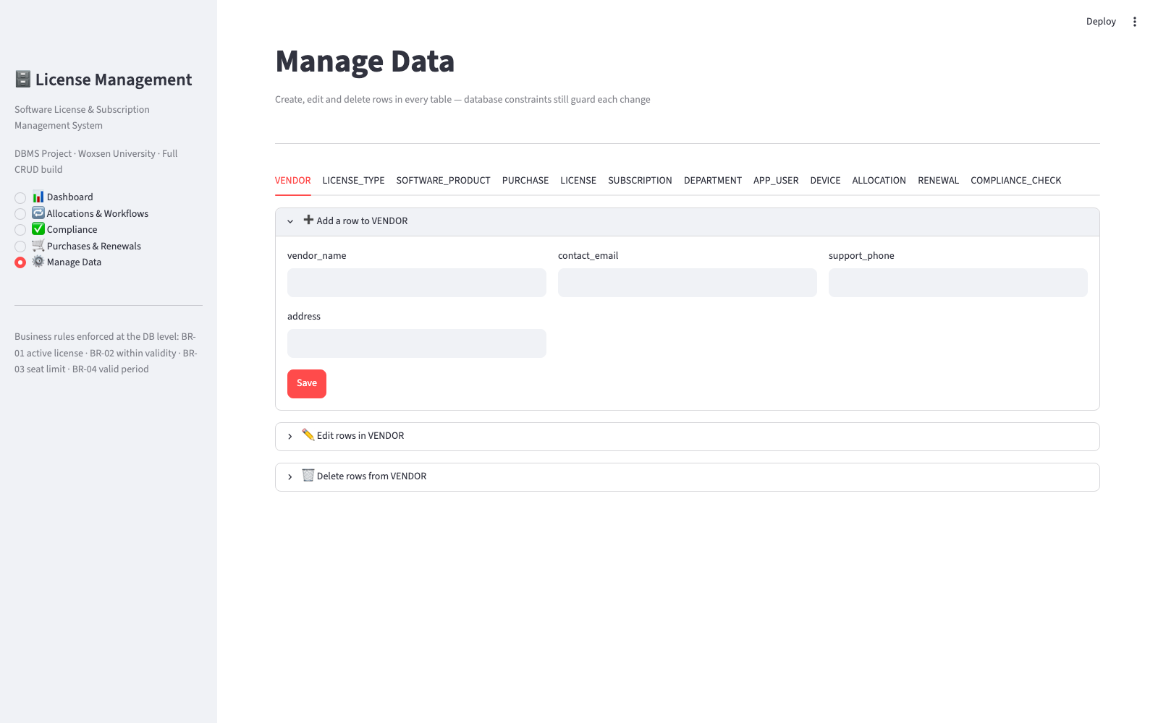
Figure 6. Manage Data — Add, Edit and Delete Rows in All 12 Tables

