Civil Service Form No. 48  DAILY TIME RECORD  -----o0o-----  Juan Dela Cruz  (Name)  For the month of March 2026  Official hours for arrival and departure Regular days Monday - Friday  Saturdays N/A  Day A.M. P.M. Undertime  Arrival Departure Arrival Departure Hours Minutes  1 8:00 12:00 1:00 5:00  2 9:00 12:00 1:00 5:00 1  3  4  5  6  7  8  9  10  11  12  13  14  15  16  17  18  19  20  21  22  23  24  25  26  27  28  29  30  31  Total  I certify on my honor that the above is a true and correct report of the hours of work performed record of which was made daily at the time of arrival and departure from office.  ______________________________________________________________  VERIFIED as to the prescribed office hours:  ________________________________________________  In Charge | Civil Service Form No. 48  DAILY TIME RECORD  -----o0o-----  Juan Dela Cruz  (Name)  For the month of March 2026  Official hours for arrival and departure Regular days Monday - Friday  Saturdays N/A  Day A.M. P.M. Undertime  Arrival Departure Arrival Departure Hours Minutes  1  2  3  4  5  6  7  8  9  10  11  12  13  14  15  16  17  18  19  20  21  22  23  24  25  26  27  28  29  30  31  Total  I certify on my honor that the above is a true and correct report of the hours of work performed record of which was made daily at the time of arrival and departure from office.  ______________________________________________________________  VERIFIED as to the prescribed office hours:  ________________________________________________  In Charge

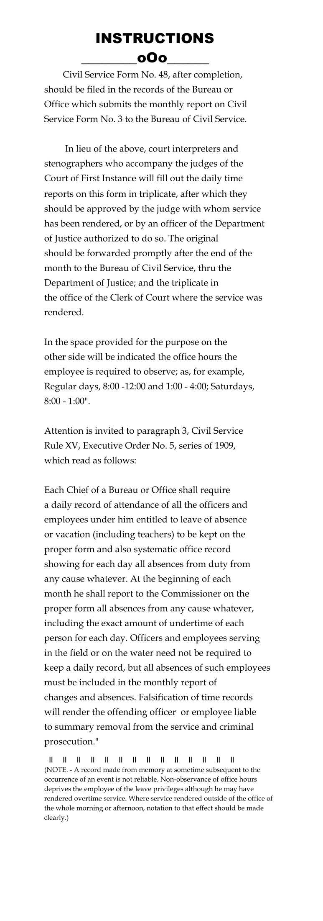 | 

