**Capstone 2: Report**

**Image Recognition – Fruit Classifier with > 90% accuracy on unseen data.**

To build the classifier, the project will be broken down in to smaller tasks, each of which will be a mini milestone, whereby a conclusion will reached. At a high level, the tasks would be:

1. Data collection and curation
2. Data cleaning
3. Data wrangling – conversion and preprocessing
4. Training basic model
5. Data Augmentation
6. Model Training and Testing
7. Advanced model tuning
8. Conclusion

**Step 1: Data Collection and curation: Using Flickr API and Google Image Search URLs**

Target is to have a “good” (post cleaning) collection of 310 images for each fruit, out of which 300 will be for training and 10 will be for testing. In order to do this, 1000+ images of fruits are downloaded for selection and cleaning. Data is collected mainly using 2 methods: *Flickr* and *Google*. Collection methods are very distinct and both are employed to overcome the limitation on number of free-to-download images. Although one can specify a high number of images to be downloaded in Flickr API, for example 1000, the actual number of relevant images that get downloaded is less. Some of the images do not get downloaded due to various reasons such as connectivity, download restriction and sometimes also have very poor quality. If the number of images from one source is not enough, the set will be supplemented by the other source. For example, to supplement the Flickr data set, Google images are downloaded via fetching the URLs using Java Script in to a txt file and downloading them in bulk by using *urllib*.

Note: Flickr API downloaded more than 900 relevant images of Strawberries and so it did not need to be supplemented by Google dataset.

***Using Flickr API:***

To use Flickr API, first the API service was registered after which they emailed a KEY and SECRET that need to be used every time an API call is made. A python function was written to download via the API by passing parameters of ‘keyword’, ‘size’ (optional) and ‘number of images’ (optional).

**def** download\_flickr\_photos(keywords, size='original', max\_nb\_img=-1):

Using this function, the keywords of 'green grapes', 'kiwi', 'blackberry', 'lemons' and 'red apples' was passed to download 1000 images of ‘square’ size (150 x 150), slightly larger than target size (100 x 100).

***Using Google Image Search:***

First the keywords to be searched were put in Image Search option of Google for the images to be loaded in the browser. For example “green grapes” (below).

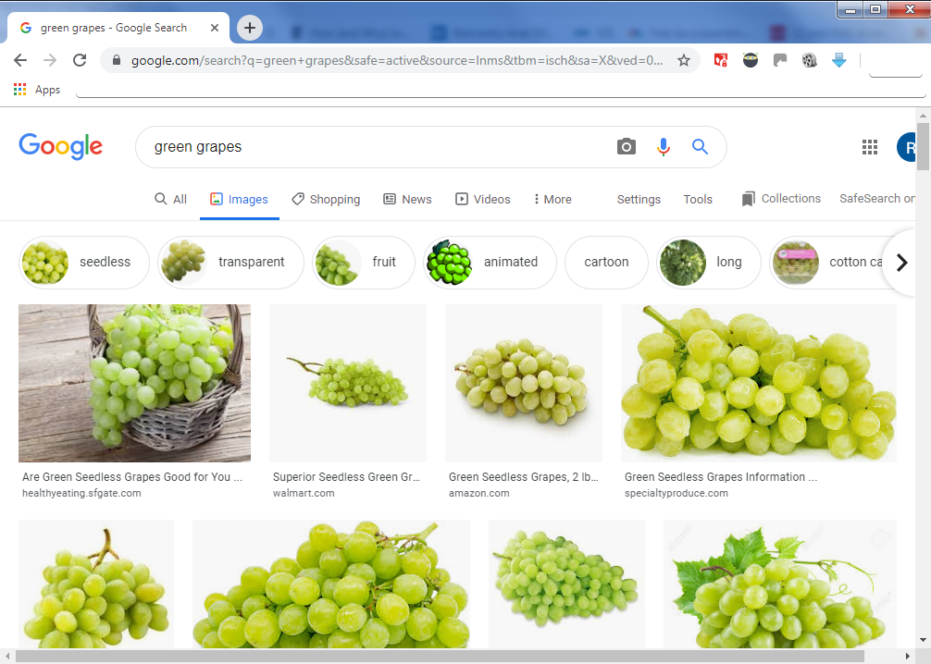

Next to load maximum number of images in the browser window, the scroll bar was clicked through bottom until a button of “Show more results” appeared.

C:\Users\Rishi\Documents\ShareX\Screenshots\2019-09\2019-09-08_11-43-49.png

After clicking on that, the browser loads more images and needs to be scrolled until no more images can be loaded. This is the full set of images that are available by Google to be downloaded. To automate the download, we need to get link of each image. To achieve this, the following JavaScript needs to be executed in the “Developer tools” of Chrome browser.

1. // Step1: pull down jquery into the JavaScript console
2. **var** script = document.createElement('script');
3. script.src = "https://ajax.googleapis.com/ajax/libs/jquery/2.2.0/jquery.min.js";
4. document.getElementsByTagName('head')[0].appendChild(script);
6. // Step2: grab the URLs
7. **var** urls = $('.rg\_di .rg\_meta').map(**function**() { **return** JSON.parse($(**this**).text()).ou; });
9. // Step3:write the URls to file (one per line)
10. **var** textToSave = urls.toArray().join('\n');
11. **var** hiddenElement = document.createElement('a');
12. hiddenElement.href = 'data:attachment/text,' + encodeURI(textToSave);
13. hiddenElement.target = '\_blank';
14. hiddenElement.download = 'urls.txt';
15. hiddenElement.click();

This script will download ‘*urls.txt*’ file will have the link of each of the images in browser. This file is renamed for each fruit class and used in a python function ‘download\_imgs’

The argument ‘arg\_str’ is used to pass the arguments to the function. For example:



This downloads the entire set of images that act as ‘raw’ image source for this project. Next, we will look at data cleaning.

**Step 2: Data Cleaning**

This step consisted of manual and auto deletion of images.

**Method 1: Auto-deletion via OpenCV**

In this, the second part of function 'download\_imgs' is employed to automatically delete the images that are bad. Bad images are classified as the ones that cannot be loaded by OpenCV's CV2. This is factored in to the function itself and the 'culling' part is run after all images are downloaded. From the execution log, you can clearly see which images were deleted.

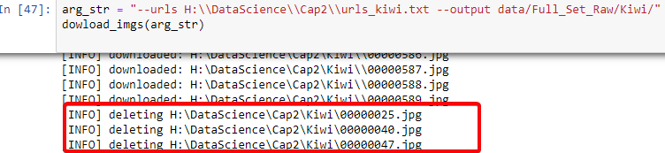

**Method 2: Manual**

For purposes of data curation, each image was manually looked up and kept only if it fit the following rules:

1. Image is clear and is relevant representation of the object. Any non-relevant images were deleted including watermarked ones.
2. Image is of whole fruits and not slices. This is because fruits can be carved/sliced in different ways and we would need a bigger set than 300 images to train different representations of the fruit. Exception to this is kiwi as there are more images of sliced Kiwi than whole Kiwi.
3. Image does not have other fruits in the picture, especially the ones we are training the CNN on. This would lead to confusion and misclassification.
4. Images have similar distance from which it is taken. This is to avoid extreme zoom (Macro) or big distances to mislead the CNN. To be able to get to this level of sophistication, you would need a bigger set and even then, it would be hard to classify extremes/outliers.

**Step 3: Data Wrangling - Image conversion and pre-processing**

The downloaded images are in various shapes and need to be standardized in to thumbnail size, (100x100) to be trained. The original image will be preserved whilst downsizing, but this gives rise to the issue of padding. Some images are rectangular and need to be transformed to thumbnail squares preserving the aspect ratio, and in the process will have some areas that need filling. The approach is to fill these areas with white pixels as majority of the images have a white background. Also, there are various libraries available in Python that accomplish the same thing. For purposes of the project, two of the options are compared, CV2 and Pillow.

**Compare: CV2 vs Pillow**

1. **Image display:** First we see if there is any noticeable difference displaying the images.

Pillow uses *Image* to load the images and Matplotlib’s *imshow* to diplay them. CV2 uses numpy array to display the images. But there is no noticeable difference to the naked eye.

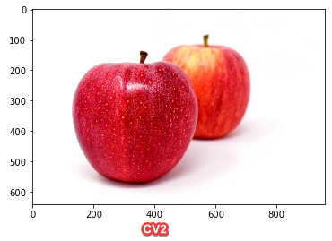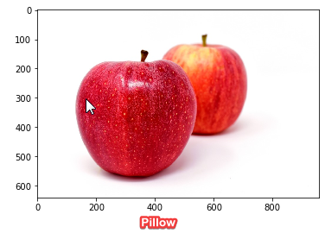

1. **Resizing:** We see what alternations need to be done when changing size to thumbnails.

Going by common notions, whenever we alter the size of image, the quality tends to suffer. To compensate for this Pillow and CV2 use different methods. Pillow uses *AntiAlias* where as CV2 uses *InterArea Interpolation*. Again, to the naked eye, both are indistinguishable.

***Pillow*** with ANTI\_ALIAS

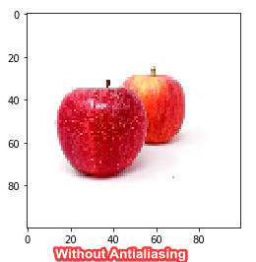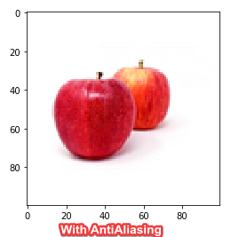

Other options there were explored but dropped in favor our antialiasing being favorite in online community. Example, BICUBIC and BILINEAR.

***CV2*** with INTER\_AREA interpolation

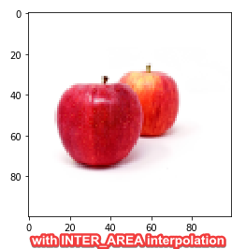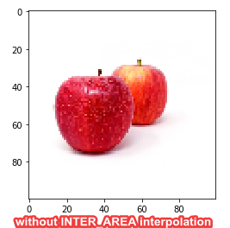

Other options that were explored but dropped in favor of INTER\_AREA

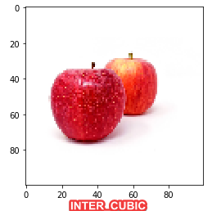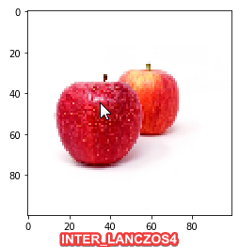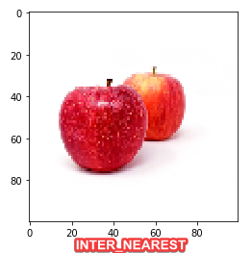

1. **Image weight:** The size of the images when saved was smaller in Pillow than that of CV2. Below is the comparison of grayscale sizes between the two

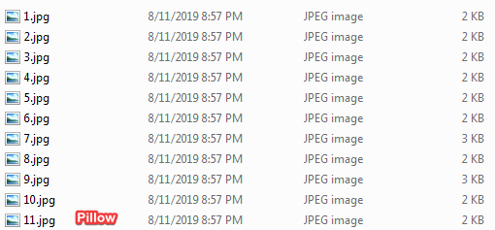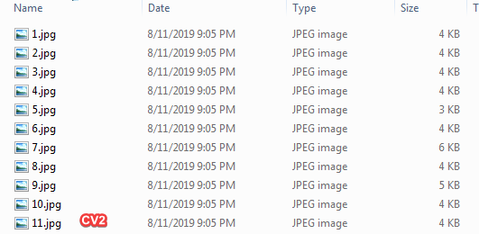

1. 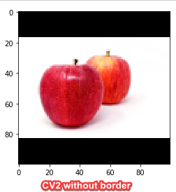**Padding method**: In Pillow, a blank image with padding color is taken on which the resized image is pasted. This insures that the left out areas automatically take over the padding color. With CV2, the *copyMakeBorder* method is used to perform padding of the desired color.
2. **Performance on grayscale:** Grayscale will be used to train an initial model for final compare between the two image converters to conclude which one is better suited for the project. Grayscale training was chosen simply because there are less channels (one color) and therefore it is easier to train than color images that have 3 channels (RGB). A simple 4-layer CNN was used training pre-processed images from Pillow and CV2 for 10 epochs. Validation loss and validation accuracy were chosen to measure performance.

**Pillow:** - 39s 80ms/step - loss: 0.1875 - acc: 0.9125 - val\_loss: 0.1700 - val\_acc: 0.9333

**CV2:** - 36s 76ms/step - loss: 0.1413 - acc: 0.9458 - val\_loss: 0.0857 - val\_acc: 0.9667

As CV2 gave better performance and was chosen to be the preprocessing tool of choice.

Preprocessing: Using CV2, all raw images are preprocessed in to two folders ‘Full\_Set\_Processed’ which has subfolders for each class with a train.csv and also to a ‘Full\_Set\_Proc\_Comb’, where all images are present without subdirectories. There are intentionally two different processed folders to try out different options of Keras library, which will be explored in Milestone 2. For now, let’s train a basic classifier to see the accuracy we can reach.

**Step 4: Training basic model**

A basic 4 layer CNN was setup to measure the time and performance of the classifier with colored thumbnails on fully processed set with this configuration:

1. model3 = Sequential()
2. model3.add(Conv2D(32, kernel\_size=(3, 3),activation='relu',input\_shape=(100,100,3), padding='same'))
3. model3.add(Conv2D(32, (3, 3), activation='relu'))
4. model3.add(MaxPooling2D(pool\_size=(2, 2)))
5. model3.add(Dropout(0.25))
6. model3.add(Conv2D(64, (3, 3), activation='relu', padding='same'))
7. model3.add(Conv2D(64, (3, 3), activation='relu'))
8. model3.add(MaxPooling2D(pool\_size=(2, 2)))
9. model3.add(Dropout(0.25))
10. model3.add(Flatten())
11. model3.add(Dense(512, activation='relu'))
12. model3.add(Dropout(0.5))
13. model3.add(Dense(5, activation='softmax'))
14. model3.compile(loss='categorical\_crossentropy',optimizer='adam',metrics=['accuracy'])
15. model3.fit(X\_train, y\_train, epochs=60, validation\_data=(X\_test, y\_test), verbose=2)

Different configurations were tried by adjusting the number of filters, kernel\_size, dropout, pool\_size etc., but the above configuration was proved to be optimum. In the interest of time, only 100 epochs were run to measure the trend or direction the model was going in. The model ran for 1 hr 7 mins and gave the below result. The training loss dropped to 0.015 and training validation was 99.67%, which is very good, but the validation loss was still very high at 1.0457 and accuracy was only 80%. This meant that whilst the model was very efficient on the training set, it wasn’t so good with the test set. It points to a performance mismatch problem, where the model is **overfitting** on the training set. The test set could have images that are under-represented in the training and/or the optimizer used wouldn’t be the best and different one needs to be chosen. But increasing the training set size isn’t an option as more images are hard to get. So, we’ll have a look at resolving this issue and taking the model to the next level.

From previous model, it can be seen that training takes a long time, especially due to lack of GPU. One epoch takes around 67 seconds and becomes severely limited on the specs of the underlying laptop. This means that there is a long wait to experiment on different parameters and also little scope of trying out different things. Here is where Google’s COLAB offering comes to the rescue.

**Google Colab** democratizes Machine Learning for the masses. It provides a platform where people can freely use 350 GB of disk and 12 GB of GPU RAM per project to train/test their models. A connection lasts for 12 hours and resources get reset after that. That should give us enough room to take this model to Colab environment and try out different things. But before we do that, lets dive in to the different offering of Keras to see if we can overcome the overfitting problem we saw.

**Step 5: Data Augmentation using ImageDataGenerator**

Keras library has a feature for generating variations of a base image by applying numerous modifications to it such as rotation, width shift, height shift, brightness range, shearing, zoom, channel shift etc. More information can be found at the official documentation page of the library at <https://keras.io/preprocessing/image/>. For the purposes of this project, we will be using these options to generate additional training images, and in effect ‘Augment’ the training dataset. These options have been chosen after testing a few times, and manually examining the output of the image generator. Options that produce reasonably recognizable images were retained to produce the training set. For example, it doesn’t make sense to rotate images 180 degrees (or vertical flip) if there are very less changes of test images (unseen) to be that way. Also, we wouldn’t want to shift images more than 20% if that meant partially visible fruits would be taken complete out of frame.

1. imgGen = ImageDataGenerator(
2. rotation\_range = 40,
3. width\_shift\_range = 0.2,
4. height\_shift\_range = 0.2,
5. rescale = 1./255,
6. shear\_range = 0.2,
7. zoom\_range = 0.2,
8. horizontal\_flip = True)
10. i = 1
11. **for** batch **in** imgGen.flow(x, batch\_size=1, save\_to\_dir=path\_keras\_output, save\_format='jpg'):
12. i += 1
13. **if** i > 7:
14. **break**

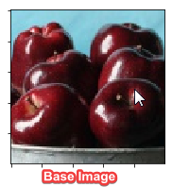 They have been normalized by ‘rescale’ parameter, which takes care of applying the normalization across all 3 channels. Also, zoom more than 20% doesn’t make sense and also a horizontal flip would provide a very good duplication of the image. All parameters take effect in a combined way and the generator randomly chooses the ones to apply at a given point. This generator then needs to be called by flow or one of the options where Keras uses the output of the generator to train data. Let’s have a look at what the generator produced from above code for the 7 augmented images.

**Augmented Images**

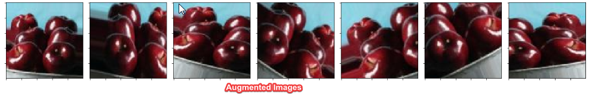

**Flows -**

There are 3 main type of flow methods that are documented in Keras online documentation. We will be exploring all 3 and choosing one of them for the project.

1. flow
2. flow\_from\_directory
3. flow\_from\_dataframe
4. **flow:** Takes data & label arrays, generates batches of augmented data. In this method, images need to be loaded, converted to arrays, reshaped and only then they are can be used by the ImageDataGenerator. Example of this is already covered in the code mentioned in data augmentation section. Drawback of this method is that additional processing is needed for the steps of loading the images and there is not any way to use it besides that. This will take up considerable resources, especially if you are loading 1000s of images. So, we won’t be using this method for now.
5. **flow\_from\_directory:** This method is good in the sense that it can read the images directly from the directory and it takes labels as the directory names. So the images need to be organized in folders so that categorical variables are applies to classes automatically. There is also an option to mention the ‘validation\_split’ parameter which splits the input set in to train and test set. Although this option worked very well on my laptop, this did not work well in Google’s Colab environment. It was observed that the train-test split was very uneven and sometimes has produced very high class imbalance. That is one of reasons this method was not chosen for the project. Also, the train test split was done using matplotlib’s preprocessing method.

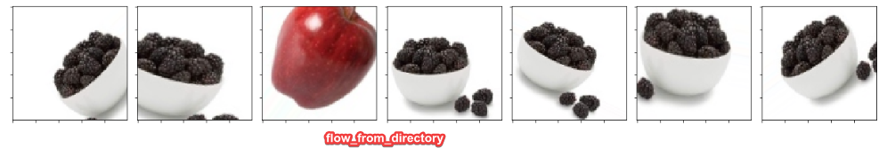

1. **flow\_from\_dataframe:** This method takes in a pandas DataFrame containing the names of the files and classes as input and generates the data from there. We could even have absolute and relative paths in here, making this method one of the most flexible ones. Also, due to very less information and examples present on how to use it, it was thought to help other flow learners guide their way by using it for the project.

**Step 6: Building Model, training and test findings**

A basic CNN was chosen as the number of classes is not big (only five) and different parameters were tried on. As this needed experimentation, the local resources on my laptop were not sufficient and Google Colab was used (Base Model):

<https://colab.research.google.com/drive/1wCAVxGcwGVJvJr3Kw8ADouNYDJx64jAd>

The way Colab works is that it temporarily installs a python shell on Google Drive, where it can read files from your drive and use them in a temporary work space. In order to make use of this construct, the training and test data (folders with combined images) were zipped and uploaded to Google Drive as 2 separate files. They were then accessed and unzipped in the code for training and testing purposes.

Parameters that were experimented-on are listed below. Both training parameters (loss and accuracy) and validation parameters (val\_loss and val\_acc) were taken in to account during decision making.

1. ImageDataGenerator’s ‘vertical\_flip’: It was observed that turning this parameter ‘on’ stalled the model’s accuracy rate at around 86% and did not lower the loss below 0.1.
2. Increasing filters: Current model has filters in layers as (32, 32, 64, 64). When more filters were added in layers beyond 64, for example 128, it increased the training time but no significant benefit was observed. These filters were changed at first 2 and last 2 levels to no improvement in val\_loss parameter.
3. Increasing convolutional layers: More layers were added beyond the 4, but no evident benefit was observed. For example, 2 more convolutional layers were added of 64 each but the accuracy levels did not change. In fact, number of epochs to get the same result slightly increased. This was due to additional layers capturing more info and contributing towards the final classification parameter. Scaling down and keeping it 4 convolutional layers seems to be optimum.
4. Changing Dropouts: The current dropouts are set to 0.25 for the convolutional layers and 0.5 for the dense layer. Increasing the dropout seems to increase the training time and reduce the overall accuracy, whereas decreasing them seemed to go towards overfitting problem.
5. Changing kernel\_size: The current kernel\_size is set to 3x3 in the convolutional layers and this seems to be optimum for 2 reasons: Increasing it caused increase in the training accuracy and loss, thereby increasing the validation accuracy and loss. Whereas decreasing it to 2x2 probably caused it to be more sensitive to small variations in the image edges. Not all images are taken from similar distances to object and this seemed to play a part in reducing the kernel size. In the end, 3x3 seems to give the best results.
6. Increasing dense layer size: The dense layer is set to 128. Increasing that number to 256 or 512 seems to increase the parameters exponentially (in model summary) and cause model to give sub optimum results. My guess is that it would take more parameters to feed to the next dense layers and weights adjustment for back propagation would also take more time.

It can be concluded that perhaps more sophistication or complexity of a model comes at a computational and timing cost and may act in detriment of a simple classification neural network. If images were larger or complex, a more deeper and denser CNN would have been required.

**Step 7: Advanced Model tuning and testing**

**Checkpoint callback:**

In the base model, it was observed during the evaluation of the model, the parameters from the last epoch played significant role. In the overall model training exercise, the training accuracy and loss did not linearly improve. They eventually improved, but in some epochs they become worse temporarily, may be due to some nonstandard images from the training set or ones generated by the ImageDataGenerator. For example, the accuracy from 84th epoch came down from 0.9307 to a low of 0.9113 and went back up in 91th epoch. This nonlinearity can result in the model not being the best state at the end of training epochs. For example, the below values on evaluation of validation dataset and test dataset (respectively) at the end of 250 epochs of model training may not be the best:

Validation set evaluation = [0.8309193852904718, 0.9]

Test set evaluation = [0.7641155040264129, 0.8599999904632568]

It would be prudent to save a copy of model that performed the best in the intermediate states of training. That is where the ‘checkpoint’ functionality of Keras is used to save the best performing model weights on the basis of least amount of ‘val\_loss’ parameter. This checkpoint is saved by ‘callback’ option given during training and later loaded to check the validation. On loading the intermediate checkpoint file ('weights\_cap2\_3.hdf5') of best weights, it can be seen that it performs better on the test (unseen) data, with accuracy of 90% vs that of 86% above.

Validation set evaluation = [0.2686952355752389, 0.97]

Test set evaluation = [0.2596906507015228, 0.9000000023841858]

**Batch normalization**

On further research online for advanced tuning and mentor feedback, it came up that ‘BatchNomalization’ on the model layers makes the model train faster. To try this and to be able to compare to the original trained model, a new Colab notebook was setup at the below location:

<https://colab.research.google.com/drive/1q_Rt6op3rv6cmog8dH_0hPMLjdG2mwoS>

It can be seen how the model is changed significantly to introduce ‘BatchNomalization’ on the four convolutional layers and also on the dense layers.

1. **from** keras **import** layers
2. model = Sequential()
3. model.add(Conv2D(32, kernel\_size=(3, 3),input\_shape=(100,100,3), padding='same', use\_bias = 'False'))
4. model.add(layers.BatchNormalization(axis=3))
5. model.add(layers.Activation('relu'))
6. model.add(Conv2D(32, (3, 3), use\_bias = 'False'))
7. model.add(layers.BatchNormalization(axis=3))
8. model.add(layers.Activation('relu'))
9. model.add(MaxPooling2D(pool\_size=(2, 2)))
10. model.add(Dropout(0.25))
11. model.add(Conv2D(64, (3, 3), use\_bias = 'False', padding='same'))
12. model.add(layers.BatchNormalization(axis=3))
13. model.add(layers.Activation('relu'))
14. model.add(Conv2D(64, (3, 3), use\_bias = 'False'))
15. model.add(layers.BatchNormalization(axis=3))
16. model.add(layers.Activation('relu'))
17. model.add(MaxPooling2D(pool\_size=(2, 2)))
18. model.add(Dropout(0.25))
19. model.add(Flatten())
20. model.add(Dense(128, use\_bias = 'False'))
21. model.add(layers.BatchNormalization())
22. model.add(layers.Activation('relu'))
23. model.add(Dropout(0.5))
24. model.add(Dense(5, use\_bias = 'False'))
25. model.add(layers.BatchNormalization())
26. model.add(layers.Activation('softmax'))

An additional argument of ‘use\_bias=False’ needs to be used in the layers preceding BatchNomalization. Also axis=3 is chosen due to apply it on the channels axis as Keras is running on TensorFlow with input tensor of [b, h, w, c] meaning batch\_size, height, width and channels. It was noticed that when this model is trained for the same number of epochs, it gave better accuracy on validation and test data. The actual time it took for each epoch slightly increased by 1s/epoch but final accuracy on unseen data (test set) increased by 4%.

Validation set evaluation = [0.14419285039727886, 0.9533333333333334]

Test set evaluation = [0.15934765964746475, 0.94]

It can be clearly seen how BatchNomalization proved to be effective in increasing not only the accuracy, but also bringing down the val\_loss to 0.1593.

It can also be inferred from the model summary that the most number of parameters were introduced by the Dense layer that takes the convolutional input from the last one of 64 layers. Almost 4.3 million parameters are introduced here, which are then pass to the next Dense layer with the last Batch Normalization introducing only 20. Overall, BatchNomalization introduced 1300 new parameters, but 650 non-trainable but gave a better performance than the one without it.

**Final evaluation**

It can be inferred from the confusion matrix that model was very good at detecting ‘Blackberries’, ‘Kiwi’ and ‘Strawberry’ but got confused with Apples as Green Grapes and Strawberry. Getting Apples mixed with Strawberries was in line of expectation as some images in the set resemble closely with each other and have the same color. But getting Apples confused with Green Grapes was a surprise. This could have been due to presence of some green apples in the training set and color and edge confusion with strawberries. There was also expectation of model getting confused between Green Grapes and Kiwi as they also have same color, but it seems like the model has become very good at distinguishing between the two. Also surprisingly, one Green Grapes was misclassified as Blackberry, perhaps of the shadow and low light conditions of the image.

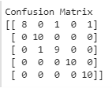

Lets have a look at which images could have been the misclassified ones.

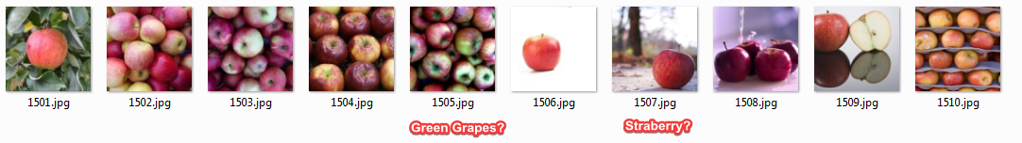

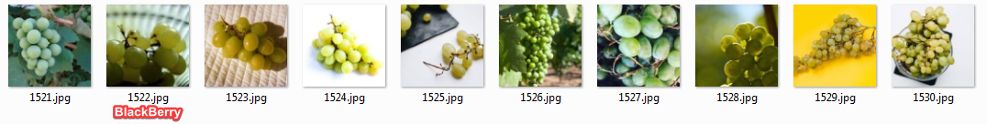

The below report gives details on the recall, precision and f1 score of the model.

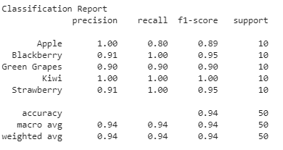

**Step 8: Conclusion**

**Challenges of accuracy and detection complete.**

It can be concluded that the model is good at detecting edges of similar colored fruits and also adept at recognizing the various shapes that a fruit may have (test set of 50 images). For example, variations in shape of apples, grapes and strawberries. The last challenge of recognizing partial fruits also has been completed as partial images were fed to the model, both during training and testing steps with accuracy of 95.3% and 94% respectively.

**Further investigations**

Some more investigation needs to done to find out what images compromise the accuracy of the model by exposing the model to more test data. This would solidify the rationale behind misdetection due to lighting conditions, proximity of the object or model limitations. It was also observed that the training set has some images that could have caused some confusion to the model whilst training. The below images are either with another fruits or too distant and could cause classification confusion

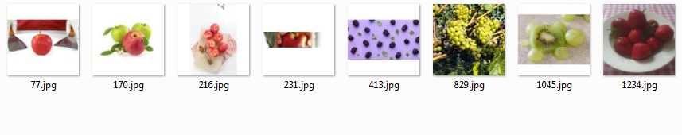

**Next steps**

* 1. Other ImageDataGenerator parameters can be used to improve the brightness adaptability of the model. Some dark images could be made lighter and some bright ones darker for training. This will make the model more robust and tolerant of different light conditions.
  2. Keras also makes image resizing easier as it is nothing but a numpy array, to which resizing can be on the fly without any preprocessing needed. This option can be tried out to see if it is any better or worse than an independent preprocessing step. Other libraries can also be tried like ‘imgaug’ so compare their performance.
  3. The scope of this classifier can be expanded to 10 or 15 classes to see if the model needs addition of more layers.