Backtracking -

What is Backtracking?
Backtracking is a problem-solving technique where we:
Choose
Explore
Undo
Choose Another

Think:
Try a choice.

If it works:
Continue.

If it doesn't:
Undo the choice.

Try another choice.

Real Life Example
Suppose you are ordering food.
Choices:
Burger
Pizza

For drinks:
Coke
Juice

Possible combinations:
Burger + Coke
Burger + Juice
Pizza + Coke
Pizza + Juice

How do we find all combinations?
Choose Burger
Choose Coke
Save Answer

Undo Coke
Choose Juice
Save Answer

Undo Burger

Choose Pizza
...

Notice:
Choose
Explore
Undo

This Undo step is called:
Backtracking

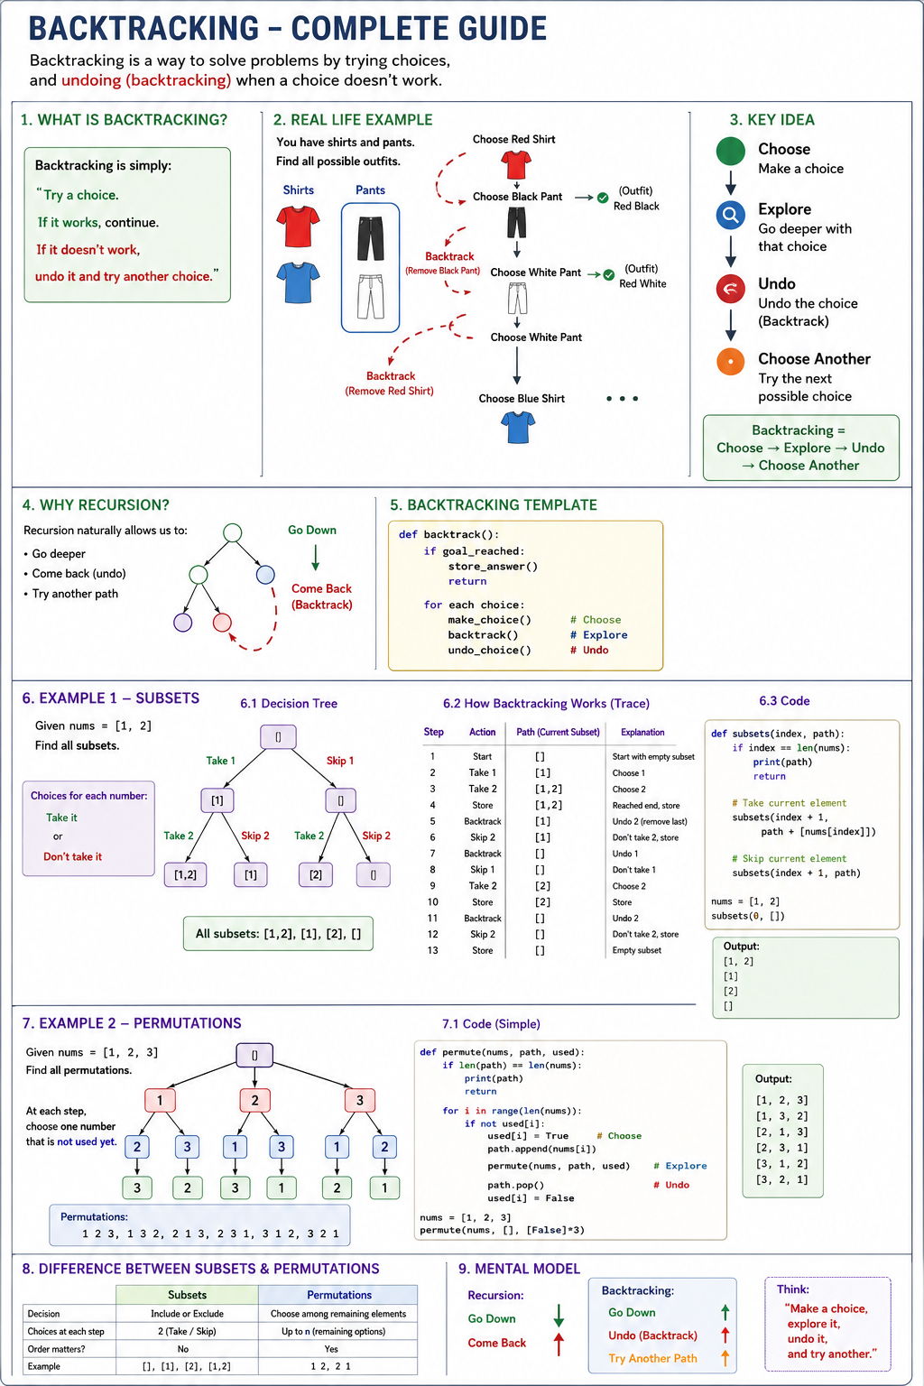

Why Do We Need Backtracking?
Suppose a problem asks:
Find ALL possible answers.

Examples:
- All subsets
- All permutations
- All paths
- All combinations

One answer is not enough.
We must explore every possibility.
Backtracking helps us systematically explore all possibilities.

Relationship Between Recursion and Backtracking
Recursion:
- Go Down
- Come Back Up

Backtracking:
- Go Down
- Undo
- Try Another Path

Think:
Recursion
=
Go Down + Come Back

Backtracking
=
Go Down + Come Back + Undo

Decision Making
This is the most important concept.
Every Backtracking problem is actually a series of decisions.
Example:
nums = [1,2]

For number 1:
Decision:
Take it
Skip it

For number 2:
Decision:
Take it
Skip it

Every step asks:
What choices do I have?

Those choices become branches in a tree.

State Space Tree
This is the concept that confuses most beginners.
Let's simplify it.

What is a State?
A State means:
Current situation

Example:
Current subset = []

This is one state.

After taking 1:
Current subset = [1]

New state.

After taking 2:
Current subset = [1,2]

Another state.

What is a State Space Tree?
A State Space Tree is simply:
A tree showing all possible states.

Example:
nums = [1,2]
Decision:
Take 1
Skip 1

Tree:
[]
/ \
[1] []

Now for each state:
Decision for 2:
Take 2
Skip 2

Tree becomes:
[]
/ \
[1] []
/ \ / \
[1,2] [1] [2] []

This complete tree is called:
State Space Tree

How Backtracking Traverses the Tree
Backtracking explores one path completely.
Example:
[]
|
Take 1
|
[1]
|
Take 2
|
[1,2]

Store answer.
Now:
Undo 2

Back to:
[1]

Try another choice:
Skip 2

Store:
[1]

Undo again.
Back to:
[]

Try another path.

Golden Formula of Backtracking
Every problem follows:
- State
- Choices
- Choose
- Explore
- Undo

Memorize this.

Generic Template
def backtrack():

choose()

backtrack()

undo()

Or:
Choose
Explore
Undo

Example 1 - Subsets
Problem:
nums = [1,2]

Find all subsets.
Answer:
[]
[1]
[2]
[1,2]

Decision Making
For every number:
Take it

OR

Skip it

Only two choices.

State Space Tree
[]
/ \
Take1 Skip1
/ \
[1] []
/ \ / \
T2 S2 T2 S2
| | | |
[1,2] [1] [2] []

How Backtracking Thinks
Start:
[]

Decision:
Take 1

State:
[1]

Decision:
Take 2

State:
[1,2]

Store answer.

Backtrack:
Remove 2

State:
[1]

Try another choice.
Skip 2

Store:
[1]

Backtrack:
Remove 1

State:
[]

Try another path.

Example 2 - Permutations
Problem:
nums = [1,2,3]

Find all arrangements.
Answer:
[1,2,3]
[1,3,2]
[2,1,3]
[2,3,1]
[3,1,2]
[3,2,1]

Decision Making
Question:
Which unused number should I place next?

Choices:
1

2

3

State Space Tree
[]
/ | \
1 2 3
/ \ / \ / \
2 3 1 3 1 2
| | | | | |
3 2 3 1 2 1

Every root-to-leaf path gives one permutation.

Backtracking Logic
Choose:
1

State:
[1]

Choose:
2

State:
[1,2]

Choose:
3

State:
[1,2,3]

Store answer.

Backtrack:
Remove 3

Try:
No more choices

Backtrack again.
Remove 2

Try:
3

State:
[1,3]

Continue.

Difference Between Subsets and Permutations
Subsets:
Decision:
Take

OR

Skip

Choices:
2

at every step.

Permutations:
Decision:
Which unused number should I place next?

Choices:
Many

depending on remaining elements.

Interview Cheat Sheet
State
Current situation

Example:
Current subset
Current permutation

Decision
What choices are available?

State Space Tree
Tree of all possible states.

Backtracking
Choose

Explore

Undo

Choose Another

Golden Formula
State

Choices

Choose

Explore

Undo

If you understand these five words, you've understood 80% of backtracking.

