**Centralized Blood Bank Management System**

**Software Requirement Specification**

**Prepared by:-**

**Akhilesh Bhogale**

**Tanjul Raikisani**

**Rishab Advani**

**Date:-13/01/2019**

**OVERVIEW**

In this project we are trying to build a web application for a Centralized Blood Bank Management System wherein Users and hospitals can donate as well as purchase the blood as per their requirements in terms of needs.

**OPERATING ENVIRONMENT**:-

Operating environment for the airline management system is as listed below.

* client/server system
* Operating system: Windows/Linux/Mac OS.
* database: MySql database
* platform: Java

**FUNCTIONAL REQUIREMENTS**

|  |  |  |
| --- | --- | --- |
| **Sr.No** | **SRS Requirement ID** | **Description** |
| 1 | **Registered User** | |
|  | F.1.1 | Login to our system |
|  | F.1.2 | View available blood stocks of various Hospitals and Blood Banks |
|  | F.1.3 | Purchase the blood units |
|  | F.1.4 | Register for Blood Donation Camps |
|  | F.1.5 | View purchase as well as donation history |
|  | F.1.6 | Update profile details |
| 2 | **Guest** | |
|  | F.2.1 | View available blood stocks of various Hospitals and Blood Banks |
|  | F.2.2 | Register into our system |
| 3 | **Hospitals** | |
|  | F.3.1 | View available blood stocks of various Hospitals and Blood Banks |
|  | F.3.2 | Update their blood stocks |
|  | F.3.3 | Purchase the blood units |
|  | F.3.4 | Update profile details. |
|  | F.3.5 | Organize Blood Donation Camps |
| 4 | **Blood Banks** | |
|  | F.4.1 | View available blood stocks of various Hospitals and Blood Banks |
|  | F.4.2 | Update their blood stocks |
|  | F.4.3 | Purchase the blood units |
|  | F.4.4 | Update profile details. |
|  | F.4.5 | Organize Blood Donation Camps |
| 5 | **System Administrator** | |
|  | F.5.1 | Add a User to the system |
|  | F.5.2 | Remove a User from the system |
|  | F.5.1 | Add a Hospital to the system |
|  | F.5.2 | Remove a Hospital from the system |
|  | F.5.3 | Add a Blood Bank to the system |
|  | F.5.4 | Remove a Blood Bank from the system |

**1.REGISTERED USER**

**F.1.1 A registered user can login in our database.**

* Login will require:
  + Login id
  + Password

**F.1.2 View available blood stocks of various Hospitals and Blood Banks**

* For viewing blood stocks user has to select a city from a drop down list.
* Once the city is selected list of all the hospitals in that city will be displayed.
* When a specific hospital in the list is clicked the blood stocks of that hospital will be displayed.
* There will be a Purchase button for the User to purchase the blood units.
* If Registered User clicks on Purchase button they will be redirected to Purchase page.

**F.1.3 Purchase the blood units**

* He can also purchase the prefered stock by clicking on the purchase button.
* After clicking on the button a confirmation message will pop up where all the details of the user will be mentioned.
* Also after purchasing following options will be available:
  + Self pick up.
  + Delivery.
* If user has selected delivery option, address of the user will be confirmed.
* Also user will be able to add another address.
* There is a limit of purchase for the user. User can select at most 3 units of blood.
* Also the limit of purchase for the blood bank/hospital will be 5.

**F.1.4 Register for Blood Donation Camps**

* Can also register for blood donation camps.
* While registering they have to fill up their details.
* Also blood group related information.

**F.1.5 View purchase as well as donation history**

* After clicking on the history button two tables will be displayed.
* Donation table.
  + All the previous blood donation history of the user will be displayed in this table .It will show the following:
  + Blood bank/hospital name
  + Date of donation.
  + Venue
* Purchase table.
  + All the previous purchases will be displayed in this table.It will show the following:
  + Blood Bank/hospital name
  + Blood group
  + Date of donation.

**F.1.6 Update profile details**

* On clicking on update profile user will be able to edit the below fields.
  + Name
  + Contact Details
  + Email ID
  + Password
  + List of addresses

**2. Guest user**

**F.2.1. View the available blood stock.**

* For viewing blood stocks user has to select a city from a drop down list.
* Once the city is selected list of all the hospitals in that city will be displayed.
* When a specific hospital in the list is clicked the blood stocks of that hospital will be displayed.
* There will be a Purchase button for the User to purchase the blood units.
* If Guest user clicks on Purchase button they will be redirected to Registration page.

**F.2.2. Register into our system.**

* When the Guest lands on the Registration page they will be asked to select between Individual User or Hospital or Blood Bank.
* After selecting that they will be asked to enter following details.

1. Name
2. Contact Details
3. Email ID
4. Password
5. Confirm Password
6. List of addresses

* Fields 1 to 5 are compulsory.
* Field 6 requires at least 1 address. More addresses can be added as per Users choice
* Detailed description of each of these fields:-
  + Name
    - Name must not contain any number or a special character.
    - Name must be at least 1 character long and can be at most 50 character long
  + Contact details
    - Contact details must contain exactly 10 digits.
    - It may or may not start with (+) symbol.
    - It may or may not contain hyphens (-) in it.
  + Email ID
    - It must be of the format [xxxxxxxxx@xxx.xxx](mailto:xxxxxxxxx@xxx.xxx)
    - It can be at most 50 character long.
    - It should be unique.
    - User entered Email ID will be checked if it already exists in the database.
    - In case it already exists in the database the User will be notified to change it.
  + Password
    - Password is case sensitive.
    - It should consist of at least one alphabet, one number and one special character.
    - It should be at least 6 characters long and at most 32 characters long.
    - It must not be same as User ID.
  + Confirm Password
    - This must match the data entered in Password field.

**3. Hospital**

**F.3.1 View available blood stocks of various Hospitals and Blood Banks**

* For viewing blood stocks they have to select a city from a drop down list.
* Once the city is selected list of all the hospitals and blood banks in that city will be displayed except their own hospital.
* When a specific hospital or blood bank in the list is clicked the blood stocks of that hospital or blood bank will be displayed.
* There will be a Purchase button for them to purchase the blood units.
* If they click on Purchase button they will be redirected to Purchase page.

**F.3.2. Update their blood stocks**

* They can update their blood stocks by clicking on Update Stocks button.

**F.3.3 Purchase the blood units**

* They can purchase the prefered stock by clicking on the purchase button.
* After clicking on the button a confirmation message will pop up where all the details of the user will be mentioned.
* They need to select one of the following options:
  + Self pick up.
  + Delivery.
* If they select Delivery, the list of previously entered addresses by the Hospital will be displayed for them to choose as a delivery address.
* If they wish to add another address they can do so by clicking on Add Address button.
* There is a limit of purchase for the user. User can select at most 3 units of blood.

**4. Blood bank**

**F.4.1 View available blood stocks of various Hospitals and Blood Banks**

* For viewing blood stocks they have to select a city from a drop down list.
* Once the city is selected list of all the hospitals and blood banks in that city will be displayed except their own blood.
* When a specific hospital or blood bank in the list is clicked the blood stocks of that hospital or blood bank will be displayed.
* There will be a Purchase button for them to purchase the blood units.
* If they click on Purchase button they will be redirected to Purchase page.

**F.4.2. Update their blood stocks**

* They can update their blood stocks by clicking on Update Stocks button.

**F.4.3 Purchase the blood units**

* They can purchase the prefered stock by clicking on the purchase button.
* After clicking on the button a confirmation message will pop up where all the details of the user will be mentioned.
* They need to select one of the following options:
  + Self pick up.
  + Delivery.
* If they select Delivery, the list of previously entered addresses of the Blood Bank will be displayed for them to choose as a delivery address.
* If they wish to add another address they can do so by clicking on Add Address button.
* There is a limit of purchase for the user. User can select at most 3 units of blood.

**5. System Administrator**

**F.5.1. Add a User to the system**

* A System Administrator can add a new User to the system by clicking on Add New User button.
* When he clicks on the button he will have to fill the following details:-
  + Name
  + Contact Details
  + Email ID
  + Password
  + Confirm Password
  + List of addresses

**F.5.2. Remove a User from the system**

* System Administrator can remove a User from the system by entering his Email Id.

**F.5.3. Add a Hospital to the system**

* A System Administrator can add a new Hospital to the system by clicking on Add New Hospital button.
* When he clicks on the button he will have to fill the following details:-
  + Name
  + Contact Details
  + Email ID
  + Password
  + Confirm Password
  + List of addresses

**F.5.4. Remove a Hospital from the system**

* System Administrator can remove a Hospital from the system by entering their Email Id.

**F.5.5. Add a Blood Bank to the system**

* A System Administrator can add a new Blood Bank to the system by clicking on Add New Blood Bank button.
* When he clicks on the button he will have to fill the following details:-
  + Name
  + Contact Details
  + Email ID
  + Password
  + Confirm Password
  + List of addresses

**F.5.6. Remove a Blood Bank from the system**

* System Administrator can remove a Blood Bank from the system by entering their Email Id.

**USE CASE DIAGRAMS**

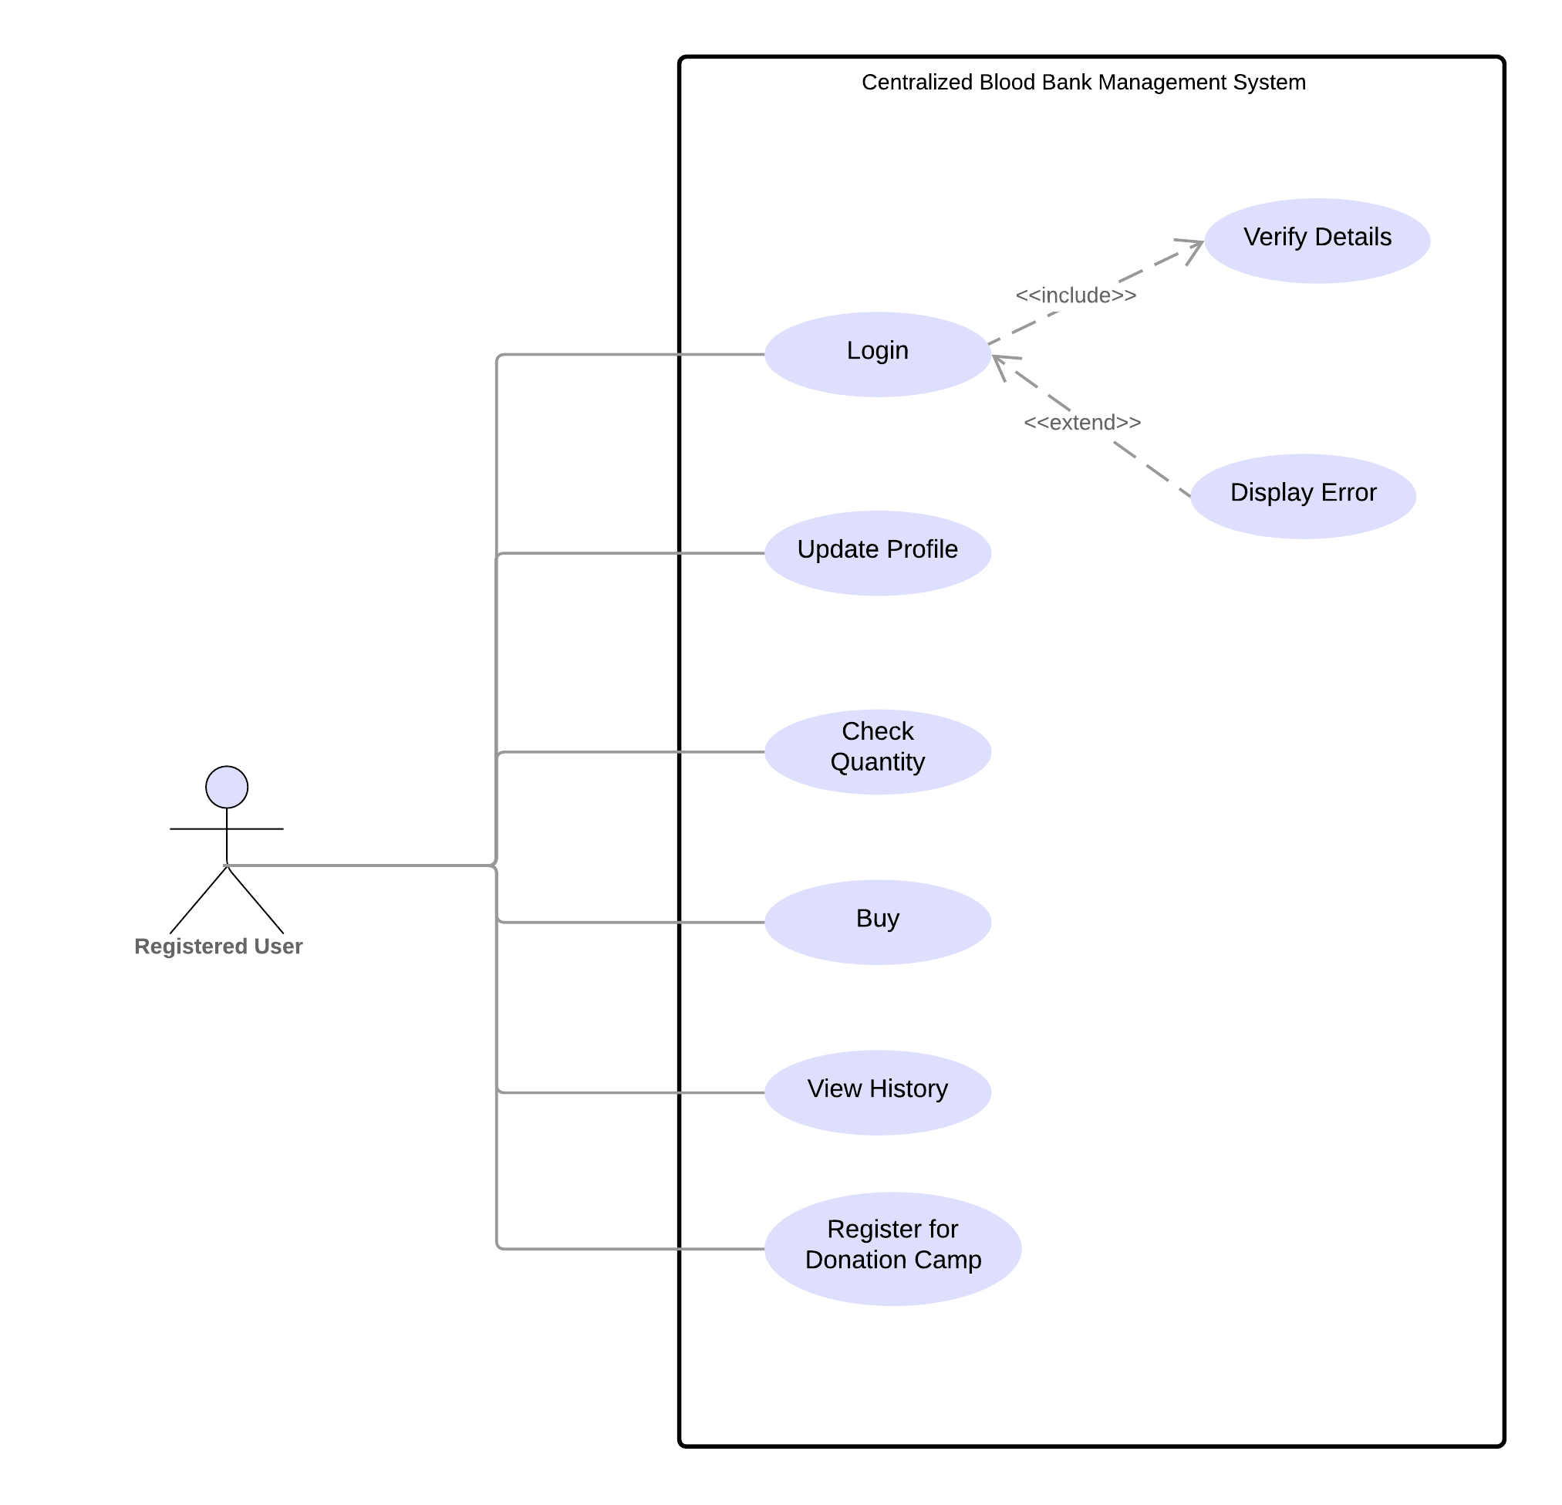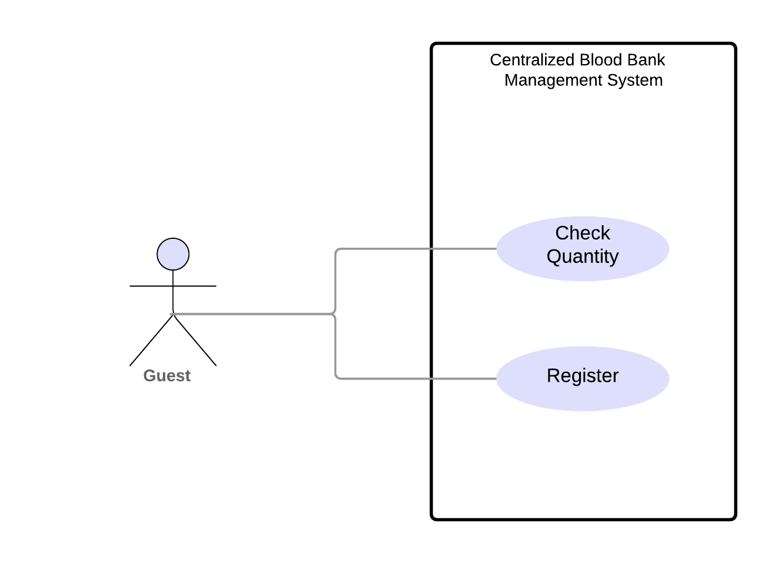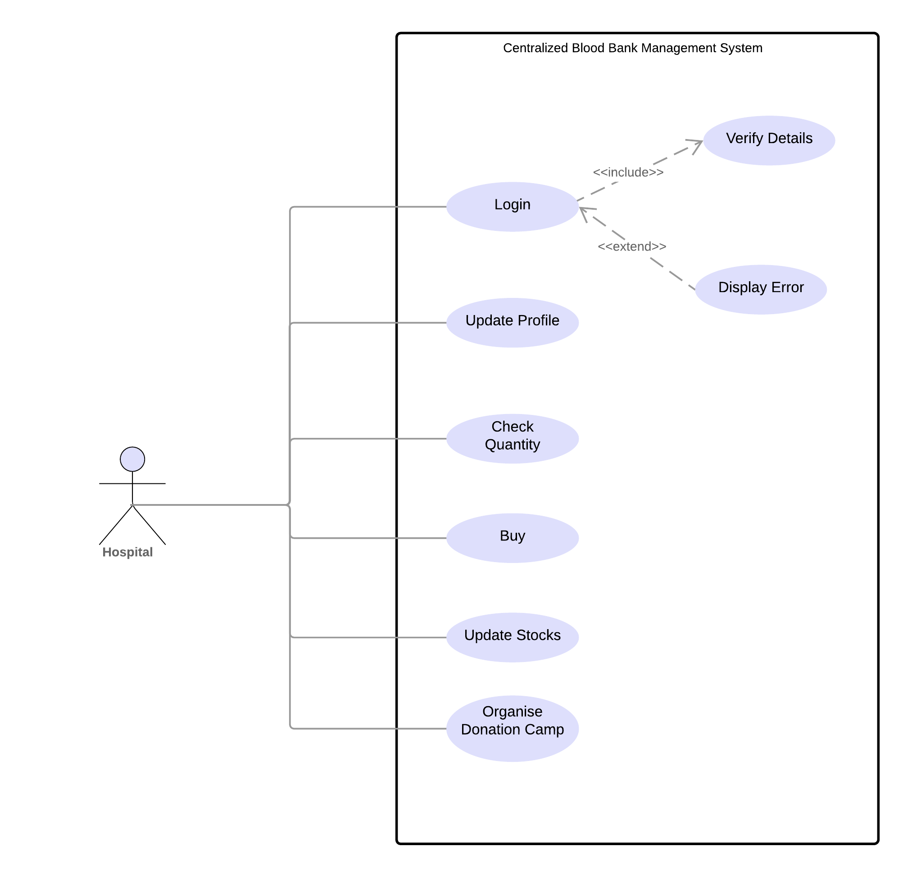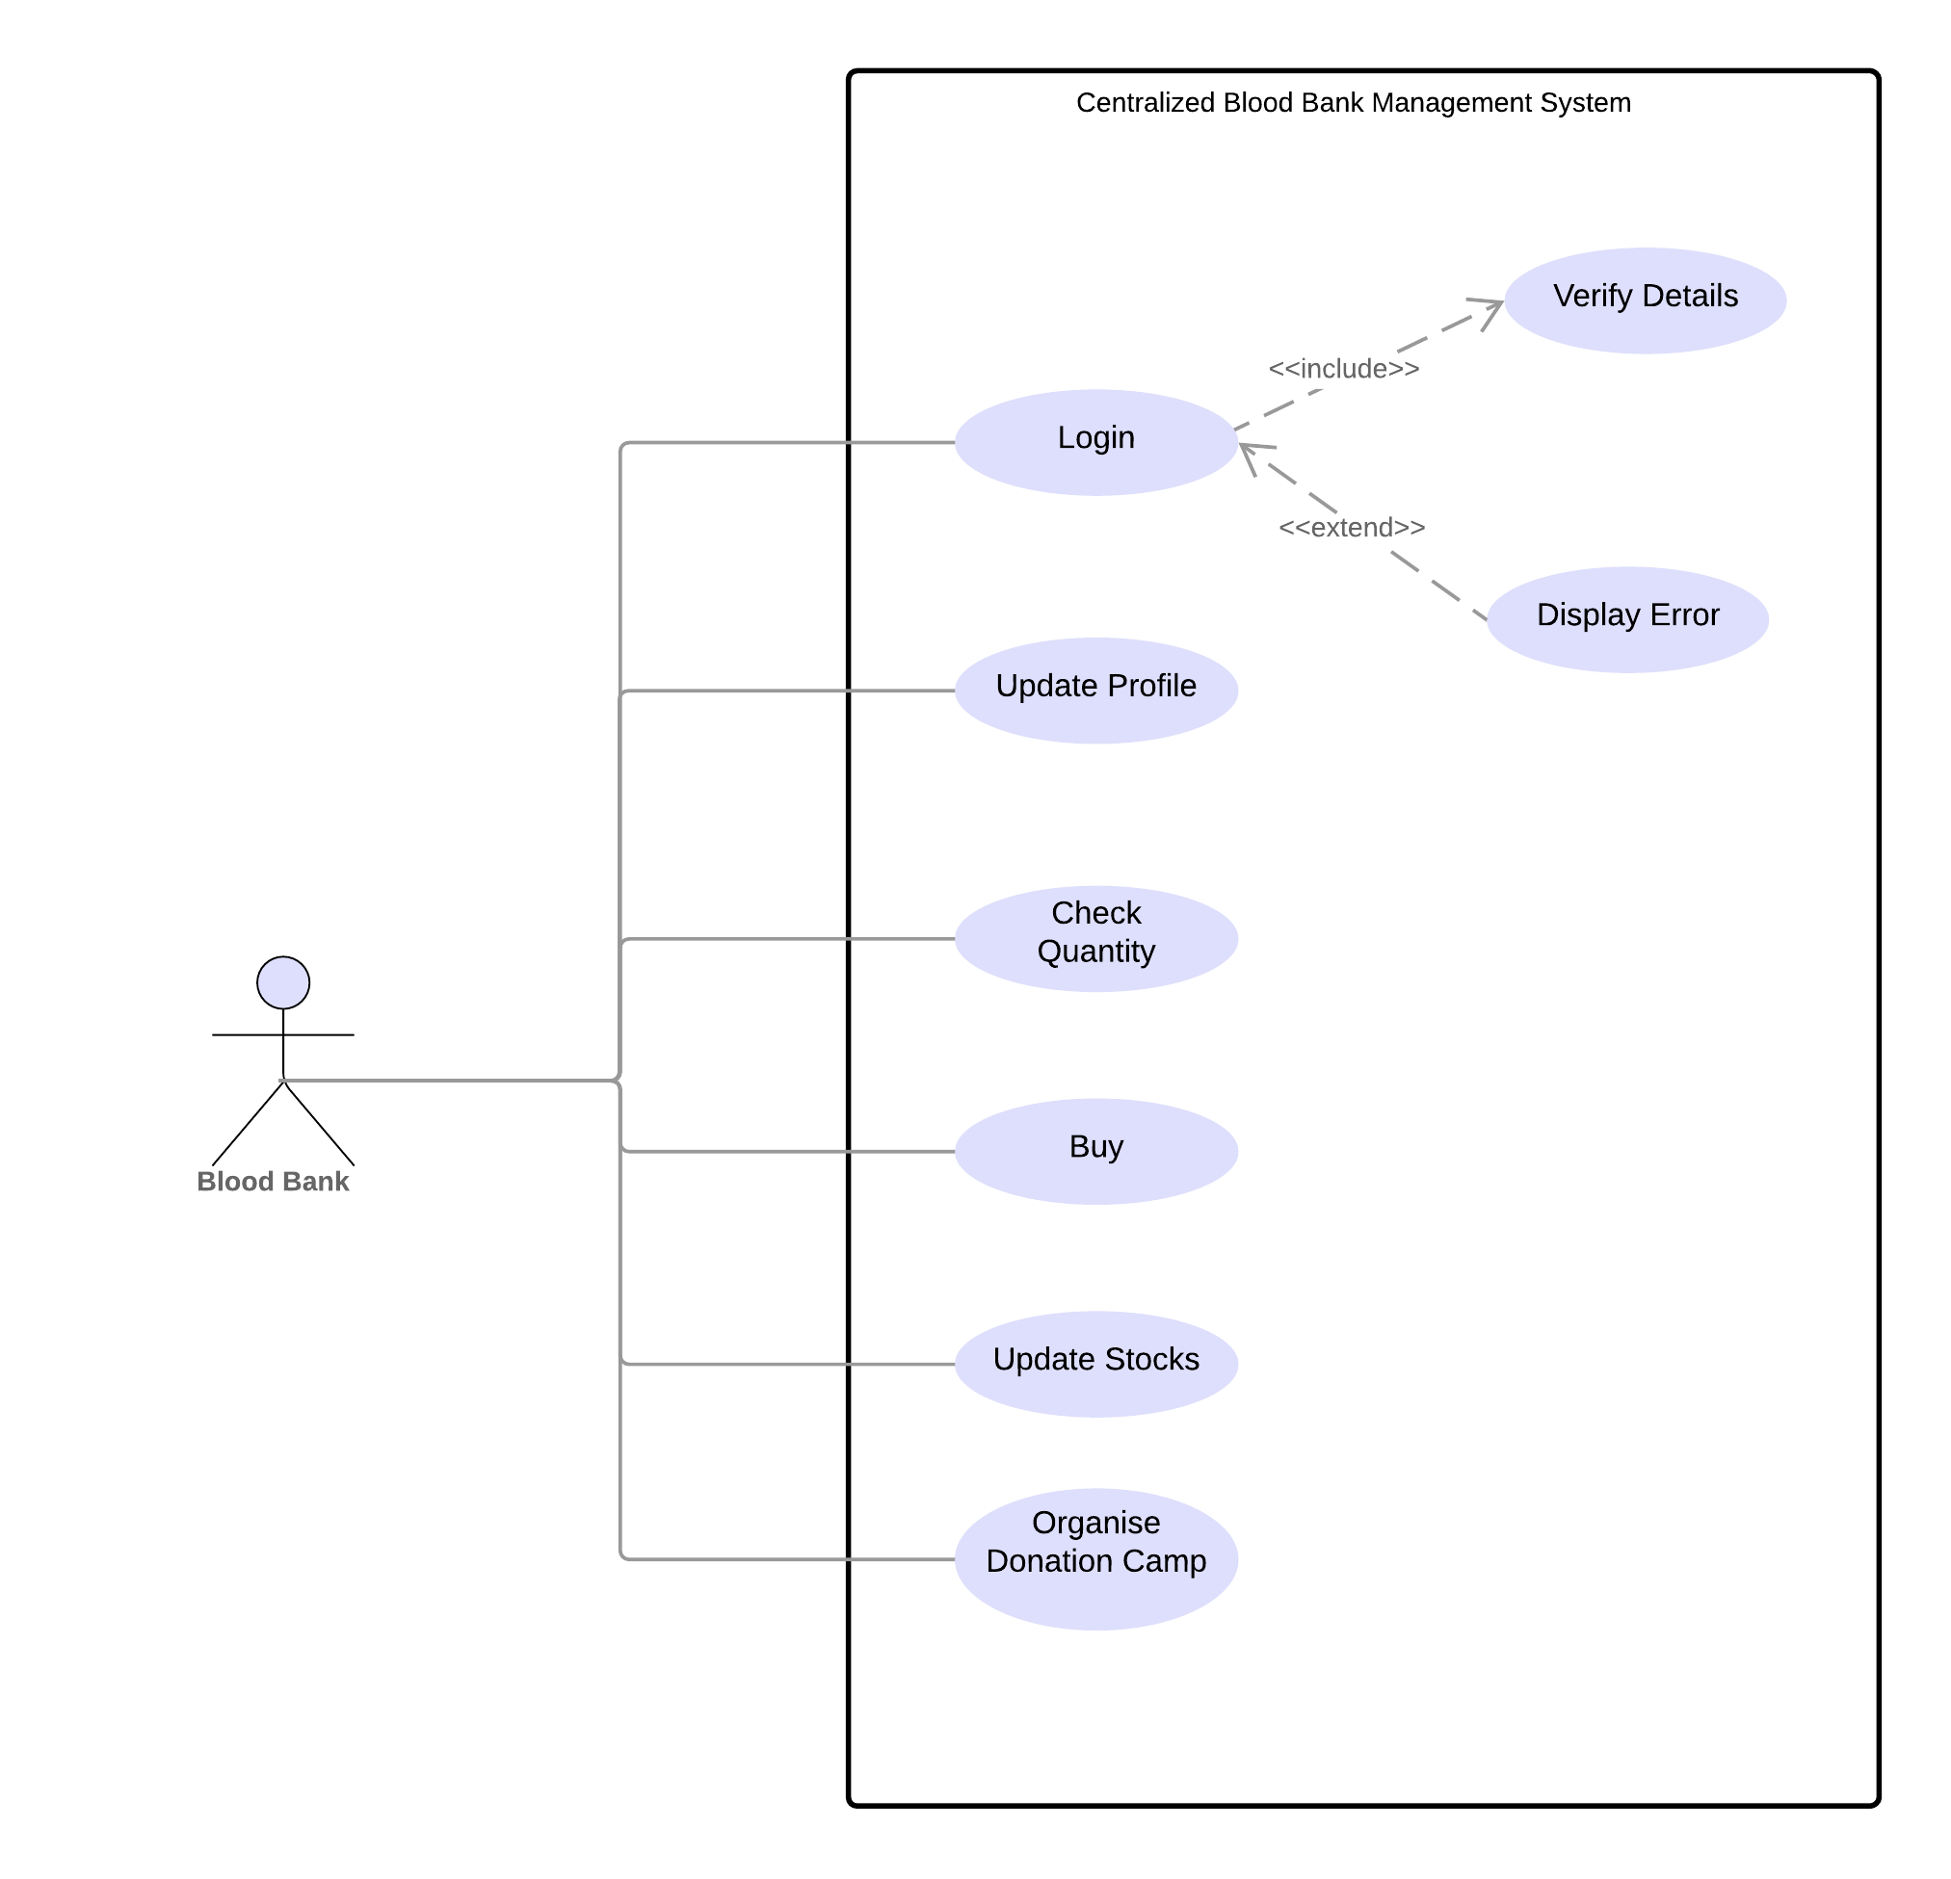

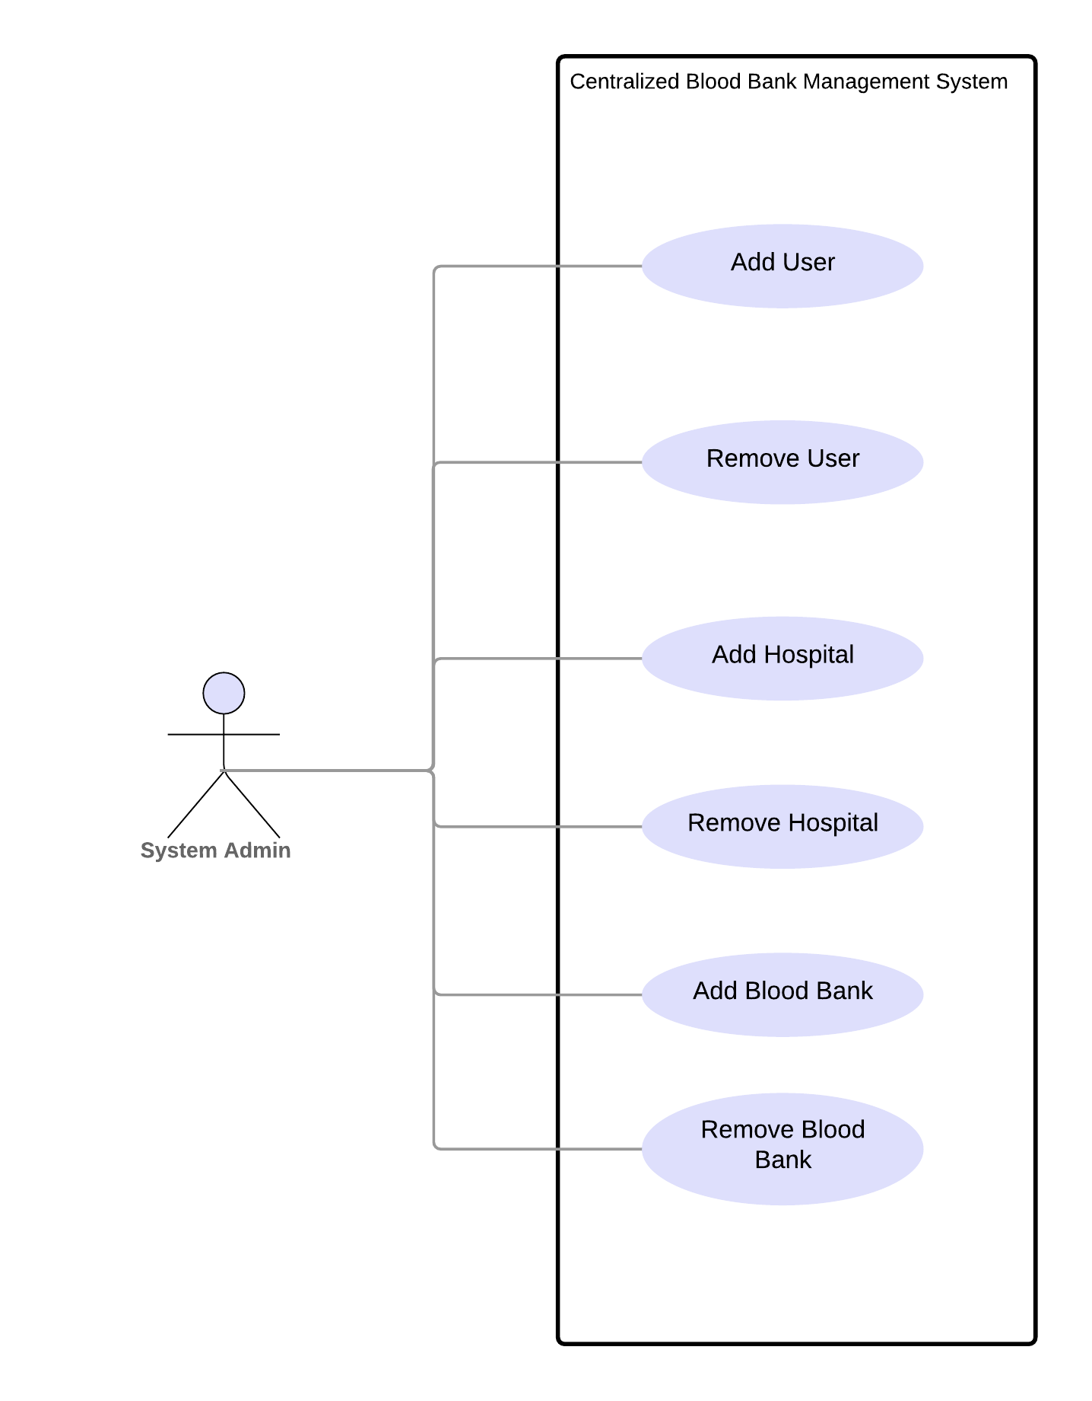

**ARCHITECTURE DIAGRAM**

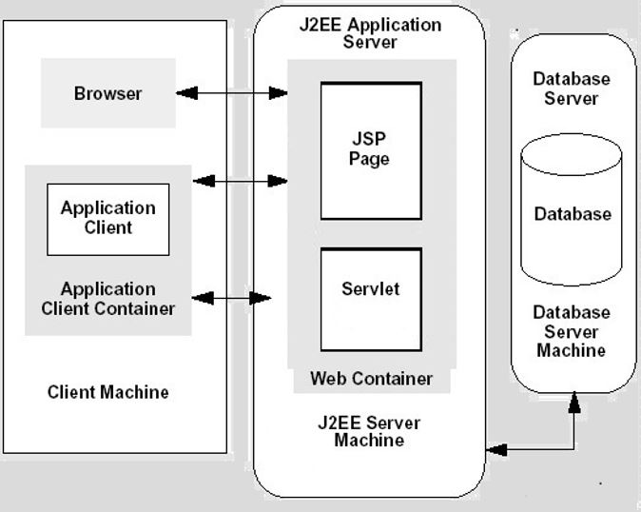

**SCHEDULE, TIMELINE AND DEADLINES**:-

|  |  |  |  |
| --- | --- | --- | --- |
| **Milestones** | **Description** | **Release Date** | **Release Iteration** |
| M1 | Documentation(SRS, BRD, etc.) | 15/01/2019 | R1 |
| M2 | Database Creation and Testing | 19/01/2019 | R1 |
| M3 | Coding | 25/01/2019 | R1 |
| M4 | Testing | 27/01/2019 | R2 |
| M5 | Final Release | 28/01/2019 | R2 |

**DELIVERABLES**

We will deliver the following during the course of development:

* Feature specification
* Product design
* Test plan
* Development document
* Source code