**Courier Management System SQL Assignment(4) Hexaware**

**Rishab H (J514) (Java Training (Batch 5))**

**Task 1: Database Design**

**ER Diagram**

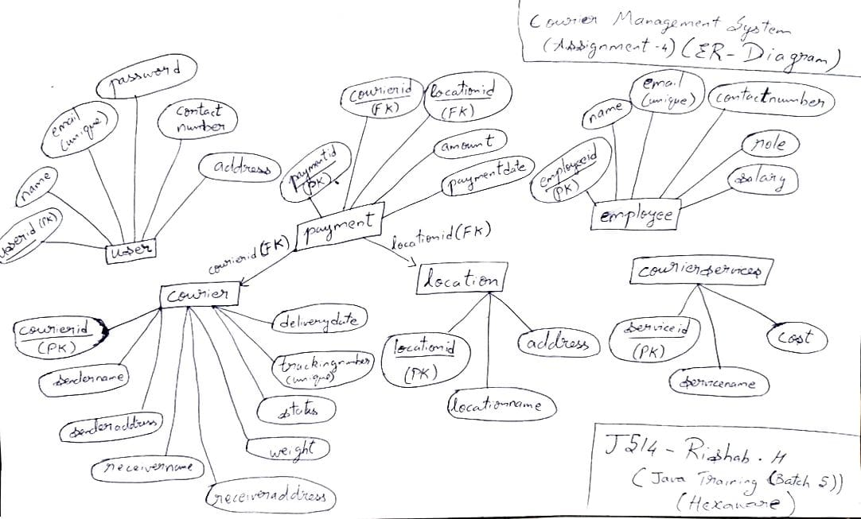

**Create tables:**

create table user (

userid int primary key auto_increment,

name varchar(25) not null,

email varchar(20) unique not null,

password varchar(20) not null,

contactnumber varchar(20) not null,

address varchar(75) not null

);

create table courier (

courierid int primary key auto_increment,

sendername varchar(25) not null,

senderaddress varchar(75) not null,

receivername varchar(25) not null,

receiveraddress varchar(75) not null,

weight decimal(5,2) not null,

status varchar(20) not null,

trackingnumber varchar(20) unique not null,

deliverydate date

);

create table courierservices (

serviceid int primary key auto_increment,

servicename varchar(75) not null,

cost decimal(8,2) not null

);

create table employee (

employeeid int primary key auto_increment,

name varchar(25) not null,

email varchar(25) unique not null,

contactnumber varchar(20) not null,

role varchar(25) not null,

salary decimal(10,2) not null

);

create table location (

locationid int primary key auto_increment,

locationname varchar(25) not null,

address varchar(75) not null

);

create table payment (

paymentid int primary key auto_increment,

courierid int not null,

locationid int not null,

amount decimal(10,2) not null,

paymentdate date not null,

foreign key (courierid) references courier(courierid),

foreign key (locationid) references location(locationid)

);

**Insert sample data:**

**user table:**

insert into user (name, email, password, contactnumber, address) values

('alice smith', 'alice@example.com', 'pass123', '1234567890', '123 main street'),

('bob johnson', 'bob@example.com', 'securepass', '0987654321', '456 park avenue');

**courier table:**

insert into courier (sendername, senderaddress, receivername, receiveraddress, weight, status, trackingnumber, deliverydate) values

('alice smith', '123 main street', 'bob johnson', '456 park avenue', 2.50, 'in transit', 'TRACK123', '2025-03-21'),

('bob johnson', '456 park avenue', 'charlie brown', '789 broadway', 5.00, 'delivered', 'TRACK456', '2025-03-15');

**courierservices table:**

insert into courierservices (servicename, cost) values

('standard delivery', 10.00),

('express delivery', 25.00);

**employee table:**

insert into employee (name, email, contactnumber, role, salary) values

('john doe', 'john@example.com', '1112223333', 'delivery driver', 35000.00),

('jane smith', 'jane@example.com', '4445556666', 'customer support', 30000.00);

**location table:**

insert into location (locationname, address) values

('warehouse a', '100 industrial road'),

('warehouse b', '200 logistics street');

**payment table:**

insert into payment (courierid, locationid, amount, paymentdate) values

(1, 1, 50.00, '2025-03-18'),

(2, 2, 30.00, '2025-03-16');

**Task 2: Select,Where**

1.] select * from user;

2.] select * from courier where receivername = 'abc';

3.] select * from courier;

4.] select * from courier where courierid = '101';

5.] select * from courier where courierid = '100';

6.] select * from courier where status != 'delivered';

7.] select * from courier where deliverydate = current_date;

8.] select * from courier where status = 'out for delivery';

9.] select courierid, count(*) as total_packages from courier group by courierid;

10.] select p.courierid, (select avg(datediff(c.deliverydate, p.paymentdate)) from payment p where p.courierid = c.courierid) as avg_delivery_time from courier c;

11.] select * from courier where weight between 5 and 10;

12.] select * from employee where name like '%john%';

13.] select * from payment where amount > 50;

**Task 3: GroupBy, Aggregate Functions, Having, Order By, where**

14.] /* Not possible to determine with given tables as no relationship exists between employee table and courier table */

15.] select locationid, sum(amount) as total_revenue from payment group by locationid;

16.] select locationid, count(courierid) as total_deliveries from payment group by locationid;

17.] select courierid, avg(datediff(deliverydate, paymentdate)) as avg_delivery_time from payment group by courierid order by avg_delivery_time limit 1;

18.] select locationid, sum(amount) as total_payments from payment group by locationid having total_payments < 5000;

19.] select locationid, sum(amount) as total_payments from payment group by locationid;

20.] select courierid, sum(amount) as total_payments from payment where locationid = X group by courierid having total_payments > 1000;

21.] select courierid, sum(amount) as total_payments from payment where paymentdate > '2025-03-21' group by courierid having total_payments > 1000;

22.] select locationid, sum(amount) as total_received from payment where paymentdate < '2025-03-21' group by locationid having total_received > 5000;

**Task 4: Inner Join,Full Outer Join, Cross Join, Left Outer Join,Right Outer Join**

23.] select p.*, c.* from payment p inner join courier c on p.courierid = c.courierid;

24.] select p.*, l.* from payment p inner join location l on p.locationid = l.locationid;

25.] select p.*, c.*, l.* from payment p inner join courier c on p.courierid = c.courierid inner join location l on p.locationid = l.locationid;

26.] select p.*, c.* from payment p inner join courier c on p.courierid = c.courierid;

27.] select courierid, sum(amount) as total_payments from payment group by courierid;

28.] select * from payment where paymentdate = '2025-03-21';

29.] select p.*, c.* from payment p inner join courier c on p.courierid = c.courierid;

30.] select p.*, l.* from payment p inner join location l on p.locationid = l.locationid;

31.] select courierid, sum(amount) as total_payments from payment group by courierid;

32.] select * from payment where paymentdate between '2025-03-10' and '2025-03-21';

33.] select u.*, c.* from user u left join courier c on u.userid = c.courierid union select u.*, c.* from user u right join courier c on u.userid = c.courierid;

34.] select c.*, cs.* from courier c left join courierservices cs on c.courierid = cs.serviceid union select c.*, cs.* from courier c right join courierservices cs on c.courierid = cs.serviceid;

35.] select e.*, p.* from employee e left join payment p on e.employeeid = p.paymentid union select e.*, p.* from employee e right join payment p on e.employeeid = p.paymentid;

36.] select * from user cross join courierservices;

37.] select * from employee cross join location;

38.] select c.*, u.name as sender_name, u.address as sender_address from courier c left join user u on c.sendername = u.name;

39.] select c.*, u.name as receiver_name, u.address as receiver_address from courier c left join user u on c.receivername = u.name;

40.] select c.*, cs.* from courier c left join courierservices cs on c.courierid = cs.serviceid;

41.] /* Not possible to determine with given tables as no relationship exists between employee table and courier table */

42.] select locationname, sum(amount) as total_revenue from payment group by locationid;

43.] select * from courier where sendername in (select sendername from courier group by sendername having count(*) > 1);

44.] select employeeid, name from employee where role in (select role from employee group by role having count(*) > 1);

45.] select * from payment where courierid in (select courierid from courier group by senderaddress having count(*) > 1);

46.] select * from courier where senderaddress in (select senderaddress from courier group by senderaddress having count(*) > 1);

47.] /* Not possible to determine with given tables as no relationship exists between employee table and courier table */

48.] select p.courierid, p.amount, cs.cost from payment p inner join courierservices cs on p.courierid = cs.serviceid where p.amount > cs.cost;

**Scope: Inner Queries, Non Equi Joins, Equi joins,Exist,Any,All**

49.] select * from courier where weight > (select avg(weight) from courier);

50.] select name from employee where salary > (select avg(salary) from employee);

51.] select sum(cost) from courierservices where cost < (select max(cost) from courierservices);

52.] select * from courier where courierid in (select courierid from payment);

53.] select locationid, locationname from location where locationid in (select locationid from payment where amount = (select max(amount) from payment));

54.] select * from courier where weight > (select max(weight) from courier where sendername = 'alice smith');