**SQL Coding Assessment (Car Rental System)**

**J514 - Rishab H (Hexaware Java Training (Batch 5))**

**Table Creation:**

create database hexaware;

use hexaware;

create table vehicle (

carid int primary key,

make varchar(50),

model varchar(50),

year int,

dailyrate decimal(10, 2),

available int,

passengercapacity int,

enginecapacity int

);

create table customer (

customerid int primary key,

firstname varchar(50),

lastname varchar(50),

email varchar(100),

phonenumber varchar(15)

);

create table lease (

leaseid int primary key,

carid int references vehicle(carid),

customerid int references customer(customerid),

startdate date,

enddate date,

leasetype varchar(15)

);

create table payment (

paymentid int primary key,

leaseid int references lease(leaseid),

paymentdate date,

amount decimal(10, 2)

);

show tables;

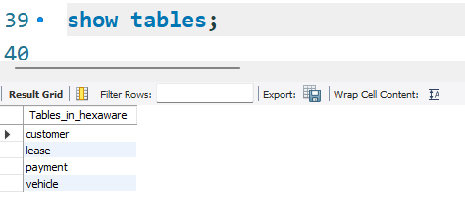

**Values insertion:**

insert into vehicle values

(1, 'toyota', 'camry', 2022, 50.00, 1, 4, 1450),

(2, 'honda', 'civic', 2023, 45.00, 1, 7, 1500),

(3, 'ford', 'focus', 2022, 48.00, 0, 4, 1400),

(4, 'nissan', 'altima', 2023, 52.00, 1, 7, 1200),

(5, 'chevrolet', 'malibu', 2022, 47.00, 1, 4, 1800),

(6, 'hyundai', 'sonata', 2023, 49.00, 0, 7, 1400),

(7, 'bmw', '3 series', 2023, 60.00, 1, 7, 2499),

(8, 'mercedes', 'c-class', 2022, 58.00, 1, 8, 2599),

(9, 'audi', 'a4', 2022, 55.00, 0, 4, 2500),

(10, 'lexus', 'es', 2023, 54.00, 1, 4, 2500);

select * from vehicle;

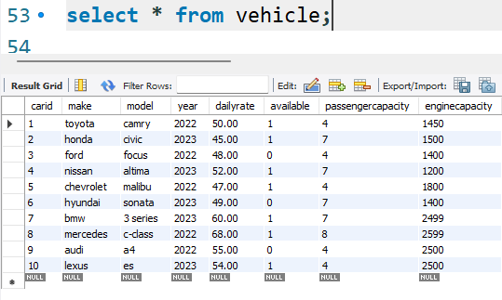

insert into customer values

(1, 'john', 'doe', 'johndoe@example.com', '555-555-5555'),

(2, 'jane', 'smith', 'janesmith@example.com', '555-123-4567'),

(3, 'robert', 'johnson', 'robert@example.com', '555-789-1234'),

(4, 'sarah', 'brown', 'sarah@example.com', '555-456-7890'),

(5, 'david', 'lee', 'david@example.com', '555-987-6543'),

(6, 'laura', 'hall', 'laura@example.com', '555-234-5678'),

(7, 'michael', 'davis', 'michael@example.com', '555-876-5432'),

(8, 'emma', 'wilson', 'emma@example.com', '555-432-1098'),

(9, 'william', 'taylor', 'william@example.com', '555-321-6547'),

(10, 'olivia', 'adams', 'olivia@example.com', '555-765-4321');

select * from customer;

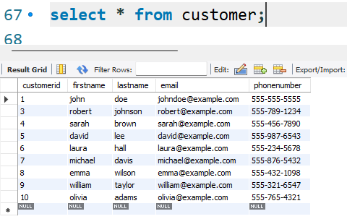

insert into lease values

(1, 1, 1, '2023-01-01', '2023-01-05', 'daily'),

(2, 2, 2, '2023-02-15', '2023-02-28', 'monthly'),

(3, 3, 3, '2023-03-10', '2023-03-15', 'daily'),

(4, 4, 4, '2023-04-20', '2023-04-30', 'monthly'),

(5, 5, 5, '2023-05-05', '2023-05-10', 'daily'),

(6, 4, 3, '2023-06-15', '2023-06-30', 'monthly'),

(7, 7, 7, '2023-07-01', '2023-07-10', 'daily'),

(8, 8, 8, '2023-08-12', '2023-08-15', 'monthly'),

(9, 3, 3, '2023-09-07', '2023-09-10', 'daily'),

(10, 10, 10, '2023-10-10', '2023-10-31', 'monthly');

select * from lease;

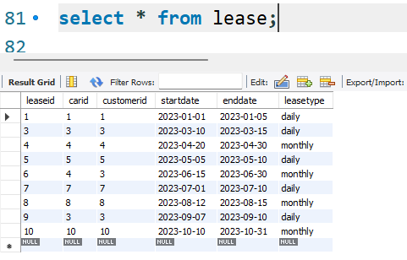

insert into payment values

(1, 1, '2023-01-03', 200.00),

(2, 2, '2023-02-20', 1000.00),

(3, 3, '2023-03-12', 75.00),

(4, 4, '2023-04-25', 900.00),

(5, 5, '2023-05-07', 60.00),

(6, 6, '2023-06-18', 1200.00),

(7, 7, '2023-07-03', 40.00),

(8, 8, '2023-08-14', 1100.00),

(9, 9, '2023-09-09', 80.00),

(10, 10, '2023-10-25', 1500.00);

select * from payment;

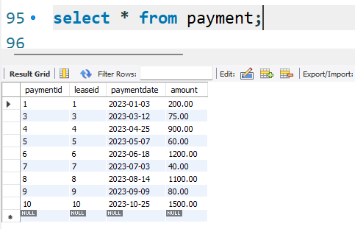

**Tasks:**

**1.] Update the daily rate for a Mercedes car to 68**

update vehicle set dailyrate = 68.00 where make = 'mercedes' and carid = 8;

select * from vehicle;

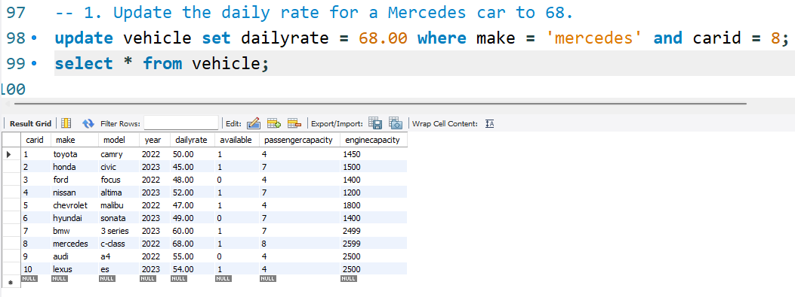

**2.] Delete a specific customer and all associated leases and payments**

delete from payment where leaseid in (select leaseid from lease where customerid = 2);

delete from lease where customerid = 2;

delete from customer where customerid = 2;

select * from payment;

select * from lease;

select * from customer;

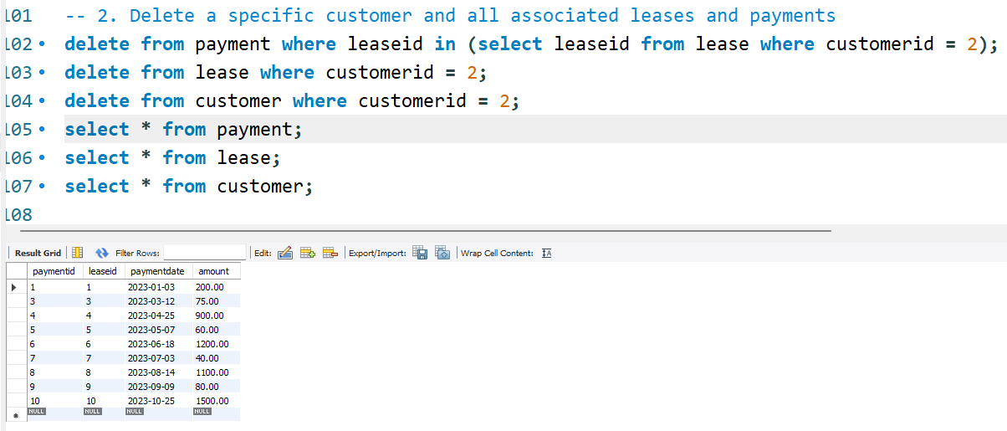

**3.] Rename the "paymentDate" column in the Payment table to "transactionDate".**

alter table payment rename column paymentdate to transactiondate;

select * from payment;

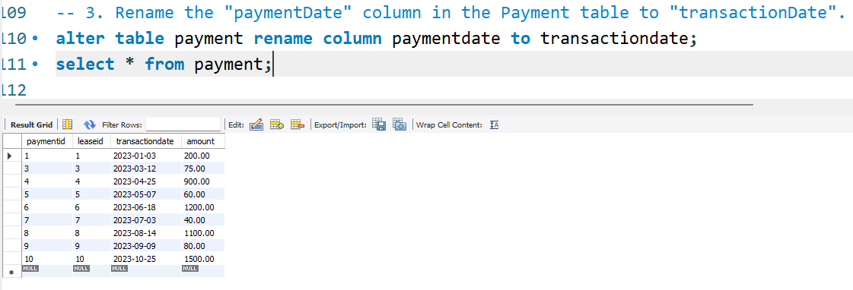

**4.] Find a specific customer by email.**

select * from customer where email = 'johndoe@example.com';

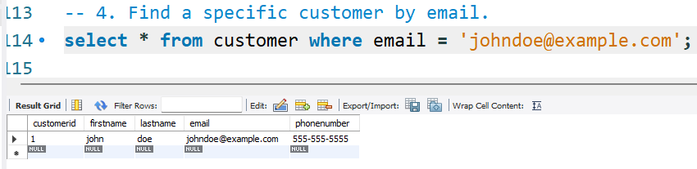

**5.] Get active leases for a specific customer**

select * from lease where customerid = 1 and enddate >= now();

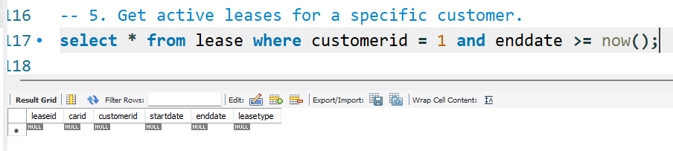

*(Output is empty because the last date of lease is ‘2023-10-31’ but current date is ‘2025-03-25’, so no active leases)*

**6.] Find all payments made by a customer with a specific phone number**

select p.* from payment p

inner join lease l on p.leaseid = l.leaseid

inner join customer c on l.customerid = c.customerid

where c.phonenumber = '555-555-5555';

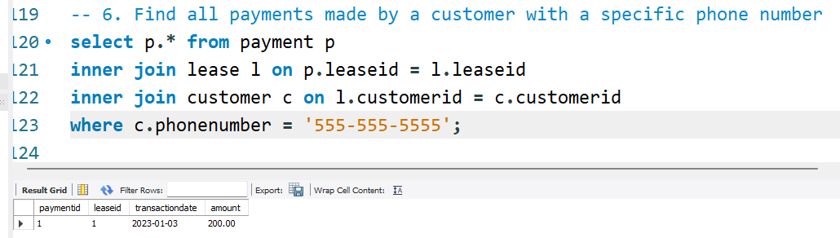

**7.] Calculate the average daily rate of all available cars**

select avg(dailyrate) as avg_rate from vehicle where available = 1;

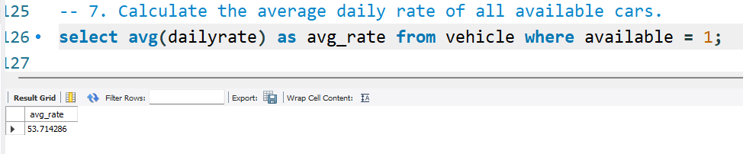

**8.] Find the car with the highest daily rate.**

select * from vehicle where dailyrate = (select max(dailyrate) from vehicle);

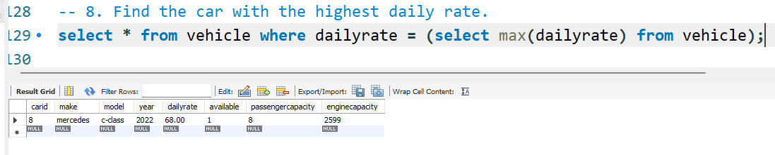

**9.] Retrieve all cars leased by a specific customer.**

select v.* from vehicle v inner join lease l on v.carid = l.carid where l.customerid = 1;

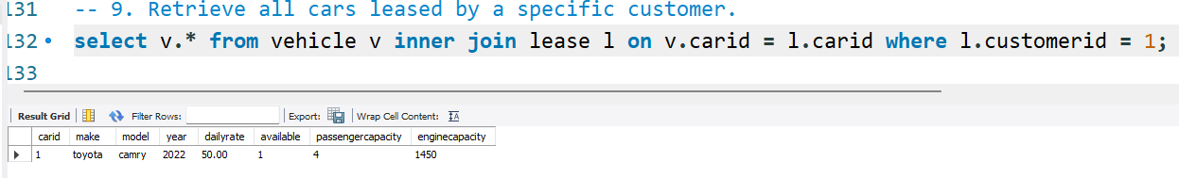

**10.] Find the details of the most recent lease.**

select * from lease order by enddate desc limit 1;

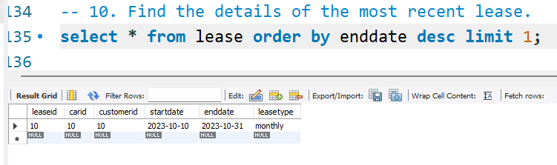

**11.] List all payments made in the year 2023.**

select * from payment where year(transactiondate) = 2023;

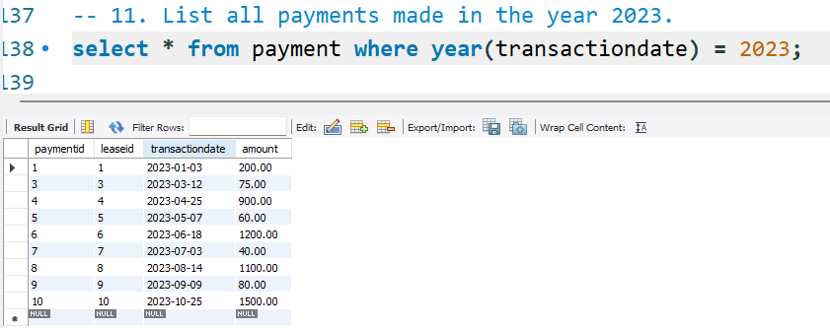

**12.] Retrieve customers who have not made any payments.**

select * from customer

where customerid not in

(select l.customerid from lease l inner join payment p on l.leaseid = p.leaseid);

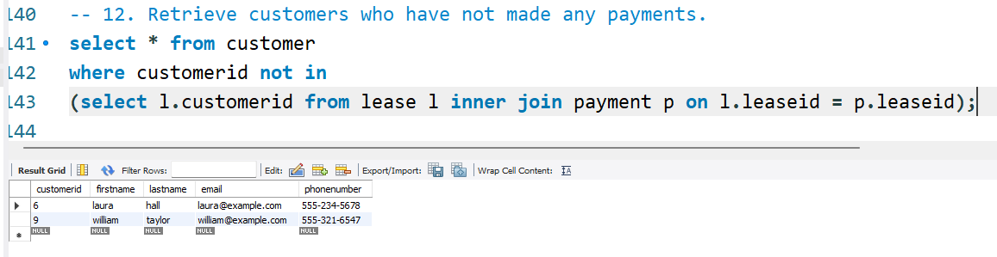

**13.] Retrieve Car Details and Their Total Payments.**

select v.*, sum(p.amount) as total_payments

from vehicle v

inner join lease l on v.carid = l.carid

inner join payment p on l.leaseid = p.leaseid

group by v.carid;

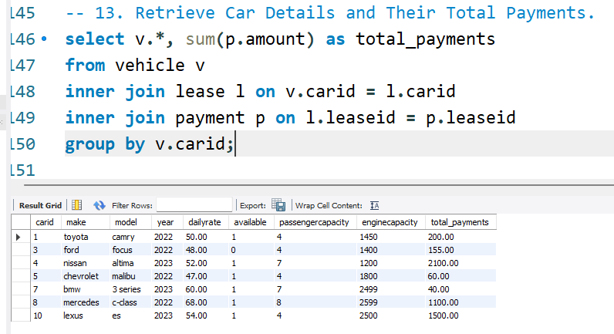

**14.] Calculate Total Payments for Each Customer.**

select c.*, sum(p.amount) as total_payments

from customer c

inner join lease l on c.customerid = l.customerid

inner join payment p on l.leaseid = p.leaseid

group by c.customerid;

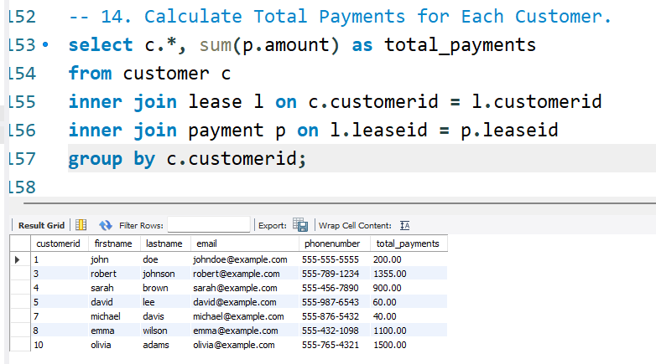

**15.] List Car Details for Each Lease.**

select v.*, l.* from vehicle v inner join lease l on v.carid = l.carid;

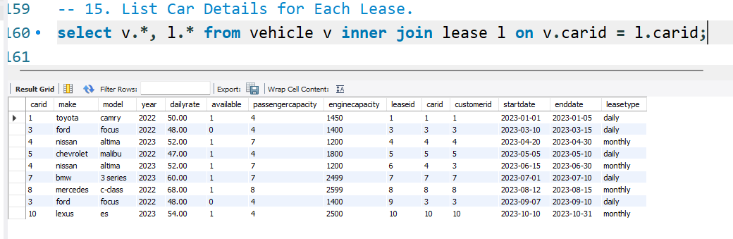

**16.] Retrieve Details of Active Leases with Customer and Car Information.**

select l.*, c.*, v.* from lease l

inner join customer c on l.customerid = c.customerid

inner join vehicle v on l.carid = v.carid

where l.enddate >= now();

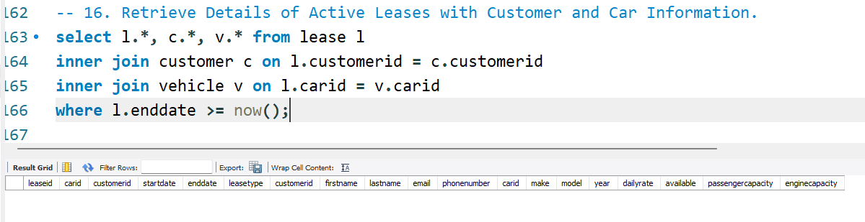

*(Output is empty because the last date of lease is ‘2023-10-31’ but current date is ‘2025-03-25’, so no active leases)*

**17.] Find the Customer Who Has Spent the Most on Leases.**

select c.*, sum(p.amount) as total_spent

from customer c

inner join lease l on c.customerid = l.customerid

inner join payment p on l.leaseid = p.leaseid

group by c.customerid

order by total_spent desc limit 1;

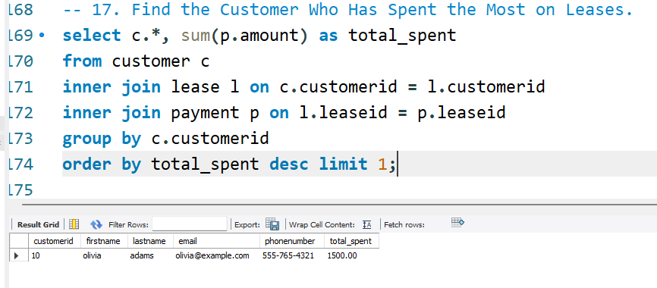

**18.] List All Cars with Their Current Lease Information**

select v.*, l.* from vehicle v left join lease l on v.carid = l.carid and l.enddate >= now();

