1. Write a java program to print a label by taking inputs from the user.

**Code:**

import java.util.Scanner;

class Label {

public static void main(String[] args) {

Scanner sc = new Scanner(System.in);

String name, sec, sub;

int roll, c;

System.out.println("Enter your name: ");

name = sc.nextLine();

System.out.println("Enter your class: ");

c = sc.nextInt();

sc.nextLine();

System.out.println("Enter your section: ");

sec = sc.nextLine();

System.out.println("Enter your Roll number: ");

roll = sc.nextInt();

sc.nextLine();

System.out.println("Enter your subject: ");

sub = sc.nextLine();

System.out.println("\tLABEL");

System.out.println("Name: " + name);

System.out.println("Class: " + c);

System.out.println("Section: " + sec);

System.out.println("Roll no: " + roll);

System.out.println("Subject: " + sub);

sc.close();

}

}

**Output:**

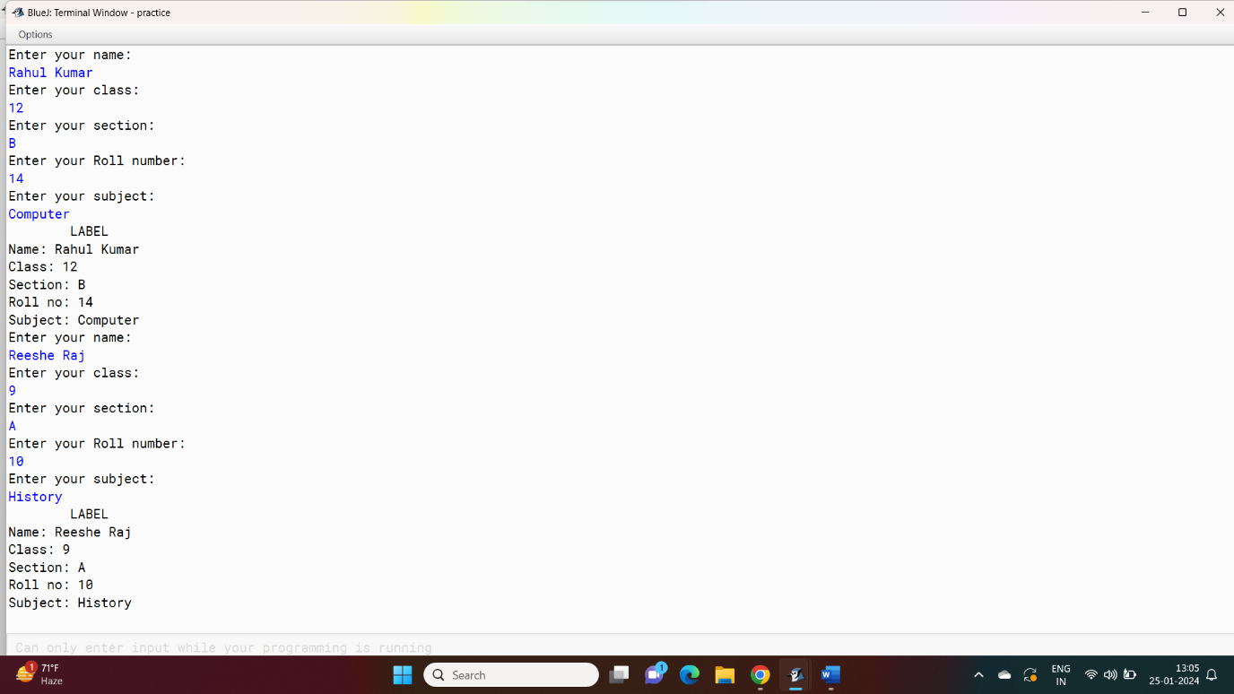

**Variable description chart:**

|  |  |  |
| --- | --- | --- |
| Name | Purpose | Type |
| name | To store the name of the student | String |
| sec | To store the section of the student in which he studies | String |
| sub | To store the subject | String |
| c | To store the class in which the student is studying | Int |
| roll | To store the roll number of the student | int |

1. Write a java program to print the time table of a class.

**Code:**

import java.util.Scanner;

public class ClassTimeTable {

public static void main(String[] args) {

Scanner scanner = new Scanner(System.in);

System.out.println("\tClass 9 Weekly Time Table");

System.out.print("Monday:\t");

printSubject("Maths");

printSubject("Hindi");

printBreak();

printSubject("English");

printSubject("History");

printSubject("Geography");

System.out.println();

System.out.print("Tuesday:");

printSubject("Physics");

printSubject("Chemistry");

printBreak();

printSubject("Biology");

printSubject("Games");

System.out.println();

System.out.print("Wednesday:");

printSubject("Maths");

printSubject("Hindi");

printBreak();

printSubject("English");

printSubject("History");

printSubject("Geography");

System.out.println();

System.out.print("Thursday:");

printSubject("Physics");

printSubject("Chemistry");

printBreak();

printSubject("Biology");

printSubject("Games");

System.out.println();

System.out.print("Friday:\t");

printSubject("Maths");

printSubject("Hindi");

printBreak();

printSubject("English");

printSubject("History");

printSubject("Geography");

System.out.println();

scanner.close();

}

private static void printSubject(String subject) {

System.out.print("\t" + subject);

}

private static void printBreak() {

System.out.print(" -- Break (30 minutes) -- ");

}

}

**Output:**

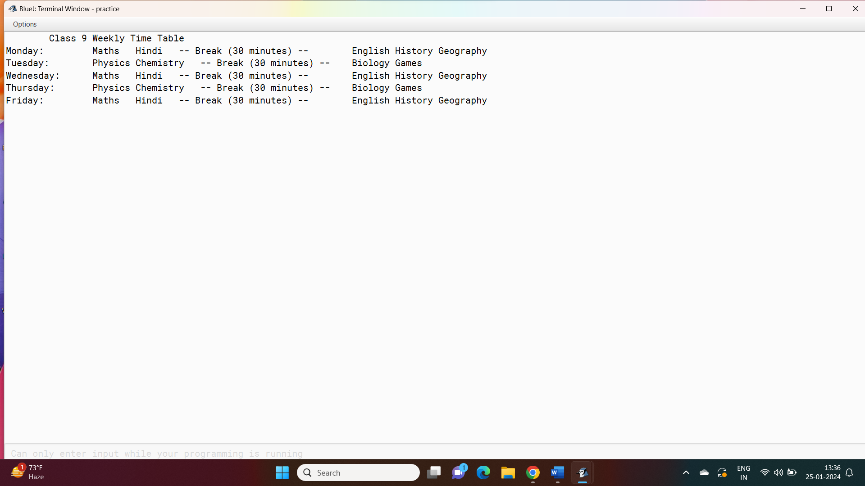

**Variable Description chart:**

no such variable are used for this program.

1. Write a java program using scanner class to show the use of different types of operators.

**Code:**

import java.util.Scanner;

public class OperatorExample {

public static void main(String[] args) {

Scanner scanner = new Scanner(System.in);

System.out.print("Enter the first number: ");

int num1 = scanner.nextInt();

System.out.print("Enter the second number: ");

int num2 = scanner.nextInt();

int sum = num1 + num2;

int difference = num1 - num2;

int product = num1 * num2;

int quotient = num1 / num2;

int remainder = num1 % num2;

System.out.println("Arithmetic Operators:");

System.out.println("Sum: " + sum);

System.out.println("Difference: " + difference);

System.out.println("Product: " + product);

System.out.println("Quotient: " + quotient);

System.out.println("Remainder: " + remainder);

System.out.print("Enter a number to compare: ");

int compareNum = scanner.nextInt();

System.out.println("Relational Operators:");

System.out.println(num1 + " > " + compareNum + ": " + (num1 > compareNum));

System.out.println(num1 + " < " + compareNum + ": " + (num1 < compareNum));

System.out.println(num1 + " == " + compareNum + ": " + (num1 == compareNum));

System.out.println(num1 + " != " + compareNum + ": " + (num1 != compareNum));

System.out.print("Enter a boolean value (true or false): ");

boolean boolValue = scanner.nextBoolean();

System.out.println("Logical Operators:");

System.out.println("!(NOT) " + boolValue + ": " + !boolValue);

System.out.println(num1 + " > 0 && " + num2 + " < 10: " + (num1 > 0 && num2 < 10));

System.out.println(num1 + " < 0 || " + num2 + " > 10: " + (num1 < 0 || num2 > 10));

scanner.close();

}

}

**Variable description chart:**

|  |  |  |
| --- | --- | --- |
| Name | Purpose | Type |
| num1 | To store the first number | Int |
| num2 | To store the second number | Int |
| compareNum | To store a number for comparison in relational operators | Int |
| boolValue | To store a Boolean value (ture or false) | Boolean |

**Output:**

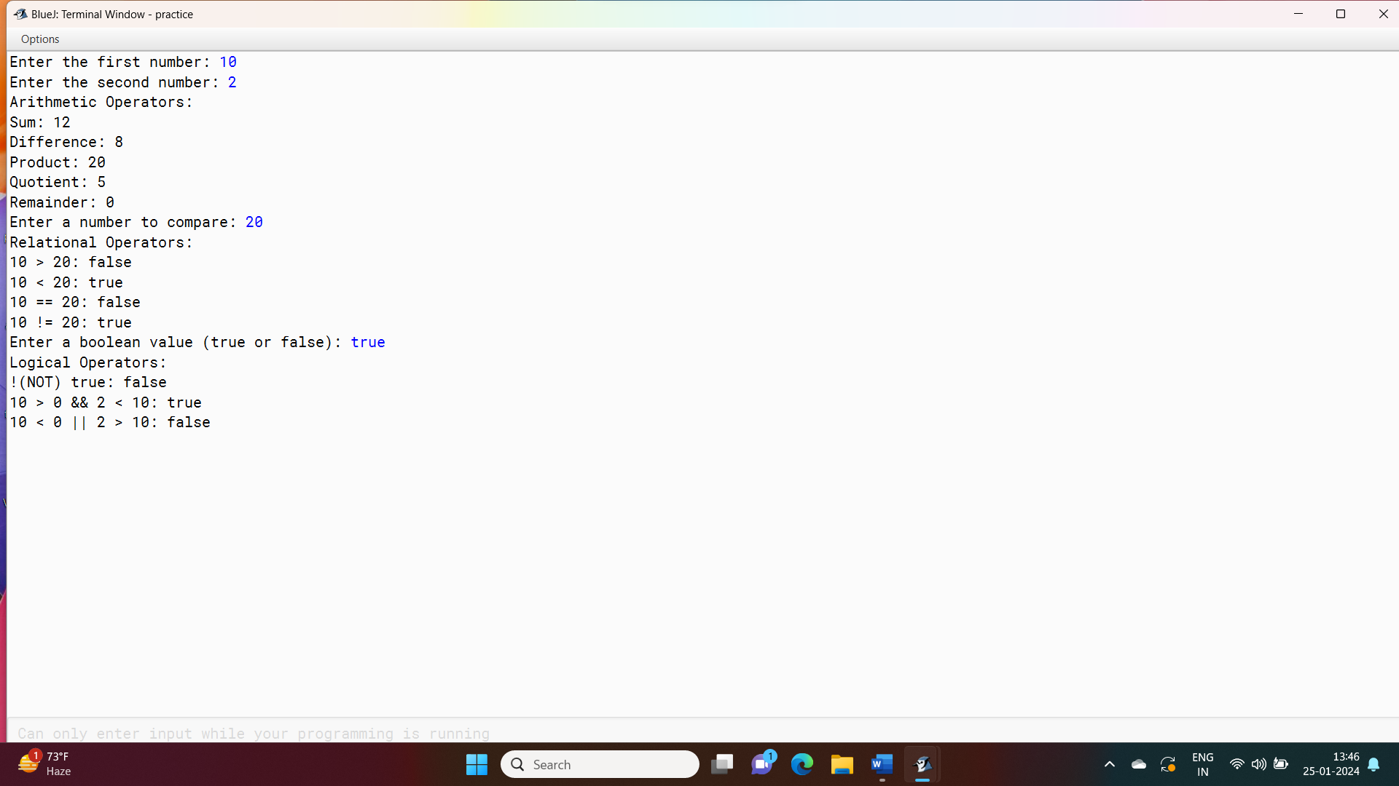

1. Write a java program to show the use of mathematical function math.pow() & math.sqrt().

**Code:**

import java.util.Scanner;

public class MathDemo {

public static void main(String[] args) {

Scanner scanner = new Scanner(System.in);

System.out.print("Enter a base number: ");

double base = scanner.nextDouble();

System.out.print("Enter an exponent: ");

double exponent = scanner.nextDouble();

double resultPower = Math.pow(base, exponent);

System.out.println("Result of " + base + " raised to the power of " + exponent + " is: " + resultPower);

System.out.print("Enter a number to find its square root: ");

double number = scanner.nextDouble();

double resultSqrt = Math.sqrt(number);

System.out.println("Square root of " + number + " is: " + resultSqrt);

scanner.close();

}

}

**Output:**

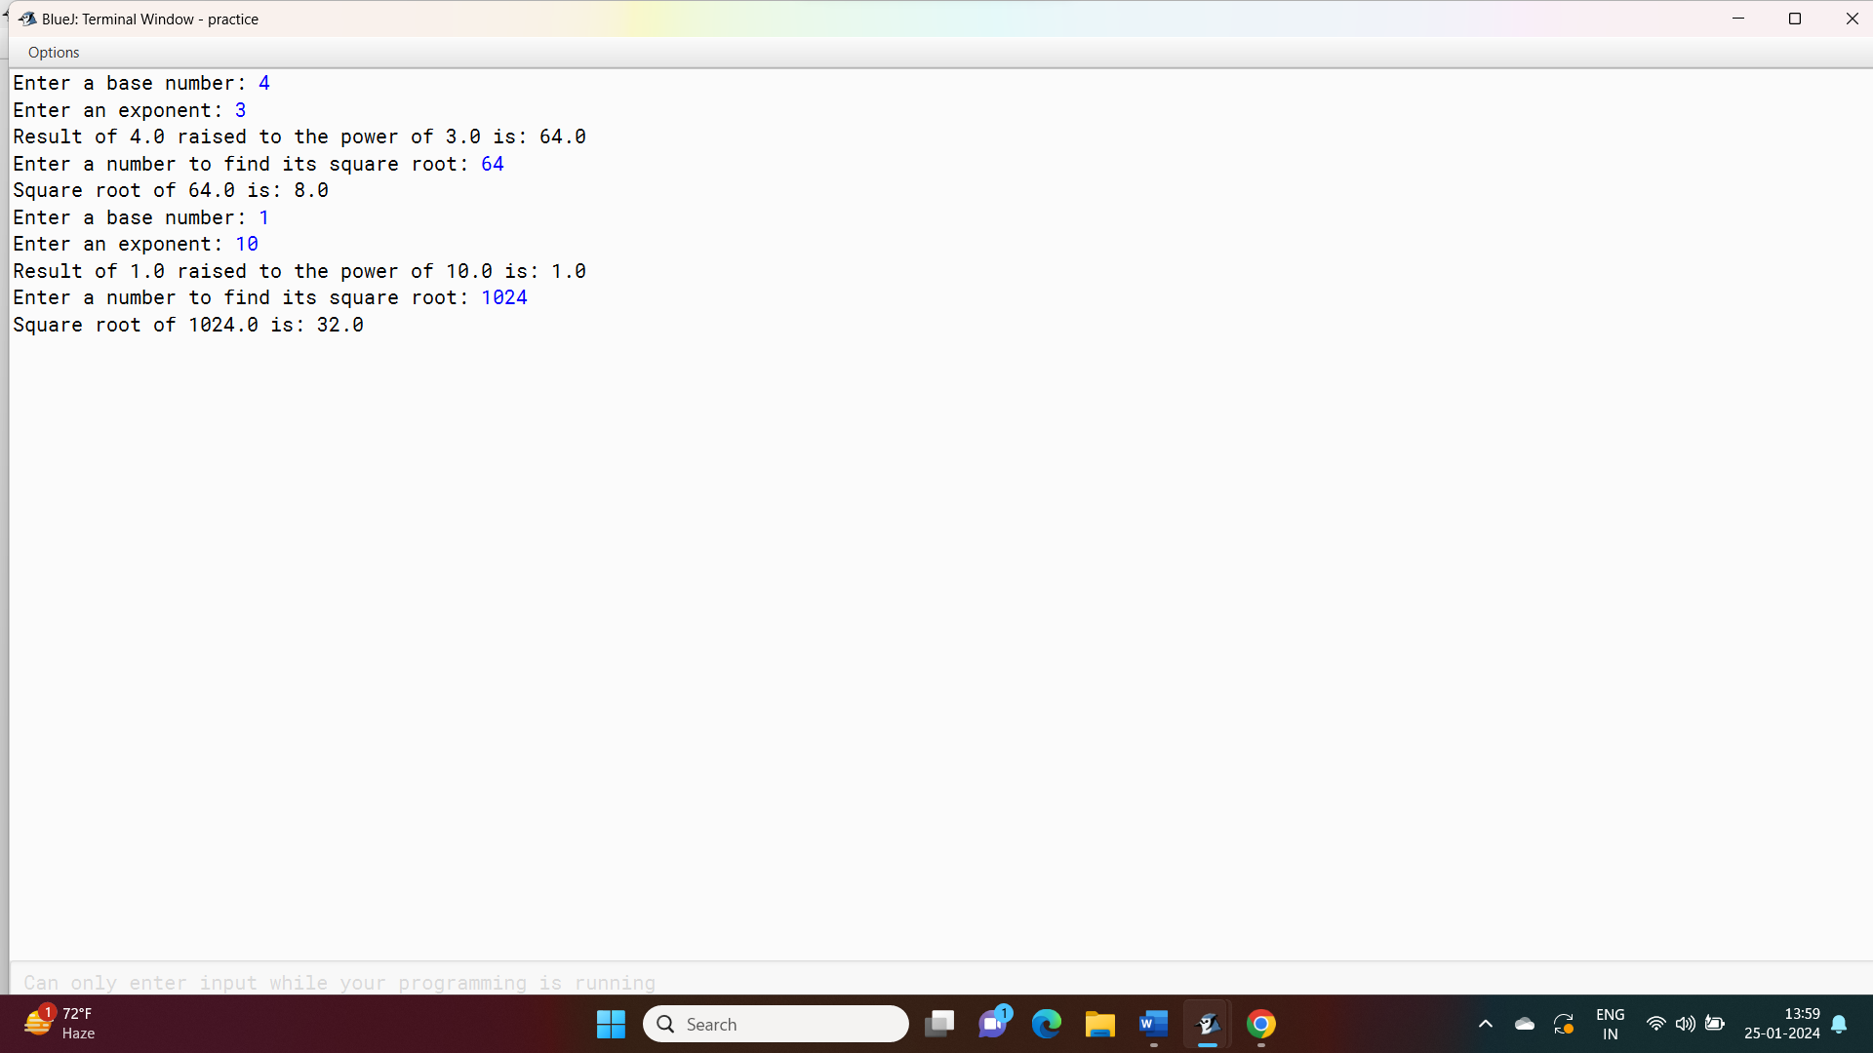

**Variable Description chart:**

|  |  |  |
| --- | --- | --- |
| Name | Purpose | Type |
| Base | To store the base number | Double |
| Exponent | To store the exponent value | Double |
| resultPower | To store the result calculated out of base and exponent | Double |
| Number | To store the number whose square root is needed | Double |
| resultSqrt | To store the result of the square root | double |

1. write a java program using scanner class to show the use of math.floor math.ciel and math.abs

**code:**

import java.util.Scanner;

public class MathFunctions {

public static void main(String[] args) {

Scanner scanner = new Scanner(System.in);

System.out.print("Enter a decimal number: ");

double inputNumber = scanner.nextDouble();

double floorResult = Math.floor(inputNumber);

System.out.println("Floor value: " + floorResult);

double ceilResult = Math.ceil(inputNumber);

System.out.println("Ceil value: " + ceilResult);

double absResult = Math.abs(inputNumber);

System.out.println("Absolute value: " + absResult);

scanner.close();

}

}

**Output:**

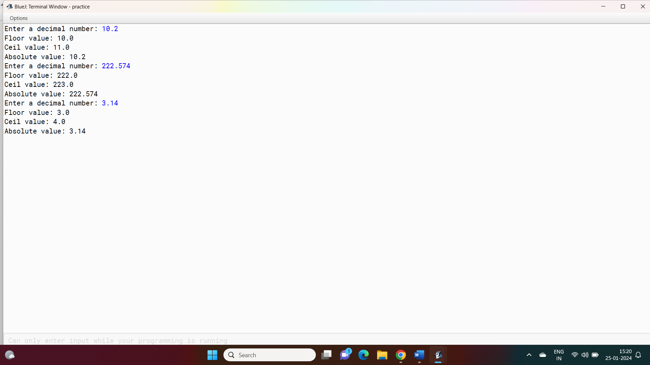

**Variable Description chart:**

|  |  |  |
| --- | --- | --- |
| Name | Purpose | Type |
| inputNumber | To store a user input decimal number. | double |

1. Write a java program using scanner class to generate a bill of taximeter using if else.

**Code:**

import java.util.Scanner;

public class TaxiMeter {

public static void main(String[] args) {

Scanner scanner = new Scanner(System.in);

System.out.print("Enter the distance traveled in kilometers: ");

double distance = scanner.nextDouble();

double initialFareINR = 50.00;

double ratePerKilometerINR = 25.00;

double totalFareINR = initialFareINR + (distance - 1) * ratePerKilometerINR;

if (distance > 10) {

totalFareINR *= 0.9;

}

System.out.println("\n----- Taxi Bill -----");

System.out.println("Distance Traveled: " + distance + " kilometers");

System.out.println("Initial Fare: ₹" + initialFareINR);

System.out.println("Fare per Kilometer: ₹" + ratePerKilometerINR);

System.out.println("Total Fare: ₹" + totalFareINR);

scanner.close();

}

}

**Output:**

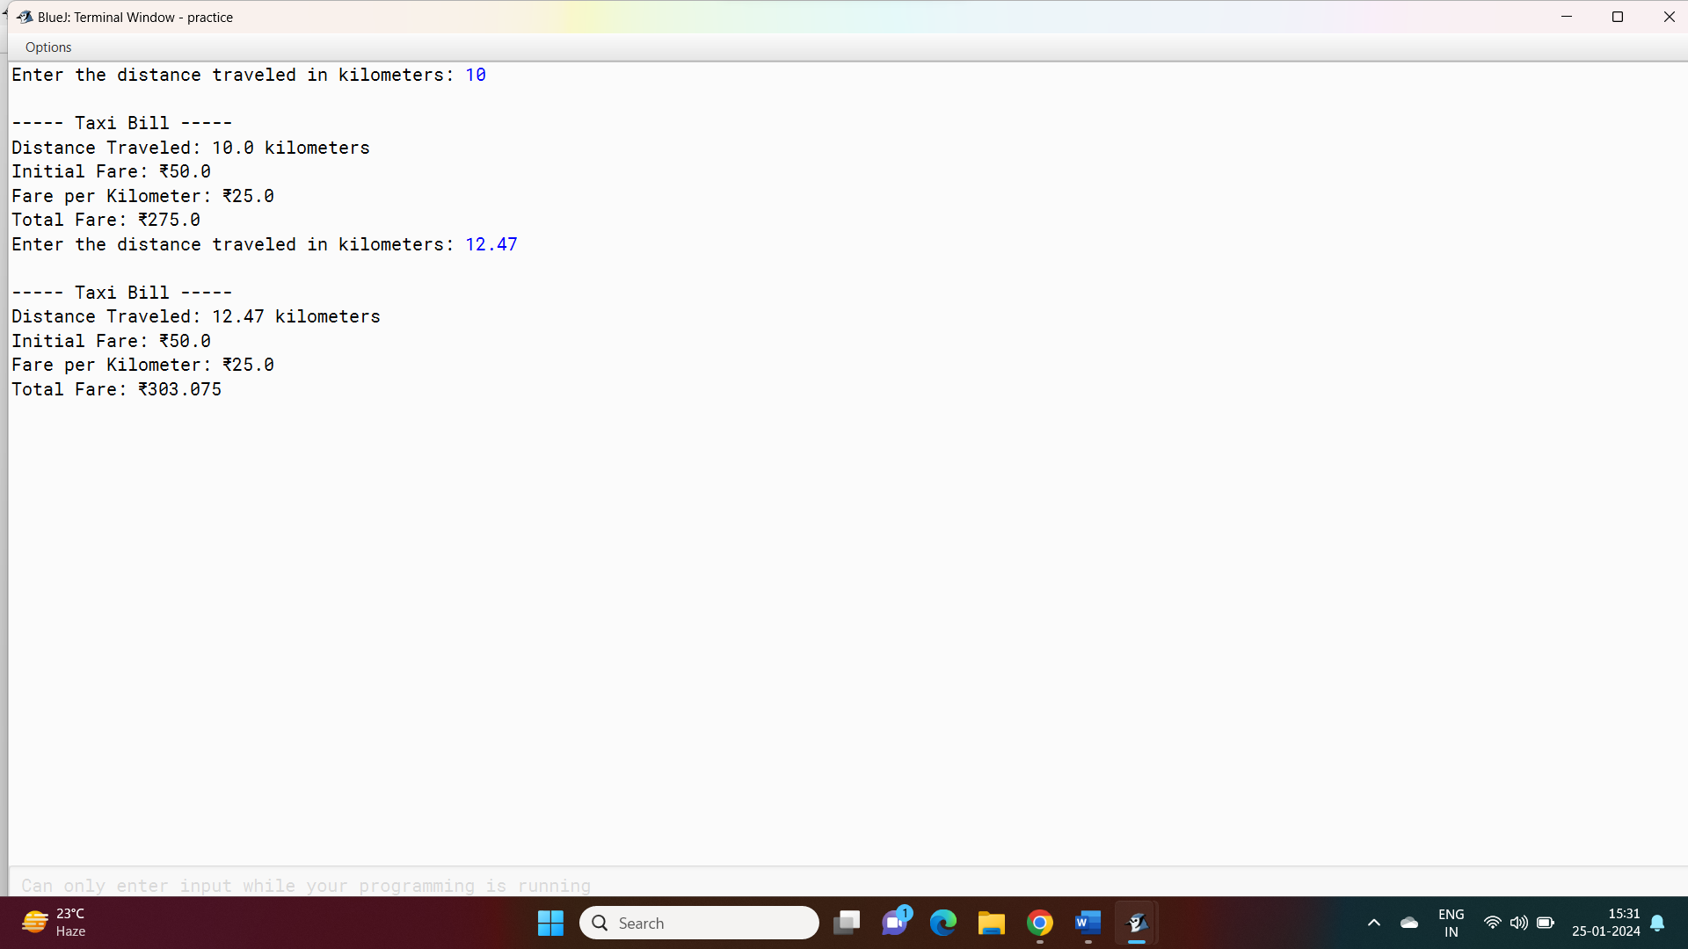

**Variable Description Chart:**

|  |  |  |
| --- | --- | --- |
| Name | Purpose | Type |
| distance | To store the distance in kilometer that has been travelled | Double |
| initialFareINR | To store the initial fare of the taxi | Double |
| ratePerKilometerINR | To store the rate of per kilometer | Double |
| totalFareINR | To store the total value of the fare | Double |

1. Write a java program using scanner class and if else statement to calculate the cost of each slabs.

**Code:**

import java.util.Scanner;

public class CostCalculatorINR {

public static void main(String[] args) {

Scanner scanner = new Scanner(System.in);

System.out.print("Enter the quantity of the product: ");

int quantity = scanner.nextInt();

double costPerUnitINR = 750.0;

int slab1Limit = 50;

double costPerUnitSlab2INR = 712.5;

double totalCostINR;

if (quantity <= slab1Limit) {

totalCostINR = quantity * costPerUnitINR;

} else {

int quantityInSlab2 = quantity - slab1Limit;

totalCostINR = slab1Limit * costPerUnitINR + quantityInSlab2 * costPerUnitSlab2INR;

}

System.out.println("\n----- Cost Calculation -----");

System.out.println("Quantity: " + quantity + " units");

if (quantity <= slab1Limit) {

System.out.println("Cost per unit: ₹" + costPerUnitINR);

System.out.println("Total Cost: ₹" + totalCostINR);

} else {

System.out.println("Cost per unit (Slab 1): ₹" + costPerUnitINR);

System.out.println("Cost per unit (Slab 2): ₹" + costPerUnitSlab2INR);

System.out.println("Total Cost: ₹" + totalCostINR);

}

scanner.close();

}

}

**Output:**

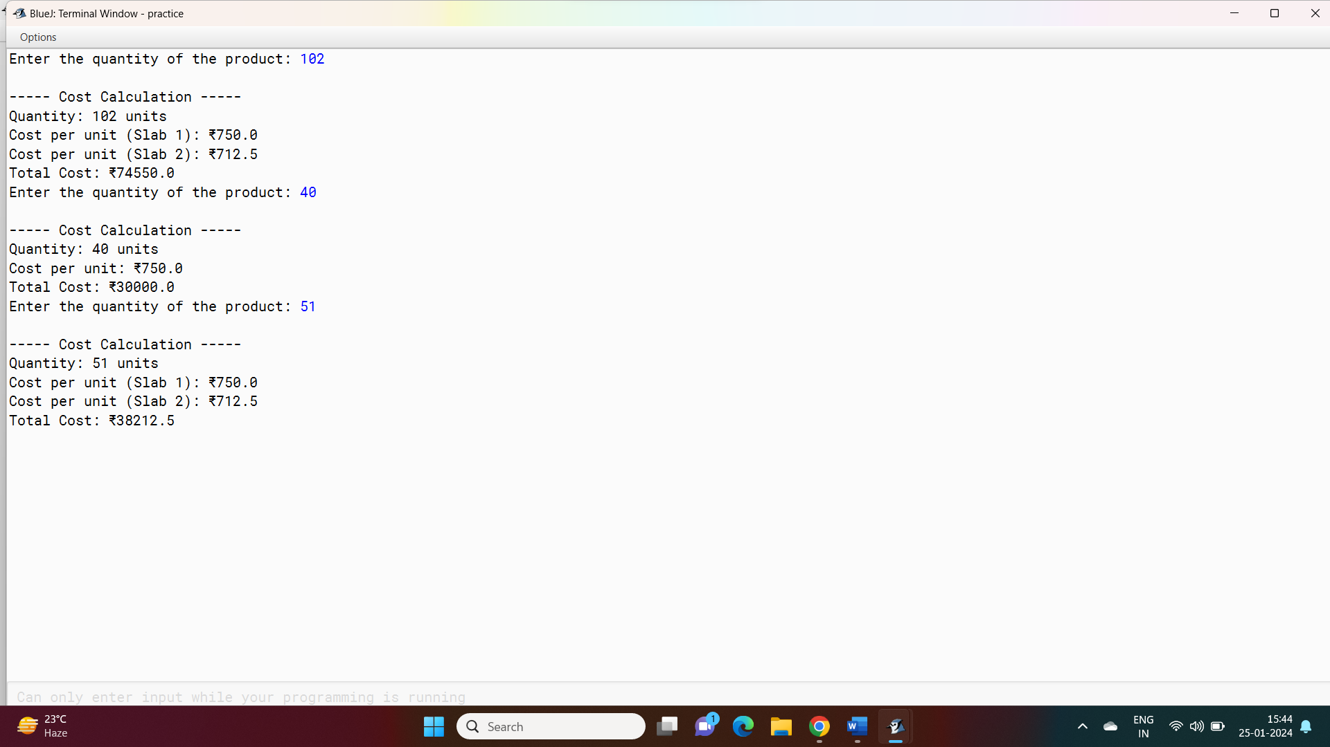

**Variable Description Chart:**

|  |  |  |
| --- | --- | --- |
| Name | Purpose | Type |
| quantity | To store the quantity of slabs the customer wants to buy | int |
| costPerUnitINR | To store the cost of slab 1 | Double |
| slab1Limit | To store the quantity of slab 1 available | Int |
| costPerUnitSlab2INR | To store the cost of slab 2 | Double |
| totalCostINR | To calculate the store the value of total quantities the customer bought. | double |

1. Write a java program using scanner class to check the number which is given by the user is odd or even.

**Code:**

import java.util.Scanner;

public class OddEvenChecker {

public static void main(String[] args) {

Scanner scanner = new Scanner(System.in);

System.out.print("Enter a number: ");

int number = scanner.nextInt();

if (number % 2 == 0) {

System.out.println(number + " is an even number.");

} else {

System.out.println(number + " is an odd number.");

}

scanner.close();

}

}

**Output:**

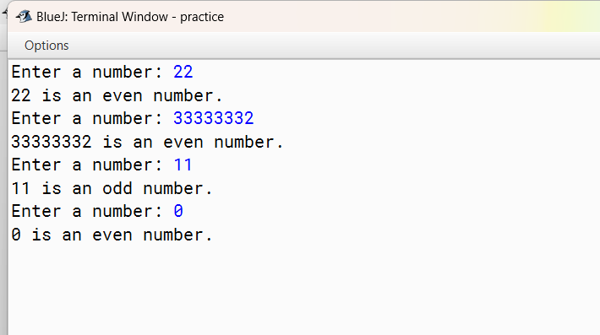

**Variable Description chart:**

|  |  |  |
| --- | --- | --- |
| Name | Purpose | Type |
| number | To store the number given as the user input | int |

1. Write a java program using switch case to check if the given number is divisible by 2,3 or 5.

**Code:**

import java.util.Scanner;

public class DivisibilityChecker {

public static void main(String[] args) {

Scanner scanner = new Scanner(System.in);

System.out.print("Enter a number: ");

int number = scanner.nextInt();

System.out.println("\n----- Divisibility Check -----");

switch (number) {

case 0:

System.out.println("The number is divisible by 2, 3, and 5 (since it is 0).");

break;

case 1:

System.out.println("The number is not divisible by 2, 3, or 5.");

break;

default:

if (number % 2 == 0) {

System.out.println("The number is divisible by 2.");

}

if (number % 3 == 0) {

System.out.println("The number is divisible by 3.");

}

if (number % 5 == 0) {

System.out.println("The number is divisible by 5.");

}

if (number % 2 != 0 && number % 3 != 0 && number % 5 != 0) {

System.out.println("The number is not divisible by 2, 3, or 5.");

}

break;

}

scanner.close();

}

}

**Output:**

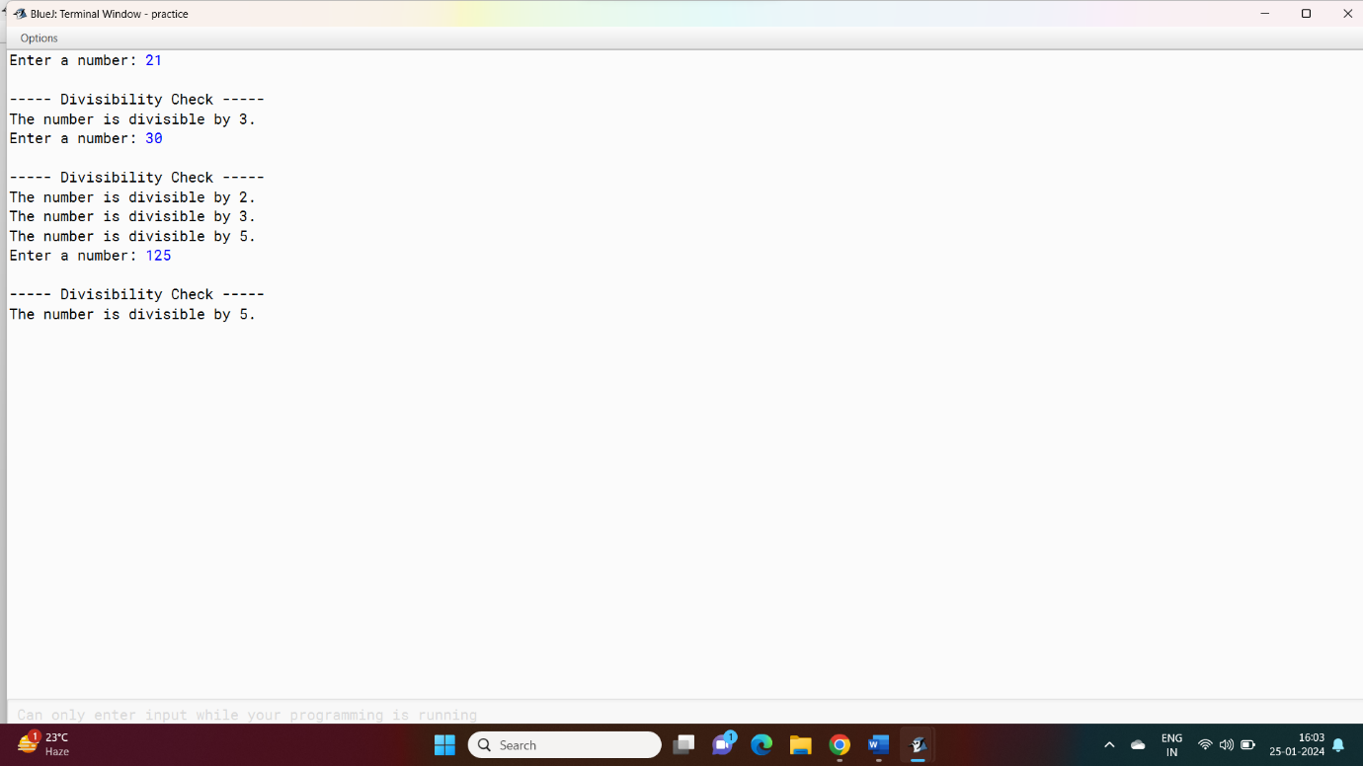

**Variable Description Chat:**

|  |  |  |
| --- | --- | --- |
| Name | Purpose | Type |
| number | To store the number given as a user input and to use it as switch variable | int |

1. Write a java program using scanner class and switch case to check if the given character is a vowel or not.

**Code:**

import java.util.Scanner;

public class VowelChecker {

public static void main(String[] args) {

Scanner scanner = new Scanner(System.in);

System.out.print("Enter a character: ");

char inputChar = scanner.next().charAt(0);

char lowercaseChar = Character.toLowerCase(inputChar);

System.out.println("\n----- Vowel Check -----");

switch (lowercaseChar) {

case 'a':

case 'e':

case 'i':

case 'o':

case 'u':

System.out.println("'" + inputChar + "' is a vowel.");

break;

default:

System.out.println("'" + inputChar + "' is not a vowel.");

break;

}

scanner.close();

}

}

**Output:**

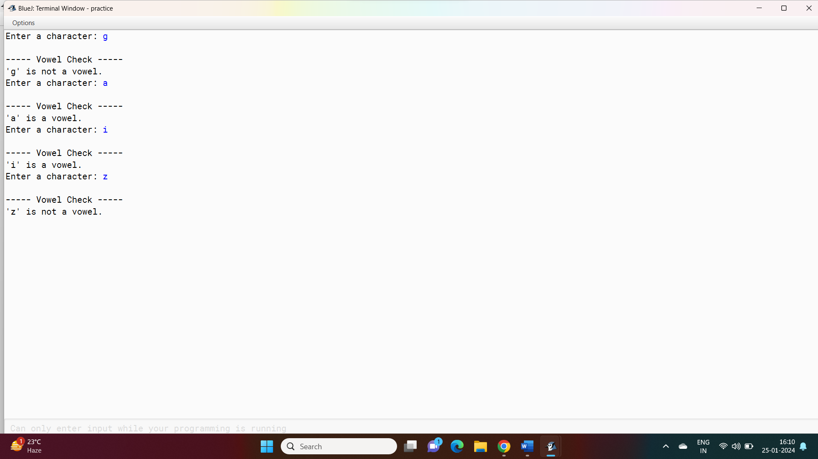

**Variable Description Chart:**

|  |  |  |
| --- | --- | --- |
| Name | Purpose | Type |
| inputChar | To store the char as user input | char |

1. Write a java program to check if the given number is a duck number or not.

**Code:**

import java.util.Scanner;

public class DuckNumberChecker {

public static void main(String[] args) {

Scanner scanner = new Scanner(System.in);

System.out.print("Enter a number: ");

String numStr = scanner.next();

if (isDuckNumber(numStr)) {

System.out.println(numStr + " is a Duck number.");

} else {

System.out.println(numStr + " is not a Duck number.");

}

scanner.close();

}

private static boolean isDuckNumber(String number) {

return number.contains("0") && number.charAt(0) != '0';

}

}

**Output:**

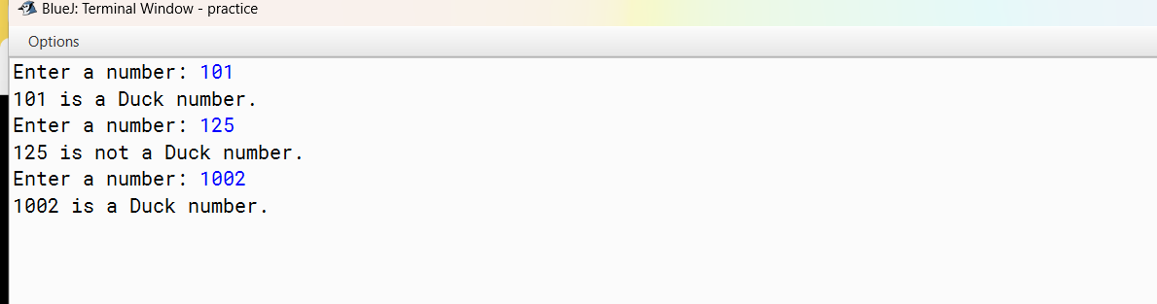

**Variable Description Chart:**

|  |  |  |
| --- | --- | --- |
| Name | Purpose | Type |
| numStr | To store the given number as a string | String |

1. Write a java program to check if the given number is a Armstrong number or not.

**Code:**

import java.util.Scanner;

public class ArmstrongNumberChecker {

public static void main(String[] args) {

Scanner scanner = new Scanner(System.in);

System.out.print("Enter a number: ");

int number = scanner.nextInt();

if (isArmstrongNumber(number)) {

System.out.println(number + " is an Armstrong number.");

} else {

System.out.println(number + " is not an Armstrong number.");

}

scanner.close();

}

private static boolean isArmstrongNumber(int num) {

int originalNum = num;

int numOfDigits = String.valueOf(num).length();

int sum = 0;

while (num > 0) {

int digit = num % 10;

sum += Math.pow(digit, numOfDigits);

num /= 10;

}

return originalNum == sum;

}

}

**Output:**

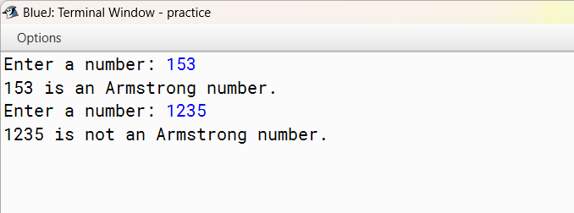

**Variable Description Chart:**

|  |  |  |
| --- | --- | --- |
| Name | Purpose | Type |
| number | To store a number which is a taken as a user input | int |

1. Write a menu driven program in java using for loop to calculate the volume and area of different shapes.

**Code:**

import java.util.Scanner;

public class ShapeCalculator {

public static void main(String[] args) {

Scanner scanner = new Scanner(System.in);

int choice;

do {

System.out.println("\n----- Shape Calculator Menu -----");

System.out.println("1. Calculate Area of Rectangle");

System.out.println("2. Calculate Area of Circle");

System.out.println("3. Calculate Volume of Cylinder");

System.out.println("4. Quit");

System.out.print("Enter your choice (1-4): ");

choice = scanner.nextInt();

switch (choice) {

case 1:

calculateRectangleArea();

break;

case 2:

calculateCircleArea();

break;

case 3:

calculateCylinderVolume();

break;

case 4:

System.out.println("Exiting the program. Goodbye!");

break;

default:

System.out.println("Invalid choice. Please enter a number between 1 and 4.");

}

} while (choice != 4);

scanner.close();

}

private static void calculateRectangleArea() {

Scanner scanner = new Scanner(System.in);

System.out.print("Enter the length of the rectangle: ");

double length = scanner.nextDouble();

System.out.print("Enter the width of the rectangle: ");

double width = scanner.nextDouble();

double area = length * width;

System.out.println("Area of the rectangle: " + area);

}

private static void calculateCircleArea() {

Scanner scanner = new Scanner(System.in);

System.out.print("Enter the radius of the circle: ");

double radius = scanner.nextDouble();

double area = Math.PI * Math.pow(radius, 2);

System.out.println("Area of the circle: " + area);

}

private static void calculateCylinderVolume() {

Scanner scanner = new Scanner(System.in);

System.out.print("Enter the radius of the cylinder: ");

double radius = scanner.nextDouble();

System.out.print("Enter the height of the cylinder: ");

double height = scanner.nextDouble();

double volume = Math.PI * Math.pow(radius, 2) * height;

System.out.println("Volume of the cylinder: " + volume);

}

}

**Variable Description Chart:**

|  |  |  |
| --- | --- | --- |
| Name | Purpose | Type |
| Choice | To store the choice of the user | Int |
| Length | To store the length of the rectangle | Double |
| Width | To store the width of the rectangle | Double |
| Radius | To store the radius of the circle or cylinder | Double |
| height | To store the height of the cylinder | Double |
| Area | To calculate and store the area of the chosen shape | Double |
| volume | To calculate and store the volume of the cylinder | Double |

**Output:**

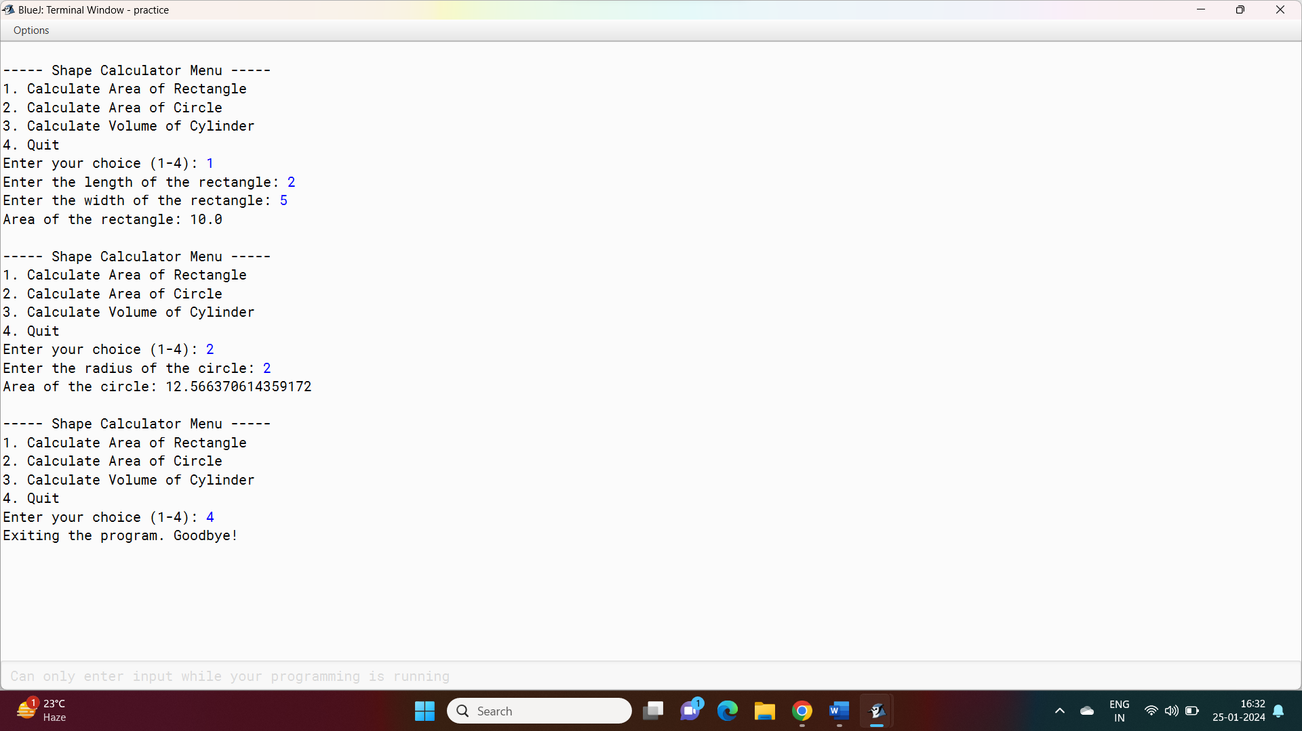

1. Write a java program to generate odd or even numbers upto n using switch case.

**Case:**

import java.util.Scanner;

public class OddEvenGenerator {

public static void main(String[] args) {

Scanner scanner = new Scanner(System.in);

System.out.print("Enter the limit (n): ");

int n = scanner.nextInt();

System.out.println("\n----- Odd/Even Number Generator Menu -----");

System.out.println("1. Generate Odd Numbers");

System.out.println("2. Generate Even Numbers");

System.out.print("Enter your choice (1 or 2): ");

int choice = scanner.nextInt();

switch (choice) {

case 1:

generateOddNumbers(n);

break;

case 2:

generateEvenNumbers(n);

break;

default:

System.out.println("Invalid choice. Please enter either 1 or 2.");

}

scanner.close();

}

private static void generateOddNumbers(int limit) {

System.out.println("\n----- Odd Numbers -----");

for (int i = 1; i <= limit; i += 2) {

System.out.print(i + " ");

}

}

private static void generateEvenNumbers(int limit) {

System.out.println("\n----- Even Numbers -----");

for (int i = 2; i <= limit; i += 2) {

System.out.print(i + " ");

}

}

}

**Output:**

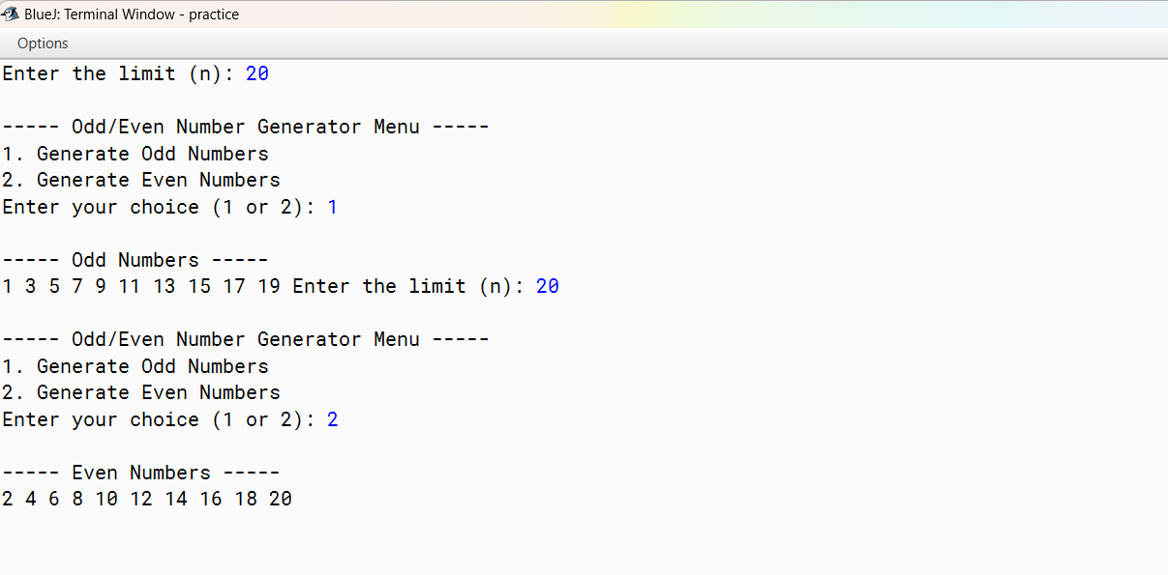

**Variable Description Chart:**

|  |  |  |
| --- | --- | --- |
| Name | Purpose | Type |
| Limit | To store a user input as a limit of the generating sequence | Int |
| choice | To store the choice of the user | int |

1. Write a java program to extract digits from the given number using while loop.

**Code:**

import java.util.Scanner;

public class DigitExtractor {

public static void main(String[] args) {

Scanner scanner = new Scanner(System.in);

System.out.print("Enter a number: ");

int number = scanner.nextInt();

System.out.println("\n----- Extracted Digits -----");

extractDigits(number);

scanner.close();

}

private static void extractDigits(int num) {

num = Math.abs(num);

int originalNum = num;

int digit;

int placeValue = 1;

while (originalNum >= 10) {

originalNum /= 10;

placeValue *= 10;

}

while (num > 0) {

digit = num / placeValue;

System.out.print(digit + "\n");

num %= placeValue;

placeValue /= 10;

}

}

}

**Variable Description Chart:**

|  |  |  |
| --- | --- | --- |
| Name | Purpose | Type |
| Number | To store the number given by the user | Int |
| originalNum | To store the copy of the given number | Int |
| digit | Used for the extraction of the digit from the original number | Int |
| PlaceValue | Used for the extraction of the digit from the original number | Int |

**Output:**

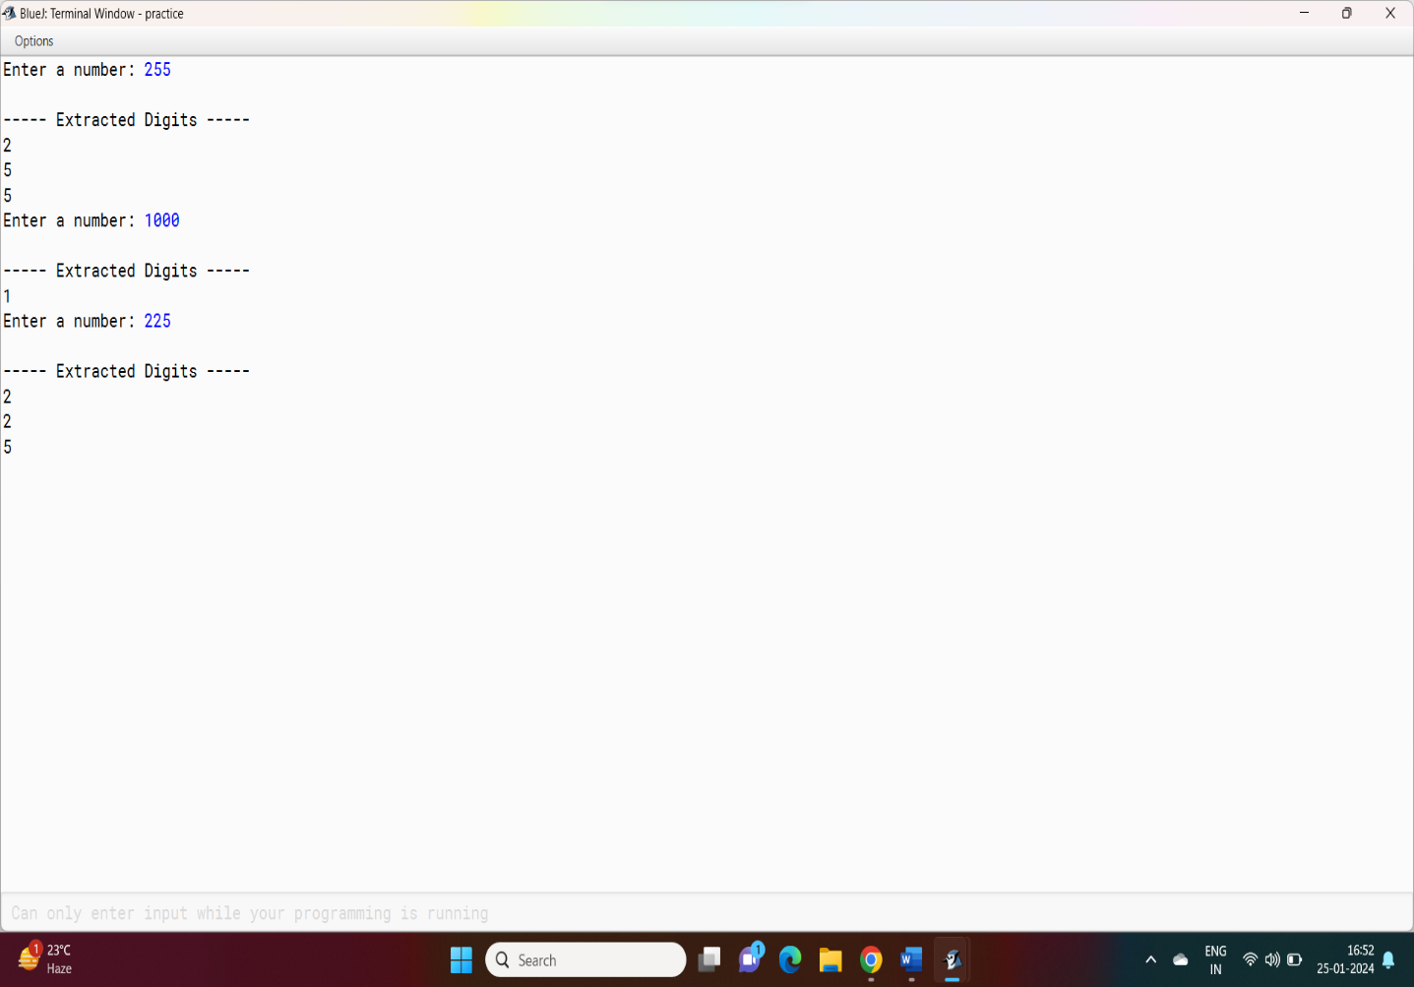

1. Write a java program to reverse a given number using scanner class and while loop.

Code:

import java.util.Scanner;

public class ReverseNumber {

public static void main(String[] args) {

Scanner scanner = new Scanner(System.in);

System.out.print("Enter a number: ");

int number = scanner.nextInt();

int reversedNumber = reverseNumber(number);

System.out.println("Reversed Number: " + reversedNumber);

scanner.close();

}

private static int reverseNumber(int num) {

num = Math.abs(num);

int reversedNum = 0;

while (num > 0) {

int digit = num % 10;

reversedNum = reversedNum * 10 + digit;

num /= 10;

}

return reversedNum;

}

}

Output:

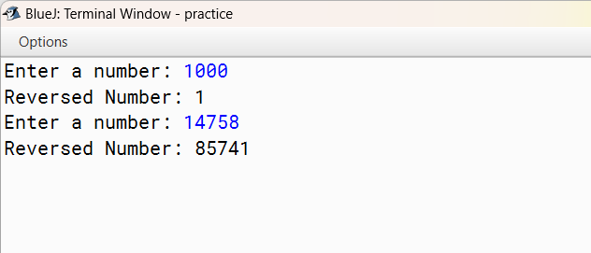

Variable Description Chart:

|  |  |  |
| --- | --- | --- |
| Name | Purpose | Type |
| Number | To store the original number given by the user | int |
| reverseNumber | To calculate and store the reversed number | Int |
| digit | Used for the extraction of the digit from the original number | Int |

1. Write a menu driven program in java to print two series as n/n+1 and n/n+2.

**Code:**

import java.util.Scanner;

public class SeriesPrinter {

public static void main(String[] args) {

Scanner scanner = new Scanner(System.in);

int choice;

do {

System.out.println("\n----- Series Printer Menu -----");

System.out.println("1. Print Series n/(n+1)");

System.out.println("2. Print Series n/(n+2)");

System.out.println("3. Quit");

System.out.print("Enter your choice (1-3): ");

choice = scanner.nextInt();

switch (choice) {

case 1:

printSeries1();

break;

case 2:

printSeries2();

break;

case 3:

System.out.println("Exiting the program. Goodbye!");

break;

default:

System.out.println("Invalid choice. Please enter a number between 1 and 3.");

}

} while (choice != 3);

scanner.close();

}

private static void printSeries1() {

System.out.println("\n----- Series n/(n+1) -----");

for (int n = 1; n <= 10; n++) {

double result = (double) n / (n + 1);

System.out.printf("%.2f ", result);

}

}

private static void printSeries2() {

System.out.println("\n----- Series n/(n+2) -----");

for (int n = 1; n <= 10; n++) {

double result = (double) n / (n + 2);

System.out.printf("%.2f ", result);

}

}

}

**Variable Description Chart:**

|  |  |  |
| --- | --- | --- |
| Name | Purpose | Type |
| Choice | To store the choice of the user as it is a menu driven program | Int |
| n | To store the value of n | int |

**Output:**

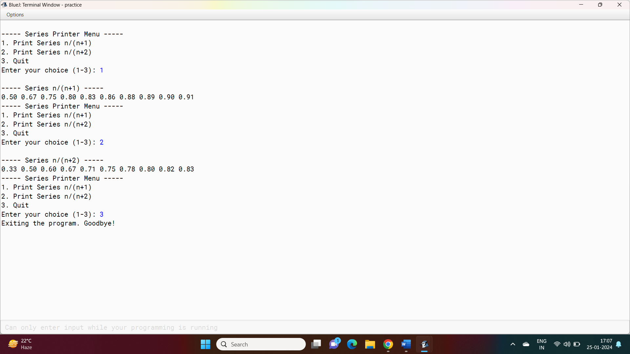

1. write a menu driven program in java to print 2 individual star patterns.

**Code:**

import java.util.Scanner;

public class StarPatternPrinter {

public static void main(String[] args) {

Scanner scanner = new Scanner(System.in);

int choice;

do {

System.out.println("\n----- Star Pattern Printer Menu -----");

System.out.println("1. Print Pattern 1");

System.out.println("2. Print Pattern 2");

System.out.println("3. Quit");

System.out.print("Enter your choice (1-3): ");

choice = scanner.nextInt();

switch (choice) {

case 1:

printPattern1();

break;

case 2:

printPattern2();

break;

case 3:

System.out.println("Exiting the program. Goodbye!");

break;

default:

System.out.println("Invalid choice. Please enter a number between 1 and 3.");

}

} while (choice != 3);

scanner.close();

}

private static void printPattern1() {

System.out.println("\n----- Pattern 1 -----");

for (int i = 1; i <= 5; i++) {

for (int j = 1; j <= i; j++) {

System.out.print("* ");

}

System.out.println();

}

}

private static void printPattern2() {

System.out.println("\n----- Pattern 2 -----");

for (int i = 5; i >= 1; i--) {

for (int j = 1; j <= i; j++) {

System.out.print("* ");

}

System.out.println();

}

}

}

**Output:**

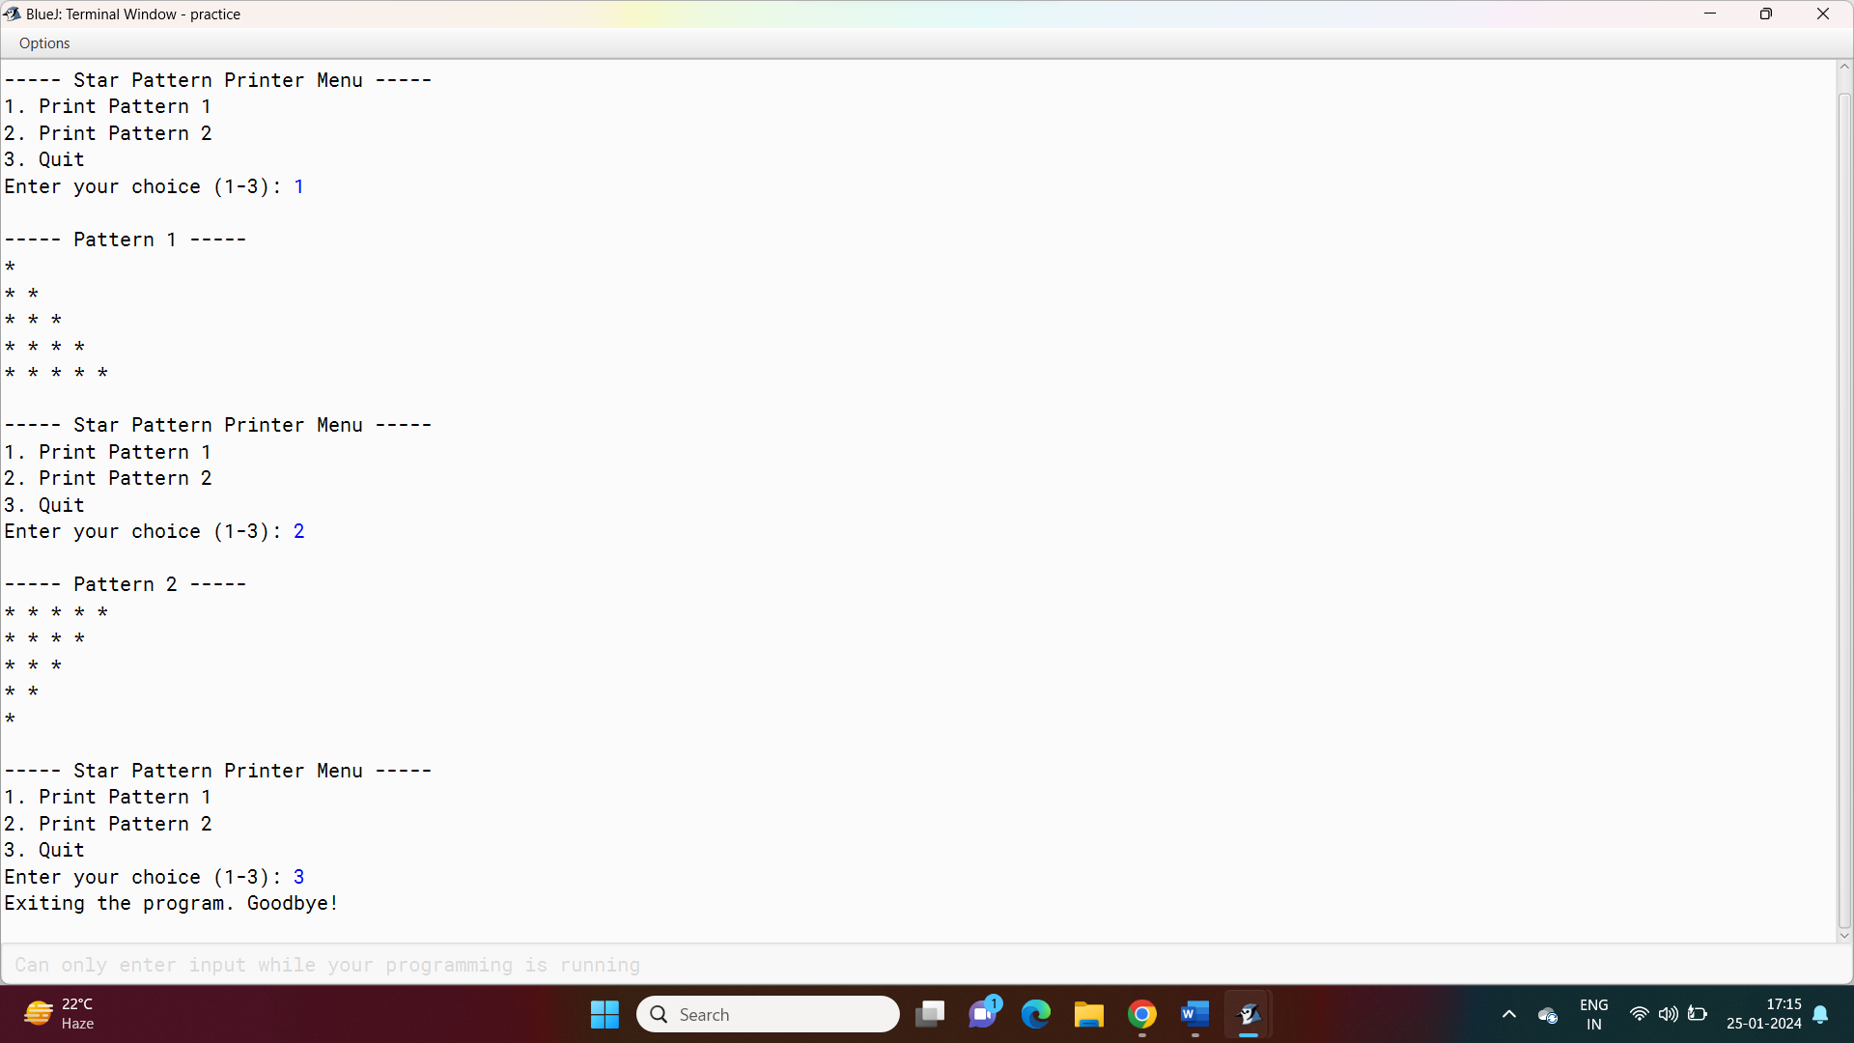

**Variable Description Chart:**

|  |  |  |
| --- | --- | --- |
| Name | Purpose | Type |
| Choice | To store the choice of the user | Int |
| I | Used as a loop variable | Int |
| j | Used as a loop variable | int |

1. Write a java program to check if the given number is prime or not.

**Code:**

import java.util.Scanner;

public class PrimeChecker {

public static void main(String[] args) {

Scanner scanner = new Scanner(System.in);

System.out.print("Enter a number: ");

int number = scanner.nextInt();

boolean isPrime = isPrimeNumber(number);

if (isPrime) {

System.out.println(number + " is a prime number.");

} else {

System.out.println(number + " is not a prime number.");

}

scanner.close();

}

private static boolean isPrimeNumber(int num) {

if (num <= 1) {

return false;

}

for (int i = 2; i <= Math.sqrt(num); i++) {

if (num % i == 0) {

return false;

}

}

return true;

}

}

**Output:**

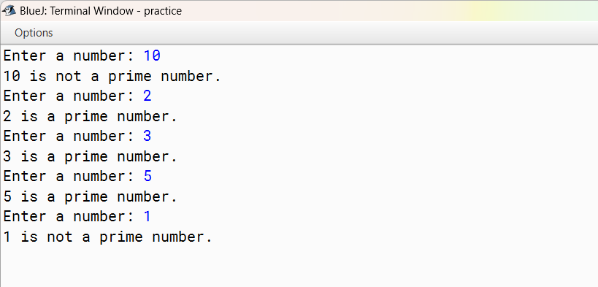

**Variable Description Chart:**

|  |  |  |
| --- | --- | --- |
| Name | Purpose | Type |
| number | To store the number given by the user | int |

1. Write a java program to print a diamond star patter.

**Code:**

import java.util.Scanner;

public class DiamondStarPattern {

public static void main(String[] args) {

Scanner scanner = new Scanner(System.in);

System.out.print("Enter the number of rows for the diamond: ");

int rows = scanner.nextInt();

for (int i = 1; i <= rows; i++) {

for (int j = 1; j <= rows - i; j++) {

System.out.print(" ");

}

for (int k = 1; k <= 2 * i - 1; k++) {

System.out.print("*");

}

System.out.println();

}

for (int i = rows - 1; i >= 1; i--) {

for (int j = 1; j <= rows - i; j++) {

System.out.print(" ");

}

for (int k = 1; k <= 2 * i - 1; k++) {

System.out.print("*");

}

System.out.println();

}

scanner.close();

}

}

**Output:**

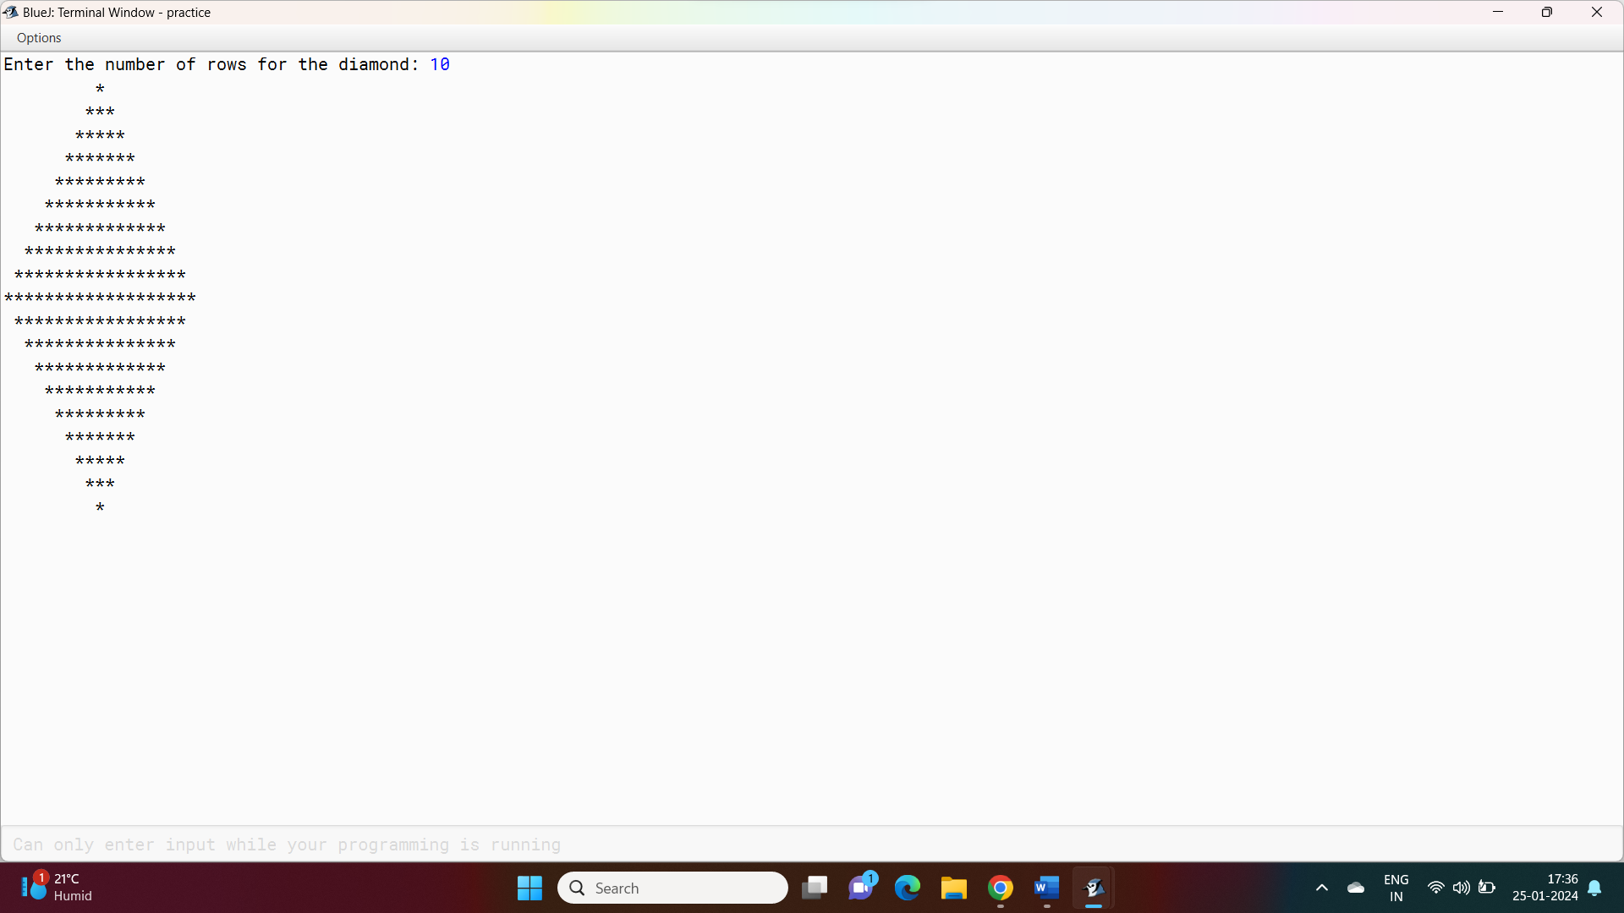

**Variable Description Chart:**

|  |  |  |
| --- | --- | --- |
| Name | Purpose | Type |
| Rows | To store the number of rows as the user input | Int |
| I | Used as loop variable | Int |
| j | Used as loop variable | int |