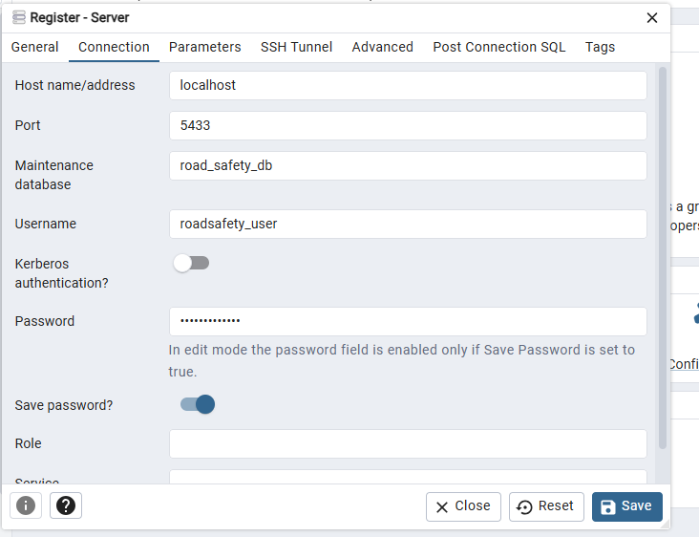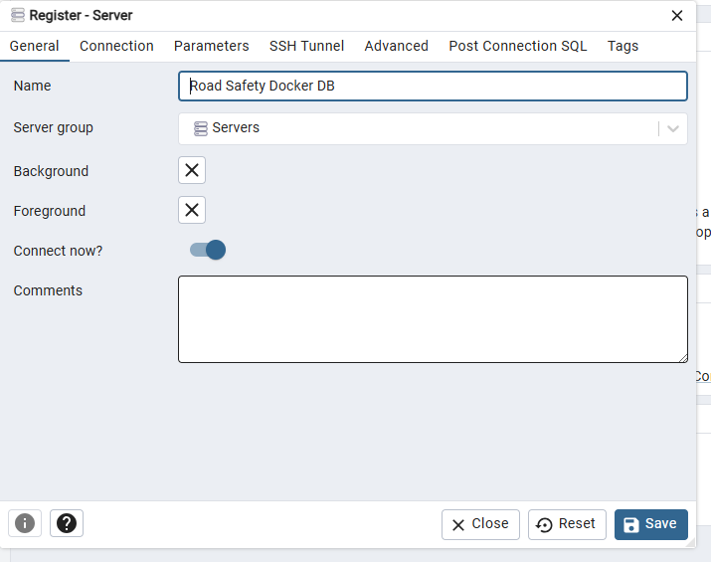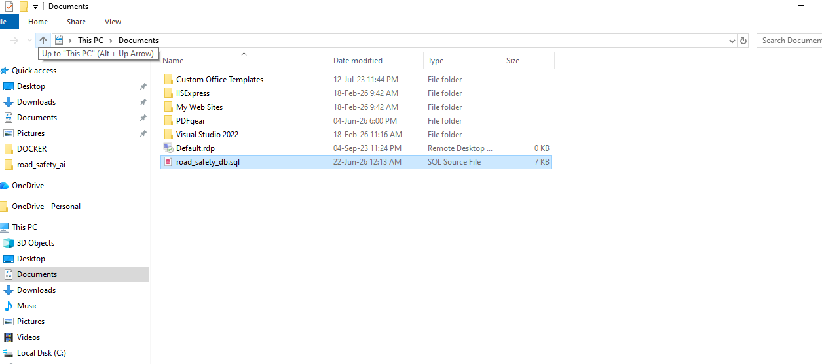
docker cp "C:\Users\User\Documents\road_safety_db.sql" road-safety-postgres:/tmp/
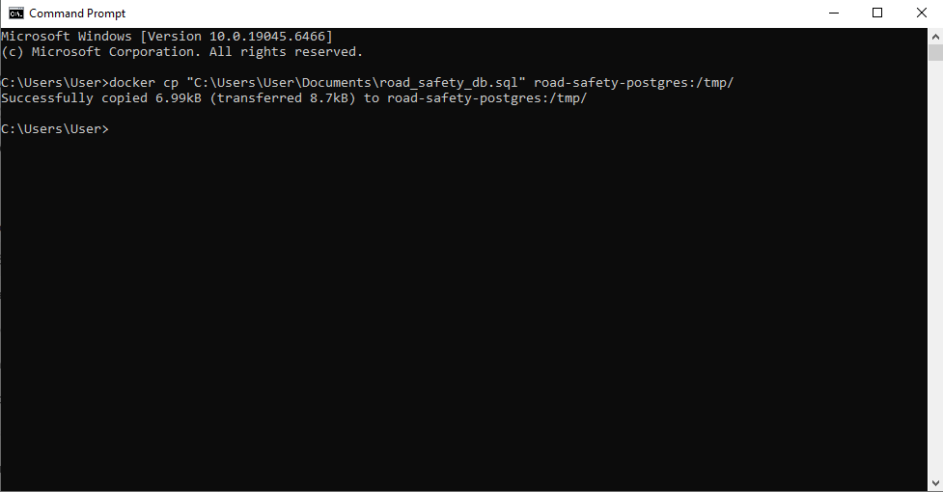

docker exec -it road-safety-postgres psql -U roadsafety_user -d road_safety_db -f /tmp/road_safety_db.sql

