* The game uses the following java configuration for execution:

1. java version "1.7.0_79"

Java(TM) SE Runtime Environment (build 1.7.0_79-b15)

Java HotSpot(TM) 64-Bit Server VM (build 24.79-b02, mixed mode)

1. The Gson library for parsing the java objects to json strings and vice versa. We have used the gson-2.2.2.jar version.

* The application uses the standard navigation keys for left and right movement.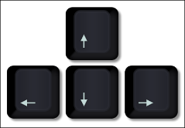

S key : This is pressed to start the game.

1 key: Select easy level

2 key: Select medium level of play

3 key: Select difficult level of play

* Game rules:

The game initializes with 15 lives for each player.

The main task is to stay alive till you are the only person left in the game.

A life is lost each time the ball touches the wall on your side.

Each time your paddle hits the ball, the score is updated by unity or two depending on the position where the ball hits.

After scoring a base score of 10 a player gets a power-up randomly.

The power-up may include larger paddle size, power to hold and release the ball, and extra lives of 15.

Every time a new player connects the game, the game must restart with zero scores and full lives for all the players.

Whenever a player disconnects during an ongoing game, the automatic player occupies its position to allow other players to complete the match.