RV COLLEGE OF ENGINEERING®

(Autonomous Institution affiliated to VTU, Belagavi)


PROJECT REPORT

On

Predicting Cricket Pitch Conditions Using Machine Learning for Data-Driven Match Strategy

Submitted in fulfilment of the Experiential Learning (EL) Phase-I requirements

Submitted by
ARAVIND R — [1RV25ET007]
RISHAB H R — [1RV25EC154]
UJWAL S NAIR — [1RV25EC229]
GROUP 31

2026 – 2027

1. Introduction

1.1 Context
Cricket is played on a pitch whose behaviour — how much the ball bounces, seams, turns or comes onto the bat — shapes scoring, wicket-taking and the decision made at the toss. Two grounds can host the same teams on the same day and produce completely different matches because the surface behaves differently. Yet no open, standard dataset records pitch behaviour directly. Public ball-by-ball archives record what happened on a pitch, not what the pitch was like.
This project asks whether pitch behaviour can be inferred, before a match, from free public data. The input is historical ball-by-ball records, player bowling styles and daily historical weather at the match city. The output is a three-class description of the surface (batting-friendly, pace-friendly or spin-friendly), an explanation of the drivers behind that prediction, and — as the applied goal — a bat-first or field-first recommendation at the toss.

1.2 Why the problem matters
Three observations motivate the work.
1. The toss is worth points. Sood and Willis (2016), analysing more than 41,000 matches, estimate that winning the toss raises the chance of winning by about 2.8% overall, with larger effects in one-day cricket. A better pre-match read of the surface therefore has a direct competitive value.
2. Visual assessment is imperfect. Adams et al. (2005) measured 92 County Championship pitches and compared umpires' ratings with high-speed video. Umpires assessed bounce reliably but not pace; pace had to be modelled from bounce and surface friction. Expert visual inspection is useful but not a measurement.
3. Venues genuinely differ. In our own T20I (Twenty20 International) sample, the 13 men's venues with at least 25 matches and at least 60% of wicket-taking roles known range from 7.1 to 9.0 runs per over. That spread is large enough to change selection and toss decisions.
The beneficiaries are teams playing at unfamiliar venues, where local knowledge is thinnest, and analysts who need a reproducible, auditable method rather than anecdote. Because the method uses only free and open data, it is also available to associate and domestic teams that cannot buy commercial scouting services.

2. Problem Definition

2.1 Problem statement
There is no open, repeatable way to classify how a cricket pitch will behave before a match. As a result, the toss decision and the pace/spin balance of the playing eleven still rest on visual inspection, broadcast commentary and venue experience. Those judgements are hard to check, hard to reproduce and unavailable to teams without a long history at the ground.
Two constraints define the problem. First, no public dataset contains physical pitch measurements linked to match identifiers. Second, weather and pitch behaviour interact (moisture, humidity, wind and temperature affect preparation and deterioration), so any useful method must combine match records with ambient conditions. The scientific difficulty is therefore one of weak supervision: the target must be constructed from observed play, and every claim must be honest about the fact that the label is a proxy.

2.2 Background and literature review
Research on cricket analytics splits into three streams: physical measurement of pitches, prediction of match outcomes, and prediction of scores or chases. None of the studies reviewed below predicts pitch behaviour itself from open ball-by-ball data.
Study | Data and method | Key finding | Limitation for our problem
Adams et al. (2005) | 92 County Championship pitches; bounce, hardness and friction measured; high-speed video on 23 | Umpires rate bounce reliably but not pace; pace can be modelled from bounce and friction | Requires on-site instruments; not scalable to historical matches
Morley and Thomas (2005) | English one-day matches; logistic regression | Home teams won about 57%; the toss matters, but team quality and match importance dominate | Models the result, not the pitch
Chakraborty et al. (2024) | T20 (Twenty20) winners; logistic regression, support vector machine, random forest, decision tree and XGBoost | Random forest best, 84.06% accuracy | Predicts the winner, not the pitch
Shah et al. (2025) | 458 T20Is, 2005–2024; seven classifiers; venue, toss, pitch and rankings | Random forest and decision tree best for high run chases | Pitch is an input, not an output
Bhatnagar and Bhatnagar (2025) | Indian Premier League (IPL) 2008–2024; automated machine learning, explainable artificial intelligence, weather and large-language-model reads of pitch reports | Pitch reports and pre-match factors help classify first-innings scores | Relies on subjective pitch reports and is IPL-only

Three trends emerge. Tree ensembles (random forest and gradient boosting) repeatedly win tabular comparisons; explainable methods are becoming standard; and the newest work tries to combine structured data with unstructured pitch reports. The gap is consistent: existing work treats the pitch as an input or predicts the result, while the pitch itself remains unmeasured.

2.3 Research gap and contribution
This project treats pitch behaviour as the target. We construct a documented proxy label from ball-by-ball evidence, build leakage-safe features from earlier matches only, train interpretable multiclass classifiers, and explain each prediction. The contribution is a reproducible open-data pipeline, a venue-level Pitch Behaviour Profile (PBP), a first version of a Pitch Wear Index (PWI), and a planned cold-start method for grounds with little history.

3. Objectives

3.1 Primary objective
Classify pitch behaviour before a match using free public data, and convert that classification into an interpretable toss recommendation.

3.2 Specific objectives and success measures
# | Objective | Measure of success | Status at Phase-I
1 | Complete the data | Weather audit passes at 98% match coverage; bowling styles known for at least 70% of T20I wickets | Partial: 42% of credited wickets have a known style; weather collection at 24 of 111 batches
2 | Build pitch features | PBP and PWI computed for every venue using past matches only | Partial: PBP built for 13 men's T20I venues; PWI is a raw second-innings step, not yet normalised
3 | Train and validate classifiers | Random forest and gradient boosting beat the majority and venue baselines; macro-F1 of at least 0.50 in time-aware cross-validation | Partial: macro-F1 0.41 on the held-out period and 0.39–0.45 in cross-validation; beats baselines on macro-F1 but not on accuracy
4 | Explain and handle new grounds | SHapley Additive exPlanations (SHAP) drivers per prediction; cold-start method tested on held-out venues | Partial: SHAP implemented; cold-start matching still planned
5 | Disseminate | IEEE-format conference paper | Planned: abstract drafted, full multi-format results pending

3.3 Secondary objectives
- Extend the same pipeline to One Day Internationals (ODIs) and Test matches with format-specific label thresholds.
- Curate the highest-impact missing bowler styles so that more matches become trainable.
- Quantify whether daily weather adds out-of-time predictive value once the weather table is complete.
- Package the pipeline so that a teammate can reproduce every table and figure from the repository.

4. Methodology

4.1 Approach and theoretical framework
The design is quantitative and observational. We use supervised multiclass learning with weak supervision: because no ground-truth pitch class exists, the label is derived by an explicit rule from match events. The rule is frozen before evaluation, documented in code, and stress-tested by changing its thresholds.
The theoretical basis is that pitch behaviour leaves a statistical signature in early-innings scoring and in the type of bowler who takes wickets. A surface that grips and turns produces more spin-bowled dismissals; a hard, fast surface produces more pace-bowled dismissals; a flat surface produces high scoring with few early dot balls. This is a behavioural proxy, not a physical measurement, and the report treats it as such throughout.
Tree ensembles are chosen because the features are tabular, mixed (numeric and categorical), non-linear and interaction-heavy. Random forest (Breiman, 2001) averages decorrelated decision trees and is robust to outliers; gradient boosting, specifically XGBoost (Extreme Gradient Boosting; Chen and Guestrin, 2016), fits trees sequentially to residual error and usually gives the best tabular accuracy. Logistic regression provides a linear benchmark. SHAP (Lundberg and Lee, 2017) assigns each feature a contribution to each prediction using Shapley values from cooperative game theory, which makes the model auditable.
The end-to-end flow is:
1. Ingest Cricsheet JSON (JavaScript Object Notation) archives and flatten each match to one row.
2. Enrich rows with bowling styles from public player registers and with daily weather from the Open-Meteo ERA5 archive.
3. Label each match using the format-specific rule.
4. Engineer match-start and prior-venue features, with strict time ordering.
5. Split chronologically into training and later held-out matches.
6. Train and compare majority, venue-prior, logistic-regression, random-forest and XGBoost models.
7. Evaluate macro-F1, balanced accuracy, per-class scores, log loss, Brier score, calibration and bootstrap confidence intervals.
8. Explain the best model with SHAP and translate drivers into toss guidance.
Figure 1 in Section 11 shows this flow as a flowchart.

4.2 Proxy label definition
The label is computed from the first innings only, because the pitch's influence on the team batting first is the quantity a pre-match decision needs. For T20 the early window is the six-over powerplay (the fielding-restriction period at the start of an innings). A dot ball is a legal delivery from which no run is scored; the dot-ball percentage measures how hard scoring was early. Run rate is runs per over.
Format | Label = Batting if | Otherwise Label = Spin if | Otherwise
T20 | First-innings run rate ≥ 8.5 and powerplay dot-ball % ≤ 35% | At least 2 bowler-credited spin wickets and spin-to-pace wicket ratio ≥ 1.25 (or no pace wickets) | Pace
ODI | First-innings run rate ≥ 5.5 and first-ten-over dot-ball % ≤ 60% | Same spin rule | Pace
Test | First-innings run rate ≥ 3.8 and first-ten-over dot-ball % ≤ 75% | Same spin rule | Pace

Only bowler-credited dismissals count (bowled, caught, caught and bowled, leg before wicket, stumped, hit wicket), so run-outs do not distort the spin/pace comparison. Wides and no-balls are excluded from legal-ball denominators. Tests have no powerplay; the first ten overs are used as an explicit opening-ten-over proxy, not as a powerplay.
This rule is an operational assumption, not a law. Section 7.6 reports how much the labels move when the cut-offs change.

4.3 Data sources
Source | Content | Licence and role
Cricsheet | Ball-by-ball JSON for all formats; venue, city, toss, teams and officials | Open Data Commons Attribution (ODC-By); primary match data
Kaggle international player statistics | Bowling style and ESPNcricinfo player identifiers | CC0; primary style source, joined on identifier
Kaggle worldwide player profiles | Broader player-style coverage | CC0; fallback join on exact normalised name
Open-Meteo historical weather API | Daily ERA5 reanalysis at the match city | Free, non-commercial; daily temperature, precipitation, wind and humidity

ERA5 is the fifth-generation atmospheric reanalysis of the European Centre for Medium-Range Weather Forecasts (ECMWF): a global, hour-by-hour reconstruction of the atmosphere from observations and a weather model. We use daily aggregates at the match city, not the stadium, and on the match date, not the start time, because Cricsheet generally does not publish start times. The weather features are therefore ambient context, not pitch measurements.

4.4 Feature engineering and leakage control
Features fall into four groups.
- Match context: format, gender, team type, venue and venue identifier, city, year, and cyclical month and day-of-year encodings (sine and cosine) so that December and January are adjacent.
- Toss: the toss decision (bat or field) and whether the toss winner batted first.
- Prior venue history: rolling means over at most the previous five matches at that venue for first-innings run rate, early dot-ball percentage and spin wicket share, plus counts of prior matches and prior matches with complete role information.
- Weather (when available): daily mean temperature, precipitation total, maximum wind speed and mean relative humidity.
Leakage is controlled in three ways. First, the same-match statistics that define the label (run rate, dot balls, wickets by style) are never used as features. Second, rolling venue features are computed from strictly earlier dates; matches on the same date do not see each other's outcomes. Third, the train/test split is chronological by unique date, and imputers and encoders are fitted inside each training fold.

4.5 Training and evaluation protocol
The most recent 20% of unique match dates form the held-out test period. Class weights compensate for imbalance. Models are compared against two baselines: always predicting the majority class, and predicting from the venue's historical label distribution. Evaluation reports accuracy, balanced accuracy (mean per-class recall, which does not reward ignoring minority classes), macro-F1 (the unweighted mean of per-class F1 scores, where F1 is the harmonic mean of precision and recall), weighted F1, multiclass log loss (a penalty for confident wrong probabilities), the Brier score (mean squared probability error), the confusion matrix, per-class precision/recall/F1, bootstrap confidence intervals, and calibration error. Five-fold time-aware cross-validation repeats the comparison across earlier periods.

5. Project Execution

5.1 Planning and design
The team began with a scoping exercise: which decision would a pitch model actually change? The answer was the toss and the composition of the attack, so the target was defined as a surface class rather than a score. The group then audited data availability, discovered that no open pitch measurements exist, and adopted the proxy-label design. The work was divided into data engineering, modelling and domain interpretation, with a shared repository and a written data manifest.
Design decisions taken before implementation:
- Use only free and open data, so results are reproducible and publishable.
- Freeze the label rule before looking at model scores.
- Evaluate on later matches only, because a random split would leak future venue knowledge.
- Keep every derived table and cache in the repository so that a run can resume on another machine.
- Treat the label as a proxy in every table, figure and sentence.

5.2 Implementation
Data ingestion. The full Cricsheet archive contains 18,585 T20, ODI and Test matches after date and format checks. The T20I subset used for the first modelling cycle contains 5,849 matches; 5,713 pass result and early-window checks.
Player-style enrichment. Cricsheet records the bowler's name but not the bowling style. Styles are joined from the two Kaggle registers, first on the ESPNcricinfo identifier and then on a conservative exact normalised name. When a credited wicket-taker cannot be classified, the match is excluded rather than guessed. This is deliberate: silent guessing would contaminate the label.
Geocoding and weather. Matches are grouped by city (or venue when the city is blank) and geocoded, with a manual review of every location that failed. All 413 location strings now have coordinates; 94 previously unresolved venues were reviewed by hand and recorded with a rationale. The collector batches up to 25 coordinates per year, caches every response, and reuses the cache on restart. At the time of writing, 24 of 111 batches are cached and 93 remain; the free API's daily quota stopped the run and resets at 05:30 Indian Standard Time on 5 November 2026.
Labels and features. The labelling pipeline and the training script were run independently and produced identical labels on all 842 comparable T20I matches, which validates the implementation.
Modelling and explanation. Five models were compared on 868 labelled T20Is (703 training, 165 test), followed by SHAP analysis, calibration analysis and a role-curation study.
Iterations. The first version used only match context and venue history. Review showed that role coverage, not model choice, limited sample size, so the team added a role-curation curve and a prioritised review queue. The second iteration added calibration and bootstrap intervals after the first results showed that a single accuracy number hid the class imbalance.

6. Tools and Techniques Used

6.1 Tools
Tool | Purpose
Python 3.13 | Main implementation language for ingestion, labelling, modelling and reporting
pandas and NumPy | Tabular data processing and numerical arrays
scikit-learn | Pipelines, imputation, one-hot encoding, logistic regression, random forest, metrics and cross-validation
XGBoost | Gradient-boosted decision trees
SHAP | Model explanation with Shapley values
Matplotlib | Figures used in the presentation and report
Git and Git Large File Storage (LFS) | Version control and storage of the 142 MB archive
Open-Meteo API | Geocoding and ERA5 daily weather retrieval
Cricsheet and Kaggle registers | Match data and bowling-style labels
Microsoft PowerPoint and Word | Presentation and report preparation

No paid software or paid data was used.

6.2 Techniques
- Weak supervision. The target is generated by a deterministic rule from observed events, then treated as a noisy label. This is the standard approach when ground truth is unavailable, and it requires explicit sensitivity analysis.
- Chronological validation. Training on the past and testing on the future mimics real use and prevents future information from leaking into features. Random cross-validation would overstate performance because the same venue appears on both sides.
- Class weighting. Minority classes (especially Batting) receive higher weight during training so that the model does not simply predict the majority class.
- Bootstrap confidence intervals. Test matches are resampled with replacement many times to estimate the uncertainty of macro-F1; overlapping intervals are treated as evidence that models are not reliably different.
- Calibration analysis. Predicted probabilities are binned and compared with observed frequencies; the Expected Calibration Error (ECE) summarises the gap. Calibration matters because a toss recommendation needs honest probabilities, not just a class.
- SHAP explanation. Shapley values from cooperative game theory decompose each prediction into additive feature contributions, giving global importance and per-match drivers.
- Cold-start matching (planned). For a venue with no history, find statistically similar venues using profile features and borrow their prior. This is the practical answer to "what about a ground we have never played on?"

7. Partial Results

7.1 Data audit
Quantity | Value
T20Is in the archive | 5,849
Usable after result and early-window checks | 5,713
Labelled matches (all wicket-taker styles known) | 868 (15%)
Credited wickets with a known bowling style | 42%
Distinct venue strings / venue identifiers | 317 / 301
Bowlers with at least one credited wicket | 4,370
Role table rows after joins | 1,069
Label distribution | Pace 587 · Spin 213 · Batting 68
Test-period labels | Pace 96 · Spin 57 · Batting 12

The dominant limitation is visible immediately: only about one match in seven can be labelled, because the style of every wicket-taker must be known. This is a data-coverage problem, not a modelling problem, and Section 7.6 quantifies how quickly it can be fixed.

7.2 Venue behaviour profiles
The first Pitch Behaviour Profile covers the 13 men's T20I venues with at least 25 matches and at least 60% role coverage. Across these grounds, higher-scoring venues have a lower share of spin wickets (Pearson correlation r = −0.64). Eden Park averages 9.0 runs per over with 25% of wickets taken by spin; Mirpur averages 7.1 with 42%. This is consistent with the intuition that flat, high-scoring surfaces offer less turn, and it is the first evidence that the proxy captures something real about venue character.
The raw Pitch Wear Index step compares the two innings. Second-innings run rate is a median 0.42 runs per over lower than first-innings run rate. This is not yet a wear measure: chasing tactics, target pressure and team strength have not been removed. The next version will normalise for those factors and for the quality of the batting and bowling units.

7.3 Model comparison
Results on the 165 matches after 9 February 2024, without weather:
Model | Accuracy | Balanced accuracy | Macro-F1 | Macro-F1 95% CI | Log loss | Brier score
Majority class | 0.582 | 0.333 | 0.245 | 0.223–0.265 | 0.913 | 0.566
Venue prior | 0.594 | 0.359 | 0.318 | 0.265–0.367 | 0.958 | 0.590
Logistic regression | 0.455 | 0.463 | 0.406 | 0.333–0.474 | 1.126 | 0.696
Random forest | 0.497 | 0.409 | 0.405 | 0.341–0.474 | 0.925 | 0.569
XGBoost | 0.497 | 0.427 | 0.410 | 0.336–0.491 | 1.015 | 0.620

XGBoost has the best macro-F1 (0.410), narrowly ahead of random forest (0.405) and logistic regression (0.406); the confidence intervals overlap, so the three cannot be separated reliably. All learned models beat the majority baseline on macro-F1, and all beat the venue prior except on accuracy. The XGBoost confusion matrix shows where the errors are:
Actual \ Predicted | Batting | Pace | Spin
Batting | 3 | 7 | 2
Pace | 22 | 50 | 24
Spin | 3 | 25 | 29

Batting is the hardest class (F1 about 0.15 from only 12 test cases). Most errors are Pace/Spin confusion, which is expected because the label depends on who took wickets rather than on a physical measurement.

7.4 Time-aware cross-validation and calibration
Five-fold time-aware cross-validation gives mean macro-F1 of 0.451 (random forest), 0.400 (logistic regression), 0.395 (XGBoost), 0.290 (venue prior) and 0.260 (majority). The ranking differs from the single held-out split, which is a warning against over-reading one test period. Accuracy is higher for the baselines (majority 0.643, venue prior 0.650) than for the learned models (random forest 0.562, XGBoost 0.539, logistic regression 0.481) because Pace dominates the test set.
Calibration error is lowest for random forest (ECE 0.022), followed by XGBoost (0.144) and logistic regression (0.183). A calibrated model is essential if probabilities are to drive a toss recommendation.

7.5 Explainability
The top SHAP contributions are: gender (0.414), prior five-match venue run rate (0.234), prior spin wicket share (0.214), prior early dot-ball percentage (0.200), toss winner batted first (0.178) and seasonal encodings (0.168 and 0.143). Removing gender drops XGBoost macro-F1 from 0.410 to 0.347 and balanced accuracy from 0.427 to 0.345.
That finding is important and uncomfortable. Gender is not a property of a pitch; it is a proxy for a different distribution of matches, venues and player pools. The label rule also behaves differently by category: women's matches are 1.8% Batting, 50.7% Pace and 47.4% Spin, while men's matches are 10.6% Batting, 75.3% Pace and 14.1% Spin. A single set of thresholds is therefore not transferable without review. Until this is resolved, the model should be read as a descriptive tool and, if used at all, with gender-stratified reporting.

7.6 Role coverage and label sensitivity
The role-curation curve shows the return on manual review:
Top missing players curated | Wicket coverage | Role-complete T20Is
0 | 42.0% | 919
50 | 48.8% | 1,021
100 | 53.4% | 1,110
200 | 60.1% | 1,318
400 | 69.5% | 1,618
800 | 81.4% | 2,350
3,291 (all) | 100% | 5,849

Curating the top 200 bowlers raises the usable sample by about 50%; curating 400 nearly doubles it. This is the single largest lever available for model quality and it costs no external data.
Threshold sensitivity changes 0–9.2% of labels. Tightening the early dot-ball limit to 30% changes 4.5% of labels; changing the spin-to-pace ratio to 1.0 changes 9.2%. The labels are therefore reasonably stable to small threshold moves, but not to large ones. The cut-offs must be reviewed by format and by category before publication.

7.7 Weather status
Weather collection is incomplete by design rather than by failure: 413 locations are resolved, 111 year/coordinate batches are required, 24 are cached and 93 are pending. The free Open-Meteo daily quota was exhausted and resets at 05:30 Indian Standard Time on 5 November 2026. The collector now stops with a clear message instead of retrying for an hour, and the cache allows an exact restart. Weather is therefore not part of any model result reported above.

8. Results and Discussion

8.1 Phase-I results
The project has produced a working, reproducible pipeline; a documented proxy label; a complete geocoding audit; a first venue profile; and the first honest model comparison. On later T20I matches, the best macro-F1 is 0.410, against 0.245 for the majority baseline and 0.318 for the venue prior. The learned models are therefore learning something beyond "Pace is most common", but the margin is modest and the accuracy paradox (0.497 for XGBoost versus 0.582 for the majority class) shows that headline accuracy is the wrong summary for this imbalanced target.

8.2 Were the objectives met?
Objective | Verdict
Complete the data | Partly met. Geocoding is complete and audited; weather is 22% cached; bowling styles cover 42% of wickets against a 70% target.
Build pitch features | Partly met. PBP exists for 13 men's venues; PWI is a raw step and is not yet normalised for team strength.
Train and validate classifiers | Partly met. Baselines are beaten on macro-F1; the 0.50 macro-F1 target is not yet reached (0.39–0.45 in cross-validation).
Explain and handle new grounds | Partly met. SHAP is implemented and interpreted; cold-start matching is designed but not validated.
Disseminate | Not yet met. The abstract is drafted; the paper needs multi-format results.

8.3 Unexpected findings
1. Gender dominates the explanation. A variable that should not describe a pitch is the strongest predictor. This points to confounding between match category and label distribution, and it must be addressed before any applied claim.
2. Accuracy and macro-F1 disagree. The majority baseline wins on accuracy but loses badly on macro-F1. Reporting accuracy alone would have made the models look worse than they are; reporting only macro-F1 would hide the weak Batting class.
3. Role coverage, not weather, is the bottleneck. At 42% wicket coverage only 15% of matches are usable. Curating 400 bowlers would nearly double the training set, which is worth more than adding weather to 868 matches.
4. Expert labels are noisy by nature. The Adams et al. result (umpires reliable on bounce, unreliable on pace) is a useful reminder that even human assessment is imperfect, which supports the decision to report proxy agreement rather than claim physical truth.

8.4 Limitations and threats to validity
- Proxy labels. The target is a behavioural rule, not a measurement. A match labelled Spin may be a pace-friendly pitch on which spinners happened to take wickets.
- Small, imbalanced sample. 868 labelled matches, 68 of them Batting, produce wide confidence intervals.
- Selection bias. Requiring complete role information favours recent matches, men's internationals and better-documented players.
- Weather is ambient and city-level. It is not stadium conditions and is not aligned to the start time.
- Single-split risk. Cross-validation and held-out rankings differ, so no model is reliably best yet.
- Geographic ambiguity. Generic place names can geocode to the wrong country; 94 such cases were reviewed by hand, but the remaining automatic geocodes deserve spot checks.

9. Prototype (Software)

9.1 Prototype description
The prototype is a command-line software system with five modules:
Module | Function
src/collect_match_weather.py | Parses the Cricsheet archive, geocodes locations, fetches and caches ERA5 daily weather, writes the geocode audit and match_weather.csv
src/phase1_phase2.py | Generates proxy labels and the leakage-safe T20 feature table
src/train_pitch_models.py | Builds features for T20/ODI/Test, joins weather, trains and evaluates the models, and writes metrics
src/run_t20_preliminary_analysis.py | Runs the T20I comparison, sensitivity analysis, role-curation curve, calibration and SHAP
src/audit_datasets.py | Checks match coverage, value ranges, duplicates and geocoding; writes a readiness report

Outputs are plain CSV (comma-separated values) and JSON files, so they can be inspected without the code. The weather cache is content-addressed: a batch's filename is a hash of its coordinates and date range, which makes restarts exact and prevents silent recomputation.

9.2 Development process
The system was built in vertical slices. The first slice read one archive, produced one label per match and wrote a feature table. The second added the second format and the weather collector. The third added model comparison and explanation. Each slice ended with a reproducibility check: rerun from the archive and compare row counts and label agreement. Challenges included a 142 MB archive (moved to Git LFS), ambiguous venue names (solved with a reviewed override table), missing start times (solved by using daily city weather), and API rate limits (solved with response caching and a fail-fast message).

9.3 Testing and validation
- Label agreement: the labelling pipeline and the training script produced identical labels on all 842 comparable matches (100%).
- Audit: the readiness audit checks one row per match, unique identifiers, archive coverage, plausible value ranges and unresolved locations, and exits non-zero on failure.
- Out-of-time testing: every model is evaluated on later matches only; rolling features use earlier dates only.
- Robustness: five-fold time-aware cross-validation, bootstrap confidence intervals, threshold sensitivity and calibration analysis.
- Reproducibility: every response is cached, every override is documented, and the repository records the exact commands.

10. Conclusion

10.1 Summary
The project set out to make pitch behaviour measurable with open data. It has delivered the infrastructure to do so: a complete match inventory, a documented proxy label, a reviewed geocoding layer, leakage-safe features, a working weather collector, and a first model comparison with explanation and calibration. The early answer is cautious but positive: the models beat simple baselines on macro-F1 (0.410 versus 0.245), and venue profiles show a plausible relationship between scoring and spin (r = −0.64). The models are not yet ready to advise a captain. Accuracy is below the majority baseline, the Batting class is weak, gender is a confounder, and the weather table is incomplete. The next phase is therefore well defined: curate bowler roles, finish weather, normalise the Pitch Wear Index, and validate cold-start behaviour before claiming applied value.

10.2 Personal reflections
Aravind R. Working on this project changed how I think about "data-driven" sport. I began assuming that more data automatically means better answers; I finished understanding that the hard part is defining the target honestly. Building the label rule forced me to read the laws of the game closely and to defend every threshold. I also learned the value of reproducibility: caching weather responses and versioning the archives felt tedious at the time, but it is the reason the team could stop and resume without losing work. The biggest lesson was to report uncertainty — confidence intervals and calibration error — rather than a single flattering number.
Rishab H R. My main contribution was the data engineering and the weather pipeline. I learned how much scientific risk sits in the unglamorous steps: geocoding a venue to the wrong country, silently guessing a bowler's style, or letting a future match leak into a rolling average would each invalidate the results. Writing the review table for 94 ambiguous locations taught me that automation needs a human checkpoint. I also learned to design for failure: the API quota ran out mid-run, but because every response was cached, no work was lost. This project improved both my Python engineering and my judgement about when a result is trustworthy.
Ujwal S Nair. I focused on the modelling and interpretation. Seeing XGBoost beat logistic regression on macro-F1 but lose on accuracy was a useful lesson in choosing metrics that match the decision. The SHAP analysis was the most surprising part: the strongest feature was gender, which is not a pitch property at all. That taught me to interrogate explanations rather than treat them as confirmation. I also learned how much domain reasoning matters in feature design — a rolling venue average is only meaningful if it respects the order of matches. The project has made me more careful about the difference between predicting a proxy and explaining a physical process.

11. Visuals
The figures below summarise the problem, the method, the data coverage and the planned decision output. They are reproduced from the Phase-I presentation.
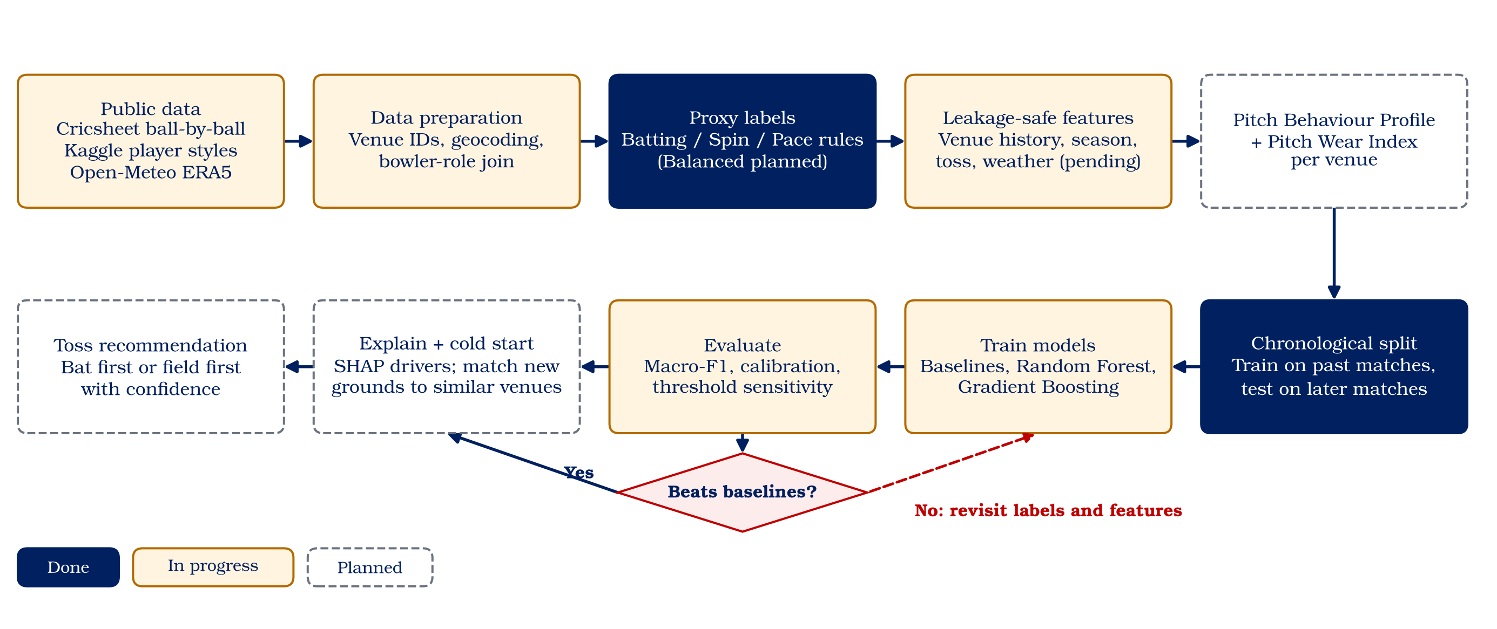
Figure 1 — Project flowchart. End-to-end flow from data collection to toss recommendation.
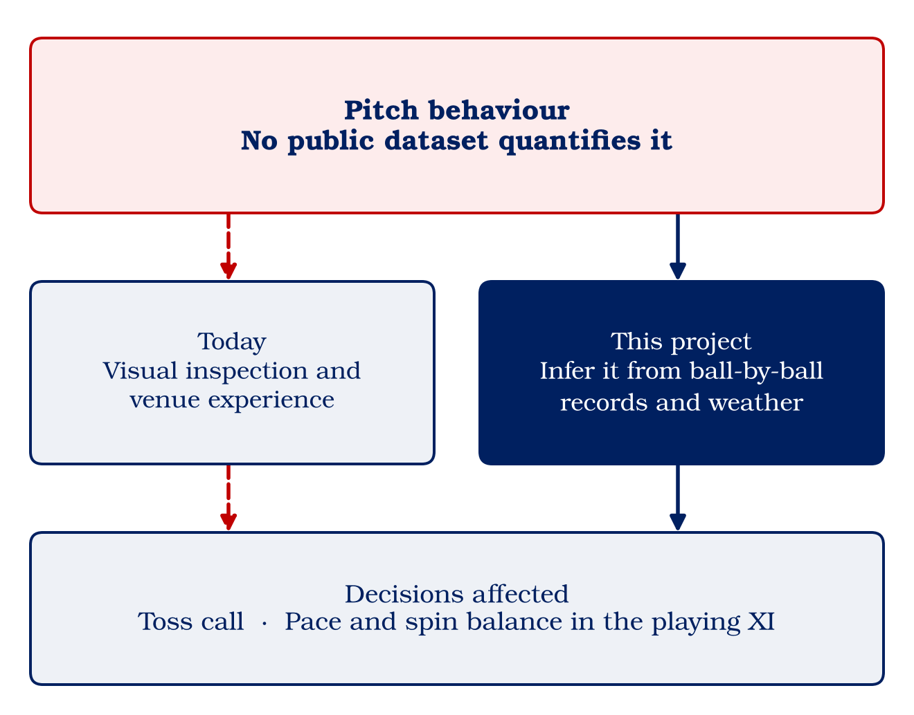
Figure 2 — Problem framing. Why pitch behaviour is unmeasured and why the toss decision matters.
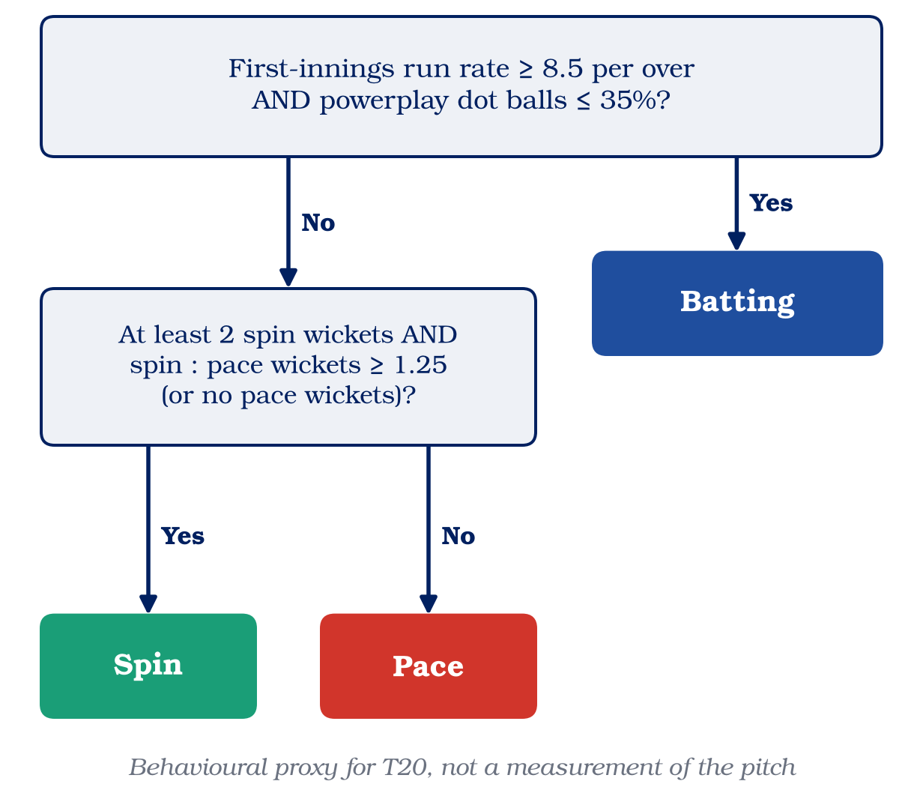
Figure 3 — Label rules. The batting, spin and pace proxy rules used for each format.
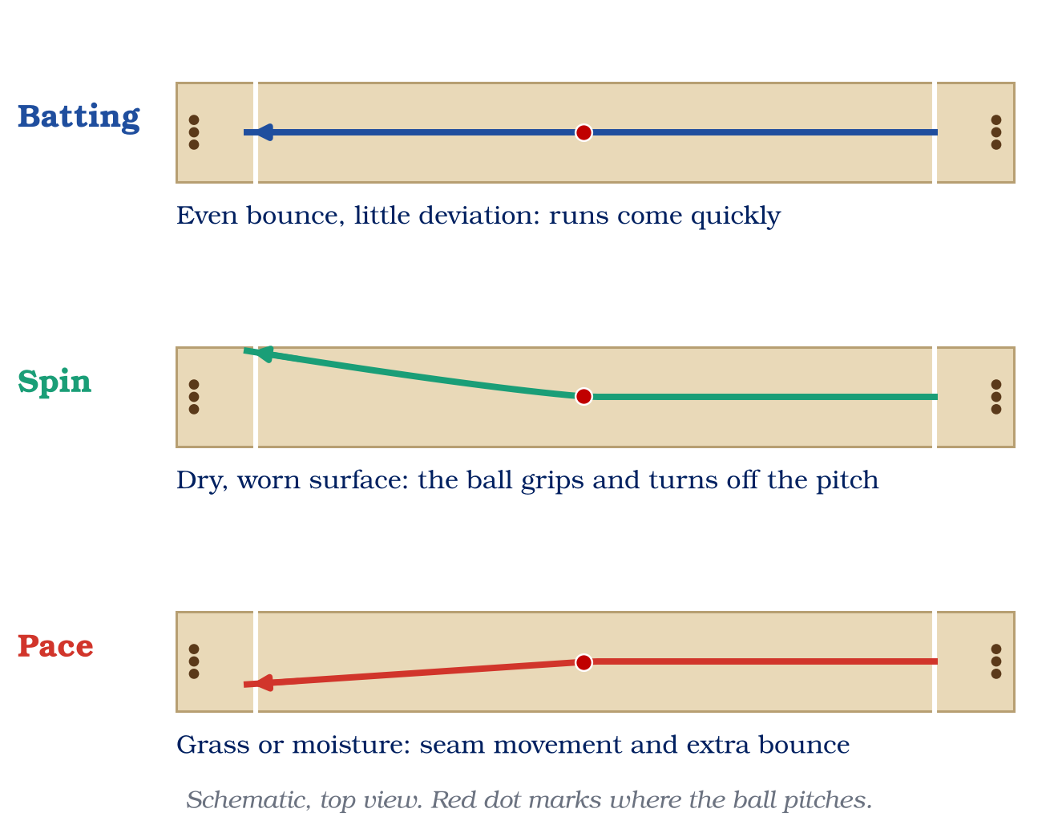
Figure 4 — Pitch types. The three behavioural classes used by the model.
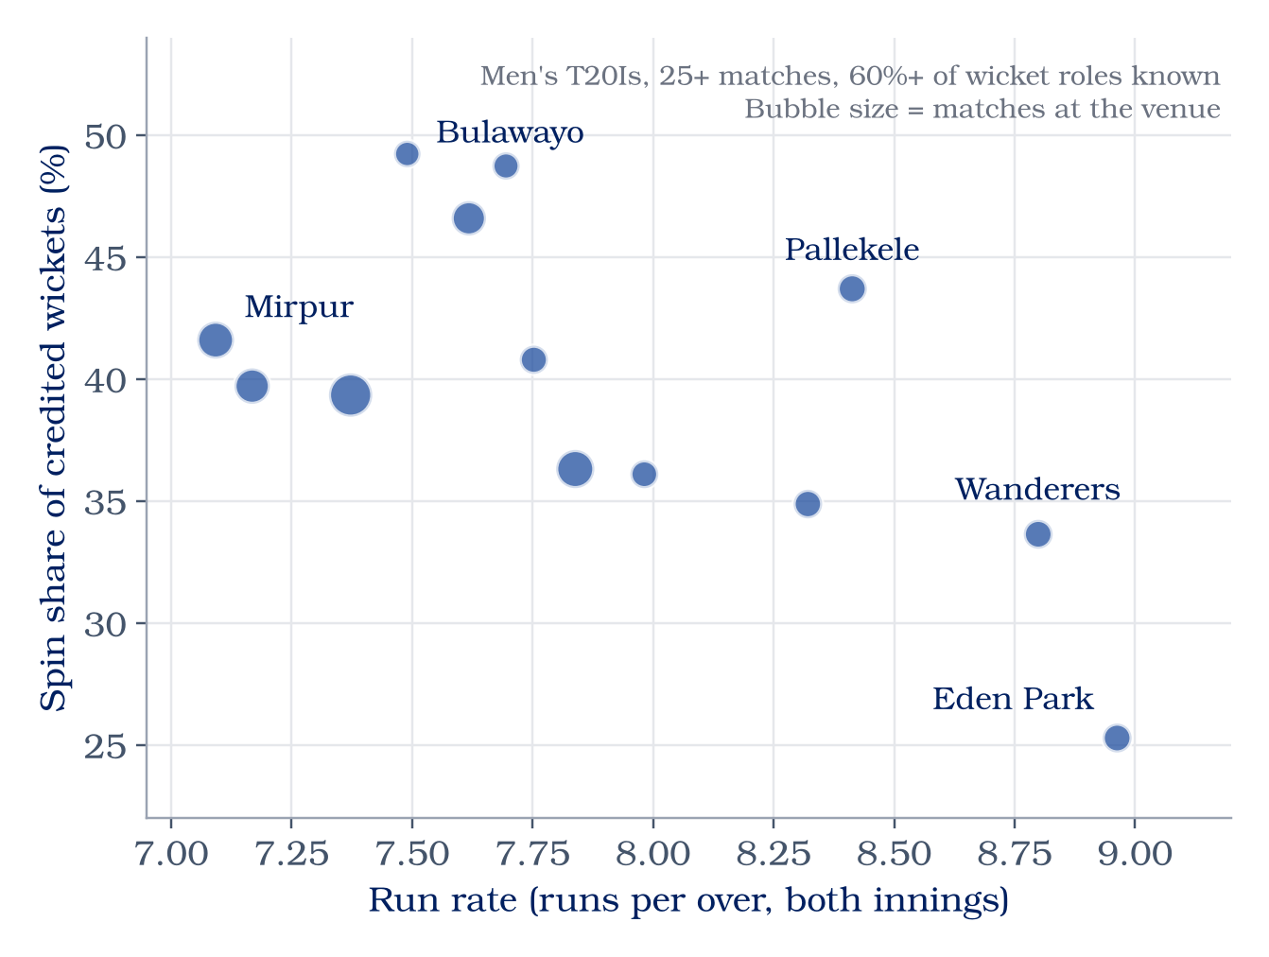
Figure 5 — Venue profiles. Run rate, boundary share, wickets per twenty overs and spin wicket share by venue.
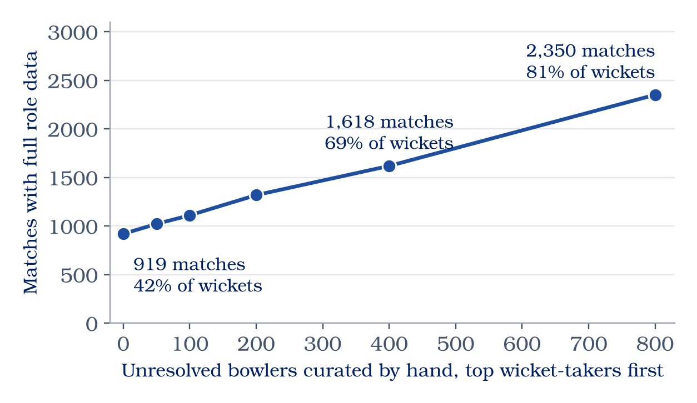
Figure 6 — Data coverage. Match counts, label coverage and the role-coverage bottleneck.
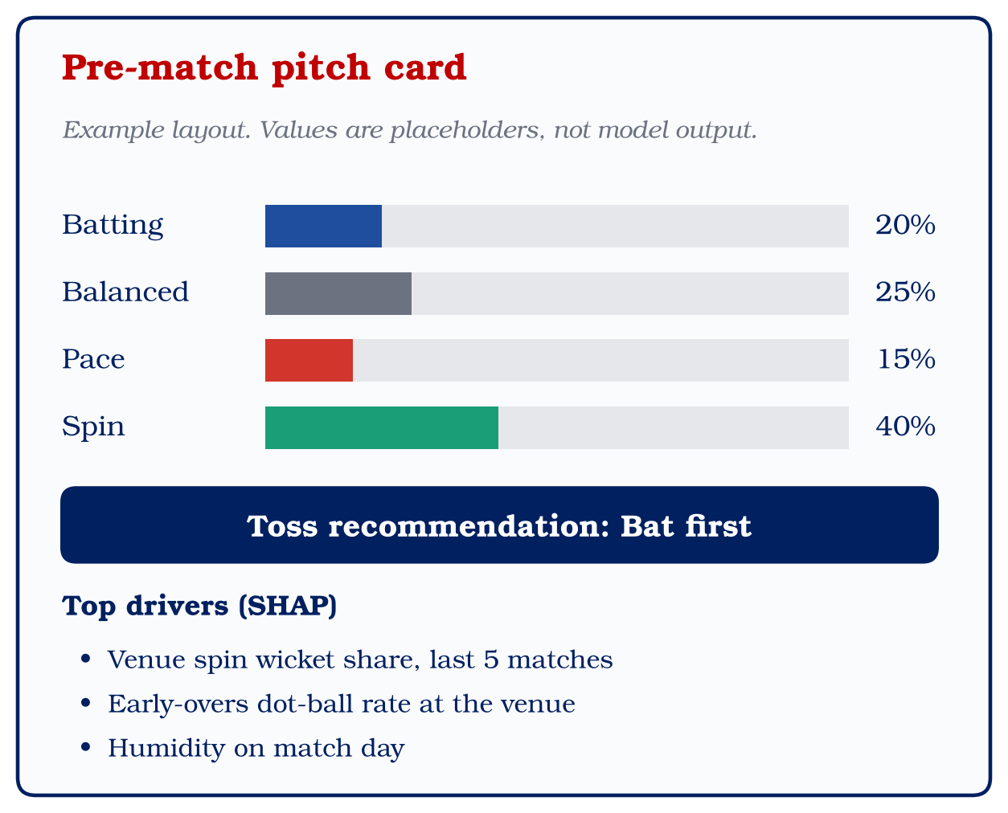
Figure 7 — Proposed output. The toss recommendation card with drivers and confidence.

12. Outcome of the Work
Primary target: conference publication. An IEEE-format paper is planned. The abstract is drafted; the full paper needs the multi-format results, the completed weather join and the role-curation update.
Stretch target: journal publication. An extended paper is feasible if the ODI and Test models and the normalised Pitch Wear Index hold up on later matches.
Software and data. The repository is a reusable open-data pipeline with documented schemas, cached weather responses and a readiness audit. It is the team's main tangible artifact at this stage.
Patent and product. No patent or commercial product is claimed. The toss-recommendation layer is a planned applied output, not a delivered product.

References
[1] W. A. Adams, S. W. Baker, D. M. James, and R. J. Young, "Measuring and modelling the bounce and pace of County Championship cricket pitches," International Turfgrass Society Research Journal, vol. 10, pp. 1021–1026, 2005.
[2] M. Bhatnagar and M. Bhatnagar, "Analyzing key factors influencing IPL cricket scores using explainability and multimodal data," Journal of Quantitative Analysis in Sports, vol. 21, no. 3, pp. 253–267, 2025, doi: 10.1515/jqas-2025-0006.
[3] L. Breiman, "Random forests," Machine Learning, vol. 45, no. 1, pp. 5–32, 2001, doi: 10.1023/A:1010933404324.
[4] S. Chakraborty et al., "Cricket data analytics: Forecasting T20 match winners through machine learning," International Journal of Knowledge-Based and Intelligent Engineering Systems, vol. 28, no. 1, pp. 73–92, 2024, doi: 10.3233/KES-230060.
[5] T. Chen and C. Guestrin, "XGBoost: A scalable tree boosting system," in Proceedings of the 22nd ACM SIGKDD International Conference on Knowledge Discovery and Data Mining, 2016, pp. 785–794, doi: 10.1145/2939672.2939785.
[6] Cricsheet, "Downloads." [Online]. Available: https://cricsheet.org/downloads/
[7] H. Hersbach et al., "The ERA5 global reanalysis," Quarterly Journal of the Royal Meteorological Society, vol. 146, no. 730, pp. 1999–2049, 2020, doi: 10.1002/qj.3803.
[8] D. M. James, M. J. Carré, and S. J. Haake, "The playing performance of county cricket pitches," Sports Engineering, vol. 7, no. 1, pp. 1–14, 2004.
[9] S. M. Lundberg and S.-I. Lee, "A unified approach to interpreting model predictions," in Advances in Neural Information Processing Systems, vol. 30, 2017, pp. 4765–4774.
[10] Open-Meteo, "Historical weather API." [Online]. Available: https://open-meteo.com/en/docs/historical-weather-api
[11] B. Morley and D. Thomas, "An investigation of home advantage and other factors affecting outcomes in English one-day cricket matches," Journal of Sports Sciences, vol. 23, no. 3, pp. 261–268, 2005.
[12] S. A. A. Shah, Q. Zaman, D. Wasim, J. Allohibi, A. A. Alharbi, and M. Shabbir, "Optimal model for predicting highest runs chase outcomes in T-20 international cricket using modern classification algorithms," Alexandria Engineering Journal, vol. 114, pp. 588–598, 2025.
[13] G. Sood and D. Willis, "Fairly random: The impact of winning the toss on the probability of winning," arXiv:1605.08753, 2016.

Appendix A — Glossary of Abbreviations
Abbreviation | Full form | Meaning in this report
API | Application Programming Interface | Programmatic interface used to query Open-Meteo
AutoML | Automated Machine Learning | Automatic model selection and tuning (reviewed literature)
CI | Confidence Interval | Range that likely contains the true metric
CPU | Central Processing Unit | Standard processor used for training when no GPU is available
CSV | Comma-Separated Values | Plain-text tabular file format
CV | Cross-Validation | Repeated train/test splits for robust evaluation
ECE | Expected Calibration Error | Average gap between predicted confidence and observed accuracy
EL | Experiential Learning | The course under which this project is undertaken
ERA5 | ECMWF Reanalysis version 5 | Global historical weather reconstruction
ECMWF | European Centre for Medium-Range Weather Forecasts | Producer of ERA5
F1 | F1-score | Harmonic mean of precision and recall
GPU | Graphics Processing Unit | Accelerator for model training
IPL | Indian Premier League | Domestic T20 league reviewed in the literature
JSON | JavaScript Object Notation | Structured text format used by Cricsheet
LFS | Large File Storage | Git extension for large binary files
LLM | Large Language Model | Text model used in one reviewed study
LR | Logistic Regression | Linear classification baseline
ML | Machine Learning | Learning patterns from data
ODI | One Day International | 50-over international format
ODC-By | Open Data Commons Attribution License | Licence of the Cricsheet data
PBP | Pitch Behaviour Profile | Venue-level summary of scoring and wicket style
PWI | Pitch Wear Index | Planned measure of within-match surface change
RF | Random Forest | Ensemble of decision trees
SHAP | SHapley Additive exPlanations | Game-theoretic feature-attribution method
SVM | Support Vector Machine | Margin-based classifier (reviewed literature)
T20 | Twenty20 | 20-over format
T20I | Twenty20 International | 20-over international match

