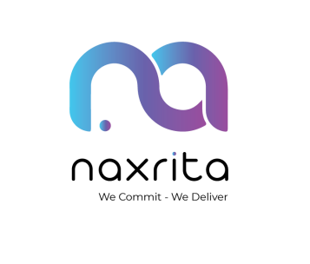


OFFER LETTER
Strictly Private and Confidential 21-Jan-2026
DevCon ID – 1500001
Position - DevCon Associate – SAP Application Development Track

Dear Yerra Lalitha,


We are pleased to inform you that you have been selected to participate as a “DevCon Associate – SAP Application Development Track” for Naxrita DevCon – Campus Edition, a structured intensive industry-readiness program conducted in collaboration with Sri Vasavi Engineering College and powered by Emax Technologies, Hyderabad. This offer is made based on your registration, eligibility, and willingness to participate in the DevCon program.

- Nature & Duration of Engagement
Title: DevCon Associate – SAP Application Development Track Engagement Type: Academic–Industry Program Engagement Program Location: Sri Vasavi Engineering College
This engagement is strictly limited to the DevCon program period only and shall automatically conclude upon program completion.
- Purpose of the Engagement
The objective of this engagement is to:
  - Provide industry-oriented SAP S/4HANA exposure
  - Build enterprise-level technical and professional discipline
  - Simulate a real corporate working environment
  - This is a learning and capability-building program, not an employment role.
  - Prepare participants for certification, internships, permanent employment, and future opportunities




- Roles & Expectations
As a DevCon Associate, you are expected to:
  - Attend all sessions punctually and regularly
  - Actively participate in hands-on workshops and practical exercises
  - Follow professional conduct, discipline, and program guidelines
  - This is a learning and capability-building program, not an employment role.
  - Complete assignments, assessments, and mini projects as required
- Evaluation & Future Opportunities
Performance during this program will be evaluated continuously.
Based on performance, discipline, and project outcomes:

  - Select participants may be considered for internships, contract roles, or future opportunities with Naxrita. Such opportunities, if any, will be communicated through separate formal offers.
  - Participation in DevCon does not guarantee employment, internship, or placement. participate in hands-on workshops and practical exercises.
- Compensation / Stipend
This DevCon engagement does not carry any salary or employment compensation
Any future stipend, allowance, or compensation (if applicable) shall be governed by separate written agreements.
- Confidentiality & Conduct
During the program, you are required to:
  - Maintain confidentiality of training material, systems, and information, Not share program content or access details externally
  - Adhere to Naxrita’s code of conduct and academic integrity standards.
- Nature of Offer
This offer letter:
  - It is program-specific and time-bound.
  - Ad Does not constitute employment, apprenticeship, or job offer.
  - Does not create any employer–employee relationship.
  - Automatically expires upon completion of the DevCon program




- Acceptance
Please sign and submit this letter as acceptance of the terms and conditions of the DevCon Associate – SAP Application Development Track.

We welcome you to Naxrita DevCon – Campus Edition and wish you a meaningful learning journey.

Warm regards,

Talent Acquisition Manager, Naxrita


Acceptance by Participant
I, Yerra Lalitha, confirm my acceptance of the above terms for participation in the DevCon Associate – SAP Application Development Track.

Signature: Date:

