**Program-3: Write a JavaScript code that displays text “TEXT- GROWING” with increasing font size in the interval of 100ms in RED COLOR, when the font size reaches 50pt it displays**

**“TEXTSHRINKING” in BLUE color. Then the font size decreases to 5pt.**

**Html:**

<!DOCTYPE html>

<html>

<head>

<title>Assignment-3</title>

</head>

<body>

<link rel="stylesheet" href="Assignment3.css">

<title>Program3</title>

<header>

<nav>

<a href="/html">HOME</a> |

<a href="/html">PLACES</a> |

<a href="/html">GALLERY</a> |

<a href="/html">ABOUT US</a>

</nav>

</header>

<h2><u>Shreya Ghoshal</u></h2>

<p id="demo"></p>

<script>

var var1 = setInterval(inTimer, 500);

var fs = 5;

var ids = document.getElementById("demo");

function inTimer()

{

ids.innerHTML = 'Shreya Ghoshal';

ids.setAttribute('style', "font-size: " + fs + "px; color: #33ccff");

fs += 5;

if (fs >= 50)

{

clearInterval(var1);

var2 = setInterval(deTimer, 500);

}

}

function deTimer()

{

fs -= 5;

ids.innerHTML = 'Shreya Ghoshal';

ids.setAttribute('style', "font-size: " + fs + "px; color: #ff3333");

if (fs == 5)

{

clearInterval(var2);

var1 = setInterval(inTimer, 500);

}

}

</script>

<title>Shreya Ghoshal</title>

<img src="rish.jpeg" alt="Shreya Ghoshal" width="400" height="233">

<br>

<h3>by<a href="/html"> Rishab</a></h3>

<article>Shreya Ghoshal is an Indian playback singer.She has sung professionally in 19+ languages including Hindi, Tamil, Telugu, Kannada, Malayalam, Marathi, Bengali, Bhojpuri, Rajasthani, Odia, Assamese, Nepali, French, Urdu, Sanskrit, Angika, Tulu, Gujarati, Punjabi etc. She sang more than 2341 songs in 20+ languages and especially in Hindi she sang 1500+ songs.</article>

<br>

<section>Year:2020<br>

Date:12th March</section>

<h3><u> Reviews</u></h3>

<section>

<strong>Miss her concerts!</strong>

<br>

<stong>Pradyumna</strong><img src="r1.png" alt="rating";>

<br>

<strong>My fav singer</strong><br>

<hr>

<strong>Always my fav</strong>

<br>

<stong>Meghana</strong><img src="r2.png" alt="rating";>

<br>

<strong>Awesome bollywood singer</strong><br>

<hr>

<strong>She is awesome</strong>

<br>

<stong>Hitesh</strong><img src="r3.png" alt="rating";>

<br>

<strong>Nice</strong><br>

<hr>

</section>

<footer><nav>

<a href="/html">HOME</a> |

<a href="/html">PLACES</a> |

<a href="/html">GALLERY</a> |

<a href="/html">ABOUT US</a>

</nav>

<br>

<strong><i>Copyright &copy; 2021-2022 by Rishab</i></strong>

</footer>

</body>

</html>

**CSS:**

p {

position: absolute;

right: 350px;

bottom: 550px;

transform: translate(-50%, -50%);

**SNAPSHOTS:**

**1.**

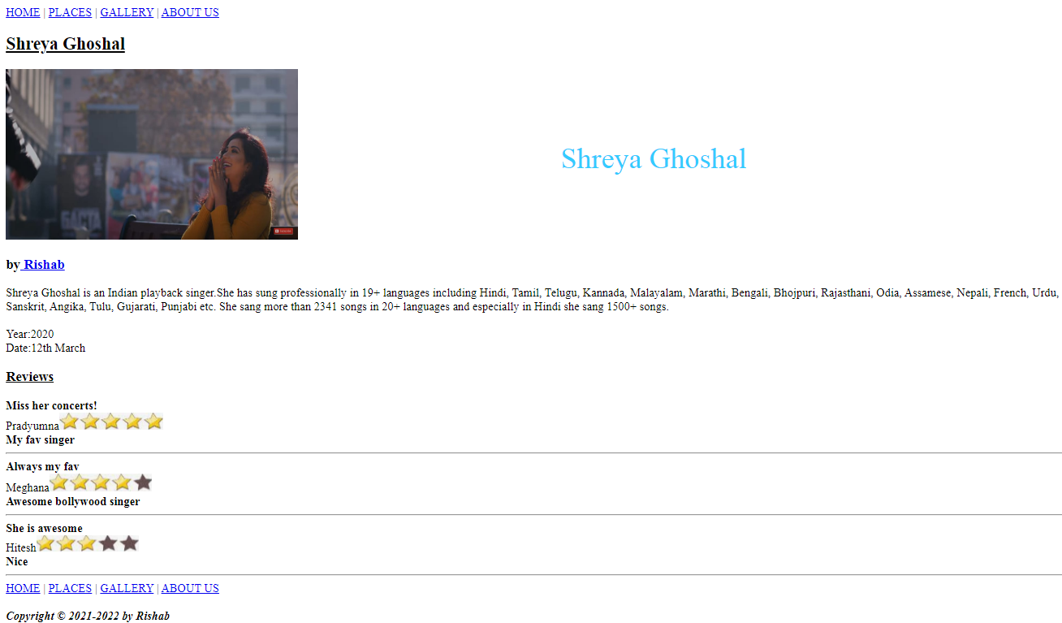

**2.**

