**PROGRAM 7: Write a PHP program to display a digital clock which displays the current time of the server.**

**CODE:**

<!DOCTYPE HTML>

<html>

<head>

<meta http-equiv="refresh" content="1" />

<style>

p {

color: white;

font-size: 30px;

position: absolute;

top: 50%;

left: 50%;

transform: translate(-50%, -50%);

}

body {

background-color: blue;

}

</style>

<p style="color: black;"> Server Time: <?php

echo date(" h: i : s A") . "<br>";

echo "Today is " . date("Y/m/d") . "<br>";

echo "Today is " . date("Y.m.d") . "<br>";

echo "Today is " . date("Y-m-d") . "<br>";

echo "Today is " . date("l");?> </p>

</head>

</html>

**SNAPSHOT**

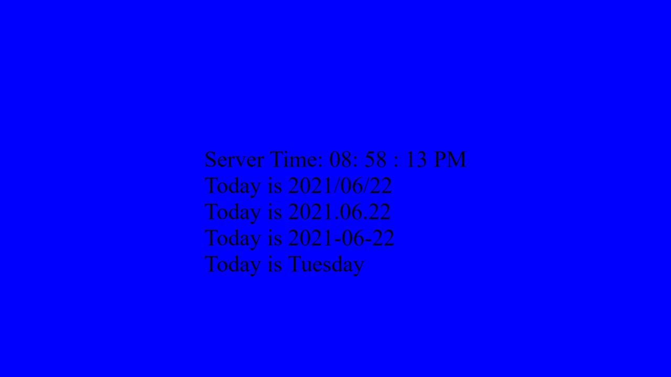

**REFERENCES:**

1. https://www.w3schools.com/tags/tag_time.asp